This text was adapted by The Saylor Foundation under a Creative Commons Attribution-NonCommercial-ShareAlike 3.0 License without attribution as requested by the work’s original creator or licensee.

Principles of Management v. 1.1

Table of Contents

Preface

Chapter 1: Introduction to Principles of Management
  - Chapter Introduction
  - Case in Point: Doing Good as a Core Business Strategy
  - Who Are Managers?
  - Leadership, Entrepreneurship, and Strategy
  - Planning, Organizing, Leading, and Controlling
  - Economic, Social, and Environmental Performance
  - Performance of Individuals and Groups
  - Your Principles of Management Survivor’s Guide

Chapter 2: Personality, Attitudes, and Work Behaviors
  - Chapter Introduction
  - Case in Point: SAS Institute Invests in Employees
  - Personality and Values
  - Perception
  - Work Attitudes
  - The Interactionist Perspective: The Role of Fit
  - Work Behaviors
  - Developing Your Positive Attitude Skills

Chapter 3: History, Globalization, and Values-Based Leadership
  - Chapter Introduction
  - Case in Point: Hanna Andersson Corporation Changes for Good
  - Ancient History: Management Through the 1990s
  - Contemporary Principles of Management
  - Global Trends
  - Globalization and Principles of Management
  - Developing Your Values-Based Leadership Skills

Chapter 4: Developing Mission, Vision, and Values
  - Chapter Introduction
  - Case in Point: Xerox Motivates Employees for Success
  - The Roles of Mission, Vision, and Values
  - Mission and Vision in the P-O-L-C Framework
  - Creativity and Passion
  - Stakeholders
  - Crafting Mission and Vision Statements
  - Developing Your Personal Mission and Vision

Chapter 5: Strategizing
  - Chapter Introduction
  - Case in Point: Flat World Knowledge Transforms Textbook Industry
  - Strategic Management in the P-O-L-C Framework
  - How Do Strategies Emerge?
  - Strategy as Trade-Offs, Discipline, and Focus
  - Developing Strategy Through Internal Analysis
  - Developing Strategy Through External Analysis
  - Formulating Organizational and Personal Strategy With the Strategy Diamond

Chapter 6: Goals and Objectives
  - Chapter Introduction
  - Case in Point: Nucor Aligns Company Goals With Employee Goals
  - The Nature of Goals and Objectives
  - From Management by Objectives to the Balanced Scorecard
  - Characteristics of Effective Goals and Objectives
  - Using Goals and Objectives in Employee Performance Evaluation
  - Integrating Goals and Objectives with Corporate Social Responsibility
  - Your Personal Balanced Scorecard

Chapter 7: Organizational Structure and Change
  - Chapter Introduction
  - Case in Point: Toyota Struggles With Organizational Structure
  - Organizational Structure
  - Contemporary Forms of Organizational Structures
  - Organizational Change
  - Planning and Executing Change Effectively
  - Building Your Change Management Skills

Chapter 8: Organizational Culture
  - Chapter Introduction
  - Case in Point: Google Creates Unique Culture
  - Understanding Organizational Culture
  - Measuring Organizational Culture
  - Creating and Maintaining Organizational Culture
  - Creating Culture Change
  - Developing Your Personal Skills: Learning to Fit In

Chapter 9: Social Networks
  - Chapter Introduction
  - Case in Point: Networking Powers Relationships
  - An Introduction to the Lexicon of Social Networks
  - How Managers Can Use Social Networks to Create Value
  - Ethical Considerations With Social Network Analysis
  - Personal, Operational, and Strategic Networks
  - Mapping and Your Own Social Network

Chapter 10: Leading People and Organizations
  - Chapter Introduction
  - Case in Point: Indra Nooyi Draws on Vision and Values to Lead
  - Who Is a Leader? Trait Approaches to Leadership
  - What Do Leaders Do? Behavioral Approaches to Leadership
  - What Is the Role of the Context? Contingency Approaches to Leadership
  - Contemporary Approaches to Leadership
  - Developing Your Leadership Skills

Chapter 11: Decision Making
  - Chapter Introduction
  - Case in Point: Bernard Ebbers Creates Biased Decision Making at WorldCom
  - Understanding Decision Making
  - Faulty Decision Making
  - Decision Making in Groups
  - Developing Your Personal Decision-Making Skills

Chapter 12: Communication in Organizations
  - Chapter Introduction
  - Case in Point: Edward Jones Communicates Caring
  - Understanding Communication
  - Communication Barriers
  - Different Types of Communication
  - Communication Channels
  - Developing Your Personal Communication Skills

Chapter 13: Managing Groups and Teams
  - Chapter Introduction
  - Case in Point: General Electric Allows Teamwork to Take Flight
  - Group Dynamics
  - Understanding Team Design Characteristics
  - Organizing Effective Teams
  - Barriers to Effective Teams
  - Developing Your Team Skills

Chapter 14: Motivating Employees
  - Chapter Introduction
  - Case in Point: Zappos Creates a Motivating Place to Work
  - Need-Based Theories of Motivation
  - Process-Based Theories
  - Developing Your Personal Motivation Skills

Chapter 15: The Essentials of Control
  - Chapter Introduction
  - Case in Point: Newell Rubbermaid Leverages Cost Controls to Grow
  - Organizational Control
  - Types and Levels of Control
  - Financial Controls
  - Nonfinancial Controls
  - Lean Control
  - Crafting Your Balanced Scorecard

Chapter 16: Strategic Human Resource Management
  - Chapter Introduction
  - Case in Point: Kronos Uses Science to Find the Ideal Employee
  - The Changing Role of Strategic Human Resource Management in Principles of Management
  - The War for Talent
  - Effective Selection and Placement Strategies
  - The Roles of Pay Structure and Pay for Performance
  - Designing a High-Performance Work System
  - Tying It All Together—Using the HR Balanced Scorecard to Gauge and Manage Human Capital, Including Your Own

Preface
Welcome to the textbook revolution (you will have to read on to learn more about the revolution that you have joined in using this material for your class). We are happy to have you on Carpenter, Bauer, and Erdogan’s Principles of Management team! Given that Principles is likely to be one of the first management courses, if not one of the first business courses, that students take, our objective in developing this material was to provide students and instructors with a solid and comprehensive foundation on the fundamentals of management. Each of the 16 chapters is comprehensive but succinct, and action-oriented but not busy (as in busy work). Moreover, the book and supplements have been written in a direct and active style that we hope students and instructors find both readily accessible and relevant.

Delivering on Our Promise
So how are we delivering on these promises? Let’s consider the top three ways cited by instructors and students. First, your Principles book is organized around the well-established planning, organizing, leading, and controlling framework (or, simply, P-O-L-C). The first three chapters introduce you to the managerial context, while the remaining 13 chapters are mapped to one of the four P-O-L-C sections. The P-O-L-C structure provides a number of benefits. Each chapter opens with a brief discussion of how the chapter topic fits in P-O-L-C. For instructors, the use of P-O-L-C as an overarching framework helps with the organization of class material, development of the class calendar, and making choices about adding or removing readings and real-life examples. It also provides them with an invaluable reference point at the beginning and conclusion of each class session to share with students “where we’ve been, and where we’re going next.” Pedagogically, this is a simple yet powerful tool to aid and promote student learning. For students, the P-O-L-C typology provides them with an enduring framework for processing and organizing just about everything they will learn and experience, during and beyond their classroom-based education, related to the management of organizations.
Second, there are three underlying themes carried through all the chapters. These themes are strategic thinking, entrepreneurial thinking, and active management. Strategy, for instance, is explicitly concerned with the determinants of high performance. Importantly, you will find that we treat performance using the notion of the triple bottom line—the idea that economic performance allows individuals and organizations to perform positively in social and environmental ways as well. The triple bottom line is financial, social, and environmental performance.
The entrepreneurial dimension reflects an underlying and growing trend that shows that students and instructors see themselves as entrepreneurs and active change agents, not just managers. By starting fresh with an entrepreneurial/change management orientation, we provide an exciting perspective on the principles of management.
Finally, starting with the opening chapter, we incorporate an active management perspective to show how leaders and leadership are essential to personal and organizational effectiveness and effective organizational change. Moreover, the concluding section of each chapter is focused on the assessment and development of particular management skills. Students and instructors are active as leaders at an increasingly early age and are sometimes painfully aware of the leadership failings they see in public and private organizations. It is the leader and leadership that bring Principles together.
Third, your author team is bringing a truly interdisciplinary perspective to your Principles course. The book that is the foundation for how you learn about, study, and teach Principles is titled Principles of Management: A Behavioral Approach, and behavioral has very important implications for our emphasis on skills and decision making, coupled with the strategic, entrepreneurial, and leadership orientations. Your authors are award-winning teachers who couple a deep knowledge and experience about the book’s conceptual underpinnings with a sincere appreciation for experiential teaching approaches.
Chapter 1
Introduction to Principles of Management
WHAT’S IN IT FOR ME?

Reading this chapter will help you do the following:

- Learn who managers are and about the nature of their work.

- Know why you should care about leadership, entrepreneurship, and strategy.

- Know the dimensions of the planning-organizing-leading-controlling (P-O-L-C) framework.

- Learn how economic performance feeds social and environmental performance.

- Understand what performance means at the individual and group levels.

- Create your survivor’s guide to learning and developing principles of management.

We’re betting that you already have a lot of experience with organizations, teams, and leadership. You’ve been through schools, in clubs, participated in social or religious groups, competed in sports or games, or taken on full- or part-time jobs. Some of your experience was probably pretty positive, but you were also likely wondering sometimes, “Isn’t there a better way to do this?”
After participating in this course, we hope that you find the answer to be “Yes!” While management is both art and science, with our help you can identify and develop the skills essential to better managing your and others’ behaviors where organizations are concerned.
Before getting ahead of ourselves, just what is management, let alone principles of management? A manager’s primary challenge is to solve problems creatively, and you should view management as “the art of getting things done through the efforts of other people.” We draw this definition from a biography of Mary Parker Follett (1868–1933) written by P. Graham. Follett was an American social worker, consultant, and author of books on democracy, human relations, and management. She worked as a management and political theorist, introducing such phrases as “conflict resolution,” “authority and power,” and “the task of leadership.” The principles of management, then, are the means by which you actually manage, that is, get things done through others—individually, in groups, or in organizations. Formally defined, the principles of management are the activities that “plan, organize, and control the operations of the basic elements of [people], materials, machines, methods, money and markets, providing direction and coordination, and giving leadership to human efforts, so as to achieve the sought objectives of the enterprise.”The fundamental notion of principles of management was developed by French management theorist Henri Fayol (1841–1925). He is credited with the original planning-organizing-leading-controlling framework (P-O-L-C), which, while undergoing very important changes in content, remains the dominant management framework in the world. See H. Fayol, General and Industrial Management (Paris: Institute of Electrical and Electronics Engineering, 1916). For this reason, principles of management are often discussed or learned using a framework called P-O-L-C, which stands for planning, organizing, leading, and controlling.
Managers are required in all the activities of organizations: budgeting, designing, selling, creating, financing, accounting, and artistic presentation; the larger the organization, the more managers are needed. Everyone employed in an organization is affected by management principles, processes, policies, and practices as they are either a manager or a subordinate to a manager, and usually they are both.
Managers do not spend all their time managing. When choreographers are dancing a part, they are not managing, nor are office managers managing when they personally check out a customer’s credit. Some employees perform only part of the functions described as managerial—and to that extent, they are mostly managers in limited areas. For example, those who are assigned the preparation of plans in an advisory capacity to a manager, to that extent, are making management decisions by deciding which of several alternatives to present to the management. However, they have no participation in the functions of organizing, staffing, and supervising and no control over the implementation of the plan selected from those recommended. Even independent consultants are managers, since they get most things done through others—those others just happen to be their clients! Of course, if advisers or consultants have their own staff of subordinates, they become a manager in the fullest sense of the definition. They must develop business plans; hire, train, organize, and motivate their staff members; establish internal policies that will facilitate the work and direct it; and represent the group and its work to those outside of the firm.

1.1 Case in Point: Doing Good as a Core Business Strategy
Goodwill Industries International (a nonprofit organization) has been an advocate of diversity for over 100 years. In 1902, in Boston, Massachusetts, a young missionary set up a small operation enlisting struggling immigrants in his parish to clean and repair clothing and goods to later sell. This provided workers with the opportunity for basic education and language training. His philosophy was to provide a “hand up,” not a “hand out.” Although today you can find retail stores in over 2,300 locations worldwide, and in 2009 more than 64 million people in the United States and Canada donated to Goodwill, the organization has maintained its core mission to respect the dignity of individuals by eliminating barriers to opportunity through the power of work. Goodwill accomplishes this goal, in part, by putting 84% of its revenue back into programs to provide employment, which in 2008 amounted to $3.23 billion. As a result of these programs, every 42 seconds of every business day, someone gets a job and is one step closer to achieving economic stability.
Goodwill is a pioneer of social enterprise and has managed to build a culture of respect through its diversity programs. If you walk into a local Goodwill retail store you are likely to see employees from all walks of life, including differences in gender and race, physical ability, sexual orientation, and age. Goodwill provides employment opportunities for individuals with disabilities, lack of education, or lack of job experience. The company has created programs for individuals with criminal backgrounds who might otherwise be unable to find employment, including basic work skill development, job placement assistance, and life skills. In 2008, more than 172,000 people obtained employment, earning $2.3 billion in wages and gaining tools to be productive members of their community. Goodwill has established diversity as an organizational norm, and as a result, employees are comfortable addressing issues of stereotyping and discrimination. In an organization of individuals with such wide-ranging backgrounds, it is not surprising that there are a wide range of values and beliefs.
Management and operations are decentralized within the organization with 166 independent community-based Goodwill stores. These regional businesses are independent, not-for-profit human services organizations. Despite its decentralization, the company has managed to maintain its core values. Seattle’s Goodwill is focused on helping the city’s large immigrant population and those individuals without basic education and English language skills. And at Goodwill Industries of Kentucky, the organization recently invested in custom software to balance daily sales at stores to streamline operations so managers can spend less time on paperwork and more time managing employees.
Part of Goodwill’s success over the years can be attributed to its ability to innovate. As technology evolves and such skills became necessary for most jobs, Goodwill has developed training programs to ensure that individuals are fully equipped to be productive members of the workforce, and in 2008 Goodwill was able to provide 1.5 million people with career services. As an organization, Goodwill itself has entered into the digital age. You can now find Goodwill on Facebook, Twitter, and YouTube. Goodwill’s business practices encompass the values of the triple bottom line of people, planet, and profit. The organization is taking advantage of new green initiatives and pursuing opportunities for sustainability. For example, at the beginning of 2010, Goodwill received a $7.3 million grant from the U.S. Department of Labor, which will provide funds to prepare individuals to enter the rapidly growing green industry of their choice. Oregon’s Goodwill Industries has partnered with the Oregon Department of Environmental Quality and its Oregon E-Cycles program to prevent the improper disposal of electronics. Goodwill discovered long ago that diversity is an advantage rather than a hindrance.
- Case written by Carlene Reynolds, Talya Bauer, and Berrin Erdogan to accompany Carpenter, M., Bauer, T., & Erdogan, B. (2009).

- Walker, R. (2008, November 2). Consumed: Goodwill hunting. New York Times Magazine, p. 18; Tabafunda, J. (2008, July 26). After 85 years, Seattle Goodwill continues to improve lives. Northwest Asian Weekly. Retrieved March 1, 2010, from http://www.nwasianweekly.com/old/2008270031/goodwill20082731.htm

- Slack, E. (2009). Selling hope. Retail Merchandiser, 49(1), 89–91

- Castillo, L. (2009, February 24). Goodwill Industries offers employment programs. Clovis News Journal. Retrieved April 22, 2010, from http://www.cnjonline.com/news/industries-32474-goodwill-duttweiler.html

- Information retrieved April 22, 2010, from the Oregon E-Cycles Web site: http://www.deq.state.or.us/lq/ecycle.

DISCUSSION QUESTIONS
- How might the implications of the P-O-L-C framework differ for an organization like Goodwill Industries versus a firm like Starbucks?

- What are Goodwill’s competitive advantages?

- Goodwill has found success in the social services. What problems might result from hiring and training the diverse populations that Goodwill is involved with?

- Have you ever experienced problems with discrimination in a work or school setting?

- Why do you think that Goodwill believes it necessary to continually innovate?

1.2 Who Are Managers?
LEARNING OBJECTIVES
- Know what is meant by “manager”.

- Be able to describe the types of managers.

- Understand the nature of managerial work.

Managers
We tend to think about managers based on their position in an organization. This tells us a bit about their role and the nature of their responsibilities. The following figure summarizes the historic and contemporary views of organizations with respect to managerial roles.
- S. Ghoshal and C. Bartlett, The Individualized Corporation: A Fundamentally New Approach to Management (New York: Collins Business, 1999).
In contrast to the traditional, hierarchical relationship among layers of management and managers and employees, in the contemporary view, top managers support and serve other managers and employees (through a process called empowerment), just as the organization ultimately exists to serve its customers and clients. Empowerment is the process of enabling or authorizing an individual to think, behave, take action, and control work and decision making in autonomous ways.
In both the traditional and contemporary views of management, however, there remains the need for different types of managers. Top managers are responsible for developing the organization’s strategy and being a steward for its vision and mission. A second set of managers includes functional, team, and general managers. Functional managers are responsible for the efficiency and effectiveness of an area, such as accounting or marketing. Supervisory or team managers are responsible for coordinating a subgroup of a particular function or a team composed of members from different parts of the organization. Sometimes you will hear distinctions made between line and staff managers.
A line manager leads a function that contributes directly to the products or services the organization creates. For example, a line manager (often called a product, or service manager) at Procter & Gamble (P&G) is responsible for the production, marketing, and profitability of the Tide detergent product line. A staff manager, in contrast, leads a function that creates indirect inputs. For example, finance and accounting are critical organizational functions but do not typically provide an input into the final product or service a customer buys, such as a box of Tide detergent. Instead, they serve a supporting role. A project manager has the responsibility for the planning, execution, and closing of any project. Project managers are often found in construction, architecture, consulting, computer networking, telecommunications, or software development.
A general manager is someone who is responsible for managing a clearly identifiable revenue-producing unit, such as a store, business unit, or product line. General managers typically must make decisions across different functions and have rewards tied to the performance of the entire unit (i.e., store, business unit, product line, etc.). General managers take direction from their top executives. They must first understand the executives’ overall plan for the company. Then they set specific goals for their own departments to fit in with the plan. The general manager of production, for example, might have to increase certain product lines and phase out others. General managers must describe their goals clearly to their support staff. The supervisory managers see that the goals are met.
Figure 1.4 The Changing Roles of Management and Managers
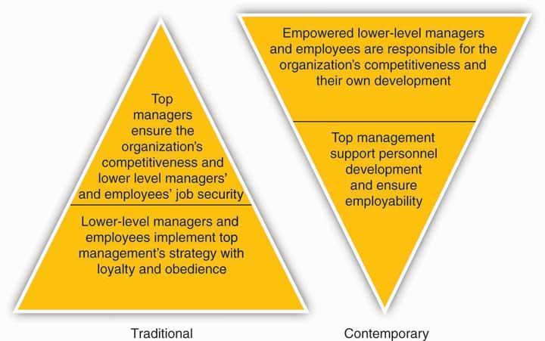

The Nature of Managerial Work
Managers are responsible for the processes of getting activities completed efficiently with and through other people and setting and achieving the firm’s goals through the execution of four basic management functions: planning, organizing, leading, and controlling. Both sets of processes utilize human, financial, and material resources.
Of course, some managers are better than others at accomplishing this! There have been a number of studies on what managers actually do, the most famous of those conducted by Professor Henry Mintzberg in the early 1970s.
- H. Mintzberg, The Nature of Managerial Work (New York: Harper & Row, 1973).
One explanation for Mintzberg’s enduring influence is perhaps that the nature of managerial work has changed very little since that time, aside from the shift to an empowered relationship between top managers and other managers and employees, and obvious changes in technology, and the exponential increase in information overload.
After following managers around for several weeks, Mintzberg concluded that, to meet the many demands of performing their functions, managers assume multiple roles. A role is an organized set of behaviors, and Mintzberg identified 10 roles common to the work of all managers. As summarized in the following figure, the 10 roles are divided into three groups: interpersonal, informational, and decisional. The informational roles link all managerial work together. The interpersonal roles ensure that information is provided. The decisional roles make significant use of the information. The performance of managerial roles and the requirements of these roles can be played at different times by the same manager and to different degrees, depending on the level and function of management. The 10 roles are described individually, but they form an integrated whole.
The three interpersonal roles are primarily concerned with interpersonal relationships. In the figurehead role, the manager represents the organization in all matters of formality. The top-level manager represents the company legally and socially to those outside of the organization. The supervisor represents the work group to higher management and higher management to the work group. In the liaison role, the manager interacts with peers and people outside the organization. The top-level manager uses the liaison role to gain favors and information, while the supervisor uses it to maintain the routine flow of work. The leader role defines the relationships between the manager and employees.

Figure 1.5 Ten Managerial Roles
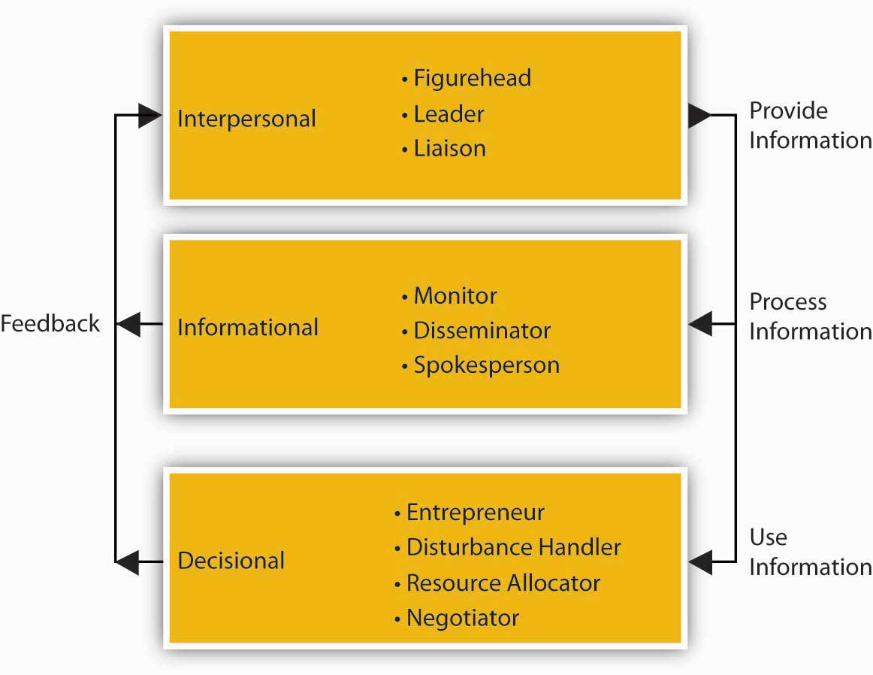

The direct relationships with people in the interpersonal roles place the manager in a unique position to get information. Thus, the three informational roles are primarily concerned with the information aspects of managerial work. In the monitor role, the manager receives and collects information. In the role of disseminator, the manager transmits special information into the organization. The top-level manager receives and transmits more information from people outside the organization than the supervisor. In the role of spokesperson, the manager disseminates the organization’s information into its environment. Thus, the top-level manager is seen as an industry expert, while the supervisor is seen as a unit or departmental expert.
The unique access to information places the manager at the center of organizational decision making. There are four decisional roles managers play. In the entrepreneur role, the manager initiates change. In the disturbance handler role, the manager deals with threats to the organization. In the resource allocator role, the manager chooses where the organization will expend its efforts. In the negotiator role, the manager negotiates on behalf of the organization. The top-level manager makes the decisions about the organization as a whole, while the supervisor makes decisions about his or her particular work unit.
The supervisor performs these managerial roles but with different emphasis than higher managers. Supervisory management is more focused and short-term in outlook. Thus, the figurehead role becomes less significant and the disturbance handler and negotiator roles increase in importance for the supervisor. Since leadership permeates all activities, the leader role is among the most important of all roles at all levels of management.
So what do Mintzberg’s conclusions about the nature of managerial work mean for you? On the one hand, managerial work is the lifeblood of most organizations because it serves to choreograph and motivate individuals to do amazing things. Managerial work is exciting, and it is hard to imagine that there will ever be a shortage of demand for capable, energetic managers. On the other hand, managerial work is necessarily fast-paced and fragmented, where managers at all levels express the opinion that they must process much more information and make more decisions than they could have ever possibly imagined. So, just as the most successful organizations seem to have well-formed and well-executed strategies, there is also a strong need for managers to have good strategies about the way they will approach their work. This is exactly what you will learn through principles of management.

KEY TAKEAWAY
Managers are responsible for getting work done through others. We typically describe the key managerial functions as planning, organizing, leading, and controlling. The definitions for each of these have evolved over time, just as the nature of managing in general has evolved over time. This evolution is best seen in the gradual transition from the traditional hierarchical relationship between managers and employees, to a climate characterized better as an upside-down pyramid, where top executives support middle managers and they, in turn, support the employees who innovate and fulfill the needs of customers and clients. Through all four managerial functions, the work of managers ranges across 10 roles, from figurehead to negotiator. While actual managerial work can seem challenging, the skills you gain through principles of management—consisting of the functions of planning, organizing, leading, and controlling—will help you to meet these challenges.

EXERCISES
- Why do organizations need managers?

- What are some different types of managers and how do they differ?

- What are Mintzberg’s 10 managerial roles?

- What three areas does Mintzberg use to organize the 10 roles?

- What four general managerial functions do principles of management include?

1.3 Leadership, Entrepreneurship, and Strategy
LEARNING OBJECTIVES
- Know the roles and importance of leadership, entrepreneurship, and strategy in principles of management.

- Understand how leadership, entrepreneurship, and strategy are interrelated.

The principles of management are drawn from a number of academic fields, principally, the fields of leadership, entrepreneurship, and strategy.
Leadership
If management is defined as getting things done through others, then leadership should be defined as the social and informal sources of influence that you use to inspire action taken by others. It means mobilizing others to want to struggle toward a common goal. Great leaders help build an organization’s human capital, then motivate individuals to take concerted action. Leadership also includes an understanding of when, where, and how to use more formal sources of authority and power, such as position or ownership. Increasingly, we live in a world where good management requires good leaders and leadership. While these views about the importance of leadership are not new (see “Views on Managers Versus Leaders”), competition among employers and countries for the best and brightest, increased labor mobility (think “war for talent” here), and hypercompetition puts pressure on firms to invest in present and future leadership capabilities.
P&G provides a very current example of this shift in emphasis to leadership as a key principle of management. For example, P&G recruits and promotes those individuals who demonstrate success through influence rather than direct or coercive authority. Internally, there has been a change from managers being outspoken and needing to direct their staff, to being individuals who electrify and inspire those around them. Good leaders and leadership at P&G used to imply having followers, whereas in today’s society, good leadership means followership and bringing out the best in your peers. This is one of the key reasons that P&G has been consistently ranked among the top 10 most admired companies in the United States for the last three years, according to Fortune magazine. Ranking of Most Admired Firms for 2006, 2007, 2008. http://www.fortune.com (accessed October 15, 2008).
Whereas P&G has been around for some 170 years, another winning firm in terms of leadership is Google, which has only been around for little more than a decade. Both firms emphasize leadership in terms of being exceptional at developing people. Google has topped Fortune’s 100 Best Companies to Work for the past two years. Google’s founders, Sergey Brin and Larry Page, built a company around the idea that work should be challenging and the challenge should be fun. http://www.google.com/intl/en/corporate/tenthings.html (accessed October 15, 2008). Google’s culture is probably unlike any in corporate America, and it’s not because of the ubiquitous lava lamps throughout the company’s headquarters or that the company’s chef used to cook for the Grateful Dead. In the same way Google puts users first when it comes to online service, Google espouses that it puts employees first when it comes to daily life in all of its offices. There is an emphasis on team achievements and pride in individual accomplishments that contribute to the company’s overall success. Ideas are traded, tested, and put into practice with a swiftness that can be dizzying. Observers and employees note that meetings that would take hours elsewhere are frequently little more than a conversation in line for lunch and few walls separate those who write the code from those who write the checks. This highly communicative environment fosters a productivity and camaraderie fueled by the realization that millions of people rely on Google results. Leadership at Google amounts to a deep belief that if you give the proper tools to a group of people who like to make a difference, they will.
Views on Managers Versus Leaders
“My definition of a leader… is a man who can persuade people to do what they don’t want to do, or do what they’re too lazy to do, and like it.”
– Harry S. Truman (1884–1972), 33rd president of the United States
“You cannot manage men into battle. You manage things; you lead people.”
– Grace Hopper (1906–1992), Admiral, U.S. Navy
“Managers have subordinates—leaders have followers.”
– Chester Bernard (1886–1961), former executive and author of Functions of the Executive
“The first job of a leader is to define a vision for the organization… Leadership is the capacity to translate vision into reality.”
– Warren Bennis (1925–), author and leadership scholar
“A manager takes people where they want to go. A great leader takes people where they don’t necessarily want to go but ought to.”
– Rosalynn Carter (1927–), First Lady of the United States, 1977–1981
Entrepreneurship
It’s fitting that this section on entrepreneurship follows the discussion of Google. Entrepreneurship is defined as the recognition of opportunities (needs, wants, problems, and challenges) and the use or creation of resources to implement innovative ideas for new, thoughtfully planned ventures. Perhaps this is obvious, but an entrepreneur is a person who engages in the process of entrepreneurship. We describe entrepreneurship as a process because it often involves more than simply coming up with a good idea—someone also has to convert that idea into action. As an example of both, Google’s leaders suggest that its point of distinction “is anticipating needs not yet articulated by our global audience, then meeting them with products and services that set new standards. This constant dissatisfaction with the way things are is ultimately the driving force behind the world’s best search engine.” http://www.google.com/intl/en/corporate/tenthings.html (accessed October 15, 2008).
Entrepreneurs and entrepreneurship are the catalysts for value creation. They identify and create new markets, as well as foster change in existing ones. However, such value creation first requires an opportunity. Indeed, the opportunity-driven nature of entrepreneurship is critical. Opportunities are typically characterized as problems in search of solutions, and the best opportunities are big problems in search of big solutions. “The greater the inconsistencies in existing service and quality, in lead times and in lag times, the greater the vacuums and gaps in information and knowledge, the greater the opportunities.”
- J. Timmons, The Entrepreneurial Process (New York: McGraw-Hill, 1999), 39.
In other words, bigger problems will often mean there will be a bigger market for the product or service that the entrepreneur creates. We hope you can see why the problem-solving, opportunity-seeking nature of entrepreneurship is a fundamental building block for effective principles of management.
Strategy
When an organization has a long-term purpose, articulated in clear goals and objectives, and these goals and objectives can be rolled up into a coherent plan of action, then we would say that the organization has a strategy. It has a good or even great strategy when this plan also takes advantage of unique resources and capabilities to exploit a big and growing external opportunity. Strategy then, is the central, integrated, externally-oriented concept of how an organization will achieve its objectives.
- D. Hambrick and J. Fredrickson, “Are You Sure You Have a Strategy?” Academy of Management Executive 15, no. 4 (2001): 2.
Strategic management is the body of knowledge that answers questions about the development and implementation of good strategies.
Strategic management is important to all organizations because, when correctly formulated and communicated, strategy provides leaders and employees with a clear set of guidelines for their daily actions. This is why strategy is so critical to the principles of management you are learning about. Simply put, strategy is about making choices: What do I do today? What shouldn’t I be doing? What should my organization be doing? What should it stop doing?
Synchronizing Leadership, Entrepreneurship, and Strategy
You know that leadership, entrepreneurship, and strategy are the inspiration for important, valuable, and useful principles of management. Now you will want to understand how they might relate to one another. In terms of principles of management, you can think of leadership, entrepreneurship, and strategic management as answering questions about “who,” “what,” and “how.” Leadership helps you understand who helps lead the organization forward and what the critical characteristics of good leadership might be. Entrepreneurial firms and entrepreneurs in general are fanatical about identifying opportunities and solving problems—for any organization, entrepreneurship answers big questions about “what” an organization’s purpose might be. Finally, strategic management aims to make sure that the right choices are made—specifically, that a good strategy is in place—to exploit those big opportunities.
One way to see how leadership, entrepreneurship, and strategy come together for an organization—and for you—is through a recent (disguised) job posting from Craigslist. Look at the ideal candidate characteristics identified in the Help Wanted ad—you don’t have to look very closely to see that if you happen to be a recent business undergrad, then the organization depicted in the ad is looking for you. The posting identifies a number of areas of functional expertise for the target candidate. You can imagine that this new position is pretty critical for the success of the business. For that reason, we hope you are not surprised to see that, beyond functional expertise, this business seeks someone with leadership, entrepreneurial, and strategic orientation and skills. Now you have a better idea of what those key principles of management involve.
Help Wanted—Chief of Staff
We’re hiring a chief of staff to bring some order to the mayhem of our firm’s growth. You will touch everything at the company, from finance to sales, marketing to operations, recruiting to human resources, accounting to investor relations. You will report directly to the CEO.
Here’s what you’re going to be asked to do across a range of functional areas in the first 90 days, before your job evolves into a whole new set of responsibilities:
Marketing
- Leverage our existing customer base using best-in-class direct marketing campaigns via e-mail, phone, Web, and print or mail communications.
- Convert our current customer spreadsheet and database into a highly functional, lean customer relationship management (CRM) system—we need to build the infrastructure to service and reach out to customers for multiple users.
- Be great at customer service personally—excelling in person and on the phone, and you will help us build a Ninja certification system for our employees and partners to be like you.
- Build our Web-enabled direct sales force, requiring a lot of strategic work, sales-force incentive design and experimentation, and rollout of Web features to support the direct channel.

Sales
- Be great at demonstrating our product in the showroom, as well as at your residence and in the field—plan to be one of the top sales reps on the team (and earn incremental variable compensation for your efforts).

Finance and Accounting
- Build our financial and accounting structures and processes, take over QuickBooks, manage our team of accountants, hire additional resources as needed, and get that profit and loss statement (P&L) rocking.
- Figure out when we should pay our bills and manage team members to get things paid on time and manage our working capital effectively.
- Track our actual revenues and expenses against your own projection—you will be building and running our financial model.

Operations
- We are building leading-edge capabilities on returns, exchanges, and shipping—you will help guide strategic thinking on operational solutions and will implement them with our operations manager.
- We are looking for new headquarters, you may help identify, build out, and launch.

HR and Recruiting
- We are recruiting a team of interns—you will take the lead on the program, and many or all of them will report to you; you will be an ombudsman of sorts for our summer program.
- The company has a host of HR needs that are currently handled by the CEO and third parties; you will take over many of these.

Production and Product Development
- The company is actively recruiting a production assistant/manager—in the meanwhile, there are a number of Web-facing and vendor-facing activities you will pitch in on.

The Ideal Candidate Is…
- a few years out of college but is at least two or three years away from going to business or other graduate school;
- charismatic and is instantly likeable to a wide variety of people, driven by sparkling wit, a high degree of extraversion, and a balanced mix of self-confidence and humility;
- able to read people quickly and knows how to treat people accordingly;
- naturally compassionate and demonstrates strong empathy, easily thinking of the world from the perspective of another person;
- an active listener and leaves people with the sense that they are well heard;
- exceptionally detail-oriented and has a memory like a steel trap—nothing falls through the cracks;
- razor sharp analytically, aced the math section of their SAT test, and excels at analyzing and solving problems;
- a perfectionist and keeps things in order with ease.

KEY TAKEAWAY
The principles of management are drawn from three specific areas—leadership, entrepreneurship, and strategic management. You learned that leadership helps you understand who helps lead the organization forward and what the critical characteristics of good leadership might be. Entrepreneurs are fanatical about identifying opportunities and solving problems—for any organization, entrepreneurship answers big questions about “what” an organization’s purpose might be. Finally, as you’ve already learned, strategic management aims to make sure that the right choices are made—specifically, that a good strategy is in place—to exploit those big opportunities.

EXERCISES
- How do you define leadership, and who would you identify as a great leader?
- What is entrepreneurship?

- What is strategy?

- What roles do leadership, entrepreneurship, and strategy play in good principles of management?

1.4 Planning, Organizing, Leading, and Controlling
LEARNING OBJECTIVES
- Know the dimensions of the planning-organizing-leading-controlling (P-O-L-C) framework.

- Know the general inputs into each P-O-L-C dimension.

A manager’s primary challenge is to solve problems creatively. While drawing from a variety of academic disciplines, and to help managers respond to the challenge of creative problem solving, principles of management have long been categorized into the four major functions of planning, organizing, leading, and controlling (the P-O-L-C framework). The four functions, summarized in the P-O-L-C figure, are actually highly integrated when carried out in the day-to-day realities of running an organization. Therefore, you should not get caught up in trying to analyze and understand a complete, clear rationale for categorizing skills and practices that compose the whole of the P-O-L-C framework.
It is important to note that this framework is not without criticism. Specifically, these criticisms stem from the observation that the P-O-L-C functions might be ideal but that they do not accurately depict the day-to-day actions of actual managers.
- H. Mintzberg, The Nature of Managerial Work (New York: Harper & Row, 1973)

- D. Lamond, “A Matter of Style: Reconciling Henri and Henry,” Management Decision 42, no. 2 (2004): 330–56.
The typical day in the life of a manager at any level can be fragmented and hectic, with the constant threat of having priorities dictated by the law of the trivial many and important few (i.e., the 80/20 rule). However, the general conclusion seems to be that the P-O-L-C functions of management still provide a very useful way of classifying the activities managers engage in as they attempt to achieve organizational goals.
- D. Lamond, “A Matter of Style: Reconciling Henri and Henry,” Management Decision 42, no. 2 (2004): 330–56.
Figure 1.7 The P-O-L-C Framework
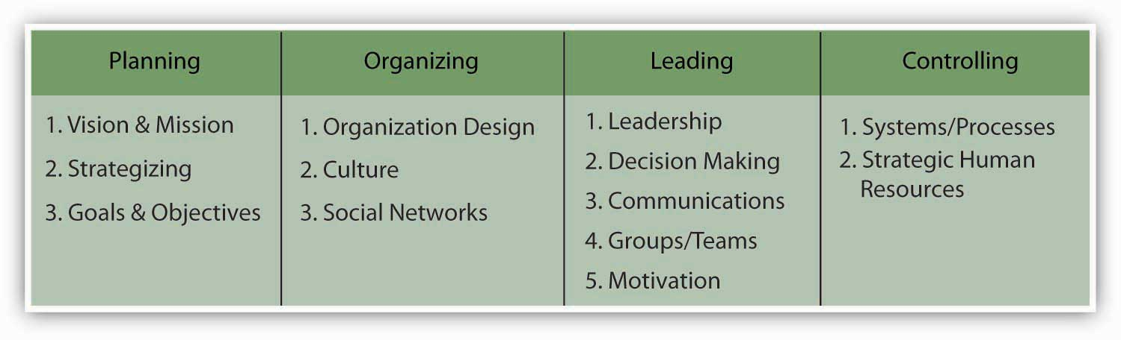
Planning
Planning is the function of management that involves setting objectives and determining a course of action for achieving those objectives. Planning requires that managers be aware of environmental conditions facing their organization and forecast future conditions. It also requires that managers be good decision makers.
Planning is a process consisting of several steps. The process begins with environmental scanning which simply means that planners must be aware of the critical contingencies facing their organization in terms of economic conditions, their competitors, and their customers. Planners must then attempt to forecast future conditions. These forecasts form the basis for planning.
Planners must establish objectives, which are statements of what needs to be achieved and when. Planners must then identify alternative courses of action for achieving objectives. After evaluating the various alternatives, planners must make decisions about the best courses of action for achieving objectives. They must then formulate necessary steps and ensure effective implementation of plans. Finally, planners must constantly evaluate the success of their plans and take corrective action when necessary.
There are many different types of plans and planning.
Strategic planning involves analyzing competitive opportunities and threats, as well as the strengths and weaknesses of the organization, and then determining how to position the organization to compete effectively in their environment. Strategic planning has a long time frame, often three years or more. Strategic planning generally includes the entire organization and includes formulation of objectives. Strategic planning is often based on the organization’s mission, which is its fundamental reason for existence. An organization’s top management most often conducts strategic planning.
Tactical planning is intermediate-range (one to three years) planning that is designed to develop relatively concrete and specific means to implement the strategic plan. Middle-level managers often engage in tactical planning.
Operational planning generally assumes the existence of organization-wide or subunit goals and objectives and specifies ways to achieve them. Operational planning is short-range (less than a year) planning that is designed to develop specific action steps that support the strategic and tactical plans.
Organizing
Organizing is the function of management that involves developing an organizational structure and allocating human resources to ensure the accomplishment of objectives. The structure of the organization is the framework within which effort is coordinated. The structure is usually represented by an organization chart, which provides a graphic representation of the chain of command within an organization. Decisions made about the structure of an organization are generally referred to as organizational design decisions.
Organizing also involves the design of individual jobs within the organization. Decisions must be made about the duties and responsibilities of individual jobs, as well as the manner in which the duties should be carried out. Decisions made about the nature of jobs within the organization are generally called “job design” decisions.
Organizing at the level of the organization involves deciding how best to departmentalize, or cluster, jobs into departments to coordinate effort effectively. There are many different ways to departmentalize, including organizing by function, product, geography, or customer. Many larger organizations use multiple methods of departmentalization.
Organizing at the level of a particular job involves how best to design individual jobs to most effectively use human resources. Traditionally, job design was based on principles of division of labor and specialization, which assumed that the more narrow the job content, the more proficient the individual performing the job could become. However, experience has shown that it is possible for jobs to become too narrow and specialized. For example, how would you like to screw lids on jars one day after another, as you might have done many decades ago if you worked in company that made and sold jellies and jams? When this happens, negative outcomes result, including decreased job satisfaction and organizational commitment, increased absenteeism, and turnover.
Recently, many organizations have attempted to strike a balance between the need for worker specialization and the need for workers to have jobs that entail variety and autonomy. Many jobs are now designed based on such principles as empowerment, job enrichment and teamwork. For example, HUI Manufacturing, a custom sheet metal fabricator, has done away with traditional “departments” to focus on listening and responding to customer needs. From company-wide meetings to team huddles, HUI employees know and understand their customers and how HUI might service them best. http://www.huimfg.com/abouthui-yourteams.aspx (accessed October 15, 2008).
Leading
Leading involves the social and informal sources of influence that you use to inspire action taken by others. If managers are effective leaders, their subordinates will be enthusiastic about exerting effort to attain organizational objectives.
The behavioral sciences have made many contributions to understanding this function of management. Personality research and studies of job attitudes provide important information as to how managers can most effectively lead subordinates. For example, this research tells us that to become effective at leading, managers must first understand their subordinates’ personalities, values, attitudes, and emotions.
Studies of motivation and motivation theory provide important information about the ways in which workers can be energized to put forth productive effort. Studies of communication provide direction as to how managers can effectively and persuasively communicate. Studies of leadership and leadership style provide information regarding questions, such as, “What makes a manager a good leader?” and “In what situations are certain leadership styles most appropriate and effective?”
Controlling
Controlling involves ensuring that performance does not deviate from standards. Controlling consists of three steps, which include (1) establishing performance standards, (2) comparing actual performance against standards, and (3) taking corrective action when necessary. Performance standards are often stated in monetary terms such as revenue, costs, or profits but may also be stated in other terms, such as units produced, number of defective products, or levels of quality or customer service.
The measurement of performance can be done in several ways, depending on the performance standards, including financial statements, sales reports, production results, customer satisfaction, and formal performance appraisals. Managers at all levels engage in the managerial function of controlling to some degree.
The managerial function of controlling should not be confused with control in the behavioral or manipulative sense. This function does not imply that managers should attempt to control or to manipulate the personalities, values, attitudes, or emotions of their subordinates. Instead, this function of management concerns the manager’s role in taking necessary actions to ensure that the work-related activities of subordinates are consistent with and contributing toward the accomplishment of organizational and departmental objectives.
Effective controlling requires the existence of plans, since planning provides the necessary performance standards or objectives. Controlling also requires a clear understanding of where responsibility for deviations from standards lies. Two traditional control techniques are budget and performance audits. An audit involves an examination and verification of records and supporting documents. A budget audit provides information about where the organization is with respect to what was planned or budgeted for, whereas a performance audit might try to determine whether the figures reported are a reflection of actual performance. Although controlling is often thought of in terms of financial criteria, managers must also control production and operations processes, procedures for delivery of services, compliance with company policies, and many other activities within the organization.
The management functions of planning, organizing, leading, and controlling are widely considered to be the best means of describing the manager’s job, as well as the best way to classify accumulated knowledge about the study of management. Although there have been tremendous changes in the environment faced by managers and the tools used by managers to perform their roles, managers still perform these essential functions.

KEY TAKEAWAY
The principles of management can be distilled down to four critical functions. These functions are planning, organizing, leading, and controlling. This P-O-L-C framework provides useful guidance into what the ideal job of a manager should look like.

EXERCISES
- What are the management functions that comprise the P-O-L-C framework?

- Are there any criticisms of this framework?

- What function does planning serve?

- What function does organizing serve?

- What function does leading serve?

- What function does controlling serve?

1.5 Economic, Social, and Environmental Performance
LEARNING OBJECTIVES
- Be able to define economic, social, and environmental performance.

- Understand how economic performance is related to social and environmental performance.

Webster’s dictionary defines performance as “the execution of an action” and “something accomplished.” http://www.merriam-webster.com/dictionary/performance (accessed October 15, 2008). Principles of management help you better understand the inputs into critical organizational outcomes like a firm’s economic performance. Economic performance is very important to a firm’s stakeholders particularly its investors or owners, because this performance eventually provides them with a return on their investment. Other stakeholders, like the firm’s employees and the society at large, are also deemed to benefit from such performance, albeit less directly. Increasingly though, it seems clear that noneconomic accomplishments, such as reducing waste and pollution, for example, are key indicators of performance as well. Indeed, this is why the notion of the triple bottom line is gaining so much attention in the business press. Essentially, the triple bottom line refers to The measurement of business performance along social, environmental, and economic dimensions. We introduce you to economic, social, and environmental performance and conclude the section with a brief discussion of the interdependence of economic performance with other forms of performance.
Economic Performance
In a traditional sense, the economic performance of a firm is a function of its success in producing benefits for its owners in particular, through product innovation and the efficient use of resources. When you talk about this type of economic performance in a business context, people typically understand you to be speaking about some form of profit.
The definition of economic profit is the difference between revenue and the opportunity cost of all resources used to produce the items sold.
- W. P. Albrecht, Economics (Englewood Cliffs, NJ: Prentice Hall, 1983)
This definition includes implicit returns as costs. For our purposes, it may be simplest to think of economic profit as a form of accounting profit where profits are achieved when revenues exceed the accounting cost the firm “pays” for those inputs. In other words, your organization makes a profit when its revenues are more than its costs in a given period of time, such as three months, six months, or a year.
Before moving on to social and environmental performance, it is important to note that customers play a big role in economic profits. Profits accrue to firms because customers are willing to pay a certain price for a product or service, as opposed to a competitor’s product or service of a higher or lower price. If customers are only willing to make purchases based on price, then a firm, at least in the face of competition, will only be able to generate profit if it keeps its costs under control.
Social and Environmental Performance
You have learned a bit about economic performance and its determinants. For most organizations, you saw that economic performance is associated with profits, and profits depend a great deal on how much customers are willing to pay for a good or service.
With regard to social and environmental performance, it is similarly useful to think of them as forms of profit—social and environmental profit to be exact. Increasingly, the topics of social and environmental performance have garnered their own courses in school curricula; in the business world, they are collectively referred to as corporate social responsibility (CSR)
CSR is a concept whereby organizations consider the interests of society by taking responsibility for the impact of their activities on customers, suppliers, employees, shareholders, communities, and the environment in all aspects of their operations. This obligation is seen to extend beyond the statutory obligation to comply with legislation and sees organizations voluntarily taking further steps to improve the quality of life for employees and their families, as well as for the local community and society at large.
Two companies that have long blazed a trail in CSR are Ben & Jerry’s and S. C. Johnson. Their statements about why they do this, summarized in Table 1.1 "Examples of leading firms with strong CSR orientations", capture many of the facets just described.
Table 1.1 Examples of leading firms with strong CSR orientations
 | Why We Do It?
Ben & Jerry’s | “We’ve taken time each year since 1989 to compile this [Social Audit] report because we continue to believe that it keeps us in touch with our Company’s stated Social Mission. By raising the profile of social and environmental matters inside the Company and recording the impact of our work on the community, this report aids us in our search for business decisions that support all three parts of our Company Mission Statement: Economic, Product, and Social. In addition, the report is an important source of information about the Company for students, journalists, prospective employees, and other interested observers. In this way, it helps us in our quest to keep our values, our actions, and public perceptions in alignment.” http://www.benjerrys.com/our_company/about_us/social_mission/social_audits (accessed October 15, 2008).
S. C. Johnson | “It’s nice to live next door to a family that cares about its neighbors, and at S. C. Johnson we are committed to being a good neighbor and contributing to the well-being of the countries and the communities where we conduct business. We have a wide variety of efforts to drive global development and growth that benefit the people around us and the planet we all share. From exceptional philanthropy and volunteerism to new business models that bring economic growth to the world’s poorest communities, we’re helping to create stronger communities for families around the globe.” http://www.scjohnson.com/community (accessed October 15, 2008).

Figure 1.9

Environmentally Neutral Design (END) designs shoes with the goal of eliminating the surplus material needed to make a shoe such that it costs less to make and is lighter than other performance shoes on the market.
Photo used with permission of Environmentally Neutral Design (END).
Integrating Economic, Social, and Environmental Performance
Is there really a way to achieve a triple bottom line in a way that actually builds up all three facets of performance—economic, social, and environmental? Advocates of CSR understandably argue that this is possible and should be the way all firms are evaluated. Increasingly, evidence is mounting that attention to a triple bottom line is more than being “responsible” but instead just good business. Critics argue that CSR detracts from the fundamental economic role of businesses; others argue that it is nothing more than superficial window dressing; still, others argue that it is an attempt to preempt the role of governments as a watchdog over powerful multinational corporations.
While there is no systematic evidence supporting such a claim, a recent review of nearly 170 research studies on the relationship between CSR and firm performance reported that there appeared to be no negative shareholder effects of such practices. In fact, this report showed that there was a small positive relationship between CSR and shareholder returns.
- J. Margolis and Hillary H. Elfenbein, “Doing well by Doing Good? Don’t Count on It,” Harvard Business Review 86 (2008): 1–2.
Similarly, companies that pay good wages and offer good benefits to attract and retain high-caliber employees “are not just being socially responsible; they are merely practicing good management.”
- R. Reich, Supercapitalism: The Transformation of Business, Democracy, and Everyday Life (New York: Knopf, 2007).
The financial benefits of social or environmental CSR initiatives vary by context. For example, environment-friendly strategies are much more complicated in the consumer products and services market. For example, cosmetics retailer The Body Shop and StarKist Seafood Company, a strategic business unit of Heinz Food, both undertook environmental strategies but only the former succeeded. The Body Shop goes to great lengths to ensure that its business is ecologically sustainable. http://www.bodyshop.com (accessed October 15, 2008). It actively campaigns against human rights abuses and for animal and environmental protection and is one of the most respected firms in the world, despite its small size. Consumers pay premium prices for Body Shop products, ostensibly because they believe that it simply costs more to provide goods and services that are environmentally friendly. The Body Shop has been wildly successful.
StarKist, too, adopted a CSR approach, when, in 1990, it decided to purchase and sell exclusively dolphin-safe tuna. At the time, biologists thought that the dolphin population decline was a result of the thousands killed in the course of tuna harvests. However, consumers were unwilling to pay higher prices for StarKist’s environmental product attributes. Moreover, since tuna were bought from commercial fishermen, this particular practice afforded the firm no protection from imitation by competitors. Finally, in terms of credibility, the members of the tuna industry had launched numerous unsuccessful campaigns in the past touting their interest in the environment, particularly the world’s oceans. Thus, consumers did not perceive StarKist’s efforts as sincerely “green.”
You might argue that The Body Shop’s customers are unusually price insensitive, hence the success of its environment-based strategy. However, individuals are willing to pay more for organic produce, so why not dolphin-safe tuna? One difference is that while the environment is a public good, organic produce produces both public and private benefits. For example, organic farming is better for the environment and pesticide-free produce is believed to be better for the health of the consumer. Dolphin-free tuna only has the public environmental benefits (i.e., preserve the dolphin population and oceans’ ecosystems), not the private ones like personal health. It is true that personal satisfaction and benevolence are private benefits, too. However, consumers did not believe they were getting their money’s worth in this regard for StarKist tuna, whereas they do with The Body Shop’s products.
Somewhere in our dialogue on CSR lies the idea of making the solution of an environmental or social problem the primary purpose of the organization. Cascade Asset Management (CAM), is a case in point. http://www.cascade-assets.com (accessed October 15, 2008). CAM was created in April 1999, in Madison, Wisconsin, and traces its beginnings to the University of Wisconsin’s Entrepreneurship program where the owners collaborated on developing and financing the initial business plan. CAM is a private, for-profit enterprise established to provide for the environmentally responsible disposition of computers and other electronics generated by businesses and institutions in Wisconsin. With their experience and relationships in surplus asset disposition and computer hardware maintenance, the founders were able to apply their skills and education to this new and developing industry.
Firms are willing to pay for CAM’s services because the disposal of surplus personal computers (PCs) is recognized as risky and highly regulated, given the many toxic materials embedded in most components. CAM’s story is also credible (whereas StarKist had trouble selling its CSR story). The company was one of the original signers of the “Electronic Recyclers Pledge of True Stewardship.” http://www.computertakeback.com/the_solutions/recycler_s_pledge.cfm (accessed October 15, 2008). Signers of the pledge are committed to the highest standards of environmental and economic sustainability in their industry and are expected to live out this commitment through their operations and partnerships. The basic principles of the pledge are as follows: no export of untested whole products or hazardous components or commodities (CRTs, circuit boards) to developing countries, no use of prison labor, adherence to an environmental and worker safety management system, provision of regular testing and audits to ensure compliance, and support efforts to encourage producers to make their products less toxic. CAM has grown rapidly and now serves over 500 business and institutional customers from across the country. While it is recognized as one of the national leaders in responsible, one-stop information technology (IT) asset disposal, its success is attracting new entrants such as IBM, which view PC recycling as another profitable service they can offer their existing client base. Search on “asset disposal solutions” at http://www.ibm.com/ibm/environment/ (accessed October 15, 2008).

KEY TAKEAWAY
Organizational performance can be viewed along three dimensions—financial, social, and environmental—collectively referred to as the triple bottom line, where the latter two dimensions are included in the definition of CSR. While there remains debate about whether organizations should consider environmental and social impacts when making business decisions, there is increasing pressure to include such CSR activities in what constitutes good principles of management. This pressure is based on arguments that range from CSR helps attract and retain the best and brightest employees, to showing that the firm is being responsive to market demands, to observations about how some environmental and social needs represent great entrepreneurial business opportunities in and of themselves.

EXERCISES
- Why is financial performance important for organizations?

- What are some examples of financial performance metrics?

- What dimensions of performance beyond financial are included in the triple bottom line?

- How does CSR relate to the triple bottom line?

- How are financial performance and CSR related?

1.6 Performance of Individuals and Groups
LEARNING OBJECTIVES
- Understand the key dimensions of individual-level performance.

- Understand the key dimensions of group-level performance.

- Know why individual- and group-level performance goals need to be compatible.

Principles of management are concerned with organization-level outcomes such as economic, social, or environmental performance, innovation, or ability to change and adapt. However, for something to happen at the level of an organization, something must typically also be happening within the organization at the individual or team level. Obviously, if you are an entrepreneur and the only person employed by your company, the organization will accomplish what you do and reap the benefits of what you create. Normally though, organizations have more than one person, which is why we introduce to you concepts of individual and group performance.
Individual-Level Performance
Individual-level performance draws upon those things you have to do in your job, or in-role performance, and those things that add value but which aren’t part of your formal job description. These “extras” are called extra-role performance or organizational citizenship behaviors (OCBs). At this point, it is probably simplest to consider an in-role performance as having productivity and quality dimensions associated with certain standards that you must meet to do your job. In contrast, OCBs can be understood as individual behaviors that are beneficial to the organization and are discretionary, not directly or explicitly recognized by the formal reward system.
- D. W. Organ, Organizational Citizenship Behavior: The Good Soldier Syndrome (Lexington, M Lexington Books, 1988).
In comparison to in-role performance, the spectrum of what constitutes extra-role performance, or OCBs, seems be great and growing. In a recent review, for example, management researchers identified 30 potentially different forms of OCB, which they conveniently collapsed into seven common themes: (1) Helping Behavior, (2) Sportsmanship, (3) Organizational Loyalty, (4) Organizational Compliance, (5) Individual Initiative, (6) Civic Virtue, and (7) Self-Development.
- P. M. Podsakoff, S. B. MacKenzie, J. B. Paine, and D. G. Bachrach, “Organizational Citizenship Behaviors: A Critical Review of the Theoretical and Empirical Literature and Suggestions for Future Research,” Journal of Management 26 (2000): 513–63.

- Definitions and examples for these seven themes are summarized in Table 1.2 "A current survey of organization citizenship behaviors". These definitions and examples are adapted from D. W. Organ, “The Motivational Basis of Organizational Citizenship Behavior,” in Research in Organizational Behavior 12 (1990): 43–72.

- J. Graham, “An Essay on Organizational Citizenship Behavior,” Employee Responsibilities and Rights Journal 4 (1991): 225, 249–70

- J. M. George, and G. R. Jones, “Experiencing work: Values, attitudes, and moods,” Human Relations 50 (1997): 393–416

- J. M. George, and G. R. Jones, “Organizational Spontaneity in Context,” Human Performance 10 (1997): 153–70

- J. W. Graham, “An Essay on Organizational Citizenship Behavior,” Employee Responsibilities and Rights Journal 4 (1991): 249–70

- D. W. Organ, “Personality and Organizational Citizenship Behavior,” Journal of Management 20 (1994): 465–78

- R. H. Moorman, and G. L. Blakely, “Individualism-Collectivism as An Individual Difference Predictor of Organizational Citizenship Behavior,” Journal of Organizational Behavior, 16 (1995): 127–42.

Table 1.2 A current survey of organization citizenship behaviors
Helping Behavior (Taking on the forms of altruism, interpersonal helping, courtesy, peacemaking, and cheerleading.) | Altruism  - Voluntary actions that help another person with a work problem.  - Instructing a new hire on how to use equipment, helping a coworker catch up with a backlog of work, fetching materials that a colleague needs and cannot procure on their own.  Interpersonal helping  - Focuses on helping coworkers in their jobs when such help was needed.  Courtesy  - Subsumes all of those foresightful gestures that help someone else prevent a problem.  - Touching base with people before committing to actions that will affect them, providing advance notice to someone who needs to know to schedule work.  Peacemaking  - Actions that help to prevent, resolve, or mitigate unconstructive interpersonal conflict.  Cheerleading  - The words and gestures of encouragement and reinforcement of coworkers.  - Accomplishments and professional development.
Sportsmanship | A citizenlike posture of tolerating the inevitable inconveniences and impositions of work without whining and grievances.
Organizational Loyalty | Identification with and allegiance to organizational leaders and the organization as a whole, transcending the parochial interests of individuals, work groups, and departments. Representative behaviors include defending the organization against threats, contributing to its good reputation, and cooperating with others to serve the interests of the whole.
Organizational Compliance (or Obedience) | An orientation toward organizational structure, job descriptions, and personnel policies that recognizes and accepts the necessity and desirability of a rational structure of rules and regulations. Obedience may be demonstrated by a respect for rules and instructions, punctuality in attendance and task completion, and stewardship of organizational resources.
Individual Initiative (or Conscientiousness) | A pattern of going well beyond minimally required levels of attendance, punctuality, housekeeping, conserving resources, and related matters of internal maintenance.
Civic Virtue | Responsible, constructive involvement in the political process of the organization, including not just expressing opinions but reading one’s mail, attending meetings, and keeping abreast of larger issues involving the organization.
Self-Development | Includes all the steps that workers take to voluntarily improve their knowledge, skills, and abilities so as to be better able to contribute to their organizations. Seeking out and taking advantage of advanced training courses, keeping abreast of the latest developments in one’s field and area, or even learning a new set of skills so as to expand the range of one’s contributions to an organization.

As you can imagine, principles of management are likely to be very concerned with individuals’ in-role performance. At the same time, just a quick glance through Table 1.2 "A current survey of organization citizenship behaviors" should suggest that those principles should help you better manage OCBs as well.
Group-Level Performance
A group is a collection of individuals. Group-level performance focuses on both the outcomes and process of collections of individuals, or groups. Individuals can work on their own agendas in the context of a group. Groups might consist of project-related groups, such as a product group or an entire store or branch of a company. The performance of a group consists of the inputs of the group minus any process loss that result in the final output, such as the quality of a product and the ramp-up time to production or the sales for a given month. Process loss is any aspect of group interaction that inhibits good problem solving.
Why do we say group instead of team? A collection of people is not a team, though they may learn to function in that way. A team is a cohesive coalition of people working together to achieve the team agenda (i.e., teamwork). Being on a team is not equal to total subordination of personal agendas, but it does require a commitment to the vision and involves each individual directly in accomplishing the team’s objective. Teams differ from other types of groups in that members are focused on a joint goal or product, such as a presentation, completing in-class exercises, discussing a topic, writing a report, or creating a new design or prototype. Moreover, teams also tend to be defined by their relatively smaller size. For example, according to one definition, “A team is a small number of people with complementary skills who are committed to a common purpose, performance goals, and approach for which they are mutually accountable.”
- J. R. Katzenbach, and D. K. Smith, The Wisdom of Teams: Creating the High-performance Organization (Boston: Harvard Business School, 1993).
The purpose of assembling a team is to accomplish bigger goals that would not be possible for the individual working alone or the simple sum of many individuals’ independent work. Teamwork is also needed in cases where multiple skills are needed or where buy-in is required from certain key stakeholders. Teams can, but do not always, provide improved performance. Working together to further the team agenda seems to increase mutual cooperation between what are often competing factions. The aim and purpose of a team is to perform, to get results, and to achieve victory in the workplace and marketplace. The very best managers are those who can gather together a group of individuals and mold them into an effective team.
Compatibility of Individual and Group Performance
As a manager, you will need to understand the compatibility of individual and group performance, typically with respect to goals and incentives. What does this mean? Looking at goals first, there should be compatibility between individual and group goals. For example, do the individuals’ goals contribute to the achievement of the group goal or are they contradictory? Incentives also need to be aligned between individuals and groups. A disconnect between these is most likely when individuals are too far insulated from the external environment or rewarded for action that is not consistent with the goal. For example, individuals may be seeking to perfect a certain technology and, in doing so, delay its release to customers, when customers would have been satisfied with the current solution and put a great priority on its timely delivery. Finally, firms need to be careful to match their goals with their reward structures. For example, if the organization’s goal is to increase group performance but the firm’s performance appraisal process rewards individual employee productivity, then the firm is unlikely to create a strong team culture.

KEY TAKEAWAY
This section helped you understand individual and group performance and suggested how they might roll up into organizational performance. Principles of management incorporate two key facets of individual performance: in-role and OCB (or extra-role) performance. Group performance, in turn, was shown to be a function of how well individuals achieved a combination of individual and group goals. A team is a type of group that is relatively small, and members are willing and able to subordinate individual goals and objectives to those of the larger group.

EXERCISES
- What is in-role performance?

- What is extra-role performance?

- What is the relationship between extra-role performance and OCBs?

- What differentiates a team from a group?

- When might it be important to understand the implications of individual performance for group performance?

1.7 Your Principles of Management Survivor’s Guide
LEARNING OBJECTIVES
- Know your learning style.

- Know how to match your style to the circumstances.

- Use the gauge-discover-reflect framework.

Principles of management courses typically combine knowledge about skills and the development and application of those skills themselves. For these reasons, it is helpful for you to develop your own strategy for learning about and developing management skills. The first part of this strategy should be based on your own disposition toward learning. The second part of this strategy should follow some form of the gauge-discover-reflect process that we outline at the end of this section.
Assess Your Learning Style
You can assess your learning style in a number of ways. At a very general level, you can assess your style intuitively (see “What Is Your Intuition about Your Learning Style?”); however, we suggest that you use a survey instrument like the Learning Style Index (LSI), the output from which you can then readily compare with your intuition. In this section, we discuss the dimensions of the LSI that you can complete easily and quickly online.
- B. A. Soloman, and R. M. Felder. http://www.engr.ncsu.edu/learningstyles/ilsweb.html (accessed October 15, 2008)
The survey will reveal whether your learning style is active or reflective, sensory or intuitive, visual or verbal, and sequential or global.This section is based heavily on the work of Richard K. Felder and Linda K. Silverman. In addition to their research, there is an online instrument used to assess preferences on four dimensions (active or reflective, sensing or intuitive, visual or verbal, and sequential or global) of a learning style model formulated by Felder and Soloman of North Carolina State University. The Learning Styles Index (LSI) may be used at no cost for noncommercial purposes by individuals who wish to determine their own learning style profile and by educators who wish to use it for teaching, advising, or research.
See:
- R. M. Felder, and R. Brent, “Understanding Student Differences,” Journal of Engineering Education 94, no. 1 (2005) : 57–72, for an exploration of differences in student learning styles, approaches to learning (deep, surface, and strategic), and levels of intellectual development, with recommended teaching practices to address all three categories.

- R. M. Felder, and J. E. Spurlin, “Applications, Reliability, and Validity of the Index of Learning Styles,” Journal of Engineering Education 21, no. 1 (2005): 103–12, provides a validation study of the LSI.

- T. A. Litzinger, S. H. Lee, J. C. Wise, and R. M. Felder, “A Psychometric Study of the Index of Learning Styles,” Journal of Engineering Education 96, no. 4 (2007): 309–19.
What Is Your Intuition About Your Learning Style?
Your learning style may be defined in large part by the answers to four questions:
- How do you prefer to process information: actively—through engagement in physical activity or discussion? Or reflectively—through introspection?

- What type of information do you preferentially perceive: sensory (external)—sights, sounds, physical sensations? Or intuitive (internal)—possibilities, insights, hunches?

- Through which sensory channel is external information most effectively perceived: visual—pictures, diagrams, graphs, demonstrations? Or verbal—words, sounds? (Other sensory channels like touch, taste, and smell are relatively untapped in most educational environments, and are not considered here.)

- How do you progress toward understanding: sequentially—in continual steps? Or globally—in large jumps, holistically?
TRY IT OUT HERE:
http://www.engr.ncsu.edu/learningstyles/ilsweb.html
Active and Reflective Learners
Everybody is active sometimes and reflective sometimes. Your preference for one category or the other may be strong, moderate, or mild. A balance of the two is desirable. If you always act before reflecting, you can jump into things prematurely and get into trouble, while if you spend too much time reflecting, you may never get anything done.
“Let’s try it out and see how it works” is an active learner’s phrase; “Let’s think it through first” is the reflective learner’s response. If you are an active learner, you tend to retain and understand information best by doing something active with it—discussing it, applying it, or explaining it to others. Reflective learners prefer to think about it quietly first.
Sitting through lectures without getting to do anything physical but take notes is hard for both learning types but particularly hard for active learners. Active learners tend to enjoy group work more than reflective learners, who prefer working alone.
Sensing and Intuitive Learners
Everybody is sensing sometimes and intuitive sometimes. Here too, your preference for one or the other may be strong, moderate, or mild. To be effective as a learner and problem solver, you need to be able to function both ways. If you overemphasize intuition, you may miss important details or make careless mistakes in calculations or hands-on work; if you overemphasize sensing, you may rely too much on memorization and familiar methods and not concentrate enough on understanding and innovative thinking.
Even if you need both, which one best reflects you? Sensors often like solving problems by well-established methods and dislike complications and surprises; intuitors like innovation and dislike repetition. Sensors are more likely than intuitors to resent being tested on material that has not been explicitly covered in class. Sensing learners tend to like learning facts; intuitive learners often prefer discovering possibilities and relationships.
Sensors tend to be patient with details and good at memorizing facts and doing hands-on (laboratory) work; intuitors may be better at grasping new concepts and are often more comfortable than sensors with abstractions and mathematical formulations. Sensors tend to be more practical and careful than intuitors; intuitors tend to work faster and to be more innovative than sensors.
Sensors don’t like courses that have no apparent connection to the real world (so if you are sensor, you should love principles of management!); intuitors don’t like “plug-and-chug” courses that involve a lot of memorization and routine calculations.
Visual and Verbal Learners
In most college classes, very little visual information is presented: students mainly listen to lectures and read material written on whiteboards, in textbooks, and on handouts. Unfortunately, most of us are visual learners, which means that we typically do not absorb nearly as much information as we would if more visual presentation were used in class. Effective learners are capable of processing information presented either visually or verbally.
Visual learners remember best what they see—pictures, diagrams, flowcharts, time lines, films, and demonstrations. Verbal learners get more out of words—written and spoken explanations. Everyone learns more when information is presented both visually and verbally.
Sequential and Global Learners
Sequential learners tend to follow logical, stepwise paths in finding solutions; global learners may be able to solve complex problems quickly or put things together in novel ways once they have grasped the big picture, but they may have difficulty explaining how they did it. Sequential learners tend to gain understanding in linear steps, with each step following logically from the previous one. Global learners tend to learn in large jumps, absorbing material almost randomly without seeing connections, and then suddenly “getting it.”
Many people who read this description may conclude incorrectly that they are global since everyone has experienced bewilderment followed by a sudden flash of understanding. What makes you global or not is what happens before the light bulb goes on. Sequential learners may not fully understand the material, but they can nevertheless do something with it (like solve the homework problems or pass the test) since the pieces they have absorbed are logically connected. Strongly global learners who lack good sequential thinking abilities, however, may have serious difficulties until they have the big picture. Even after they have it, they may be fuzzy about the details of the subject, while sequential learners may know a lot about specific aspects of a subject but may have trouble relating them to different aspects of the same subject or to different subjects.
Adapt Your Style
OK, so you’ve assessed your learning style. What should you do now? You can apply this valuable and important information about yourself to how you approach your principles of management course and the larger P-O-L-C framework.
Active Learners
If you act before you think, you are apt to make hasty and potentially ill-informed judgments. You need to concentrate on summarizing situations and taking time to sit by yourself to digest information you have been given before jumping in and discussing it with others.
If you are an active learner in a class that allows little or no class time for discussion or problem-solving activities, you should try to compensate for these lacks when you study. Study in a group in which the members take turns explaining different topics to one another. Work with others to guess what you will be asked on the next test, and figure out how you will answer. You will always retain information better if you find ways to do something with it.
Reflective Learners
If you think too much, you risk doing nothing—ever. There comes a time when a decision has to be made or an action taken. Involve yourself in group decision making whenever possible, and try to apply the information you have in as practical a manner as possible.
If you are a reflective learner in a class that allows little or no class time for thinking about new information, you should try to compensate for this lack when you study. Don’t simply read or memorize the material; stop periodically to review what you have read and to think of possible questions or applications. You might find it helpful to write short summaries of readings or class notes in your own words. Doing so may take extra time but will enable you to retain the material more effectively.
Sensory Learners
If you rely too much on sensing, you tend to prefer what is familiar and concentrate on facts you know instead of being innovative and adapting to new situations. Seek out opportunities to learn theoretical information and then bring in facts to support or negate these theories.
Sensors remember and understand information best if they can see how it connects to the real world. If you are in a class where most of the material is abstract and theoretical, you may have difficulty. Ask your instructor for specific examples of concepts and procedures, and find out how the concepts apply in practice. If the teacher does not provide enough specifics, try to find some in your course text or other references or by brainstorming with friends or classmates.
Intuitive Learners
If you rely too much on intuition, you risk missing important details, which can lead to poor decision making and problem solving. Force yourself to learn facts or memorize data that will help you defend or criticize a theory or procedure you are working with. You may need to slow down and look at detail you would otherwise typically skim.
Many college lecture classes are aimed at intuitors. However, if you are an intuitor and you happen to be in a class that deals primarily with memorization and rote substitution in formulas, you may have trouble with boredom. Ask your instructor for interpretations or theories that link the facts, or try to find the connections yourself. You may also be prone to careless mistakes on tests because you are impatient with details and don’t like repetition (as in checking your completed solutions). Take time to read the entire question before you start answering, and be sure to check your results.
Visual Learners
If you concentrate more on pictorial or graphical information than on words, you put yourself at a distinct disadvantage because verbal and written information is still the main preferred choice for delivery of information. Practice your note taking, and seek out opportunities to explain information to others using words.
If you are a visual learner, try to find diagrams, sketches, schematics, photographs, flowcharts, or any other visual representation of course material that is predominantly verbal. Ask your instructor, consult reference books, and see whether any videotapes or CD-ROM displays of the course material are available. Prepare a concept map by listing key points, enclosing them in boxes or circles, and drawing lines with arrows between concepts to show connections. Color-code your notes with a highlighter so that everything relating to one topic is the same color.
Verbal Learners
As with visual learners, look for opportunities to learn through audiovisual presentations (such as CD-ROM and Webcasts). When making notes, group information according to concepts, and then create visual links with arrows going to and from them. Take every opportunity you can to create charts, tables, and diagrams.
Write summaries or outlines of course material in your own words. Working in groups can be particularly effective: you gain understanding of material by hearing classmates’ explanations, and you learn even more when you do the explaining.
Sequential Learners
When you break things down into small components you are often able to dive right into problem solving. This seems to be advantageous but can often be unproductive. Force yourself to slow down and understand why you are doing something and how it is connected to the overall purpose or objective. Ask yourself how your actions are going to help you in the long run. If you can’t think of a practical application for what you are doing, then stop and do some more “big picture” thinking.
Most college courses are taught in a sequential manner. However, if you are a sequential learner and you have an instructor who jumps around from topic to topic or skips steps, you may have difficulty following and remembering. Ask the instructor to fill in the skipped steps, or fill them in yourself by consulting references. When you are studying, take the time to outline the lecture material for yourself in logical order. In the long run, doing so will save you time. You might also try to strengthen your global-thinking skills by relating each new topic you study to things you already know. The more you can do so, the deeper your understanding of the topic is likely to be.
Global Learners
If grasping the big picture is easy for you, then you can be at risk of wanting to run before you can walk. You see what is needed but may not take the time to learn how best to accomplish it. Take the time to ask for explanations, and force yourself to complete all problem-solving steps before coming to a conclusion or making a decision. If you can’t explain what you have done and why, then you may have missed critical details.
If you are a global learner, it can be helpful for you to realize that you need the big picture of a subject before you can master details. If your instructor plunges directly into new topics without bothering to explain how they relate to what you already know, it can cause problems for you. Fortunately, there are steps you can take that may help you get the big picture more rapidly. Before you begin to study the first section of a chapter in a text, skim through the entire chapter to get an overview. Doing so may be time consuming initially, but it may save you from going over and over individual parts later. Instead of spending a short time on every subject every night, you might find it more productive to immerse yourself in individual subjects for large blocks. Try to relate the subject to things you already know, either by asking the instructor to help you see connections or by consulting references. Above all, don’t lose faith in yourself; you will eventually understand the new material, and understanding how it connects to other topics and disciplines may enable you to apply it in ways that most sequential thinkers would never dream of.
Gauge-Discover-Reflect
You have already begun to apply the spirit of what we recommend in this third part of the development of your principles of management survival kit, by gauging your learning style. The three essential components are (1) gauge—take stock of your knowledge and capabilities about a topic; (2) discover—learn enough about a topic so that you can set specific development goals on which you can apply and practice, and later gauge again your progress toward your set goals; and (3) reflect—step back and look at the ways you have achieved your goals, take the opportunity to set new ones, and chronicle this experience and thought process in a daily journal.
Gauge
It is always good to start any self-development process by getting some sense of where you are. That is why we commence with the gauge stage. For learning and developing in the area of principles of management, such knowledge is essential. By analogy, let’s say you want to take a road trip out of town. Even if you have a map and a compass, it still is pretty important to know exactly where you are starting on the map!
Your instructor will likely introduce you to a number of different types of management assessment tools, and you should experiment with them to see how they work and the degree to which results resonate with your intuition. A word of caution here—just because some assessment results may clash with your intuition or self-image, do not immediately assume that they are wrong. Instead, use them as an opportunity and motivation for further probing (this can fuel your work in the discovery and reflect stages).
The obvious value of commencing your learning process with some form of assessment is that you have a clear starting point, in terms of knowledge. This also means that you now have a basis for comparing your achievement to any relevant specific goals that you set. Less obvious perhaps is the experience you will gain with principles of management skill assessments in general. More and more organizations use some form of assessment in the recruiting, human resources development, and yes, even promotion processes. Your experience with these different surveys will give you the confidence to take other surveys and the knowledge needed to show organizations that you are aware of your areas of strength and development opportunities.
Discover
The discovery stage of your principles of management survival kit has four related facets: (1) learn, (2) set goals, (3) apply, and (4) practice. Let us look at each one in turn.
Learn
You have probably learned a little about a certain subject just by virtue of gauging your depth in it. In some cases, you might even have read up on the subject a lot to accurately gauge where you were strong or weak. There is not an existing survey for every subject, and it is beneficial to learn how you might gauge this or that area of interest.
The learning facet essentially asks that you build your knowledge base about a particular topic. As you know, learning has multiple facets, from simply mastering facts and definitions, to developing knowledge of how you might apply that knowledge. You will typically want to start with some mastery over facts and definitions and then build your knowledge base to a more strategic level—that is, be able to understand when, where, and how you might use those definitions and facts in principles of management.
Set SMART Goals
The combination of gauging and learning about a topic should permit you to set some goals related to your focal topic. For example, you want to develop better team communication skills or better understand change management. While your goals should reflect the intersection of your own needs and the subject, we do know that effective goals satisfy certain characteristics. These characteristics—specific, measurable, aggressive, realistic, and time bound—yield the acronym SMART. In his seminal 1954 work, The Practice of Management, Peter Drucker coined the usage of the acronym for SMART objectives while discussing objective-based management. Here is how to tell if your goals are SMART goals.
Specific
Specific goals are more likely to be achieved than a general goal. To set a specific goal, you must answer the six “W” questions:
- Who: Who is involved?

- What: What do I want to accomplish?

- Where: At what location?

- When: In what time frame?

- Which: What are the requirements and constraints?

- Why: What specific reasons, purpose, or benefits are there to the accomplishment of the goal?

http://www.topachievement.com/smart.html (accessed October 15, 2008).

EXAMPLE: A general goal would be, “Get a job as a retail store manager.” But a specific goal would say, “Identify my development needs in the next three weeks to become a retail store manager.” “Are You Ready to Be a Great Retail Store Manager?” provides you with an introductory list of survey questions that might help you accelerate your progress on this particular goal set.
Are You Ready to Be a Great Retail Store Manager?
The service sector employs more than 80% of the U.S. workforce, and the position of retail store manager is in increasing demand. Have you already developed the skills to be a great store manager? Score yourself on each of these 10 people skills. How close did you get to 100? Identify two areas to develop, and then move on to two more areas once that goal is achieved.
- “I challenge employees to set new performance goals.”

Never: 1 Seldom: 3 Often: 5 Regularly: 10

- “I coach employees to resolve performance problems.”

Never: 1 Seldom: 3 Often: 5 Regularly: 10

- “I encourage employees to contribute new ideas.”

Never: 1 Seldom: 3 Often: 5 Regularly: 10

- “I take an interest in my employees’ personal lives.”

Never: 1 Seldom: 3 Often: 5 Regularly: 10

- “I delegate well.”

Never: 1 Seldom: 3 Often: 5 Regularly: 10

- “I communicate my priorities and directions clearly.”

Never: 1 Seldom: 3 Often: 5 Regularly: 10

- “I resolve conflicts in a productive way.”

Never: 1 Seldom: 3 Often: 5 Regularly: 10

- “I behave in a professional way at work.”

Never: 1 Seldom: 3 Often: 5 Regularly: 10

- “I inspire my employees with a dynamic personality.”

Never: 1 Seldom: 3 Often: 5 Regularly: 10

- “I am a good listener.”

Never: 1 Seldom: 3 Often: 5 Regularly: 10

Measurable
When goals are specific, performance tends to be higher.
- M. E. Tubbs, “Goal setting: A Meta-analytic Examination of the Empirical Evidence,” Journal of Applied Psychology 71 (1986): 474–83
Why? If goals are not specific and measurable, how would you know whether you have reached the goal? Any performance level becomes acceptable. For the same reason, telling someone, “Do your best” is not an effective goal because it is not measurable and does not give the person a specific target.
Aggressive
This may sound counterintuitive, but effective goals are difficult, not easy. Aggressive goals are also called stretch goals. Why are effective goals aggressive? Easy goals do not provide a challenge. When goals are aggressive and when they require people to work harder or smarter, performance tends to be dramatically higher.
Realistic
While goals should be difficult, they should also be based in reality. In other words, if a goal is viewed as impossible to reach, it does not have any motivational value. Only you can decide which goal is realistic and which is impossible to achieve; just be sure that the goal you set, while it is aggressive, remains grounded in reality.
Timely
The goal should contain a statement regarding when the proposed performance level will be reached. This way, it provides the person with a sense of urgency.
Apply and Practice
Your knowledge of the subject, plus your SMART goals, give you an opportunity to apply and test your knowledge. Going back to our road-trip analogy, gauging gives you a starting point, learning gives you a road map and compass, and goals give you a target destination. Practice, in turn, simply means some repetition of the application process. Your objective here should be to apply and practice a subject long enough that, when you gauge it again, you are likely to see some change or progress.
Reflect
This final stage has two parts: (1) gauge again and (2) record.
Gauge Again
As suggested under “Apply and Practice,” you will want to gauge your progress. Have you become more innovative? Do you better communicate in teams? Do you have a better understanding of other key principles of management?
Record
Many people might stop at the gauge again point, but they would be missing out on an incredibly valuable opportunity. Specifically, look at what you have learned and achieved regarding your goals, and chronicle your progress in some form of a journal.
- K. Bromley, Journaling: Engagements in Reading, Writing, and Thinking (New York: Scholastic, 1993)
A journal may be a required component of a principles of management course, so there may be extrinsic as well as intrinsic motives for starting to keep a journal.
There are also various exercises that you can partake in through your journaling. These allow you to challenge yourself and think more creatively and deeply. An effective journal entry should be written with clear images and feelings. You should aim to include your reactions along with the facts or events related to your developmental goals. The experience of certain experiments may not necessarily be what you thought it would be, and this is what is important to capture. You are bound to feel turmoil in various moments, and these feelings are excellent fodder for journaling. Journaling allows you to vent and understand emotions. These types of entries can be effective at giving yourself a more rounded perspective on past events.
In addition to the goals you are evaluating, there are numerous things to write about in a journal. You can reflect on the day, the week, or even the year. You can reflect on events that you have been a part of or people you have met. Look for conclusions that you may have made or any conflicts that you faced. Most important, write about how you felt. This will allow you to examine your own emotional responses. You may find that you need to make a personal action or response to those conflicts. The conclusions that you make from your journal entries are the ingredients to self-growth. Facing those conflicts may also change your life for the better, as you are able to grow as a person.
You should also always go back and review what you have written. Think about each journal entry you have made and what it means. This is the true aspect of self-growth through journaling. It is easy to recognize changes in yourself through your journaling. You may find that you had a disturbing idea one day, but the next your attitude was much better. You may also find that your attitude grows and improves day by day. This is what makes journaling a true self-growth tool.
Journaling may be inexpensive, but it does require time and commitment. The time factor itself can be small, only about 10 minutes a day or maybe 30 minutes a week, depending on how you would like to summarize your life. You do, however, have to be motivated to write on a regular basis. Even if you do not have a lot of time to write, you will still be able to enjoy the large amount of personal growth that is available through journaling. Perhaps this suggests that your first goal set relates to time set aside for journaling.

KEY TAKEAWAY
You have seen how different individuals approach the learning process and that an understanding of these differences can help you with your objectives related to principles of management. Beyond this general understanding of your own learning style, you also have an opportunity to put together your own survival kit for this course. Your kit will have answers and resources based on the gauge-discover-reflect framework. The development of SMART goals are particularly important in the successful application of the framework.

EXERCISES
- What is your learning style?

- How does your style compare with your prior intuition?

- What target learning issue could you use to experiment with the gauge discover-reflect framework?

- What does the acronym SMART refer to, in the context of goal setting?

5. What SMART goals could you apply to your target learning issue?

Chapter 2
Personality, Attitudes, and Work Behaviors
WHAT’S IN IT FOR ME?
Reading this chapter will help you do the following:
1. Understand the roles of personality and values in determining work behaviors.

2. Explain the process of perception and how it affects work behaviors.

3. Identify the major work attitudes that affect work behaviors.

4. Define the concept of person-organization fit and how it affects work behaviors.

5. List the key set of behaviors that matter for organizational performance.

6. Be able to develop your positive attitude skills.

Figure 2.2 The P-O-L-C Framework

Individuals bring a number of differences to work. They have a variety of personalities, values, and attitudes. When they enter into organizations, their stable or transient characteristics affect how they behave and perform. Moreover, companies hire people with the expectation that they have certain knowledge, skills, abilities, personalities, and values.
Recall that you are learning about the principles of management through the planning-organizing-leading-controlling (P-O-L-C) framework. Employees’ personalities, attitudes, and work behaviors affect how managers approach each P-O-L-C dimension. Here are just a few examples:
- When conducting environmental scanning during the planning process, a manager’s perceptions color the information that is absorbed and processed.

- Employee preferences for job design and enrichment (aspects of organizing) may be a function of individuals’ personalities and values.

- Leading effectively requires an understanding of employees’ personalities, values, and attitudes.

- Absenteeism can challenge a manager’s ability to control costs and performance (both at the group and individual levels).

Therefore, it is important for managers to understand the individual characteristics that matter for employee and manager behaviors.
2.1 Case in Point: SAS Institute Invests in Employees
Who are your best customers? Which customers are bringing you the most profits and which are the least profitable? Companies are increasingly relying on complicated data mining software to answer these and other questions. More than 92% of the top 100 companies on the Fortune Global 500 list are using software developed by SAS Institute Inc., the world’s largest privately held software company, for their business intelligence and analytical needs. The Cary, North Carolina, company is doing extremely well by any measure. They have over 10,000 employees worldwide, operate in over 100 countries, ranked number 1 on Fortune’s 2010 list of the “Best Companies to Work For,” and reported $2.31 billion in revenue in 2009 (their 33rd consecutive year of growth and profitability). They reinvested 23% of their 2009 revenue into research and development (R&D) activities. The company is quick to attribute their success to the performance and loyalty of their workforce. This is directly correlated with how they treat their employees.
SAS has perfected the art of employee management. It has been ranked on Fortune magazine’s best places to work list every year since the list was first published. Employees seem to genuinely enjoy working at SAS and are unusually attached to the company, resulting in a turnover rate that is less than 4% in an industry where 20% is the norm. In fact, when Google designed their own legendary campus in California, they visited the SAS campus to get ideas.
One thing SAS does well is giving its employees opportunities to work on interesting and challenging projects. The software developers have the opportunity to develop cutting-edge software to be used around the world. The company makes an effort to concentrate its business in the areas of analytics, which add the most value and help organizations best analyze disparate data for decision making, creating opportunities for SAS workers to be challenged. Plus, the company removes obstacles for employees. Equipment, policies, rules, and meetings that could impede productivity are eliminated.
SAS has treated employees well in bad times as well as in good times. CEO Jim Goodnight is quoted as saying, “For 2010, I make the same promise that I did last year—SAS will have no layoffs. Too many companies worldwide sacrificed employees and benefits to cut costs in 2009. SAS took the opposite stance, and we have been rewarded in employee loyalty and overall success of the business. Maintaining this position throughout the downturn puts us in the best position to meet the expected market upturn.”
In addition, the company has a reputation as a pioneer when it comes to the perks it offers employees, but these perks are not given with a mentality of “offer everything but the kitchen sink.” There is careful thinking and planning behind the choice of perks the company offers. SAS conducts regular employee satisfaction surveys, and any future benefits and perks offered are planned in response to the results. The company wants to eliminate stressors and anything that dissatisfies from people’s lives. To keep employees healthy and fit, there are athletic fields; a full gym; a swimming pool; and tennis, basketball, and racquetball courts on campus. Plus, the company offers free on-site health care for employees, covers dependents at their fully staffed primary medical care center, and offers unlimited sick leave. The company understands that employees have a life and encourages employees to work reasonable hours and then go home to their families. In fact, a famous motto in the company is, “If you are working for more than 8 hours, you are just adding bugs.” SAS is truly one of the industry leaders in leveraging its treatment of people for continued business success.
Primary Resource:
Secondary Resources:
- Doing well by being rather nice. (2007, December 1). Economist. Retrieved April 30, 2010, from http://www.financialexpress.com/news/doing-well-by-being-rather-nice/247090

- Cakebread, C. (2005, July). SAS…not SOS. Benefits Canada, 29(7), 18; Florida, R., & Goodnight, J. (2005, July–August). Managing for creativity. Harvard Business Review, 83(7/8), 124–131

- Karlgaard, R. (2006, October 16). Who wants to be public? Forbes Asia, 2(17), 22

- SAS ranks No. 1 on Fortune “Best Companies to Work For” list in America. (2010, January 21). SAS press release. Retrieved May 27, 2010, from http://www.sas.com/news/preleases/2010fortuneranking.html

DISCUSSION QUESTIONS
1. How would you translate SAS’s art of employee management in terms of the P-O-L-C framework?

2. SAS is a global company. Do you think that the benefits offered and the strategy used to improve employee satisfaction vary from country to country?

3. If a company is unable to provide the benefits that SAS does, in what other ways might a firm create positive work attitudes?

- What risks could be associated with giving workplace surveys, as was done at SAS?

- What are some effective strategies to create a balanced work and home life? Is this more or less of a challenge when you are starting a new career?

2.2 Personality and Values
LEARNING OBJECTIVES
1. Identify the major personality traits that are relevant to organizational behavior.

2. Explain the potential pitfalls of personality testing.

3. Describe the relationship between personality and work behaviors.

4. Understand what values are.

5. Describe the link between values and work behaviors.
Personality
Personality encompasses a person’s relatively stable feelings, thoughts, and behavioral patterns. Each of us has a unique personality that differentiates us from other people, and understanding someone’s personality gives us clues about how that person is likely to act and feel in a variety of situations. To manage effectively, it is helpful to understand the personalities of different employees. Having this knowledge is also useful for placing people into jobs and organizations.
If personality is stable, does this mean that it does not change? You probably remember how you have changed and evolved as a result of your own life experiences, parenting style and attention you have received in early childhood, successes and failures you experienced over the course of your life, and other life events. In fact, personality does change over long periods of time. For example, we tend to become more socially dominant, more conscientious (organized and dependable), and more emotionally stable between the ages of 20 and 40, whereas openness to new experiences tends to decline as we age.
- Roberts, B. W., Walton, K. E., & Viechtbauer, W. (2006). Patterns of mean-level change in personality traits across the life course: A meta-analysis of longitudinal studies. Psychological Bulletin, 132, 1–25
In other words, even though we treat personality as relatively stable, change occurs. Moreover, even in childhood, our personality matters, and it has lasting consequences for us. For example, studies show that part of our career success and job satisfaction later in life can be explained by our childhood personality.
- Judge, T. A., & Higgins, C. A. (1999). The big five personality traits, general mental ability, and career success across the life span. Personnel Psychology, 52, 621–652

- Staw, B. M., Bell, N. E., & Clausen, J. A. (1986). The dispositional approach to job attitudes: A lifetime longitudinal test. Administrative Science Quarterly, 31, 56–77
Is our behavior in organizations dependent on our personality? To some extent, yes, and to some extent, no. While we will discuss the effects of personality for employee behavior, you must remember that the relationships we describe are modest correlations. For example, having a sociable and outgoing personality may encourage people to seek friends and prefer social situations. This does not mean that their personality will immediately affect their work behavior. At work, we have a job to do and a role to perform. Therefore, our behavior may be more strongly affected by what is expected of us, as opposed to how we want to behave. Especially in jobs that involve a lot of autonomy, or freedom, personality tends to exert a strong influence on work behavior. Something to consider when engaging in Organizing activities such as job design or enrichment.
- Barrick, M. R., & Mount, M. K. (1993). Autonomy as a moderator of the relationships between the big five personality dimensions and job performance. Journal of Applied Psychology, 78, 111–118
Big Five Personality Traits
How many personality traits are there? How do we even know? In every language, there are many words describing a person’s personality. In fact, in the English language, more than 15,000 words describing personality have been identified. When researchers analyzed the traits describing personality characteristics, they realized that many different words were actually pointing to a single dimension of personality. When these words were grouped, five dimensions seemed to emerge, and these explain much of the variation in our personalities.
- Goldberg, L. R. (1990). An alternative “description of personality”: The big-five factor structure. Journal of Personality & Social Psychology, 59, 1216–1229
These five are not necessarily the only traits out there. There are other, specific traits that represent other dimensions not captured by the Big Five. Still, understanding them gives us a good start for describing personality.
Figure 2.5 The Big Five Personality Traits
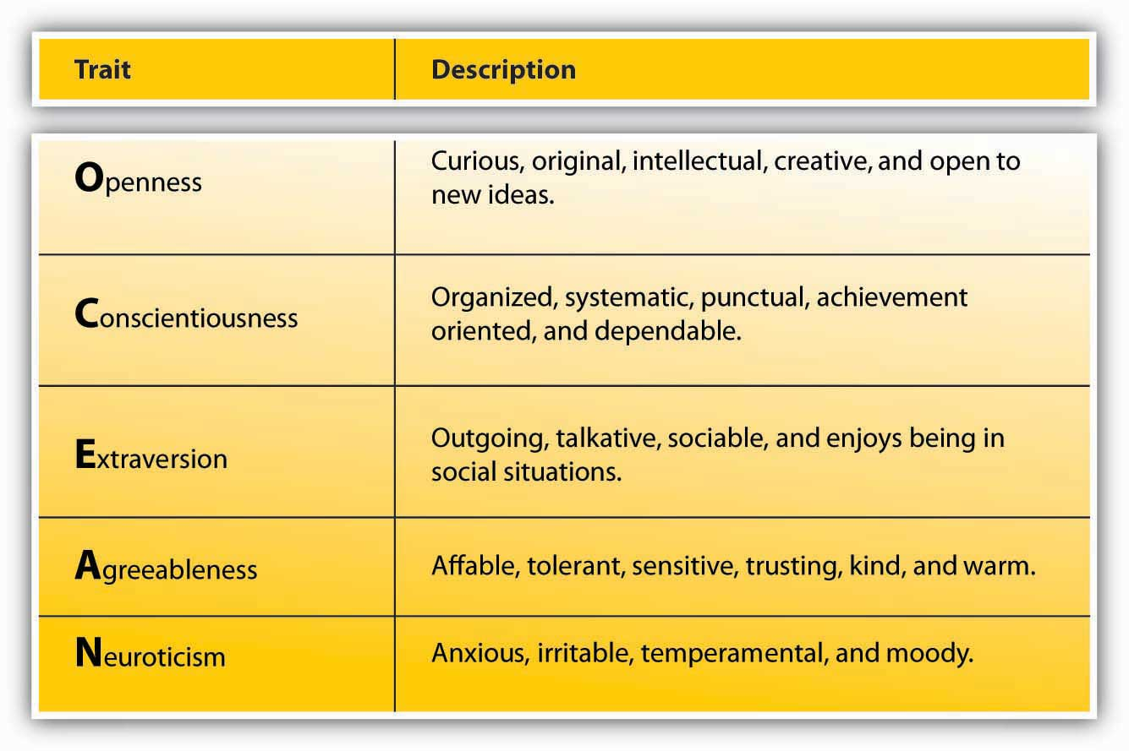
Source: Goldberg, L. R. (1990). An alternative “description of personality”: The big-five factor structure. Journal of Personality & Social Psychology, 59, 1216–1229.
As you can see, the Big Five dimensions are openness, conscientiousness, extraversion, agreeableness, and Neuroticism—if you put the initials together, you get the acronym OCEAN. Everyone has some degree of each of these traits; it is the unique configuration of how high a person rates on some traits and how low on others that produces the individual quality we call personality.
Openness is the degree to which a person is curious, original, intellectual, creative, and open to new ideas. People high in openness seem to thrive in situations that require flexibility and learning new things. They are highly motivated to learn new skills, and they do well in training settings.
- Barrick, M. R., & Mount, M. K. (1991). The big five personality dimensions and job performance: A meta-analysis. Personnel Psychology, 44, 1–26

- Lievens, F., Harris, M. M., Van Keer, E., & Bisqueret, C. (2003). Predicting cross-cultural training performance: The validity of personality, cognitive ability, and dimensions measured by an assessment center and a behavior description interview. Journal of Applied Psychology, 88, 476–489
They also have an advantage when they enter into a new organization. Their open-mindedness leads them to seek a lot of information and feedback about how they are doing and to build relationships, which leads to quicker adjustment to the new job.
- Wanberg, C. R., & Kammeyer-Mueller, J. D. (2000). Predictors and outcomes of proactivity in the socialization process. Journal of Applied Psychology, 85, 373–385
When given support, they tend to be creative.
- Baer, M., & Oldham, G. R. (2006). The curvilinear relation between experienced creative time pressure and creativity: Moderating effects of openness to experience and support for creativity. Journal of Applied Psychology, 91, 963–970
Open people are highly adaptable to change, and teams that experience unforeseen changes in their tasks do well if they are populated with people high in openness.
- LePine, J. A. (2003). Team adaptation and postchange performance: Effects of team composition in terms of members’ cognitive ability and personality. Journal of Applied Psychology, 88, 27–39
Compared with people low in openness, they are also more likely to start their own business.
- Zhao, H., & Seibert, S. E. (2006). The big five personality dimensions and entrepreneurial status: A meta-analytic review. Journal of Applied Psychology, 91, 259–271
The potential downside is that they may also be prone to becoming more easily bored or impatient with routine.
Conscientiousness refers to the degree to which a person is organized, systematic, punctual, achievement-oriented, and dependable. Conscientiousness is the one personality trait that uniformly predicts how high a person’s performance will be across a variety of occupations and jobs.
- Barrick, M. R., & Mount, M. K. (1991). The big five personality dimensions and job performance: A meta-analysis. Personnel Psychology, 44, 1–26
In fact, conscientiousness is the trait most desired by recruiters, and highly conscientious applicants tend to succeed in interviews.
- Dunn, W. S., Mount, M. K., Barrick, M. R., & Ones, D. S. (1995). Relative importance of personality and general mental ability in managers’ judgments of applicant qualifications. Journal of Applied Psychology, 80, 500–509

- Tay, C., Ang, S., & Van Dyne, L. (2006). Personality, biographical characteristics, and job interview success: A longitudinal study of the mediating effects of interviewing self-efficacy and the moderating effects of internal locus of control. Journal of Applied Psychology, 91, 446–454
Once they are hired, conscientious people not only tend to perform well, but they also have higher levels of motivation to perform, lower levels of turnover, lower levels of absenteeism, and higher levels of safety performance at work.
- Judge, T. A., & Ilies, R. (2002). Relationship of personality to performance motivation: A meta-analytic review. Journal of Applied Psychology, 87, 797–807

- Judge, T. A., Martocchio, J. J, & Thoresen, C. J. (1997). Five-factor model of personality and employee absence. Journal of Applied Psychology, 82, 745–755

- Wallace, C., & Chen, G. (2006). A multilevel integration of personality, climate, self-regulation, and performance. Personnel Psychology, 59, 529–557

- Zimmerman, R. D. (2008). Understanding the impact of personality traits on individuals’ turnover decisions: A meta-analytic path model. Personnel Psychology, 61, 309–348
One’s conscientiousness is related to career success and career satisfaction over time.
- Judge, T. A., & Higgins, C. A. (1999). The big five personality traits, general mental ability, and career success across the life span. Personnel Psychology, 52, 621–652
Finally, it seems that conscientiousness is a valuable trait for entrepreneurs. Highly conscientious people are more likely to start their own business compared with those who are not conscientious, and their firms have longer survival rates.
- Certo, S. T., & Certo, S. C. (2005). Spotlight on entrepreneurship. Business Horizons, 48, 271–274

- Zhao, H., & Seibert, S. E. (2006). The big five personality dimensions and entrepreneurial status: A meta-analytic review. Journal of Applied Psychology, 91, 259–271
A potential downside is that highly conscientious individuals can be detail-oriented rather than seeing the big picture.
Extraversion is the degree to which a person is outgoing, talkative, sociable, and enjoys socializing. One of the established findings is that they tend to be effective in jobs involving sales.
- Barrick, M. R., & Mount, M. K. (1991). The big five personality dimensions and job performance: A meta-analysis. Personnel Psychology, 44, 1–26

- Vinchur, A. J., Schippmann, J. S., Switzer, F. S., & Roth, P. L. (1998). A meta-analytic review of predictors of job performance for salespeople. Journal of Applied Psychology, 83, 586–597
Moreover, they tend to be effective as managers and they demonstrate inspirational leadership behaviors.
- Bauer, T. N., Erdogan, B., Liden, R. C., & Wayne, S. J. (2006). A longitudinal study of the moderating role of extraversion: Leader-member exchange, performance, and turnover during new executive development. Journal of Applied Psychology, 91, 298–310

- Bono, J. E., & Judge, T. A. (2004). Personality and transformational and transactional leadership: A meta-analysis. Journal of Applied Psychology, 89, 901–910
Extraverts do well in social situations, and, as a result, they tend to be effective in job interviews. Part of this success comes from preparation, as they are likely to use their social network to prepare for the interview.
- Caldwell, D. F., & Burger, J. M. (1998). Personality characteristics of job applicants and success in screening interviews. Personnel Psychology, 51, 119–136

- Tay, C., Ang, S., & Van Dyne, L. (2006). Personality, biographical characteristics, and job interview success: A longitudinal study of the mediating effects of interviewing self-efficacy and the moderating effects of internal locus of control. Journal of Applied Psychology, 91, 446–454
Extraverts have an easier time than introverts do when adjusting to a new job. They actively seek information and feedback and build effective relationships, which helps them adjust.
- Wanberg, C. R., & Kammeyer-Mueller, J. D. (2000). Predictors and outcomes of proactivity in the socialization process. Journal of Applied Psychology, 85, 373–385
Interestingly, extraverts are also found to be happier at work, which may be because of the relationships they build with the people around them and their easier adjustment to a new job.
- Judge, T. A. Heller, D., & Mount, M. K. (2002). Five-factor model of personality and job satisfaction: A meta-analysis. Journal of Applied Psychology, 87, 530–541
However, they do not necessarily perform well in all jobs; jobs depriving them of social interaction may be a poor fit. Moreover, they are not necessarily model employees. For example, they tend to have higher levels of absenteeism at work, potentially because they may miss work to hang out with or attend to the needs of their friends.
- Judge, T. A., Martocchio, J. J., & Thoresen, C. J. (1997). Five-factor model of personality and employee absence. Journal of Applied Psychology, 82, 745–755
Agreeableness is the degree to which a person is affable, tolerant, sensitive, trusting, kind, and warm. In other words, people who are high in agreeableness are likeable people who get along with others. Not surprisingly, agreeable people help others at work consistently; this helping behavior does not depend on their good mood.
- Ilies, R., Scott, B. A., & Judge, T. A. (2006). The interactive effects of personal traits and experienced states on intraindividual patterns of citizenship behavior. Academy of Management Journal, 49, 561–575
They are also less likely to retaliate when other people treat them unfairly.
- Skarlicki, D. P., Folger, R., & Tesluk, P. (1999). Personality as a moderator in the relationship between fairness and retaliation. Academy of Management Journal, 42, 100–108
This may reflect their ability to show empathy and to give people the benefit of the doubt. Agreeable people may be a valuable addition to their teams and may be effective leaders because they create a fair environment when they are in leadership positions.
- Mayer, D., Nishii, L., Schneider, B., & Goldstein, H. (2007). The precursors and products of justice climates: Group leader antecedents and employee attitudinal consequences. Personnel Psychology, 60, 929–963
At the other end of the spectrum, people low in agreeableness are less likely to show these positive behaviors. Moreover, people who are disagreeable are shown to quit their jobs unexpectedly, perhaps in response to a conflict with a boss or a peer.
- Zimmerman, R. D. (2008). Understanding the impact of personality traits on individuals’ turnover decisions: A meta-analytic path model. Personnel Psychology, 61, 309–348
If agreeable people are so nice, does this mean that we should only look for agreeable people when hiring? You might expect some jobs to require a low level of agreeableness. Think about it: When hiring a lawyer, would you prefer a kind and gentle person or someone who can stand up to an opponent? People high in agreeableness are also less likely to engage in constructive and change-oriented communication.
- LePine, J. A., & Van Dyne, L. (2001). Voice and cooperative behavior as contrasting forms of contextual performance: Evidence of differential relationships with big five personality characteristics and cognitive ability. Journal of Applied Psychology, 86, 326–336
Disagreeing with the status quo may create conflict, and agreeable people may avoid creating such conflict, missing an opportunity for constructive change.
Neuroticism refers to the degree to which a person is anxious, irritable, temperamental, and moody. It is perhaps the only Big Five dimension where scoring high is undesirable. Neurotic people have a tendency to have emotional adjustment problems and habitually experience stress and depression. People very high in Neuroticism experience a number of problems at work. For example, they have trouble forming and maintaining relationships and are less likely to be someone people go to for advice and friendship.
- Klein, K. J., Beng-Chong, L., Saltz, J. L., & Mayer, D. M. (2004). How do they get there? An examination of the antecedents of centrality in team networks. Academy of Management Journal, 47, 952–963
They tend to be habitually unhappy in their jobs and report high intentions to leave, but they do not necessarily actually leave their jobs.
- Judge, T. A., Heller, D., & Mount, M. K. (2002). Five-factor model of personality and job satisfaction: A meta-analysis. Journal of Applied Psychology, 87, 530–541

- Zimmerman, R. D. (2008). Understanding the impact of personality traits on individuals’ turnover decisions: A meta-analytic path model. Personnel Psychology, 61, 309–348

Being high in Neuroticism seems to be harmful to one’s career, as these employees have lower levels of career success (measured with income and occupational status achieved in one’s career). Finally, if they achieve managerial jobs, they tend to create an unfair climate at work.
- Mayer, D., Nishii, L., Schneider, B., & Goldstein, H. (2007). The precursors and products of justice climates: Group leader antecedents and employee attitudinal consequences. Personnel Psychology, 60, 929–963
In contrast, people who are low on Neuroticism—those who have a positive affective disposition—tend to experience positive moods more often than negative moods. They tend to be more satisfied with their jobs and more committed to their companies.
- Connolly, J. J., & Viswesvaran, C. (2000). The role of affectivity in job satisfaction: A meta-analysis. Personality and Individual Differences, 29, 265–281

- Thoresen, C. J., Kaplan, S. A., Barsky, A. P., de Chermont, K., & Warren, C. R. (2003). The affective underpinnings of job perceptions and attitudes: A meta-analytic review and integration. Psychological Bulletin, 129, 914–945
This is not surprising, as people who habitually see the glass as half full will notice the good things in their work environment while those with the opposite character will find more things to complain about. Whether these people are more successful in finding jobs and companies that will make them happy, build better relationships at work that increase their satisfaction and commitment, or simply see their environment as more positive, it seems that low Neuroticism is a strong advantage in the workplace.
Evaluate Yourself on the Big Five Personality Factors
Go to http://www.outofservice.com/bigfive to see how you score on these factors.
Other Personality Dimensions
In addition to the Big Five, researchers have proposed various other dimensions, or traits, of personality. These include self-monitoring, proactive personality, self-esteem, and self-efficacy.
Self-monitoring refers to the extent to which a person is capable of monitoring his or her actions and appearance in social situations. People who are social monitors are social chameleons who understand what the situation demands and act accordingly, while low social monitors tend to act the way they feel.
- Snyder, M. (1974). Self-monitoring of expressive behavior. Journal of Personality and Social Psychology, 30, 526–537

- Snyder, M. (1987). Public Appearances/Public Realities: The Psychology of Self-Monitoring. New York: Freeman
High social monitors are sensitive to the types of behaviors the social environment expects from them. Their ability to modify their behavior according to the demands of the situation they are in and to manage their impressions effectively are great advantages for them.
- Turnley, W. H., & Bolino, M. C. (2001). Achieving desired images while avoiding undesired images: Exploring the role of self-monitoring in impression management. Journal of Applied Psychology, 86, 351–360
They are rated as higher performers and emerge as leaders.
- Day, D. V., Schleicher, D. J., Unckless, A. L., & Hiller, N. J. (2002). Self-monitoring personality at work: A meta-analytic investigation of construct validity. Journal of Applied Psychology, 87, 390–401
They are effective in influencing other people and are able to get things done by managing their impressions. As managers, however, they tend to have lower accuracy in evaluating the performance of their employees. It seems that while trying to manage their impressions, they may avoid giving accurate feedback to their subordinates to avoid confrontations, which could hinder a manager’s ability to carry out the Controlling function.
- Jawahar, I. M. (2001). Attitudes, self-monitoring, and appraisal behaviors. Journal of Applied Psychology, 86, 875–883
Proactive personality refers to a person’s inclination to fix what is wrong, change things, and use initiative to solve problems. Instead of waiting to be told what to do, proactive people take action to initiate meaningful change and remove the obstacles they face along the way. Proactive individuals tend to be more successful in their job searches.
- Brown, D. J., Cober, R. T., Kane, K., Levy, P. E., & Shalhoop, J. (2006). Proactive personality and the successful job search: A field investigation with college graduates. Journal of Applied Psychology, 91, 717–726
They also are more successful over the course of their careers because they use initiative and acquire greater understanding of how the politics within the company work.
- Seibert, S. E. (1999). Proactive personality and career success. Journal of Applied Psychology, 84, 416–427

- Seibert, S. E., Kraimer, M. L., & Crant, M. J. (2001). What do proactive people do? A longitudinal model linking proactive personality and career success. Personnel Psychology, 54, 845–874
Proactive people are valuable assets to their companies because they may have higher levels of performance.
- Crant, M. J. (1995). The proactive personality scale and objective job performance among real estate agents. Journal of Applied Psychology, 80, 532–537
They adjust to their new jobs quickly because they understand the political environment better and make friends more quickly.
- Kammeyer-Mueller, J. D., & Wanberg, C. R. (2003). Unwrapping the organizational entry process: Disentangling multiple antecedents and their pathways to adjustment. Journal of Applied Psychology, 88, 779–794

- Thompson, J. A. (2005). Proactive personality and job performance: A social capital perspective. Journal of Applied Psychology, 90, 1011–1017
Proactive people are eager to learn and engage in many developmental activities to improve their skills.
- Major, D. A., Turner, J. E., & Fletcher, T. D. (2006). Linking proactive personality and the big five to motivation to learn and development activity. Journal of Applied Psychology, 91, 927–935
For all their potential, under some circumstances proactive personality may be a liability for a person or an organization. Imagine a person who is proactive but is perceived as too pushy, trying to change things other people are not willing to let go of, or using their initiative to make decisions that do not serve a company’s best interests. Research shows that a proactive person’s success depends on his or her understanding of the company’s core values, ability, and skills to perform the job and ability to assess situational demands correctly.
- Chan, D. (2006). Interactive effects of situational judgment effectiveness and proactive personality on work perceptions and work outcomes. Journal of Applied Psychology, 91, 475–481

- Erdogan, B., & Bauer, T. N. (2005). Enhancing career benefits of employee proactive personality: The role of fit with jobs and organizations. Personnel Psychology, 58, 859–891
Self-esteem is the degree to which a person has overall positive feelings about himself or herself. People with high self-esteem view themselves in a positive light, are confident, and respect themselves. In contrast, people with low self-esteem experience high levels of self-doubt and question their self-worth. High self-esteem is related to higher levels of satisfaction with one’s job and higher levels of performance on the job.
- Judge, T. A., & Bono, J. E. (2001). Relationship of core self-evaluations traits—self esteem, generalized self efficacy, locus of control, and emotional stability—with job satisfaction and job performance: A meta-analysis. Journal of Applied Psychology, 86, 80–92
People with low self-esteem are attracted to situations where they will be relatively invisible, such as large companies.
- Turban, D. B., & Keon, T. L. (1993). Organizational attractiveness: An interactionist perspective. Journal of Applied Psychology, 78, 184–193
Managing employees with low self-esteem may be challenging at times because negative feedback given with the intention of improving performance may be viewed as a negative judgment on their worth as an employee. Therefore, effectively managing employees with relatively low self-esteem requires tact and providing lots of positive feedback when discussing performance incidents.
Self-Esteem Around the Globe
Which nations have the highest average self-esteem? Researchers asked this question by surveying almost 17,000 individuals across 53 nations, in 28 languages.
On the basis of this survey, these are the top 10 nations in terms of self-reported self-esteem:
- Serbia
- Chile
- Israel
- Peru
- Estonia
- United States of America
- Turkey
- Mexico
- Croatia
10. Austria

The following are the 10 nations with the lowest self-reported self-esteem:
- South Korea
- Switzerland
- Morocco
- Slovakia
- Fiji
- Taiwan
- Czech Republic
- Bangladesh
- Hong Kong
- Japan

Source:
- J. J. A., Penke, L., & Schmitt, D. P. (2008, July). Self-esteem reactions to social interactions: Evidence for sociometer mechanisms across days, people, and nations. Journal of Personality & Social Psychology, 95, 181–196

- Hitti, M. (2005). Who’s No. 1 in self-esteem? Serbia is tops, Japan ranks lowest, U.S. is no. 6 in global survey

- WebMD. Retrieved November 14, 2008, from http://www.webmd.com/skin-beauty/news/20050927/whos-number-1-in-self-esteem

- Schmitt, D. P., & Allik, J. (2005). The simultaneous administration of the Rosenberg self-esteem scale in 53 nationals: Culture-specific features of global self-esteem. Journal of Personality and Social Psychology, 89, 623–642
Self-efficacy is a belief that one can perform a specific task successfully. Research shows that the belief that we can do something is a good predictor of whether we can actually do it. Self-efficacy is different from other personality traits in that it is job specific. You may have high self-efficacy in being successful academically, but low self-efficacy in relation to your ability to fix your car. At the same time, people have a certain level of generalized self-efficacy, and they have the belief that whatever task or hobby they tackle, they are likely to be successful in it.
Research shows that self-efficacy at work is related to job performance.
- Bauer, T. N., Bodner, T., Erdogan, B., Truxillo, D. M., & Tucker, J. S. (2007). Newcomer adjustment during organizational socialization: A meta-analytic review of antecedents, outcomes, and methods. Journal of Applied Psychology, 92, 707–721

- Judge, T. A., Jackson, C. L., Shaw, J. C., Scott, B. A., & Rich, B. L. (2007). Self-efficacy and work-related performance: The integral role of individual differences. Journal of Applied Psychology, 92, 107–127

- Stajkovic, A. D., & Luthans, F. (1998). Self-efficacy and work-related performance: A meta-analysis. Psychological Bulletin, 124, 240–261
This is probably because people with high self-efficacy actually set higher goals for themselves and are more committed to their goals, whereas people with low self-efficacy tend to procrastinate.
- Phillips, J. M., & Gully, S. M. (1997). Role of goal orientation, ability, need for achievement, and locus of control in the self-efficacy and goal-setting process. Journal of Applied Psychology, 82, 792–802

- Steel, P. (2007). The nature of procrastination: A meta-analytic and theoretical review of quintessential self-regulatory failure. Psychological Bulletin, 133, 65–94

- Wofford, J. C., Goodwin, V. L., & Premack, S. (1992). Meta-analysis of the antecedents of personal goal level and of the antecedents and consequences of goal commitment. Journal of Management, 18, 595–615
Academic self-efficacy is a good predictor of your grade point average, as well as whether you persist in your studies or drop out of college.
- Robbins, S. B., Lauver, K., Le, H., Davis, D., Langley, R., & Carlstrom, A. (2004). Do psychosocial and study skill factors predict college outcomes? A meta-analysis. Psychological Bulletin, 130, 261–288
Is there a way of increasing employee’s self-efficacy? In addition to hiring people who are capable of performing the required job tasks, training people to increase their self-efficacy may be effective. Some people may also respond well to verbal encouragement. By showing that you believe they can be successful and effectively playing the role of cheerleader, a manager may be able to increase self-efficacy beliefs. Empowering people—giving them opportunities to test their skills so that they can see what they are capable of—is also a good way of increasing self-efficacy.
- Ahearne, M., Mathieu, J., & Rapp, A. (2005). To empower or not to empower your sales force? An empirical examination of the influence of leadership empowerment behavior on customer satisfaction and performance. Journal of Applied Psychology, 90, 945–955
Personality Testing in Employee Selection
Personality is a potentially important predictor of work behavior. In job interviews, companies try to assess a candidate’s personality and the potential for a good match, but interviews are only as good as the people conducting them. In fact, interviewers are not particularly good at detecting the best trait that predicts performance: conscientiousness.
- Barrick, M. R., Patton, G. K., & Haugland, S. N. (2000). Accuracy of interviewer judgments of job applicant personality traits. Personnel Psychology, 53, 925–951
One method some companies use to improve this match and detect the people who are potentially good job candidates is personality testing. Several companies conduct preemployment personality tests. Companies using them believe that these tests improve the effectiveness of their selection and reduce turnover. For example, Overnight Transportation in Atlanta found that using such tests reduced their on-the-job delinquency by 50%–100%.
- Emmett, A. (2004, October). Snake oil or science? That’s the raging debate on personality testing. Workforce Management, 83, 90–92

- Gale, S. F. (2002, April). Three companies cut turnover with tests. Workforce, 81 (4), 66–69
Figure 2.7
Companies such as Kronos and Hogan Assessments conduct preemployment personality tests. Kronos Incorporated Headquarters is located in Chelmsford, Massachusetts.
Source: http://en.wikipedia.org/wiki/Image:Kronos-incorporated.jpg
Yet, are these methods good ways of employee selection? Experts have not yet reached an agreement on this subject and the topic is highly controversial. Some experts cite data indicating that personality tests predict performance and other important criteria such as job satisfaction. However, we must understand that how a personality test is used influences its validity. Imagine filling out a personality test in class. You will probably fill it out as honestly as you can. Then, if your instructor correlates your personality scores with your class performance, we could say that the correlation is meaningful. But now imagine that your instructor tells you, before giving you the test, that based on your test scores, you will secure a coveted graduate assistant position, which comes with a tuition waiver and a stipend. In that case, would you still fill out the test honestly or would you try to make your personality look as “good” as possible?
In employee selection, where the employees with the “best” personalities will be the ones receiving a job offer, a complicating factor is that people filling out the survey do not have a strong incentive to be honest. In fact, they have a greater incentive to guess what the job requires and answer the questions in a way they think the company is looking for. As a result, the rankings of the candidates who take the test may be affected by their ability to fake. Some experts believe that this is a serious problem.
- Morgeson, F. P., Campion, M. A., Dipboye, R. L., Hollenbeck, J. R., Murphy, K., & Schmitt, N. (2007). Reconsidering the use of personality tests in personnel selection contexts. Personnel Psychology, 60, 683–729

- Morgeson, F. P., Campion, M. A., Dipboye, R. L., Hollenbeck, J. R., Murphy, K., & Schmitt, N. (2007). Are we getting fooled again? Coming to terms with limitations in the use of personality tests for personnel selection. Personnel Psychology, 60, 1029–1049
Others point out that even with faking the tests remain valid—the scores are related to job performance.
- Barrick, M. R., & Mount, M. K. (1996). Effects of impression management and self-deception on the predictive validity of personality constructs. Journal of Applied Psychology, 81, 261–272

- Ones, D. S., Dilchert, S., Viswesvaran, C., & Judge, T. A. (2007). In support of personality assessment in organizational settings. Personnel Psychology, 60, 995–1027

- Ones, D. S., Viswesvaran, C., & Reiss, A. D. (1996). Role of social desirability in personality testing for personnel selection. Journal of Applied Psychology, 81, 660–679

- Tett, R. P., & Christiansen, N. D. (2007). Personality tests at the crossroads: A response to Morgeson, Campion, Dipboye, Hollenbeck, Murphy, and Schmitt (2007). Personnel Psychology, 60, 967–993
It is even possible that the ability to fake is related to a personality trait that increases success at work, such as social monitoring.
Scores on personality self-assessments are distorted for other reasons beyond the fact that some candidates can fake better than others. Do we even know our own personalities? Are we the best person to ask this question? How supervisors, coworkers, and customers see our personality may matter more than how we see ourselves. Therefore, using self-report measures of performance may not be the best way of measuring someone’s personality.
- Mount, M. K., Barrick, M. R., & Strauss, J. P. (1994). Validity of observer ratings of the big five personality factors. Journal of Applied Psychology, 79, 272–280
We have our blind areas. We may also give “aspirational” answers. If you are asked whether you are honest, you may think “yes, I always have the intention to be honest.” This actually says nothing about your actual level of honesty.
Another problem with using these tests is the uncertain relationship between performance and personality. On the basis of research, personality is not a particularly strong indicator of how a person will perform. According to one estimate, personality only explains about 10%–15% of variation in job performance. Our performance at work depends on many factors, and personality does not seem to be the key factor for performance. In fact, cognitive ability (your overall mental intelligence) is a more powerful predictor of job performance. Instead of personality tests, cognitive ability tests may do a better job of predicting who will be good performers. Personality is a better predictor of job satisfaction and other attitudes, but screening people out on the assumption that they may be unhappy at work is a challenging argument to make in an employee selection context.
In any case, if an organization decides to use these tests for selection, it is important to be aware of their limitations. If they are used together with other tests, such as tests of cognitive abilities, they may contribute to making better decisions. The company should ensure that the test fits the job and actually predicts performance. This is called validating the test. Before giving the test to applicants, the company could give it to existing employees to find out the traits that are most important for success in this particular company and job. Then, in the selection context, the company can pay particular attention to those traits.
Finally, the company also needs to make sure that the test does not discriminate against people on the basis of sex, race, age, disabilities, and other legally protected characteristics. Rent-a-Center experienced legal difficulties when the test they used was found to violate the Americans with Disabilities Act (ADA). The company used the Minnesota Multiphasic Personality Inventory for selection purposes, but this test was developed to diagnose severe mental illnesses; it included items such as “I see things or people around me others do not see.” In effect, the test served the purpose of a clinical evaluation and was discriminating against people with mental illnesses, which is a protected category under ADA.
- Heller, M. (2005, September). Court ruling that employer’s integrity test violated ADA could open door to litigation. Workforce Management, 84 (9), 74–77
Values
Figure 2.8 Values Included in Schwartz’s (1992) Value Inventory
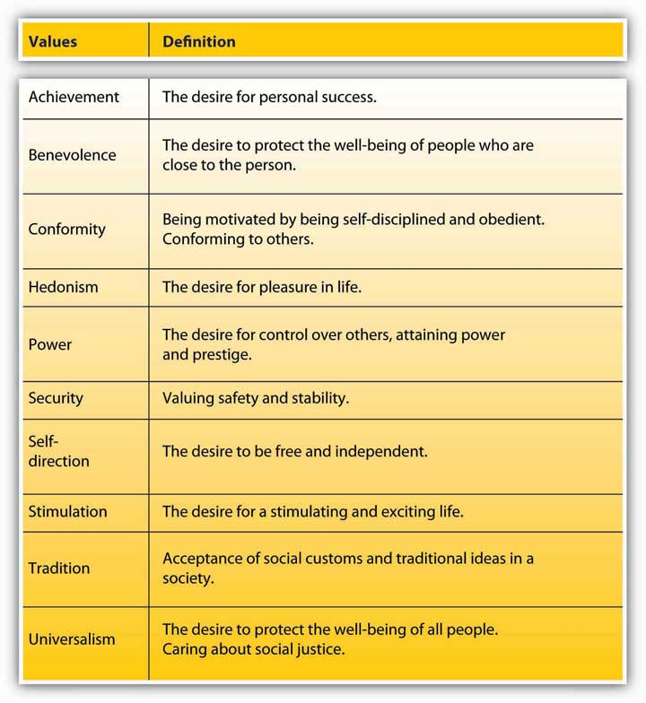

Values refer to people’s stable life goals, reflecting what is most important to them. Values are established throughout one’s life as a result of accumulating life experiences, and values tend to be relatively stable.
- Lusk, E. J., & Oliver, B. L. (1974). Research notes. American manager’s personal value systems-revisited. Academy of Management Journal, 17 (3), 549–554

- Rokeach, M. (1973). The Nature of Human Values. New York: Free Press
The values that are important to a person tend to affect the types of decisions they make, how they perceive their environment, and their actual behaviors. Moreover, a person is more likely to accept a job offer when the company possesses the values he or she cares about.
- Judge, T. A., & Bretz, R. D. (1992). Effects of work values on job choice decisions. Journal of Applied Psychology, 77, 261–271

- Ravlin, E. C., & Meglino, B. M. (1987). Effect of values on perception and decision making: A study of alternative work values measures. Journal of Applied Psychology, 72, 666–673
Value attainment is one reason people stay in a company. When a job does not help them attain their values, they are likely to decide to leave if they are dissatisfied with the job.
- George, J. M., & Jones, G. R. (1996). The experience of work and turnover intentions: Interactive effects of value attainment, job satisfaction, and positive mood. Journal of Applied Psychology, 81, 318–325
What are the values people care about? As with personality dimensions, researchers have developed several frameworks, or typologies, of values. One of the particularly useful frameworks includes 10 values.
- Schwartz, S. H. (1992). Universals in the content and structure of values: Theoretical advances and empirical tests in 20 countries. In M. Zanna (Ed.), Advances in Experimental Social Psychology (pp. 1–65). San Diego: Academic Press
Values a person holds will affect their employment. For example, someone who values stimulation highly may seek jobs that involve fast action and high risk, such as firefighter, police officer, or emergency medicine. Someone who values achievement highly may be likely to become an entrepreneur or intrapreneur. And an individual who values benevolence and universalism may seek work in the nonprofit sector with a charitable organization or in a “helping profession,” such as nursing or social work. Like personality, values have implications for Organizing activities, such as assigning duties to specific jobs or developing the chain of command; employee values are likely to affect how employees respond to changes in the characteristics of their jobs.
In terms of work behaviors, a person is more likely to accept a job offer when the company possesses the values he or she cares about. A firm’s values are often described in the company’s mission and vision statements, an element of the Planning function.
- Judge, T. A., & Bretz, R. D. (1992). Effects of work values on job choice decisions. Journal of Applied Psychology, 77, 261–271

- Ravlin, E. C., & Meglino, B. M. (1987). Effect of values on perception and decision making: A study of alternative work values measures. Journal of Applied Psychology, 72, 666–673
Value attainment is one reason people stay in a company. When a job does not help them attain their values, they are likely to decide to leave if they are also dissatisfied with the job.
- George, J. M., & Jones, G. R. (1996). The experience of work and turnover intentions: Interactive effects of value attainment, job satisfaction, and positive mood. Journal of Applied Psychology, 81, 318–325

KEY TAKEAWAY
Personality traits and values are two dimensions on which people differ. Personality is the unique, relatively stable pattern of feelings, thoughts, and behavior that each individual displays. Big Five personality dimensions (openness, conscientiousness, extraversion, agreeableness, and Neuroticism) are important traits; others that are particularly relevant for work behavior include self-efficacy, self-esteem, social monitoring, and proactive personality. While personality is a stronger influence over job attitudes, its relation to job performance is weaker. Some companies use personality testing to screen out candidates. Companies using personality tests are advised to validate their tests and use them to supplement other techniques with greater validity, such as tests of cognitive ability. Companies must also ensure that a test does not discriminate against any protected group. Values express a person’s life goals; they are similar to personality traits in that they are relatively stable over time. In the workplace, a person is more likely to accept a job that provides opportunities for value attainment. People are also more likely to remain in a job and career that satisfy their values.

EXERCISES
- Think about the personality traits covered in this section. Can you think of jobs or occupations that seem particularly suited to each trait? Which traits would be universally desirable across all jobs?

- What are the unique challenges of managing employees who have low self-efficacy and self-esteem? How would you deal with this situation?

- What are some methods that companies can use to assess employee personality?

- Have you ever held a job where your personality did not match the demands of the job? How did you react to this situation? How were your attitudes and behaviors affected?

- Identify ways in which the Big Five (of the manager and/or the employees) may affect how you as a manager would carry out the Leadership function.
2.3 Perception
LEARNING OBJECTIVES
- Understand the influence of biases in the process of perception.

- Describe how we perceive visual objects and how these tendencies may affect our behavior.

- Describe the biases of self-perception.

- Describe the biases inherent in our perceptions of other people.

Our behavior is not only a function of our personality and values but also of the situation. We interpret our environment, formulate responses, and act accordingly. Perception may be defined as the process by which individuals detect and interpret environmental stimuli. What makes human perception so interesting is that we do not solely respond to the stimuli in our environment. We go beyond the information that is present in our environment, pay selective attention to some aspects of the environment, and ignore other elements that may be immediately apparent to other people.
Our perception of the environment is not entirely rational. For example, have you ever noticed that while glancing at a newspaper or a news Web site, information that is especially interesting or important to you jumps out of the page and catches your eye? If you are a sports fan, while scrolling down the pages, you may immediately see a news item describing the latest success of your team. If you are the mother of a picky eater, an advice column on toddler feeding may be the first thing you see when looking at the page. If you were recently turned down for a loan, an item of financial news may jump out at you. Therefore, what we see in the environment is a function of what we value, our needs, our fears, and our emotions.
- Higgins, E. T., & Bargh, J. A. (1987). Social cognition and social perception. Annual Review of Psychology, 38, 369–425

- Keltner, D., Ellsworth, P. C., & Edwards, K. (1993). Beyond simple pessimism: Effects of sadness and anger on social perception. Journal of Personality and Social Psychology, 64, 740–752
In fact, what we see in the environment may be objectively flat out wrong because of such mental tendencies. For example, one experiment showed that when people who were afraid of spiders were shown spiders, they inaccurately thought that the spider was moving toward them.
- Riskind, J. H., Moore, R., & Bowley, L. (1995). The looming of spiders: The fearful perceptual distortion of movement and menace. Behaviour Research and Therapy, 33, 171
In this section, we will describe some common perceptual tendencies we engage in when perceiving objects or other people and the consequences of such perceptions. Our coverage of these perceptual biases is not exhaustive—there are many other biases and tendencies that can be found in the way people perceive stimuli.
Visual Perception
Figure 2.10
What do you see?
Our visual perception definitely goes beyond the physical information available to us; this phenomenon is commonly referred to as “optical illusions.” Artists and designers of everything from apparel to cars to home interiors make use of optical illusions to enhance the look of the product. Managers rely on their visual perception to form their opinions about people and objects around them and to make sense of data presented in graphical form. Therefore, understanding how our visual perception may be biased is important.
First, we extrapolate from the information available to us. Take a look at the first figure. The white triangle you see in the middle is not really there, but we extrapolate from the information available to us and see it there. Similarly, when we look at objects that are partially blocked, we see the whole.
- Kellman, P. J., & Shipley, T. F. (1991). A theory of visual interpolation in object perception. Cognitive Psychology, 23, 141–221
Figure 2.11
What do you see?
Source: http://en.wikipedia.org/wiki/Image:Cup_or_faces_paradox.svg
Now, look at the next figure. What do you see? Most people look at this figure and see two faces or a goblet, depending on which color—black or white—they focus upon. Our visual perception is often biased because we do not perceive objects in isolation. The contrast between our focus of attention and the remainder of the environment may make an object appear bigger or smaller.
This principle is shown here in the third figure. At first glance, the circle on the left may appear bigger, but they are the same size. This is due to the visual comparison of the middle circle on the left with its surrounding circles, whereas the middle circle on the right is compared with the bigger circles surrounding it.
How do these tendencies influence behavior in organizations? The fact that our visual perception is faulty means that managers should not always take what they see at face value. Let’s say that you do not like one of your peers and you think that you saw this person surfing the Web during work hours. Are you absolutely sure, or are you simply filling the gaps? Have you really seen this person surf unrelated Web sites, or is it possible that the person was searching for work-related purposes? The tendency to fill in the gaps also causes our memory to be faulty. Imagine that you have been at a meeting where several people made comments that you did not agree with. After the meeting, you may attribute most of these comments to people you did not like. In other words, you may twist the reality to make your memories more consistent with your opinions of people.
The tendency to compare and contrast objects and people to each other also causes problems. For example, if you are a manager who has been given an office much smaller than the other offices on the floor, you may feel that your workspace is crowded and uncomfortable. If the same office is surrounded by smaller offices, you may actually feel that your office is comfortable and roomy. In short, our biased visual perception may lead to the wrong inferences about the people and objects around us.
Figure 2.12
Which of the circles in the middle is bigger?
Self-Perception
Human beings are prone to errors and biases when perceiving themselves. Moreover, the type of bias people have depends on their personality. Many people suffer from self-enhancement bias. This is the tendency to overestimate our performance and capabilities and see ourselves in a more positive light than others see us. People who have a narcissistic personality are particularly subject to this bias, but many others also have this bias to varying degrees.
- John, O. P., & Robins, R. W. (1994). Accuracy and bias in self-perception: Individual differences in self-enhancement and the role of narcissism. Journal of Personality and Social Psychology, 66, 206–219
At the same time, other people have the opposing extreme, which may be labeled as self-effacement bias (or modesty bias). This is the tendency to underestimate our performance and capabilities and to see events in a way that puts ourselves in a more negative light. We may expect that people with low self-esteem may be particularly prone to making this error. These tendencies have real consequences for behavior in organizations. For example, people who suffer from extreme levels of self-enhancement tendencies may not understand why they are not getting promoted or rewarded, while those who have a tendency to self-efface may project low confidence and take more blame for their failures than necessary.
When human beings perceive themselves, they are also subject to the false consensus error. Simply put, we overestimate how similar we are to other people.
- Fields, J. M., & Schuman, H. (1976). Public beliefs about the beliefs of the public. The Public Opinion Quarterly, 40 (4), 427–448

- Ross, L., Greene, D., & House, P. (1977). The “false consensus effect”: An egocentric bias in social perception and attribution processes. Journal of Experimental Social Psychology, 13, 279–301
We assume that whatever quirks we have are shared by a larger number of people than in reality. People who take office supplies home, tell white lies to their boss or colleagues, or take credit for other people’s work to get ahead may genuinely feel that these behaviors are more common than they really are. The problem for behavior in organizations is that, when people believe that a behavior is common and normal, they may repeat the behavior more freely. Under some circumstances, this may lead to a high level of unethical or even illegal behaviors.
Social Perception
How we perceive other people in our environment is also shaped by our biases. Moreover, how we perceive others will shape our behavior, which in turn will shape the behavior of the person we are interacting with.
One of the factors biasing our perception is stereotypes. Stereotypes are generalizations based on a group characteristic. For example, believing that women are more cooperative than men or that men are more assertive than women are stereotypes. Stereotypes may be positive, negative, or neutral. In the abstract, stereotyping is an adaptive function—we have a natural tendency to categorize the information around us to make sense of our environment. Just imagine how complicated life would be if we continually had to start from scratch to understand each new situation and each new person we encountered! What makes stereotypes potentially discriminatory and a perceptual bias is the tendency to generalize from a group to a particular individual. If the belief that men are more assertive than women leads to choosing a man over an equally qualified female candidate for a position, the decision will be biased, unfair, and potentially illegal.
Stereotypes often create a situation called self-fulfilling prophecy. This happens when an established stereotype causes one to behave in a certain way, which leads the other party to behave in a way that confirms the stereotype.
- Snyder, M., Tanke, E. D., & Berscheid, E. (1977). Social perception and interpersonal behavior: On the self-fulfilling nature of social stereotypes. Journal of Personality and Social Psychology, 35, 656–666
If you have a stereotype such as “Asians are friendly,” you are more likely to be friendly toward an Asian person. Because you are treating the other person more nicely, the response you get may also be nicer, which confirms your original belief that Asians are friendly. Of course, just the opposite is also true. Suppose you believe that “young employees are slackers.” You are less likely to give a young employee high levels of responsibility or interesting and challenging assignments. The result may be that the young employee reporting to you may become increasingly bored at work and start goofing off, confirming your suspicions that young people are slackers!
Stereotypes persist because of a process called selective perception. Selective perception simply means that we pay selective attention to parts of the environment while ignoring other parts, which is particularly important during the Planning process. Our background, expectations, and beliefs will shape which events we notice and which events we ignore. For example, an executive’s functional background will affect the changes he or she perceives in the environment.
- Waller, M. J., Huber, G. P., & Glick, W. H. (1995). Functional background as a determinant of executives’ selective perception. Academy of Management Journal, 38, 943–974
Executives with a background in sales and marketing see the changes in the demand for their product, while executives with a background in information technology may more readily perceive the changes in the technology the company is using. Selective perception may also perpetuate stereotypes because we are less likely to notice events that go against our beliefs. A person who believes that men drive better than women may be more likely to notice women driving poorly than men driving poorly. As a result, a stereotype is maintained because information to the contrary may not even reach our brain!
Let’s say we noticed information that goes against our beliefs. What then? Unfortunately, this is no guarantee that we will modify our beliefs and prejudices. First, when we see examples that go against our stereotypes, we tend to come up with subcategories. For example, people who believe that women are more cooperative when they see a female who is assertive may classify her as a “career woman.” Therefore, the example to the contrary does not violate the stereotype and is explained as an exception to the rule.
- Higgins, E. T., & Bargh, J. A. (1987). Social cognition and social perception. Annual Review of Psychology, 38, 369–425
Or, we may simply discount the information. In one study, people in favor of and against the death penalty were shown two studies, one showing benefits for the death penalty while the other disconfirming any benefits. People rejected the study that went against their belief as methodologically inferior and ended up believing in their original position even more!
- Lord, C. G., Ross, L., & Lepper, M. R. (1979) Biased assimilation and attitude polarization: The effects of prior theories on subsequently considered evidence. Journal of Personality and Social Psychology, 37, 2098–2109
In other words, using data to debunk people’s beliefs or previously established opinions may not necessarily work, a tendency to guard against when conducting Planning and Controlling activities.
One other perceptual tendency that may affect work behavior is first impressions. The first impressions we form about people tend to have a lasting effect. In fact, first impressions, once formed, are surprisingly resilient to contrary information. Even if people are told that the first impressions were caused by inaccurate information, people hold on to them to a certain degree because once we form first impressions, they become independent from the evidence that created them.
- Ross, L., Lepper, M. R., & Hubbard, M. (1975). Perseverance in self-perception and social perception: Biased attributional processes in the debriefing paradigm. Journal of Personality and Social Psychology, 32, 880–892
Therefore, any information we receive to the contrary does not serve the purpose of altering them. Imagine the first day that you met your colleague Anne. She treated you in a rude manner, and when you asked for her help, she brushed you off. You may form the belief that Anne is a rude and unhelpful person. Later on, you may hear that Anne’s mother is seriously ill, making Anne very stressed. In reality, she may have been unusually stressed on the day you first met her. If you had met her at a time when her stress level was lower, you could have thought that she is a really nice person. But chances are, your impression that she is rude and unhelpful will not change even when you hear about her mother. Instead, this new piece of information will be added to the first one: She is rude, unhelpful, and her mother is sick.
As a manager, you can protect yourself against this tendency by being aware of it and making a conscious effort to open your mind to new information. It would also be to your advantage to pay careful attention to the first impressions you create, particularly during job interviews.

KEY TAKEAWAY
Perception is how we make sense of our environment in response to environmental stimuli. While perceiving our surroundings, we go beyond the objective information available to us and our perception is affected by our values, needs, and emotions. There are many biases that affect human perception of objects, self, and others. When perceiving the physical environment, we fill in the gaps and extrapolate from the available information. When perceiving others, stereotypes influence our behavior. Stereotypes may lead to self-fulfilling prophecies. Stereotypes are perpetuated because of our tendency to pay selective attention to aspects of the environment and ignore information inconsistent with our beliefs. Understanding the perception process gives us clues to understanding human behavior.

EXERCISES
- What are some of the typical errors, or optical illusions, that we experience when we observe physical objects?

- What are the problems of false consensus error? How can managers deal with this tendency?

- Describe a situation where perception biases have or could affect any of the P-O-L-C facets. Use an example you have experienced or observed, or, if you do not have such an example, create a hypothetical situation. How do we manage the fact that human beings develop stereotypes? Is there such as thing as a good stereotype? How would you prevent stereotypes from creating unfairness in management decisions?

- Describe a self-fulfilling prophecy you have experienced or observed in action. Was the prophecy favorable or unfavorable? If unfavorable, how could the parties have chosen different behavior to produce a more positive outcome?
2.4 Work Attitudes
LEARNING OBJECTIVES
- Define what work attitudes are.

- Define and differentiate between job satisfaction and organizational commitment.

- List several important factors influencing job satisfaction and organizational commitment.

- Identify two ways companies can track attitudes in the workplace.
How we behave at work often depends on how we feel about being there. Therefore, making sense of how people behave depends on understanding their work attitudes. An attitude refers to our opinions, beliefs, and feelings about aspects of our environment. We have attitudes toward the food we eat, people we meet, courses we take, and things we do. At work, two job attitudes have the greatest potential to influence how we behave. These are job satisfaction and organizational commitment.
Job satisfaction refers to the feelings people have toward their job. If the number of studies conducted on job satisfaction is an indicator, job satisfaction is probably the most important job attitude. Institutions such as Gallup or the Society for Human Resource Management (SHRM) periodically conduct studies of job satisfaction to track how satisfied employees are at work. According to a recent Gallup survey, 90% of the employees surveyed said that they were at least somewhat satisfied with their jobs. A recent SHRM study revealed 40% who were very satisfied.
- Anonymous. (2007, August). What keeps employees satisfied? HR Focus, 10–13

- Sandberg, J. (2008, April 15). For many employees, a dream job is one that isn’t a nightmare. Wall Street Journal, B1.
Organizational commitment is the emotional attachment people have toward the company they work for. A highly committed employee is one who accepts and believes in the company’s values, is willing to put out effort to meet the company’s goals, and has a strong desire to remain with the company. People who are committed to their company often refer to their company as “we” as opposed to “they” as in “in this company, we have great benefits.” The way we refer to the company indicates the type of attachment and identification we have with the company.
There is a high degree of overlap between job satisfaction and organizational commitment because things that make us happy with our job often make us more committed to the company as well. Companies believe that these attitudes are worth tracking because they often are associated with outcomes that are important to the Controlling role, such as performance, helping others, absenteeism, and turnover.
What Causes Positive Work Attitudes?
What makes you satisfied with your job and develop commitment to your company? Research shows that people pay attention to several factors of their work environment, including characteristics of the job (a function of Organizing activities), how they are treated (related to Leadership actions), the relationships they form with colleagues and managers (also Leadership related), and the level of stress the job entails.
As we have seen earlier in this chapter, personality and values play important roles in how employees feel about their jobs.
Figure 2.14 Factors Contributing to Job Satisfaction and Organizational Commitment
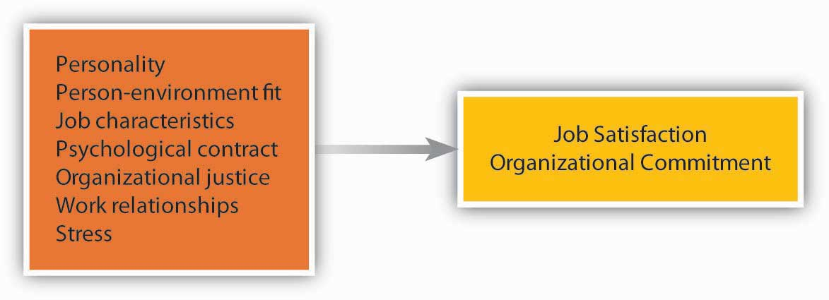

Job Characteristics
Employees tend to be more satisfied and committed in jobs that involve certain characteristics. The ability to use a variety of skills, having autonomy at work, receiving feedback on the job, and performing a significant task are some job characteristics that are related to satisfaction and commitment. However, the presence of these factors is not important for everyone. Some people have a high need for growth. These employees tend to be more satisfied when their jobs help them build new skills and improve.
- Loher, B. T., Noe, R. A., Moeller, N. L., & Fitzgerald, M. P. (1985). A meta-analysis of the relation of job characteristics to job satisfaction. Journal of Applied Psychology, 70, 280–289

- Mathieu, J. E., & Zajac, D. M. (1990). A review and meta-analysis of the antecedents, correlates, and consequences of organizational commitment. Psychological Bulletin, 108, 171–194
Organizational Justice and the Psychological Contract
A strong influence over our satisfaction level is how fairly we are treated. People pay attention to the fairness of company policies and procedures, fair and kind treatment from supervisors, and fairness of their pay and other rewards they receive from the company.
- Cohen-Charash, Y., & Spector, P. E. (2001). The role of justice in organizations: A meta-analysis. Organizational Behavior and Human Decision Processes, 86, 278–321

- Colquitt, J. A., Conlon, D. E., Wesson, M. J., Porter, C. O. L. H., & Ng, K. Y. (2001). Justice at the millennium: A meta-analytic review of 25 years of organizational justice research. Journal of Applied Psychology, 86, 425–445

- Meyer, J. P., Stanley, D. J., Herscivitch, L., & Topolnytsky, L. (2002). Affective, continuance, and normative commitment to the organization: A meta-analysis of antecedents, correlates, and consequences. Journal of Vocational Behavior, 61, 20–52.
Organizational justice can be classified into three categories: (1) procedural (fairness in the way policies and processes are carried out), (2) distributive (the allocation of resources or compensation and benefits), and (3) interactional (the degree to which people are treated with dignity and respect). At the root of organizational justice is trust, something that is easier to break than to repair if broken.
The psychological contract is the unspoken, informal understanding that an employee will contribute certain things to the organization (e.g., work ability and a willing attitude) and will receive certain things in return (e.g., reasonable pay and benefits). Under the psychological contract, an employee may believe that if he or she works hard and receives favorable performance evaluations, he or she will receive an annual bonus, periodic raises and promotions, and will not be laid off. Since the “downsizing” trend of the past 20 years, many commentators have declared that the psychological contract is violated more often than not.
Relationships at Work
Two strong predictors of our happiness at work and commitment to the company are our relationships with coworkers and managers. The people we interact with, how friendly they are, whether we are socially accepted in our work group, whether we are treated with respect by them are important to our happiness at work. Research also shows that our relationship with our manager, how considerate the manager is, and whether we build a trust-based relationship with our manager are critically important to our job satisfaction and organizational commitment.
- Bauer, T. N., Bodner, T., Erdogan, B., Truxillo, D. M., & Tucker, J. S. (2007). Newcomer adjustment during organizational socialization: A meta-analytic review of antecedents, outcomes, and methods. Journal of Applied Psychology, 92, 707–721

- Gerstner, C. R., & Day, D. V. (1997). Meta-analytic review of leader-member exchange theory: Correlates and construct issues. Journal of Applied Psychology, 82(6), 827–844

- Judge, T. A., Piccolo, R. F., & Ilies, R. (2004). The forgotten ones? The validity of consideration and initiating structure in leadership research. Journal of Applied Psychology, 89, 36–51

- Kinicki, A. J., McKee-Ryan, F. M., Schriesheim, C. A., & Carson, K. P. (2002). Assessing the construct validity of the job descriptive index: A review and meta-analysis. Journal of Applied Psychology, 87, 14–32

- Mathieu, J. E., & Zajac, D. M. (1990). A review and meta-analysis of the antecedents, correlates, and consequences of organizational commitment. Psychological Bulletin, 108, 171–194

- Meyer, J. P., Stanley, D. J., Herscivitch, L., & Topolnytsky, L. (2002). Affective, continuance, and normative commitment to the organization: A meta-analysis of antecedents, correlates, and consequences. Journal of Vocational Behavior, 61, 20–52

- Rhoades, L., & Eisenberger, R. (2002). Perceived organizational support: A review of the literature. Journal of Applied Psychology, 87, 698–714
When our manager and overall management listen to us, care about us, and value our opinions, we tend to feel good at work. When establishing effective relations with employees, little signals that you care about your employees go a long way. For example, in 2004 San Francisco’s Hotel Carlton was taken over and renovated by a new management group, Joie de Vivre Hospitality. One of the small things the new management did that created dramatic results was that, in response to an employee attitude survey, they replaced the old vacuum cleaners housekeepers were using and started replacing them every year. It did not cost the company much to replace old machinery, but this simple act of listening to employee problems and taking action went a long way to make employees feel better.
- Dvorak, P. (2007, December 17). Theory and practice: Hotelier finds happiness keeps staff checked in; focus on morale boosts Joie de Vivre’s grades from workers, guests. Wall Street Journal, B3
Stress
Not surprisingly, the amount of stress present in a job is related to employee satisfaction and commitment. Stressors range from environmental ones (noise, heat, inadequate ventilation) to interpersonal ones (organizational politics, conflicts with coworkers) to organizational ones (pressure to avoid making mistakes, worrying about the security of the job). Some jobs, such as intensive care unit nurse and military fighter pilot, are inherently very stressful.
Another source of stress has to do with the roles people are expected to fulfill on and off the job. Role ambiguity is uncertainty about what our responsibilities are in the job. Role conflict involves contradictory demands at work; it can also involve conflict between fulfilling one’s role as an employee and other roles in life, such as the role of parent, friend, or community volunteer.
Generally speaking, the higher the stress level, the lower job satisfaction tends to be. But not all stress is bad, and some stressors actually make us happier! For example, working under time pressure and having a high degree of responsibility are stressful, but they are also perceived as challenges and tend to be related to high levels of satisfaction.
- Kinicki, A. J., McKee-Ryan, F. M., Schriesheim, C. A., & Carson, K. P. (2002). Assessing the construct validity of the job descriptive index: A review and meta-analysis. Journal of Applied Psychology, 87, 14–32

- Meyer, J. P., Stanley, D. J., Herscivitch, L., & Topolnytsky, L. (2002). Affective, continuance, and normative commitment to the organization: A meta-analysis of antecedents, correlates, and consequences. Journal of Vocational Behavior, 61, 20–52

- Miller, B. K., Rutherford, M. A., & Kolodinsky, R. W. (2008). Perceptions of organizational politics: A meta-analysis of outcomes. Journal of Business and Psychology, 22, 209–222

- Podsakoff, N. P., LePine, J. A., & LePine, M. A. (2007). Differential challenge stressor-hindrance stressor relationships with job attitudes, turnover intentions, turnover, and withdrawal behavior: A meta-analysis. Journal of Applied Psychology, 92, 438–454
Assessing Work Attitudes in the Workplace
Given that work attitudes may give us clues about who will leave or stay, who will perform better, and who will be more engaged, tracking satisfaction and commitment levels is a helpful step for companies. If there are companywide issues that make employees unhappy and disengaged, these need to be resolved. There are at least two systematic ways in which companies can track work attitudes: through attitude surveys and exit interviews. Companies such as KFC and Long John Silver restaurants, the SAS Institute, Google, and others give periodic attitude surveys, which are used to track employee work attitudes. Companies can get more out of these surveys if responses are held confidential. If employees become concerned that their individual responses will be shared with their immediate manager, they are less likely to respond honestly. Moreover, success of these surveys depends on the credibility of management in the eye of employees. If management periodically collects these surveys but no action comes out of them, employees may adopt a more cynical attitude and start ignoring these surveys, hampering the success of future efforts. Exit interviews involve a meeting with the departing employee. This meeting is often conducted by a member of the human resource management department. If conducted well, this meeting may reveal what makes employees dissatisfied at work and give management clues about areas for improvement.
How strong is the attitude-behavior link? First of all, it depends on the attitude in question. Your attitudes toward your colleagues may influence whether you actually help them on a project, but they may not be a good predictor of whether you quit your job. Second, it is worth noting that attitudes are more strongly related to intentions to behave in a certain way, rather than actual behaviors. When you are dissatisfied with your job, you will have the intention to leave. Whether you actually leave will be a different story! Your leaving will depend on many factors, such as availability of alternative jobs in the market, your employability in a different company, and sacrifices you have to make while changing jobs. Thus, while the attitudes assessed through employee satisfaction surveys and exit interviews can provide some basis for predicting how a person might behave in a job, remember that behavior is also strongly influenced by situational constraints.

KEY TAKEAWAY
Work attitudes are the feelings we have toward different aspects of the work environment. Job satisfaction and organizational commitment are two key attitudes that are the most relevant to important outcomes. In addition to personality and fit with the organization, work attitudes are influenced by the characteristics of the job, perceptions of organizational justice and the psychological contract, relationships with coworkers and managers, and the stress levels experienced on the job. Many companies assess employee attitudes through surveys of worker satisfaction and through exit interviews. The usefulness of such information is limited, however, because attitudes create an intention to behave in a certain way, but they do not always predict actual behaviors.

EXERCISES
- What is the difference between job satisfaction and organizational commitment? How do the two concepts relate to one another?

- In your opinion, of the factors that influence work attitudes, which three are the most important in making people dissatisfied with their jobs? Which three are the most important relating to organizational commitment?

- Do you think making employees happier at work is a good way of motivating people? When would high satisfaction not be related to high performance?

- How important is pay in making people attached to a company and making employees satisfied?

- Do you think younger and older people are similar in what makes them happier at work and makes them committed to their companies? Do you think there are male-female differences? Explain your answers.
2.5 The Interactionist Perspective: The Role of Fit
LEARNING OBJECTIVES
- Differentiate between person-organization and person-job fit.

- Understand the relationship between person-job fit and work behaviors.

- Understand the relationship between person-organization fit and work behaviors.
As we have seen in the earlier sections of this chapter, human beings bring in their personality, values, attitudes, perceptions, and other stable traits to work. Imagine that you are interviewing an employee who is proactive, creative, and willing to take risks. Would this person be a good job candidate? What behaviors would you expect this person to demonstrate?
The questions we pose here are misleading. While human beings bring their traits to work, every organization is also different, and every job is different. According to the interactionist perspective, behavior is a function of the person and the situation interacting with each other. Think about it. Would a shy person speak up in class? While a shy person may not feel like speaking if he or she is very interested in the subject, knows the answers to the questions, feels comfortable within the classroom environment, and knows that class participation is 30% of the course grade, this person may speak up in class regardless of his or her shyness. Similarly, the behavior you may expect from someone who is proactive, creative, and willing to take risks will depend on the situation.
The fit between what we bring to our work environment and the environmental demands influences not only our behavior but also our work attitudes. Therefore, person-job fit and person-organization fit are positively related to job satisfaction and commitment. When our abilities match job demands, and when our values match company values, we tend to be more satisfied with our job and more committed to the company we work for.
- Kristof-Brown, A. L., Zimmerman, R. D., & Johnson, E. C. (2005). Consequences of individuals’ fit at work: A meta-analysis of person-job, person-organization, person-group, and person-supervisor fit. Personnel Psychology, 58, 281–342

- Verquer, M. L., Beehr, T. A., & Wagner, S. H. (2003). A meta-analysis of relations between person-organization fit and work attitudes. Journal of Vocational Behavior, 63, 473–489
When companies hire employees, they are interested in assessing at least two types of fit. Person-organization fit refers to the degree to which a person’s personality, values, goals, and other characteristics match those of the organization. Person-job fit is the degree to which a person’s knowledge, skills, abilities, and other characteristics match the job demands. (Human resources professionals often use the abbreviation KSAO to refer to these four categories of attributes.) Thus, someone who is proactive and creative may be a great fit for a company in the high-tech sector that would benefit from risk-taking individuals but may be a poor fit for a company that puts a high priority on routine and predictable behavior, such as a nuclear power plant. Similarly, this proactive and creative person may be a great fit for a field-based job such as marketing manager but a poor fit for an office job highly dependent on rules such as accountant.
When people fit into their organization, they tend to be more satisfied with their jobs, more committed to their companies, are more influential in their company, and remain longer in their company.
- Anderson, C., Spataro, S. E., & Flynn, F. J. (2008). Personality and organizational culture as determinants of influence. Journal of Applied Psychology, 93, 702–710

- Cable, D. M., & DeRue, D. S. (2002). The convergent and discriminant validity of subjective fit perceptions. Journal of Applied Psychology, 87, 875–884

- Kristof-Brown, A. L., Zimmerman, R. D., & Johnson, E. C. (2005). Consequences of individuals’ fit at work: A meta-analysis of person-job, person-organization, person-group, and person-supervisor fit. Personnel Psychology, 58, 281–342

- O’Reilly, C. A., Chatman, J., & Caldwell, D. F. (1991). People and organizational culture: A profile comparison approach to assessing person-organization fit. Academy of Management Journal, 34, 487–516

- Saks, A. M., & Ashforth, B. E. (2002). Is job search related to employment quality? It all depends on the fit. Journal of Applied Psychology, 87, 646–654
One area of controversy is whether these people perform better. Some studies found a positive relationship between person-organization fit and job performance, but this finding was not present in all studies, so it seems that only sometimes fitting with a company’s culture predicts job performance.
- Arthur, W., Bell, S. T., Villado, A. J., & Doverspike, D. (2006). The use of person-organization fit in employment decision making: An assessment of its criterion-related validity. Journal of Applied Psychology, 91, 786–801
It also seems that fitting in with the company values is important to some people more than to others. For example, people who have worked in multiple companies tend to understand the effect of a company’s culture better and therefore pay closer attention to whether they will fit in with the company when making their decisions.
- Kristof-Brown, A. L., Jansen, K. J., & Colbert, A. E. (2002). A policy-capturing study of the simultaneous effects of fit with jobs, groups, and organizations. Journal of Applied Psychology, 87, 985–993
Also, when they build good relationships with their supervisors and the company, being a misfit does not seem to matter as much.
- Erdogan, B., Kraimer, M. L., & Liden, R. C. (2004). Work value congruence and intrinsic career success. Personnel Psychology, 57, 305–332

KEY TAKEAWAY
While personality, values, attitudes, perceptions, and KSAOs are important, we need to keep in mind that behavior is jointly determined by the person and the situation. Certain situations bring out the best in people, and someone who is a poor performer in one job may turn into a star employee in a different job. Therefore, managers need to consider the individual and the situation when making Organizing decisions about the job or when engaging in Leadership activities like building teams or motivating employees.

EXERCISES
- How can a company assess person-job fit before hiring employees? What are the methods you think would be helpful?

- How can a company determine person-organization fit before hiring employees? Which methods do you think would be helpful?

- What can organizations do to increase person-job and person-organization fit after they hire employees?
2.6 Work Behaviors
LEARNING OBJECTIVES
- Define job performance, organizational citizenship, absenteeism, and turnover.

- Explain factors associated with each type of work behavior.
One of the important objectives of the field of organizational behavior is to understand why people behave the way they do. Which behaviors are we referring to here? We will focus on four key work behaviors: job performance, organizational citizenship behaviors, absenteeism, and turnover. Note that the first two behaviors are desirable ones, whereas the other two are often regarded as undesirable. While these four are not the only behaviors organizational behavior is concerned about, if you understand what we mean by these behaviors and the major influences over each type of behavior, you will gain more clarity about analyzing the behaviors of others in the workplace.
Figure 2.15 Factors That Have the Strongest Influence over Work Behaviors
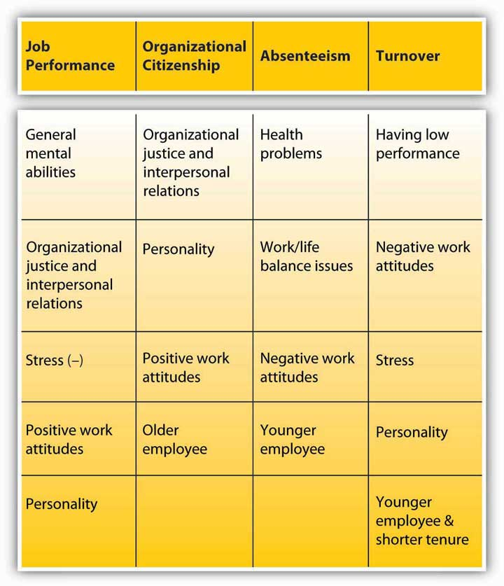

Job Performance
Job performance refers to the level to which an employee successfully fulfills the factors included in the job description. For each job, the content of job performance may differ. Measures of job performance include quality and quantity of work performed by the employee, the accuracy and speed with which the job is performed, and the overall effectiveness of the person on the job.
In many companies, job performance determines whether a person is promoted, rewarded with pay raises, given additional responsibilities, or fired from the job. Therefore, most employers observe and track job performance. This is done by keeping track of data on topics such as the number of sales the employee closes, the number of clients the employee visits, the number of defects found in the employee’s output, or the number of customer complaints or compliments received about the person’s work. In some jobs, objective performance data may not be available, and instead supervisor, coworker, customer, and subordinate assessments of the quality and quantity of work performed by the person become the indicators of job performance. Job performance is one of the main outcomes studied in organizational behavior and is an important variable managers must assess when they are engaged in the Controlling role.
What Are the Major Predictors of Job Performance?
Under which conditions do people perform well, and what are the characteristics of high performers? These questions receive a lot of research attention. It seems that the most powerful influence over our job performance is our general mental ability also known as cognitive ability or intelligence, and often abbreviated as “g.” General mental ability can be divided into several components—reasoning abilities, verbal and numerical skills, and analytical skills—and it seems to be important across different situations. It seems that “g” starts influencing us early in our school days because it is strongly correlated with measures of academic success even in childhood.
- Kuncel, N. R., Hezlett, S. A., & Ones, D. S. (2004). Academic performance, career potential, creativity, and job performance: Can one construct predict them all? Journal of Personality and Social Psychology, 86, 148–161
In adult life, “g” is also correlated with different measures of job performance.
- Bertua, C., Anderson, N., & Salgado, J. F. (2005). The predictive validity of cognitive ability tests: A UK meta-analysis. Journal of Occupational and Organizational Psychology, 78, 387–409

- Kuncel, N. R., Hezlett, S. A., & Ones, D. S. (2004). Academic performance, career potential, creativity, and job performance: Can one construct predict them all? Journal of Personality and Social Psychology, 86, 148–161

- Salgado, J. F., Anderson, N., Moscoso, S., Bertua, C., de Fruyt, F., & Rolland, J. P. (2003). A meta-analytic study of general mental ability validity for different occupations in the European Community. Journal of Applied Psychology, 88, 1068–1081

- Schmidt, F. L., & Hunter, J. (2004). General mental ability of the world of work: Occupational attainment and job performance. Journal of Personality and Social Psychology, 86 (1), 162–173

- Vinchur, A. J., Schippmann, J. S., Switzer, F. S., & Roth, P. L. (1998). A meta-analytic review of predictors of job performance for salespeople. Journal of Applied Psychology, 83, 586–597
It seems that the influence of “g” on performance is important across different settings, but there is also variation. In jobs with high complexity, it is much more critical to have high general mental abilities. Examples of such jobs are manager, sales representative, engineer, and professions such as law and medicine. In jobs such as police officer and clerical worker, the importance of “g” for high performance is still important but weaker.
Perceptions of organizational justice and interpersonal relationships are factors determining our performance level. When we feel that we are being fairly treated by the company, that our manager is supportive and rewards high performance, and when we trust the people we work with, we tend to perform better. Why? It seems that when we believe we are treated well, we want to reciprocate. Therefore, we treat the company well by performing our job more effectively.
The stress we experience on the job also determines our performance level. When we are stressed, our mental energies are drained. Instead of focusing on the task at hand, we start concentrating on the stressor trying to cope with it. Because our attention and energies are diverted to dealing with stress, our performance suffers. Having role ambiguity and experiencing conflicting role demands are related to lower performance.
- Gilboa, S., Shirom, A., Fried, Y., & Cooper, C. (2008). A meta-analysis of work demand stressors and job performance: Examining main and moderating effects. Personnel Psychology, 61, 227–271
Stress that prevents us from doing our jobs does not have to be related to our experiences at work. For example, according to a survey conducted by Workplace Options, 45% of the respondents said that financial stress affects work performance. When people are in debt, worrying about their mortgage payments or college payments of their kids, their performance will suffer.
- Anonymous. (2008, June). Financial stress: The latest worker risk. HR focus, 85(6), 12
Our work attitudes, particularly job satisfaction, are also correlates of job performance but not to as great a degree as you might expect. Many studies have been devoted to understanding whether happy employees are more productive. Some studies show weak correlations between satisfaction and performance while others show higher correlations (what researchers would call “medium sized” correlations of .30).
- Iaffaldano, M. T., & Muchinsky, P. M. (1985). Job satisfaction and job performance: A meta-analysis. Psychological Bulletin, 97, 251–273

- Judge, T. A., Thoresen, C. J., Bono, J. E., & Patton, G. T. (2001). The job satisfaction–job performance relationship: A qualitative and quantitative review. Journal of Applied Psychology, 127, 376–407

- Riketta, M. (2008). The causal relation between job attitudes and performance: A meta-analysis of panel studies. Journal of Applied Psychology, 93, 472–481
The correlation between commitment and performance tends to be even weaker.
- Mathieu, J. E., & Zajac, D. M. (1990). A review and meta-analysis of the antecedents, correlates, and consequences of organizational commitment. Psychological Bulletin, 108, 171–194

- Riketta, M. (2002). Attitudinal organizational commitment and job performance: A meta-analysis. Journal of Organizational Behavior, 23, 257–266

- Wright, T. A., & Bonnett, D. G. (2002). The moderating effects of employee tenure on the relation between organizational commitment and job performance: A meta-analysis. Journal of Applied Psychology, 87, 1183–1190
Even with a correlation of .30, though, the relationship may be lower than you may have expected. Why is this the case?
It seems that happy workers have an inclination to be more engaged at work. They may want to perform better. They may be more motivated. But there are also exceptions. Think about this: Because you want to perform, does this mean that you will actually perform better? Chances are your skill level in performing the job will matter. There are also some jobs where performance depends on factors beyond an employee’s control, such as the pace of the machine they are working on. Because of this reason, in professional jobs such as with engineers and researchers, we see a stronger link between work attitudes and performance, as opposed to manual jobs such as assembly-line workers.
- Riketta, M. (2002). Attitudinal organizational commitment and job performance: A meta-analysis. Journal of Organizational Behavior, 23, 257–266
Also, think about the alternative possibility: If you don’t like your job, does this mean that you will reduce your performance? Maybe up to a certain point, but there will be factors that prevent you from reducing your performance: such as the fear of getting fired, the desire to get a promotion so that you can get out of the job that you dislike so much, or your professional work ethic. As another example, among nurses, there seems to be a weak correlation between satisfaction and performance. Even when they are unhappy, nurses put a lot of effort into their work because they feel a moral obligation to help their patients. As a result, we should not expect a one-on-one relationship between satisfaction and performance. Still, the observed correlation between work attitudes and performance is important and has practical value.
Finally, job performance has a modest relationship with personality traits, particularly conscientiousness. People who are organized, reliable, dependable, and achievement-oriented seem to outperform others in various contexts.
- Barrick, M. R., & Mount, M. K. (1991). The big five personality dimensions and job performance: A meta-analysis. Personnel Psychology, 44, 1–26

- Dudley, N. M., Orvis, K. A., Lebiecki, J. E., & Cortina, J. M. (2006). A meta-analytic investigation of conscientiousness in the prediction of job performance: Examining the intercorrelations and the incremental validity of narrow traits. Journal of Applied Psychology, 91, 40–57

- Vinchur, A. J., Schippmann, J. S., Switzer, F. S., & Roth, P. L. (1998). A meta-analytic review of predictors of job performance for salespeople. Journal of Applied Psychology, 83, 586–597
Organizational Citizenship Behaviors
While job performance refers to the performance of duties listed in one’s job description, organizational citizenship behaviors involve performing behaviors that are more discretionary. Organizational citizenship behaviors (OCB) are voluntary behaviors employees perform to help others and benefit the organization. Helping a new coworker understand how things work in this company, volunteering to organize the company picnic, and providing suggestions to management about how to improve business processes are some examples of citizenship behaviors. These behaviors contribute to the smooth operation of business.
What are the major predictors of citizenship behaviors? Unlike performance, citizenship behaviors do not depend so much on one’s abilities. Job performance, to a large extent, depends on our general mental abilities. When you add the education, skills, knowledge, and abilities that are needed to perform well, the role of motivation on performance becomes more limited. As a result, just because someone is motivated will not mean that the person will perform well. For citizenship behaviors, in contrast, the motivation-behavior link is clearer. We help others around us if we feel motivated to do so, and managers, in the Leadership role, are responsible for motivating employees.
Perhaps the most important factor explaining our citizenship behaviors is organizational justice and interpersonal relationships. When we have a good relationship with our manager and we are supported by our manager, when we are treated fairly, when we are attached to our peers, when we trust the people around us, we are more likely to engage in citizenship behaviors. A high-quality relationship with people we work with will mean that simply doing our job will not be enough to maintain the relationship. In a high-quality relationship, we feel the obligation to reciprocate and go the extra mile to help them out.
- Cohen-Charash, Y., & Spector, P. E. (2001). The role of justice in organizations: A meta-analysis. Organizational Behavior and Human Decision Processes, 86, 278–321

- Colquitt, J. A., Conlon, D. E., Wesson, M. J., Porter, C. O. L. H., & Ng, K. Y. (2001). Justice at the millenium: A meta-analytic review of 25 years of organizational justice research. Journal of Applied Psychology, 86, 425–445

- Colquitt, J. A., Scott, B. A., & LePine, J. A. (2007). Trust, trustworthiness, and trust propensity: A meta-analytic test of their unique relationships with risk taking and job performance. Journal of Applied Psychology, 92, 909–927

- Fassina, N. E., Jones, D. A., & Uggerslev, K. L. (2008). Relationship clean-up time: Using meta-analysis and path analysis to clarify relationships among job satisfaction, perceived fairness, and citizenship behaviors. Journal of Management, 34, 161–188

- Hoffman, B. J., Blair, C. A., Meriac, J. P., & Woehr, D. J. (2007). Expanding the criterion domain? A quantitative review of the OCB literature. Journal of Applied Psychology, 92, 555–566

- Ilies, R., Nahrgang, J. D., & Morgeson, F. P. (2007). Leader-member exchange and citizenship behaviors: A meta-analysis. Journal of Applied Psychology, 92, 269–277

- Lepine, J. A., Erez, A., & Johnson, D. E. (2002). The nature and dimensionality of organizational citizenship behavior: A critical review and meta-analysis. Journal of Applied Psychology, 87, 52–65

- Organ, D. W., & Ryan, K. (1995). A meta-analytic review of attitudinal and dispositional predictors of organizational citizenship behavior. Personnel Psychology, 48, 775–802

- Podsakoff, P. M., MacKenzie, S. B., & Bommer, W. H. (1996). Meta-analysis of the relationships between Kerr and Jermier’s substitutes for leadership and employee job attitudes, role perceptions, and performance. Journal of Applied Psychology, 81, 380–399

- Riketta, M., & Van Dick, R. (2005). Foci of attachment in organizations: A meta-analytic comparison of the strength and correlates of workgroup versus organizational identification and commitment. Journal of Vocational Behavior, 67, 490–510
Our personality is yet another explanation for why we perform citizenship behaviors. Personality is a modest predictor of actual job performance but a much better predictor of citizenship. People who are conscientious, agreeable, and low on Neuroticism tend to perform citizenship behaviors more often than others.
- Borman, W. C., Penner, L. A., Allen, T. D., & Motowidlo, S. J. (2001). Personality predictors of citizenship performance. International Journal of Selection and Assessment, 9, 52–69

- Dalal, R. S. (2005). A meta-analysis of the relationship between organizational citizenship behavior and counterproductive work behavior. Journal of Applied Psychology, 90, 1241–1255

- Diefendorff, J. M., Brown, D. J., Kamin, A. M., & Lord, R. G. (2002). Examining the roles of job involvement and work centrality in predicting organizational citizenship behaviors and job performance. Journal of Organizational Behavior, 23, 93–108

- Organ, D. W., & Ryan, K. (1995). A meta-analytic review of attitudinal and dispositional predictors of organizational citizenship behavior. Personnel Psychology, 48, 775–802
Job attitudes are also moderately related to citizenship behaviors—more so than they are to job performance. People who are happier at work, those who are more committed to their companies, and those who have overall positive attitudes toward their work situation tend to perform citizenship behaviors more often than others. When people are unhappy, they tend to be disengaged from their jobs and rarely go beyond the minimum that is expected of them.
- Dalal, R. S. (2005). A meta-analysis of the relationship between organizational citizenship behavior and counterproductive work behavior. Journal of Applied Psychology, 90, 1241–1255

- Diefendorff, J. M., Brown, D. J., Kamin, A. M., & Lord, R. G. (2002). Examining the roles of job involvement and work centrality in predicting organizational citizenship behaviors and job performance. Journal of Organizational Behavior, 23, 93–108

- Fassina, N. E., Jones, D. A., & Uggerslev, K. L. (2008). Relationship clean-up time: Using meta-analysis and path analysis to clarify relationships among job satisfaction, perceived fairness, and citizenship behaviors. Journal of Management, 34, 161–188

- Hoffman, B. J., Blair, C. A., Meriac, J. P., & Woehr, D. J. (2007). Expanding the criterion domain? A quantitative review of the OCB literature. Journal of Applied Psychology, 92, 555–566

- Lepine, J. A., Erez, A., & Johnson, D. E. (2002). The nature and dimensionality of organizational citizenship behavior: A critical review and meta-analysis. Journal of Applied Psychology, 87, 52–65

- Organ, D. W., & Ryan, K. (1995). A meta-analytic review of attitudinal and dispositional predictors of organizational citizenship behavior. Personnel Psychology, 48, 775–802

- Riketta, M. (2002). Attitudinal organizational commitment and job performance: A meta-analysis. Journal of Organizational Behavior, 23, 257–266

- Riketta, M., & Van Dick, R. (2005). Foci of attachment in organizations: A meta-analytic comparison of the strength and correlates of workgroup versus organizational identification and commitment. Journal of Vocational Behavior, 67, 490–510
Interestingly, age seems to be related to the frequency with which we demonstrate citizenship behaviors. People who are older are better citizens. It is possible that with age we gain more experiences to share. It becomes easier to help others because we have more accumulated company and life experiences to draw from.
- Ng, T. W. H., & Feldman, D. C. (2008). The relationship of age to ten dimensions of job performance. Journal of Applied Psychology, 93, 392–423
Absenteeism
Absenteeism refers to Unscheduled absences from work. Such absences are costly to companies because of their unpredictable nature, affecting a manager’s ability to Control the firm’s or department’s budget. When an employee has an unscheduled absence from work, companies struggle to find replacement workers at the last minute. This may involve hiring contingent workers, having other employees work overtime, or scrambling to cover for an absent coworker. The cost of absenteeism to organizations is estimated at $74 billion. According to a Mercer Human Resource consulting study, 15% of the money spent on payroll is related to absenteeism.
- Conlin, M. (2007, November 12). Shirking working: The war on hooky. Business Week, 4058, 72–75

- Gale, S. F. (2003, September). Sickened by the cost of absenteeism, companies look for solutions. Workforce Management, 82 (9), 72–75
What causes absenteeism? First, we need to look at the type of absenteeism. Some absenteeism is unavoidable and is related to health reasons. For example, reasons such as acute or serious illness, lower back pain, migraines, accidents one may have on or off the job, or acute stress are important reasons for absenteeism.
- Farrell, D., & Stamm, C. L. (1988). Meta-analysis of the correlates of employee absence. Human Relations, 41, 211–227

- Martocchio, J. J., Harrison, D. A., & Berkson, H. (2000). Connections between lower back pain, interventions, and absence from work: A time-based meta-analysis. Personnel Psychology, 53, 595–624
Health-related absenteeism is costly, but it would be unreasonable and unfair to institute organizational policies penalizing it. When an employee has a contagious illness, showing up at work will infect coworkers and will not be productive. If the illness is not contagious, it is still in the organization’s best interest for the employee to receive proper medical treatment and rest to promote a full recovery. Indeed, companies are finding that programs aimed at keeping workers healthy are effective in dealing with this type of absenteeism. Companies using wellness programs, educating employees about proper nutrition, helping them exercise, and rewarding them for healthy habits have reported reduced absenteeism.
- Parks, K. M., & Steelman, L. A. (2008). Organizational wellness programs: A meta-analysis. Journal of Occupational and Organizational Psychology, 13, 58–68
Work/life balance is another common reason for absences. Staying home to care for a sick family member, attending the wedding or funeral of a loved one, and skipping work to study for an exam are all common reasons for unscheduled absences. Companies may deal with these by giving employees more flexibility in work hours. If employees can manage their own time, they are less likely to be absent. Conversely, when a company has “sick leave” but no other leave for social and family obligations, they may fake being sick and use their “sick leave.” One solution is to have a single paid time off policy that would allow workers to balance work and life and allow companies to avoid unscheduled absences. Organizations such as Lahey Clinic at Burlington, Massachusetts, have found this to be effective in dealing with unscheduled absences. Some companies such as IBM got rid of sick leave altogether and instead allow employees to take as much time off as they need, so long as the work gets done.
- Cole, C. L. (2002, September). Sick of absenteeism? Get rid of sick days. Workforce, 81(9), 56–61

- Conlin, M. (2007, November 12). Shirking working: The war on hooky. Business Week, 4058, 72–75

- Baltes, B. B., Briggs, T. E., Huff, J. W., Wright, J. A., & Neuman, G. A. (1999). Flexible and compressed workweek schedules: A meta-analysis of their effects on work-related criteria. Journal of Applied Psychology, 84, 496–513
Sometimes, absenteeism is a form of work withdrawal and a step followed by turnover. In other words, poor work attitudes lead to absenteeism. When employees are dissatisfied with their work or have low organizational commitment, they are likely to be absent more often. Thus, absenteeism is caused by the desire to avoid an unpleasant work environment. In this case, management may deal with absenteeism by investigating the causes of dissatisfaction and dealing with them.
Are there personal factors contributing to absenteeism? Research does not reveal a consistent link between personality and absenteeism, but there is one demographic criterion that predicts absenteeism: age. Interestingly, and against some stereotypes that increased age would bring more health problems, research shows that age is negatively related to both frequency and duration of absenteeism. That is, younger workers are the ones more likely to be absent. Because of reasons that include higher loyalty to their company and a stronger work ethic, older employees are less likely be absent from work.
- Martocchio, J. J. (1989). Age-related differences in employee absenteeism: A meta-analysis. Psychology and Aging, 4, 409–414

- Ng, T. W. H., & Feldman, D. C. (2008). The relationship of age to ten dimensions of job performance. Journal of Applied Psychology, 93, 392–423
Turnover
Turnover refers to an employee’s leaving an organization. Employee turnover has potentially harmful consequences, such as poor customer service and poor company-wide performance. When employees leave, their jobs still need to be performed by someone, so companies spend time recruiting, hiring, and training new employees, all the while suffering from lower productivity. Yet, not all turnover is bad. Turnover is particularly a problem when high-performing employees leave, while a poor performer’s leaving may actually give the company a chance to improve productivity and morale.
Why do employees leave? An employee’s performance level is an important reason. People who perform poorly are actually more likely to leave. These people may be fired, may be encouraged to quit, or may quit because of their fear of being fired. Particularly if a company has pay-for-performance systems, poor performers will find that they are not earning much due to their below-standard performance. This gives poor performers an extra incentive to leave. This does not mean that high performers will definitely stay with a company. High performers may find it easier to find alternative jobs, so when they are unhappy, they can leave more quickly.
Work attitudes are often the primary culprit in why people leave. When workers are unhappy at work, and when they do not feel committed to their companies, they are more likely to leave. Loving the things you do, being happy with the opportunities for advancement within the company, being happy about pay are all aspects of our work attitudes relating to turnover. Of course, the link between work attitudes and turnover is not direct. When employees are unhappy, they will have the intention to leave and may start looking for a job. But their ability to actually leave will depend on many factors, such as their employability and the condition of the job market. For this reason, when national and regional unemployment is high, many people who are unhappy will still continue to work for their current company. When the economy is doing well, people will start moving to other companies in response to being unhappy. Understanding the connection between employee happiness and turnover, many companies make an effort to make employees happy. SAS Institute employees have a 35-hour workweek and enjoy amenities such as a swimming pool and child care at work. The company’s turnover is around 4%–5%, in comparison to the industry averages ranging from 12%–20%.
- Carsten, J. M., & Spector, P. E. (1987). Unemployment, job satisfaction, and employee turnover: A meta-analytic test of the Muchinsky model. Journal of Applied Psychology, 72, 374–381

- Cohen, A. (1991). Career stage as a moderator of the relationships between organizational commitment and its outcomes: A meta-analysis. Journal of Occupational Psychology, 64, 253–268

- Cohen, A. (1993). Organizational commitment and turnover: A meta-analysis. Academy of Management Journal, 36, 1140–1157

- Cohen, A., & Hudecek, N. (1993). Organizational commitment—turnover relationship across occupational groups: A meta-analysis. Group & Organization Management, 18, 188–213

- Griffeth, R. W., Hom, P. W., & Gaertner, S. (2000). A meta-analysis of antecedents and correlates of employee turnover: Update, moderator tests, and research implications for the next millennium. Journal of Management, 26, 463–488

- Hom, P. W., Caranikas-Walker, F., Prussia, G. E., & Griffeth, R. W. (1992). A meta-analytical structural equations analysis of a model of employee turnover. Journal of Applied Psychology, 77, 890–909

- Karlgaard, R. (2006, October 16). Who wants to be public? Forbes Asia, 2(17), 22; Meyer, J. P., Stanley, D. J., Herscivitch, L., & Topolnytsky, L. (2002). Affective, continuance, and normative commitment to the organization: A meta-analysis of antecedents, correlates, and consequences. Journal of Vocational Behavior, 61, 20–52

- Steel, R. P., & Ovalle, N. K. (1984). A review and meta-analysis of research on the relationship between behavioral intentions and employee turnover. Journal of Applied Psychology, 69, 673–686

- Tett, R. P., & Meyer, J. P. (1993). Job satisfaction, organizational commitment, turnover intentions, and turnover: Path analyses based on meta-analytic findings. Personnel Psychology, 46, 259–293
People are more likely to quit their jobs if they experience stress at work as well. Stressors such as role conflict and role ambiguity drain energy and motivate people to seek alternatives. For example, call center employees experience a great deal of stress because of poor treatment from customers, long work hours, and constant monitoring of their every action. Companies such as EchoStar realize that one method that is effective in retaining their best employees is to give them opportunities to move to higher-responsibility jobs elsewhere in the company. When a stressful job is a step toward a more desirable job, employees seem to stick around longer.
- Badal, J. (2006, July 24). “Career path” programs help retain workers. Wall Street Journal, B1

- Griffeth, R. W., Hom, P. W., & Gaertner, S. (2000). A meta-analysis of antecedents and correlates of employee turnover: Update, moderator tests, and research implications for the next millennium. Journal of Management, 26, 463–488

- Podsakoff, N. P., LePine, J. A., & LePine, M. A. (2007). Differential challenge stressor-hindrance stressor relationships with job attitudes, turnover intentions, turnover, and withdrawal behavior: A meta-analysis. Journal of Applied Psychology, 92, 438–454
There are also individual differences in whether people leave or stay. For example, personality is a factor in the decision to quit one’s job. People who are conscientious, agreeable, and emotionally stable are less likely to quit their jobs. Many explanations are possible. People with these personality traits may perform better at work, which leads to lower quit rates. Or, they may have better relations with coworkers and managers, which is a factor in their retention. Whatever the reason, it seems that some people are likely to stay longer at any given job regardless of the circumstances.
- Salgado, J. F. (2002). The big five personality dimensions and counterproductive behaviors. International Journal of Selection and Assessment, 10, 117–125

- Zimmerman, R. D. (2008). Understanding the impact of personality traits on individuals’ turnover decisions: A meta-analytic path model. Personnel Psychology, 61, 309–348
Whether we leave a job or stay also depends on our age and how long we have been there. It seems that younger employees are more likely to leave. This is not surprising because people who are younger often have fewer responsibilities such as supporting a household or having dependents. As a result, they can quit a job they don’t like much more easily. They may also have higher expectations and thus be more easily disappointed when a job proves to be less rewarding than they had imagined. Similarly, people who have been with a company for a short period of time can quit more easily. For example, Sprint Nextel found that many of their new hires were likely to quit within 45 days of their hiring dates. When they investigated, they found that newly hired employees were experiencing a lot of stress from avoidable problems such as unclear job descriptions or problems with hooking up their computers. Sprint was able to solve the turnover problem by paying special attention to orienting new hires. New employees experience a lot of stress at work, and there is usually not much keeping them in the company such as established bonds to a manager or colleagues. New employees may even have ongoing job interviews with other companies when they start working. This, too, gives them the flexibility to leave more easily.

KEY TAKEAWAY
Employees demonstrate a wide variety of positive and negative behaviors at work. Among these, four are critically important and have been extensively studied in the OB literature. Job performance is the degree of success with which one accomplishes the tasks listed in one’s job description. A person’s abilities, particularly general mental ability, are the main predictor of job performance in many occupations. How we are treated at work, the level of stress experienced at work, work attitudes, and, to a lesser extent, our personality are also factors relating to one’s job performance. Citizenship behaviors are tasks helpful to the organization that go above and beyond one’s job description. Performance of citizenship behaviors are less a function of our abilities and more of motivation. How we are treated at work, personality, work attitudes, and our age are the main predictors of citizenship. Among negative behaviors employees demonstrate, absenteeism and turnover are critically important. People who experience health problems and work/life balance issues are prone to more absenteeism. Poor work attitudes are also related to absenteeism, and younger employees are more likely to be absent from work, especially when dissatisfied. Turnover is higher among low performers, people who have negative work attitudes, and those who experience a great deal of stress. Personality and being younger are personal predictors of turnover.

EXERCISES
1. What is the difference between performance and organizational citizenship behaviors? As a manager, how would you improve someone’s performance? How would you increase citizenship behaviors?

2. Are citizenship behaviors always beneficial to the company? Can you think of any citizenship behaviors employees may perform with the intention of helping a company but that may have negative consequences overall?

3. Given the factors correlated with job performance, which employee selection methods should be better at identifying future high performers?

4. What are the major causes of absenteeism at work? How can companies minimize the level of absenteeism that takes place?

5. In some companies, managers are rewarded for minimizing the turnover within their department or branch. A part of their bonus is directly tied to keeping the level of turnover below a minimum. What do you think about the potential effectiveness of these programs? Do you see any downsides to such programs?
2.7 Developing Your Positive Attitude Skills
LEARNING OBJECTIVES
- Learn to be happier at work.

- Leverage your attitudes for optimum work performance. Have you ever wondered how you could be happier at work and how greater work satisfaction could improve your overall effectiveness? Here are some ideas that may help you achieve a great sense of peace for yourself as well as when you are working with a negative coworker.

- Leverage your Big Five traits. Your personality is a big part of your happiness. Which of the Big Five positive traits are you strongest on? Be aware of them and look for opportunities to express them at work. Are you high on Neuroticism? If so, work to overcome this challenge: If you choose to find the negative side of everything, you will.

- Find a job and company that fit you well. Good fit with the job and company are important to your happiness. This starts with knowing yourself, your chosen career, and the particular job in question: What do you want from the job? What do you enjoy doing?

- Get accurate information about the job and the company. Ask detailed questions about what life is like in this company. Do your research. Read about the company; use your social network to understand the company’s culture.

- Develop good relationships at work. Make friends. Try to get a mentor if your company does not have a formal mentoring program. Approach a person you admire and attempt to build a relationship with this person. An experienced mentor can be a great help in navigating life at a company. Your social network can help you weather the bad days and provide you with emotional and instrumental support during your time at a company as well as afterward.

- Pay is important, but job characteristics matter more to your job satisfaction. So don’t sacrifice the job itself for a bit more money. When choosing a job, look at the level of challenge and the potential of the job to make you feel engaged.

- Be proactive in managing organizational life. If the job is stressful, cope with it by effective time management and having a good social network, as well as being proactive in getting to the source of stress. If you don’t have enough direction, ask for it!

- Know when to leave. If the job makes you unhappy over an extended period of time and there is little hope of solving the problems, it may be time to look elsewhere.

KEY TAKEAWAY
Promoting a positive work attitude will increase your overall effectiveness as a manager. You can increase your own happiness at work by knowing yourself as a person, by ensuring that you work at a job and company where you fit in, and by building effective work relationships with your manager, coworkers, and subordinates. Concentrating on the motivating potential of the job when choosing a job and solving the problems you encounter in a proactive manner may be helpful as well.

EXERCISES
- Do you believe that your own happiness at work is in your hands? What have you done in the past to increase your own satisfaction with work?

- Consider the most negative person you work or interact with. Why do you think they focus more on the negative side of life?

- On the basis of what you have read in this chapter, can you think of ways in which you can improve your effectiveness in dealing with negative coworkers?

Chapter 3
History, Globalization, and Values-Based Leadership
WHAT’S IN IT FOR ME?
Reading this chapter will help you do the following:

- Learn about the history of principles of management.

- Know the context for contemporary principles of management.

- Understand key global trends.

- See how globalization is affecting management principles and practices.

- Appreciate the importance of value-based leadership (ethics) in management.
The planning-organizing-leading-controlling (P-O-L-C) framework is summarized in the following figure. In this chapter, you’ll learn that some principles of management are enduring, but you’ll also see that managers need to be continually adapting to changing times. Each facet of the framework—from planning, to organizing, to leading, to controlling—has to be adapted to take advantage of, and to manage in, our changing world. Global trends affect both the style and the substance of management. As the world becomes more global, managers find themselves leading workforces that may be distributed across the country—and the world. Workers are more educated, but more is expected of them.
Figure 3.2 The P-O-L-C Framework

The realm of managers is expanding. As a leader, you’ll be a role model in the organization, setting the tone not just for what gets done but how it gets done. Increasingly, good business practice extends to stewardship, not just of the organization but of the environment and community at large. Ethics and values-based leadership aren’t just good ideas—they’re vital to attracting talent and retaining loyal customers and business partners.
3.1 Case in Point: Hanna Andersson Corporation Changes for Good
Figure 3.3
Source: Used by permission from Hanna Andersson Corporation.
Born from a desire to bring quality European-style children’s clothing to the United States, Hanna Andersson Corporation has sold colorful clothing and accessories since 1983. Husband and wife cofounders, Tom and Gun (pronounced “gōōn”) Denhart, started the Portland, Oregon–based company by distributing imported Swedish clothing from their home. Named for Gun’s Swedish grandmother, the company now boasts over $100 million in annual sales and employs over 500 people. Growing from an exclusive mail-order catalog business in the early 1980s, today Hanna Andersson also distributes products online, in 29 retail stores nationwide, and through select specialty retailers.
Over the years, Hanna Andersson has shown that it deeply values its employees. The company provides supplemental child-care reimbursement to all employees—even part-time sales associates. Additional employee benefits include part-time and flexible work hours, considerable paid time off, and 8 hours per year of paid time for employees to volunteer in the community. More important, though, employees feel like they are part of the Hanna Andersson family. In fact, in the beginning many of the employees were friends and family members of the Denharts.
It was important to the Denharts that they were involved in the decisions of the company and that those decisions took quality of life issues into account. Gun states, “If you can create balance among your work, your community, your family, and your friends, then you’re going to be more satisfied.” Examples of this philosophy infusing Hanna Andersson include the establishment of HannaDowns, a clothing recycling program where customers can return used clothing and receive a 20% off coupon for their next purchase. The charitable nature of Hanna Andersson has continued through what is now the HannaHelps program. This program awards grants and donates products to schools and nonprofit groups, helping children in the community and around the world. In addition, under Gun’s leadership Hanna Andersson established ongoing donations, 5% of pretax profits, to charities that benefit women and children.
The considerable growth and development the business experienced did not come without its challenges and necessary organizational change. In the 1990s and early 2000s, increased competition from other retailers and the introduction of online commerce posed some challenges for Hanna Andersson. The Denharts found themselves without a solid growth plan for the future. They worried that they might have lost sight of market forces. Change was necessary if Hanna Andersson was to remain viable.
Realizing the need for help and direction, the Denharts promoted from within the company to help initiate change and strategic growth, and in 1995, Phil Iosca took the strategic lead as CEO. Hanna Andersson was then sold to a private equity firm in 2001 and has since changed ownership several times, leading to a new business direction for the company. After selling the business, Gun remained on the Hanna board of directors until 2007. She also served as chair of the Hanna Andersson Children’s Foundation from 2001 to 2006. She still partners with the company from time to time on charitable events in the community.
Under Iosca’s steady leadership, the company opened several retail stores throughout the country in 2002 and established online commerce. In 2009, Hanna Andersson began distributing merchandise wholesale through retail partners such as Nordstrom and Costco. The implementation of each of these new distribution avenues required a great deal of change within the company. HR Vice President Gretchen Peterson explains, “The growth of the retail business required the greatest shift in our internal processes from both technical systems, to inventory planning and buying to distribution processes to our organizational communication and HR processes (recruitment, compensation, etc.), as well as our marketing communication programs.” Tenured employees throughout the company found themselves in unfamiliar territory, unsure of the company’s future as the board and owners debated the risks and rewards of retail expansion. Fortunately, the changes were mostly offset by a consistent leadership team. Petersen, who has been with the company since 1994, explains, “From 1995 to 2010, we retained the same CEO (Iosca) and therefore, the face of the company and the management style did not fluctuate greatly.”
When Iosca retired in early 2010, chief operating officer Adam Stone took over as CEO. He helped his company weather yet another transition with a calm push for changes within the company. To help understand different points of view at Hanna Andersson, Stone often sat in on inventory and operational planning meetings. Step by step, Stone was able to break down work initiatives so the continuing changes were not so overwhelming to the company and its valued employees. Over time, his and other company leaders’ presence has helped employees make better, more strategic decisions. Rather than resisting change, they now feel heard and understood.
The decision to sell wholesale turned out to be a good one, as it has enabled the company to weather the recession’s negative effect on retail and online purchases. Accounting for approximately 10% of total sales, the company’s wholesale business is expected to boost yearly revenue by 5%. With more conscientious inventory purchases and strategic distribution initiatives, Hanna Andersson has realized a higher sales volume, lower inventory at year-end, and less liquidation. Through it all, company management has done an effective job at interpreting the desired growth goals of its owners while inspiring change within the company. With continued clear communication, direction, and willingness to try new techniques, Hanna Andersson is poised for growth and success in the future while not forgetting to take care of its employees.
Primary Resource:
Secondary Resources:
- D. (1996). Aiming higher: 25 stories of how companies prosper by combining sound management and social vision (pp. 23–35). New York: The Business Enterprise Trust; Boulé, M. (2009, July 16).

- “Hanna Andersson employee can’t say enough of a thank-you to co-workers who helped her through cancer.” Oregonian. Retrieved March 4, 2010, from http://www.oregonlive.com/news/oregonian/margie_boule/index.ssf/2009/07/hanna_andersson_employee_cant.html

- Information retrieved February 28, 2010, from the Hanna Andersson Web site: http://www.hannaandersson.com

- Muoio, A. (1998, November 30). Giving back. Fast Company. Retrieved March 1, 2010, from http://www.fastcompany.com/magazine/20/one.html?page=0%2C1

- Goldfield, R. (2002, June 14). Hanna sees bricks-and-mortar future. Portland Business Journal; Peterson, G. (2010, March 5 and April 5). Personal communication; Information retrieved March 1, 2010, from http://www.answers.com/topic/hanna-andersson

- Raphel, M., & Raphel, N. (1995). Up the loyalty ladder (pp. 83–90). New York: HarperCollins.

DISCUSSION QUESTIONS
- How has Hanna Andersson applied values-based leadership in terms of the organization’s choices related to P-O-L-C?

- How did company leaders like Iosca, Petersen, and Stone help facilitate change within the company? Did they remain consistent with the values of the founders?

- What were the reasons for organizational change within Hanna Andersson, both internally and externally?

- What unique challenges do family-owned and -operated businesses face?

- How did the mission of Hanna Andersson evolve over time?

3.2 Ancient History: Management Through the 1990s
LEARNING OBJECTIVES
- Early motivation for development of principles.
- What problems did these principles solve?
- What were the limitations of these early views?
Early Management Principles
Early management principles were born of necessity. The most influential of these early principles were set forth by Henri Fayol a French mining engineer. In 1888, Fayol became director of a mining company. The company was in difficulty, but Fayol was able to turn it around and make the company profitable again. When he retired, Fayol wrote down what he’d done to save the company. He helped develop an “administrative science” and developed principles that he thought all organizations should follow if they were to run properly.
Fayol’s 14 Principles of Management
- Specialization/Division of Labor – By specializing in a limited set of activities, workers become more efficient and increase their output.

- Authority/Responsibility – Managers must have the authority to issue commands, but with that authority comes the responsibility to ensure that the work gets done.

- Discipline – Workers must obey orders if the business is to run smoothly. But good discipline is the result of effective leadership: workers must understand the rules and management should use penalties judiciously if workers violate the rules.

- Unity of Command – An employee should receive orders only from one boss to avoid conflicting instructions.

- Unity of Direction – Each unit or group has only one boss and follows one plan so that work is coordinated.

- Subordination of Individual Interest – The interests of one person should never take precedence over what is best for the company as a whole.

- Remuneration – Workers must be fairly paid for their services.

- Centralization – Centralization refers to decision making: specifically, whether decisions are centralized (made by management) or decentralized (made by employees). Fayol believed that whether a company should centralize or decentralize its decision making depended on the company’s situation and the quality of its workers.

- Line of Authority – The line of authority moves from top management down to the lowest ranks. This hierarchy is necessary for unity of command, but communication can also occur laterally if the bosses are kept aware of it. The line should not be overextended or have too many levels.

- Order – Orderliness refers both to the environment and materials as well as to the policies and rules. People and materials should be in the right place at the right time.

- Equity – Fairness (equity), dignity, and respect should pervade the organization. Bosses must treat employees well, with a “combination of kindliness and justice.”

- Stability of Tenure – Organizations do best when tenure is high (i.e., turnover is low). People need time to learn their jobs, and stability promotes loyalty. High employee turnover is inefficient.
- Initiative – Allowing everyone in the organization the right to create plans and carry them out will make them more enthusiastic and will encourage them to work harder.

- Esprit de Corps – Harmony and team spirit across the organization builds morale and unity.
Time and Motion
Frederick Winslow Taylor, a contemporary of Fayol’s, formalized the principles of scientific management in his 1911 book, The Principles of Scientific Management. Taylor described how productivity could be greatly improved by applying the scientific method to management; for this reason, the scientific approach is sometimes referred to as Taylorism.
Taylor is most famous for his “time studies,” in which he used a stopwatch to time how long it took a worker to perform a task, such as shoveling coal or moving heavy loads. Then he experimented with different ways to do the tasks to save time. Sometimes the improvement came from better tools. For example, Taylor devised the “science of shoveling,” in which he conducted time studies to determine how much weight a worker could lift with a shovel without tiring. He determined that 21 pounds was the optimal weight. But since the employer expected each worker to bring his own shovel, and there were different materials to be shoveled on the job, it was hard to ensure that 21-pound optimum. So, Taylor provided workers with the optimal shovel for each density of materials, like coal, dirt, snow, and so on. With these optimal shovels, workers became three or four times more productive, and they were rewarded with pay increases.
Frank Gilbreth and Lillian Moller Gilbreth, his wife (who outlived Frank by 48 years!), were associates of Taylor and were likewise interested in standardization of work to improve productivity. Retrieved January 28, 2009, from http://en.wikipedia.org/wiki/Cheaper_by_the_Dozen. Cheaper by the Dozen was made into a 1950 motion picture starring Clifton Webb and Myrna Loy as Frank and Lillian Gilbreth. They went one better on Taylor’s time studies, devising “motion studies” by photographing the individual movements of each worker (they attached lights to workers’ hands and photographed their motions at slow speeds). The Gilbreths then carefully analyzed the motions and removed unnecessary ones. These motion studies were preceded by timing each task, so the studies were called “time and motion studies.”
Applying time and motion studies to bricklaying, for example, the Gilbreths devised a way for workers to lay bricks that eliminated wasted motion and raised their productivity from 1,000 bricks per day to 2,700 bricks per day. Frank Gilbreth applied the same technique to personal tasks, like coming up with “the best way to get dressed in the morning.” He suggested the best way to button the waistcoat, for example, was from bottom up rather than top down. Why? Because then a man could straighten his tie in the same motion, rather than having to raise his hands back up from the bottom of the waistcoat.
Limitations of the Early Views
Fayol, Taylor, and the Gilbreths all addressed productivity improvement and how to run an organization smoothly. But those views presumed that managers were overseeing manual labor tasks. As work began to require less manual labor and more knowledge work, the principles they had developed became less effective. Worse, the principles of Taylorism tended to dehumanize workers. The writer Upton Sinclair who raised awareness of deplorable working conditions in the meatpacking industry in his 1906 book, The Jungle, was one of Taylor’s vocal critics. Sinclair pointed out the relatively small increase in pay (61%) that workers received compared with their increased productivity (362%). Frederick Taylor answered Sinclair’s criticism, saying that workers should not get the full benefit because it was management that devised and taught the workers to produce more. But Taylor’s own words compare workers to beasts of burden: The worker is “not an extraordinary man difficult to find; he is merely a man more or less the type of an ox, heavy both mentally and physically.”
- Sinclair, U. (1911, June). A criticism. American Magazine, 243–244

- Taylor, F. W. (June 1911). An answer to the criticism. American Magazine, 243–244 Retrieved January 28, 2009, from http://stevens.cdmhost.com/cdm4/document.php?CISOROOT=/p4100coll1&CISOPTR=244&REC=14&CISOSHOW=242
When work was manual, it made sense for a manager to observe workers doing a task and to devise the most efficient motions and tools to do that task. As we moved from a manufacturing society to a service-based one, that kind of analysis had less relevance. Managers can’t see inside the head of a software engineer to devise the fastest way to write code. Effective software programming depends on knowledge work, not typing speed.
Likewise, a services-based economy requires interactions between employees and customers. Employees have to be able to improvise, and they have to be motivated and happy if they are to serve the customer in a friendly way. Therefore, new management theories were developed to address the new world of management and overcome the shortcomings of the early views.
Finally, early views of management were heavily oriented toward efficiency, at the expense of attention to the manager-as-leader. That is, a manager basically directs resources to complete predetermined goals or projects. For example, a manager may engage in hiring, training, and scheduling employees to accomplish work in the most efficient and cost-effective manner possible. A manager is considered a failure if he or she is not able to complete the project or goals with efficiency or when the cost becomes too high. However, a leader within a company develops individuals to complete predetermined goals and projects. A leader develops relationships with his or her employees by building communication, by evoking images of success, and by eliciting loyalty. Thus, later views of management evoke notions of leaders and leadership in discussing the challenges and opportunities for modern managers.
Management Ideas of the 1990s
Peter Drucker was the first scholar to write about how to manage knowledge workers, with his earliest work appearing in 1969. Drucker addressed topics like management of professionals, the discipline of entrepreneurship and innovation, and how people make decisions. In 1982, Tom Peters and Robert Waterman wrote In Search of Excellence, which became an international best seller and ushered a business revolution by changing the way managers viewed their relationships with employees and customers. On the basis of the authors’ research focusing on 43 of America’s most successful companies in six major industries, the book introduced nine principles of management that are embodied in excellent organizations:
- Managing Ambiguity and Paradox – The ability of managers to hold two opposing ideas in mind at the same time and still be able to function effectively.

- A Bias for Action – A culture of impatience with lethargy and inertia that otherwise leaves organizations unresponsive.

- Close to the Customer – Staying close to the customer to understand and anticipate customer needs and wants.

- Autonomy and Entrepreneurship – Actions that foster innovation and nurture customer and product champions.

- Productivity through People – Treating rank-and-file employees as a source of quality.

- Hands-On, Value-Driven – A management philosophy that guides everyday practice and shows management’s commitment.

- Stick to the Knitting – Stay with what you do well and the businesses you know best.

- Simple Form, Lean Staff – The best companies have very minimal, lean headquarters staff.

- Simultaneous – Loose-Tight Properties

- Peters, T. J., & Waterman, R. H. (1982). In Search of Excellence. New York: Knopf. Autonomy in shop-floor activities plus centralized values.
Following up, Peters wrote a Passion for Excellence, which placed further emphasis on leadership, innovation, and valuing people. His book Thriving on Chaos, published the day of the biggest stock market crash of the time (“Black Monday,” October 19, 1987), addressed the uncertainty of the times; and Liberation Management, published in 1992, laid out 45 prescriptions for how to lead companies in a rapidly changing world. The book called for empowering people by involving everyone in decision making and eliminating bureaucratic rules and humiliating conditions. Peters urged organizational leaders (i.e., managers) to celebrate and recognize employees for their contributions. His advice to leaders was to “master paradox” (i.e., develop a level of comfort with complexity and ambiguity) and establish direction for the company by developing an inspiring vision and leading by example.
Beginning in the 1970s, Warren Bennis pioneered a new theory of leadership that addressed the need for leaders to have vision and to communicate that vision. More than just a manager, an effective leader was defined as someone with the ability to influence and motivate others not only to perform work tasks but also to support the organization’s values and meet the organization’s goals. Different views of leadership through the ages are shown next.
Views of Leadership Through the Ages
“A leader is a dealer in hope.”
—Napoleon
“I suppose that leadership at one time meant muscle; but today it means getting along with people.”
—Indira Gandhi
“What leaders really do: set direction, align people, and motivate people.”
—John Kotter

KEY TAKEAWAY
Early management theorists developed principles for managing organizations that suited the times. A century ago, few workers were highly educated; most work was manual, tasks were repetitive, and rates of change were slow. Hierarchy brought unity and control, and principles of management in which managers defined tasks and coordinated workers to move in a unified direction made sense. As the economy moved from manufacturing to services, the need for engaging workers’ minds and hearts became more important. Drucker, Peters, and Waterman presented ideas on how managers could achieve excellence in a continually changing business environment, while Bennis encouraged managers to become inspiring leaders who empowered people.

EXERCISES
- What goals seem to dominate early management principles?

- Do you see any commonalities between Fayol’s principles of management from 1911 and those of Tom Peters in the 1990s?

- Are there any jobs today for which time and motion studies would make sense to do? Would any other skills need to be taught as well?

- What do early management principles leave out?

- How would you put some of the ideas of the 1990s into practice?

- What aspects of P-O-L-C would be most likely to change based on what you have learned in this section?
3.3 Contemporary Principles of Management
LEARNING OBJECTIVES
- Recognize organizations as social movements.
- Understand the benefits of social networking.
- Recognize learning organizations.
- Understand virtual organizations.
Corporations as Social Movements
Traditionally, we’ve thought of corporations as organizations that had clear boundaries, formal procedures, and well-defined authority structures. In contrast, social movements are seen as more spontaneous and fluid. The term social movement refers to a type of group action that is focused on specific political or social issues; examples include the civil rights movement, the feminist movement, and the gay rights movement. Leaders of social movements depend on charisma rather than authority to motivate participants to action. Contemporary management theory, however, is showing that the lines between the two are blurring: corporations are becoming more like social movements, and social movements are taking on more permanence. Just as companies are outsourcing specific jobs, so social movements can contract out tasks like lobbying and fundraising.
Corporations can implement initiatives that mimic a social movement. Consider how the CEO of one bank described a program he introduced: “The hierarchical management structure will give way to some collective activities that will improve our effectiveness in the marketplace. Decisions won’t flow from a management level to people on the line who are expected to implement those decisions.…We’re telling everyone, choose a process, figure out what and where the problems are, work together to come up with solutions, and then put your solutions to work.”
- Davis, G. F., McAdam, D., Scott, W. R., & Zald, M. N. (Eds.). (2005). Social Movements and Organization Theory. Cambridge Studies in Contentious Politics. Cambridge, UK: Cambridge University Press, 283
Thus, more and more leading businesses are harnessing the mechanics of social movements to improve how they will manage their businesses in the future.
Social Networking
Social networking refers to systems that allow members of a specific site to learn about other members’ skills, talents, knowledge, or preferences. Companies use these systems internally to help identify experts.
In the world, at large, social networks are groups of individuals who share a common interest or passion. Poker players, dog lovers, and high school alumni are a few examples of social networks in action. In the corporate world, a social network is made up of individuals who share an employer and, potentially, other interests as well. But in the pre-Internet age, managers lacked the tools to recognize or tap the business value of in-house social networks. The company softball team was a social network, sure. But what did that have to do with the bottom line?
Today, social networks are starting points for corporate innovation: potentially limitless arrangements of individuals inspired by opportunities, affinities, or tasks. People feel better and work better when they belong to a group of other people like themselves.
- Rummler, L. (2007, July). Corporate social networking updates definition of women’s groups. Retrieved January 28, 2009, from http://www.talentmgt.com/newsletters/recruitment_perspectives/2007/July/380/index.php
This new attitude toward social networks in the workplace has been fueled by the growth of social networking sites like Facebook.
Facebook was started by then-college student Mark Zuckerberg in 2004 as a way of connecting a social network—specifically, university students. Since then, Facebook has changed the way organizations connect as well. Some companies maintain a physical presence on Facebook that allows consumers to chime in about their passions (or lack of them) for corporate offerings, news, and products. Starbucks has adopted this model, asking consumers to help them revive their product lines and image.
As Zuckerberg told the Wall Street Journal, “We just want to share information more efficiently.”
- Vara, V. (2007, May 21). Facebook opens its pages as a way to fuel growth. Wall Street Journal. Retrieved January 28, 2009, from http://online.wsj.com/public/article/SB117971397890009177-wjdKPmjAqS_9ZZbwiRp_CoSqvwQ_20070620.html
And, in the information age, that’s what social networks do best. Companies are applying the online social networking model of open and closed groups to their corporate intranets, creating secure sites for employees in different locations to collaborate on projects based on common interests, management directives, and incentives. For example, IBM’s pilot virtual world will let Big Blue employees use chat, instant messaging, and voice communication programs while also connecting to user-generated content in the public spaces of Second Life, another large social networking site. IBM also opened a virtual sales center in Second Life and, separately from the Second Life partnership, is building an internal virtual world where work groups can have meetings.
The use of online social networking principles can open the door to outside collaborations. For example, Netflix offered a million-dollar reward to anyone in the company’s social network of interested inventors who could improve the algorithm that matches movie lovers to new titles they might enjoy. Companies like Procter & Gamble and InnoCentive are tapping social networks of scientists to improve their products.
Social networks fueled by passion can help managers retain, motivate, and educate staff. They might even help Facebook’s Mark Zuckerberg with an in-house dilemma as his company grows. According to the Wall Street Journal, the world’s most dynamic social networking site has “little management experience.”
Learning Organizations
In a 1993 article, Harvard Business School professor David Garvin defined a learning organization as “an organization skilled at creating, acquiring, and transferring knowledge, and at modifying its behavior to reflect new knowledge and insights.”
- Garvin, D. (1993, July–August). Building a learning organization. Harvard Business Review, 78–91
The five building blocks of learning organizations are:
- Systematic problem solving: The company must have a consistent method for solving problems, using data and statistical tools rather than assumptions.

- Experimentation: Experiments are a way to test ideas in small steps. Experiments let companies hunt for and test new knowledge, such as new ways of recycling waste or of structuring an incentive program.

- Learning from past experience: It’s essential for companies to review projects and products to learn what worked and what didn’t. Boeing, for example, systematically gathered hundreds of “lessons learned” from previous airplane models, such as the 737 and 747, which it applied to the 757s and 767s, making those the most successful, error-free launches in Boeing’s history.

- Learning from others: Recognizing that good ideas come from anywhere, not just inside the company, learning organizations network with other companies in a continual search for good ideas to adapt and adopt.

- Transferring knowledge: Sharing knowledge quickly throughout the organization is the way to make everyone a smart, contributing member.
Virtual Organizations
A virtual organization is one in which employees work remotely—sometimes within the same city, but more often across a country and across national borders. The company relies on computer and telecommunications technologies instead of physical presence for communication between employees. E-mail, wikis, Web meetings (i.e., like Webex or GoToMeeting), phone, and Internet relay chat (IRC) are used extensively to keep everyone in touch. Virtual companies present special leadership challenges because it’s essential for leaders to keep people informed of what they are supposed to be doing and what other arms of the organization are doing. Communication in a commons area is preferable to one-on-one communication because it keeps everyone up to speed and promotes learning across the organization.
The Value of Wikis
Wikis provide companies with a number of benefits.
- Tapscott, A., & A. D. Williams. (2006). Wikinomics: How Mass Collaboration Changes Everything. New York: Portfolio

- Wikis pool the talent of experts as well as everyone from across the company and beyond it—in all time zones and geographic locations.

- Input from unanticipated people brings fresh ideas and unexpected connections.

- Wikis let people contribute to a project any time, giving them flexibility in managing their time.

- It’s easy to see the evolution of an idea, and new people can get up to speed quickly by seeing the history of the project.

- Co-creation of solutions eliminates the need to “sell” those solutions to get buy-in.

- Wikis cut the need for e-mail by 75% and the need for meetings by 50%.

With more and more companies outsourcing work to other countries, managers are turning to tools like wikis to structure project work globally. A wiki is a way for many people to collaborate and contribute to an online document or discussion (see “The Value of Wikis”). The document remains available for people to access anytime. The most famous example is Wikipedia. A wikified organization puts information into everyone’s hands. Managers don’t just talk about empowering workers—the access to information and communication empowers workers directly. People who are passionate about an idea can tap into the network to make the idea happen. Customers, too, can rally around an issue and contribute their opinions.
Many companies that are not solely virtual use the principles of a virtual organization as a way to structure the work of globally distributed teams. VeriFone, one of the largest providers of electronic payment systems worldwide, has development teams working on software projects around the world. In what the company calls a “relay race,” developers in Dallas working on a rush project send unfinished work at quitting time to another development center in Laupahoehoe, Hawaii. When the sun sets there, the project is handed off to programmers in Bangalore, India, for further work, and by morning, it’s back in Dallas, 16 hours closer to completion. Similarly, midwestern Paper Converting Machine Co. (PCMC) outsourced some design work to Chennai, India. Having U.S. and Indian designers collaborate 24/7 has helped PCMC slash development costs and time, enabling the company to stay in business, according to CEO Robert Chapman. Chapman said, ““We can compete and create great American jobs, but not without offshoring.”
- Engardio, P. (2006, January 30). The future of outsourcing. BusinessWeek.
Virtual organizations also pose management challenges. In practical terms, if everyone is empowered to be a decision maker but various people disagree, how can decisions be made? If all workers can work at the times they choose, how can management be sure that workers are doing their work—as opposed to reading Web sites for fun, shopping, or networking with friends—and that they are taking appropriate breaks from work to avoid burnout? There are also challenges related to the virtual environment’s dependence on computers and Web security.

KEY TAKEAWAY
In today’s fast-changing world, organizations are becoming more like social movements, with more fluid boundaries and more participation in leadership across all levels. Social networks within corporations let employees find out about one another and access the people who have the skills, knowledge, or connections to get the job done. Continuous learning is important, not just for individuals but for organizations as a whole, to transfer knowledge and try out new ideas as the pace of change increases. Virtual organizations can speed up cycle time, but they pose new challenges for managers on how to manage remote workers. Communications technologies and the Web let employees work from anywhere—around the corner or around the world—and require special attention to managing communication.

EXERCISES
- What commonalities do you see between organizations and social movements?

- How would you use a social network to solve a work-related task?

- Why do social networks inspire employees?

- How do social networks help managers plan, organize, lead, and control?

- What steps would you take to help your organization become a learning organization?

- What are the advantages of a virtual organization?

- What aspects of P-O-L-C would be most likely to change based on what you have learned in this section?
3.4 Global Trends
LEARNING OBJECTIVES
- What are the top 10 ways that the world is changing?

- What is the pace of these changes?
As the summary “Top Trends” suggests, we are living in exciting times, and you’re at the forefront of it. The world is changing in dramatic ways, and as a manager, you’re in the best position to take advantage of these changes. Let’s look at 10 major ways in which the world is changing; we’ll characterize the first five as challenges and the next five as solutions.
Top Trends
Top 5 Challenge Trends
- Increasing Concern for the Environment
- Greater Personalization and Customization
- Faster Pace of Innovation
- Increasing Complexity
- Increasing Competition for Talent

Top 5 Solution Trends
- Becoming More Connected
- Becoming More Global
- Becoming More Mobile
- Rise of the Creative Class
- Increasing Collaboration
Top 5 Challenge Trends
Increasing Concern for the Environment
We all seem to believe that the weather has been getting weirder in recent decades, and analysis by the National Oceanic and Atmospheric Administration (NOAA) suggests that there have been more catastrophic weather events in recent years than 10–20 years ago.Retrieved October 7, 2008, from http://www.ncdc.noaa.gov/oa/climate/severeweather/extremes.html. People are seeing the growing threat of global warming, which is leading to failing crops, rising sea levels, shortages of drinking water, and increasing death tolls from disease outbreaks such as malaria and dengue fever. Currently, 175 nations have signed the Kyoto Protocol on climate change and pledged to begin the long process of reducing greenhouse gas emissions. According to McKinsey’s Global Survey of Business Executives, executives across the world believe that business plays a wider role in society and has responsibility to address issues such as environmental concerns beyond just following the letter of the law to minimize pollution. More and more companies now watch the “triple bottom line”—the benchmark of how they benefit, not just (1) profits but also (2) employees and (3) the environment as a whole. Companies realize they have to take bold steps to minimize their carbon footprint, create environmentally friendly products, and manage the company for more than just the next quarter’s profits. Managers can’t simply “greenwash” (pretend to be green through tiny steps and heavy advertising).
Greater Personalization and Customization
We’re no longer happy with cookie-cutter products. Consumers are demanding more say in products and services. One size no longer fits all, and that means tailoring products and services to meet specific customer preferences. And as companies sell their products globally, that tailoring has to meet vastly different needs, cultural sensitivities, and income levels. Even something simple such as Tide laundry detergent can come in hundreds of potential variants in terms of formulations (powders, liquids, tablets), additives (whiteners, softeners, enzymes), fragrances (unscented, mountain fresh, floral), and package sizes (from single-load laundromat sizes to massive family/economy sizes). Customization and the growing numbers of products mean managing more services and more products. For example, for just $4.99 plus shipping, you can create your own Kleenex oval tissue box! Retrieved October 13, 2008, from http://www.mykleenextissue.com/?WT.srch=1&WT.mc_id=5659768&iq_id=5659768. Managing for mass production won’t suffice in the future.
Faster Pace of Innovation
We all want the next new thing, and we want it now. New models, new products, and new variations—companies are speeding new products to market in response to customer demands. The Finland-based mobile phone maker Nokia sells 150 different devices, of which 50–60 are newly introduced each year. The new variations are tailored to local languages, case colors, carriers, add-ons, and content. David Glazer, engineering director at Google, explained how his company adapts to this fast pace: “Google has a high tolerance for chaos and ambiguity. When we started OpenSocial [a universal platform for social-network applications], we didn’t know what the outcome was going to be.” So Google started running a bunch of experiments. “We set an operational tempo: when in doubt, do something,” Glazer said, “If you have two paths and you’re not sure which is right, take the fastest path.”
- Fast company. (2008, March). Retrieved January 28, 2009, from http://www.fastcompany.com/magazine/123/google.html
Increasing Complexity
Because we want more sustainability, more customization, and more innovation, companies face growing complexity. Nokia’s 50–60 new phone models a year all have 300–400 components, some of which contain millions or hundreds of millions of transistors. Those components have to arrive at the right manufacturing location (Nokia has 10 worldwide) from whichever country they originated and arrive just in time to be manufactured.
Increasing Competition for Talent
We need people who can solve all these tough problems, and that’s a challenge all by itself. According to McKinsey’s global survey of trends, business executives think that this trend, among all trends, will have the greatest effect on their companies in the next five years. Jobs are also getting more complex. Consider people who work in warehouses doing shipping and receiving. At Intel, these workers were jokingly called “knuckle-dragging box pushers” and known for using their brawn to move boxes. Now, the field of transportation and shipping has become known as “supply chain management” and employees need brains as well as brawn—they need to know science and advanced math. They’re called on to do mathematical models of transportation networks to find the most efficient trucking routes (to minimize environmental impact) and to load the truck for balance (to minimize fuel use) and for speed of unloading at each destination. Intel now acknowledges the skills that supply chain people need. The company created a career ladder leading to “supply chain master” that recognizes employees for developing expertise in supply chain modeling, statistics, risk management, and transportation planning. Overall, demand will grow for new types of talent such as in the green energy industry. At the same time, companies face a shrinking supply of seasoned managers as baby boomers retire in droves. Companies will have to deal with shortages of specific skills.
Top 5 Solution Trends
Becoming More Connected
We can now use the Internet and World Wide Web to connect people with people as never before. By mid-2008, more than 1.4 billion people were online, and that number continues to increase each year as the developing world catches up with the developed world on Internet usage. Retrieved October 7, 2000, from http://www.internetworldstats.com/stats.htm. Through over a 100 million Web sites, we can access information, words, sounds, pictures, and video with an ease previously unimaginable.
Becoming More Global
We can now tap into more global suppliers and global talent. Whatever problem a manager faces, someone in the world probably has the innovative products, the knowledge, or the talent to address the problem. And the Internet gives managers to the tools to help problems find solutions, customers find suppliers, and innovators find markets. The global problems we face will require people to work together to solve them. Ideas need to be shaped and implemented. Moving ideas around the world is a lot less costly and generates less greenhouse gases than moving people and products around the world. Organizations and social movements alike are using social networking to help people find others with the skills and talents to solve pressing problems.
Becoming More Mobile
We can now reach employees, suppliers, and customers wherever they are. By the end of 2008, 60% of the world’s population—4 billion people—were using mobile phones. Retrieved October 13, 2008, from http://www.itu.int/newsroom/press_releases/2008/29.html. And, like Internet use, mobile phone adoption continues to grow. The penetration of mobile phones is changing the way we do business because people are more connected and able to share more information. Two-way, real-time dialogue and collaboration are available to people anytime, anywhere. The low cost of phones compared with computers puts them in the hands of more people around the world, and the increasing sophistication of software and services for the phone expands its use in business settings. Phones are not just a voice communication device—they can send text as well as be a connective device to send data. The fastest mobile phone growth is in developing countries, bringing connectivity to the remotest regions. Fisherman off the coast of southern India can now call around to prospective buyers of their catch before they go ashore, which is increasing their profits by 8% while actually lowering the overall price consumers have to pay for fish by 4%.
- Corbett, S. (2008, April 13). Can the cellphone help end global poverty? New York Times
In South Africa, 85% of small black-owned businesses rely solely on mobile phones. Nokia has 120,000 outlets selling phones in India, where half the population lives in rural areas, not cities.
Rise of the Creative Class
With blogs, Flickr, and YouTube, anyone can post their creative efforts. And with open source and wikis, anyone can contribute ideas and insights. We have ubiquitous opportunities for creativity that are nurturing a new creative class. For example, OhmyNews, a popular newspaper, is written by 60,000 contributing “citizen reporters.” It has become one of South Korea’s most influential news sources, with more than 750,000 unique users a day.
- Hua, V. (2007, March 27). South Korea: Everyone’s a Journalist. http://www.pbs.org/frontlineworld/rough/2007/03/south_korea.html

- Schonfeld, & Yi-Wyn Yen. It’s a Web, Web, Web 2.0 world. Business 2.0 Magazine http://money.cnn.com/galleries/2007/biz2/0707/gallery.web_world.biz2/14.html
The demand for workers and ability for workers to work from anywhere may lead to an “e-lance economy.” Workers may become free agents, working temporarily on one project and then moving to another when that project is done. Mobile connectivity means these new workers can live anywhere in the world and can work from anywhere in their community. For you as a manager, this means managing workers who might be in a cubicle in Columbus, Ohio, an apartment in Amsterdam, or an Internet café in Bangalore.
Increasing Collaboration
These solution trends combine to foster a rise in collaboration across space and time. We can now bring more people together to solve more problems more quickly. To design new products quickly—and make sure they meet consumer needs—companies are now looking beyond their four walls for innovation. Google, for example, identifies itself as an organization that believes in open, decentralized innovation. “Google can’t do everything. And we shouldn’t,” said Andy Rubin, senior director of Mobile Platforms. “
- That’s why we formed the Open Handset Alliance with more than 34 partners.”Fast company. (2008, March). Retrieved January 28, 2009, from http://www.fastcompany.com/magazine/123/google.html
While the handset alliance is about open cell phones (i.e., phones that aren’t tied to any particular phone company and can be programmed by users just like Apple or Palm’s “apps”), collaboration means much more than communications. People can now not just communicate but actually collaborate, building coalitions, projects, and products. –
- Friedman, T. (2005). The World Is Flat: A Brief History of the Twenty-first Century. New York: Farrar, Straus & Giroux, 81
Groups self-organize on the Web. For example, the MIT-based Vehicle Design Summit is virtual, so students from around the world can participate. The goal is to make a low-cost, 200-mpg four-seater for the Indian market; in 2008, about 200 students participated in this international open-source project. Retrieved April 2008 from http://www.fastcompany.com/magazine/124/the-amazing-race.html. A cross section of more trend predictions follows.
Trends, Trends, Trends
It seems that trend-tracking has become somewhat of a business. Glance over these top trends from the editors of Wired, McKinsey Quarterly, and USA Today.
Wired 2008 Business Trends
- Open Source Tycoons
- Social Networks Grow Up
- Green on the Outside
- Invisible Internet
- Rise of the Instapreneur
- Building a Better Banner
- Invented in China
- VCs Look for a New Life
- The Human Touch

- Wired. (2008, March). http://www.wired.com/techbiz/it/magazine/16–04/bz_opensource.

Top business trends likely to have the greatest effect on business over the next five years
- Competition for talent will intensify, become more global.
- Centers of economic activity will shift globally, regionally.
- Technological connectivity will increase.
- Ubiquitous access to information will change economics of knowledge.
- Demand for natural resources will grow, as will strain on environment.
- Population in developed economies will age.
- Consumer landscape will change, expand significantly.
- Role, behavior of business will come under increasing scrutiny.
- Organizations will become larger, more complex.
10. New global industry structures will emerge (e.g., private equity, networked).

- The organizational challenges of global trends: A McKinsey Global Survey. (2007, November). McKinsey Quarterly. http://www.mckinseyquarterly.com/

Countdown of the biggest trends in small business
- Web 2.0
- Rise of e-marketing
- Little is the new big
- The new consumer
- Fragmentation
- The world is getting flatter
- Personalization
- Work anywhere, any place
- Global warming may put you out of business

- Retrieved January 28, 2009, from http://www.usatoday.com/money/smallbusiness/columnist/strauss/2007-01-07-trends-2_x.htm.

KEY TAKEAWAY
Today’s world faces many challenges, from the need to protect the natural environment to the rapid pace of innovation and change. Technological connectivity is bringing the world closer together and enabling people to work from anywhere. Demand for talent and low-cost workers gives rise to outsourcing and employees working remotely, whether from home or from remote different countries. At the same time, information is now available to more and more people. This drives demand for personalization. It increases complexity but at the same time gives us the collaboration tools needed to solve tough problems.

EXERCISES
- How do you manage innovation if ideas can come from anywhere, including people who aren’t your direct employees—or aren’t even part of the company?

- If, according to some trends, you can work anytime and anywhere, how do you decide when to work? When do you stop working?

- What advantages do you see from a global workforce?

- What commonalities do you see across the trends presented in “Trends, Trends, Trends”?

- Which of the trends depend on technology?

- What aspects of P-O-L-C would be most likely to change based on what you have learned in this section?

3.5 Globalization and Principles of Management
LEARNING OBJECTIVES
- Why might global trends influence management principles?

- What is the GLOBE project, and why is it relevant to management?

- What is a cultural dimension, and how do cultural dimensions affect business dealings and management decisions?
Globalization and Cross-Cultural Lessons
Despite the growing importance of global business, Fortune 500 companies have reported a shortage of global managers with the necessary skills.
- 2008 Global Relocation Trends Survey report. Retrieved October 13, 2008, from http://www.gmacglobalrelocation.com

- Gregersen, H. B., Morrison, A. J., & Black, J. S. (1998, Fall). Developing leaders for the global frontier. Sloan Management Review, 21–32
Some experts have argued that most U.S. companies are not positioned to implement global strategies due to a lack of global leadership capabilities.
- Hollenbeck, G. P., & McCall, M. W. 2003. Competence, not competencies: Making global executive development work. In W. Mobley & P. Dorfman (Eds.), Advances in Global Leadership (Vol. 3). Oxford: JAI Press
It’s easy to understand the problem: communicating and working with people from different countries can be a challenge—not just because of language issues but also because of different cultural norms. For example, in the United States, we tend to be direct in our communication. If you ask a U.S. manager a question, you’ll tend to get a direct answer. In other cultures, particularly in southern Europe and Japan, the answer to a question begins with background and context—not the bottom line—so that the listener will understand how the person arrived at the conclusion. Similarly, in some cultures, it is considered rude to deliver bad news or say “no” to a request—instead, the speaker would give a noncommittal answer like “we’ll see” or “we’ll try.”
Country-by-country differences are so prevalent that a worldwide team of scholars proposed to create and validate a theory of the relationship between culture and societal, organizational, and leadership effectiveness. Called the GLOBE Project, it included 170 researchers working together for 10 years to collect and analyze data on cultural values and practices and leadership attributes from more than 17,000 managers in 62 societal cultures. In its 2006 report, GLOBE identified the following nine dimensions of culture.
- Javidan, M., Dorfman, P. W., de Luque, M. S., & House R. J. (2006, February). In the eye of the beholder: Cross cultural lessons in leadership from Project GLOBE. Academy of Management Perspectives, 20, 67–90
Performance Orientation
Should you reward people for performance improvement and excellence? In countries like the United States and Singapore, the answer is yes. Organizations in these countries use employee training and development to help people improve their skills and performance. In countries like Russia and Greece, however, family and background count for more than performance.
Uncertainty Avoidance
Life often brings unpredictable events, and with them anxiety. Uncertainty avoidance reflects the extent to which members of a society attempt to cope with anxiety by minimizing uncertainty. Should you establish rules, procedures, and social norms to help your employees deal with uncertainty? In countries where uncertainty avoidance is high, like Brazil and Switzerland, the answer is yes. People in such societies want strict rules, laws, and policies to eliminate or control the unexpected. Employees in these countries tend to seek order, consistency, and structure. Countries with low uncertainty avoidance, in contrast, are less rule-oriented. They tolerate a variety of opinions and are open to change and taking risks. Countries with low uncertainty avoidance include Hong Kong and Malaysia.
Assertiveness
How assertive, confrontational, or aggressive should you be in relationships with others? In highly assertive countries like the United States and Austria, competition between individuals and groups is encouraged. Managers may set up incentives that reward the best idea, even it it’s contrary to established practices. People in less assertive countries, like Sweden and New Zealand, prefer harmony in relationships and emphasize loyalty and solidarity.
Power Distance
Power distance reflects the extent to which the less powerful members of institutions and organizations expect and accept that power is distributed unequally. Should you distribute decision-making power equally among the group? In high-power-distance countries like Thailand, Brazil, and France, the answer is no. People in these societies expect unequal power distribution and greater stratification, whether that stratification is economic, social, or political. People in positions of authority in these countries expect (and receive) obedience. Decision making is hierarchical with limited participation and communication. Australia, in contrast, has a power distance rating that is much lower than the world average. The Australian view reinforces cooperative interaction across power levels and stresses equality and opportunity for everyone.
Gender Egalitarianism
Should you promote men rather than women? Counties with low gender egalitarianism are male dominated. Men hold positions of power to a much greater extent in low-gender-egalitarianism countries like Egypt and South Korea. Companies operating in more gender-egalitarian countries such as the Nordic countries, Germany, and the Netherlands encourage tolerance for diversity of ideas and roles regardless of gender.
Institutional Collectivism
Institutional collectivism refers to the extent to which people act predominantly as a member of a lifelong group or organization. Should you reward groups rather than individuals? In countries with high institutional collectivism such as Sweden, the answer is yes. Countries with low institutional collectivism, such as in the United States, emphasize individual achievement and rewards.
Humane Orientation
Should you reward people for being fair, altruistic, generous, and kind to others? In countries such as Malaysia, this practice is more prevalent and encouraged than in low-humane-orientation countries such as Germany.
Future Orientation
Will your employees favor activities that involve planning and investing in the future for long-term payoff? Or do they want to see short-term results? Future orientation is defined as one’s expectations and the degree to which one is thoughtful about the future. It is a multifaceted concept that includes planning, realism, and a sense of control. Companies in countries with high future orientation, such as China and Singapore, will have a longer-term planning horizon, and they will be more systematic about planning. Corporations in countries that are the least future-oriented, such as Argentina and Russia, will be more opportunistic and less systematic. At the same time, they’ll be less risk averse.
Global Ventures Gone Awry
When Corning proposed a joint venture with a Mexican glass manufacturer, Vitro, the match seemed made in heaven. But just two years later, the venture was terminated. What happened? Cultural clashes eroded what could have been a lucrative partnership. To start, American managers were continually frustrated with what they perceived to be slow decision making by Mexican managers. Mexico ranks higher on the power distance dimension than the United States—company structures are hierarchical, and decisions are made only by top managers. Loyalty to these managers is a high priority in Mexico, and trying to work around them is a big taboo. Mexicans also have a less urgent approach to time. They see time as more abundant than their U.S. counterparts. As a result, Mexicans thought that Americans wanted to move too fast on decisions, and they perceived American directness in communication as aggressive.
- Brake, T. (1996). The Global Leader (p. 203). New York: McGraw-Hill.
Additional vignettes on managing across borders are shared next.
Managing Across Borders
Lines on the Map Miss the Real Story
Diversity is deeper than variations between countries. Sometimes those differences appear in different regions of the same country. For example, some parts of Mexico don’t use Spanish as the primary language. Wal-Mart’s Mexico’s Juchitan store, therefore, conducts business in the local Zapotec tongue, encourages female employees to wear traditional Zapotec skirts, and does the morning company cheer in Zapotec.
Talent Abroad
With so much variation across countries, it’s no surprise that countries vary in level of talent and the supply of managerial, skilled, and unskilled labor. Companies shouldn’t assume that emerging market countries offer inferior labor pools. GM, for instance, found that 50% of its assembly-line workers in India have college degrees—a ratio much higher than in other countries.
Local Solutions by People Who Understand Local Needs
Nokia uses local designers to create country-specific handset models. The models designed in India for Indians are dust resistant and have a built-in flashlight. The models designed in China for the Chinese have a touch screen, stylus, and Chinese character recognition. Local designers are more likely to understand the needs of the local population than headquarters-located designers do.
- Strategies in emerging markets conference, held by the MIT Center for Transportation and Logistics (CTL) on March 7, 2007, Cambridge, MA

KEY TAKEAWAY
Because the business environment increasingly depends on collaboration across regional and national borders, a successful global manager needs to be culturally sensitive and have an understanding for how business is done in different cultures. In some countries, loyalty to the group is key. Other countries celebrate mavericks and rule breakers if they can get things done. Knowing how best to communicate with your coworkers and employees—whether to be direct or indirect, whether to follow strict protocol or be more causal, whom to involve in decisions—are all important considerations.

EXERCISES
- You’ve just been made a manager in Sweden, known for its institutional collectivism. What incentives and reward structures would you use to motivate your employees?

- How would you prepare workers for an overseas assignment?

- Your company has 12 branches in the United States and will be opening its first branch in Brazil. Your company prides itself on its self-managed teams. Will you keep this policy in the new country? Why or why not?

- You’re a manager in Japan, and you’ve just discovered that a team leader under your supervision has made a mistake that will result in a quality problem. How will you handle this mistake?

- You work in Hong Kong for a Swiss-owned firm. The Swiss are known for their high uncertainty avoidance. What differences might you expect to see from your Swiss bosses compared with your Hong Kong employees?

- What aspects of P-O-L-C would be most likely to change based on what you have learned in this section?
3.6 Developing Your Values-Based Leadership Skills
LEARNING OBJECTIVES
- What ethical challenges do managers likely face?

- Why are ethics relevant to principles of management?

- What decision-making framework can you use to help integrate ethics into your own principles of management?
Ethical Challenges Managers Face
It’s late at night and the office is quiet—except that you’ve got a nagging voice in your head. Your product is already two weeks behind schedule. You’ve got to get it out this week or lose the deal. But you’ve discovered a problem. To correct the problem would mean another 3-week delay—and you know the client won’t go for that. It’s a small error—it’ll probably never become an issue. What do you do?
Managers face these kinds of issues all the time. Ethical dilemmas can arise from a variety of areas, such as:
- Advertising (desire to present your product or service in the best light)

- Sourcing of raw materials (does the company buy from a supplier who may be underpaying their people or damaging the environment?)

- Privacy (should the company have access to private e-mails that employees write on company time? or the Web sites they visit during work hours?)

- Safety (employee and community)

- Pay scales (relation of the pay of top executives to the rest of the company)

- Product pricing policies (variable pricing, discounts)

- Communication (with stockholders, announcements of plant closings, etc.)

- It’s easy to think that people who behave unethically are simply bad apples or have a character flaw. But in fact, it’s often the situation or circumstances that create the ethical pressures. A global study of business ethics, published by the American Management Association, found that the main reasons for a lapse of ethics are:
  - Pressure to meet unrealistic business objectives/deadlines.
  - A desire to further one’s career.
  - A desire to protect one’s livelihood.

- The Ethical Enterprise: A Global Study of Business Ethics. (2005). New York: American Management Association

You may have developed your own personal code of ethics, but the social environment of the organization can be a barrier to fulfilling that code if management is behaving unethically. At Enron, vice president Sherron Watkins pointed out the accounting misdeeds, but she didn’t take action beyond sending a memo to the company’s chairman. Although she was hailed as a hero and whistleblower, she in fact did not disclose the issue to the public. Similarly, auditors at Arthur Andersen saw the questionable practices that Enron was pursuing, but when the auditors reported these facts to management, Arthur Andersen’s managers pointed to the $100 million of business they were getting from the Enron account. Those managers put profits ahead of ethics. In the end, both companies were ruined, not to mention the countless employees and shareholders left shattered and financially bankrupt.
Since 2002, when the Sarbanes-Oxley Act was passed, companies have been required to write a code of ethics. The act sought to reform corporate governance practices in large U.S. public companies. The purpose of the rules is to “define a code of ethics as a codification of standards that is reasonably necessary to deter wrongdoing and to promote honest and ethical conduct,” including the ethical handling of actual or apparent conflicts of interest, compliance with laws, and accountability to adhere to the code. Retrieved January 28, 2009, from http://www.sec.gov/news/press/2002-150.htm. The U.S. financial crisis of late 2008 pointed out that other areas, particularly in the financial services industry, needed stiffer regulations and regulatory scrutiny as well, and those moves will begin to take effect in early 2009. Some companies go a step further and articulate a set of values that drives their code of conduct, as “Procter & Gamble’s Values and Code of Ethics” shows.
Procter & Gamble’s Values and Code of Ethics
Procter & Gamble Company lives by a set of five values that drive its code of business conduct. These values are:
- Integrity

- We always try to do the right thing.
- We are honest and straightforward with each other.
- We operate within the letter and spirit of the law.
- We uphold the values and principles of P&G in every action and decision.
- We are data-based and intellectually honest in advocating proposals, including recognizing risks.

- Passion for Winning

- We are determined to be the best at doing what matters most.
- We have a healthy dissatisfaction with the status quo. We have a compelling desire to improve and to win in the marketplace.

- Leadership

- We are all leaders in our area of responsibility, with a deep commitment to delivering leadership results.
- We have a clear vision of where we are going.
- We focus our resources to achieve leadership objectives and strategies.
- We develop the capability to deliver our strategies and eliminate organizational barriers.

- Trust

- We respect our P&G colleagues, customers and consumers, and treat them as we want to be treated.
- We have confidence in each other’s capabilities and intentions.
- We believe that people work best when there is a foundation of trust.

- Ownership

- We accept personal accountability to meet our business needs, improve our systems, and help others improve their effectiveness.
- We all act like owners, treating the Company’s assets as our own and behaving with the Company’s long-term success in mind.

- Retrieved January 28, 2009, from http://www.pg.com/company/who_we_are/ppv.jhtml;jsessionid=MCSCEC20KZGJTQFIASJXKZOAVACJG3MK.
Importance of Ethics in Management
Ethical behavior among managers is even more important in organizations because leaders set the moral tone of the organization and serve as role models. Ethical leaders build trust in organizations. If employees see leaders behaving unethically, chances are the employees may be less inclined to behave ethically themselves. Companies may have printed codes of ethics, but the key standard is whether leaders uphold those values and standards. We tend to watch leaders for cues on appropriate actions and behavior that the company expects. Decisions that managers make are an indicator of their ethics. If the company says it cares about the safety of employees but then does not buy enough protective gear for them, it is not behaving in line with its code. Likewise, if managers exhibit unsafe behavior or look the other way when employees act unsafely, their behavior is not aligned with their stated code.
Without integrity, there can be no trust. Leadership is based on trust. Ethics drive effectiveness because employees know they can do the right thing decisively and with confidence. Ethical behavior earns the trust of customers and suppliers as well. It earns the public’s good will. Ethical managers and ethical businesses tend to be more trusted and better treated. They suffer less resentment, inefficiency, litigation, and government interference. If top management cuts corners, however, or if they make shady decisions, then no matter how good the code of ethics sounds, people will emulate the questionable behavior, not the code.
As a manager, you can make it clear to employees that you expect them to conduct business in an ethical manner by offering seminars on ethics, having an ethics hotline via which employees can anonymously raise issues, and having an ombudsman office or ethics committee to investigate issues.
Integrating Ethics into Managerial Decision Making
Ethics implies making a choice between decision-making rules. For instance, when choosing between two suppliers, do you choose the cheapest (decision rule 1) or the highest quality (decision rule 2). Ethics also implies deciding on a course of action when no clear decision rule is available. Dilemmas occur when the choices are incompatible and when one course of action seems to better serve your self-interest but appears to violate a moral principle. One way to tackle ethical dilemmas is to follow an ethical decision-making process, like the one described below.
Steps in an Ethical Decision-Making Process
- Assess the situation: What are you being asked to do? Is it illegal? Is it unethical? Who might be harmed?

- Identify the stakeholders and consider the situation from their point of view. For example, consider the point of view of the company’s employees, top management, stockholders, customers, suppliers, and community.

- Consider the alternatives you have available to you and how they affect the stakeholders:

- Consequences
- Duties, Rights, and Principles
- Implications for Personal Integrity and Character

- How does the action make you feel about yourself? How would you feel if your actions were reported tomorrow in the Wall Street Journal (or your daily newspaper)? How would you explain your actions to your mother or to your 10-year-old child?

- Make a decision. This might involve going to your boss or to a neutral third party (such as an ombudsman or ethics committee). Know your values and your limits. If the company does nothing to rectify the situation, do you want to continue working for the company?

- Monitor outcomes. How did the decision work out? How did it turn out for all concerned? If you had it to do over again, what would you do differently?

- Hartman, L., and DesJardins, J. (2008). Business Ethics: Decision-Making for Personal Integrity and Social Responsibility. New York: McGraw-Hill.
If you see unethical behavior in others, confronting it early is better. Early on, you have more of an opportunity to talk with the person in a fact-finding (rather than an accusatory) way. The discussion may nip the problem in the bud and prevent it from escalating. Keeping silent because you want to avoid offending the person may lead to much greater problems later on. As French playwright Jean-Baptiste Moliere wrote, “It’s not only for what we do that we are held responsible, but for what we do not do.”

KEY TAKEAWAY
Management involves decision making, and decisions often have an ethical component. Beyond personal ethics or a moral code, managers face making decisions that reflect the company as a whole, affecting its future success and vitality. Ethics doesn’t just mean following the law but acting in accordance with basic values.
XERCISES
- What are the consequences of unethical behavior?

- If you were writing a code of ethics for your company, what would you include?

- In times of economic downturn, is ethical behavior a luxury?

- How would you handle an ethical violation committed by one of your employees?

- Nobel laureate economist Milton Friedman said that companies should focus on maximizing profits, not social responsibilities or purposes. Do you agree with this view? Why or why not?

- What aspects of P-O-L-C would be most likely to change based on what you have learned in this section?

Chapter 4
Developing Mission, Vision, and Values
WHAT’S IN IT FOR ME?
Reading this chapter will help you do the following:

- Understand the roles of mission, vision, and values in the planning process.

- Understand how mission and vision fit into the planning-organizing-leading-controlling (P-O-L-C) framework.

- See how creativity and passion are related to vision.

- Incorporate stakeholder interests into mission and vision.

- Develop statements that articulate organizational mission and vision.

- Apply mission, vision, and values to your personal goals and professional career.
As you are reminded in the figure, the letter “P” in the P-O-L-C framework stands for “planning.” Good plans are meant to achieve something—this something is captured in verbal and written statements of an organization’s mission and vision (its purpose, in addition to specific goals and objectives). With a mission and vision, you can craft a strategy for achieving them, and your benchmarks for judging your progress and success are clear goals and objectives. Mission and vision communicate the organization’s values and purpose, and the best mission and vision statements have an emotional component in that they incite employees to delight customers. The three “planning” topics of your principles of management cover (1) mission and vision, (2) strategy, and (3) goals and objectives. The figure summarizes how these pieces work together.

Figure 4.2 Mission and Vision as P-O-L-C Components
Figure 4.3 Mission and Vision in the Planning Process
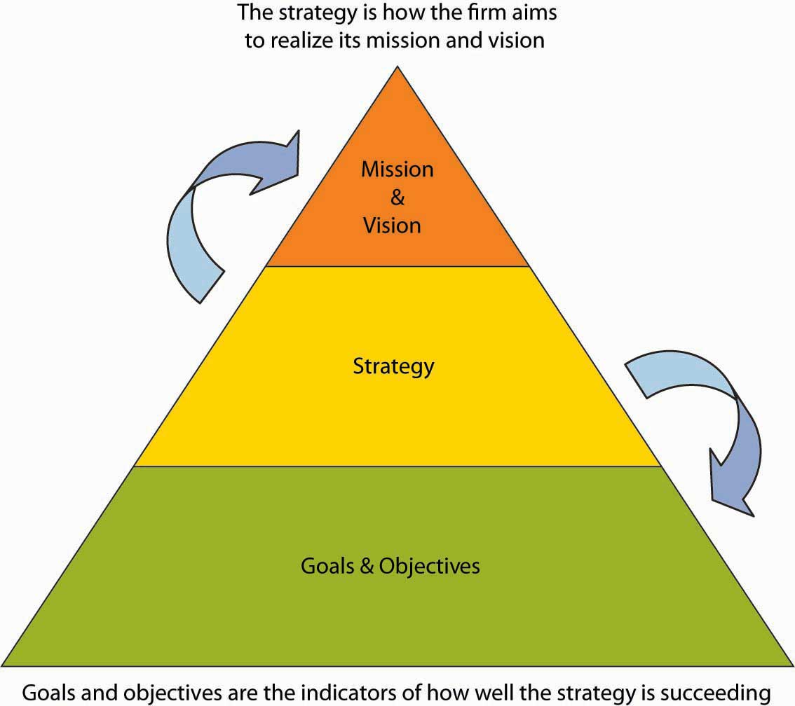

4.1 Case in Point: Xerox Motivates Employees for Success
Figure 4.4
Anne Mulcahy, Former Xerox Chairman of the Board (left), and Ursula Burns, Xerox CEO (right)
Source: Photo courtesy of Xerox Corporation.
As of 2010, Xerox Corporation (NYSE: XRX) is a $22 billion, multinational company founded in 1906 and operating in 160 countries. Xerox is headquartered in Norwalk, Connecticut, and employs 130,000 people. How does a company of such size and magnitude effectively manage and motivate employees from diverse backgrounds and experiences? Such companies depend on the productivity and performance of their employees. The journey over the last 100 years has withstood many successes and failures. In 2000, Xerox was facing bankruptcy after years of mismanagement, piles of debt, and mounting questions about its accounting practices.
Anne Mulcahy turned Xerox around. Mulcahy joined Xerox as an employee in 1976 and moved up the corporate ladder, holding several management positions until she became CEO in 2001. In 2005, Mulcahy was named by Fortune magazine as the second most powerful woman in business. Based on a lifetime of experience with Xerox, she knew that the company had powerful employees who were not motivated when she took over. Mulcahy believed that among other key businesses changes, motivating employees at Xerox was a key way to pull the company back from the brink of failure. One of her guiding principles was a belief that in order to achieve customer satisfaction, employees must be treated as key stakeholders and become interested and motivated in their work. Mulcahy not only successfully saw the company through this difficult time but also was able to create a stronger and more focused company.
In 2009, Mulcahy became the chairman of Xerox’s board of directors and passed the torch to Ursula Burns, who became the new CEO of Xerox. Burns became not only the first African American woman CEO to head a Standard & Poor’s (S&P) company but also the first woman to succeed another woman as the head of an S&P 100 company. Burns is also a lifetime Xerox employee who has been with the company for over 30 years. She began as a graduate intern and was hired full time after graduation. Because of her tenure with Xerox, she has close relationships with many of the employees, which provides a level of comfort and teamwork. She describes Xerox as a nice family. She maintains that Mulcahy created a strong and successful business but encouraged individuals to speak their mind, to not worry about hurting one another’s feelings, and to be more critical.
Burns explains that she learned early on in her career, from her mentors at Xerox, the importance of managing individuals in different ways and not intentionally intimidating people but rather relating to them and their individual perspectives. As CEO, she wants to encourage people to get things done, take risks, and not be afraid of those risks. She motivates her teams by letting them know what her intentions and priorities are. The correlation between a manager’s leadership style and the productivity and motivation of employees is apparent at Xerox, where employees feel a sense of importance and a part of the process necessary to maintain a successful and profitable business. In 2010, Anne Mulcahy retired from her position on the board of directors to pursue new projects.
Primary Source:
- Employee satisfaction leads to customer service. AllBusiness. Retrieved April 5, 2010, from http://www.allbusiness.com/marketing/market-research/341288-1.html

- 50 most powerful women. (2006). Fortune. Retrieved April 5, 2010, from http://money.cnn.com/popups/2006/fortune/mostpowerfulwomen/2.html

- Profile: Anne M. Mulcahy. (2010). Forbes. Retrieved April 5, 2010, from http://people.forbes.com/profile/anne-m-mulcahy/19732

- Whitney, L. (2010, March 30). Anne Mulcahy to retire as Xerox chairman. CNET News. Retrieved April 5, 2010, from http://news.cnet.com/8301-1001_3-20001412-92.html

- Bryant, A. (2010, February 20). Xerox’s new chief tries to redefine its culture. New York Times. Retrieved April 5, 2010, from http://www.nytimes.com/2010/02/21/business/21xerox.html?pagewanted=18dpc.DISCUSSIO QUSTIONS
- In terms of the P-O-L-C framework, what values do the promotion and retention of Mulcahy and Burns suggest are important at Xerox? How might these values be reflected in its vision and mission statements?

- How do you think Xerox was able to motivate its employees through the crisis it faced in 2000?

- How do CEOs with large numbers of employees communicate priorities to a worldwide workforce?

- How might Ursula Burns motivate employees to take calculated risks?

- Both Anne Mulcahy and Ursula Burns were lifetime employees of Xerox. How does an organization attract and keep individuals for such a long period of time?
4.2 The Roles of Mission, Vision, and Values
LEARNING OBJECTIVES
- Be able to define mission and vision.

- See how values are important for mission and vision.

- Understand the roles of vision, mission, and values in the P-O-L-C framework.
Mission, Vision, and Values
Mission and vision both relate to an organization’s purpose and are typically communicated in some written form. Mission and vision are statements from the organization that answer questions about who we are, what do we value, and where we’re going. A study by the consulting firm Bain and Company reports that 90% of the 500 firms surveyed issue some form of mission and vision statements.
- Bart, C. K., & Baetz, M. C. (1998). The relationship between mission statements and firm performance: An exploratory study. Journal of Management Studies, 35, 823–853
Moreover, firms with clearly communicated, widely understood, and collectively shared mission and vision have been shown to perform better than those without them, with the caveat that they related to effectiveness only when strategy and goals and objectives were aligned with them as well.
- Bart, C. K., Bontis, N., & Taggar, S. (2001). A model of the impact of mission statements on firm performance. Management Decision, 39(1), 19–35
A mission statement communicates the organization’s reason for being, and how it aims to serve its key stakeholders. Customers, employees, and investors are the stakeholders most often emphasized, but other stakeholders like government or communities (i.e., in the form of social or environmental impact) can also be discussed. Mission statements are often longer than vision statements. Sometimes mission statements also include a summation of the firm’s values. Values are the beliefs of an individual or group, and in this case the organization, in which they are emotionally invested. The Starbucks mission statement describes six guiding principles that, as you can see, also communicate the organization’s values:
- Provide a great work environment and treat each other with respect and dignity.

- Embrace diversity as an essential component in the way we do business.

- Apply the highest standards of excellence to the purchasing, roasting and fresh delivery of our coffee.

- Develop enthusiastically satisfied customers all of the time.

- Contribute positively to our communities and our environment.

- Recognize that profitability is essential to our future success.

- Retrieved October 27, 2008, from http://www.starbucks.com/aboutus.

Similarly, Toyota declares its global corporate principles to be:
- Honor the language and spirit of the law of every nation and undertake open and fair corporate activities to be a good corporate citizen of the world.

- Respect the culture and customs of every nation and contribute to economic and social development through corporate activities in the communities.

- Dedicate ourselves to providing clean and safe products and to enhancing the quality of life everywhere through all our activities.

- Create and develop advanced technologies and provide outstanding products and services that fulfill the needs of customers worldwide.

- Foster a corporate culture that enhances individual creativity and teamwork value, while honoring mutual trust and respect between labor and management.

- Pursue growth in harmony with the global community through innovative management.

- Work with business partners in research and creation to achieve stable, long-term growth and mutual benefits, while keeping ourselves open to new partnerships.

- Retrieved October 27, 2008, from http://www.toyota.co.jp/en/vision/philosophy.

A vision statement, in contrast, is a future-oriented declaration of the organization’s purpose and aspirations. In many ways, you can say that the mission statement lays out the organization’s “purpose for being,” and the vision statement then says, “based on that purpose, this is what we want to become.” The strategy should flow directly from the vision, since the strategy is intended to achieve the vision and thus satisfy the organization’s mission. Typically, vision statements are relatively brief, as in the case of Starbuck’s vision statement, which reads: “Establish Starbucks as the premier purveyor of the finest coffee in the world while maintaining our uncompromising principles as we grow.”
Any casual tour of business or organization Web sites will expose you to the range of forms that mission and vision statements can take. To reiterate, mission statements are longer than vision statements, often because they convey the organizations core values. Mission statements answer the questions of “Who are we?” and “What does our organization value?” Vision statements typically take the form of relatively brief, future-oriented statements—vision statements answer the question “Where is this organization going?” Increasingly, organizations also add a values statement which either reaffirms or states outright the organization’s values that might not be evident in the mission or vision statements.
Roles Played by Mission and Vision
Mission and vision statements play three critical roles: (1) communicate the purpose of the organization to stakeholders, (2) inform strategy development, and (3) develop the measurable goals and objectives by which to gauge the success of the organization’s strategy. These interdependent, cascading roles, and the relationships among them, are summarized in the figure.
Figure 4.5 Key Roles of Mission and Vision
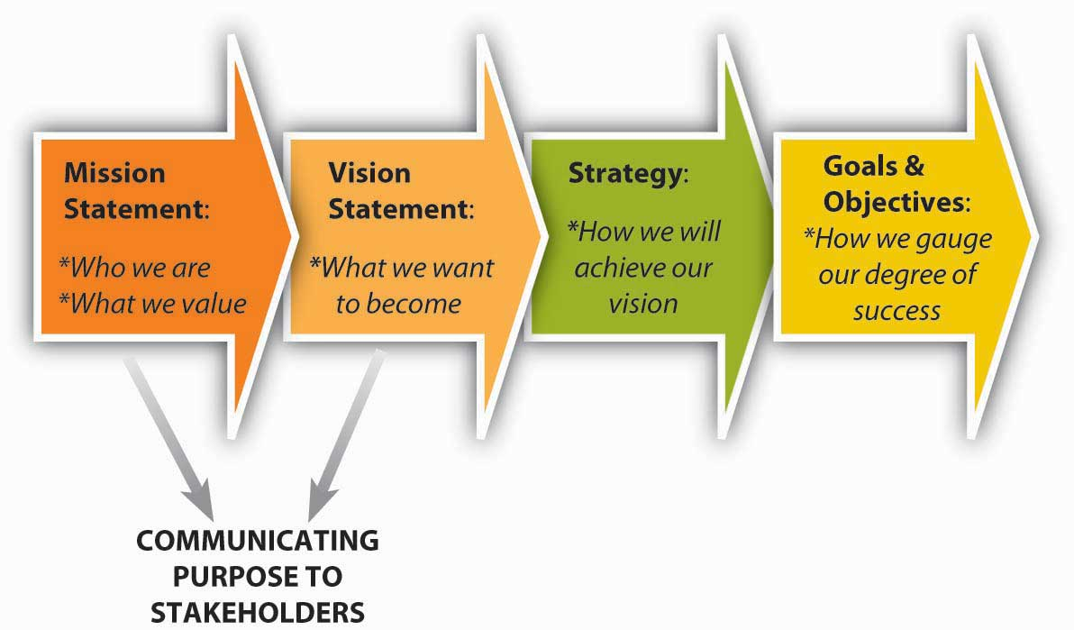

First, mission and vision provide a vehicle for communicating an organization’s purpose and values to all key stakeholders. Stakeholders are those key parties who have some influence over the organization or stake in its future. You will learn more about stakeholders and stakeholder analysis later in this chapter; however, for now, suffice it to say that some key stakeholders are employees, customers, investors, suppliers, and institutions such as governments. Typically, these statements would be widely circulated and discussed often so that their meaning is widely understood, shared, and internalized. The better employees understand an organization’s purpose, through its mission and vision, the better able they will be to understand the strategy and its implementation.
Second, mission and vision create a target for strategy development. That is, one criterion of a good strategy is how well it helps the firm achieve its mission and vision. To better understand the relationship among mission, vision, and strategy, it is sometimes helpful to visualize them collectively as a funnel. At the broadest part of the funnel, you find the inputs into the mission statement. Toward the narrower part of the funnel, you find the vision statement, which has distilled down the mission in a way that it can guide the development of the strategy. In the narrowest part of the funnel you find the strategy —it is clear and explicit about what the firm will do, and not do, to achieve the vision. Vision statements also provide a bridge between the mission and the strategy. In that sense the best vision statements create a tension and restlessness with regard to the status quo—that is, they should foster a spirit of continuous innovation and improvement. For instance, in the case of Toyota, its “moving forward” vision urges managers to find newer and more environmentally friendly ways of delighting the purchaser of their cars. London Business School professors Gary Hamel and C. K. Prahalad describe this tense relationship between vision and strategy as stretch and ambition. Indeed, in a study of such able competitors as CNN, British Airways, and Sony, they found that these firms displaced competitors with stronger reputations and deeper pockets through their ambition to stretch their organizations in more innovative ways.
- Hamel, G., & Prahalad, C. K. (1993, March–April). Strategy as stretch and leverage. Harvard Business Review, 75–84.
Third, mission and vision provide a high-level guide, and the strategy provides a specific guide, to the goals and objectives showing success or failure of the strategy and satisfaction of the larger set of objectives stated in the mission. In the cases of both Starbucks and Toyota, you would expect to see profitability goals, in addition to metrics on customer and employee satisfaction, and social and environmental responsibility.

KEY TAKEAWAY
Mission and vision both relate to an organization’s purpose and aspirations, and are typically communicated in some form of brief written statements. A mission statement communicates the organization’s reason for being and how it aspires to serve its key stakeholders. The vision statement is a narrower, future-oriented declaration of the organization’s purpose and aspirations. Together, mission and vision guide strategy development, help communicate the organization’s purpose to stakeholders, and inform the goals and objectives set to determine whether the strategy is on track.

EXERCISES
- What is a mission statement?

- What is a vision statement?

- How are values important to the content of mission and vision statements?

- Where does the purpose of mission and vision overlap?

- How do mission and vision relate to a firm’s strategy?

- Why are mission and vision important for organizational goals and objectives?
4.3 Mission and Vision in the P-O-L-C Framework
LEARNING OBJECTIVES
- Understand the role of mission and vision in organizing.

- Understand the role of mission and vision in leading.

- Understand the role of mission and vision in controlling.

Mission and vision play such a prominent role in the planning facet of the P-O-L-C framework. However, you are probably not surprised to learn that their role does not stop there. Beyond the relationship between mission and vision, strategy, and goals and objectives, you should expect to see mission and vision being related to the organizing, leading, and controlling aspects as well. Let’s look at these three areas in turn.
Mission, Vision, and Organizing
Organizing is the function of management that involves developing an organizational structure and allocating human resources to ensure the accomplishment of objectives. The organizing facet of the P-O-L-C framework typically includes subjects such as organization design, staffing, and organizational culture. With regard to organizing, it is useful to think about alignment between the mission and vision and various organizing activities. For instance, organizational design is a formal, guided process for integrating the people, information, and technology of an organization. It is used to match the form of the organization as closely as possible to the purpose(s) the organization seeks to achieve. Through the design process, organizations act to improve the probability that the collective efforts of members will be successful.
Organization design should reflect and support the strategy—in that sense, organizational design is a set of decision guidelines by which members will choose appropriate actions, appropriate in terms of their support for the strategy. As you learned in the previous section, the strategy is derived from the mission and vision statements and from the organization’s basic values. Strategy unifies the intent of the organization and focuses members toward actions designed to accomplish desired outcomes. The strategy encourages actions that support the purpose and discourages those that do not.
To organize, you must connect people with each other in meaningful and purposeful ways. Further, you must connect people—human resources—with the information and technology necessary for them to be successful. Organization structure defines the formal relationships among people and specifies both their roles and their responsibilities. Administrative systems govern the organization through guidelines, procedures, and policies. Information and technology define the process(es) through which members achieve outcomes. Each element must support each of the others, and together they must support the organization’s purpose, as reflected in its mission and vision.
For example, in 2006, Disney acquired Pixar, a firm is renowned for its creative prowess in animated entertainment. Disney summarizes the Pixar strategy like this: “Pixar’s [strategy] is to combine proprietary technology and world-class creative talent to develop computer-animated feature films with memorable characters and heartwarming stories that appeal to audiences of all ages.”
- Retrieved October 27, 2008, from http://www.pixar.com/companyinfo/about_us/overview.htm.
Disney has helped Pixar achieve this strategy through an important combination of structural design choices. First, Pixar is an independent division of Disney and is empowered to make independent choices in all aspects of idea development. Second, Pixar gives its “creatives”—its artists, writers, and designers—great leeway over decision making. Third, Pixar protects its creatives’ ability to share work in progress, up and down the hierarchy, with the aim of getting it even better. Finally, after each project, teams conduct “postmortems” to catalog what went right and what went wrong. This way, innovations gained through new projects can be shared with later projects, while at the same time sharing knowledge about potential pitfalls.
- Catmull, E. (2008, September). How Pixar fosters collective creativity. Harvard Business Review, 1–11.
Organizational culture is the workplace environment formulated from the interaction of the employees in the workplace. Organizational culture is defined by all of the life experiences, strengths, weaknesses, education, upbringing, and other attributes of the employees. While executive leaders play a large role in defining organizational culture by their actions and leadership, all employees contribute to the organizational culture.
As you might imagine, achieving alignment between mission and vision and organizational culture can be very powerful, but culture is also difficult to change. This means that if you are seeking to change your vision or mission, your ability to change the organization’s culture to support those new directions may be difficult, or, at least, slow to achieve.
For instance, in 2000, Procter & Gamble (P&G) sought to change a fundamental part of its vision in a way that asked the organization to source more of its innovations from external partners. Historically, P&G had invested heavily in research and development and internal sources of innovation—so much so that “not invented here” (known informally as NIH) was the dominant cultural mind-set.
- Lafley, A. G., & Charan, R. (2008). The game changer. Upper Saddle River, NJ: Crown Books.
NIH describes a sociological, corporate, or institutional culture that avoids using products, research, or knowledge that originated anywhere other than inside the organization. It is normally used in a pejorative sense. As a sociological phenomenon, the “not invented here” syndrome is manifested as an unwillingness to adopt an idea or product because it originates from another culture. P&G has been able to combat this NIH bias and gradually change its culture toward one that is more open to external contributions, and hence in much better alignment with its current mission and vision.
Social networks are often referred to as the “invisible organization.” They consist of individuals or organizations connected by one or more specific types of interdependency. You are probably already active in social networks through such Web communities as MySpace, Facebook, and LinkedIn. However, these sites are really only the tip of the iceberg when it comes to the emerging body of knowledge surrounding social networks. Networks deliver three unique advantages: access to “private” information (i.e., information that companies do not want competitors to have), access to diverse skill sets, and power. You may be surprised to learn that many big companies have breakdowns in communications even in divisions where the work on one project should be related to work on another. Going back to our Pixar example, for instance, Disney is fostering a network among members of its Pixar division in a way that they are more likely to share information and learn from others. The open internal network also means that a cartoon designer might have easier access to a computer programmer and together they can figure out a more innovative solution. Finally, since Pixar promotes communication across hierarchical levels and gives creatives decision-making authority, the typical power plays that might impede sharing innovation and individual creativity are prevented. Managers see these three network advantages at work every day but might not pause to consider how their networks regulate them.
Mission, Vision, and Leading
Leading involves influencing others toward the attainment of organizational objectives. Leading and leadership are nearly synonymous with the notions of mission and vision. We might describe a very purposeful person as being “on a mission.” As an example, Steve Demos had the personal mission of replacing cow’s milk with soy milk in U.S. supermarkets, and this mission led to his vision for, and strategy behind, the firm White Wave and its Silk line of soy milk products.
- Carpenter, M. A., & Sanders, W. G. (2006). Strategic management: A dynamic perspective. (1st ed.). Upper Saddle River, NJ: Pearson/Prentice-Hall
Similarly, we typically think of some individuals as leaders because they are visionary. For instance, when Walt Disney suggested building a theme park in a Florida swamp back in the early 1960s, few other people in the world seemed to share his view.
Any task—whether launching Silk or building the Disney empire— is that much more difficult if attempted alone. Therefore, the more that a mission or vision challenges the status quo—and recognizing that good vision statements always need to create some dissonance with the status quo—the greater will be the organization’s need of what leadership researcher Shiba calls “real change leaders”—people who will help diffuse the revolutionary philosophy even while the leader (i.e., the founder or CEO) is not present. Without real change leaders, a revolutionary vision would remain a mere idea of the visionary CEO—they are the ones who make the implementation of the transformation real.
In most cases where we think of revolutionary companies, we associate the organization’s vision with its leader—for instance, Apple and Steve Jobs, Dell and Michael Dell, or Google with the team of Sergey Brin and Larry Page. Most important, in all three of these organizations, the leaders focused on creating an organization with a noble mission that enabled the employees and management team to achieve not only the strategic breakthrough but to also realize their personal dreams in the process. Speaking to the larger relationship between mission, vision, strategy, and leadership, are the Eight principles of visionary leadership, derived from Shiba’s 2001 book, Four Practical Revolutions in Management (summarized in “Eight Principles of Visionary Leadership”
- Shiba, S., & Walden, D. (2001). Four practical revolutions in management: Systems for creating unique organizational capability. New York: Productivity Press
Eight Principles of Visionary Leadership
Principle 1: The visionary leader must do on-site observation leading to personal perception of changes in societal values from an outsider’s point of view.

Principle 2: Even though there is resistance, never give up; squeeze the resistance between outside-in (i.e., customer or society-led) pressure in combination with top-down inside instruction.

Principle 3: Revolution is begun with symbolic disruption of the old or traditional system through top-down efforts to create chaos within the organization.

Principle 4: The direction of revolution is illustrated by a symbolically visible image and the visionary leader’s symbolic behavior.

Principle 5: Quickly establishing new physical, organizational, and behavioral systems is essential for successful revolution.

Principle 6: Real change leaders are necessary to enable revolution.

Principle 7: Create an innovative system to provide feedback from results.

Principle 8: Create a daily operation system, including a new work structure, new approach to human capabilities and improvement activities.
Vision That Pervades the Organization
A broader definition of visionary leadership suggests that, if many or most of an organization’s employees understand and identify with the mission and vision, efficiency will increase because the organization’s members “on the front lines” will be making decisions fully aligned with the organization’s goals. Efficiency is achieved with limited hands-on supervision because the mission and vision serve as a form of cruise control. To make frontline responsibility effective, leadership must learn to trust workers and give them sufficient opportunities to develop quality decision-making skills.
The classic case about Johnsonville Sausage, recounted by CEO Ralph Stayer, documents how that company dramatically improved its fortunes after Stayer shared responsibility for the mission and vision, and ultimately development of the actual strategy, with all of his employees. His vision was the quest for an answer to “What Johnsonville would have to be to sell the most expensive sausage in the industry and still have the biggest market share?”
- Stayer, R. (1990, November). How I learned to let my workers lead. Harvard Business Review.
Of course, he made other important changes as well, such as decentralizing decision making and tying individual’s rewards to company-wide performance, but he initiated them by communicating the organization’s mission and vision and letting his employees know that he believed they could make the choices and decisions needed to realize them.
Mission and vision are also relevant to leadership well beyond the impact of one or several top executives. Even beyond existing employees, various stakeholders—customers, suppliers, prospective new employees—are visiting organizations’ Web sites to read their mission and vision statements. In the process, they are trying to understand what kind of organization they are reading about and what the organization’s values and ethics are. Ultimately, they are seeking to determine whether the organization and what it stands for are a good fit for them.
Vision, Mission, and Controlling
Controlling involves ensuring that performance does not deviate from standards. Controlling consists of three steps: (1) establishing performance standards, (2) comparing actual performance against standards, and (3) taking corrective action when necessary. Mission and vision are both directly and indirectly related to all three steps.
Performance Standards
Recall that mission and vision tell a story about an organization’s purpose and aspirations. Mission and vision statements are often ambiguous by design because they are intended to inform the strategy not be the strategy. Nevertheless, those statements typically provide a general compass heading for the organization and its employees. For instance, vision may say something about innovativeness, growth, or firm performance, and the firm will likely have set measurable objectives related to these. Performance standards often exceed actual performance but, ideally, managers will outline a set of metrics that can help to predict the future, not just evaluate the past.
It is helpful to think about such metrics as leading, lagging, and pacing indicators. A leading indicator actually serves to predict where the firm is going, in terms of performance. For instance, General Electric asks customers whether they will refer it new business, and GE’s managers have found that this measure of customer satisfaction does a pretty good job of predicting future sales. A pacing indicator tells you in real time that the organization is on track, for example, in on-time deliveries or machinery that is in operation (as opposed to being under repair or in maintenance). A lagging indicator is the one we are all most familiar with. Firm financial performance, for instance, is an accounting-based summary of how well the firm has done historically. Even if managers can calculate such performance quickly, the information is still historic and not pacing or leading. Increasingly, firms compile a set of such leading, lagging, and pacing goals and objectives and organize them in the form of a dashboard or Balanced Scorecard.
Actual Versus Desired Performance
The goals and objectives that flow from your mission and vision provide a basis for assessing actual versus desired performance. In many ways, such goals and objectives provide a natural feedback loop that helps managers see when and how they are succeeding and where they might need to take corrective action. This is one reason goals and objectives should ideally be specific and measurable. Moreover, to the extent that they serve as leading, lagging, and pacing performance metrics, they enable managers to take corrective action on any deviations from goals before too much damage has been done.
Corrective Action
Finally, just as mission and vision should lead to specific and measurable goals and objectives and thus provide a basis for comparing actual and desired performance, corrective action should also be prompted in cases where performance deviates negatively from performance objectives. It is important to point out that while mission and vision may signal the need for corrective action, because they are rather general, high-level statements they typically will not spell out what specific actions—that latter part is the role of strategy, and mission and vision are critical for good strategies but not substitutes for them. A mission and vision are statements of self-worth. Their purpose is not only to motivate employees to take meaningful action but also to give leadership a standard for monitoring progress. It also tells external audiences how your organization wishes to be viewed and have its progress and successes gauged.
Strategic human resources management (SHRM) reflects the aim of integrating the organization’s human capital—its people—into the mission and vision. Human resources management alignment means to integrate decisions about people with decisions about the results an organization is trying to obtain. Research indicates that organizations that successfully align human resources management with mission and vision accomplishment do so by integrating SHRM into the planning process, emphasizing human resources activities that support mission goals, and building strong human resources/management capabilities and relationships.
- Gerhart, B. A., & Rynes, S. L. (2003). Compensation: Theory, Evidence, and Strategic Implications. Thousand Oaks, CA, Sage

KEY TAKEAWAY
In addition to being a key part of the planning process, mission and vision also play key roles in the organizing, leading, and controlling functions of management. While mission and vision start the planning function, they are best realized when accounted for across all four functions of management—P-O-L-C. In planning, mission and vision help to generate specific goals and objectives and to develop the strategy for achieving them. Mission and vision guide choices about organizing, too, from structure to organizational culture. The cultural dimension is one reason mission and vision are most effective when they pervade the leadership of the entire organization, rather than being just the focus of senior management. Finally, mission and vision are tied to the three key steps of controlling: (1) establishing performance standards, (2) comparing actual performance against standards, and (3) taking corrective action when necessary. Since people make the place, ultimately strategic human resources management must bring these pieces together.

EXERCISES
- How might mission and vision influence organizational design?

- How might mission and vision influence leadership practices?

- Why might a specific replacement CEO candidate be a good or poor?

- choice for a firm with an existing mission and vision?

- Which aspects of controlling do mission and vision influence?

- Why are mission and vision relevant to the management of internal organizational social networks?

- What performance standards might reinforce a firm’s mission and vision?

- What is the role of mission and vision with strategic human resource management?
4.4 Creativity and Passion
LEARNING OBJECTIVES
- Understand how creativity relates to vision.

- Develop some creativity tools.

- Understand how passion relates to vision.
Creativity and passion are of particular relevance to mission and vision statements. A simple definition of creativity is the power or ability to invent. We sometimes think of creativity as being a purely artistic attribute, but creativity in business is the essence of innovation and progress. Passion at least in the context we invoke here, refers to an intense, driving, or overmastering feeling or conviction. Passion is also associated with intense emotion compelling action. We will focus mostly on the relationship between creativity, passion, and vision in this section because organizational visions are intended to create uneasiness with the status quo and help inform and motivate key stakeholders to move the organization forward. This means that a vision statement should reflect and communicate something that is relatively novel and unique, and such novelty and uniqueness are the products of creativity and passion.
Creativity and passion can, and probably should, also influence the organization’s mission. In many ways, the linkages might be clearest between creativity and vision statements and passion and mission statements because the latter is an expression of the organization’s values and deeply held beliefs. Similarly, while we will discuss creativity and passion separately in this section, your intuition and experience surely tell you that creativity eventually involves emotion, to be creative, you have to care about—be passionate about—what you’re doing.
Creativity and Vision
More recently, work by DeGraf and Lawrence, suggest a finer-grained view into the characteristics and types of creativity.
- DeGraf, J., & Lawrence, K. A. (2002). Creativity at Work: Developing the Right Practices to Make It Happen. San Francisco: Jossey-Bass.
They argued that creativity “types” could be clustered based on some combination of flexibility versus control and internal versus external orientation. For the manager, their typology is especially useful as it suggests ways to manage creativity, as in simply hiring creative individuals. As summarized in the figure, their research suggests that there are four types of creativity: (1) investment (external orientation with high control), (2) imagination (external orientation with flexibility emphasis), (3) improvement (internal orientation with high control), and (4) incubation (internal orientation with flexibility emphasis).
The first type of creativity, investment, is associated with speed—being first and being fast. It is also a form of creativity fostered from the desire to be highly competitive. Perhaps one of the most recent examples of this type of creativity crucible is the beer wars—the battle for U.S. market share between SABMiller and Anheuser Busch (AB; Budweiser). Miller was relentless in attacking the quality of AB’s products through its advertisements, and at the same time launched a myriad number of new products to take business from AB’s stronghold markets.
- Retrieved October 27, 2008, from http://www.bizjournals.com/milwaukee/stories/2004/05/31/story7.html.
The second type of creativity, imagination, is the form that most of us think of first. This type of creativity is characterized by new ideas and breakthroughs: Apple’s stylish design of Macintosh computers and then game-changing breakthroughs with its iPod and iPhone. Oftentimes, we can tie this type of creativity to the drive or genius of a single individual, such as Apple’s Steve Jobs.
Figure 4.8 Four Creativity Types
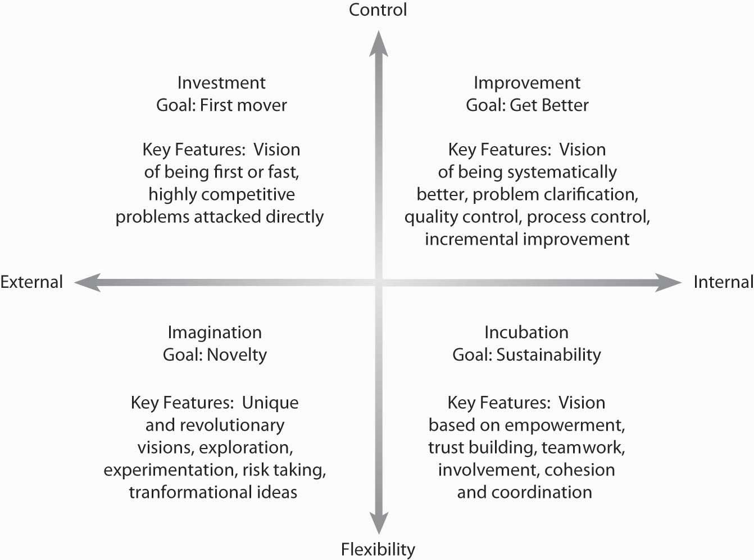

Adapted from DeGraf, J., & Lawrence, K. A. (2002). Creativity at Work: Developing the Right Practices to Make It Happen. San Francisco: Jossey-Bass.
Where big ideas come from the imagination quadrant, improvement is a type of creativity that involves making an existing idea better. Two great examples of this are McDonald’s and Toyota. Ray Kroc, McDonald’s founder, had the idea of creating quality and cooking standards for preparing tasty burgers and fries. While there were many other burger joints around at the time (the 1950s), Kroc’s unique process-oriented approach gave McDonald’s a big advantage. Similarly, Toyota has used the refinement of its automaking and auto-assembly processes (called the Toyota Business System) to be one of the largest and most successful, high-quality car makers in the world.
Finally, the fourth area of creativity is incubation. Incubation is a very deliberate approach that concerns a vision of sustainability—that is, leaving a legacy. This type of creativity is more complex because it involves teamwork, empowerment, and collective action. In their chapter on problem solving, David Whetten and Kim Cameron provide Gandhi as an example of incubation creativity:
“Mahatma Gandhi was probably the only person in modern history who has single-handedly stopped a war. Lone individuals have started wars, but Gandhi was creative enough to stop one. He did so by mobilizing networks of people to pursue a clear vision and set of values. Gandhi would probably have been completely noncreative and ineffective had he not been adept at capitalizing on incubation dynamics. By mobilizing people to march to the sea to make salt, or to burn passes that demarcated ethnic group status, Gandhi was able to engender creative outcomes that had not been considered possible. He was a master at incubation by connecting, involving, and coordinating people.”
- Whetten, D., & Camerson, K. (2007). Developing Management skills. (7th ed.). Upper Saddle River, NJ: Pearson/Prentice-Hall, 185.
While no one of these four types of creativity is best, they have some contradictory or conflicting characteristics. For example, imagination and improvement emphasize different approaches to creativity. The size of the new idea, for instance, is typically much bigger with imagination (i.e., revolutionary solutions) than with improvement (i.e., incremental solutions). Investment and incubation also are very different—investment is relatively fast, and the other relatively slow (i.e., incubation emphasizes deliberation and development).
Creativity Tools
In this section, we introduce you to two creativity tools: SCAMPER and the Nominal Group Technique. This set of tools is not exhaustive but gives you some good intuition and resources to develop new ideas—either to craft a vision for a new company or revise an existing mission and vision. The first three tools can be used and applied individually or in groups; Nominal Group Technique is designed to bolster creativity in groups and can build on individual and group insights provided by the other tools.
All these tools help you to manage two divergent forms of thinking necessary for creativity—programmed thinking and lateral thinking. Programmed thinking often called left-brained thinking, relies on logical or structured ways of creating a new product or service. In terms of mission and vision, this means a logical and deliberate process is used to develop the vision statement. Lateral thinking a term coined by Edward DeBono in his book The Use of Lateral Thinking (1967), is about changing patterns and perceptions; it is about ideas that may not be obtainable by using only traditional step-by-step, programmed, logic.
- De Bono, E. (1992). Serious Creativity. New York: Harper Business

- Osborn, A. (1953). Applied Imagination. New York: Scribner’s . Lateral thinking draws on the right side of our brains.
Each type of approach—programmed versus lateral—has its strength. Logical and disciplined programmed thinking is enormously effective in making products and services better. It can, however, only go so far before all practical improvements have been carried out. Lateral thinking can generate completely new concepts and ideas and brilliant improvements to existing systems. In the wrong place, however, it can be impractical or unnecessarily disruptive.
SCAMPER
Developed by Bob Eberle, SCAMPER is a checklist tool that helps you to think of changes you can make to an existing marketplace to create a new one—a new product, a new service, or both.
- Eberle, R. (1997). Scamper: Creative Games and Activities for Imagination Development. New York: Prufrock Press.
You can use these changes either as direct suggestions or as starting points for lateral thinking. This, in turn, can inspire a new vision statement. Table 4.1 "Creativity through SCAMPER" provides you with the SCAMPER question steps and examples of new products or services that you might create.
Table 4.1 Creativity through SCAMPER
Questions: | Examples:
Substitute: What else instead? Who else instead? Other ingredients? Other material? Other time? Other place? | Vegetarian hot dogs
Combine: How about a blend? Combine purposes? Combine materials? | Musical greeting cards
Adapt: What else is like this? What other idea does this suggest? How can I adjust to these circumstances? | Snow tires
Modify: Different order, form, shape? Minify: What to make smaller? Slower? Lighter? What to do with less frequency? Magnify: What to make higher? Longer? Thicker? What to do with greater frequency? | Scented crayons; Bite-sized Snickers bars; Super-sized french fries
Put to other uses: New ways to use as is? Other uses I modified? Other places to use an item or movement? | Towel as fly swatter
Eliminate: What to remove? Omit? Understate? | Cordless telephone
Rearrange: Other layout? Other sequence? Transpose cause and effect? Transpose positive and negative? How about opposites? Reverse: Interchange components? Other pattern? Backward? Upside down? | Vertical stapler; Reversible clothing

As shown in the Table 4.1 "Creativity through SCAMPER", by taking a topic or problem and then using SCAMPER, you can generate possible new products. It may be some combination of these SCAMPER changes that lead to highly innovative solutions. For instance, the entertainment company Cirque du Soliel has modeled its shows on the traditional circus. However, it has adapted aspects of theater and opera, eliminated animals, and reduced the number of rings from three to one. As a result, it offers a highly stylized (and much more expensive!) version of what, nostalgically, we call a circus today. Many of the ideas may be impractical. However, some of these ideas could be good starting points for a new organization or revision of the vision for an existing one.
Nominal Group Technique
The Nominal Group Technique (NGT) is a method of facilitating a group of people to produce a large number of ideas in a relatively short time.This section is reproduced with permission of the University of Wisconsin Extension Program.
A circulation version can be found at:
- http://www.uwex.edu/ces/pdande/resources/pdf/Tipsheet3.pdf (retrieved October 28, 2008).
Additional information on NGT can be gained by reading the following:
- Delbecq, A., Van de Ven, A., & Gustafson, D. (1975). Group Techniques for Program Planning: A Guide to Nominal Group and Delphi Processes. Glenview, IL: Scott, Foresman

- Tague, N. (1995). The Quality Toolbox. Milwaukee, WI: ASQC Quality Press; Witkin, B., & Altschuld, J. (1995). Planning and Conducting Needs Assessment: A Practical Guide. Thousands Oaks, CA, Sage
In addition to using NGT to develop a mission and vision statement, it can be useful:
- To generate numerous creative ideas
- To ensure everyone is heard
- When there is concern that some people may not be vocal
- To build consensus
- When there is controversy or conflict
As shown in “NGT Preparation and Supplies,” preparation and supplies are modest. It encourages contributions from everyone by allowing for equal participation among group members. A question is posed to the group. Individually and silently, each participant writes down his or her ideas. In round-robin fashion, each member supplies an idea until all ideas are shared. Generally, 6 to 10 people participate. “Nominal” means that the participants form a group in name only. For most of the session, they do not interact as they would in other group processes.
NGT Preparation and Supplies
Formulate your discussion question. Ensure that the wording prevents misunderstanding and is objective. Supplies needed include:
- Flip chart for each table
- Masking tape
- 3 × 5 cards for each participant
- Work tables
- Felt pens

The group is divided into small work groups, each with a leader. A flip chart and markers are needed at each table. Position the flip chart so that all can see the ideas. The remaining simple procedures are summarized in “NGT Procedure.”
NGT Procedure
- Introduction: Briefly welcome participants, clarify the purpose of the group exercise, and explain the procedure to be followed and how results are to be used.

- Present question: Orally present the question that is written on the flip chart; clarify as needed.

- Silent generation of ideas: Each participant silently thinks of and writes down (on 3 × 5 card) as many ideas as possible. Allow 5 to 10 minutes.

- Record ideas: In turn, each participant reads aloud one idea, and it is recorded on the flip chart for all to see.

- Continue until all ideas are recorded.

- Discourage discussion, not even questions for clarification.

- Encourage “hitchhiking,” that is, expanding on another’s statement. Ideas do not have to be from the participant’s written list.

- Participants may pass a turn and then add an idea at a subsequent turn.

- Discourage combining ideas from individuals unless they are exactly the same.

- Group discussion: After all ideas are recorded, the person who suggested the idea is given the opportunity to explain it further.

- Duplicates may be combined.

- Wording may be changed if the originator agrees.

- Ideas are deleted only by unanimous agreement.

- Restrict discussion to clarify meaning; the value or merit of ideas is not discussed.
Passion and Vision
Passion as we invoke the term in this chapter, refers to intense, driving, or overmastering feeling or conviction. Passion is also associated with intense emotion compelling action. Passion is relevant to vision in at least two ways: (1) Passion about an idea as inspiration of the vision and vision statement and (2) shared passion among organizational members about the importance of the vision.
Passion as Inspiration
Entrepreneur Curt Rosengren makes this observation about the relationship between passion and entrepreneurship: “Strangely, in spite of its clear importance, very few entrepreneurs or managers consciously incorporate passion into their decisions, ultimately leaving one of their most valuable assets on their path to success largely to chance, even though there is little question that passion can be a part of vision creation.”
- Retrieved October 28, 2008, from http://www.astroprojects.com/media/MSPassion8.html
Rosengren comments further that:
“Passion is the essence of the entrepreneurial spirit. It is an entrepreneur’s fuel, providing the drive and inspiration to create something out of nothing while enduring all the risks, uncertainty, and bumps in the road that that entails.”
“Entrepreneurs’ lives consist of a nonstop mission to communicate their vision and inspire others to support their efforts. As evangelists, salespeople, fundraisers, and cheerleaders they need to breathe life into their vision while enlisting others in their dream. From creating a vision for the future to selling the idea to investors, from attracting high-quality employees to inspiring them to do what nobody thought possible, that passion is a key ingredient.”
“Passion also plays a key role in their belief that they can achieve the so-called impossible, bouncing back from failure and ignoring the chorus of No that is inevitably part of the entrepreneurial experience.”
“Robin Wolaner, founder of Parenting magazine and author of Naked In The Boardroom: A CEO Bares Her Secrets So You Can Transform Your Career, put it succinctly when she said, ‘To succeed in starting a business you have to suspend disbelief, because the odds are against you. Logic is going to stop you.’ Passion, on the other hand, will help you fly.”
Retrieved October 28, 2008, from http://www.astroprojects.com/media/MSPassion8.html
Passion About the Vision
Passion doesn’t just have benefits for the individual entrepreneur or manager when formulating a vision statement, it can help the whole business thrive. While there is little academic research on the relationship between passion and vision, studies suggest that fostering engagement, a concept related to passion, in employees has a significant effect on the corporate bottom line. Gallup, for instance, has been on the forefront of measuring the effect of what it calls employee engagement. Employee engagement is a concept that is generally viewed as managing discretionary effort; that is, when employees have choices, they will act in a way that furthers their organization’s interests. An engaged employee is fully involved in, and enthusiastic about, his or her work.
- http://www.gallup.com/consulting/52/Employee-Engagement.aspx.
The consulting firm BlessingWhite offers this description of engagement and its value (and clear relationship with passion):
“Engaged employees are not just committed. They are not just passionate or proud. They have a line-of-sight on their own future and on the organization’s mission and goals. They are ‘enthused’ and ‘in gear’ using their talents and discretionary effort to make a difference in their employer’s quest for sustainable business success.”
- BlessingWhite. (2008, April). 2008 employee engagement report.
Engaged employees are those who are performing at the top of their abilities and happy about it. According to statistics that Gallup has drawn from 300,000 companies in its database, 75%–80% of employees are either “disengaged” or “actively disengaged.”
- Retrieved October 28, 2008, from http://gmj.gallup.com/content/24880/Gallup-Study-Engaged-Employees-Inspire-Company.aspx.
That’s an enormous waste of potential. Consider Gallup’s estimation of the impact if 100% of an organization’s employees were fully engaged:
- Customers would be 70% more loyal.
- Turnover would drop by 70%.
- Profits would jump by 40%.

Job satisfaction studies in the United States routinely show job satisfaction ratings of 50%–60%. But one recent study by Harris Interactive of nearly 8,000 American workers went a step further.
- Retrieved October 29, 2008, from http://www.agewave.com/media_files/rough.html.http:// What did the researchers find?
- Only 20% feel very passionate about their jobs.
- Less than 15% agree that they feel strongly energized by their work.
- Only 31% (strongly or moderately) believe that their employer inspires the best in them.

Consciously creating an environment where passion is both encouraged and actively developed can yield an enormous competitive advantage. That environment starts at the top through the development and active communication of mission and vision.

KEY TAKEAWAY
You learned about the relationship between creativity and passion and mission and vision. You learned that creativity relates to the power or ability to create and that passion is intense emotion compelling action. Creativity is important if the desired mission and vision are desired to be novel and entrepreneurial; passion is important both from the standpoint of adding energy to the mission and vision and to key stakeholders following the mission and vision.

EXERCISES
- What is creativity?

- Why is creativity relevant to vision and vision statements?

- What are some useful creativity tools?

- What is passion?

- Why is passion relevant to vision and vision statements?

- What is the relationship between passion and engagement?
4.5 Stakeholders
LEARNING OBJECTIVES
- Learn about stakeholders and their importance.

- Understand stakeholder analysis.

- Be able to map stakeholders and their level of participation.
Stakeholders and Stakeholder Analysis
Stakeholders are individuals or groups who have an interest in an organization’s ability to deliver intended results and maintain the viability of its products and services. We’ve already stressed the importance of stakeholders to a firm’s mission and vision. We’ve also explained that firms are usually accountable to a broad range of stakeholders, including shareholders, who can make it either more difficult or easier to execute a strategy and realize its mission and vision. This is the main reason managers must consider stakeholders’ interests, needs, and preferences.
Considering these factors in the development of a firm’s mission and vision is a good place to start, but first, of course, you must identify critical stakeholders, get a handle on their short- and long-term interests, calculate their potential influence on your strategy, and take into consideration how the firms strategy might affect the stakeholders (beneficially or adversely). Table 4.2 "Stakeholder Categories" provides one way to begin thinking about the various stakeholder groups, their interests, importance, and influence. Influence reflects a stakeholder’s relative power over and within an organization; importance indicates the degree to which the organization cannot be considered successful if a stakeholder’s needs, expectations, and issues are not addressed.
Table 4.2 Stakeholder Categories
Stakeholder | Categories | Interests | Importance | Influence
Owners
Managers
Employees
Customers
Environmental
Social
Government
Suppliers
Competitors
Other?

Adapted from http://www.stsc.hill.af.mil/crosstalk/2000/12/smith.html.
As you can imagine, for instance, one key stakeholder group comprises the CEO and the members of the top-management team. These are key managers, and they might be owners as well. This group is important for at least three reasons:
- Its influence as either originator or steward of the organization’s mission and vision.
- Its responsibility for formulating a strategy that realizes the mission and vision.
- Its ultimate role in strategy implementation.

Typically, stakeholder evaluation of both quantitative and qualitative performance outcomes will determine whether management is effective. Quantitative outcomes include stock price, total sales, and net profits, while qualitative outcomes include customer service and employee satisfaction. As you can imagine, different stakeholders may place more emphasis on some outcomes than other stakeholders, who have other priorities.
Stakeholders, Mission, and Vision
Stakeholder analysis refers to the range of techniques or tools used to identify and understand the needs and expectations of major interests inside and outside the organization environment. Managers perform stakeholder analysis to gain a better understanding of the range and variety of groups and individuals who not only have a vested interest in the organization, and ultimately the formulation and implementation of a firm’s strategy, but who also have some influence on firm performance. Managers thus develop mission and vision statements, not only to clarify the organization’s larger purpose but also to meet or exceed the needs of its key stakeholders.
Stakeholder analysis may also enable managers to identify other parties that might derail otherwise well-formulated strategies, such as local, state, national, or foreign governmental bodies. Finally, stakeholder analysis enables organizations to better formulate, implement, and monitor their strategies, and this is why stakeholder analysis is a critical factor in the ultimate implementation of a strategy.
Identifying Stakeholders
The first step in stakeholder analysis is identifying major stakeholder groups. As you can imagine, the groups of stakeholders who will, either directly or indirectly, be affected by or have an effect on a firm’s strategy and its execution can run the gamut from employees, to customers, to competitors, to the government. Ultimately, we will want to take these stakeholders and plot them on a chart, similar to that shown in the following figure.
Figure 4.10 Stakeholder Mapping
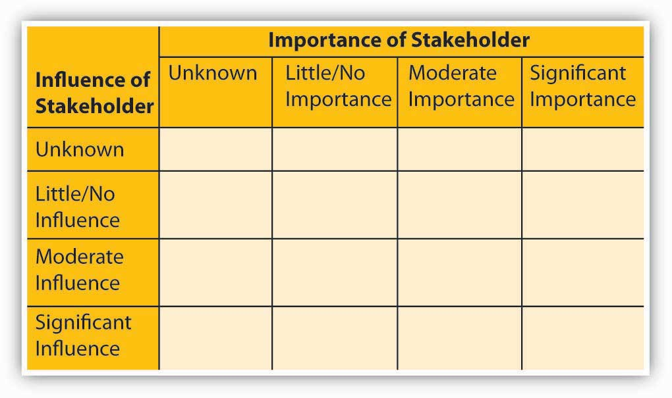
Adapted from Freeman, R. E. (1984). Strategic Management: A Stakeholder Approach. Boston: Pitman.
Let’s pause for a moment to consider the important constituencies we will be charting on our stakeholder map. Before we start, however, we need to remind ourselves that stakeholders can be individuals or groups—communities, social or political organizations, and so forth. In addition, we can break groups down demographically, geographically, by level and branch of government, or according to other relevant criteria. In so doing, we’re more likely to identify important groups that we might otherwise overlook.
With these facts in mind, you can see that, externally, a map of stakeholders will include such diverse groups as governmental bodies, community-based organizations, social and political action groups, trade unions and guilds, and even journalists. National and regional governments and international regulatory bodies will probably be key stakeholders for global firms or those whose strategy calls for greater international presence. Internally, key stakeholders include shareholders, business units, employees, and managers.
Steps in Identifying Stakeholders
Identifying all of a firm’s stakeholders can be a daunting task. In fact, as we will note again shortly, a list of stakeholders that is too long actually may reduce the effectiveness of this important tool by overwhelming decision makers with too much information. To simplify the process, we suggest that you start by identifying groups that fall into one of four categories: organizational, capital market, product market, and social. Let’s take a closer look at this step.
Step 1: Determining Influences on Mission, Vision, and Strategy Formulation.
One way to analyze the importance and roles of the individuals who compose a stakeholder group is to identify the people and teams who should be consulted as strategy is developed or who will play some part in its eventual implementation. These are organizational stakeholders, and they include both high-level managers and frontline workers. Capital-market stakeholders are groups that affect the availability or cost of capital—shareholders, venture capitalists, banks, and other financial intermediaries. Product-market stakeholders include parties with whom the firm shares its industry, including suppliers and customers. Social stakeholders consist broadly of external groups and organizations that may be affected by or exercise influence over firm strategy and performance, such as unions, governments, and activist groups. The next two steps are to determine how various stakeholders are affected by the firm’s strategic decisions and the degree of power that various stakeholders wield over the firm’s ability to choose a course of action.
Step 2: Determining the Effects of Key Decisions on the Stakeholder.
Step 2 in stakeholder analysis is to determine the nature of the effect of the firm’s strategic decisions on the list of relevant stakeholders. Not all stakeholders are affected equally by strategic decisions. Some effects may be rather mild, and any positive or negative effects may be secondary and of minimal impact. At the other end of the spectrum, some stakeholders bear the brunt of firm decisions, good or bad.
In performing step 1, companies often develop overly broad and unwieldy lists of stakeholders. At this stage, it’s critical to determine the stakeholders who are most important based on how the firm’s strategy affects the stakeholders. You must determine which of the groups still on your list have direct or indirect material claims on firm performance or which are potentially adversely affected. For instance, it is easy to see how shareholders are affected by firm strategies—their wealth either increases or decreases in correspondence with the firm’s actions. Other parties have economic interests in the firm as well, such as parties the firm interacts with in the marketplace, including suppliers and customers. The effects on other parties may be much more indirect. For instance, governments have an economic interest in firms doing well—they collect tax revenue from them. However, in cities that are well diversified with many employers, a single firm has minimal economic impact on what the government collects. Alternatively, in other areas, individual firms represent a significant contribution to local employment and tax revenue. In those situations, the effect of firm actions on the government would be much greater.
Step 3: Determining Stakeholders’ Power and Influence over Decisions.
The third step of a stakeholder analysis is to determine the degree to which a stakeholder group can exercise power and influence over the decisions the firm makes. Does the group have direct control over what is decided, veto power over decisions, nuisance influence, or no influence? Recognize that although the degree to which a stakeholder is affected by firm decisions (i.e., step 2) is sometimes highly correlated with their power and influence over the decision, this is often not the case. For instance, in some companies, frontline employees may be directly affected by firm decisions but have no say in what those decisions are. Power can take the form of formal voting power (boards of directors and owners), economic power (suppliers, financial institutions, and unions), or political power (dissident stockholders, political action groups, and governmental bodies). Sometimes the parties that exercise significant power over firm decisions don’t register as having a significant stake in the firm (step 2). In recent years, for example, Wal-Mart has encountered significant resistance in some communities by well-organized groups who oppose the entry of the mega-retailer. Wal-Mart executives now have to anticipate whether a vocal and politically powerful community group will oppose its new stores or aim to reduce their size, which decreases Wal-Mart’s per store profitability. Indeed, in many markets, such groups have been effective at blocking new stores, reducing their size, or changing building specifications.
Once you’ve determined who has a stake in the outcomes of the firm’s decisions as well as who has power over these decisions, you’ll have a basis on which to allocate prominence in the strategy-formulation and strategy-implementation processes. The framework in the figure will also help you categorize stakeholders according to their influence in determining strategy versus their importance to strategy execution. For one thing, this distinction may help you identify major omissions in strategy formulation and implementation.
Having identified stakeholder groups and differentiated them by how they are affected by firm decisions and the power they have to influence decisions, you’ll want to ask yourself some additional questions:
- Have I identified any vulnerable points in either the strategy or its potential implementation?
- Which groups are mobilized and active in promoting their interests?
- Have I identified supporters and opponents of the strategy?
- Which groups will benefit from successful execution of the strategy and which may be adversely affected?
- Where are various groups located? Who belongs to them? Who represents them?

The stakeholder-analysis framework summarized in the figure is a good starting point. Ultimately, because mission and vision are necessarily long term in orientation, identifying important stakeholder groups will help you to understand which constituencies stand to gain or to lose the most if they’re realized.
Two Challenges
Two of the challenges of performing stakeholder analysis are determining how stakeholders are affected by a firm’s decisions and how much influence they have over the implementation of the decisions that are made. Many people have a tendency to fall into the trap of assessing all stakeholders as being important on both dimensions. In reality, not all stakeholders are affected in the same way and not all stakeholders have the same level of influence in determining what a firm does. Moreover, when stakeholder analysis is executed well, the resulting strategy has a better chance of succeeding, simply because the entities you might rely on in the implementation phase were already involved in the strategy starting with the formulation phase. Thus, you now have a good idea of how to engage various stakeholders in all the stages of the P-O-L-C framework.

KEY TAKEAWAY
This section introduced stakeholders, their roles, and how to begin assessing their roles in the development of the organization’s mission and vision. While any person or organization with a stake in your organization is a stakeholder, managers are most concerned with those stakeholders who have the most influence on, or will be most influenced by, the organization. On the basis of your assessment of stakeholders, you now can be proactive in involving them in the P-O-L-C stages.

EXERCISES
- What are stakeholders, and why are they relevant to mission and vision?

- Are stakeholders equally relevant to all parts of P-O-L-C, or only mission and vision?

- What is stakeholder analysis? What are the three identification steps?

- How does stakeholder analysis help you craft a mission and vision statement?

- Which important stakeholders might you intentionally exclude from a mission or vision statement?

- What are the risks of not conducting stakeholder analysis as an input to the formulation of your mission and vision?
4.6 Crafting Mission and Vision Statements
LEARNING OBJECTIVES
- Learn about the basics of the mission and vision development process.

- Understand the content of good mission and vision statements.
Communicating and Monitoring Mission and Vision
At this point, you have an understanding of what a mission and vision statement is and how creativity, passion, and stakeholder interests might be accounted for. The actual step-by-step process of developing a mission and vision might start with the mission and vision statements, but you should think of this process more broadly in terms of multiple steps: (1) the process, (2) the content of the mission and vision statements, (3) communicating mission and vision to all relevant stakeholders, and (4) monitoring. As shown in “Process, Content, Application, and Monitoring in Mission and Vision Development,” Information Week contributor Sourabh Hajela breaks out one way you might manage your mission/vision development checklist. Let’s dive in to the development process first.
Mission and vision statements are statements of an organization’s purpose and potential; what you want the organization to become. Both statements should be meaningful to you and your organization. It should be shared with all of the employees in the organization to create a unified direction for everyone to move in.
Process, Content, Application, and Monitoring in Mission and Vision Development
- Let the business drive the mission and vision.

- Involve all stakeholders in its development; otherwise, they won’t consider it theirs.

- Assign responsibility so that it’s clear how each person, including each stakeholder, can contribute.

- Seek expert facilitation to reach a vision supported by all.

- Revise and reiterate; you’ll likely go through multiple iterations before you’re satisfied.

- Start from where you are to get to where you want to go.

- Build in the values of the organization: Every organization has a soul. Tap into yours, and adjust as needed. Mission and vision built on your values will not just hold promise but also deliver on it.

- Build on the core competencies of the organization: A mission and vision are useless if they can’t be put into operation. This requires recognition of your organization’s strengths and weaknesses.

- Factor in your style: A mission and vision must reflect the leader’s style. You can’t sustain action that goes against it.

- Make it visual: A picture is worth a thousand words.

- Make it simple to understand: Complex language and disconnected statements have little impact—people can’t implement what they don’t understand.

- Make it achievable: A mission and vision are an organization’s dreams for the future. Unachievable goals discourage people.

- Phase it in: Reach for the sky—in stages.

- Make it actionable: If it’s too abstract, no one knows what to do next.

- Communicate often: Internal communications are the key to success. People need to see the mission and vision, identify with them, and know that leadership is serious about it.

- Create messages that relate to the audience: To adopt a mission and vision, people must see how they can achieve it, and what’s in it for them.

- Create messages that inspire action: It’s not what you say, but how you say it.

- Use it: Beyond printing it, posting it, and preaching it, you also need to practice what is laid out in the mission and vision…“walk the talk”

- Live it: Management must lead by example.

- Be real: It’s better to adjust the mission statement as needed than to not live up to the standards it sets.

- Identify key milestones: While traveling to your destination, acknowledge the milestones along the way.

- Monitor your progress: A strategic audit, combined with key metrics, can be used to measure progress against goals and objectives.

- Use external audit team: An external team brings objectivity, plus a fresh perspective.

Sourabh Hajela
Adapted from:
- http://www.informationweek.com/news/management/showArticle.jhtml?articleID=17500069 (retrieved October 29, 2008).
Mission and Vision-Development Process
Mission and vision development are analogous to the “P” (planning) in the P-O-L-C framework. Start with the people. To the greatest extent possible, let those people responsible for executing the mission and vision drive their development. Sometimes this means soliciting their input and guiding them through the development of the actual statements, but ideally, it means teaching them how to craft those statements themselves. Involve as many key stakeholders as possible in its development; otherwise, they won’t consider it theirs. Assign responsibility so that it’s clear how each person, including each stakeholder, can contribute.
Content
The content of the mission and vision statements are analogous to the O (organizing) part of the P-O-L-C framework. Begin by describing the best possible business future for your company, using a target of 5 to 10 years in the future. Your written goals should be dreams, but they should be achievable dreams. Jim Collins (author of Good to Great) suggests that the vision be very bold, or what he likes to call a BHAG—a big, hairy, audacious goal—like the United State’s goal in the 1960s to go to the moon by the end of the decade, or Martin Luther King’s vision for a nonracist America.
Recognizing that the vision statement is derived from aspects of the mission statement, it is helpful to start there. Richard O’ Hallaron and his son, David R. O’ Hallaron, in The Mission Primer: Four Steps to an Effective Mission Statement, suggest that you consider a range of objectives, both financial and nonfinancial.
- O’Hallaron, R., & O’Hallaron, D. (2000). The Mission Primer: Four Steps to an Effective Mission Statement, Richmond: Mission Incorporated
Their approach is based on Gast’s Laws, a set of principles developed in the 1940s and 1950s by the late business professor Walter Gast. Among other ideas, Gast’s Laws hold that businesses must be dedicated to more than making money if they are to succeed. Specifically, the O’Hallarons find that the best mission statements have given attention to the following six areas:
- What “want-satisfying” service or commodity do we produce and work constantly to improve?

- How do we increase the wealth or quality of life or society?

- How do we provide opportunities for the productive employment of people?

- How are we creating a high-quality and meaningful work experience for employees?

- How do we live up to the obligation to provide fair and just wages?

- How do we fulfill the obligation to provide a fair and just return on capital?

When writing your statements, use the present tense, speaking as if your business has already become what you are describing. Use descriptive statements describing what the business looks like, feels like, using words that describe all of a person’s senses. Your words will be a clear written motivation for where your business organization is headed. Mission statements, because they cover more ground, tend to be longer than vision statements, but you should aim to write no more than a page. Your words can be as long as you would like them to be, but a shorter vision statement may be easier to remember.
Communications
The communications step of the mission and vision statements development process is analogous to the “L” (leading) part of the P-O-L-C framework. Communicate often: Internal communications are the key to success. People need to see the vision, identify with it, and know that leadership is serious about it.
Managers must evaluate both the need and the necessary tactics for persuasively communicating a strategy in four different directions: upward, downward, across, and outward.
- Hambrick, D. C., & Cannella, A. A. (1989). Strategy implementation as substance and selling. Academy of Management Executive, 3(4), 278–285.
Communicating Upward
Increasingly, firms rely on bottom-up innovation processes that encourage and empower middle-level and division managers to take ownership of mission and vision and propose new strategies to achieve them. Communicating upward means that someone or some group has championed the vision internally and has succeeded in convincing top management of its merits and feasibility.
Communicating Downward
Communicating downward means enlisting the support of the people who’ll be needed to implement the mission and vision. Too often, managers undertake this task only after a strategy has been set in stone, thereby running the risk of undermining both the strategy and any culture of trust and cooperation that may have existed previously. Starting on the communication process early is the best way to identify and surmount obstacles, and it usually ensures that a management team is working with a common purpose and intensity that will be important when it’s time to implement the strategy.
Communicating Across and Outward
The need to communicate across and outward reflects the fact that realization of a mission and vision will probably require cooperation from other units of the firm (across) and from key external stakeholders, such as material and capital providers, complementors, and customers (outward). Internally, for example, the strategy may call for raw materials or services to be provided by another subsidiary; perhaps it depends on sales leads from other units. The software company Emageon couldn’t get hospitals to adopt the leading-edge visualization software that was produced and sold by one subsidiary until its hardware division started cross-selling the software as well. This internal coordination required a champion from the software side to convince managers on the hardware side of the need and benefits of working together.
Application
It is the successful execution of this step—actually using the mission and vision statements—that eludes most organizations. “Yes, it is inconvenient and expensive to move beyond the easy path” and make decisions that support the mission statement, says Lila Booth, a Philadelphia-area consultant who is on the faculty of the Wharton Small Business Development Center. But ditching mission for expediency “is short-term thinking,” she adds, “which can be costly in the end, costly enough to put a company out of business.”
- Krattenmaker, T. (2002). Writing a Mission Statement That Your Company Is Willing to Live. Boston: Harvard Business School Press.
That is not to say that a mission statement is written in stone. Booth cites her own consulting business. It began well before merger mania but has evolved with the times and now is dedicated in significant part to helping merged companies create common cultures. “Today, our original mission statement would be very limiting,” she says.
Even the most enthusiastic proponents acknowledge that mission statements are often viewed cynically by organizations and their constituents. That is usually due to large and obvious gaps between a company’s words and deeds. “Are there companies that have managers who do the opposite of what their missions statements dictate? Of course,” says Geoffrey Abrahams, author of The Mission Statement Book. “Mission statements are tools, and tools can be used or abused or ignored.…Management must lead by example. It’s the only way employees can live up to the company’s mission statement.”
- Abrahams, J. (1999). The Mission Statement Book: 301 Corporate Mission Statements from America’s Top Companies. Berkeley: Ten Speed Press.
Ultimately, if you are not committed to using the mission statement then you are best advised not to create one.
Monitoring
The monitoring step of the mission and vision statements development process is analogous to the “C” (controlling) part of the P-O-L-C framework. Identify key milestones that are implied or explicit in the mission and vision. Since mission and vision act like a compass for a long trip to a new land, as Information Week’s Hajela suggests, “while traveling to your destination, acknowledge the milestones along the way. With these milestones you can monitor your progress: A strategic audit, combined with key metrics, can be used to measure progress against goals and objectives. To keep the process moving, try using an external audit team. One benefit is that an external team brings objectivity, plus a fresh perspective.”
- Retrieved October 28, 2008, from http://www.informationweek.com/news/management/showArticle.jhtml?articleID=17500069.
It also helps motivate your team to stay on track.

KEY TAKEAWAY
This section described some of the basic inputs into crafting mission and vision statements. It explored how mission and vision involved initiation, determination of content, communication, application, and then monitoring to be sure if and how the mission and vision were being followed and realized. In many ways, you learned how the development of mission and vision mirrors the P-O-L-C framework itself—from planning to control (monitoring).

EXERCISES
- Who should be involved in the mission and vision development process?

- What are some key content areas for mission and vision?

- Why are organizational values important to mission and vision?

- Why is communication important with mission and vision?

- To which stakeholders should the mission and vision be communicated?

- What role does monitoring play in mission and vision?
4.7 Developing Your Personal Mission and Vision
LEARNING OBJECTIVES
- Determine what mission and vision mean for you.

- Develop some guidelines for developing your mission and vision.

Mission and vision are concepts that can be applied to you, personally, well beyond their broader relevance to the P-O-L-C framework. Personal mission and vision communicate the direction in which you are headed, as well as providing some explanation for why you are choosing one direction or set of objectives over others. Thinking about and writing down mission and vision statements for your life can help provide you with a compass as you work toward your own goals and objectives.
Your Mission and Vision
Note that the development of a personal mission and vision, and then a strategy for achieving them, are exactly the opposite of what most people follow. Most people do not plan further ahead than their next job or activity (if they plan their career at all). They take a job because it looks attractive, and then they see what they can do with it. We advocate looking as far into the future as you can and deciding where you want to end up and what steps will lead you there. In that way, your life and your career fit into some intelligent plan, and you are in control of your own life.
Guidelines
The first step in planning a career is obviously a long-term goal. Where do you want to end up, ultimately? Do you really want to be a CEO or president of the United States, now that you know what it costs to be either one? There are a couple basic parts to this process.
BHAG
First, set out a bold vision—Jim Collins, author of Good to Great, describes this as a BHAG a big, hairy, audacious goal.
Five guiding criteria for good BHAGs is that they:
- Are set with understanding, not bravado.

- Fit squarely in the three circles of:

  - what you are deeply passionate about (including your core values and purpose);
  - what drives your economic logic; and
  - what differentiates you (what you can be the best in the world at).

- Have a long time frame—10 to 30 years.

- Are clear, compelling, and easy to grasp.

- Directly reflect your core values and core purpose.
Values
Second, sketch out your personal values, or “Guiding Philosophy”—a set of core values and principles like your own Declaration of Independence.
Schedule
Once the vision is set, you have to develop some long-term goal (or goals), then intermediate-term goals, and so on. If you want to be President, what jobs will you have to take first to get there and when do you have to get these jobs? Where should you live? What training do you need? What political connections do you need? Then you have to set up an orderly plan for obtaining the connections and training that you need and getting into these steppingstone jobs.
Finally, you need to establish short-term goals to fit clearly into a coherent plan for your entire career. Your next job (if you are now a fairly young person) should be picked not only for its salary or for its opportunities for advancement but for its chances to provide you with the training and connections you need to reach your long-term goals. The job that is superficially attractive to you because it has a high salary, offers the opportunity for immediate advancement, or is located in a desirable place may be a mistake from the standpoint of your long-term career.
Five Steps
Former business school professor, entrepreneur (founder of www.quintcareers.com), and colleague Randall S. Hansen, PhD, has done a masterful job of assembling resources that aim to help your career, including an excellent five-step plan for creating personal mission statements. With his generous permission, he has allowed us to reproduce his five-step plan—adapted by us to encompass both mission and vision—in this section.
The Five-Step Plan
A large percentage of companies, including most of the Fortune 500, have corporate mission and vision statements.
- Retrieved October 29, 2008, from http://www.quintcareers.com/creating_personal_mission_statements.html.
Reproduced and adapted with written permission from Randall S. Hansen. The content of this work is his, and any errors or omissions are our responsibility. Mission and vision statements are designed to provide direction and thrust to an organization, an enduring statement of purpose. A mission and vision statement act as an invisible hand that guides the people in the organization. A mission and vision statement explains the organization’s reason for being and answers the question, “What business are we in?”
A personal mission and vision statement is a bit different from a company mission statement, but the fundamental principles are the same. Writing a personal mission and vision statement offers the opportunity to establish what’s important and perhaps make a decision to stick to it before we even start a career. Or it enables us to chart a new course when we’re at a career crossroads. Steven Covey (in First Things First) refers to developing a mission and vision statement as “connecting with your own unique purpose and the profound satisfaction that comes from fulfilling it.”
- Covey, S. R. (1994). First Things First. New York: Simon & Schuster.
A personal mission and vision statement helps job seekers identify their core values and beliefs. Michael Goodman (in The Potato Chip Difference: How to Apply Leading Edge Marketing Strategies to Landing the Job You Want) states that a personal mission statement is “an articulation of what you’re all about and what success looks like to you.”
- Goodman, M. (2001). The Potato Chip Difference. New York: Dialogue Press.
A personal mission and vision statement also allows job seekers to identify companies that have similar values and beliefs and helps them better assess the costs and benefits of any new career opportunity.
The biggest problem most job seekers face is not in wanting to have a personal mission and vision statement but actually writing it. So, to help you get started on your personal mission and vision statement, here is a five-step mission/vision-building process. Take as much time on each step as you need, and remember to dig deeply to develop a mission and vision statement that is both authentic and honest. To help you better see the process, Professor Hansen included an example of one friend’s process in developing her mission and vision statements.
Sample Personal Mission Statement Development
- Past success:

- developed new product features for stagnant product
- part of team that developed new positioning statement for product
- helped child’s school with fundraiser that was wildly successful
- increased turnout for the opening of a new local theater company

- Themes: Successes all relate to creative problem solving and execution of a solution.

- Core values:

- Hard working
- Industrious
- Creativity
- Problem solving
- Decision maker
- Friendly
- Outgoing
- Positive
- Family-oriented
- Honest
- Intelligent
- Compassionate
- Spiritual
- Analytical
- Passionate
- Contemplative

- Most important values:

- Problem solving
- Creativity
- Analytical
- Compassionate
- Decision maker
- Positive

- Most important value:

- Creativity

- Identify Contributions:

- the world in general: develop products and services that help people achieve what they want in life. To have a lasting effect on the way people live their lives.
- my family: to be a leader in terms of personal outlook, compassion for others, and maintaining an ethical code; to be a good mother and a loving wife; to leave the world a better place for my children and their children.
- my employer or future employers: to lead by example and demonstrate how innovative and problem-solving products can be both successful in terms of solving a problem and successful in terms of profitability and revenue generation for the organization.
- my friends: to always have a hand held out for my friends; for them to know they can always come to me with any problem.
- my community: to use my talents in such a way as to give back to my community.

- Identify Goals:

- Short term: To continue my career with a progressive employer that allows me to use my skills, talent, and values to achieve success for the firm.
- Long term: To develop other outlets for my talents and develop a longer-term plan for diversifying my life and achieving both professional and personal success.

- Mission Statement:

- To live life completely, honestly, and compassionately, with a healthy dose of realism mixed with the imagination and dreams that all things are possible if one sets their mind to finding an answer.
- Vision Statement:To be the CEO of a firm that I start, that provides educational exercise experiences to K–6 schools. My company will improve children’s health and fitness, and create a lasting positive impact on their lives, and that of their children.

Step 1: Identify Past Successes. Spend some time identifying four or five examples where you have had personal success in recent years. These successes could be at work, in your community, or at home. Write them down. Try to identify whether there is a common theme—or themes—to these examples. Write them down.
Step 2: Identify Core Values. Develop a list of attributes that you believe identify who you are and what your priorities are. The list can be as long as you need. Once your list is complete, see whether you can narrow your values to five or six most important values. Finally, see whether you can choose the one value that is most important to you. We’ve added “Generating Ideas for Your Mission and Vision” to help jog your memory and brainstorm about what you do well and really like to do.
Step 3: Identify Contributions. Make a list of the ways you could make a difference. In an ideal situation, how could you contribute best to:
- the world in general
- your family
- your employer or future employers
- your friends
- your community
Generating Ideas for Your Mission and Vision
A useful mission and vision statement should include two pieces: what you wish to accomplish and contribute and who you want to be, the character strengths and qualities you wish to develop. While this sounds simple, those pieces of information are not always obvious. Try these tools for generating valuable information about yourself.
Part I
- Describe your ideal day. This is not about being practical. It is designed to include as many sides of you and your enthusiasms as possible: creative, competent, artistic, introverted, extraverted, athletic, playful, nurturing, contemplative, and so on.

- Imagine yourself 132 years old and surrounded by your descendants or those descendants of your friends. You are in a warm and relaxed atmosphere (such as around a fireplace). What would you say to them about what is important in life? This exercise is designed to access the values and principles that guide your life.

- Imagine that it is your 70th birthday (or another milestone in your life). You have been asked by national print media to write a press release about your achievements. Consider what you would want your family, friends, coworkers in your profession and in your community to say about you. What difference would you like to have made in their lives? How do you want to be remembered? This is designed to inventory your actions and accomplishments in all areas of your life.

Part II
Review your notes for these three exercises. With those responses in mind, reflect on questions 1, 2, and 3 above. Then write a rough draft (a page of any length) of your mission statement. Remember that it should describe what you want to do and who you want to be. This is not a job description. Carry it with you, post copies in visible places at home and work, and revise and evaluate. Be patient with yourself. The process is as important as the outcome. After a few weeks, write another draft. Ask yourself whether your statement was based on proven principles that you believe in, if you feel direction, motivation, and inspiration when you read it. Over time, reviewing and evaluating will keep you abreast of your own development.
Step 4: Identify Goals. Spend some time thinking about your priorities in life and the goals you have for yourself. Make a list of your personal goals, perhaps in the short term (up to three years) and the long term (beyond three years).
Step 5: Write Mission and Vision Statements. On the basis of the first four steps and a better understanding of yourself, begin writing your personal mission and vision statements.
Final thoughts: A personal mission and vision statement is, of course, personal. But if you want to see whether you have been honest in developing your personal mission and vision statement, we suggest sharing the results of this process with one or more people who are close to you. Ask for their feedback. Finally, remember that mission and vision statements are not meant to be written once and blasted into stone. You should set aside some time annually to review your career, job, goals, and mission and vision statements—and make adjustments as necessary.

KEY TAKEAWAY
In this section, you learned how to think of mission and vision in terms of your personal circumstances, whether it is your career or other aspects of your life. Just as you might do in developing an organization’s vision statement, you were encouraged to think of a big, hairy audacious goal as a starting point. You also learned a five-step process for developing a personal vision statement.

EXERCISES
- How does a personal mission and vision statement differ from one created for an organization?

- What time period should a personal mission and vision statement cover?

- What are the five steps for creating a personal mission and vision statement?

- What type of goals should you start thinking about in creating a personal mission and vision?

- How are your strengths and weaknesses relevant to mission and vision?

- What stakeholders seem relevant to your personal mission and vision?

Chapter 5

Strategizing

WHAT’S IN IT FOR ME?
Reading this chapter will help you do the following:
- See how strategy fits in the planning-organizing-leading-controlling (P-O-L-C) framework.
- Better understand how strategies emerge.
- Understand strategy as trade-offs, discipline, and focus.
- Conduct internal analysis to develop strategy.
- Conduct external analysis to develop strategy.
- Formulate organizational and personal strategy with the strategy diamond.
Strategic management, strategizing for short, is essentially about choice—in terms of what the organization will do and won’t do to achieve specific goals and objectives, where such goals and objectives lead to the realization of a stated mission and vision. Strategy is a central part of the planning function in P-O-L-C. Strategy is also about making choices that provide an organization with some measure of competitive advantage or even a sustainable competitive advantage. For the most part, this chapter emphasizes strategy formulation (answers to the “What should our strategy be?” question) as opposed to strategy implementation (answers to questions about “How do we execute a chosen strategy?”). The central position of strategy is summarized in the following figure. In this chapter, you will learn about strategic management and how it fits in the P-O-L-C framework. You will also learn some of the key internal and external analyses that support the development of good strategies. Finally, you will see how the concept of strategy can be applied to you personally, in addition to professionally.

Figure 5.2 The P-O-L-C Framework

Figure 5.3 Where Strategy Fits in “Planning”
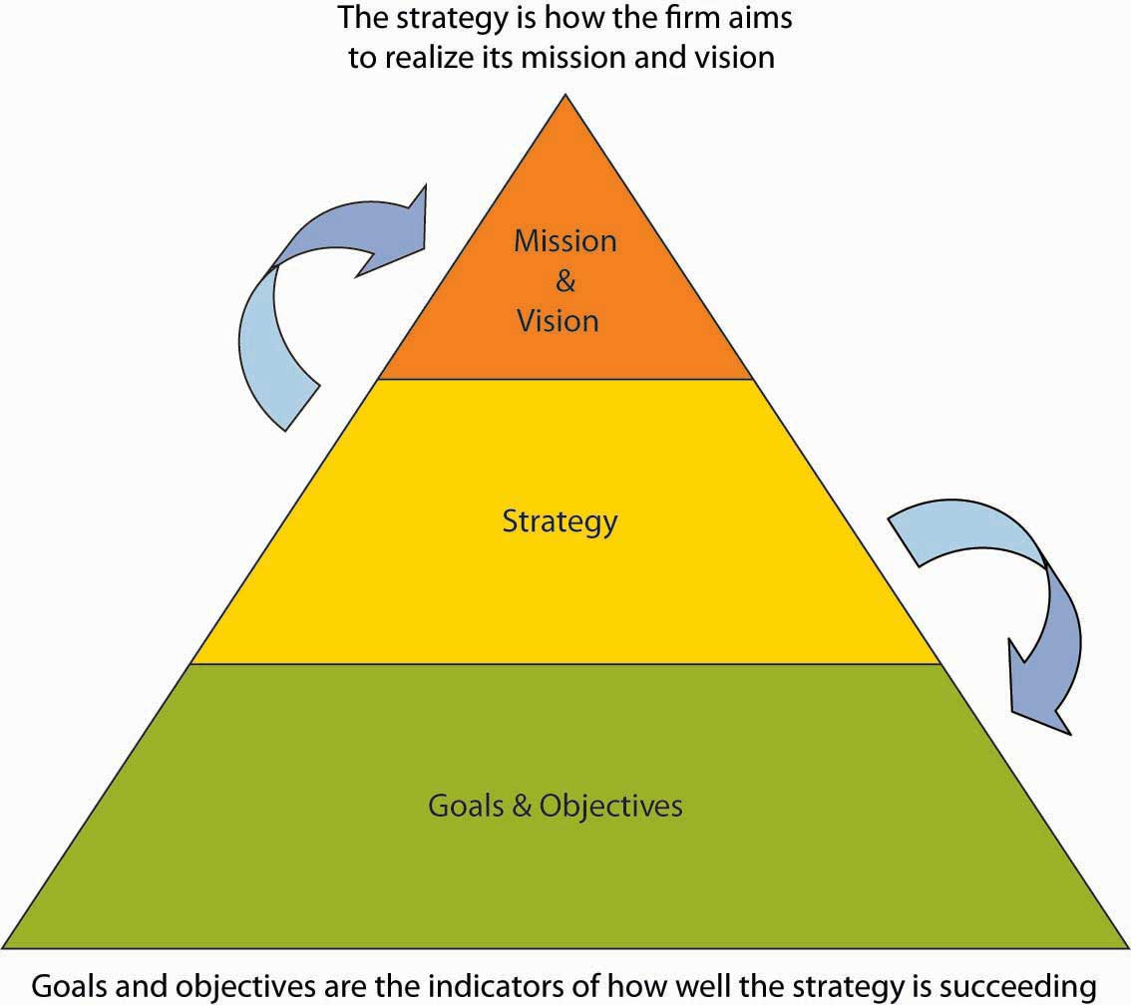

5.1 Case in Point: Flat World Knowledge Transforms Textbook Industry

Figure 5.4 Flat World Knowledge Cofounder, Jeff Shelstad
Source: Used by permission from Flat World Knowledge Inc.
Two textbook publishing industry veterans, Jeff Shelstad and Eric Frank, started Flat World Knowledge (FWK), a privately held company, in 2007 to be a new and disruptive model for the college textbook market. Traditional business textbook publishers carry a portfolio of 5 to 10 titles per subject and charge premium prices for new textbooks, an average of $1,000 in textbooks for a college student’s first year, according to a recent General Accounting Office (GAO) report. FWK’s strategy aims to turn the traditional model on its head by providing online textbook access free to students. FWK earns revenues by selling students the digital textbooks in alternate formats, print and audio initially, and also by selling highly efficient and mobile study aids. Despite the fact that professors have rated the academic quality of FWK textbooks as equal to or higher than that of textbooks from traditional publishers, the cost to students is a fraction of current market prices due to the efficiencies of the FWK business model. Moreover, with FWK’s open-source platform, instructors who adopt FWK books for their classes are able to pick and choose the material provided to their students, even if it is from earlier versions of textbooks that have since been revised.
Shelstad and Frank founded FWK because they believed that big publishers would continue to experiment and innovate, and enjoy the advantages of scale, capital, content, and brand. But the FWK founders also believed that the pace and nature of change by the big publishers of the textbook industry would remain modest and marginal, held back by an inflexible go-to market strategy, with a reflexive (and shortsighted) exercise of pricing power, outdated business models, intransigent channel partners, existing contracts, and a fear of price cannibalization, as well as the traditional culture and organizational barriers.
To seize this perceived market opportunity, FWK designed a strategy based on publishing textbooks around the three main pillars of books that are (1) free, (2) open, and (3) authored by highly respected authors. Ultimately students (or parents) pay for books. Between a publisher and the student is a gatekeeper—the instructor. The first step to revenue is to convince the gatekeeper to assign (“adopt”) an FWK textbook instead of other choices. Only then does FWK establish a relationship with the gatekeeper’s students and earn the opportunity to monetize those relationships through the sale of print books, study aids, user-generated content, and corporate sponsorship. FWK’s strategy, therefore, aims to provide a compelling value proposition to instructors to maximize adoptions and, thus, student relationships.

Figure 5.5
Source: Used by permission from Flat World Knowledge Inc.
How is FWK’s strategy working so far? Through the start of 2010, the FWK strategy has proven effective. New customers and books come online daily and the growth trends are positive. Its first term (fall of 2009), FWK had 40,000 students using its textbooks. This has continued to rise. Several new projects are under way in international business, entrepreneurship, legal environment, and mathematical economics. Media attention to the fledgling FWK has generally been favorable. Social media experts also gave the company accolades. For example, Chris Anderson devoted a page to the FWK business model in his bestselling book Free. Moreover, early user reviews of the product were also very positive. For instance, an instructor who adopted Principles of Management noted, “I highly recommend this book as a primary textbook for…business majors. The overall context is quite appropriate and the search capability within the context is useful. I have been quite impressed [with] how they have highlighted the key areas.” At the same time, opportunities to improve the Web interface still existed, with the same reviewer noting, “The navigation could be a bit more user friendly, however.” FWK uses user input like this to better adjust the strategy and delivery of its model. This type of feedback led the FWK design squad to improve its custom Web interface, so that instructors can more easily change the book. Only time will tell if the $11 million invested in FWK by 2010 will result in the establishment of a new titan in textbook publishing or will be an entrepreneurial miss.
Primary Resource:
- Carpenter, M., Bauer, T., & Erdogan, B. (2009). Principles of management (1st ed.). New York: Flat World Knowledge
Secondary Resources:
- Based on information from United States Government Accountability Office. (2005, July). College textbooks: Enhanced offering appear to drive recent price increases (GAO-05-806). Retrieved April 22, 2010, from http://www.gao.gov/cgi-bin/getrpt?GAO-05-806
- Community College Open Textbook Collaborative. (2009). Business reviews. Retrieved April 22, 2010, fromhttp://www.collegeopentextbooks.org/reviews/business.html
Personal interviews with Jeff Shelstad and Eric Frank.

DISCUSSION QUESTIONS
- Planning is a key component to the P-O-L-C framework. What type of planning do you think the founders of Flat World Knowledge engaged in?
- What competitive advantages does Flat World Knowledge possess?
- What are Flat World Knowledge’s key strengths, weaknesses, opportunities, and threats?
- How might the extensive textbook industry experience the Flat World Knowledge founders possess help or hinder their strategy formulation and ultimate success or failure?
- Based on Porter’s strategies summarized in the figure below, which type of strategy do you see Flat World Knowledge employing? Support your response.

Figure 5.6
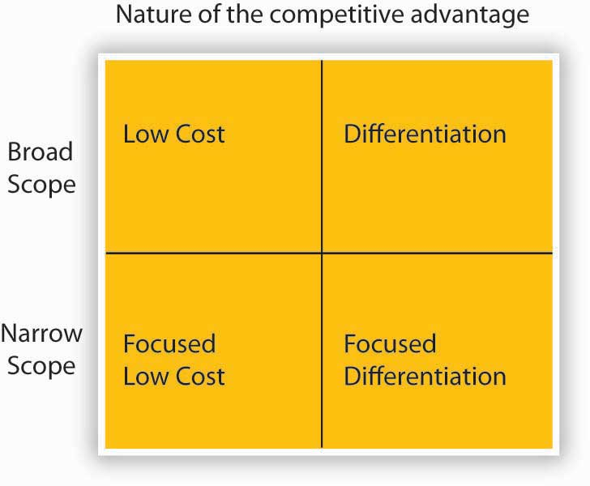
Source: Porter, M. E. (1980). Competitive Strategy. New York: Free Press.

5.2 Strategic Management in the P-O-L-C Framework

LEARNING OBJECTIVES
- Be able to define strategic management.
- Understand how strategic management fits in the P-O-L-C framework.
- Broadly identify the inputs for strategy formulation.

What Is Strategic Management?
As you already know, the P-O-L-C framework starts with “planning.” You might also know that planning is related to, but not synonymous with, strategic management. Strategic management reflects what a firm is doing to achieve its mission and vision, as seen by its achievement of specific goals and objectives.
A more formal definition tells us that the strategic management process “is the process by which a firm manages the formulation and implementation of its strategy.”
- Carpenter, M. A., & Sanders, W. G. (2009). Strategic management (p. 8). Upper Saddle River, NJ: Pearson/Prentice-Hall
The strategic management process is “the coordinated means by which an organization achieves its goals and objectives.”
- Carpenter, M. A., & Sanders, W. G. (2009). Strategic management (p. 10). Upper Saddle River, NJ: Pearson/Prentice-Hall
Others have described strategy as the pattern of resource allocation choices and organizational arrangements that result from managerial decision making.
- Mintzberg, H. 1978. Patterns in strategy formulation. Management Science, 24, 934–949
Planning and strategy formulation sometimes called business planning, or strategic planning, have much in common, since formulation helps determine what the firm should do. Strategy implementation tells managers how they should go about putting the desired strategy into action.
The concept of strategy is relevant to all types of organizations, from large, public companies like GE, to religious organizations, to political parties.

Strategic Management in the P-O-L-C Framework
If vision and mission are the heart and soul of planning (in the P-O-L-C framework), then strategy, particularly strategy formulation, would be the brain. The following figure summarizes where strategy formulation (strategizing) and implementation fit in the planning and other components of P-O-L-C. We will focus primarily on the strategy formulation aspects of strategic management because implementation is essentially organizing, leading, and controlling P-O-L-C components.

Figure 5.7 Strategizing in P-O-L-C
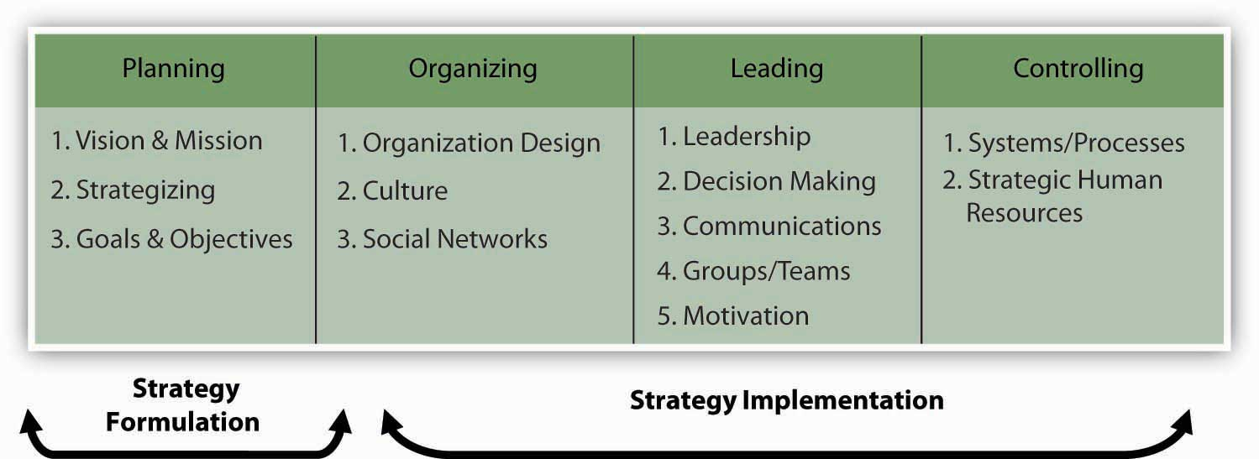
You see that planning starts with vision and mission and concludes with setting goals and objectives. In-between is the critical role played by strategy. Specifically, a strategy captures and communicates how vision and mission will be achieved and which goals and objectives show that the organization is on the right path to achieving them.
At this point, even in terms of strategy formulation, there are two aspects of strategizing that you should recognize. The first, corporate strategy answers strategy questions related to “What business or businesses should we be in?” and “How does our business X help us compete in business Y, and vice versa?” In many ways, corporate strategy considers an organization to be a portfolio of businesses, resources, capabilities, or activities. You are probably familiar with McDonald’s, for instance, and their ubiquitous golden arches fast-food outlets. However, you may be less likely to know that McDonald’s owned the slightly upscale burrito vendor Chipotle for several years as well.
- Carpenter, M. A., & Sanders, W. G. (2008) Fast food chic? The Chipotle burrito. University of Wisconsin Business Case
The McDonald’s corporate strategy helped its managers evaluate and answer questions about whether it made sense for McDonald’s set of businesses to include different restaurants such as McDonald’s and Chipotle. While other food-service companies have multiple outlets—YUM! Brands, for example, owns A&W, Taco Bell, Pizza Hut, Long John Silver’s, and Kentucky Fried Chicken—McDonald’s determined that one brand (McDonald’s) was a better strategy for it in the future, and sold off Chipotle in 2006. The following figure provides a graphic guide to this kind of planning.

Figure 5.8 Corporate and Business Strategy
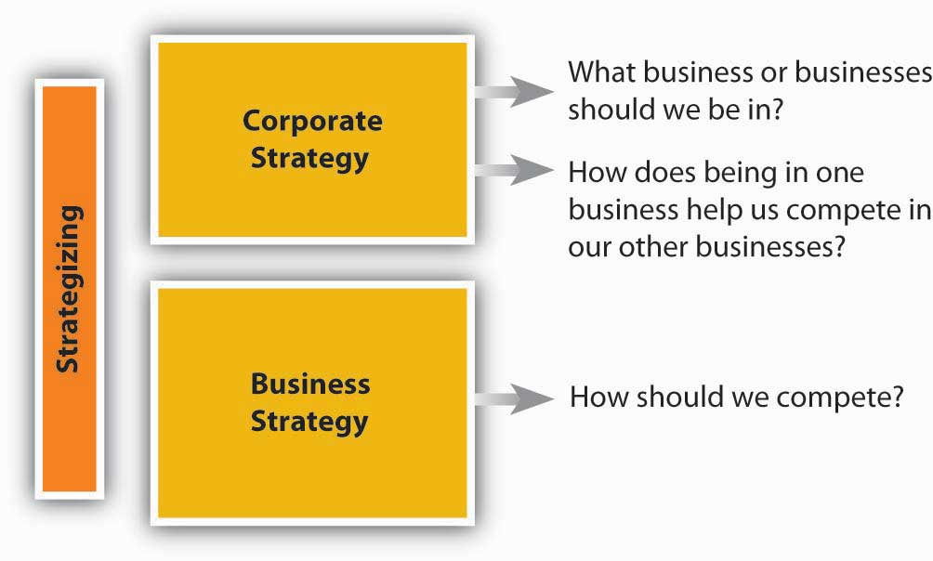
The logic behind corporate strategy is one of synergy and diversification. That is, synergies arise when each of YUM! Brands food outlets does better because they have common ownership and can share valuable inputs into their businesses. Specifically, synergy exists when the interaction of two or more activities (such as those in a business) create a combined effect greater than the sum of their individual effects. The idea is that the combination of certain businesses is stronger than they would be individually because they either do things more cheaply or of higher quality as a result of their coordination under a common owner.
Diversification in contrast, is where an organization participates in multiple businesses that are in some way distinct from each other, as Taco Bell is from Pizza Hut, for instance. Just as with a portfolio of stock, the purpose of diversification is to spread out risk and opportunities over a larger set of businesses. Some may be high growth, some slow growth or declining; some may perform worse during recessions, while others perform better. Sometimes the businesses can be very different, such as when fashion sunglass maker Maui Jim diversified into property and casualty insurance through its merger with RLI Corporation.
- Retrieved October 30, 2008, http://www.secinfo.com/dRqWm.89X3.htm#34f.
Perhaps more than a coincidence, RLI was founded some 60 years earlier as Replacement Lens International (later changed to its abbreviation, RLI, in line with its broader insurance products offerings), with the primary business of providing insurance for replacement contact lenses. There are three major diversification strategies: (1) concentric diversification, where the new business produces products that are technically similar to the company’s current product but that appeal to a new consumer group; (2) horizontal diversification, where the new business produces products that are totally unrelated to the company’s current product but that appeal to the same consumer group; and (3) conglomerate diversification, where the new business produces products that are totally unrelated to the company’s current product and that appeal to an entirely new consumer group.
Whereas corporate strategy looks at an organization as a portfolio of things, business strategyfocuses on how a given business needs to compete to be effective. Again, all organizations need strategies to survive and thrive. A neighborhood church, for instance, probably wants to serve existing members, build new membership, and, at the same time, raise surplus monies to help it with outreach activities. Its strategy would answer questions surrounding the accomplishment of these key objectives. In a for-profit company such as McDonald’s, its business strategy would help it keep existing customers, grow its business by moving into new markets and taking customers from competitors like Taco Bell and Burger King, and do all this at a profit level demanded by the stock market.

Strategic Inputs
So what are the inputs into strategizing? At the most basic level, you will need to gather information and conduct analysis about the internal characteristics of the organization and the external market conditions. This means an internal appraisal and an external appraisal. On the internal side, you will want to gain a sense of the organization’s strengths and weaknesses; on the external side, you will want to develop some sense of the organization’s opportunities and threats. Together, these four inputs into strategizing are often called SWOT analysis which stands for strengths, weaknesses, opportunities, and threats (see the SWOT analysis figure). It does not matter if you start this appraisal process internally or externally, but you will quickly see that the two need to mesh eventually. At the very least, the strategy should leverage strengths to take advantage of opportunities and mitigate threats, while the downside consequences of weaknesses are minimized or managed.

Figure 5.9 SWOT Analysis
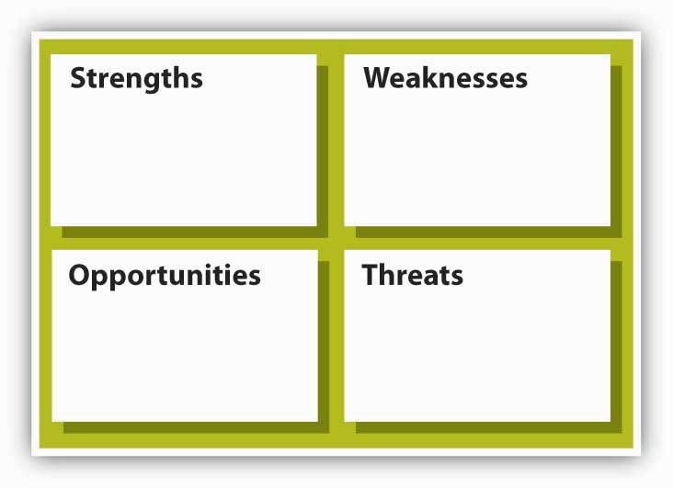

SWOT was developed by Ken Andrews in the early 1970s.
- Andrews, K. (1971). The concept of corporate strategy. Homewood, IL: R. D. Irwin.
An assessment of strengths and weaknesses occurs as a part of organizational analysis; that is, it is an audit of the company’s internal workings, which are relatively easier to control than outside factors. Conversely, examining opportunities and threats is a part of environmental analysis—the company must look outside of the organization to determine opportunities and threats, over which it has lesser control.
Andrews’s original conception of the strategy model that preceded the SWOT asked four basic questions about a company and its environment: (1) What can we do? (2) What do we want to do? (3) What might we do? and (4) What do others expect us to do?

Strengths and Weaknesses
A good starting point for strategizing is an assessment of what an organization does well and what it does less well. In general good strategies take advantage of strengths and minimize the disadvantages posed by any weaknesses. Michael Jordan, for instance, is an excellent all-around athlete; he excels in baseball and golf, but his athletic skills show best in basketball. As with Jordan, when you can identify certain strengths that set an organization well apart from actual and potential competitors, that strength is considered a source of competitive advantage. The hardest thing for an organization to do is to develop its competitive advantage into a sustainable competitive advantage where the organization’s strengths cannot be easily duplicated or imitated by other firms, nor made redundant or less valuable by changes in the external environment.

Opportunities and Threats
On the basis of what you just learned about competitive advantage and sustainable competitive advantage, you can see why some understanding of the external environment is a critical input into strategy. Opportunities assess the external attractive factors that represent the reason for a business to exist and prosper. These are external to the business. What opportunities exist in its market, or in the environment, from which managers might hope the organization will benefit? Threats include factors beyond your control that could place the strategy, or the business, at risk. These are also external—managers typically have no control over them, but may benefit by having contingency plans to address them if they should occur.

SWOT Analysis of Flat World Knowledge
Flat World Knowledge is a new college textbook company (and the publisher of this POM text!) that operates with the tagline vision of “Free textbooks. Online. Anytime. Anywhere. Anyone.”
Strengths
- Great management team.
- Great college business textbooks.
- Experienced author pool.
- Proprietary technology.
Weaknesses
- Limited number of books.
- New technology.
- Relatively small firm size.
Opportunities
- External pressure to lower higher education costs, including textbook prices.
- Internet savvy students and professors.
- Professors and students largely displeased with current textbook model.
- Technology allows textbook customization.
Threats
- Strong competitors.
- Competitors are few, very large, and global.
- Substitute technologies exist.
In a nutshell, SWOT analysis helps you identify strategic alternatives that address the following questions:
- Strengths and Opportunities (SO)—How can you use your strengths to take advantage of the opportunities?
- Strengths and Threats (ST)—How can you take advantage of your strengths to avoid real and potential threats?
- Weaknesses and Opportunities (WO)—How can you use your opportunities to overcome the weaknesses you are experiencing?
- Weaknesses and Threats (WT)—How can you minimize your weaknesses and avoid threats?
Before wrapping up this section, let’s look at a few of the external and internal analysis tools that might help you conduct a SWOT analysis. These tools are covered in greater detail toward the end of the chapter.

Internal Analysis Tools
Internal analysis tools help you identify an organization’s strengths and weaknesses. The two tools that we identify here, and develop later in the chapter, are the value chain and VRIO tools. The value chain asks you, in effect, to take the organization apart and identify the important constituent parts. Sometimes these parts take the form of functions, like marketing or manufacturing. For instance, Disney is really good at developing and making money from its branded products, such as Cinderella or Pirates of the Caribbean. This is a marketing function (it is also a design function, which is another Disney strength).
Value chain functions are also called capabilities. This is where VRIO comes in. VRIO stands for valuable, rare, inimitable, and organization—basically, the VRIO framework suggests that a capability, or a resource, such as a patent or great location, is likely to yield a competitive advantage to an organization when it can be shown that it is valuable, rare, difficult to imitate, and supported by the organization (and, yes, this is the same organization that you find in P-O-L-C). Essentially, where the value chain might suggest internal areas of strength, VRIO helps you understand whether those strengths will give it a competitive advantage. Going back to our Disney example, for instance, strong marketing and design capabilities are valuable, rare, and very difficult to imitate, and Disney is organized to take full advantage of them.

External Analysis Tools
While there are probably hundreds of different ways for you to study an organizations’ external environment, the two primary tools are PESTEL and industry analysis. PESTEL, as you probably guessed, is simply an acronym. It stands for political, economic, sociocultural, technological, environmental, and legal environments. Simply, the PESTEL framework directs you to collect information about, and analyze, each environmental dimension to identify the broad range of threats and opportunities facing the organization. Industry analysis, in contrast, asks you to map out the different relationships that the organization might have with suppliers, customers, and competitors. Whereas PESTEL provides you with a good sense of the broader macro-environment, industry analysis should tell you about the organization’s competitive environment and the key industry-level factors that seem to influence performance.

KEY TAKEAWAY
Strategy formulation is an essential component of planning; it forms the bridge that enables the organization to progress from vision and mission to goals and objectives. In terms of the P-O-L-C framework, strategy formulation is the P (planning) and strategy implementation is realized by O-L-C. Corporate strategy helps to answer questions about which businesses to compete in, while business strategy helps to answer questions about how to compete. The best strategies are based on a thorough SWOT analysis—that is, a strategy that capitalizes on an organization’s strengths, weaknesses, opportunities, and threats.

EXERCISES
- What is the difference between strategy formulation and strategy implementation?
- What is the difference between business strategy and corporate strategy?
- What are some of the forms of diversification, and what do they mean?
- What do you learn from a SWOT analysis?
- In SWOT analysis, what are some of the tools you might use to understand the internal environment (identify strengths and weaknesses)?
- In SWOT analysis, what are some of the tools you might use to understand the external environment (identify opportunities and threats)?

5.3 How Do Strategies Emerge?

LEARNING OBJECTIVES
- Understand the difference between intended and realized strategy.
- Understand how strategy is made.
- Understand the need for a balance between strategic design and emergence.
How do the strategies we see in organizations come into being? In this section, you will learn about intended and realized strategies. The section concludes with discussion of how strategies are made.

Intended and Realized Strategies
“The best-laid plans of mice and men often go awry.”
– Robert Burns, “To a Mouse,” 1785
This quote from English poet Robert Burns is especially applicable to strategy. While we have been discussing strategy and strategizing as if they were the outcome of a rational, predictable, analytical process, your own experience should tell you that a fine plan does not guarantee a fine outcome. Many things can happen between the development of the plan and its realization, including (but not limited to): (1) the plan is poorly constructed, (2) competitors undermine the advantages envisioned by the plan, or (3) the plan was good but poorly executed. You can probably imagine a number of other factors that might undermine a strategic plan and the results that follow.
How organizations make strategy has emerged as an area of intense debate within the strategy field. Henry Mintzberg and his colleagues at McGill University distinguish intended, deliberate, realized, and emergent strategies.
- Mintzberg, H. (1987, July–August). Crafting strategy. Harvard Business Review, pp. 66–75
- Mintzberg, H. (1996). The entrepreneurial organization. In H. Mintzberg & J. B. Quinn (Eds.), The strategy process (3rd ed.). Englewood Cliffs, NJ: Prentice-Hall
- Mintzberg, H., & Waters, J. A. (1985). Of strategies, deliberate and emergent. Strategic Management Journal, 6, 257–272.
These four different aspects of strategy are summarized in the following figure. Intended strategy is strategy as conceived by the top management team. Even here, rationality is limited and the intended strategy is the result of a process of negotiation, bargaining, and compromise, involving many individuals and groups within the organization. However, realized strategy—the actual strategy that is implemented—is only partly related to that which was intended (Mintzberg suggests only 10%–30% of intended strategy is realized).

Figure 5.11 Intended, Deliberate, Realized, and Emergent Strategies
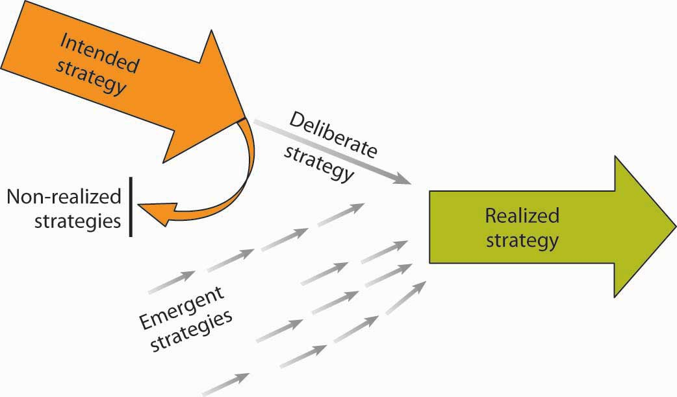
The primary determinant of realized strategy is what Mintzberg terms emergent strategy—the decisions that emerge from the complex processes in which individual managers interpret the intended strategy and adapt to changing external circumstances.
See:
- Mintzberg, H. Patterns in strategy formulation. (1978). Management Science, 24, 934–948
- Mintzberg, H., & Waters, J. A. (1985). Of strategies, deliberate and emergent. Strategic Management Journal, 6, 257–272. (1985)
- Mintzberg, H. (1988). Mintzberg on management: Inside our strange world of organizations. New York: Free Press.
Thus, the realized strategy is a consequence of deliberate and emerging factors. Analysis of Honda’s successful entry into the U.S. motorcycle market has provided a battleground for the debate between those who view strategy making as primarily a rational, analytical process of deliberate planning (the design school) and those that envisage strategy as emerging from a complex process of organizational decision making (the emergence or learning school). The two views of Honda are captured in two Harvard cases: Honda [A]. (1989). Boston: Harvard Business School, Case 384049, and Honda [B]. (1989). Boston: Harvard Business School, Case 384050.
Although the debate between the two schools continues, we hope that it is apparent to you that the central issue is not “Which school is right?” but “How can the two views complement one another to give us a richer understanding of strategy making?” Let us explore these complementarities in relation to the factual question of how strategies are made and the normative question of how strategies should be made.
For further debate of the Honda case, see:
- Mintzberg, H., Pascale, R. T., Goold, M., & Rumelt, Richard P. (1996, Summer). The Honda effect revisited. California Management Review, 38, 78–117.

The Making of Strategy

How Is Strategy Made?
Robert Grant, author of Contemporary Strategy Analysis, shares his view of how strategy is made as follows.
- Grant, R. M. (2002). Contemporary strategy analysis (4th ed., pp. 25–26). New York: Blackwell.
For most organizations, strategy making combines design and emergence. The deliberate design of strategy (through formal processes such as board meetings and strategic planning) has been characterized as a primarily top-down process. Emergence has been viewed as the result of multiple decisions at many levels, particularly within middle management, and has been viewed as a bottom-up process. These processes may interact in interesting ways. At Intel, the key historic decision to abandon memory chips and concentrate on microprocessors was the result of a host of decentralized decisions taken at divisional and plant level that were subsequently acknowledged by top management and promulgated as strategy.
- Burgelman, R. A., & Grove, A. (1996, Winter). Strategic dissonance. California Management Review, 38, 8–28.
In practice, both design and emergence occur at all levels of the organization. The strategic planning systems of large companies involve top management passing directives and guidelines down the organization and the businesses passing their draft plans up to corporate. Similarly, emergence occurs throughout the organization—opportunism by CEOs is probably the single most important reason why realized strategies deviate from intended strategies. What we can say for sure is that the role of emergence relative to design increases as the business environment becomes increasingly volatile and unpredictable.
Organizations that inhabit relatively stable environments—the Roman Catholic Church and national postal services—can plan their strategies in some detail. Organizations whose environments cannot be forecast with any degree of certainty—a gang of car thieves or a construction company located in the Gaza Strip—can establish only a few strategic principles and guidelines; the rest must emerge as circumstances unfold.

What’s the Best Way to Make Strategy?
Mintzberg’s advocacy of strategy making as an iterative process involving experimentation and feedback is not necessarily an argument against the rational, systematic design of strategy. The critical issues are, first, determining the balance of design and emergence and, second, how to guide the process of emergence. The strategic planning systems of most companies involve a combination of design and emergence. Thus, headquarters sets guidelines in the form of vision and mission statements, business principles, performance targets, and capital expenditure budgets. However, within the strategic plans that are decided, divisional and business unit managers have considerable freedom to adjust, adapt, and experiment.

KEY TAKEAWAY
You learned about the processes surrounding strategy development. Specifically, you saw the difference between intended and realized strategy, where intended strategy is essentially the desired strategy, and realized strategy is what is actually put in place. You also learned how strategy is ultimately made. Ultimately, the best strategies come about when managers are able to balance the needs for design (planning) with being flexible enough to capitalize on the benefits of emergence.

EXERCISES
- What is an intended strategy?
- What is a realized strategy?
- Why is it important to understand the difference between intended and realized strategies?
- Why is there not a perfect match-up between realized and intended strategies?
- What might interfere with the realization of an intended strategy?
- How might you manage the balance between design and emergence strategizing processes in an organization?

5.4 Strategy as Trade-Offs, Discipline, and Focus

LEARNING OBJECTIVES
- Understand the nature of strategic focus.
- Strategy as trade-offs (Porter).
- Strategy as discipline (Treacy and Wiersema).
This section helps you understand that a strategy provides a company with focus. Strategy is ultimately about choice—what the organization does and does not do. As we’ve seen, vision and mission provide a good sense of direction for the organization, but they are not meant to serve as, or take the place of, the actual strategy. Strategy is about choices, and that eventually means making trade-offs such that the strategy and the firm are distinctive in the eyes of stakeholders. In this section, you will learn about strategic focus—that is, how trade-offs are reconciled—as well as two frameworks for thinking about what such focus might entail.

What Is Strategic Focus?
While there are different schools of thought about how strategy comes about, researchers generally agree that strategic focus is a common characteristic across successful organizations. Strategic focus is seen when an organization is very clear about its mission and vision and has a coherent, well-articulated strategy for achieving those. When a once high-flying firm encounters performance problems, it is not uncommon to hear business analysts say that the firm’s managers have lost focus on the customers or markets where they were once highly successful. For instance, Dell Computer’s strategy is highly focused around the efficient sale and manufacture of computers and computer peripheral devices. However, during the mid-2000s, Dell started branching out into other products such as digital cameras, DVD players, and flat-screen televisions. As a result, it lost focus on its core sales and manufacturing business, and its performance flagged. As recently as mid-2008, however, Dell has realized a tremendous turnaround: “We are executing on all points of our strategy to drive growth in every product category and in every part of the world,” said a press release from Michael Dell, chairman and CEO. “These results are early signs of our progress against our five strategic priorities. Through a continued focus, we expect to continue growing faster than the industry and increase our revenue, profitability and cash flow for greater shareholder value.”
- Dell increases revenue and earnings, lowers operating expenses. (2008, May 28). Dell press release. Retrieved November 3, 2008, from http://www.dell.com/content/topics/global.aspx/corp/pressoffice/en/2008/2008_05_29_rr_000?c=us&l=en’s=corp
Dell provides an excellent example of what is meant by strategic focus. This spirit of focus is echoed in the following two parts of this section where we introduce you to the complementary notions of strategy as trade-offs and strategy as discipline.

Strategy as Trade-Offs
Three of the most widely read books on competitive analysis in the 1980s were:
- Michael Porter’s Competitive Strategy, Competitive Advantage, and Competitive Advantage of Nations.Porter, M. (1985).
- Competitive advantage: Creating and sustaining superior performance. New York: Free Press; Porter, M. (1989).
- Competitive advantage of nations. New York: Free Press. Porter, M. (1980).
In his various books, Porter developed three generic strategies that, he argues, can be used singly or in combination to create a defendable position and to outperform competitors, whether they are within an industry or across nations. The strategies are (1) overall cost leadership, (2) differentiation, and (3) focus on a particular market niche.

Cost Leadership, Differentiation, and Scope
These strategies are termed generic because they can be applied to any size or form of business. We refer to them as trade-off strategies because Porter argues that a firm must choose to embrace one strategy or risk not having a strategy at all. Overall lower cost or cost leadership refers to the strategy where a firm’s competitive advantage is based on the bet that it can develop, manufacture, and distribute products more efficiently than competitors. Differentiation refers to the strategy where competitive advantage is based on superior products or service. Superiority arises from factors other than low cost, such as customer service, product quality, or unique style. To put these strategies into context, you might think about Wal-Mart as pursuing a cost-leadership strategy and Harley Davidson as pursuing a differentiation strategy.
Porter suggests that another factor affecting a company’s competitive position is its competitive scope. Competitive scope defines the breadth of a company’s target market. A company can have a broad (mass market) competitive scope or a narrow (niche market) competitive scope. A firm following the focus strategy concentrates on meeting the specialized needs of its customers. Products and services can be designed to meet the needs of buyers. One approach to focusing is to service either industrial buyers or consumers but not both. Martin-Brower, the third-largest food distributor in the United States, serves only the eight leading fast-food chains. It is the world’s largest distributor of products to the world’s largest restaurant company—McDonald’s. With its limited customer list, Martin-Brower need only stock a limited product line; its ordering procedures are adjusted to match those of its customers; and its warehouses are located so as to be convenient to customers.
Firms using a narrow focus strategy can also tailor advertising and promotional efforts to a particular market niche. Many automobile dealers advertise that they are the largest volume dealer for a specific geographic area. Other car dealers advertise that they have the highest customer satisfaction scores within their defined market or the most awards for their service department.
Another differentiation strategy is to design products specifically for a customer. Such customization may range from individually designing a product for a single customer to offering a menu from which customers can select options for the finished product. Tailor-made clothing and custom-built houses include the customer in all aspects of production, from product design to final acceptance, and involve customer input in all key decisions. However, providing such individualized attention to customers may not be feasible for firms with an industry-wide orientation. At the other end of the customization scale, customers buying a new car, even in the budget price category, can often choose not only the exterior and interior colors but also accessories such as CD players, rooftop racks, and upgraded tires.
By positioning itself in either broad scope or narrow scope and a low-cost strategy or differentiation strategy, an organization will fall into one of the following generic competitive strategies: cost leadership, cost focus, differentiation, and focused differentiation.

Figure 5.13 Porter’s Generic Strategies
Source: Porter, M. E. (1980). Competitive Strategy. New York: Free Press.

Cost Leadership/Low Cost
Cost leadership is a low-cost, broad-based market strategy. Firms pursuing this type of strategy must be particularly efficient in engineering tasks, production operations, and physical distribution. Because these firms focus on a large market, they must also be able to minimize costs in marketing and research and development (R&D). A low-cost leader can gain significant market share enabling it to procure a more powerful position relative to both suppliers and competitors. This strategy is particularly effective for organizations in industries where there is limited possibility of product differentiation and where buyers are very price sensitive.
Overall cost leadership is not without potential problems. Two or more firms competing for cost leadership may engage in price wars that drive profits to very low levels. Ideally, a firm using a cost-leader strategy will develop an advantage that others cannot easily copy. Cost leaders also must maintain their investment in state-of-the-art equipment or face the possible entry of more cost-effective competitors. Major changes in technology may drastically change production processes so that previous investments in production technology are no longer advantageous. Finally, firms may become so concerned with maintaining low costs that they overlook needed changes in production or marketing.
The cost-leadership strategy may be more difficult in a dynamic environment because some of the expenses that firms may seek to minimize are research and development costs or marketing research costs—expenses the firm may need to incur to remain competitive.

Focused Low-Cost
A cost-focus strategy is a low-cost, narrowly focused market strategy. Firms employing this strategy may focus on a particular buyer segment or a particular geographic segment and must locate a niche market that wants or needs an efficient product and is willing to forgo extras to pay a lower price for the product. A company’s costs can be reduced by providing little or no service, providing a low-cost method of distribution, or producing a no-frills product.

Differentiation
A differentiation strategy involves marketing a unique product to a broad-based market. Because this type of strategy involves a unique product, price is not the significant factor. In fact, consumers may be willing to pay a high price for a product that they perceive as different. The product difference may be based on product design, method of distribution, or any aspect of the product (other than price) that is significant to a broad group of consumers. A company choosing this strategy must develop and maintain a product perceived as different enough from the competitors’ products to warrant the asking price.
Several studies have shown that a differentiation strategy is more likely to generate higher profits than a cost-leadership strategy, because differentiation creates stronger entry barriers. However, a cost-leadership strategy is more likely to generate increases in market share.

Focused Differentiation
A differentiation-focus strategy is the marketing of a differentiated product to a narrow market, often involving a unique product and a unique market. This strategy is viable for a company that can convince consumers that its narrow focus allows it to provide better goods and services than its competitors.
Differentiation does not allow a firm to ignore costs; it makes a firm’s products less susceptible to cost pressures from competitors because customers see the product as unique and are willing to pay extra to have the product with the desirable features. Differentiation can be achieved through real product features or through advertising that causes the customer to perceive that the product is unique.
Differentiation may lead to customer brand loyalty and result in reduced price elasticity. Differentiation may also lead to higher profit margins and reduce the need to be a low-cost producer. Since customers see the product as different from competing products and they like the product features, customers are willing to pay a premium for these features. As long as the firm can increase the selling price by more than the marginal cost of adding the features, the profit margin is increased. Firms must be able to charge more for their differentiated product than it costs them to make it distinct, or else they may be better off making generic, undifferentiated products. Firms must remain sensitive to cost differences. They must carefully monitor the incremental costs of differentiating their product and make certain the difference is reflected in the price.
Firms pursuing a differentiation strategy are vulnerable to different competitive threats than firms pursuing a cost-leader strategy. Customers may sacrifice features, service, or image for cost savings. Price-sensitive customers may be willing to forgo desirable features in favor of a less costly alternative. This can be seen in the growth in popularity of store brands and private labels. Often, the same firms that produce name-brand products produce the private-label products. The two products may be physically identical, but stores are able to sell the private-label products for a lower price because very little money was put into advertising to differentiate the private-label product.
Imitation may also reduce the perceived differences between products when competitors copy product features. Thus, for firms to be able to recover the cost of marketing research or R&D, they may need to add a product feature that is not easily copied by a competitor.
A final risk for firms pursuing a differentiation strategy is changing consumer tastes. The feature that customers like and find attractive about a product this year may not make the product popular next year. Changes in customer tastes are especially obvious in the fashion industry. For example, although Ralph Lauren’s Polo has been a very successful brand of apparel, some younger consumers have shifted to Tommy Hilfiger and other youth-oriented brands.
For a variety of reasons, including the differences between intended versus realized strategies discussed in an earlier section, none of these competitive strategies is guaranteed to achieve success. Some companies that have successfully implemented one of Porter’s generic strategies have found that they could not sustain the strategy. Several risks associated with these strategies are based on evolved market conditions (buyer perceptions, competitors, etc.).

Straddling Positions or Stuck in the Middle?
Can forms of competitive advantage be combined? That is, can a firm straddle strategies so that it is simultaneously the low-cost leader and a differentiator? Porter asserts that a successful strategy requires a firm to stake out a market position aggressively and that different strategies involve distinctly different approaches to competing and operating the business. Some research suggests that straddling strategies is a recipe for below-average profitability compared to the industry. Porter also argues that straddling strategies is an indication that the firm’s managers have not made necessary choices about the business and its strategy. A straddling strategy may be especially dangerous for narrow scope firms that have been successful in the past, but then start neglecting their focus.
An organization pursuing a differentiation strategy seeks competitive advantage by offering products or services that are unique from those offered by rivals, either through design, brand image, technology, features, or customer service. Alternatively, an organization pursuing a cost-leadership strategy attempts to gain competitive advantage based on being the overall low-cost provider of a product or service. To be “all things to all people” can mean becoming “stuck in the middle” with no distinct competitive advantage. The difference between being “stuck in the middle” and successfully pursuing combination strategies merits discussion. Although Porter describes the dangers of not being successful in either cost control or differentiation, some firms have been able to succeed using combination strategies.
Research suggests that, in some cases, it is possible to be a cost leader while maintaining a differentiated product. Southwest Airlines has combined cost-cutting measures with differentiation. The company has been able to reduce costs by not assigning seating and by eliminating meals on its planes. It has also been able to promote in its advertising that its fares are so low that checked bags fly free, in contrast to the fees that competitors such as American and United charge for checked luggage. Southwest’s consistent low-fare strategy has attracted a significant number of passengers, allowing the airline to succeed.
Another firm that has pursued an effective combination strategy is Nike. You may think that Nike has always been highly successful, but it has actually weathered some pretty aggressive competitive assaults. For instance, when customer preferences moved to wide-legged jeans and cargo pants, Nike’s market share slipped. Competitors such as Adidas offered less expensive shoes and undercut Nike’s price. Nike’s stock price dropped in 1998 to half its 1997 high. However, Nike achieved a turnaround by cutting costs and developing new, distinctive products. Nike reduced costs by cutting some of its endorsements. Company research suggested the endorsement by the Italian soccer team, for example, was not achieving the desired results. Michael Jordan and a few other “big name” endorsers were retained while others, such as the Italian soccer team, were eliminated, resulting in savings estimated at over $100 million. Laying off 7% of its 22,000 employees allowed the company to lower costs by another $200 million, and inventory was reduced to save additional money. As a result of these moves, Nike reported a 70% increase in earnings for the first quarter of 1999 and saw a significant rebound in its stock price. While cutting costs, the firm also introduced new products designed to differentiate Nike’s products from the competition.
Some industry environments may actually call for combination strategies. Trends suggest that executives operating in highly complex environments, such as health care, do not have the luxury of choosing exclusively one strategy over another. The hospital industry may represent such an environment, as hospitals must compete on a variety of fronts. Combination (i.e., more complicated) strategies are both feasible and necessary to compete successfully. For instance, reimbursement to diagnosis-related groups, and the continual lowering of reimbursement ceilings have forced hospitals to compete on the basis of cost. At the same time, many of them jockey for position with differentiation based on such features as technology and birthing rooms. Thus, many hospitals may need to adopt some form of hybrid strategy to compete successfully.
- Walters, B. A., & Bhuian, S. (2004). Complexity absorption and performance: A structural analysis of acute-care hospitals. Journal of Management, 30, 97–121.

Strategy as Discipline
While Michael Porter’s generic strategies were introduced in the 1980s and still dominate much of the dialogue about strategy and strategizing, a complementary approach was offered more recently by CSC Index consultants Michael Treacy and Fred Wiersema. Their value disciplines model is quite similar to the three generic strategies from Porter (cost leadership, differentiation, focus). However, there is at least one major difference. According to the value disciplines model, no discipline may be neglected: threshold levels on the two disciplines that are not selected must be maintained. According to Porter, companies that act like this run a risk of getting “stuck in the middle.”
In their book, The Discipline of Market Leaders, they offered four rules that competing companies must obey with regard to strategy formulation:
- Provide the best offer in the marketplace, by excelling in one specific dimension of value. Market leaders first develop a value proposition, one that is compelling and unmatched.
- Maintain threshold standards on other dimensions of value. You can’t allow performance in other dimensions to slip so much that it impairs the attractiveness of your company’s unmatched value.
- Dominate your market by improving the value year after year. When a company focuses all its assets, energies, and attention on delivering and improving one type of customer value, it can nearly always deliver better performance in that dimension than another company that divides its attention among more than one.
- Build a well-tuned operating model dedicated to delivering unmatched value. In a competitive marketplace, the customer value must be improved. This is the imperative of the market leader. The operating model is the key to raising and resetting customer expectation.
- Treacy, M., & Wiersema, F. (1997). The discipline of market leaders: Choose your customers, narrow your focus, dominate your market. Reading, M Addison-Wesley

What Are Value Disciplines?
Treacy and Wiersema describe three generic value disciplines: operational excellence, product leadership, and customer intimacy. As with Porter’s perspective about the importance of making trade-offs, any company must choose one of these value disciplines and consistently and vigorously act on it, as indicated by the four rules mentioned earlier.

Operational Excellence
The case study that their book uses to illustrate the “operational excellence” value discipline is AT&T’s experience in introducing the Universal Card, a combined long-distance calling card and general purpose credit card, featuring low annual fees and customer-friendly service.
Key characteristics of the strategy are superb operations and execution, often by providing a reasonable quality at a very low price, and task-oriented vision toward personnel. The focus is on efficiency, streamlined operations, supply chain management, no frills, and volume. Most large international corporations are operating according to this discipline. Measuring systems are important, as is extremely limited variation in product assortment.

Product Leadership
Firms that do this strategy well are very strong in innovation and brand marketing. Organization leaders demonstrate a recognition that the company’s current success and future prospects lie in its talented product design people and those who support them. The company operates in dynamic markets. The focus is on development, innovation, design, time to market, and high margins in a short time frame. Company cultures are flexible to encourage innovation. Structure also encourages innovation through small ad hoc working groups, an “experimentation is good” mind-set, and compensation systems that reward success. Intel, the leading computer chip company, is a great example of a firm pursuing a successful product leadership strategy.

Customer Intimacy
Companies pursuing this strategy excel in customer attention and customer service. They tailor their products and services to individual or almost individual customers. There is large variation in product assortment. The focus is on: customer relationship management (CRM), deliver products and services on time and above customer expectations, lifetime value concepts, reliability, being close to the customer. Decision authority is given to employees who are close to the customer. The operating principles of this value discipline include having a full range of services available to serve customers upon demand—this may involve running what the authors call a “hollow company,” where a variety of goods or services are available quickly through contract arrangements, rather than the supplier business having everything in stock all the time.
The recent partnership between Airborne Express, IBM, and Xerox is a great example of an effective customer intimacy strategy. Airborne also provides centralized control to IBM and Xerox part-distribution networks. Airborne provides Xerox and IBM with a central source of shipment data and performance metrics. The air-express carrier also manages a single, same-day delivery contract for both companies. In addition, Airborne now examines same-day or special-delivery requirements and recommends a lower-priced alternative where appropriate. Retrieved November 3, 2008, from http://www.logisticsmgmt.com/article/CA145552.html

Only One Discipline
Treacy and Wiersema maintain that, because of the focus of management time and resources that is required, a firm can realistically choose only one of these three value disciplines in which to specialize. This logic is similar to Porter’s in that firms that mix different strategies run the risk of being “stuck in the middle.” Most companies, in fact, do not specialize in any of the three, and thus they realize only mediocre or average levels of achievement in each area.
The companies that do not make the hard choices associated with focus are in no sense market leaders. In today’s business environment of increased competition and the need more than ever before for competitive differentiation, their complacency will not lead to increased market share, sales, or profits.
“When we look at these managers’ businesses [complacent firms], we invariably find companies that don’t excel, but are merely mediocre on the three disciplines…What they haven’t done is create a breakthrough on any one dimension to reach new heights of performance. They have not traveled past operational competence to reach operational excellence, past customer responsiveness to achieve customer intimacy, or beyond product differentiation to establish product leadership. To these managers we say that if you decide to play an average game, to dabble in all areas, don’t expect to become a market leader.”
- Treacy, M., & Wiersema, F. (1997). The discipline of market leaders: Choose your customers, narrow your focus, dominate your market (p. 40).
Within the context of redesigning the operating model of a company to focus on a particular value discipline, Treacy and Wiersema discuss creating what they call “the cult of the customer.” This is a mind-set that is oriented toward putting the customer’s needs as a key priority throughout the company, at all levels. They also review some of the challenges involved in sustaining market leadership once it is attained (i.e., avoiding the natural complacency that tends to creep into an operation once dominance of the market is achieved).

KEY TAKEAWAY
Strategic focus seems to be a common element in the strategies across successful firms. Two prevalent views of strategy where focus is a key component are strategy as trade-offs and strategy as discipline. Michael Porter identifies three flavors of strategy: (1) cost leadership, (2) differentiation, or (3) focus of cost leadership or differentiation on a particular market niche. Firms can straddle these strategies, but such straddling is likely to dilute strategic focus. Strategy also provides discipline. Treacy and Wiersema’s three strategic disciplines are (1) operational excellence, (2) product leadership, and (3) customer intimacy.

EXERCISES
- What is strategic focus and why is it important?
- What are Porter’s three generic strategies?
- Can a firm simultaneously pursue a low-cost and a differentiation strategy?
- What are the three value disciplines?
- What four rules underlie the three value disciplines?
- How do Porter’s generic strategies differ from, and relate to, the Treacy and Wiersema approaches?

5.5 Developing Strategy Through Internal Analysis

LEARNING OBJECTIVES
- Learn about internal analysis.
- Understand resources, capabilities, and core competencies.
- See how to evaluate resources, capabilities, and core competencies using VRIO analysis.
In this section, you will learn about some of the basic internal inputs for strategy formulation—starting with the organization’s strengths and weaknesses. We will focus on three aspects of internal analysis here, though you recognize that these should be complemented by external analysis as well. There is no correct order in which to do internal and external analyses, and the process is likely to be iterative. That is, you might do some internal analysis that suggests the need for other external analysis, or vice versa. For the internal environment, it is best to start with an assessment of resources and capabilities and then work your way into the identification of core competences using VRIO analysis.

Internal Analysis
By exploiting internal resources and capabilities and meeting the demanding standards of global competition, firms create value for customers.
- McEvily, S. K., & Chakravarthy, B. (2002). The persistence of knowledge-based advantage: An empirical test for product performance and technological knowledge. Strategic Management Journal, 23, 285–305
- Buckley, P. J., & Carter, M. J. (2000). Knowledge management in global technology markets: Applying theory to practice. Long Range Planning, 33(1), 55–71
Value is measured by a product’s performance characteristics and by its attributes for which customers are willing to pay.
- Pocket Strategy. (1998). Value (p. 165). London: The Economist Books.
Those particular bundles of resources and capabilities that provide unique advantages to the firm are considered core competencies.
- Prahalad, C. K., and Hamel, G. (1990). The core competence of the organization. Harvard Business Review, 90, 79–93
Core competencies are resources and capabilities that serve as a source of a firm’s competitive advantage over rivals. Core competencies distinguish a company competitively and reflect its personality. Core competencies emerge over time through an organizational process of accumulating and learning how to deploy different resources and capabilities. As the capacity to take action, core competencies are “crown jewels of a company,” the activities the company performs especially well compared with competitors and through which the firm adds unique value to its goods or services over a long period of time.
- Hafeez, K., Zhang, Y. B., & Malak, N. (2002). Core competence for sustainable competitive advantage: A structured methodology for identifying core competence. IEEE Transactions on Engineering Management, 49(1), 28–35
- Prahalad, C. K., & Hamel, G. (1990). The core competence of the corporation. Harvard Business Review, 68(3), 79–93
Sometimes consistency and predictability provide value to customers, such as the type of value Walgreens drugstores provides. As a Fortune magazine writer noted, “Do you realize that from 1975 to today, Walgreens beat Intel? It beat Intel nearly two to one, GE almost five to one. It beat 3M, Coke, Boeing, Motorola.”
- Useem, J. (2001, February 19). Most admired: Conquering vertical limits. Fortune, pp. 84–96
Walgreens was able to do this by using its core competencies to offer value desired by its target customer group. Instead of responding to the trends of the day, “During the Internet scare of 1998 and 1999, when slogans of ‘Change or Die!’ were all but graffitied on the subway, Walgreens obstinately stuck to its corporate credo of ‘Crawl, walk, run.’ Its refusal to act until it thoroughly understood the implications of e-commerce was deeply unfashionable, but…Walgreens is the epitome of the inner-directed company.”
- Useem, J. (2001, February 19). Most admired: Conquering vertical limits. Fortune, pp. 84–96
Thus, Walgreens creates value by focusing on the unique capabilities it has built, nurtured, and continues to improve across time.
During the past several decades, the strategic management process was concerned largely with understanding the characteristics of the industry in which the firm competed and, in light of those characteristics, determining how the firm should position itself relative to competitors. This emphasis on industry characteristics and competitive strategy may have understated the role of the firm’s resources and capabilities in developing competitive advantage. In the current competitive landscape, core competencies, in combination with product-market positions, are the firm’s most important sources of competitive advantage.
- Hitt, M. A., Nixon, R. D., Clifford, P. G., & Coyne, K. P. (1999). The development and use of strategic resources. In M. A. Hitt, P. G. Clifford, R. D. Nixon, & K. P. Coyne (Eds.), Dynamic Strategic Resources (pp. 1–14)
The core competencies of a firm, in addition to its analysis of its general, industry, and competitor environments, should drive its selection of strategies. As Clayton Christensen noted, “Successful strategists need to cultivate a deep understanding of the processes of competition and progress and of the factors that undergird each advantage. Only thus will they be able to see when old advantages are poised to disappear and how new advantages can be built in their stead.”
- Christensen, C. M. (2001). The past and future of competitive advantage. Sloan Management Review, 42(2), 105–109
By drawing on internal analysis and emphasizing core competencies when formulating strategies, companies learn to compete primarily on the basis of firm-specific differences, but they must be aware of how things are changing as well.

Resources and Capabilities

Resources
Broad in scope, resources cover a spectrum of individual, social, and organizational phenomena.
- Eisenhardt, K., & Martin, J. (2000). Dynamic capabilities: What are they? Strategic Management Journal, 21, 1105–1121
- Michalisin, M. D., Kline, D. M., & Smith. R. D. (2000). Intangible strategic assets and firm performance: A multi-industry study of the resource-based view, Journal of Business Strategies, 17(2), 91–117
Typically, resources alone do not yield a competitive advantage.
- West, G. P., & DeCastro, J. (2001). The Achilles heel of firm strategy: Resource weaknesses and distinctive inadequacies. Journal of Management Studies, 38(3), 26–45
- Deeds, D. L., DeCarolis, D., & J. Coombs. (2000). Dynamic capabilities and new product development in high technology ventures: An empirical analysis of new biotechnology firms. Journal of Business Venturing, 15, 211–229
- Chi, T. (1994). Trading in strategic resources: Necessary conditions, transaction cost problems, and choice of exchange structure. Strategic Management Journal, 15, 271–290
In fact, the core competencies that yield a competitive advantage are created through the unique bundling of several resources.
- Berman, S., Down, J., & Hill, C. (2002). Tacit knowledge as a source of competitive advantage in the National Basketball Association. Academy of Management Journal, 45, 13–31
For example, Amazon.com has combined service and distribution resources to develop its competitive advantages. The firm started as an online bookseller, directly shipping orders to customers. It quickly grew large and established a distribution network through which it could ship “millions of different items to millions of different customers.” Compared with Amazon’s use of combined resources, traditional bricks-and-mortar companies, such as Toys “R” Us and Borders, found it hard to establish an effective online presence. These difficulties led them to develop partnerships with Amazon. Through these arrangements, Amazon now handles online presence and the shipping of goods for several firms, including Toys “R” Us and Borders, which now can focus on sales in their stores. Arrangements such as these are useful to the bricks-and-mortar companies because they are not accustomed to shipping so much diverse merchandise directly to individuals.
- Shepard, S. (2001, April 30). Interview: “The company is not in the stock.” Business Week, pp. 94–96
Some of a firm’s resources are tangible while others are intangible. Tangible resources are assets that can be seen and quantified. Production equipment, manufacturing plants, and formal reporting structures are examples of tangible resources. Intangible resources typically include assets that are rooted deeply in the firm’s history and have accumulated over time. Because they are embedded in unique patterns of routines, intangible resources are relatively difficult for competitors to analyze and imitate. Knowledge, trust between managers and employees, ideas, the capacity for innovation, managerial capabilities, organizational routines (the unique ways people work together), scientific capabilities, and the firm’s reputation for its goods or services and how it interacts with people (such as employees, customers, and suppliers) are all examples of intangible resources.
- Feldman, M. S. (2000). Organizational routines as a source of continuous change, Organization Science, 11, 611–629
- Knott, A. M., & McKelvey, B. (1999). Nirvana efficiency: A comparative test of residual claims and routines.Journal of Economic Behavior & Organization, 38, 365–383
The four types of tangible resources are financial, organizational, physical, and technological. The three types of intangible resources are human, innovation, and reputational.
As a manager or entrepreneur, you will be challenged to understand fully the strategic value of your firm’s tangible and intangible resources. The strategic value of resources is indicated by the degree to which they can contribute to the development of core competencies, and, ultimately, competitive advantage. For example, as a tangible resource, a distribution facility is assigned a monetary value on the firm’s balance sheet. The real value of the facility, however, is grounded in a variety of factors, such as its proximity to raw materials and customers, but also in intangible factors such as the manner in which workers integrate their actions internally and with other stakeholders, such as suppliers and customers.
- Gavetti, G., & Levinthal, D. (2000). Looking forward and looking backward: Cognitive and experimental search. Administrative Science Quarterly, 45, 113–137
- Coff, R. W. (1999). How buyers cope with uncertainty when acquiring firms in knowledge-intensive industries: Caveat emptor.Organization Science, 10, 144–161
- Marsh, S. J., & Ranft, A. L. (1999). Why resources matter: An empirical study of knowledge-based resources on new market entry. In M. A. Hitt, P. G. Clifford, R. D. Nixon, & K. P. Coyne (Eds.), Dynamic strategic resources (pp. 43–66). Chichester: Wiley.

Capabilities
Capabilities are the firm’s capacity to deploy resources that have been purposely integrated to achieve a desired end state.
- Helfat, C. E., & Raubitschek, R. S. (2000). Product sequencing: Co-evolution of knowledge, capabilities, and products. Strategic Management Journal, 21, 961–979
The glue that holds an organization together, capabilities emerge over time through complex interactions among tangible and intangible resources. Capabilities can be tangible, like a business process that is automated, but most of them tend to be tacit and intangible. Critical to forming competitive advantages, capabilities are often based on developing, carrying, and exchanging information and knowledge through the firm’s human capital.
- Hitt, M. A., Bierman, L., Shimizu, K., & Kochhar, R. (2001) Direct and moderating effects of human capital on strategy and performance in professional service firms: A resource-based perspective. Academy of Management Journal, 44(1), 13–28
- Hitt, M. A., Ireland, R. D., & Lee, H. (2000). Technological learning, knowledge management, firm growth and performance: An introductory essay. Journal of Engineering and Technology Management, 17, 231–246
- Hoopes, D. G., & Postrel, S. (1999). Shared knowledge: “Glitches,” and product development performance. Strategic Management Journal, 20, 837–865
- Quinn, J. B. (1994). The Intelligent Enterprise. New York: Free Press.
Because a knowledge base is grounded in organizational actions that may not be explicitly understood by all employees, repetition and practice increase the value of a firm’s capabilities.
The foundation of many capabilities lies in the skills and knowledge of a firm’s employees and, often, their functional expertise. Hence, the value of human capital in developing and using capabilities and, ultimately, core competencies cannot be overstated. Firms committed to continuously developing their people’s capabilities seem to accept the adage that “the person who knows how will always have a job. The person who knows why will always be his boss.”
- Thoughts on the business of life. (1999, May 17).Forbes, p. 352
Global business leaders increasingly support the view that the knowledge possessed by human capital is among the most significant of an organization’s capabilities and may ultimately be at the root of all competitive advantages. But firms must also be able to use the knowledge that they have and transfer it among their operating businesses.
- Argote, L., & Ingram, P. (2000). Knowledge transfer: A basis for competitive advantage in firms. Organizational Behavior and Human Decision Processes, 82, 150–169
For example, researchers have suggested that “in the information age, things are ancillary, knowledge is central. A company’s value derives not from things, but from knowledge, know-how, intellectual assets, competencies—all of it embedded in people.”
- Dess, G. G., & Picken, J. C. (1999). Beyond productivity. New York: AMACOM
Given this reality, the firm’s challenge is to create an environment that allows people to fit their individual pieces of knowledge together so that, collectively, employees possess as much organizational knowledge as possible.
- Coy, P. (2002, Spring). High turnover, high risk [Special Issue]. Business Week, p. 24
To help them develop an environment in which knowledge is widely spread across all employees, some organizations have created the new upper-level managerial position of chief learning officer (CLO). Establishing a CLO position highlights a firm’s belief that “future success will depend on competencies that traditionally have not been actively managed or measured—including creativity and the speed with which new ideas are learned and shared.”
- Baldwin, T. T., & Danielson, C. C. (2000). Building a learning strategy at the top: Interviews with ten of America’s CLOs. Business Horizons, 43(6), 5–14
In general, the firm should manage knowledge in ways that will support its efforts to create value for customers.
- Kuratko, D. F., Ireland, R. D., & Hornsby, J. S. (2001). Improving firm performance through entrepreneurial actions: Acordia’s corporate entrepreneurship strategy. Academy of Management Executive, 15(4), 60–71
- Hansen, M. T., Nhoria, N., & Tierney, T. (1999). What’s your strategy for managing knowledge? Harvard Business Review, 77(2), 106–116

Figure 5.15 The Value Chain
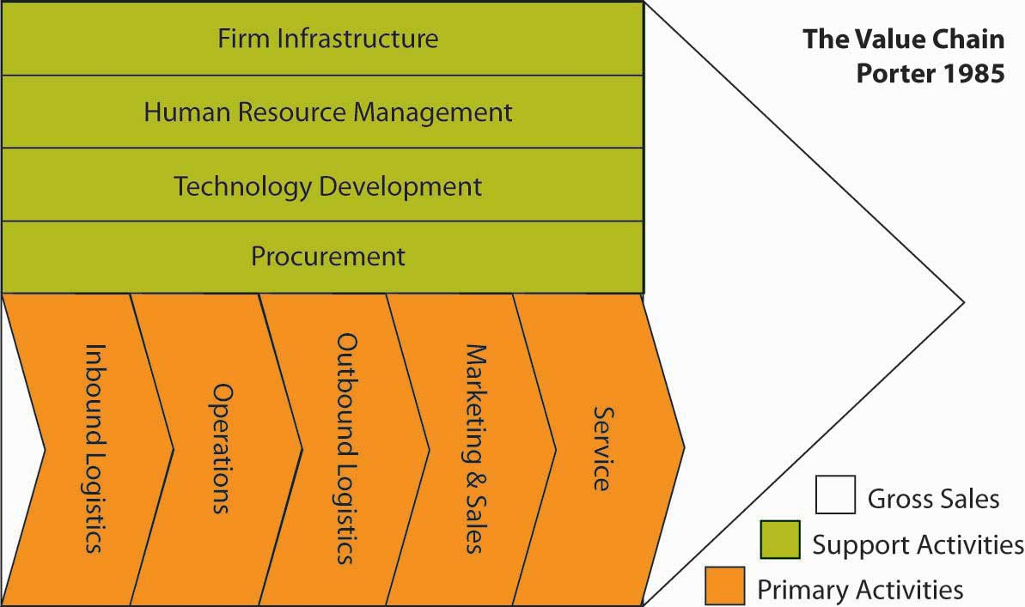
Adapted from Porter, M. (1985). Competitive Advantage. New York: Free Press. Exhibit is creative commons licensed at http://en.wikipedia.org/wiki/Image:ValueChain.PNG.
Capabilities are often developed in specific functional areas (such as manufacturing, R&D, and marketing) or in a part of a functional area (for example, advertising). The value chain, popularized by Michael Porter’s book Competitive Advantage, is a useful tool for taking stock of organizational capabilities. A value chain is a chain of activities. In the value chain, some of the activities are deemed to be primary, in the sense that these activities add direct value. In the preceding figure, primary activities are logistics (inbound and outbound), marketing, and service. Support activities include how the firm is organized (infrastructure), human resources, technology, and procurement. Products pass through all activities of the chain in order, and at each activity, the product gains some value. A firm is effective to the extent that the chain of activities gives the products more added value than the sum of added values of all activities.
It is important not to mix the concept of the value chain with the costs occurring throughout the activities. A diamond cutter can be used as an example of the difference. The cutting activity may have a low cost, but the activity adds to much of the value of the end product, since a rough diamond is significantly less valuable than a cut, polished diamond. Research suggests a relationship between capabilities developed in particular functional areas and the firm’s financial performance at both the corporate and business-unit levels, suggesting the need to develop capabilities at both levels.
- Hitt, M. A., & Ireland, R. D. (1986). Relationships among corporate level distinctive competencies, diversification strategy, corporate structure, and performance. Journal of Management Studies, 23, 401–416
- Hitt, M. A., & Ireland, R. D. (1985). Corporate distinctive competence, strategy, industry, and performance. Strategic Management Journal, 6, 273–293
- Hitt, M. A., Ireland, R. D., & Palia, K. A. (1982). Industrial firms’ grand strategy and functional importance.Academy of Management Journal, 25, 265–298
- Hitt, M. A., Ireland, R. D., & Stadter, G. (1982). Functional importance and company performance: Moderating effects of grand strategy and industry type. Strategic Management Journal, 3, 315–330
- Snow, C. C., & Hrebiniak, E. G. (1980). Strategy, distinctive competence, and organizational performance. Administrative Science Quarterly, 25, 317–336

VRIO Analysis
Given that almost anything a firm possesses can be considered a resource or capability, how should you attempt to narrow down the ones that are core competencies, and explain why firm performance differs? To lead to a sustainable competitive advantage, a resource or capability should be valuable, rare, inimitable (including nonsubstitutable), and organized. This VRIO framework is the foundation for internal analysis.
- VRIO analysis is at the core of the resource-based view of the firm. Wernerfelt, B. (1984). A resource-based view of the firm. Strategic Management Journal, 5, 171–180
- Barney, J. B. (1991). Firm resources and sustained competitive advantage. Journal of Management, 19, 99–120
VRIO is an acronym for valuable, rare, inimitable, and organization.
If you ask managers why their firms do well while others do poorly, a common answer is likely to be “our people.” But this is really not an answer. It may be the start of an answer, but you need to probe more deeply—what is it about “our people” that is especially valuable? Why don’t competitors have similar people? Can’t competitors hire our people away? Or is it that there something special about the organization that brings out the best in people? These kinds of questions form the basis of VRIO and get to the heart of why some resources help firms more than others.

Figure 5.16 VRIO and Relative Firm Performance
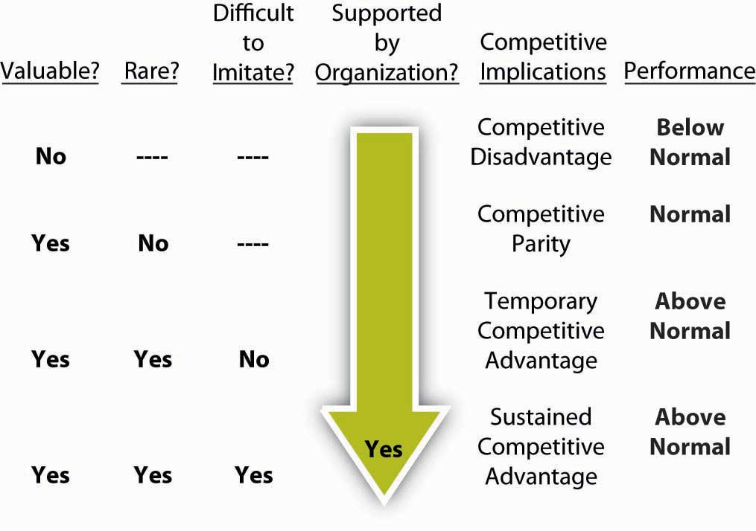
Moreover, your ability to identify whether an organization has VRIO resources will also likely explain their competitive position. In the figure, you can see that a firm’s performance relative to industry peers is likely to vary according to the level to which resources, capabilities, and ultimately core competences satisfy VRIO criteria. The four criteria are explored next.

Valuable
A resource or capability is said to be valuable if it allows the firm to exploit opportunities or negate threats in the environment. Union Pacific’s extensive network of rail-line property and equipment in the Gulf Coast of the United States is valuable because it allows the company to provide a cost-effective way to transport chemicals. Because the Gulf Coast is the gateway for the majority of chemical production in the United States, the rail network allows the firm to exploit a market opportunity. Delta’s control of the majority of gates at the Cincinnati / Northern Kentucky International Airport (CVG) gives it a significant advantage in many markets. Travelers worldwide have rated CVG one of the best airports for service and convenience 10 years running. The possession of this resource allows Delta to minimize the threat of competition in this city. Delta controls air travel in this desirable hub city, which means that this asset (resource) has significant value. If a resource does not allow a firm to minimize threats or exploit opportunities, it does not enhance the competitive position of the firm. In fact, some scholars suggest that owning resources that do not meet the VRIO test of value actually puts the firm at a competitive disadvantage.
- Barney, J. B. (1991). Firm resources and sustained competitive advantage. Journal of Management, 17, 99–120

Rare
A resource is rare simply if it is not widely possessed by other competitors. Of the criteria this is probably the easiest to judge. For example, Coke’s brand name is valuable but most of Coke’s competitors (Pepsi, 7Up, RC) also have widely recognized brand names, making it not that rare. Of course, Coke’s brand may be the most recognized, but that makes it more valuable, not more rare, in this case.
A firm that possesses valuable resources that are not rare is not in a position of advantage relative to competitors. Rather, valuable resources that are commonly held by many competitors simply allow firms to be at par with competitors. However, when a firm maintains possession of valuable resources that are rare in the industry they are in a position of competitive advantage over firms that do not possess the resource. They may be able to exploit opportunities or negate threats in ways that those lacking the resource will not be able to do. Delta’s virtual control of air traffic through Cincinnati gives it a valuable and rare resource in that market.
How rare do the resources need to be for a firm to have a competitive advantage? In practice, this is a difficult question to answer unequivocally. At the two extremes (i.e., one firm possesses the resource or all firms possess it), the concept is intuitive. If only one firm possesses the resource, it has significant advantage over all other competitors. For instance, Monsanto had such an advantage for many years because they owned the patent to aspartame, the chemical compound in NutraSweet, they had a valuable and extremely rare resource. Because during the lifetime of the patent they were the only firm that could sell aspartame, they had an advantage in the artificial sweetener market. However, meeting the condition of rarity does not always require exclusive ownership. When only a few firms possess the resource, they will have an advantage over the remaining competitors. For instance, Toyota and Honda both have the capabilities to build cars of high quality at relatively low cost.
- Dyer, J. H., Kale, P., & Singh, H. (2004, July–August). When to ally and when to acquire. Harvard Business Review, 109–115
Their products regularly beat rival firms’ products in both short-term and long-term quality ratings.
- Dyer, J. H., & Hatch, N. (2004). Using Supplier Networks to Learn Faster. Sloan Management Review, 45(3), 57–63
Thus, the criterion of rarity requires that the resource not be widely possessed in the industry. It also suggests that the more exclusive a firm’s access to a particularly valuable resource, the greater the benefit for having it.

Inimitable
An inimitable (the opposite of imitable) resource is difficult to imitate or to create ready substitutes for. A resource is inimitable and nonsubstitutable if it is difficult for another firm to acquire it or to substitute something else in its place. A valuable and rare resource or capability will grant a competitive advantage as long as other firms do not gain subsequently possession of the resource or a close substitute. If a resource is valuable and rare and responsible for a market leader’s competitive advantage, it is likely that competitors lacking the resource or capability will do all that they can to obtain the resource or capability themselves. This leads us to the third criterion—inimitability. The concept of imitation includes any form of acquiring the lacking resource or substituting a similar resource that provides equivalent benefits. The criterion important to be addressed is whether competitors face a cost disadvantage in acquiring or substituting the resource that is lacking. There are numerous ways that firms may acquire resources or capabilities that they lack.
As strategy researcher Scott Gallagher notes:
“This is probably the toughest criterion to examine because given enough time and money almost any resource can be imitated. Even patents only last 17 years and can be invented around in even less time. Therefore, one way to think about this is to compare how long you think it will take for competitors to imitate or substitute something else for that resource and compare it to the useful life of the product. Another way to help determine if a resource is inimitable is why/how it came about. Inimitable resources are often a result of historical, ambiguous, or socially complex causes. For example, the U.S. Army paid for Coke to build bottling plants around the world during World War II. This is an example of history creating an inimitable asset. Generally, intangible (also called tacit) resources or capabilities, like corporate culture or reputation, are very hard to imitate and therefore inimitable.”
- Retrieved January 30, 2009, from http://falcon.jmu.edu/~gallagsr/WDFPD-Internal.pdf.

Organized
The fourth and final VRIO criterion that determines whether a resource or capability is the source of competitive advantage recognizes that mere possession or control is necessary but not sufficient to gain an advantage. The firm must likewise have the organizational capability to exploit the resources. The question of organization is broad and encompasses many facets of a firm but essentially means that the firm is able to capture any value that the resource or capability might generate. Organization, essentially the same form as that taken in the P-O-L-C framework, spans such firm characteristics as control systems, reporting relationships, compensation policies, and management interface with both customers and value-adding functions in the firm. Although listed as the last criterion in the VRIO tool, the question of organization is a necessary condition to be satisfied if a firm is to reap the benefits of any of the three preceding conditions. Thus, a valuable but widely held resource only leads to competitive parity for a firm if they also possess the capabilities to exploit the resource. Likewise, a firm that possesses a valuable and rare resource will not gain a competitive advantage unless it can actually put that resource to effective use.
Many firms have valuable and rare resources that they fail to exploit (the question of imitation is not relevant until the firm exploits valuable and rare resources). For instance, for many years Novell had a significant competitive advantage in computer networking based on its core NetWare product. In high-technology industries, remaining at the top requires continuous innovation. Novell’s decline during the mid- to late 1990s led many to speculate that Novell was unable to innovate in the face of changing markets and technology. However, shortly after new CEO Eric Schmidt arrived from Sun Microsystems to attempt to turnaround the firm, he arrived at a different conclusion. Schmidt commented: “I walk down Novell hallways and marvel at the incredible potential of innovation here. But, Novell has had a difficult time in the past turning innovation into products in the marketplace.”Personal communication with Margaret Haddox. (2003). Novell Corporate Librarian. He later commented to a few key executives that it appeared the company was suffering from “organizational constipation.”Personal communication with former executives. Novell appeared to still have innovative resources and capabilities, but they lacked the organizational capability (e.g., product development and marketing) to get those new products to market in a timely manner.
Likewise, Xerox proved unable to exploit its innovative resources. Xerox created a successful research team housed in a dedicated facility in Palo Alto, California, known as Xerox PARC. Scientists in this group invented an impressive list of innovative products, including laser printers, Ethernet, graphical interface software, computers, and the computer mouse. History has demonstrated that these technologies were commercially successful. Unfortunately, for Xerox shareholders, these commercially successful innovations were exploited by other firms. Xerox’s organization was not structured in a way that information about these innovations flowed to the right people in a timely fashion. Bureaucracy was also suffocating ideas once they were disseminated. Compensation policies did not reward managers for adopting these new innovations but rather rewarded current profits over long-term success. Thus, Xerox was never able exploit the innovative resources and capabilities embodied in their off-site Xerox PARC research center.
- Kearns, D. T., & Nadler, D. A. (1992). Prophets in the dark. New York: HarperColllins
- Barney, J. B. (1995). Looking inside for competitive advantage. Academy of Management Executive, 9, 49–61

SWOT and VRIO
As you already know, many scholars refer to core competencies. A core competency is simply a resource, capability, or bundle of resources and capabilities that is VRIO. While VRIO resources are the best, they are quite rare, and it is not uncommon for successful firms to simply be combinations of a large number of VR _ O or even V _ _ O resources and capabilities. Recall that even a V _ _ O resource can be considered a strength under a traditional SWOT analysis.

KEY TAKEAWAY
Internal analysis begins with the identification of resources and capabilities. Resources can be tangible and intangible; capabilities may have such characteristics as well. VRIO analysis is a way to distinguish resources and capabilities from core competencies. Specifically, VRIO analysis should show you the importance of value, rarity, inimitability, and organization as building blocks of competitive advantage.

EXERCISES
- What is the objective of internal analysis?
- What is the difference between a resource and a capability?
- What is the difference between a tangible and an intangible resource or capability?
- What is a core competency?
- What framework helps you identify those resources, capabilities, or core competencies that provide competitive advantage?
- Why might competitive advantage for a firm be fleeting?

5.6 Developing Strategy Through External Analysis

LEARNING OBJECTIVES
- Understand the basics of general environment analysis.
- See the components of microenvironment analysis that support industry analysis.
- Learn the features of Porter’s Five Forces industry analysis.
In this section, you will learn about some of the basic external inputs for strategy formulation—the determinants of a firm’s opportunities and threats. We will focus on three aspects of external analysis here, though you recognize that these should be complemented by internal analysis as well. For the external environment, it is best to start with the general environment, and then work your way into the focal industry or industry segment.

The General Environment
When appraising the external environment of the organization you will typically start with its general environment. But what does this mean? The general environment is composed of dimensions in the broader society that influence an industry and the firms within it.
- Fahey, L. (1999). Competitors. New York: Wiley
- Walters, B. A., & Priem, R. L. (1999). Business strategy and CEO intelligence acquisition. Competitive Intelligence Review, 10(2), 15–22
We group these dimensions into six segments: political, economic, social, technical or technological, environmental, and legal. You can use the simple acronym, PESTEL, to help remind you of these six general environment segments. Examples of elements analyzed in each of these segments are shown next.

Table 5.1 PESTEL Analysis
Political | Economic
How stable is the political environment? | What are current and forecast interest rates?
What are local taxation policies, and how do these affect your business? | What is the level of inflation, what is it forecast to be, and how does this affect the growth of your market?
Is the government involved in trading agreements such as EU, NAFTA, ASEAN, or others? | What are local employment levels per capita and how are they changing?
What are the foreign trade regulations? | What are the long-term prospects for the economy gross domestic product (GDP) per capita, and so on?
What are the social welfare policies? | What are exchange rates between critical markets and how will they affect production and distribution of your goods?
Social or Socio-cultural | Technical or Technological
What are local lifestyle trends? | What is the level of research funding in government and the industry, and are those levels changing?
What are the current demographics, and how are they changing? | What is the government and industry’s level of interest and focus on technology?
What is the level and distribution of education and income? | How mature is the technology?
What are the dominant local religions and what influence do they have on consumer attitudes and opinions? | What is the status of intellectual property issues in the local environment?
What is the level of consumerism and popular attitudes toward it? | Are potentially disruptive technologies in adjacent industries creeping in at the edges of the focal industry?
What pending legislation is there that affects corporate social policies (e.g., domestic partner benefits, maternity/paternity leave)? | How fast is technology changing?
What are the attitudes toward work and leisure? | What role does technology play in competitive advantage?

Environmental | Legal
What are local environmental issues? | What are the regulations regarding monopolies and private property?
Are there any ecological or environmental issues relevant to your industry that are pending? | Does intellectual property have legal protections?
How do the activities of international pressure groups affect your business (e.g., Greenpeace, Earth First, PETA)? | Are there relevant consumer laws?
Are there environmental protection laws? What are the regulations regarding waste disposal and energy consumption? | What is the status of employment, heath and safety, and product safety laws?
Firms cannot directly control the general environment’s segments and elements. Accordingly, successful companies gather the information required to understand each segment and its implications for the selection and implementation of the appropriate strategies. For example, the terrorist attacks in the United States on September 11, 2001, surprised businesses throughout the world. This single set of events had substantial effects on the U.S. economy. Although individual firms were affected differently, none could control the U.S. economy. Instead, companies around the globe were challenged to understand the effects of this economy’s decline on their current and future strategies. A similar set of events and relationships was seen around the world as financial markets began to struggle one after the other starting in late 2008.
Although the degree of impact varies, these environmental segments affect each industry and its firms. The challenge to the firm is to evaluate those elements in each segment that are of the greatest importance. Resulting from these efforts should be a recognition of environmental changes, trends, opportunities, and threats.

Analyzing the Organization’s Microenvironment
When we say microenvironment we are referring primarily to an organization’s industry, and the upstream and downstream markets related to it. An industry is a group of firms producing products that are close substitutes. In the course of competition, these firms influence one another. Typically, industries include a rich mix of competitive strategies that companies use in pursuing strategic competitiveness and above-average returns. In part, these strategies are chosen because of the influence of an industry’s characteristics.
- Spanos, Y. E., & Lioukas, S. (2001). An examination into the causal logic of rent generation: Contrasting Porter’s competitive strategy framework and the resource-based perspective. Strategic Management Journal, 22, 907–934
Upstream markets are the industries that provide the raw material or inputs for the focal industry, while downstream markets are the industries (sometimes consumer segments) that consume the industry outputs. For example, the oil production market is upstream of the oil-refining market (and, conversely, the oil refiners are downstream of the oil producers), which in turn is upstream of the gasoline sales market. Instead of upstream and downstream, the terms wholesale and retail are often used. Accordingly, the industry microenvironment consists of stakeholder groups that a firm has regular dealings with. The way these relationships develop can affect the costs, quality, and overall success of a business.

Porter’s Five-Forces Analysis of Market Structure

Figure 5.18 Porter’s Five Forces
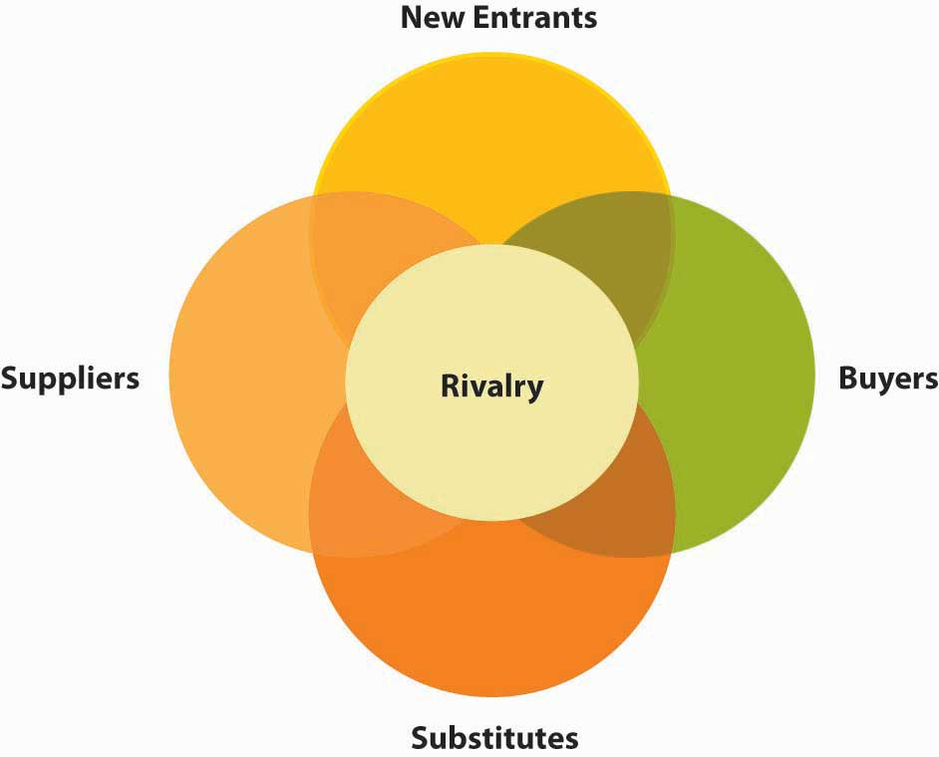
Adapted from Porter, M. (1980). Competitive strategy. New York: Free Press.
You can distill down the results of PESTEL and microenvironment analysis to view the competitive structure of an industry using Michael Porter’s five forces. Here you will find that your understanding of the microenvironment is particularly helpful. Porter’s model attempts to analyze the attractiveness of an industry by considering five forces within a market. According to Porter, the likelihood of firms making profits in a given industry depends on five factors: (1) barriers to entry and new entry threats, (2) buyer power, (3) supplier power, (4) threat from substitutes, and (5) rivalry.
- Porter, M. E. (1980).Competitive strategy. New York: Free Press.
Compared with the general environment, the industry environment has a more direct effect on the firm’s strategic competitiveness and above-average returns, as exemplified in the strategic focus. The intensity of industry competition and an industry’s profit potential (as measured by the long-run return on invested capital) are a function of five forces of competition: the threats posed by new entrants, the power of suppliers, the power of buyers, product substitutes, and the intensity of rivalry among competitors.
Porter’s five-forces model of competition expands the arena for competitive analysis. Historically, when studying the competitive environment, firms concentrated on companies with which they competed directly. However, firms must search more broadly to identify current and potential competitors by identifying potential customers as well as the firms serving them. Competing for the same customers and thus being influenced by how customers value location and firm capabilities in their decisions is referred to as the market microstructure.
- Zaheer, S., & Zaheer, A. (2001). Market microstructure in a global b2b network, Strategic Management Journal, 22, 859–873
Understanding this area is particularly important because, in recent years, industry boundaries have become blurred. For example, in the electrical utilities industry, cogenerators (firms that also produce power) are competing with regional utility companies. Moreover, telecommunications companies now compete with broadcasters, software manufacturers provide personal financial services, airlines sell mutual funds, and automakers sell insurance and provide financing.
- Hitt, M. A., Ricart I Costa, J., & Nixon, R. D. (1999). New managerial mindsets. New York: Wiley
In addition to focusing on customers rather than specific industry boundaries to define markets, geographic boundaries are also relevant. Research suggests that different geographic markets for the same product can have considerably different competitive conditions.
- Pan, Y., & Chi, P. S. K. (1999). Financial performance and survival of multinational corporations in China. Strategic Management Journal, 20, 359–374
- Brooks, G. R. (1995). Defining market boundaries Strategic Management Journal, 16, 535–549
The five-forces model recognizes that suppliers can become a firm’s competitors (by integrating forward), as can buyers (by integrating backward). Several firms have integrated forward in the pharmaceutical industry by acquiring distributors or wholesalers. In addition, firms choosing to enter a new market and those producing products that are adequate substitutes for existing products can become competitors of a company.
Another way to think about industry market structure is that these five sets of stakeholders are competing for profits in the given industry. For instance, if a supplier to an industry is powerful, they can charge higher prices. If the industry member can’t pass those higher costs onto their buyers in the form of higher prices, then the industry member makes less profit. For example, if you have a jewelry store, but are dependent on a monopolist like De Beers for diamonds, then De Beers actually is extracting more relative value from your industry (i.e., the retail jewelry business).

New Entrants
The likelihood of new entry is a function of the extent to which barriers to entry exist. Evidence suggests that companies often find it difficult to identify new competitors.
- Geroski, P. A. (1999). Early warning of new rivals. Sloan Management Review, 40(3), 107–116
Identifying new entrants is important because they can threaten the market share of existing competitors. One reason new entrants pose such a threat is that they bring additional production capacity. Unless the demand for a good or service is increasing, additional capacity holds consumers’ costs down, resulting in less revenue and lower returns for competing firms. Often, new entrants have a keen interest in gaining a large market share. As a result, new competitors may force existing firms to be more effective and efficient and to learn how to compete on new dimensions (for example, using an Internet-based distribution channel).
The more difficult it is for other firms to enter a market, the more likely it is that existing firms can make relatively high profits. The likelihood that firms will enter an industry is a function of two factors: barriers to entry and the retaliation expected from current industry participants. Entry barriers make it difficult for new firms to enter an industry and often place them at a competitive disadvantage even when they are able to enter. As such, high-entry barriers increase the returns for existing firms in the industry.
- Robinson, K. C., & McDougall, P. P. (2001). Entry barriers and new venture performance: A comparison of universal and contingency approaches. Strategic Management Journal, 22, 659–685

Buyer Power
The stronger the power of buyers in an industry, the more likely it is that they will be able to force down prices and reduce the profits of firms that provide the product. Firms seek to maximize the return on their invested capital. Alternatively, buyers (customers of an industry or firm) want to buy products at the lowest possible price—the point at which the industry earns the lowest acceptable rate of return on its invested capital. To reduce their costs, buyers bargain for higher-quality, greater levels of service, and lower prices. These outcomes are achieved by encouraging competitive battles among the industry’s firms.

Supplier Power
The stronger the power of suppliers in an industry, the more difficult it is for firms within that sector to make a profit because suppliers can determine the terms and conditions on which business is conducted. Increasing prices and reducing the quality of its products are potential means used by suppliers to exert power over firms competing within an industry. If a firm is unable to recover cost increases by its suppliers through its pricing structure, its profitability is reduced by its suppliers’ actions.

Substitutes
This measures the ease with which buyers can switch to another product that does the same thing, such as using aluminum cans rather than glass or plastic bottles to package a beverage. The ease of switching depends on what costs would be involved (e.g., while it may be easy to sell Coke or Pepsi in bottles or cans, transferring all your data to a new database system and retraining staff could be expensive) and how similar customers perceive the alternatives to be. Substitute products are goods or services from outside a given industry that perform similar or the same functions as a product that the industry produces. For example, as a sugar substitute, NutraSweet places an upper limit on sugar manufacturers’ prices—NutraSweet and sugar perform the same function but with different characteristics.
Other product substitutes include fax machines instead of overnight deliveries, plastic containers rather than glass jars, and tea substituted for coffee. Recently, firms have introduced to the market several low-alcohol fruit-flavored drinks that many customers substitute for beer. For example, Smirnoff’s Ice was introduced with substantial advertising of the type often used for beer. Other firms have introduced lemonade with 5% alcohol (e.g., Doc Otis Hard Lemon) and tea and lemon combinations with alcohol (e.g., BoDean’s Twisted Tea). These products are increasing in popularity, especially among younger people, and, as product substitutes, have the potential to reduce overall sales of beer.
- Khermouch, G. (2001, March 5). Grown-up drinks for tender taste buds. Business Week, p. 96
In general, product substitutes present a strong threat to a firm when customers face few, if any, switching costs and when the substitute product’s price is lower or its quality and performance capabilities are equal to or greater than those of the competing product. Differentiating a product along dimensions that customers value (such as price, quality, service after the sale, and location) reduces a substitute’s attractiveness.

Rivalry
This measures the degree of competition between existing firms. The higher the degree of rivalry, the more difficult it is for existing firms to generate high profits. The most prominent factors that experience shows to affect the intensity of firms’ rivalries are (1) numerous competitors, (2) slow industry growth, (3) high fixed costs, (4) lack of differentiation, (5) high strategic stakes and (6) high exit barriers.

Numerous or Equally Balanced Competitors
Intense rivalries are common in industries with many companies. With multiple competitors, it is common for a few firms to believe that they can act without eliciting a response. However, evidence suggests that other firms generally are aware of competitors’ actions, often choosing to respond to them. At the other extreme, industries with only a few firms of equivalent size and power also tend to have strong rivalries. The large and often similar-sized resource bases of these firms permit vigorous actions and responses. The Fuji/Kodak and Airbus/Boeing competitive battles exemplify intense rivalries between pairs of relatively equivalent competitors.

Slow Industry Growth
When a market is growing, firms try to use resources effectively to serve an expanding customer base. Growing markets reduce the pressure to take customers from competitors. However, rivalry in nongrowth or slow-growth markets becomes more intense as firms battle to increase their market shares by attracting their competitors’ customers.
Typically, battles to protect market shares are fierce. Certainly, this has been the case with Fuji and Kodak. The instability in the market that results from these competitive engagements reduce profitability for firms throughout the industry, as is demonstrated by the commercial aircraft industry. The market for large aircraft is expected to decline or grow only slightly over the next few years. To expand market share, Boeing and Airbus will compete aggressively in terms of the introduction of new products and product and service differentiation. Both firms are likely to win some and lose other battles. Currently, however, Boeing is the leader.

High Fixed Costs or High Storage Costs
When fixed costs account for a large part of total costs, companies try to maximize the use of their productive capacity. Doing so allows the firm to spread costs across a larger volume of output. However, when many firms attempt to maximize their productive capacity, excess capacity is created on an industry-wide basis. To then reduce inventories, individual companies typically cut the price of their product and offer rebates and other special discounts to customers. These practices, however, often intensify competition. The pattern of excess capacity at the industry level followed by intense rivalry at the firm level is observed frequently in industries with high storage costs. Perishable products, for example, lose their value rapidly with the passage of time. As their inventories grow, producers of perishable goods often use pricing strategies to sell products quickly.

Lack of Differentiation or Low Switching Costs
When buyers find a differentiated product that satisfies their needs, they frequently purchase the product loyally over time. Industries with many companies that have successfully differentiated their products have less rivalry, resulting in lower competition for individual firms.
- Deephouse, D. L. (1999). To be different, or to be the same? It’s a question (and theory) of strategic balance. Strategic Management Journal, 20, 147–166
However, when buyers view products as commodities (as products with few differentiated features or capabilities), rivalry intensifies. In these instances, buyers’ purchasing decisions are based primarily on price and, to a lesser degree, service. Film for cameras is an example of a commodity. Thus, the competition between Fuji and Kodak is expected to be strong.
The effect of switching costs is identical to that described for differentiated products. The lower the buyers’ switching costs, the easier it is for competitors to attract buyers through pricing and service offerings. High switching costs, however, at least partially insulate the firm from rivals’ efforts to attract customers. Interestingly, the switching costs—such as pilot and mechanic training—are high in aircraft purchases, yet, the rivalry between Boeing and Airbus remains intense because the stakes for both are extremely high.

High Strategic Stakes
Competitive rivalry is likely to be high when it is important for several of the competitors to perform well in the market. For example, although it is diversified and is a market leader in other businesses, Samsung has targeted market leadership in the consumer electronics market. This market is quite important to Sony and other major competitors such as Hitachi, Matsushita, NEC, and Mitsubishi. Thus, we can expect substantial rivalry in this market over the next few years.
High strategic stakes can also exist in terms of geographic locations. For example, Japanese automobile manufacturers are committed to a significant presence in the U.S. marketplace. A key reason for this is that the United States is the world’s single largest market for auto manufacturers’ products. Because of the stakes involved in this country for Japanese and U.S. manufacturers, rivalry among firms in the U.S. and global automobile industry is highly intense. While close proximity tends to promote greater rivalry, physically proximate competition has potentially positive benefits as well. For example, when competitors are located near one another, it is easier for suppliers to serve them and they can develop economies of scale that lead to lower production costs. Additionally, communications with key industry stakeholders such as suppliers are facilitated and more efficient when they are close to the firm.
- Chung, W., & Kalnins, A. (2001). Agglomeration effects and performance: Test of the Texas lodging industry Strategic Management Journal, 22, 969–988

High Exit Barriers
Sometimes companies continue competing in an industry even though the returns on their invested capital are low or negative. Firms making this choice likely face high exit barriers, which include economic, strategic, and emotional factors, causing companies to remain in an industry when the profitability of doing so is questionable.

Attractiveness and Profitability
Using Porter’s analysis firms are likely to generate higher profits if the industry:
- Is difficult to enter.
- There is limited rivalry.
- Buyers are relatively weak.
- Suppliers are relatively weak.
- There are few substitutes.
Profits are likely to be low if:
- The industry is easy to enter.
- There is a high degree of rivalry between firms within the industry.
- Buyers are strong.
- Suppliers are strong.
- It is easy to switch to alternatives.
Effective industry analyses are products of careful study and interpretation of data and information from multiple sources. A wealth of industry-specific data is available to be analyzed. Because of globalization, international markets and rivalries must be included in the firm’s analyses. In fact, research shows that in some industries, international variables are more important than domestic ones as determinants of strategic competitiveness. Furthermore, because of the development of global markets, a country’s borders no longer restrict industry structures. In fact, movement into international markets enhances the chances of success for new ventures as well as more established firms.
- Kuemmerle, W. (2001). Home base and knowledge management in international ventures. Journal of Business Venturing, 17, 99–122
- Lorenzoni, G., & Lipparini, A. (1999). The leveraging of interfirm relationships as a distinctive organizational capability: A longitudinal study. Strategic Management Journal, 20, 317–338
Following study of the five forces of competition, the firm can develop the insights required to determine an industry’s attractiveness in terms of its potential to earn adequate or superior returns on its invested capital. In general, the stronger competitive forces are, the lower the profit potential for an industry’s firms. An unattractive industry has low entry barriers, suppliers and buyers with strong bargaining positions, strong competitive threats from product substitutes, and intense rivalry among competitors. These industry characteristics make it very difficult for firms to achieve strategic competitiveness and earn above-average returns. Alternatively, an attractive industry has high entry barriers, suppliers and buyers with little bargaining power, few competitive threats from product substitutes, and relatively moderate rivalry.
- Porter, M. E. (1980). Competitive strategy. New York: Free Press

KEY TAKEAWAY
External environment analysis is a key input into strategy formulation. PESTEL is an external environment analysis framework that helps guide your prospecting in the political, economic, social, technological, environmental, and legal spheres of an organization’s external environment. Working inward to the focal organization, we discussed the broad dimensions of the stakeholders feeding into the firm. Porter’s five forces analysis considers (1) barriers to entry and new entry threats, (2) buyer power, (3) supplier power, (4) threat from substitutes, and (5) rivalry as key external environmental forces in developing strategy.

EXERCISES
- What are the six dimensions of the environment that are of broad concern when you conduct a PESTEL analysis?
- Which of the PESTEL dimensions do you believe to be most important, and why?
- What are the key dimensions of a firm’s microenvironment?
- What are the five forces referred to in the Porter framework?
- Is there a dimension of industry structure that Porter’s model appears to omit?

5.7 Formulating Organizational and Personal Strategy With the Strategy Diamond

LEARNING OBJECTIVES
- Learn about the strategy diamond.
- See how you can add staging, pacing, and vehicles to the strategy.
- Use the diamond to formulate your personal strategy.
This section introduces you to the strategy diamond, a tool that will help you understand how clearly and completely you have crafted a strategy. The diamond relates to both business and corporate strategy, and regardless of whether you are a proponent of design or emergent schools of strategizing, it provides you with a good checklist of what your strategy should cover. The section concludes by walking you through the application of the strategy diamond to the task of developing your personal strategy.

The Strategy Diamond
All organizations have strategies. The real question for a business is not whether it has a strategy but rather whether its strategy is effective or ineffective, and whether the elements of the strategy are chosen by managers, luck, or by default. You have probably heard the saying, “luck is a matter of being in the right place at the right time”—well, the key to making sure you are in the right place at the right time is preparation, and in many ways, strategizing provides that type of preparation. Luck is not a bad thing. The challenge is to recognize luck when you see it, capitalize on luck, and put the organization repeatedly in luck’s path.
The strategy diamond was developed by strategy researchers Don Hambrick and Jim Fredrickson as a framework for checking and communicating a strategy.
- Hambrick, D. C., & Fredrickson, J. W. (2001). Are you sure you have a strategy? Academy of Management Executive, 19(4), 51–62
You have already learned in this chapter about the need for focus and choice with strategy, but you might also have noticed that generic strategies and value disciplines do not spell out a strategy’s ingredients. In critiquing the field of strategy, these researchers noted that “after more than 30 years of hard thinking about strategy, consultants and scholars have provided executives with an abundance of frameworks for analyzing strategic situations.…Missing, however, has been any guidance as to what the product of these tools should be—or what actually constitutes a strategy.”
- Hambrick, D. C., & Fredrickson, J. W. (2001). Are you sure you have a strategy? Academy of Management Executive, 19(4), 51–62, esp. p. 53

Figure 5.20 The Strategy Diamond
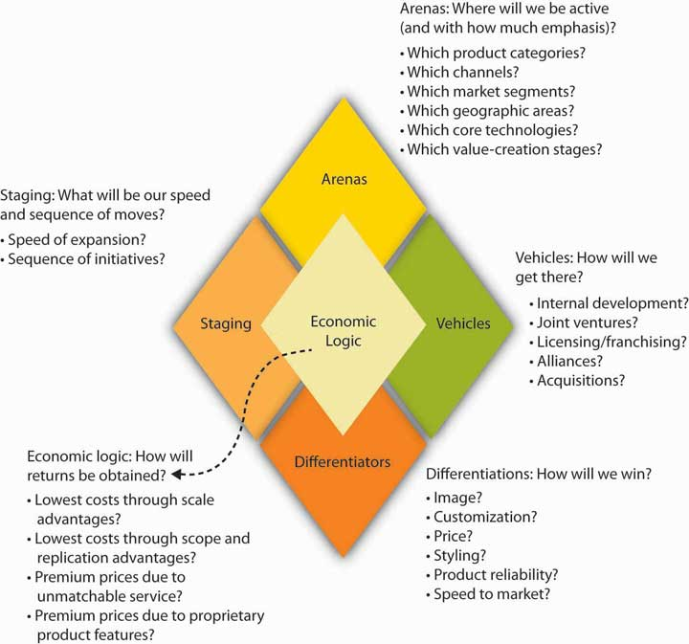
Adapted from Hambrick, D. C., & Fredrickson, J. W. (2001). Are you sure you have a strategy? Academy of Management Executive, 19 (4), 51–62.
Because of their critique and analysis, they concluded that if an organization must have a strategy, then the strategy must necessarily have parts. The figure summarizes the parts of their diamond model, its facets, and some examples of the different ways that you can think about each facet. The diamond model does not presuppose that any particular theory should dictate the contents of each facet. Instead, a strategy consists of an integrated set of choices, but it isn’t a catchall for every important choice a manager faces. In this section, we will tell you a bit about each facet, addressing first the traditional strategy facets of arenas, differentiators, and economic logic; then we will discuss vehicles and finally the staging and pacing facet.

Arenas, Differentiators, and Economic Logic
We refer to the first three facets of the strategy diamond—arenas, differentiators, and economic logic—as traditional in the sense that they address three longstanding hallmarks of strategizing. Specifically, strategy matches up market needs and opportunities (located in arenas) with unique features of the firm (shown by its differentiators) to yield positive performance (economic logic). While performance is typically viewed in financial terms, it can have social or environmental components as well.
Let’s start with arenas. Answers to strategy questions about arenas tell managers and employees wherethe firm will be active. For instance, Nike is headquartered in Washington County, on the outskirts of Beaverton, Oregon. Today, Nike’s geographic market arenas are most major markets around the globe, but in the early 1960s, Nike’s arenas were limited to Pacific Northwest track meets accessible by founder Phil Knight’s car. In terms of product markets (another part of where), the young Nike company (previously Blue Ribbon Sports) sold only track shoes and not even shoes it manufactured.
Beyond geographic-market and product-market arenas, an organization can also make choices about the value-chain arenas in its strategy. To emphasize the choice part of this value-chain arena, Nike’s competitor New Balance manufactures nearly all the athletic shoes that it sells in the United States. Thus, these two sports-shoe companies compete in similar geographic- and product-market arenas but differ greatly in terms of their choice of value-chain arenas.
What about differentiators? Differentiators are the things that are supposedly unique to the firm such that they give it a competitive advantage in its current and future arenas. A differentiator could be asset based, that is, it could be something related to an organization’s tangible or intangible assets. Atangible asset has a value and physically exists. Land, machines, equipment, automobiles, and even currencies, are examples of tangible assets. For instance, the oceanfront land on California’s Monterey Peninsula, where the Pebble Beach Golf Course and Resort is located, is a differentiator for it in the premium golf-course market. An intangible asset is a nonphysical resource that provides gainful advantages in the marketplace. Brands, copyrights, software, logos, patents, goodwill, and other intangible factors afford name recognition for products and services. Obviously, the Nike brand has become a valuable intangible asset because of the broad awareness and reputation for quality and high performance that it has built. Differentiators can also be found in capabilities, that is, how the organization does something. Wal-Mart, for instance, is very good at keeping its costs low. Nike, in contrast, focuses on developing leading-edge, high-performance athletic performance technologies, as well as up-to-the-minute fashion in active sportswear.
The third facet of the strategy diamond in this traditional view is economic logic, which explains how the firm makes money. Economic logic tells us how profits will be generated above the firm’s cost of capital. The collapse in the late 1990s of stock market valuations for Internet companies lacking in profits—or any prospect of profits—marked a return to economic reality. Profits above the firm’s cost of capital are required to yield sustained or longer-term shareholder returns. While the economic logic can include environmental and social profits (benefits reaped by society), the strategy must earn enough financial profits to keep investors (owners, tax payers, governments, and so on) willing to continue to fund the organization’s costs of doing business. A firm performs well (i.e., has a strong, positive economic logic) when its differentiators are well aligned with its chosen arenas.

Vehicles
You can see why the first three facets of the strategy diamond—arenas, differentiators, and economic logic—might be considered the traditional facets of strategizing in that they cover the basics: (1) external environment, (2) internal organizational characteristics, and (3) some fit between them that has positive performance consequences. The fourth facet of the strategy diamond is called vehicles. If arenas and differentiators show where you want to go, then vehicles communicate how the strategy will get you there.
Specifically, vehicles refer to how you might pursue a new arena through internal means, through help from a new partner or some other outside source, or even through acquisition. In the context of vehicles, this is where you determine whether your organization is going to grow organically, acquisitively, or through a combination of both. Organic growth is the growth rate of a company excluding any growth from takeovers, acquisitions, or mergers. Acquisitive growth, in contrast, refers precisely to any growth from takeovers, acquisitions, or mergers. Augmenting either organic or acquisitive growth is growth through partnerships with other organizations. Sometimes such partnership-based growth is referred to as co-opetition, because an organization cooperates with others, even some competitors, in order to compete and grow.
Vehicles are considered part of the strategy because there are different skills and competencies associated with different vehicles. For instance, acquisitions fuel rapid growth, but they are challenging to negotiate and put into place. Similarly, alliances are a great way to spread the risk and let each partner focus on what it does best. But at the same time, to grow through alliances also means that you must be really good at managing relationships in which you are dependent on another organization over which you do not have direct control. Organic growth, particularly for firms that have grown primarily through partnering or acquisition, has its own distinct challenges, such as the fact that the organization is on its own to put together everything it needs to fuel its growth.

Staging and Pacing
Staging and pacing constitute the the fifth and final facet of the strategy diamond. Staging and pacingreflect the sequence and speed of strategic moves. This powerful facet of strategizing helps you think about timing and next steps, instead of creating a strategy that is a static, monolithic plan. As an example, the managers of Chuy’s, a chain of Austin, Texas-based Tex-Mex restaurants, wanted to grow the business outside of Austin, but at the same time, they knew it would be hard to manage these restaurants that were farther away. How should they identify in which cities to experiment with new outlets? Their creative solution was to choose cities that were connected to Austin by Southwest Airlines. Since Southwest is inexpensive and its point-to-point system means that cities are never much more than an hour apart, the Austin managers could easily and regularly visit their new ventures out of town. Remember, strategizing is about making choices, and sequencing and speed should be key choices along with the other facets of the strategy. The staging and pacing facet also helps to reconcile the designed and emergent portions of your strategy.

The Strategy Diamond and Your Personal Growth and Development Strategy
The strategy diamond is a useful professional and personal tool for managers. How might it benefit them personally? Well, in the same way it can benefit you—the following figure maps out how your strategy fits in the planning aspect of P-O-L-C. Remember that, like in P-O-L-C, your personal strategy should be guided by your own mission and vision. Let’s look at how you might apply the strategy diamond to your personal growth and development objectives.

Figure 5.21 Planning and Your Personal Growth and Development Strategy
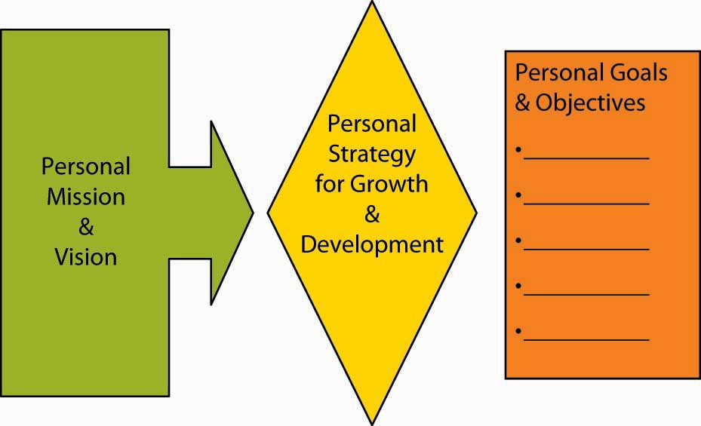

Personal Arenas and Differentiators
Your arenas and differentiators will answer such personal growth and development questions as:
- What type of work do I want to do?
- What leisure activities do I like?
- Where do I want to live?
- What capabilities (differentiators) do I need to participate in these arenas?
- What organizations value these capabilities (differentiators)?
- What capabilities (differentiators) do I want to have and excel in?
Your personal arenas can be an activity you want to do, a specific job, or simply a geographic location. For instance, do you want to be a store manager, an accountant, an entrepreneur, or a CEO? Or do you want to live in a certain locale? For instance, I will do anything just as long as I can live in Paris! It can also be a combination of several. For example, perhaps you want to be a software designer for Google and live in San Francisco.
The more specific you are about the arenas in your strategy, the better you will be able to plot out the other facets. Going back to our Google example, your personal differentiators would likely have to include the demonstration of excellence in software design and an affinity for the Google corporate culture. More broadly, the differentiators facet of your personal strategy should map on to your arenas facet—that is, they should clearly fit together. Also, recognize too that your differentiators are subject to VRIO, in that where your capabilities are valuable and rare, you may be more likely to economically benefit from them with employers (this foreshadows the link between personal differentiators and personal economic logic).

Personal Vehicles
The personal vehicles facet of your strategy answers questions such as:
- What do I need to accomplish on my own?
- What do I want to accomplish on my own?
- What do I need to accomplish with the help of others?
- Who are they?
We often think that our careers and quality of life are up to us—will be based on our choices and actions alone. If that is your belief (i.e., you are a rugged individualist), then your personal growth and development strategy seems to be highly dependent on what you do but not on the contributions of others.
It is true that we have to develop our own knowledge and capabilities to move forward. However, in reality, we also typically get most things done through and with others. You have friends and family outside of work and colleagues, employees, and bosses at work.
The vehicles component of your personal strategy diamond should spell out how your growth and development is a function of what you do (when we talk about organizations, we refer to this as organic growth), and what you depend on others to do. The better you understand your dependence on others, the better you will likely be able to manage those relationships.

Personal Staging and Pacing
You can think of personal staging and pacing as the implications of your strategy for your own Outlook calendar. Personal staging and pacing answers questions like:
- What sequence of events does my strategy require?
- What are the financial requirements and consequences of each event?
- What is my deadline for the first event?
- Is the deadline flexible? Can I manage the pacing of the achievement of each event?
- How will timing affect achievement of my personal growth and development strategy?
- Do some events provide an opportunity to reconsider or adjust my strategy?
For instance, if you want to be a manager of a retail store it is likely you might need a related college degree and experience. Your personal staging and pacing would answer questions about how you would achieve these, the financial implications of each, as well as their timing.

Personal Economic Logic
Finally, your personal growth and development strategy will likely have an economic logic. Personal economic logic answers questions such as:
- How does achievement of my strategy help me pay the bills?
- What dimensions of my strategy, like arenas or differentiators, is the economic logic of my strategy most dependent on?
- How sustainable is the economic logic of my strategy?
We can see this most clearly when magazines publish lists of high-demand jobs. When employees have skills that are in high demand by employers, the price of those skills in the form of paycheck, is usually bid up in the market. For organizations, economic logic is typically viewed in terms of financial performance. However, increasingly, firms target social and environmental performance as well—similarly, the economic logic of your strategy can have implications for what you do to improve social and environmental conditions. This can happen directly through your volunteer hours or indirectly through your financial support of causes you believe in.

KEY TAKEAWAY
In this section, we discussed how to put together a strategy diamond. The first step involves identifying the organization’s arenas, differentiators, and economic logic. This step involves a basic understanding of strategy and summarizes many of the traditional views in strategic management. The second step involves contemplating how the organization would compete or grow in existing or new arenas, and this is where the vehicles came into play. Finally, you considered the sequencing and speed of strategic initiatives by learning about the strategy diamond facet of staging and pacing. Together, these five facets (i.e., arenas, differentiators, economic logic, vehicles, staging, and pacing) constitute the strategy diamond. We concluded the chapter with an application of the strategy diamond to your personal situation.

EXERCISES
- What are the five facets of the Hambrick and Fredrickson strategy diamond?
- What is the relationship between arenas and differentiators if the strategy yields a positive economic logic?
- If a firm is performing poorly financially, what might this say about the differentiators, arenas, or both?
- Why is it important to consider vehicles as part of an organization’s strategy?
- What is the difference between staging and pacing in terms of the strategy diamond?
- What are some ways that you might apply staging and pacing to an organization’s strategy?

Chapter 6

Goals and Objectives

WHAT’S IN IT FOR ME?
Reading this chapter will help you do the following:
- Understand the nature of goals and objectives and why they are important.
- See how our thinking about goals and objectives has evolved.
- Know what characterizes good goals and objectives.
- Understand the roles of goals and objectives in employee performance reviews.
- Map out relationships among economic, social, and environmental goals and objectives.
- Set and manage your own goals and objectives.
Goals and objectives are a critical component of management, both in terms of planning and in terms of the larger planning-organizing-leading-controlling (P-O-L-C) framework. You can see their role summarized in the P-O-L-C figure. Unfortunately, because their role and importance seem obvious, they also tend to be neglected in managerial practice or poorly aligned with the organization’s strategy. You can imagine why this might be problematic, particularly since one of a manager’s functions is to evaluate employee performance—it would be nice if employees could be evaluated based on how their achievement of individual goals and objectives contributes to those critical to the organization’s survival and success. In this chapter, we introduce you to the basics on goals and objectives and provide you with an understanding of how their usage has evolved. We also show you how to develop a personalized set of goals and objectives to help you achieve your personal and professional aspirations.

Figure 6.2 Goals and Objectives in the P-O-L-C Framework

6.1 Case in Point: Nucor Aligns Company Goals With Employee Goals
Manufacturing steel is not a glamorous job. The industry is beset by many problems, and more than 40 steel manufacturers have filed for bankruptcy in recent years. Most young employees do not view working at a steel mill as their dream job. Yet, one company distinguished itself from all the rest by remaining profitable for over 130 quarters and by providing an over 350% return on investment (ROI) to shareholders. The company is clearly doing well by every financial metric available and is the most profitable in its industry.
How do they achieve these amazing results? For one thing, every one of Nucor Corporation’s (NYSE: NUE) 12,000 employees acts like an owner of the company. The overarching goal is “take care of our customers.” Employees are encouraged to fix the things they see as wrong and have real power on their jobs. When there is a breakdown in a plant, a supervisor does not have to ask employees to work overtime; employees volunteer for it. In fact, the company is famous for its decentralized structure and for pushing authority and responsibility down to lower levels in the hierarchy. Tasks that previously belonged to management are performed by line workers. Management listens to lower level employees and routinely implements their new ideas.
The reward system in place at Nucor is also unique, and its employees may be the highest paid steelworkers in the world. In 2005, the average Nucor employee earned $79,000, followed by a $2,000 bonus decided by the company’s annual earnings and $18,000 in the form of profit sharing. At the same time, a large percentage of these earnings are based on performance. People have the opportunity to earn a lot of money if the company is doing well, and there is no upward limit to how much they can make. However, they will do much worse than their counterparts in other mills if the company does poorly. Thus, it is to everyone’s advantage to help the company perform well. The same incentive system exists at all levels of the company. CEO pay is clearly tied to corporate performance. The incentive system penalizes low performers while increasing commitment to the company as well as to high performance.
Nucor’s formula for success seems simple: align company goals with employee goals and give employees real power to make things happen. The results seem to work for the company and its employees. Evidence of this successful method is that the company has one of the lowest employee turnover rates in the industry and remains one of the few remaining nonunionized environments in manufacturing. Nucor is the largest U.S. minimill and steel scrap recycler.
Primary Resource:
Secondary Resources:
- Based on information from Byrnes, N., & Arndt, M. (2006, May 1). The art of motivation. BusinessWeek. Retrieved April 30, 2010, from http://www.businessweek.com/magazine/content/06_18/b3982075.htm
- Foust, D. (2008, April 7). The best performers of 2008. BusinessWeek. Retrieved April 30, 2010, from http://www.businessweek.com/magazine/toc/08_14/B4078bw50.htm?chan=magazine+channel_top+stories
- Jennings, J. (2003). Ways to really motivate people: Authenticity is a huge hit with Gen X and Y. The Secured Lender, 59, 62–70
- Marks, S. J. (2001). Incentives that really reward and motivate. Workforce, 80, 108–114

DISCUSSION QUESTIONS
- How do goals and objectives at NUCOR relate to the planning facet of the P-O-L-C framework?
- What negative consequences might arise at Nucor Corporation as a result of tying pay to company performance?
- What effects do penalizing low performers have on Nucor employees?
- What other ways can a company motivate employees to increase productivity, in addition to monetary incentives?
- How might the different reward systems at Nucor, individual empowerment and economic incentives, motivate people differently? Or do they have the same effect?
- How would unionization at Nucor impact the dynamic of the organization?

6.2 The Nature of Goals and Objectives

LEARNING OBJECTIVES
- Know the difference between goals and objectives.
- Know the relationship between goals and objectives.
- See how goals and objectives fit in the P-O-L-C framework.

What Are Goals and Objectives?
Goals and objectives provide the foundation for measurement. Goals are outcome statements that define what an organization is trying to accomplish, both programmatically and organizationally. Goals are usually a collection of related programs, a reflection of major actions of the organization, and provide rallying points for managers. For example, Wal-Mart might state a financial goal of growing its revenues 20% per year or have a goal of growing the international parts of its empire. Try to think of each goal as a large umbrella with several spokes coming out from the center. The umbrella itself is a goal.
In contrast to goals, objectives are very precise, time-based, measurable actions that support the completion of a goal. Objectives typically must (1) be related directly to the goal; (2) be clear, concise, and understandable; (3) be stated in terms of results; (4) begin with an action verb; (5) specify a date for accomplishment; and (6) be measurable. Apply our umbrella analogy and think of each spoke as an objective. Going back to the Wal-Mart example, and in support of the company’s 20% revenue growth goal, one objective might be to “open 20 new stores in the next six months.” Without specific objectives, the general goal could not be accomplished—just as an umbrella cannot be put up or down without the spokes. Importantly, goals and objectives become less useful when they are unrealistic or ignored. For instance, if your university has set goals and objectives related to class sizes but is unable to ever achieve them, then their effectiveness as a management tool is significantly decreased.
Measures are the actual metrics used to gauge performance on objectives. For instance, the objectiveof improved financial performance can be measured using a number metrics, ranging from improvement in total sales, profitability, efficiencies, or stock price. You have probably heard the saying, “what gets measured, gets done.” Measurement is critical to today’s organizations. It is a fundamental requirement and an integral part of strategic planning and of principles of management more generally. Without measurement, you cannot tell where you have been, where you are now, or if you are heading in the direction you are intending to go. While such statements may sound obvious, the way that most organizations have set and managed goals and objectives has generally not kept up with this commonsense view.

Measurement Challenges
There are three general failings that we can see across organizations related to measurement. First, many organizations still emphasize historic financial goals and objectives, even though financial outcomes are pretty narrow in scope and are purely historic; by analogy, financial measures let you know where you’ve been, but may not be a good predictor of where you are going.
- Frost, B. (2000). Measuring performance. Dallas: Measurement International
Second, financial outcomes are often short term in nature, so they omit other key factors that might be important to the longer-term viability of the organization. For instance, return on sales (ROS, or net profit divided by total sales) is a commonly used measure of financial performance, and firms set goals and objectives related to return on sales. However, an organization can increase return on sales by cutting investments in marketing and research and development (since they are costs that lessen the “return” dimension of ROS). It may be a good thing to cut such costs, but that type of cost-cutting typically hurts the organization’s longer-term prospects. Decreases in marketing may reduce brand awareness, and decreases in research and development (R&D) will likely stifle new product or service development.
Finally, goals and objectives, even when they cover more than short-term financial metrics, are often not tied to strategy and ultimately to vision and mission. Instead, you may often see a laundry list of goals and objectives that lack any larger organizing logic. Or the organization may have adopted boilerplate versions of nonfinancial measurement frameworks such as Kaplan and Norton’s Balanced Scorecard, Accenture’s Performance Prism, or Skandia’s Intellectual Capital Navigator.
- Ittner, C. D., & Larcker, D. (2003, November). Coming up short on nonfinancial performance measurement. Harvard Business Review, pp. 1–8

Goals and Objectives in P-O-L-C
Goals and objectives are an essential part of planning. They also have cascading implications for all the aspects of organizing, leading, and controlling. Broadly speaking, goals and objectives serve to:
- Gauge and report performance
- Improve performance
- Align effort
- Manage accountabilities

Goals, Objectives, and Planning
Planning typically starts with a vision and a mission. Then managers develop a strategy for realizing the vision and mission; their success and progress in achieving vision and mission will be indicated by how well the underlying goals and objectives are achieved. A vision statement usually describes some broad set of goals—what the organization aspires to look like in the future. Mission statements too have stated goals—what the organization aspires to be for its stakeholders. For instance, Mars, Inc., the global food giant, sets out five mission statement goals in the areas of quality, responsibility, mutuality, efficiency, and freedom. Thus, goals are typically set for the organization as a whole and set the stage for a hierarchy of increasingly specific and narrowly set goals and objectives.
However, unless the organization consists of only a single person, there are typically many working parts in terms of functional areas and product or service areas. Functional areas like accounting and marketing will need to have goals and objectives that, if measured and tracked, help show if and how those functions are contributing to the organization’s goals and objectives. Similarly, product and service areas will likely have goals and objectives. Goals and objectives can also be set for the way that functions and product or service areas interact. For instance, are the accounting and marketing functions interacting in a way that is productive? Similarly, is marketing delivering value to product or service initiatives?

Goals, Objectives, and Organizing, Leading, and Controlling
Within the planning facet of P-O-L-C alone, you can think of goals and objectives as growing in functional or product/service arena specificity as you move down the organization. Similarly, the time horizon can be shorter as you move down the organization as well. This relationship between hierarchy and goals and objectives is summarized in the following figure.
Obviously, the role of goals and objectives does not stop in the planning stage. If goals and objectives are to be achieved and actually improve the competitive position of the firm, then the organizing, leading, and controlling stages must address goals and objectives as well.
The way that the firm is organized can affect goals and objectives in a number of ways. For instance, a functional organizational structure, where departments are broken out by finance, marketing, operations, and so on, will likely want to track the performance of each department, but exactly what constitutes performance will probably vary from function to function.
In terms of leadership, it is usually top managers who set goals and objectives for the entire organization. Ideally, then, lower-level managers would set or have input into the goals and objectives relevant to their respective parts of the business. For example, a CEO might believe that the company can achieve a sales growth goal of 20% per year. With this organizational goal, the marketing manager can then set specific product sales goals, as well as pricing, volume, and other objectives, throughout the year that show how marketing is on track to deliver its part of organizational sales growth. Goal setting is thus a primary function of leadership, along with holding others accountable for their respective goals and objectives.

Figure 6.4 Goals and Objectives in Planning
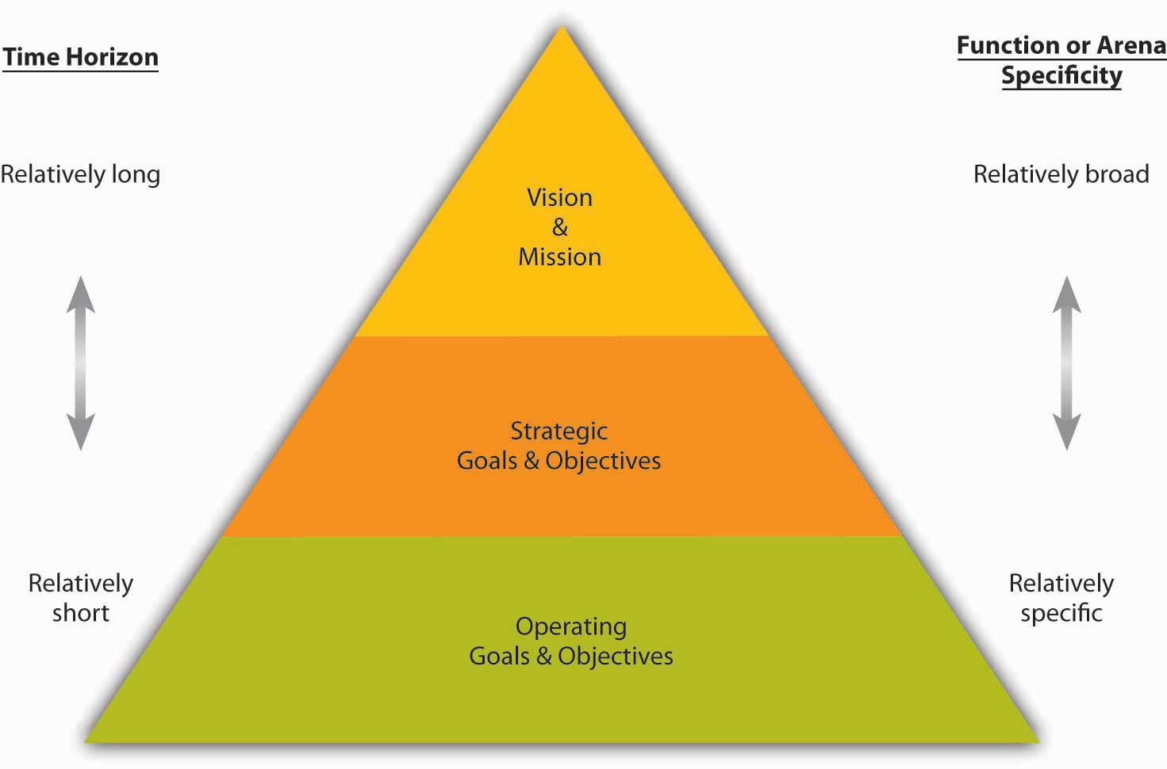
Finally, goals and objectives can provide a form of control since they create a feedback opportunity regarding how well or how poorly the organization executes its strategy. Goals and objectives also are a basis for reward systems and can align interests and accountability within and across business units. For instance, in a business with several divisions, you can imagine that managers and employees may behave differently if their compensation and promotion are tied to overall company performance, the performance of their division, or some combination of the two.

KEY TAKEAWAY
Goals are typically outcome statements, while objectives are very precise, time-based, and measurable actions that support the completion of goals. Goals and objectives are an essential element in planning and are a key referent point in many aspects of organizing, leading, and controlling. Broadly speaking, within the P-O-L-C framework, goals and objectives serve to (1) gauge and report performance, (2) improve performance, (3) align effort and, (4) manage accountabilities.

EXERCISES
- What is the difference between a goal and an objective?
- What is the relationship between a goal and an objective?
- What characteristics should a good objective have?
- What four broad ways do goals and objectives fit in the P-O-L-C framework?
- Why are goals and objectives relevant to leadership?
- In what ways do goals and objectives help managers control the organization?

6.3 From Management by Objectives to the Balanced Scorecard

LEARNING OBJECTIVES
- Be able to describe management by objectives.
- Be able to describe the Balanced Scorecard.
- Understand the evolution of performance measurement systems.
As you might expect, organizations use a variety of measurement approaches—that is, how they go about setting and managing goals and objectives. If you have an understanding of how the use of these approaches has evolved, starting with management by objectives (MBO), you will also have a much better view of how and why the current incarnations, as seen by variations on the Balanced Scorecard, have many desirable features.

Management by Objectives
MBO is a systematic and organized approach that allows management to focus on achievable goals and to attain the best possible results from available resources. MBO aims to increase organizational performance by aligning the subordinate objectives throughout the organization with the overall goals that management has set. Ideally, employees get strong input to identify their objectives, time lines for completion, and so on. MBO includes ongoing tracking and feedback in the process to reach objectives.
MBO was first outlined by Peter Drucker in 1954 in The Practice of Management. One of Drucker’s core ideas in MBO was where managers should focus their time and energy. According to Drucker, effective MBO managers focus on the result, not the activity. They delegate tasks by “negotiating a contract of objectives” with their subordinates and by refraining from dictating a detailed road map for implementation. MBO is about setting goals and then breaking these down into more specific objectives or key results. MBO involves (1) setting company-wide goals derived from corporate strategy, (2) determining team- and department-level goals, (3) collaboratively setting individual-level goals that are aligned with corporate strategy, (4) developing an action plan, and (5) periodically reviewing performance and revising goals.
- Greenwood, R. G. (1981). Management by objectives: As developed by Peter Drucker, assisted by Harold Smiddy. Academy of Management Review, 6, 225–230
- Muczyk, J. P., & Reimann, B. C. (1989). MBO as a complement to effective leadership. Academy of Management Executive, 3, 131–138
- Reif, W. E., & Bassford, G. (1975). What MBO really is: Results require a complete program.Business Horizons, 16, 23–30
A review of the literature shows that 68 out of the 70 studies conducted on this topic showed performance gains as a result of MBO implementation.
- Rodgers, R., & Hunter, J. E. (1991). Impact of management by objectives on organizational productivity. Journal of Applied Psychology, 76, 322–336
It also seems that top management commitment to the process is the key to successful implementation of MBO programs.
- Rodgers, R., Hunter, J. E., & Rogers, D. L. (1993). Influence of top management commitment on management program success. Journal of Applied Psychology, 78, 151–155
The broader principle behind MBO is to make sure that everybody within the organization has a clear understanding of the organization’s goals, as well as awareness of their own roles and responsibilities in achieving objectives that will help to attain those goals. The complete MBO system aims to get managers and empowered employees acting to implement and achieve their plans, which automatically achieves the organization’s goals.

Setting Objectives
In MBO systems, goals and objectives are written down for each level of the organization, and individuals are given specific aims and targets. As consultants Robert Heller and Tim Hindle explain, “The principle behind this is to ensure that people know what the organization is trying to achieve, what their part of the organization must do to meet those aims, and how, as individuals, they are expected to help. This presupposes that organization’s programs and methods have been fully considered. If they have not, start by constructing team objectives and ask team members to share in the process.”
- Heller, R., & Hindle, T. (1998). Essential manager’s manual. London: Dorling Kindersley
Echoing Drucker’s philosophy, “the one thing an MBO system should provide is focus; most people disobey this rule, try to focus on everything, and end up with no focus at all,” says Andy Grove, who ardently practiced MBO at Intel. This implies that objectives are precise and few in effective MBO systems.
Similarly, for MBO to be effective, individual managers must understand the specific objectives of their job and how those objectives fit in with the overall company goals set by the board of directors. As Drucker wrote, “A manager’s job should be based on a task to be performed in order to attain the company’s goals…the manager should be directed and controlled by the objectives of performance rather than by his boss.”
- Drucker, P. (1974). Management: Tasks, responsibilities, practices. London: Heinemann.
The managers of an organization’s various units, subunits, or departments should know not only the objectives of their unit but should also actively participate in setting these objectives and make responsibility for them. The review mechanism enables the organization’s leaders to measure the performance of the managers who report to them, especially in the key result areas: marketing, innovation, human organization, financial resources, physical resources, productivity, social responsibility, and profit requirements.

Seeking a Balance: The Move Away from MBO
In recent years, opinion has moved away from placing managers into a formal, rigid system of objectives. In the 1990s, Drucker decreased the significance of this organization management method when he said, “It’s just another tool. It is not the great cure for management inefficiency.”
- Drucker, P. (1986). The frontiers of management: Where tomorrow’s decisions are being shaped today. New York: Plume.
Recall also that goals and objectives, when managed well, are tied in with compensation and promotion. In 1975, Steve Kerr published his critical management article titled, “On the Folly of Rewarding A, While Hoping for B,” in which he lambasted the rampant disconnect between reward systems and strategy.
- Kerr, S. (1975). On the folly of rewarding A, while hoping for B. Academy of Management Journal, 18, 769–783
Some of the common management reward follies suggested by Kerr and others are summarized in the following table. His criticism included the objective criteria characteristic of most MBO systems. Kerr went on to lead GE’s human resources function in the mid-1970’s and is credited with turning that massive organization’s recruiting, reward, and retention systems into one of its key sources of competitive advantage.

Table 6.1 Common Management Reward Follies
We hope for… | But we often reward…
Long-term growth; environmental responsibility | Quarterly earnings
Teamwork | Individual effort
Setting challenging “stretch” goals | Achieving objectives; “making the numbers”
Downsizing; rightsizing; restructuring | Adding staffing; adding budget
Commitment to quality | Shipping on schedule, even with defects
Commitment to customer service | Keeping customers from bothering usThis item was not one of Kerr’s originals but is consistent with the spirit of Kerr’s article. We thank our developmental editor, Elsa Peterson, for this suggestion.
Candor; surfacing bad news early | Reporting good news, whether it’s true or not; agreeing with the boss, whether or not she or he is right
Even though formal MBO programs have been out of favor since the late 1980s and early 1990s, linking employee goals to company-wide goals is a powerful idea that benefits organizations. This is where the Balanced Scorecard and other performance management systems come into play.

The Balanced Scorecard
Developed by Robert Kaplan and David Norton in 1992, the Balanced Scorecard approach to management has gained popularity worldwide since the 1996 release of their text, The Balanced Scorecard: Translating Strategy into Action. In 2001, the Gartner Group estimated that at least 40% of all Fortune 1000 companies were using Balanced Scorecard; however, it can be complex to implement, so it is likely that the format of its usage varies widely across firms.
The Balanced Scorecard is a framework designed to translate an organization’s mission and vision statements and overall business strategy into specific, quantifiable goals and objectives and to monitor the organization’s performance in terms of achieving these goals. Among other criticisms of MBO, one was that it seemed disconnected from a firm’s strategy, and one of Balanced Scorecard’s innovations is explicit attention to vision and strategy in setting goals and objectives. Stemming from the idea that assessing performance through financial returns only provides information about how well the organization did prior to the assessment, the Balanced Scorecard is a comprehensive approach that analyzes an organization’s overall performance in four ways, so that future performance can be predicted and proper actions taken to create the desired future.

Four Related Areas
Balanced Scorecard shares several common features. First, as summarized in the following figure, it spells out goals and objectives for the subareas of customers, learning and growth, internal processes, and financial performance. The customer area looks at customer satisfaction and retention. Learning and growth explore the effectiveness of management in terms of measures of employee satisfaction and retention and information system performance. The internal area looks at production and innovation, measuring performance in terms of maximizing profit from current products and following indicators for future productivity. Finally, financial performance, the most traditionally used performance indicator, includes assessments of measures such as operating costs and return-on-investment.

Figure 6.6 The Balanced Scorecard
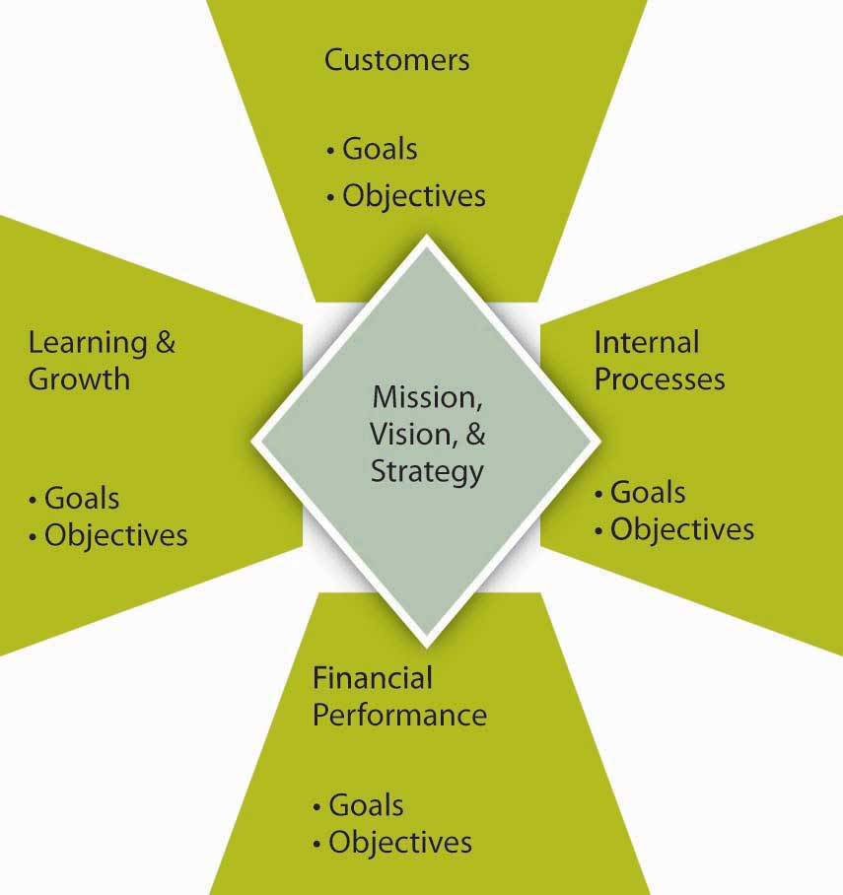
Source: Adapted from Kaplan, R., & Norton, D. (2001). The Strategy-Focused Organization. Boston: Harvard Business School Press.
On the basis of how the organization’s strategy is mapped out in terms of customer, learning, internal, and financial goals and objectives, specific measures, and the specific activities for achieving those are defined as well. This deeper Balanced Scorecard logic is summarized in the following figure. The method examines goals, objectives, measures, and activities in four areas. When performance measures for areas such as customer relationships, internal processes, and learning and growth are added to the financial metrics, proponents of the Balanced Scorecard argue that the result is not only a broader perspective on the company’s health and activities, it’s also a powerful organizing framework. It is a sophisticated instrument panel for coordinating and fine-tuning a company’s operations and businesses so that all activities are aligned with its strategy.
As a structure, Balanced Scorecard breaks broad goals down successively into objectives, measures, and tactical activities. As an example of how the method might work, an organization might include in its mission or vision statement a goal of maintaining employee satisfaction (for instance, the mission statement might say something like “our employees are our most valuable asset”). This would be a key part of the organization’s mission but would also provide an “internal” target area for that goal in the Balanced Scorecard. Importantly, this goal, when done correctly, would also be linked to the organization’s total strategy where other parts of the scorecard would show how having great employees provides economic, social, and environmental returns. Strategies for achieving that human resources vision might include approaches such as increasing employee-management communication. Tactical activities undertaken to implement the strategy could include, for example, regularly scheduled meetings with employees. Finally, metrics could include quantifications of employee suggestions or employee surveys.

Figure 6.7 Using the Balanced Scorecard to Translate Goals into Activities
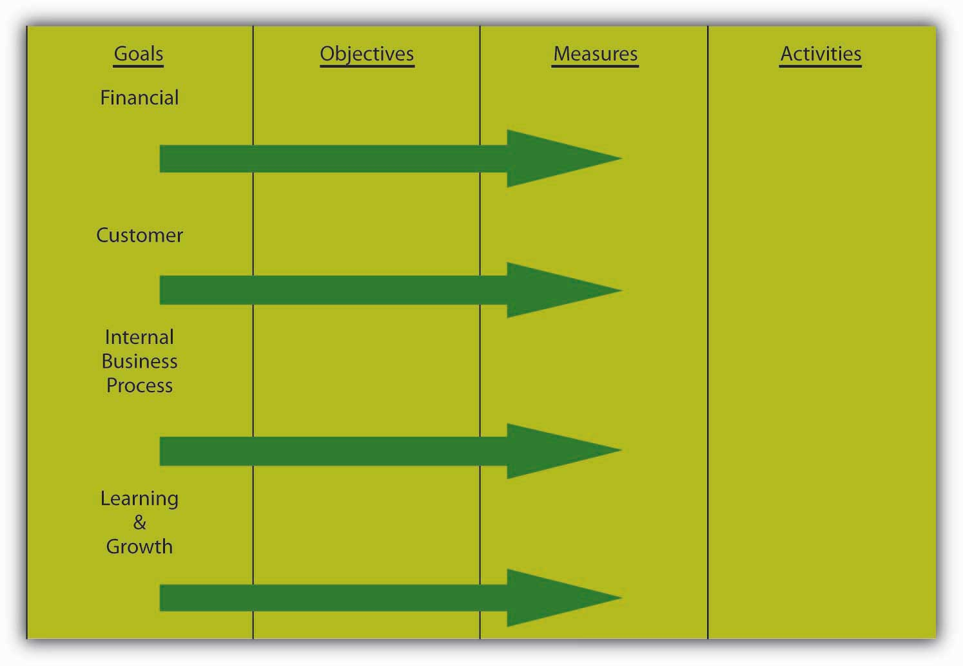
Source: Adapted from Kaplan, R., & Norton, D. (2001). The Strategy-Focused Organization. Boston: Harvard Business School Press.

The Balanced Scorecard in Practice
In practice, the Balanced Scorecard is supposed to be more than simply a framework for thinking about goals and objectives, but even in that narrow sense, it is a helpful organizing framework. The Balanced Scorecard’s own inventors “rightly insist that every company needs to dig deep to discover and track the activities that truly affect the frameworks’ broad domains (domains such as ‘financial,’ ‘customer,’ ‘internal business processes,’ and ‘innovation and learning’).”
- Ittner, C. D., & Larcker, D. (2003, November). Coming up short on nonfinancial performance measurement, Harvard Business Review, pp. 1–8
In its broadest scope, where the scorecard operates much like a map of the firm’s vision, mission, and strategy, the Balanced Scorecard relies on four processes to bind short-term activities to long-term objectives:
- Translating the vision. By relying on measurement, the scorecard forces managers to come to agreement on the metrics they will use to translate their lofty visions into everyday realities.
- Communicating and linking. When a scorecard is disseminated up and down the organizational chart, strategy becomes a tool available to everyone. As the high-level scorecard cascades down to individual business units, overarching strategic objectives and measures are translated into objectives and measures appropriate to each particular group. Tying these targets to individual performance and compensation systems yields “personal scorecards.” Thus, individual employees understand how their own productivity supports the overall strategy.
- Business planning. Most companies have separate procedures (and sometimes units) for strategic planning and budgeting. Little wonder, then, that typical long-term planning is, in the words of one executive, where “the rubber meets the sky.” The discipline of creating a Balanced Scorecard forces companies to integrate the two functions, thereby ensuring that financial budgets indeed support strategic goals. After agreeing on performance measures for the four scorecard perspectives, companies identify the most influential “drivers” of the desired outcomes and then set milestones for gauging the progress they make with these drivers.
- Feedback and learning. By supplying a mechanism for strategic feedback and review, the Balanced Scorecard helps an organization foster a kind of learning often missing in companies: the ability to reflect on inferences and adjust theories about cause-and-effect relationships.

Other Peformance Measurement Systems
You can imagine that it might be difficult for organizations to change quickly from something like MBO to a Balanced Scorecard approach. Indeed, both MBO and the Balanced Scorecard fit in the larger collection of tools called performance management systems. Such systems outline “the process through which companies ensure that employees are working towards organizational goals.”
- Ghorpade, J., & Chen, M. (1995). Creating quality-driven performance appraisal systems. Academy of Management Executive, 9(1): 23–41
Performance management begins with a senior manager linking his or her goals and objectives to the strategic goals of the organization. The manager then ensures that direct reports develop their goals in relation to the organization’s overall goals. In a multidivisional or multilocation organization, lower-level managers develop their goals, and thus their departmental goals, to correspond to the organizational goals. Staff members within each department then develop their objectives for the year, in cooperation with their managers. Using this pattern for planning, all activities, goals, and objectives for all employees should be directly related to the overall objectives of the larger organization.
Performance management systems are more than the performance review because reviews typically are the final event in an entire year of activity. At the beginning of the year, the manager and employee discuss the employee’s goals or objectives for the year. This will form the basis for ongoing discussion recorded in a document called the performance plan. The manager assists employees in developing their objectives by helping them to understand how their work relates to the department goals and the overall goals of the organization. The employee and manager also should work together to determine the measurements for evaluating each of the objectives. It is important that both the manager and employee agree what the objectives are and how they are to be measured.
Employees should not be set up with unrealistic expectations, which will only lead to a sense of failure. If additional support or education is required during the year to help employees meet their objectives, those can also be identified and planned for at this time.
The performance plan will contain the section on goals or objectives. It also should include a section that identifies the organization’s expectations of employee competencies. The set of expectations will involve a range of competencies applicable to employees based on their level in the organization. These competencies include expectations of how employees deal with problems, how proactive they are with respect to changing work, and how they interact with internal and external customers. While less complex than the Balanced Scorecard, you can see how the essential components are related. In addition to basic behavioral traits, supervisors and managers are expected to exhibit leadership and, more senior still, provide vision and strategic direction. It is important to ensure that employees understand these competencies in respect to themselves.
Throughout the year, the supervisor must participate actively in coaching and assisting all employees to meet their individual goals and objectives. Should a problem arise—either in the way that success is being measured or in the nature of the objectives set at the beginning of the year—it can be identified well in advance of any review, and adjustments to the goals or support for the employee can be provided. This is referred to as continual assessment.
For example, suppose a staff member predicted that he or she would complete a particular project by a particular date, yet they have encountered problems in receiving vital information from another department. Through active involvement in staff activities, the supervisor is made aware of the situation and understands that the employee is intimidated by the supervisor they must work with in the other department. With coaching, the employee develops a method for initiating contact with the other department and receives the vital information she requires to meet her objective.

KEY TAKEAWAY
The way that goals and objectives are managed in the P-O-L-C process has evolved over time. While organizations can have very simple performance measurement systems, these systems typically track multiple goals and objectives. The management by objectives (MBO) approach is perhaps one of the earliest systematic approaches to working with goals and objectives. The Balanced Scorecard is aimed to make key improvements on a simple MBO system, particularly by more clearly tying goals and objectives to vision, mission, and strategy and branching out beyond purely financial goals and objectives. MBO and the Balanced Scorecard belong to the larger family of systems called performance management systems.

EXERCISES
- What is Management by objectives (MBO)?
- What are some of the advantages of MBO?
- What are some of the disadvantages and criticisms of MBO?
- What is a Balanced Scorecard?
- What are some of the advantages of a Balanced Scorecard?
- What are some of the disadvantages of a Balanced Scorecard?

6.4 Characteristics of Effective Goals and Objectives

LEARNING OBJECTIVES
- Be able to set appropriate goals.
- Be able to troubleshoot an existing set of goals and objectives.
- Understand the characteristics of good goals and objectives.
To be clear, this section does not outline which goals or objectives are appropriate or inappropriate, economically, ethically, morally, or otherwise. Instead, you will learn many of the characteristics of good goals and objectives, with the aim of becoming a better organizational goal setter (in the last section of this chapter, we remind you about SMART criteria, which is the application of many of this section’s takeaways to the development of your personal and professional goals and objectives). At the same time, you should be able to look at a set of goals and objectives and critique them effectively, such that more appropriate goals and objectives can be developed to replace them.

Eight Characteristics of Appropriate Goals and Objectives

Figure 6.8 Characteristics of Appropriate Goals and Objectives
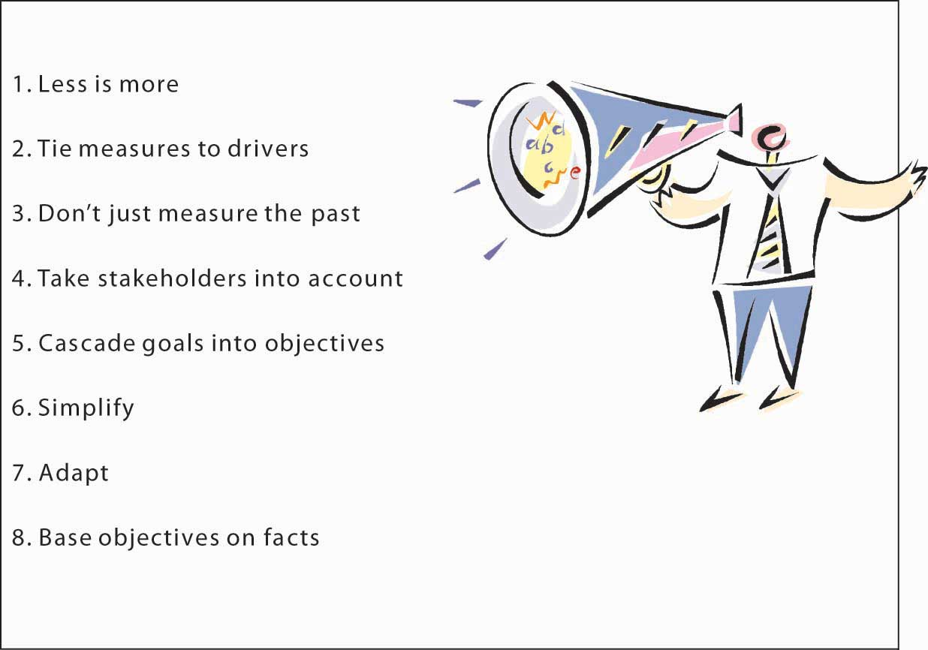
We tend to think that goals and objectives are easy to set, and yet, this intuition is often wrong in the organizational context. Goals and objectives are difficult to set because we might not know what they should cover or because we lay out too many of them with the hope that we are covering all the bases. Similarly, goals and objectives can proliferate in organizations because new ones are set, while old ones are not discarded. Stanford University management professor Kathleen Eisenhardt noted that there must be a certain balance to the number and type of goals and objectives: too many goals and objectives are paralyzing; too few, confusing.
- Eisenhardt, K., & Sull, D. (2001, January). Strategy as simple rules.Harvard Business Review, pp. 1–11
In his popular book, Keeping Score, Mark Graham Brown lists several important factors to aid managers in “rethinking” their approach to setting and managing goals and objectives, what we might call the organization’s measurement system more broadly.
- Brown, M. G. (1996). Keeping score. New York: Productivity Press
- Fewer are better. Concentrate on measuring the vital few key variables rather than the trivial many.
- Measures should be linked to the factors needed for success—key business drivers.
- Measures should be a mix of past, present, and future to ensure the organization is concerned with all three perspectives.
- Measures should be based around the needs of customers, shareholders, and other key stakeholders.
- Measures should start at the top and flow down to all levels of employees in the organization.
- Multiple indices can be combined into a single index to give a better overall assessment of performance.
- Measures should be changed or at least adjusted as the environment and your strategy changes.
- Measures need to have targets or objectives established that are based on research rather than arbitrary numbers.
- Brown, M. G. (1996). Keeping score. New York: Productivity Press.
Let’s walk through each of these criteria to gain a better understanding of these desirable characteristics of organizational goals and objectives. It is useful here to start by recognizing that goals, objectives, and measures are different animals. As explained at the beginning of this chapter, goals tend to be general statements, whereas objectives are specific and time bound. Measures are the indicators used to assess achievement of the objective. In some cases, a goal, an objective, and a measure can be the same thing, but more often you will set a goal, have a few objectives underlying that goal, and then one or more measures for each of the objectives.

Less Is More
Less is more, fewer is better, and simple rules are the common mantra here. Eisenhardt suggests that organizations should have two to seven key goals, or rules, using her vocabulary.
- Eisenhardt, K., & Sull, D. (2001, January). Strategy as simple rules. Harvard Business Review, pp. 1–11
Such goals guide how the firm operates, identify which opportunities to pursue, set priorities, manage timing of actions, and even inform business exit decisions.
If the organization should have only two to seven key goals, what about objectives and measures? Metric guru Graham Brown suggests that managers should not try to follow any more than 20 measures of performance in terms of performance on objectives. Thus, with two to seven goals, and 20 performance measures, this means that you will likely have a number of objectives somewhere between the number of set goals and the number of measures. Why this limit? “No individual can monitor and control more than twenty variables on a regular basis,” says Graham Brown.
- Brown, M. G. (1996). Keeping score. New York: Productivity Press.

Tie Measures to Drivers of Success
One of the key litmus tests for setting goals, objectives, and measures is whether they are linked in some way to the key factors driving an organization’s success or competitive advantage. This means that they must provide a verified path to the achievement of a firm’s strategy, mission, and vision. This characteristic of effective goals, objectives, and measures is one reason that many managers use some form of Balanced Scorecard in their businesses. The Balanced Scorecard process provides a framework for evaluating the overall measurement system in terms of what strategic objectives it contributes to. The big challenge, however, is to verify and validate the link to success factors. Managers who do not scrupulously uncover the fundamental drivers of their units’ performance face several potential problems. They often end up measuring too many things, trying to fill every perceived gap in the measurement system.

Don’t Just Measure the Past
For a variety of reasons it is important to capture past performance. After all, many stakeholders such as investors, owners, customers, and regulators have an interest in how the firm has lived up to it obligations. However, particularly in the area of objectives and measurement, the best systems track the past, present, and future. Echoing this observation, Robert Kaplan, co-originator of the Balanced Scorecard framework, published another book on the subject called The Balanced Scorecard: You Can’t Drive a Car Solely Relying on a Rearview Mirror. A combination of goals, objectives, and measures that provides such information is sometimes referred to as a dashboard—like the analogy that a dashboard tells you how the car is running, and through the windshield you can see where you are going. Indicators on how well the economy is doing, for instance, can suggest whether your business can experience growing or declining sales. Another leading indicator is customer satisfaction. General Electric, for instance, asks its customers whether they will refer other customers to GE. GE’s managers have found that the higher this likelihood of referral, the greater the next quarter’s sales demands. As a result, GE uses this measure to help it forecast future growth, as well as evaluate the performance of each business unit.

Take Stakeholders Into Account
While it is important to track the goals and objectives most relevant to the needs of the business, relevance is subjective. This is why it is valuable to understand who the organization’s key stakeholders are, and set the goals, objectives, and measures in such a way that stakeholders can be satisfied. Or, at the very least, stakeholders can gain information relevant to their particular interests. Some stakeholders may never be entirely satisfied with companies’ performance—for example, some environmental groups may continue to criticize a company’s environmental impact, but they can be somewhat placated with more transparent reporting of what the company is doing on the environmental front. Similarly, stakeholders with social concerns will appreciate transparency in reporting on the organization’s corporate social responsibility efforts.

Cascade Goals Into Objectives
The less-is-more concept can apply to the way that goals cascade into objectives, which cascade into measures. Tying goals and objectives to drivers of success means that vision, mission, and strategy cascade down to goals, and so on. The first benefit of this cascade approach is that goals and objectives are consistent with the strategy, vision, and mission. A second benefit is that goals and objectives in lower levels of the organization are more likely to be vertically and horizontally consistent since they should be designed to achieve the higher-level goals and objectives and, ultimately, the overarching strategy of the organization.

Simplify
Information overload is a challenge facing all managers (and students and teachers!), and simplification builds on the idea that managers can attend to a few things well but many things poorly. Simplification refers both to the use of fewer, not more, metrics, objectives and goals, and the idea that multiple measures should be distilled down into single measures like an index or a simple catch-all question. For instance, GE’s use of the single question about referring customers is a powerful but effective leading metric and a metric that it can reinforce with its rewards system. When metrics involve multiple dimensions, in areas where the organization wants to gauge customer satisfaction, for example, a survey can have 10 or more questions. Think about the many customer satisfaction surveys you are asked to complete after making an online purchase. Which question is the most important? The challenge, of course, is that a simple average of the customer survey scores, while providing a simpler indicator, also may hide some key indicator that is now buried in the average score. Therefore, the organization might need to experiment a bit with different ways of simplifying the measures with the aim of providing one that best reflects achievement of the key objective.

Adapt
An organization’s circumstances and strategies tend to change over time. Since goals, objectives, and measures need to tie directly to the organization’s strategy, they should be changed as well when the strategy changes. For example, many U.S. automakers set out to dominate certain car and truck segments on the basis of vehicle features and price, not fuel efficiency. However, the recent fluctuations in oil prices gave rise to a market for more fuel-efficient vehicles. Unless the automakers set some aggressive fuel efficiency objectives for their new models, however, that is unlikely to be a differentiating feature of their cars and trucks. Adaptation of metrics is not the same as adding more or other metrics. In the spirit of fewer and simpler measures, managers should be asked to take a measure away if they plan to introduce a new one.

Base Objectives on Facts
Finally, while goals may sometimes be general (such as performance goals in which managers simply state, grow profits 10%), the objectives and the metrics that gauge them should be quite specific and set based on facts and information, not intuition. A fact-based decision-making process starts with the compilation of relevant data about the particular goal. This in turn typically requires that the organization invest in information and in information-gathering capabilities.
For example, early in Jack Welch’s tenure as CEO of GE, he set out a financial goal for the company of improving its return on assets (ROA), a measure of financial efficiency. One of the underlying determinants of ROA is inventory-turn, that is, how many times a firm can sell its stock of inventory in a given year. So, to improve ROA, a firm will likely have to also improve its inventory turns. One of GE’s divisions manufactured refrigerators and turned its inventory seven times per year. What objective should Welch set for the refrigerator division’s inventory turn? Instead of simply guessing, Welch sent a team of managers into another manufacturing firm (with permission of the firm’s owners and top managers) in a different industry and learned that it was achieving turns of 12 to 17 times per year! Armed with this information, Welch could then set a clear and fact-based inventory-turn objective for that division, which in turn supported one of the overarching financial goals he had set for GE.

Figure 6.9 Steve Jobs Announcing Apple’s Release of the iPhone
Source:http://www.flickr.com/photos/51035629850@N01/522131312
Fact-based objectives typically can be clearer and more precise the shorter the relative time to their achievement. For instance, a firm can likely predict next week’s sales better than next year’s sales. This means that goals and objectives for the future will likely need to be more specific when they are fairly current but will necessarily be less precise down the road.
The main challenge with fact-based objectives is that many firms find future opportunities in markets where there is not an existing set of customers today. For instance, before Apple released the iPhone, how big would you expect that market to be? There certainly were no facts, aside from general demographics and the technology, to set fact-based goals and objectives. In such cases, firms will need to conduct “experiments” where they learn about production and market characteristics, such that the first goals and objectives will be related to learning and growth, with more specific fact-based objectives to follow. Otherwise, firms will only take action in areas where there are data and facts, which clearly creates a paradox for managers if the future is uncertain in their particular industry.

KEY TAKEAWAY
This section described eight general characteristics of good goals, objectives, and measures. Fewer and simpler goals and objectives are better than more and complex ones. Similarly, goals and objectives should be tied to strategy and, ultimately, to vision and mission, in a cascading pattern so that objectives and measures support the goals they are aiming to help achieve. Goals and objectives must also change with the times and, wherever possible, be anchored in facts or fact-finding and learning.

EXERCISES
- Why might fewer goals be better than more goals and objectives?
- Why should managers strive for a balance of history-based, present, and future-oriented metrics of performance?
- What is meant by cascading goals and objectives?
- What roles do strategy, vision, and mission play with respect to goals and objectives?
- What are some ways to simplify goals and objectives?
- When might fact-based objective setting be difficult or inappropriate?

6.5 Using Goals and Objectives in Employee Performance Evaluation

LEARNING OBJECTIVES
- Understand where goals and objectives fit in employee development.
- See how goals and objectives are part of an effective employee performance evaluation process.

Goals, Objectives, and Performance Reviews
Since leadership is tasked with accomplishing things through the efforts of others, an important part of your principles of management tool kit is the development and performance evaluation of people. Aperformance evaluation is a constructive process to acknowledge an employee’s performance. Goals and objectives are a critical component of effective performance evaluations, so we need to cover the relationship among them briefly in this section. For instance, the example evaluation form needs to have a set of measurable goals and objectives spelled out for each area. Some of these, such asattendance, are more easy to describe and quantify than others, such as knowledge. Moreover, research suggests that individual and organizational performance increase 16% when an evaluation system based on specific goals and objectives is implemented.
- Rynes, S., Brown, K., & Colbert, A. 2002. Seven common misconceptions about human resource practices: Research findings versus practitioner beliefs. Academy of Management Executive, 16(3): 92–102

Role and Limitations of Performance Evaluations
Most organizations conduct employee performance evaluations at least once a year, but they can occur more frequently when there is a clear rationale for doing so—for instance, at the end of a project, at the end of each month, and so on. For example, McKinsey, a leading strategy consulting firm, has managers evaluate employees at the end of every consulting engagement. So, in addition to the annual performance evaluation, consultants can receive up to 20 mini-evaluations in a year. Importantly, the timing should coincide with the needs of the organization and the development needs of the employee.
Performance evaluations are critical. Organizations are hard-pressed to find good reasons why they can’t dedicate an hour-long meeting at least once a year to ensure the mutual needs of the employee and organization are being met. Performance reviews help managers feel more honest in their relationships with their subordinates and feel better about themselves in their supervisory roles. Subordinates are assured clear understanding of what goals and objectives are expected from them, their own personal strengths and areas for development, and a solid sense of their relationship with their supervisor. Avoiding performance issues ultimately decreases morale, decreases credibility of management, decreases the organization’s overall effectiveness, and wastes more of management’s time to do what isn’t being done properly.
Finally, it is important to recognize that performance evaluations are a not a panacea for individual and organizational performance problems. Studies show that performance-appraisal errors are extremely difficult to eliminate.
- Rynes, S., Brown, K., & Colbert, A. 2002. Seven common misconceptions about human resource practices: Research findings versus practitioner beliefs
- Academy of Management Executive, 16(3): 92–102
Training to eliminate certain types of errors often introduces other types of errors and sometimes reduces accuracy. The most common appraisal error is leniency, and managers often realize they are committing it. Mere training is insufficient to eliminate these kinds of errors: action that is more systematic is required, such as intensive monitoring or forced rankings.

Figure 6.11 Example Employee Evaluation Form
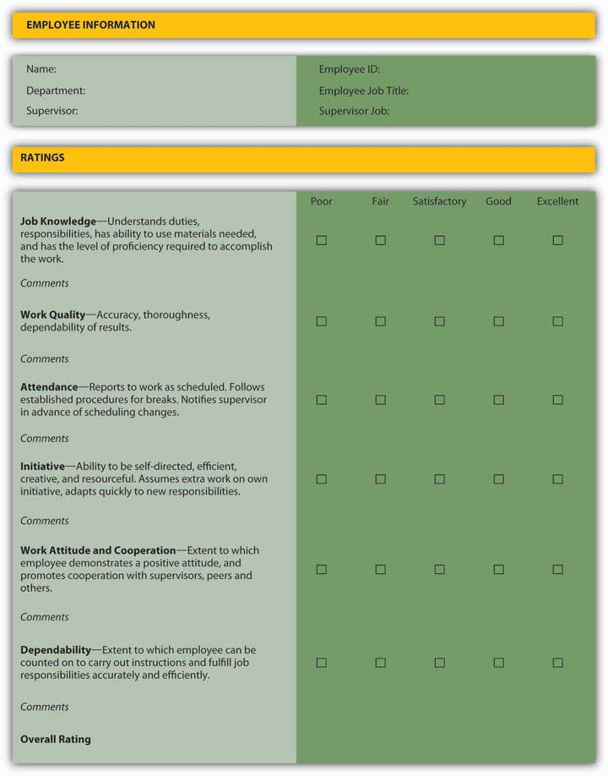

An Example of the Performance Review Process
For the purpose of this example, let’s assume that the organization has determined that annual performance evaluations fit the strategic needs of the organization and the developmental needs of employees. This does not mean however that management and employees discuss goals, objectives, and performance only once a year. In our example, the organization has opted to have a midyear information meeting and then an end-of-year performance evaluation meeting.
At some point in the year, the supervisor should hold a formal discussion with each staff member to review individual activities to date and to modify the goals and objectives that employee is accountable for. This agreed-upon set of goals and objectives is sometimes called an employee performance plan. There should be no surprises at this meeting. The supervisor should have been actively involved in continual assessment of his or her staff through regular contact and coaching. If major concerns arise, the performance plan can be modified or the employees can receive development in areas in which they may be weak. This also is a time for the employee to provide formal feedback to the supervisor on the coaching, on the planning, and on how the process seems to be working.
At the end of the year, a final review of the activities and plans for developing the next year’s objectives begin. Again, this is a chance to provide constructive and positive feedback and to address any ongoing concerns about the employee’s activities and competencies. Continuing education opportunities can be identified, and for those systems linked to compensation, salary raises will be linked to the employee’s performance during the year. Again, there should be no surprises to either employee or supervisor, as continual assessment and coaching should take place throughout the year. Supervisors and managers are involved in the same series of activities with their own supervisors to ensure that the entire organization is developing and focused on the same common objectives.
There are many varieties of performance management systems available, but you must be aware that you will need to tailor any system to suit the needs of the organization and the staff. As the organization and its competitive environment change over time, the system will also need to develop to reflect changes to employee competencies, ranking systems, and rewards linked to the plan.
How do you handle your reviews, that is, when you are the focus of the review process? “Your Performance Review” summarizes some key ideas you might keep in mind for your next review.

Your Performance Review
There are typically three areas you should think about when having your own performance reviewed: (1) preparation for the review, (2) what to do if the review is negative, and (3) what should you ultimately take away from the review.
Prepare for an upcoming review. Document your achievements and list anything you want to discuss at the review. If you haven’t kept track of your achievements, you may have to spend some time figuring out what you have accomplished since your last review and, most importantly, how your employer has benefited, such as increased profits, grown the client roster, maintained older clients, and so on. These are easier to document when you have had clear goals and objectives.
What should you do if you get a poor review? If you feel you have received an unfair review, you should consider responding to it. You should first try to discuss the review with the person who prepared it. Heed this warning, however. Wait until you can look at the review objectively. Was the criticism you received really that off the mark or are you just offended that you were criticized in the first place? If you eventually reach the conclusion that the review was truly unjust, then set an appointment to meet with your reviewer. If there are any points that were correct, acknowledge those. Use clear examples that counteract the criticisms made. A paper trail is always helpful. Present anything you have in writing that can back you up. If you didn’t leave a paper trail, remember to do this in the future.
What should you take away from a performance review? Ultimately, you should regard your review as a learning opportunity. For instance, did you have clear goals and objectives such that your performance was easy to document? You should be able to take away valuable information, whether it is about yourself or your reviewer.

Best Practices
While there is no single “best way” to manage performance evaluations, the collective actions across a number of high-performing firms suggests a set of best practices.
- Decide what you are hoping to achieve from the system. Is it to reward the stars and to correct problems? Or is its primary function to be a tool in focusing all staff activities through better planning?
- Develop goals and objectives that inspire, challenge, and stretch people’s capabilities. Once goals and objectives are clearly communicated and accepted, enlist broad participation, and do not shut down ideas. Support participation and goal attainment through the reward system, such as with gainsharing or other group incentive programs.
- Ensure you have commitment from the top. Planning must begin at the executive level and be filtered down through the organization to ensure that employees’ plans are meaningful in the context of the organization’s direction. Top managers should serve as strong role models for the performance evaluation process and attach managerial consequences to the quality of performance reviews (for instance, McKinsey partners are evaluated on how well they develop their consultants, not just the profitability of their particular practice).
- Ensure that all key staff are involved in the development of the performance management processes from the early phases. Provide group orientations to the program to decrease anxiety over the implementation of a new system. It will ensure a consistent message communicated about the performance management system.
- If the performance management system is not linked to salary, be sure employees are aware of it. For example, university business school professors are paid salaries based on highly competitive external labor markets, not necessarily the internal goals and objectives of the school such as high teaching evaluations, and so on. Make sure employees know the purpose of the system and what they get out of it.
- Provide additional training for supervisors on how to conduct the midyear and year-end performance reviews. Ensure that supervisors are proficient at coaching staff. Training, practice, and feedback about how to avoid appraisal errors are necessary, but often insufficient, for eliminating appraisal errors. Eliminating errors may require alternative approaches to evaluation, such as forced distribution (for instance, General Electric must rank the lowest 10% of performers and often ask them to find work with another employer).
- Plan to modify the performance management system over time, starting with goals and objectives, to meet your organization’s changing needs. Wherever possible, study employee behaviors in addition to attitudes; the two do not always converge.

KEY TAKEAWAY
This section outlined the relationship between goals and objectives and employee performance evaluation. Performance evaluation is a tool that helps managers align individual performance with organizational goals and objectives. You saw that the tool is most effective when evaluation includes well-developed goals and objectives that are developed with the needs of both the organization and employee in mind. The section concluded with a range of best practices for the performance evaluation process, including the revision of goals and objectives when the needs of the organization change.

EXERCISES
- How are goals and objectives related to employee performance evaluation?
- How often should performance evaluations be performed?
- What kinds of goals and objectives might be best for performance evaluation to be most effective?
- What should be included in an employee performance plan?
- What performance evaluation best practices appear to most directly involve goals and objectives?

6.6 Integrating Goals and Objectives with Corporate Social Responsibility

LEARNING OBJECTIVES
- Understand the nature of corporate social responsibility.
- See how corporate social responsibility, like other goals and objectives, can be incorporated using the Balanced Scorecard.
- Understand that corporate social responsibility, like any other goal and objective, helps the firm only when aligned with its strategy, vision, and mission.
One of the overarching lessons of this chapter is that goals and objectives are only effective to the extent that they reinforce the organization’s strategy and therefore the realization of its vision and mission. This section is somewhat integrative in that it provides knowledge about the ways that goals and objectives related to social and environmental issues can be tied back into strategy using a Balanced Scorecard approach.

Corporate Social Responsibility
The corporate social responsibility (CSR) movement is not new and has been gathering momentum for well over a decade.C
- Crawford, D., & Scaletta, T. (2005, November 24). http://www.greenbiz.com/feature/2005/10/24/the-balanced-scorecard-and-corporate-social-responsibility-aligning-values-profit (accessed November 11, 2008)
CSR is about how companies manage their business processes to produce an overall positive effect on society. This growth has raised questions—how to define the concept and how to integrate it into the larger body of an organization’s goals and objectives. The Dow Jones Sustainability Index created a commonly accepted definition of CSR: “a business approach that creates long-term shareholder value by embracing opportunities and managing risks deriving from economic, environmental and social developments.” Specifically, the Dow Jones Sustainability Index looks at competence in five areas:
- Strategy: Integrating long-term economic, environmental, and social aspects in their business strategies while maintaining global competitiveness and brand reputation.
- Financial: Meeting shareholders’ demands for sound financial returns, long-term economic growth, open communication, and transparent financial accounting.
- Customer and Product: Fostering loyalty by investing in customer relationship management, and product and service innovation that focuses on technologies and systems, which use financial, natural, and social resources in an efficient, effective, and economic manner over the long term.
- Governance and Stakeholder: Setting the highest standards of corporate governance and stakeholder engagement, including corporate codes of conduct and public reporting.
- Human: Managing human resources to maintain workforce capabilities and employee satisfaction through best-in-class organizational learning and knowledge management practices and remuneration and benefit programs.

CSR and the Balanced Scorecard
Since you are already familiar with the Balanced Scorecard from the previous section, you will probably already see how it can be used for CSR (a brief summary of the Balanced Scorecard concept is found in “The Balanced Scorecard at a Glance”). As experts from GreenBiz.com have observed:
“One of the fundamental opportunities for the CSR movement is how to effectively align consumer and employee values with strategy to generate long-term benefits—a better understanding of precisely with whom, what, when, where, how and why an enterprise makes a profit or surplus. CSR requires more holistic strategic thinking and a wider stakeholder perspective. Because the Balanced Scorecard is a recognized and established management tool, it is well positioned to support a knowledge-building effort to help organizations make their CSR values and visions a reality. The Balanced Scorecard enables individuals to make daily decisions based upon values and metrics that can be designed to support these long-term cognizant benefits.”
- Crawford, D., and Scaletta, T. (2005, November 24). www.greenbiz.com/feature/2005/10/24/the-balanced-scorecard-and-corporate-social-responsibility-aligning-values-profit (accessed November 11, 2008)
Thus, the Balanced Scorecard is an ideal vehicle for integrating CSR concerns with the organization’s mission, vision, and strategy.

The Balanced Scorecard at a Glance
As you know, the Balanced Scorecard is a focused set of key financial and nonfinancial indicators. These indicators include leading, pacing, and lagging measures. The term “balanced” does not mean equivalence among the measures but rather an acknowledgment of other key performance metrics that are not financial. The now classic scorecard, as outlined by Robert Kaplan and David Norton, has four quadrants or perspectives: (1) learning and growth, (2) internal, (3) customer, and (4) financial. Moreover, the idea is that each of these perspectives should be linked. For example, increased training for employees (learning and growth) can lead to enhanced operations or processes (internal), which leads to more satisfied customers through either improved delivery time and/or lower prices (customers), which finally leads to higher financial performance for the organization (financial).
A number of academic authors as well as global management consulting firms like McKinsey and KPMG have written about the pressures facing firms with regard to social and environmental issues. For instance, KPMG’s “International Survey of Corporate Responsibility Reporting 2008” reflects the growing importance of corporate responsibility as a key indicator of nonfinancial performance, as well as a driver of financial performance. In the 2008 survey, KPMG noted a significant increase in the publication of corporate responsibility reports in the United States, from 37% in their 2005 survey to 74% in 2008. KPMG concluded that the survey findings also reflect a growing sense of responsibility in the business community to improve transparency and accountability to the wider community—not just to shareholders (see below for a summary of KPMG’s analysis of U.S. CSR practices).

Summary of KPMG’s 2008 Report on U.S. Firm CSR Practices
“The increase in corporate responsibility reporting by the top 100 companies in the United States may be attributed to an increased focus on sustainability issues within US business in the last several years. This year’s survey found that the top three drivers for corporate responsibility reporting remained the same as in ethical considerations, economic considerations, and innovation and learning.
“However, within these drivers, ethical considerations (70 percent) replaced economic considerations (50 percent) as the primary driver. We also noticed a gradual maturation of corporate responsibility programs by US companies. Of the 74 percent that reported publicly, 82 percent had a defined corporate responsibility or sustainability strategy, and 77 percent had implemented management systems for their corporate responsibility goals. Furthermore, 78 percent had defined specific indicators relating to stated objectives and 68 percent actually reported on performance against the stated objectives.”
http://www.kpmg.com/Global/IssuesAndInsights/ArticlesAndPublications/Pages/Sustainability-corporate-responsibility-reporting-2008.aspx (accessed November 11, 2008).
The actual effect of these challenges and opportunities was recently identified in an earlier (2006) KPMG’s “International Survey of Corporate Responsibility Reporting.”http://www.kpmg.nl/Docs/Corporate_Site/Publicaties/International_Survey_Corporate_Responsibility_2005.pdf. This report surveyed more than 1,600 companies worldwide and documented the top 10 motivators driving corporations to engage in CSR for competitive reasons, which are:
- Economic considerations
- Ethical considerations
- Innovation and learning
- Employee motivation
- Risk management or risk reduction
- Access to capital or increased shareholder value
- Reputation or brand
- Market position or share
- Strengthened supplier relationships
- Cost savings
By creatively responding to these market forces, and others generated by the CSR movement, organizations can reap considerable benefits. There are many examples of how companies are being affected by CSR drivers and motivators. The following two examples are just a brief sample of the myriad CSR performance motivators that are top of mind for managers.

IKEA
Swedish home furnishings retailer IKEA discloses a lot of detailed information with regard to supply chain management in its annual CSR report. http://www.ikea-group.ikea.com/ (accessed November 11, 2008). As IKEA has suppliers in countries where the risk of labor rights abuses are perceived as high, they are obligated to work on these issues in a systematic way, which can be followed up on both internally and externally. IKEA’s 2007 “Social and Environmental Responsibility Report” is noteworthy because of its transparency on its supply chain. For example, IKEA reported on the top five purchasing countries as well as on how many IKEA suppliers are IWAY approved (The IKEA Way on Purchasing Home Furnishing Products). http://www.ikea.com/ms/en_US/about_ikea/social_environmental/the_ikea_way.html (accessed January 30, 2009). China is number one in the top five purchasing countries at 22%, yet at the same time has the lowest number of IWAY-approved suppliers (4%). IKEA seems aware that transparency also calls for completeness and has disclosed well-developed information about the challenges in Asia in general and in China specifically.

PEMEX
PEMEX (Mexico) is a government-controlled body that was created as a decentralized government agency of the Federal Public Administration. Its core purpose is to drive the nation’s central and strategic development activities in the state’s petroleum industry. PEMEX holds the number 11 position as a crude oil producer and is one of the three main suppliers of crude oil for the U.S. market. In 2007, total sales amounted to approximately $104.5 billion. Active personnel at PEMEX at the end of 2007 rose to 154,802 workers. PEMEX has been publishing corporate responsibility reports since 1999. The 2007 report complies with the indicators set forth in the Global Reporting Initiative (GRI) Guidelines and was the first Mexican GRI Application Level A+ report—the highest level. http://www.pemex.com (accessed 2008, November 11). Moreover, the report meets the guidelines of the United Nations Global Compact for communication in progress. The report addressed the needs of a complex sector, including the national oil and gas industry, a vast list of stakeholders, and a citizen participation group composed of highly renowned specialists to address citizens’ concerns.

Measures and CSR
One of the organizational challenges with CSR is that it requires firms to measure and report on aspects of their operations that were either previously unmonitored or don’t clearly map into the firm’s strategy. Thus, goals and objectives related to growing revenues through green consumers in the Lifestyles of Health and Sustainability (LOHAS) marketplace comes with the price of increased transparency—this customer group demands the necessary data to make informed decisions. Ethical considerations, KPMG’s second driver, are directly linked to the LOHAS market. LOHAS describes a $226.8 billion marketplace for goods and services focused on health, the environment, social justice, personal development, and sustainable living. The consumers attracted to this market have been collectively referred to as “cultural creatives” and represent a sizable group in the United States.
- Florida, R. (2005). The flight of the creative class: The global competition for talent. New York: HarperCollins
Interested stakeholders, such as employees, regulators, investors, and nongovernmental organizations (NGOs), pressure organizations to disclose more CSR information. Companies in particular are increasingly expected to generate annual CSR reports in addition to their annual financial reports.
CSR reporting measures an organization’s economic, social, and environmental performance and impacts. The measurement of CSR’s three dimensions is commonly called the triple bottom line (TBL). The Global Reporting Initiative (GRI), mentioned in the case of PEMEX, is the internationally accepted standard for TBL reporting. The GRI was created in 1997 to bring consistency to the TBL reporting process by enhancing the quality, rigor, and utility of sustainability reporting. GRI issued its first comprehensive reporting guidelines in 2002 and its G3 Reporting Framework in October 2006. Since GRI was established, more than 1,000 international companies had registered with the GRI and issued corporate sustainability reports using its standards.http://www.globalreporting.org/Home.
Representatives from business, accounting societies, organized labor, investors, and other stakeholders all participated in the development of what are now known as the GRI Sustainability Guidelines. The guidelines are composed of both qualitative and quantitative indicators. The guidelines and indicators were not designed, nor intended, to replace Generally Accepted Accounting Principles (GAAP) or other mandatory financial reporting requirements. Rather, the guidelines are intended to complement GAAP by providing the basis for credibility and precision in non-financial reporting.
Some firms develop and apply their own sets of metrics. Royal Dutch Shell spent in excess of $1 million to develop its environmental and social responsibility metrics. Instead of picking numbers from established sources, such as the GRI template, Shell held 33 meetings with stakeholders and shareholders.The Shell metrics effort was widely reported in a number of newsletters and articles. See, for example, http://www.juergendaum.com/news/05_12_2001.htm. The derived metrics became a much more accurate reflection of what its customers and other stakeholders wanted, and thus, a true reflection of its strategy, mission, and vision.
One of the key benefits for an organization using a Balanced Scorecard is improved strategic alignment. The Balanced Scorecard can be an effective format for reporting TBL indicators, as it illustrates the cause-and-effect relationship between good corporate citizenship and a successful business. Enterprises can use the combination of the Balanced Scorecard and CSR to help create a competitive advantage by letting decision makers know whether they are truly entering into a CSR virtuous cycle in which economic and environmental performance, coupled with social impacts, combine to improve organizational performance exponentially.
What do we mean by virtuous cycle? A company could begin to compete on cost leadership as a result of improved technology and effective and efficient processes, which leads to improved ecological protection, which results in better risk management and a lower cost of capital. Alternatively, a company could differentiate from its competitors’ values and performance as a result of its community-building activities, which can improve corporate reputation, result in improved brand equity, creating customer satisfaction, which increases sales. The move to a broad differentiation strategy can also be achieved through extensive knowledge of green consumers and leveraging their information needs through appropriate CSR reporting to improve brand equity and reputation. These examples are designed to illustrate the interrelationships in an organization’s triple bottom line.
Several organizations have already recognized this powerful combination and have adapted or introduced a Balanced Scorecard that includes CSR elements to successfully implement strategy reflective of evolving societal values. Many managers are familiar with the Balanced Scorecard and thus have a tool at their disposal to help them navigate the sometimes foggy worlds of strategy and CSR. The Balanced Scorecard can help organizations strategically manage the alignment of cause-and-effect relationships of external market forces and impacts with internal CSR drivers, values, and behavior. It is this alignment combined with CSR reporting that can enable enterprises to implement either broad differentiation or cost leadership strategies. If managers believe there will be resistance to stand-alone CSR initiatives, they can use the Balanced Scorecard to address CSR opportunities and challenges. If you are so motivated, the managerial skills and tools you gain through an understanding of P-O-L-C will help you to lead your organization toward a CSR virtuous cycle of cognizant benefits, understanding precisely how and why their company’s profits are made.

KEY TAKEAWAY
This section explored the challenges and opportunities of incorporating social and environmental goals and objectives into the P-O-L-C process. Many organizations refer to social and environmental activities as corporate social responsibility (CSR). For many firms, general operating goals and objectives have not been well integrated with strategy, vision, and mission, so it may not be surprising that social and environmental goals, in particular, have not gained much traction. However, when an organization uses tools such as the Balanced Scorecard to manage goals and objectives, then there is a coherent vehicle for incorporating social and environmental objectives in the mix as well.

EXERCISES
- What does corporate social responsibility mean?
- Why might it be challenging for organizations to effectively set and achieve social and environmental goals and objectives, in addition to their operating goals and objectives?
- Why might an organization pay greater attention to adding social and environmental goals and objectives today than, say, 10 years ago?
- What is meant by “virtuous cycle” with respect to CSR?
- How does a Balanced Scorecard help managers develop social and environmental goals and objectives?
- In what ways does achievement of CSR goals and objectives strategically differentiate an organization?

6.7 Your Personal Balanced Scorecard

LEARNING OBJECTIVES
- Develop a more personalized understanding of the Balanced Scorecard concept.
- See how your vision and mission can be linked to your goals and objectives.
- Be able to develop S-M-A-R-T goals and objectives.
One of the powerful tools in a manager’s tool kit is the Balanced Scorecard, a model that groups goals, objectives, and metrics into the areas of financial, customer, internal business process, and learning and growth. As you know, the scorecard is effective because it helps managers link vision, mission, and strategy to the goals and objectives that employees strive to achieve. What you may not know, however, is that you can apply the scorecard to your personal and professional objectives. Through this process you might also learn more about where and how a Balanced Scorecard can be applied in an organizational context in your role as a manager or employee. That is the purpose of this section.

From an Organizational Scorecard to a Personal One
The Balanced Scorecard, championed by Kaplan and Norton, can be translated into your own individual scorecard, one that helps you achieve your personal and professional goals and objectives. Recall that the scorecard for an organization starts with vision and mission, followed by goals (financial, internal business processes, customer, and learning and growth), which have corresponding objectives, metrics, and tactical activities. When these components are applied to you as an individual, you might see the pieces of the scorecard labeled as shown in the following figure. Let’s review each piece together.

Figure 6.14 My Balanced Scorecard
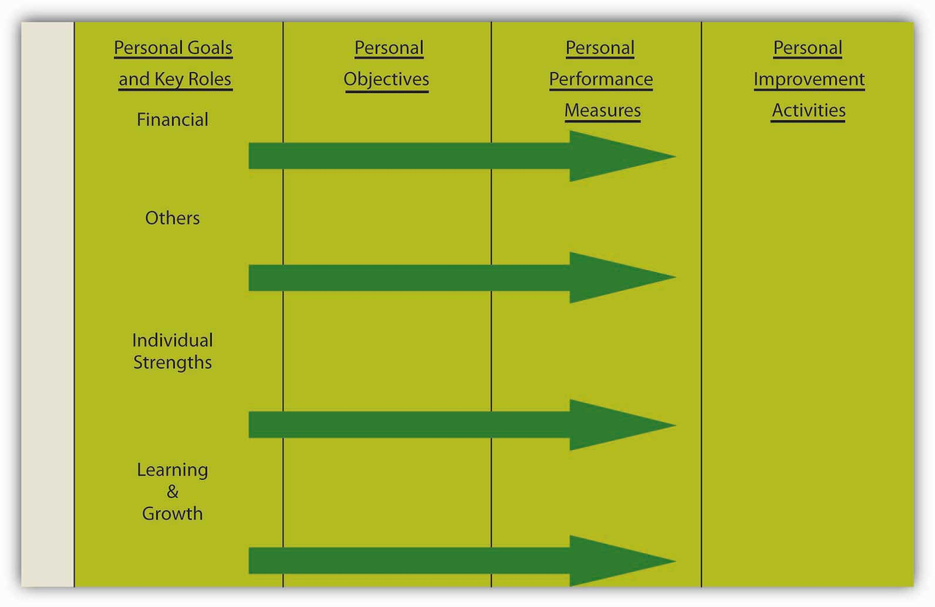

Personal Mission, Vision, and Strategy
As with an organization’s mission and vision, your personal mission and vision reflect who you are and where you want to go. Mission reflects your values and philosophy of life. Vision captures what you want to achieve. Which values and principles guide your way? What are your most deeply cherished aspirations? What do you want to achieve? How do you distinguish yourself in society and among your peers and family? If you were to read your biography in 20 years, what would you want it to say about you?

Personal Goals and Key Roles
Goals and roles are set out with respect to the areas of financial, others, individual strengths, and learning and growth. Financial, for instance, captures your needs and aspirations about money, as well as the financial obligations that you might have as a result of your role of caring for a parent, sibling, or child. Others reflect goals that you have in relation to other individuals or society at large. How do you want to be seen? Also, in terms of roles, what do relations with your partner, children, friends, employer, colleagues, and others imply for your goals? Individual strengths represent the internal perspective, reflecting goals related to your health and well-being. This category also reflects those strengths that you wish to be distinguishing features. Finally, learning and growth refer to your skills, abilities, and aims with regard to personal and professional learning and growth. How can you learn and remain successful in the future? What type of skills and learning are required now, for future aspired roles?

Using SMART Criteria
These portions of the scorecard get more specific in terms of which measurable short-term personal results you want to achieve. What are the most important changes you want to tackle in your career? Similarly, you will want to answer how you can measure your personal results. What values do you have to obtain, and what are your specific targets?
For personal objectives and performance measures to be most effective, you might try seeing how they measure up to SMART criteria. These characteristics, based on specific, measurable, attainable, realistic, and time bound yield the acronym SMART.
- Drucker, P. (1954). The Practice of management. New York: HarperCollins.
Drucker coined the usage of the acronym for SMART objectives while discussing objective-based management. Here is how to tell if your objectives, measures, and targets are SMART.

Specific
A specific objective has a much greater chance of being accomplished than a general one. To set a specific objective, you must answer the six “W” questions:
- Who: Who is involved?
- What: What do I want to accomplish?
- Where: Identify a location.
- When: Establish a time frame.
- Which: Identify requirements and constraints.
- Why: Specific reasons, purpose or benefits of accomplishing the objective.
EXAMPLE: A personal goal would be, “Get in shape.” But a specific objective would say, “Get into good enough shape that 6 months from now I can hike to the summit of a 14,000-foot mountain and back in one day. To do so, by next Monday I will join a health club within 5 miles of home and work out for at least 45 minutes 3 days a week for 3 months, then reassess my progress.” We thank Elsa Peterson, our developmental editor, for providing this example based on one of her friend’s personal experiences. Another real-life comparable example is shown here:
- Manochio, M. (2008, September 30). http://www.dailyrecord.com/apps/pbcs.dll/article?AID=/20080930/COMMUNITIES12/809300311 (accessed November 10, 2008).

Measurable
Establish concrete criteria for measuring progress toward the attainment of each objective you set. When you measure your progress, you stay on track, reach your target dates, and experience the exhilaration of achievement that spurs you on to continued effort required to reach your objective.
To determine whether your objective is measurable, ask questions such as: How much? How many? How will I know when it is accomplished? Notice that the specific version of the “get in shape” objective includes metrics of time and distance.

Attainable
When you identify objectives that are most important to you, you begin to figure out ways you can make them come true. You develop the attitudes, abilities, skills, and financial capacity to reach them. You begin seeing previously overlooked opportunities to bring yourself closer to the achievement of your goals and objectives.
You can attain most any objective you set when you plan your steps wisely and establish a time frame that allows you to carry out those steps. Goals that may have seemed far away and out of reach eventually move closer and become attainable, not because your goals shrink but because you grow and expand to match them through the achievement of nearer-term objectives. When you list your objectives, you build your self-image. You see yourself as worthy of these goals and objectives and develop the traits and personality that allow you to possess them.
Notice that the “get in shape” example outlines steps toward being able to climb the mountain.

Realistic
To be realistic, an objective must represent an objective toward which you are both willing and able to work. An objective can be both high and realistic; you are the only one who can decide just how high your objective should be. But be sure that every objective represents substantial progress. A high objective is frequently easier to reach than a low one because a low objective exerts low motivational force. Some of the hardest jobs you ever accomplished actually seem easy simply because they were a labor of love.
Your objective is probably realistic if you truly believe that it can be accomplished. Additional ways to know whether your objective is realistic is to determine whether you have accomplished anything similar in the past or ask yourself what conditions would have to exist to accomplish this objective.
You might decide whether an objective to climb a 14,000-foot mountain is realistic by considering whether people of your age and ability have been able to do it.

Timely
An objective should be grounded within a time frame. With no time frame tied to it, there’s no sense of urgency. If you want to lose 10 pounds, when do you want to lose it by? “Someday” won’t work. But if you anchor it within a time frame, “by May 1st,” then you’ve set your unconscious mind into motion to begin working on the objective.
T can also stand for Tangible.
An objective is tangible when you can experience it with one of the senses, that is, taste, touch, smell, sight, or hearing. When your objective is tangible, you have a better chance of making it specific and measurable and thus attainable.
The objective of climbing the mountain is both grounded in a time frame—six months from now—and tangible, in that you will either experience climbing the mountain successfully or not.

Personal Improvement Activities
The next step is implementation. One way to think about implementation of your Balanced Scorecard is through the plan-do-act-dare cycle (PDAD cycle), to be followed continuously.Rampersad. 2005.
- Personal Balanced Scorecard: The way to individual happiness, personal integrity, and organizational effectiveness. Charlotte, NC: Information Age Publishing.
As summarized in the following figure, the PDAD cycle consists of the following four phases:

Figure 6.15 The PDAD Cycle
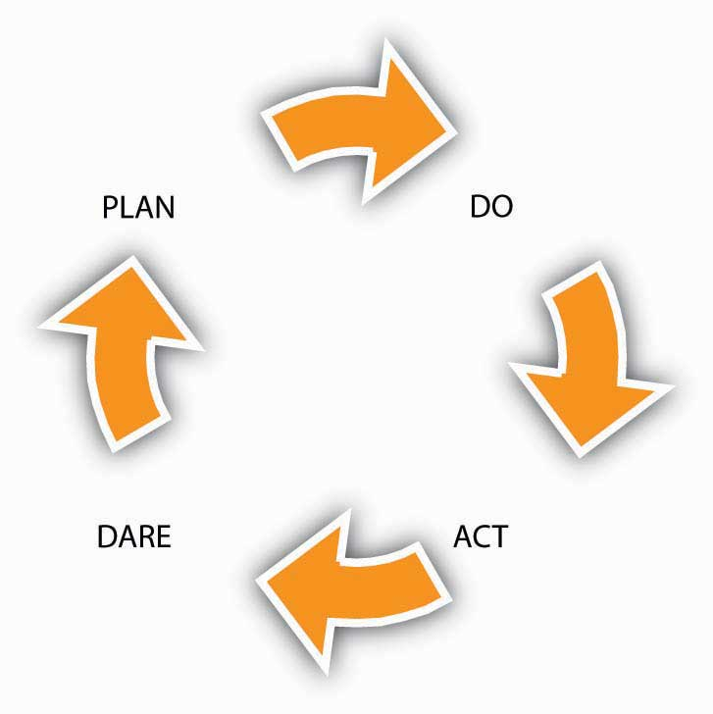

Plan
Formulate or update your scorecard, which focuses on your work as well as on your spare time. This spans vision and mission through personal objectives and performance metrics.

Do
Start with a simple objective from your scorecard with corresponding improvement activity, keeping in mind the priorities that have been identified. Each morning, focus on a selected improvement action that you will strive to implement during the day. Execute the improvement activity with emotional dedication, self-confidence, and willpower and concentrate on the action. This must be in concordance with your present skills. Share your good intentions with a trusted person (spouse, friend, colleague, or manager), who will ask questions and give you honest feedback. Doing is related to acting with purpose and to deliver efforts to realize your objective. Ask often for feedback from the trusted person. This gives you the opportunity to measure the progress you have made. Start with habits, which restrict you, influence your life unfavorably, and deliver poor results.

Act
Check whether the improvement activity is working and take action when it is not. Review the results according to the defined personal performance measures and targets, measure your progress, and check to what extent you have realized your personal objectives—as suggested by the “assess my progress” portion of the mountain-climbing goal. If you have not been able to realize your objective, start again. You will improve steadily as it becomes a habit to do good things right the first time and evaluate your scorecard each month with your trusted person. Think of three people who can act as your trusted person, who provide you with inspiration and motivation support for realizing your objectives and improvement actions. Plan to meet with each one of them regularly. Listen enthusiastically to them, brainstorm with them, and take their wise counsel. Develop your skills and competencies to achieve the objectives you selected. Recognize your responsibility to constantly develop yourself. Implement the proven personal improvements, assess the personal results, document the lessons learned, and improve and monitor your actions and thinking continuously. Also think about bringing your personal ambition and your personal behavior into balance, which will result in influencing your ethical behavior. According to Steven Covey, author of The Seven Habits of Highly Effective People, after a few weeks, you will notice small differences in yourself. In two months, the behavioral change will become firmly embedded. After five months, the important personal quality will be yours.

Dare
Accept larger challenges by daring to take on a more difficult objective and corresponding improvement action from your scorecard and get on with it. Take a chance and be conscientious to choose a more challenging objective in line with your improved skills when the current improvement action becomes boring. Enjoy the pleasant experience, and document what you have learned and unlearned during the execution of the improvement action. Refine it, and review your scorecard regularly.

KEY TAKEAWAY
The purpose of this section was to help you translate the Balanced Scorecard to your own personal and professional situation. You learned how you might construct the scorecard, and take action to achieve personal results. Through this process, you might also learn more about where and how a Balanced Scorecard can be applied in an organizational context in your role as a manager or employee.

EXERCISES
- What can you achieve by applying the concept of a Balanced Scorecard to your personal situation?
- How similar or different does the scorecard seem to function at an individual level as opposed to an organizational level?
- What are key characteristics of effective objectives?
- Why should personal objectives and measures of performance be specific?
- What are some of the activities you can undertake to implement your scorecard?
- When is the implementation of a personal Balanced Scorecard completed?

Chapter 7

Organizational Structure and Change

WHAT’S IN IT FOR ME?
Reading this chapter will help you do the following:
- Define organizational structure and its basic elements.
- Describe matrix, boundaryless, and learning organizations.
- Describe why and how organizations change.
- Understand reasons why people resist change, and strategies for planning and executing change effectively.
- Build your own organizational design skills.

Figure 7.2 The P-O-L-C Framework
Creating or enhancing the structure of an organization defines managers’ Organizational Design task. Organizational design is one of the three tasks that fall into the organizing function in the planning-organizing-leading-controlling (P-O-L-C) framework. As much as individual- and team-level factors influence work attitudes and behaviors, the organization’s structure can be an even more powerful influence over employee actions.

7.1 Case in Point: Toyota Struggles With Organizational Structure

Figure 7.3
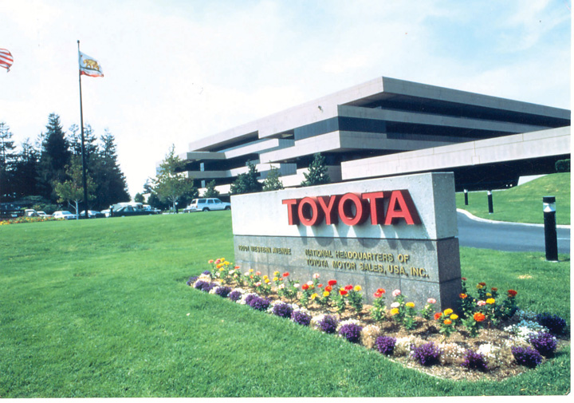
Source: Photograph courtesy of Toyota Motor Sales, USA, Inc.
Toyota Motor Corporation (TYO: 7203) has often been referred to as the gold standard of the automotive industry. In the first quarter of 2007, Toyota (NYSE: TM) overtook General Motors Corporation in sales for the first time as the top automotive manufacturer in the world. Toyota reached success in part because of its exceptional reputation for quality and customer care. Despite the global recession and the tough economic times that American auto companies such as General Motors and Chrysler faced in 2009, Toyota enjoyed profits of $16.7 billion and sales growth of 6% that year. However, late 2009 and early 2010 witnessed Toyota’s recall of 8 million vehicles due to unintended acceleration. How could this happen to a company known for quality and structured to solve problems as soon as they arise? To examine this further, one has to understand about the Toyota Production System (TPS).
TPS is built on the principles of “just-in-time” production. In other words, raw materials and supplies are delivered to the assembly line exactly at the time they are to be used. This system has little room for slack resources, emphasizes the importance of efficiency on the part of employees, and minimizes wasted resources. TPS gives power to the employees on the front lines. Assembly line workers are empowered to pull a cord and stop the manufacturing line when they see a problem.
However, during the 1990s, Toyota began to experience rapid growth and expansion. With this success, the organization became more defensive and protective of information. Expansion strained resources across the organization and slowed response time. Toyota’s CEO, Akio Toyoda, the grandson of its founder, has conceded, “Quite frankly, I fear the pace at which we have grown may have been too quick.”
Vehicle recalls are not new to Toyota; after defects were found in the company’s Lexus model in 1989, Toyota created teams to solve the issues quickly, and in some cases the company went to customers’ homes to collect the cars. The question on many people’s minds is, how could a company whose success was built on its reputation for quality have had such failures? What is all the more puzzling is that brake problems in vehicles became apparent in 2009, but only after being confronted by United States transportation secretary Ray LaHood did Toyota begin issuing recalls in the United States. And during the early months of the crisis, Toyota’s top leaders were all but missing from public sight.
The organizational structure of Toyota may give us some insight into the handling of this crisis and ideas for the most effective way for Toyota to move forward. A conflict such as this has the ability to paralyze productivity but if dealt with constructively and effectively, can present opportunities for learning and improvement. Companies such as Toyota that have a rigid corporate culture and a hierarchy of seniority are at risk of reacting to external threats slowly. It is not uncommon that individuals feel reluctant to pass bad news up the chain within a family company such as Toyota. Toyota’s board of directors is composed of 29 Japanese men, all of whom are Toyota insiders. As a result of its centralized power structure, authority is not generally delegated within the company; all U.S. executives are assigned a Japanese boss to mentor them, and no Toyota executive in the United States is authorized to issue a recall. Most information flow is one-way, back to Japan where decisions are made.
Will Toyota turn its recall into an opportunity for increased participation for its international manufacturers? Will decentralization and increased transparency occur? Only time will tell.
Primary Resource:
Secondary Resources:
- “Accelerating into Trouble”. (2010, February 11). Economist. Retrieved March 8, 2010, from http://www.economist.com/opinion/displaystory.cfm?story_id=15498249
- Dickson, D. (2010, February 10). Toyota’s bumps began with race for growth.Washington Times, p. 1
- Maynard, M., Tabuchi, H., Bradsher, K., & Parris, M. (2010, February 7). Toyota has pattern of slow response on safety issues. New York Times, p. 1
- Simon, B. (2010, February 24). LaHood voices concerns over Toyota culture. Financial Times. Retrieved March 10, 2010, from http://www.ft.com/cms/s/0/11708d7c-20d7-11df-b920-00144feab49a.html
- Werhane, P., & Moriarty, B. (2009). Moral imagination and management decision making. Business Roundtable Institute for Corporate Ethics. Retrieved April 30, 2010, from http://www.corporate-ethics.org/pdf/moral_imagination.pdf
- Atlman, A. (2010, February 24). Congress puts Toyota (and Toyoda) in the hot seat. Time. Retrieved March 11, 2010, from http://www.time.com/time/nation/article/0,8599,1967654,00.html.

DISCUSSION QUESTIONS
- What changes in the organizing facet of the P-O-L-C framework might you make at Toyota to prevent future mishaps like the massive recalls related to brake and accelerator failures?
- Do you think Toyota’s organizational structure and norms are explicitly formalized in rules, or do the norms seem to be more inherent in the culture of the organization?
- What are the pros and cons of Toyota’s structure?
- What elements of business would you suggest remain the same and what elements might need revising?
- What are the most important elements of Toyota’s organizational structure?

7.2 Organizational Structure

LEARNING OBJECTIVES
- Explain the roles of formalization, centralization, levels in the hierarchy, and departmentalization in employee attitudes and behaviors.
- Describe how the elements of organizational structure can be combined to create mechanistic and organic structures.
- Understand the advantages and disadvantages of mechanistic and organic structures for organizations.
Organizational structure refers to how individual and team work within an organization are coordinated. To achieve organizational goals and objectives, individual work needs to be coordinated and managed. Structure is a valuable tool in achieving coordination, as it specifies reporting relationships (who reports to whom), delineates formal communication channels, and describes how separate actions of individuals are linked together. Organizations can function within a number of different structures, each possessing distinct advantages and disadvantages. Although any structure that is not properly managed will be plagued with issues, some organizational models are better equipped for particular environments and tasks.

Building Blocks of Structure
What exactly do we mean by organizational structure? Which elements of a company’s structure make a difference in how we behave and how work is coordinated? We will review four aspects of structure that have been frequently studied in the literature: centralization, formalization, hierarchical levels, and departmentalization. We view these four elements as the building blocks, or elements, making up a company’s structure. Then we will examine how these building blocks come together to form two different configurations of structures.

Centralization
Centralization is the degree to which decision-making authority is concentrated at higher levels in an organization. In centralized companies, many important decisions are made at higher levels of the hierarchy, whereas in decentralized companies, decisions are made and problems are solved at lower levels by employees who are closer to the problem in question.
As an employee, where would you feel more comfortable and productive? If your answer is “decentralized,” you are not alone. Decentralized companies give more authority to lower-level employees, resulting in a sense of empowerment. Decisions can be made more quickly, and employees often believe that decentralized companies provide greater levels of procedural fairness to employees. Job candidates are more likely to be attracted to decentralized organizations. Because centralized organizations assign decision-making responsibility to higher-level managers, they place greater demands on the judgment capabilities of CEOs and other high-level managers.
Many companies find that the centralization of operations leads to inefficiencies in decision making. For example, in the 1980s, the industrial equipment manufacturer Caterpillar suffered the consequences of centralized decision making. At the time, all pricing decisions were made in the corporate headquarters in Peoria, Illinois. This meant that when a sales representative working in Africa wanted to give a discount on a product, they needed to check with headquarters. Headquarters did not always have accurate or timely information about the subsidiary markets to make an effective decision. As a result, Caterpillar was at a disadvantage against competitors such as the Japanese firm Komatsu. Seeking to overcome this centralization paralysis, Caterpillar underwent several dramatic rounds of reorganization in the 1990s and 2000s.
- Nelson, G. L., & Pasternack, B. A. (2005). Results: Keep what’s good, fix what’s wrong, and unlock great performance. New York: Crown Business.

Figure 7.4
Changing their decision-making approach to a more decentralized style has helped Caterpillar compete at the global level.
Source: http://commons.wikimedia.org/wiki /Image:Bauma_2007 _Buldozer_Caterpillar_2.jpg
However, centralization also has its advantages. Some employees are more comfortable in an organization where their manager confidently gives instructions and makes decisions. Centralization may also lead to more efficient operations, particularly if the company is operating in a stable environment.
- Ambrose, M. L., & Cropanzano, R. S. (2000). The effect of organizational structure on perceptions of procedural fairness. Journal of Applied Psychology, 85, 294–304
- Miller, D., Droge, C., & Toulouse, J. (1988). Strategic process and content as mediators between organizational context and structure. Academy of Management Journal, 31, 544–569
- Oldham, G. R., & Hackman, R. J. (1981). Relationships between organizational structure and employee reactions: Comparing alternative frameworks. Administrative Science Quarterly, 26, 66–83
- Pierce, J. L., & Delbecq, A. L. (1977). Organization structure, individual attitudes, and innovation. Academy of Management Review, 2, 27–37
- Schminke, M., Ambrose, M. L., & Cropanzano, R. S. (2000). The effect of organizational structure on perceptions of procedural fairness. Journal of Applied Psychology, 85, 294–304
- Turban, D. B., & Keon, T. L. (1993). Organizational attractiveness: An interactionist perspective. Journal of Applied Psychology, 78, 184–193
- Wally, S., & Baum, J. R. (1994). Personal and structural determinants of the pace of strategic decision making.Academy of Management Journal, 37, 932–956
In fact, organizations can suffer from extreme decentralization. For example, some analysts believe that the Federal Bureau of Investigation (FBI) experiences some problems because all its structure and systems are based on the assumption that crime needs to be investigated after it happens. Over time, this assumption led to a situation where, instead of following an overarching strategy, each FBI unit is completely decentralized and field agents determine how investigations should be pursued. It has been argued that due to the change in the nature of crimes, the FBI needs to gather accurate intelligence before a crime is committed; this requires more centralized decision making and strategy development.
- Brazil, J. J. (2007, April). Mission: Impossible? Fast Company, 114, 92–109
Hitting the right balance between decentralization and centralization is a challenge for many organizations. At the Home Depot, the retail giant with over 2,000 stores across the United States, Canada, Mexico, and China, one of the major changes instituted by former CEO Bob Nardelli was to centralize most of its operations. Before Nardelli’s arrival in 2000, Home Depot store managers made a number of decisions autonomously and each store had an entrepreneurial culture. Nardelli’s changes initially saved the company a lot of money. For example, for a company of that size, centralizing purchasing operations led to big cost savings because the company could negotiate important discounts from suppliers. At the same time, many analysts think that the centralization went too far, leading to the loss of the service-oriented culture at the stores. Nardelli was ousted after seven years.
- Charan, R. (2006, April). Home Depot’s blueprint for culture change. Harvard Business Review, 84(4), 60–70
- Marquez, J. (2007, January 15). Big bucks at door for Depot HR leader. Workforce Management, 86(1)

Formalization
Formalization is the extent to which an organization’s policies, procedures, job descriptions, and rules are written and explicitly articulated. Formalized structures are those in which there are many written rules and regulations. These structures control employee behavior using written rules, so that employees have little autonomy to decide on a case-by-case basis. An advantage of formalization is that it makes employee behavior more predictable. Whenever a problem at work arises, employees know to turn to a handbook or a procedure guideline. Therefore, employees respond to problems in a similar way across the organization; this leads to consistency of behavior.
While formalization reduces ambiguity and provides direction to employees, it is not without disadvantages. A high degree of formalization may actually lead to reduced innovativeness because employees are used to behaving in a certain manner. In fact, strategic decision making in such organizations often occurs only when there is a crisis. A formalized structure is associated with reduced motivation and job satisfaction as well as a slower pace of decision making.
- Fredrickson, J. W. (1986). The strategic decision process and organizational structure. Academy of Management Review, 11, 280–297
- Oldham, G. R., & Hackman, R. J. (1981). Relationships between organizational structure and employee reactions: Comparing alternative frameworks. Administrative Science Quarterly, 26, 66–83
- Pierce, J. L., & Delbecq, A. L. (1977). Organization structure, individual attitudes, and innovation. Academy of Management Review, 2, 27–37
- Wally, S., & Baum, R. J. (1994). Strategic decision speed and firm performance. Strategic Management Journal, 24, 1107–1129
The service industry is particularly susceptible to problems associated with high levels of formalization. Sometimes employees who are listening to a customer’s problems may need to take action, but the answer may not be specified in any procedural guidelines or rulebook. For example, while a handful of airlines such as Southwest do a good job of empowering their employees to handle complaints, in many airlines, lower-level employees have limited power to resolve a customer problem and are constrained by stringent rules that outline a limited number of acceptable responses.

Hierarchical Levels
Another important element of a company’s structure is the number of levels it has in its hierarchy. Keeping the size of the organization constant, tall structures have several layers of management between frontline employees and the top level, while flat structures consist of only a few layers. In tall structures, the number of employees reporting to each manager tends to be smaller, resulting in greater opportunities for managers to supervise and monitor employee activities. In contrast, flat structures involve a larger number of employees reporting to each manager. In such a structure, managers will be relatively unable to provide close supervision, leading to greater levels of freedom of action for each employee.
Research indicates that flat organizations provide greater need satisfaction for employees and greater levels of self-actualization.
- Ghiselli, E. E., & Johnson, D. A. (1970). Need satisfaction, managerial success, and organizational structure. Personnel Psychology, 23, 569–576
- Porter, L. W., & Siegel, J. (2006). Relationships of tall and flat organization structures to the satisfactions of foreign managers. Personnel Psychology, 18, 379–392
At the same time, there may be some challenges associated with flat structures. Research shows that when managers supervise a large number of employees, which is more likely to happen in flat structures, employees experience greater levels of role ambiguity—the confusion that results from being unsure of what is expected of a worker on the job.
- Chonko, L. B. (1982). The relationship of span of control to sales representatives’ experienced role conflict and role ambiguity. Academy of Management Journal, 25, 452–456
This is especially a disadvantage for employees who need closer guidance from their managers. Moreover, in a flat structure, advancement opportunities will be more limited because there are fewer management layers. Finally, while employees report that flat structures are better at satisfying their higher-order needs such as self-actualization, they also report that tall structures are better at satisfying security needs of employees.
- Porter, L. W., & Lawler, E. E. (1964). The effects of tall versus flat organization structures on managerial job satisfaction. Personnel Psychology, 17, 135–148
Because tall structures are typical of large and well-established companies, it is possible that when working in such organizations employees feel a greater sense of job security.

Figure 7.5
Companies such as IKEA, the Swedish furniture manufacturer and retailer, are successfully using flat structures within stores to build an employee attitude of job involvement and ownership.
Source:http://commons.wikimedia.org/wiki/Image:Ikea_almhult.jpg

Departmentalization
Organizational structures differ in terms of departmentalization, which is broadly categorized as either functional or divisional.
Organizations using functional structures group jobs based on similarity in functions. Such structures may have departments such as marketing, manufacturing, finance, accounting, human resources, and information technology. In these structures, each person serves a specialized role and handles large volumes of transactions. For example, in a functional structure, an employee in the marketing department may serve as an event planner, planning promotional events for all the products of the company.
In organizations using divisional structures, departments represent the unique products, services, customers, or geographic locations the company is serving. Thus each unique product or service the company is producing will have its own department. Within each department, functions such as marketing, manufacturing, and other roles are replicated. In these structures, employees act like generalists as opposed to specialists. Instead of performing specialized tasks, employees will be in charge of performing many different tasks in the service of the product. For example, a marketing employee in a company with a divisional structure may be in charge of planning promotions, coordinating relations with advertising agencies, and planning and conducting marketing research, all for the particular product line handled by his or her division.
In reality, many organizations are structured according to a mixture of functional and divisional forms. For example, if the company has multiple product lines, departmentalizing by product may increase innovativeness and reduce response times. Each of these departments may have dedicated marketing, manufacturing, and customer service employees serving the specific product; yet, the company may also find that centralizing some operations and retaining the functional structure makes sense and is more cost effective for roles such as human resources management and information technology. The same organization may also create geographic departments if it is serving different countries.
Each type of departmentalization has its advantages. Functional structures tend to be effective when an organization does not have a large number of products and services requiring special attention. When a company has a diverse product line, each product will have unique demands, deeming divisional (or product-specific) structures more useful for promptly addressing customer demands and anticipating market changes. Functional structures are more effective in stable environments that are slower to change. In contrast, organizations using product divisions are more agile and can perform better in turbulent environments. The type of employee who will succeed under each structure is also different. Research shows that when employees work in product divisions in turbulent environments, because activities are diverse and complex, their performance depends on their general mental abilities.
- Hollenbeck, J. R., Moon, H., Ellis, A. P. J., West, B. J., Ilgen, D. R., et al. (2002). Structural contingency theory and individual differences: Examination of external and internal person-team fit. Journal of Applied Psychology, 87, 599–606

Figure 7.6 An Example of a Pharmaceutical Company with a Functional Departmentalization Structure
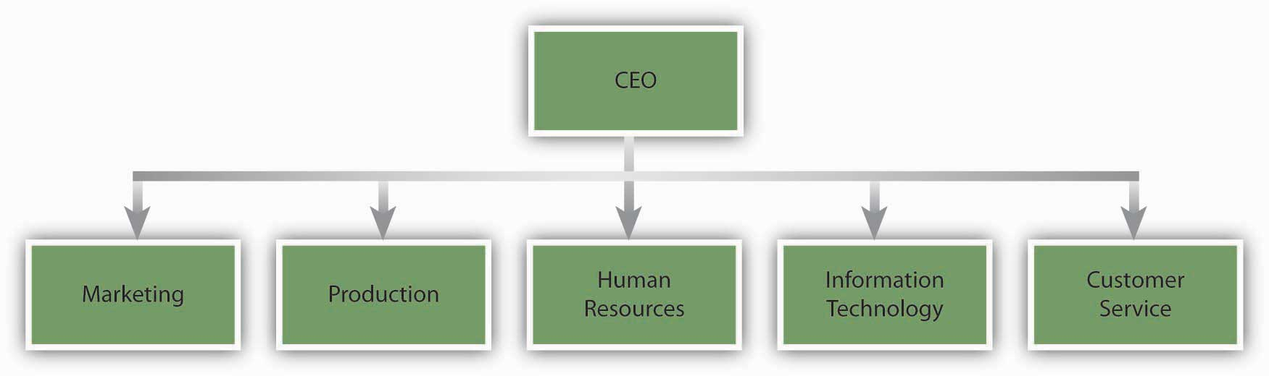

Figure 7.7 An Example of a Pharmaceutical Company with a Divisional Departmentalization Structure
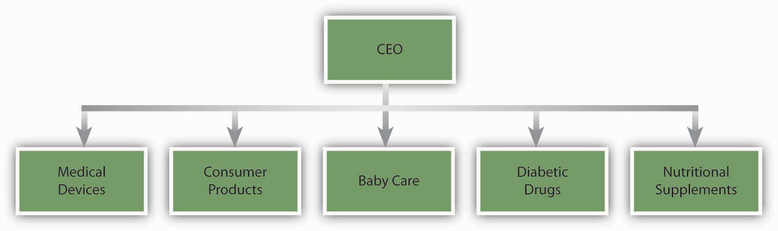

Two Configurations: Mechanistic and Organic Structures
The different elements making up organizational structures in the form of formalization, centralization, number of levels in the hierarchy, and departmentalization often coexist. As a result, we can talk about two configurations of organizational structures, depending on how these elements are arranged.
Mechanistic structures are those that resemble a bureaucracy. These structures are highly formalized and centralized. Communication tends to follow formal channels and employees are given specific job descriptions delineating their roles and responsibilities. Mechanistic organizations are often rigid and resist change, making them unsuitable for innovativeness and taking quick action. These forms have the downside of inhibiting entrepreneurial action and discouraging the use of individual initiative on the part of employees. Not only do mechanistic structures have disadvantages for innovativeness, but they also limit individual autonomy and self-determination, which will likely lead to lower levels of intrinsic motivation on the job.
- Burns, T., & Stalker, M. G. (1961). The Management of innovation. London: Tavistock; Covin, J. G., & Slevin, D. P. (1988). The influence of organizational structure.Journal of Management Studies. 25, 217–234
- Schollhammer, H. (1982). Internal corporate entrepreneurship. Englewood Cliffs, NJ: Prentice-Hall; Sherman, J. D., & Smith, H. L. (1984). The influence of organizational structure on intrinsic versus extrinsic motivation. Academy of Management Journal, 27, 877–885
- Slevin, D. P., & Covin, J. G. (1990). Juggling entrepreneurial style and organizational structure—how to get your act together. Sloan Management Review, 31(2), 43–53
Despite these downsides, however, mechanistic structures have advantages when the environment is more stable. The main advantage of a mechanistic structure is its efficiency. Therefore, in organizations that are trying to maximize efficiency and minimize costs, mechanistic structures provide advantages. For example, McDonald’s has a famously bureaucratic structure where employee jobs are highly formalized, with clear lines of communication and specific job descriptions. This structure is an advantage for them because it allows McDonald’s to produce a uniform product around the world at minimum cost. Mechanistic structures can also be advantageous when a company is new. New businesses often suffer from a lack of structure, role ambiguity, and uncertainty. The presence of a mechanistic structure has been shown to be related to firm performance in new ventures.
- Sine, W. D., Mitsuhashi, H., & Kirsch, D. A. (2006). Revisiting Burns and Stalker: Formal structure and new venture performance in emerging economic sectors. Academy of Management Journal, 49, 121–132
In contrast to mechanistic structures, organic structures are flexible and decentralized, with low levels of formalization. In Organizations with an organic structure, communication lines are more fluid and flexible. Employee job descriptions are broader and employees are asked to perform duties based on the specific needs of the organization at the time as well as their own expertise levels. Organic structures tend to be related to higher levels of job satisfaction on the part of employees. These structures are conducive to entrepreneurial behavior and innovativeness.
- Burns, T., & Stalker, M. G. (1961). The Management of Innovation. London: Tavistock; Covin, J. G., & Slevin, D. P. (1988) The influence of organizational structure. Journal of Management Studies, 25, 217–234
An example of a company that has an organic structure is the diversified technology company 3M. The company is strongly committed to decentralization. At 3M, there are close to 100 profit centers, with each division feeling like a small company. Each division manager acts autonomously and is accountable for his or her actions. As operations within each division get too big and a product created by a division becomes profitable, the operation is spun off to create a separate business unit. This is done to protect the agility of the company and the small-company atmosphere.
- Adair, J. (2007). Leadership for innovation: How to organize team creativity and harvest ideas. London: Kogan Page

KEY TAKEAWAY
The degree to which a company is centralized and formalized, the number of levels in the company hierarchy, and the type of departmentalization the company uses are key elements of a company’s structure. These elements of structure affect the degree to which the company is effective and innovative as well as employee attitudes and behaviors at work. These elements come together to create mechanistic and organic structures. Mechanistic structures are rigid and bureaucratic and help companies achieve efficiency, while organic structures are decentralized, flexible, and aid companies in achieving innovativeness.

EXERCISES
- What are the advantages and disadvantages of decentralization?
- All else being equal, would you prefer to work in a tall or flat organization? Why?
- What are the advantages and disadvantages of departmentalization by product?

7.3 Contemporary Forms of Organizational Structures

LEARNING OBJECTIVES
- Explain what a matrix structure is and the challenges of working in a structure such as this.
- Define boundaryless organizations.
- Define learning organizations, and list the steps organizations can take to become learning organizations.
For centuries, technological advancements that affected business came in slow waves. Over 100 years passed between the invention of the first reliable steam engine and the first practical internal combustion engine. During these early days of advancement, communication would often go hand in hand with transportation. Instead of delivering mail hundreds of miles by horse, messages could be transported more quickly by train and then later by plane. Beginning in the 1900s, the tides of change began to rise much more quickly. From the telegraph to the telephone to the computer to the Internet, each advancement brought about a need for an organization’s structure to adapt and change.
Business has become global, moving into new economies and cultures. Previously nonexistent industries, such as those related to high technology, have demanded flexibility by organizations in ways never before seen. The diverse and complex nature of the current business environment has led to the emergence of several types of organizational structures. Beginning in the 1970s, management experts began to propose organizational designs that they believed were better adapted to the needs of the emerging business environment. Each structure has unique qualities to help businesses handle their particular environment.

Matrix Organizations
Matrix organizations have a design that combines a traditional functional structure with a product structure. Instead of completely switching from a product-based structure, a company may use a matrix structure to balance the benefits of product-based and traditional functional structures. Specifically, employees reporting to department managers are also pooled together to form project or product teams. As a result, each person reports to a department manager as well as a project or product manager. In a matrix structure, product managers have control and say over product-related matters, while department managers have authority over matters related to company policy. Matrix structures are created in response to uncertainty and dynamism of the environment and the need to give particular attention to specific products or projects. Using the matrix structure as opposed to product departments may increase communication and cooperation among departments because project managers will need to coordinate their actions with those of department managers. In fact, research shows that matrix structure increases the frequency of informal and formal communication within the organization.
- Joyce, W. F. (1986). Matrix organization: A social experiment. Academy of Management Journal, 29, 536–561
Matrix structures also have the benefit of providing quick responses to technical problems and customer demands. The existence of a project manager keeps the focus on the product or service provided.

Figure 7.8
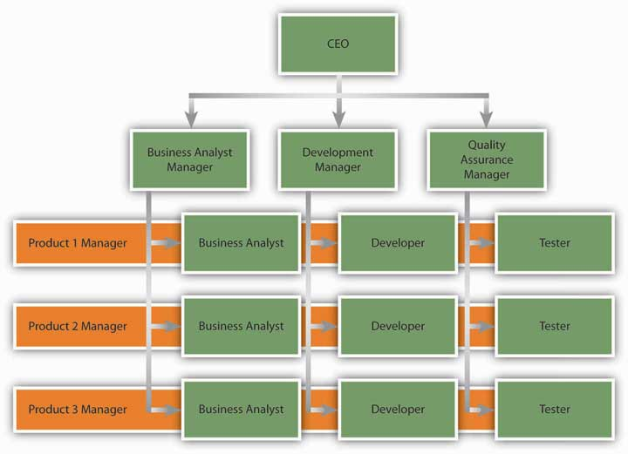
An example of a matrix structure at a software development company. Business analysts, developers, and testers each report to a functional department manager and to a project manager simultaneously.
Despite these potential benefits, matrix structures are not without costs. In a matrix, each employee reports to two or more managers. This situation is ripe for conflict. Because multiple managers are in charge of guiding the behaviors of each employee, there may be power struggles or turf wars among managers. As managers are more interdependent compared to a traditional or product-based structure, they will need to spend more effort coordinating their work. From the employee’s perspective, there is potential for interpersonal conflict with team members as well as with leaders. The presence of multiple leaders may create role ambiguity or, worse, role conflict—being given instructions or objectives that cannot all be met because they are mutually exclusive. The necessity to work with a team consisting of employees with different functional backgrounds increases the potential for task conflict at work.
- Ford, R. C., & Randolph, W. A. (1992). Cross-functional structures: A review and integration of matrix organization and project management. Journal of Management, 18, 267–294
Solving these problems requires a great level of patience and proactivity on the part of the employee.
The matrix structure is used in many information technology companies engaged in software development. Sportswear manufacturer Nike is another company that uses the matrix organization successfully. New product introduction is a task shared by regional managers and product managers. While product managers are in charge of deciding how to launch a product, regional managers are allowed to make modifications based on the region.
- Anand, N., & Daft, R. L. (2007). What is the right organization design? Organizational Dynamics, 36(4), 329–344

Boundaryless Organizations
Boundaryless organization is a term coined by Jack Welch during his tenure as CEO of GE; it refers to an organization that eliminates traditional barriers between departments as well as barriers between the organization and the external environment.
- Ashkenas, R., Ulrich, D., Jick, T., & Kerr, S. (1995). The Boundaryless organization: Breaking the chains of organizational structure. San Francisco: Jossey-Bass
Many different types of boundaryless organizations exist. One form is the modular organization, in which all nonessential functions are outsourced. The idea behind this format is to retain only the value-generating and strategic functions in-house, while the rest of the operations are outsourced to many suppliers. An example of a company that does this is Toyota. By managing relationships with hundreds of suppliers, Toyota achieves efficiency and quality in its operations.Strategic alliances constitute another form of boundaryless design. In this form, similar to a joint venture, two or more companies find an area of collaboration and combine their efforts to create a partnership that is beneficial for both parties. In the process, the traditional boundaries between two competitors may be broken. As an example, Starbucks formed a highly successful partnership with PepsiCo to market its Frappuccino cold drinks. Starbucks has immediate brand-name recognition in this cold coffee drink, but its desire to capture shelf space in supermarkets required marketing savvy and experience that Starbucks did not possess at the time. By partnering with PepsiCo, Starbucks gained an important head start in the marketing and distribution of this product. Finally, boundaryless organizations may involve eliminating the barriers separating employees; these may be intangible barriers, such as traditional management layers, or actual physical barriers, such as walls between different departments. Structures such as self-managing teams create an environment where employees coordinate their efforts and change their own roles to suit the demands of the situation, as opposed to insisting that something is “not my job.”
- Dess, G. G., Rasheed, A. M. A., McLaughlin, K. J., & Priem, R. L. (1995). The new corporate architecture. Academy of Management Executive, 9(3), 7–18
- Rosenbloom, B. (2003). Multi-channel marketing and the retail value chain. Thexis, 3, 23–26

Learning Organizations
A learning organization is one whose design actively seeks to acquire knowledge and change behavior as a result of the newly acquired knowledge. In learning organizations, experimenting, learning new things, and reflecting on new knowledge are the norms. At the same time, there are many procedures and systems in place that facilitate learning at all organization levels.
In learning organizations, experimentation and testing potentially better operational methods are encouraged. This is true not only in response to environmental threats but also as a way of identifying future opportunities. 3M is one company that institutionalized experimenting with new ideas in the form of allowing each engineer to spend one day a week working on a personal project. At IBM, learning is encouraged by taking highly successful business managers and putting them in charge of emerging business opportunities (EBOs). IBM is a company that has no difficulty coming up with new ideas, as evidenced by the number of patents it holds. Yet commercializing these ideas has been a problem in the past because of an emphasis on short-term results. To change this situation, the company began experimenting with the idea of EBOs. By setting up a structure where failure is tolerated and risk taking is encouraged, the company took a big step toward becoming a learning organization.
- Deutschman, A. (2005, March). Building a better skunk works. Fast Company, 92, 68–73
Learning organizations are also good at learning from experience—their own or a competitor’s. To learn from past mistakes, companies conduct a thorough analysis of them. Some companies choose to conduct formal retrospective meetings to analyze the challenges encountered and areas for improvement. To learn from others, these companies vigorously study competitors, market leaders in different industries, clients, and customers. By benchmarking against industry best practices, they constantly look for ways of improving their own operations. Learning organizations are also good at studying customer habits to generate ideas. For example, Xerox uses anthropologists to understand and gain insights to how customers are actually using their office products.
- Garvin, D. A. (1993, July/August). Building a learning organization. Harvard Business Review, 71(4), 78–91
By using these techniques, learning organizations facilitate innovation and make it easier to achieve organizational change.

KEY TAKEAWAY
The changing environment of organizations creates the need for newer forms of organizing. Matrix structures are a cross between functional and product-based divisional structures. They facilitate information flow and reduce response time to customers but have challenges because each employee reports to multiple managers. Boundaryless organizations blur the boundaries between departments or the boundaries between the focal organization and others in the environment. These organizations may take the form of a modular organization, strategic alliance, or self-managing teams. Learning organizations institutionalize experimentation and benchmarking.

EXERCISES
- Have you ever reported to more than one manager? What were the challenges of such a situation? As a manager, what could you do to help your subordinates who have other bosses besides yourself?
- What do you think are the advantages and disadvantages of being employed by a boundaryless organization?
- What can organizations do to institutionalize organizational learning? What practices and policies would aid in knowledge acquisition and retention?

7.4 Organizational Change

LEARNING OBJECTIVES
- Identify the external forces creating change on the part of organizations.
- Understand how organizations respond to changes in the external environment.
- Understand why people resist change.

Why Do Organizations Change?
Organizational change is the movement of an organization from one state of affairs to another. A change in the environment often requires change within the organization operating within that environment. Change in almost any aspect of a company’s operation can be met with resistance, and different cultures can have different reactions to both the change and the means to promote the change. To better facilitate necessary changes, several steps can be taken that have been proved to lower the anxiety of employees and ease the transformation process. Often, the simple act of including employees in the change process can drastically reduce opposition to new methods. In some organizations, this level of inclusion is not possible, and instead organizations can recruit a small number of opinion leaders to promote the benefits of coming changes.
Organizational change can take many forms. It may involve a change in a company’s structure, strategy, policies, procedures, technology, or culture. The change may be planned years in advance or may be forced on an organization because of a shift in the environment. Organizational change can be radical and swiftly alter the way an organization operates, or it may be incremental and slow. In any case, regardless of the type, change involves letting go of the old ways in which work is done and adjusting to new ways. Therefore, fundamentally, it is a process that involves effective people management.
Managers carrying out any of the P-O-L-C functions often find themselves faced with the need to manage organizational change effectively. Oftentimes, the planning process reveals the need for a new or improved strategy, which is then reflected in changes to tactical and operational plans. Creating a new organizational design (the organizing function) or altering the existing design entails changes that may affect from a single employee up to the entire organization, depending on the scope of the changes. Effective decision making, a Leadership task, takes into account the change-management implications of decisions, planning for the need to manage the implementation of decisions. Finally, any updates to controlling systems and processes will potentially involve changes to employees’ assigned tasks and performance assessments, which will require astute change management skills to implement. In short, change management is an important leadership skill that spans the entire range of P-O-L-C functions.

Workplace Demographics
Organizational change is often a response to changes to the environment. For example, agencies that monitor workplace demographics such as the U.S. Department of Labor and the Organization for Economic Co-operation and Development have reported that the average age of the U.S. workforce will increase as the baby boom generation nears retirement age and the numbers of younger workers are insufficient to fill the gap.
- Lerman, R. I., & Schmidt, S. R. (2006). Trends and challenges for work in the 21st century. Retrieved September 10, 2008, from U.S. Department of Labor Web site, http://www.dol.gov/oasam/programs/history/herman/reports/futurework/conference/trends/trendsI.htm.
What does this mean for companies? Organizations may realize that as the workforce gets older, the types of benefits workers prefer may change. Work arrangements such as flexible work hours and job sharing may become more popular as employees remain in the workforce even after retirement. It is also possible that employees who are unhappy with their current work situation will choose to retire, resulting in a sudden loss of valuable knowledge and expertise in organizations. Therefore, organizations will have to devise strategies to retain these employees and plan for their retirement. Finally, a critical issue is finding ways of dealing with age-related stereotypes which act as barriers in the retention of these employees.

Technology
Sometimes change is motivated by rapid developments in technology. Moore’s law (a prediction by Gordon Moore, cofounder of Intel) dictates that the overall complexity of computers will double every 18 months with no increase in cost.
- Anonymous. Moore’s Law. Retrieved September 5, 2008, from Answers.com, http://www.answers.com/topic/moore-s-law
Such change is motivating corporations to change their technology rapidly. Sometimes technology produces such profound developments that companies struggle to adapt. A recent example is from the music industry. When music CDs were first introduced in the 1980s, they were substantially more appealing than the traditional LP vinyl records. Record companies were easily able to double the prices, even though producing CDs cost a fraction of what it cost to produce LPs. For decades, record-producing companies benefited from this status quo. Yet when peer-to-peer file sharing through software such as Napster and Kazaa threatened the core of their business, companies in the music industry found themselves completely unprepared for such disruptive technological changes. Their first response was to sue the users of file-sharing software, sometimes even underage kids. They also kept looking for a technology that would make it impossible to copy a CD or DVD, which has yet to emerge. Until Apple’s iTunes came up with a new way to sell music online, it was doubtful that consumers would ever be willing to pay for music that was otherwise available for free (albeit illegally so). Only time will tell if the industry will be able to adapt to the changes forced on it.
- Lasica, J. D. (2005). Darknet: Hollywood’s war against the digital generation. Hoboken, NJ: Wiley.

Figure 7.9
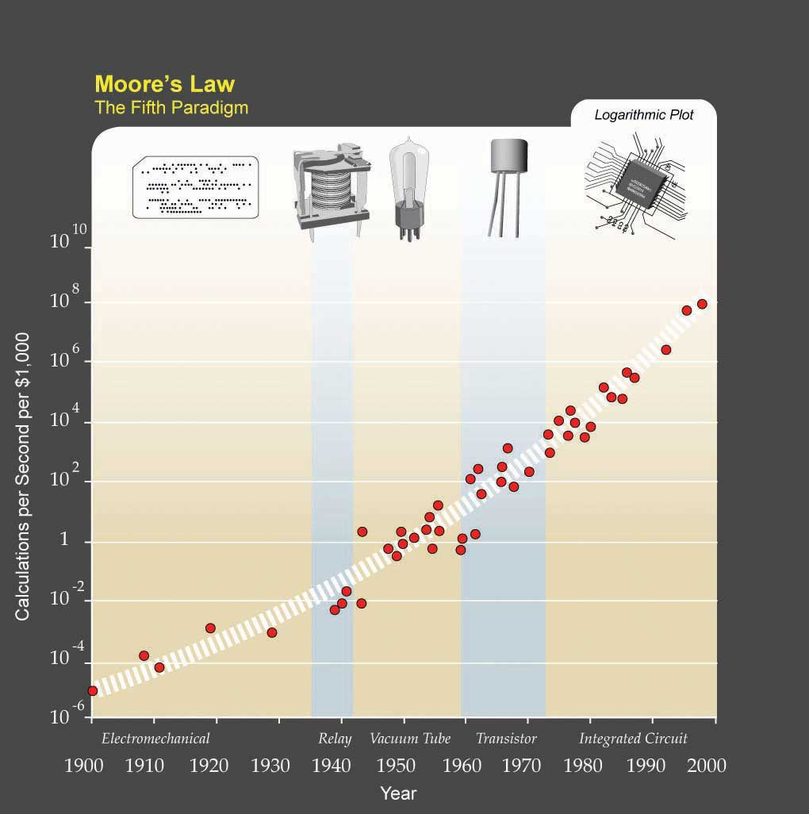
Kurzweil expanded Moore’s law from integrated circuits to earlier transistors, vacuum tubes, relays, and electromechanical computers to show that his trend holds there as well.
Source: http://upload.wikimedia.org/wikipedia/commons/c/c5/PPTMooresLawai.jpg

Globalization
Globalization is another threat and opportunity for organizations, depending on their ability to adapt to it. Because of differences in national economies and standards of living from one country to another, organizations in developed countries are finding that it is often cheaper to produce goods and deliver services in less developed countries. This has led many companies to outsource (or “offshore”) their manufacturing operations to countries such as China and Mexico. In the 1990s, knowledge work was thought to be safe from outsourcing, but in the 21st century we are also seeing many service operations moved to places with cheaper wages. For example, many companies have outsourced software development to India, with Indian companies such as Wipro and Infosys emerging as global giants. Given these changes, understanding how to manage a global workforce is a necessity. Many companies realize that outsourcing forces them to operate in an institutional environment that is radically different from what they are used to at home. Dealing with employee stress resulting from jobs being moved overseas, retraining the workforce, and learning to compete with a global workforce on a global scale are changes companies are trying to come to grips with.

Changes in the Market Conditions
Market changes may also create internal changes as companies struggle to adjust. For example, as of this writing, the airline industry in the United States is undergoing serious changes. Demand for air travel was reduced after the September 11 terrorist attacks. At the same time, the widespread use of the Internet to book plane travels made it possible to compare airline prices much more efficiently and easily, encouraging airlines to compete primarily based on cost. This strategy seems to have backfired when coupled with the dramatic increases in the cost of fuel that occurred begining in 2004. As a result, by mid-2008, airlines were cutting back on amenities that had formerly been taken for granted for decades, such as the price of a ticket including meals, beverages, and checking luggage. Some airlines, such as Delta and Northwest Airlines, merged to stay in business.
How does a change in the environment create change within an organization? Environmental change does not automatically change how business is done. Whether the organization changes or not in response to environmental challenges and threats depends on the decision makers’ reactions to what is happening in the environment.

Growth

Figure 7.10
In 1984, brothers Kurt (on the left) and Rob Widmer (on the right) founded Widmer Brothers, which has merged with another company to become the 11th largest brewery in the United States.
Photo and permission given by Widmer Brothers Brewing Co.
It is natural for once small start-up companies to grow if they are successful. An example of this growth is the evolution of the Widmer Brothers Brewing Company, which started as two brothers brewing beer in their garage to becoming the 11th largest brewery in the United States. This growth happened over time as the popularity of their key product—Hefeweizen—grew in popularity and the company had to expand to meet demand growing from the two founders to the 11th largest brewery in the United States by 2008. In 2007, Widmer Brothers merged with Redhook Ale Brewery. Anheuser-Busch continues to have a minority stake in both beer companies. So, while 50% of all new small businesses fail in their first year. Those that succeed often evolve into large, complex organizations over time.
- Get ready. United States Small Business Association. Retrieved November 21, 2008, from http://www.sba.gov/smallbusinessplanner/plan/getready/SERV_SBPLANNER_ISENTFORU.html.

Poor Performance
Change can also occur if the company is performing poorly and if there is a perceived threat from the environment. In fact, poorly performing companies often find it easier to change compared with successful companies. Why? High performance actually leads to overconfidence and inertia. As a result, successful companies often keep doing what made them successful in the first place. When it comes to the relationship between company performance and organizational change, the saying “nothing fails like success” may be fitting. For example, Polaroid was the number one producer of instant films and cameras in 1994. Less than a decade later, the company filed for bankruptcy, unable to adapt to the rapid advances in one-hour photo development and digital photography technologies that were sweeping the market. Successful companies that manage to change have special practices in place to keep the organization open to changes. For example, Finnish cell phone maker Nokia finds that it is important to periodically change the perspective of key decision makers. For this purpose, they rotate heads of businesses to different posts to give them a fresh perspective. In addition to the success of a business, change in a company’s upper-level management is a motivator for change at the organization level. Research shows that long-tenured CEOs are unlikely to change their formula for success. Instead, new CEOs and new top management teams create change in a company’s culture and structure.
- Barnett, W. P., & Carroll, G. R. (1995). Modeling internal organizational change. Annual Review of Sociology,21, 217–236
- Boeker, W. (1997). Strategic change: The influence of managerial characteristics and organizational growth. Academy of Management Journal, 40, 152–170
- Deutschman, A. (2005, March). Building a better skunk works. Fast Company, 92, 68–73

Resistance to Change
Changing an organization is often essential for a company to remain competitive. Failure to change may influence the ability of a company to survive. Yet employees do not always welcome changes in methods. According to a 2007 survey conducted by the Society for Human Resource Management (SHRM), employee resistance to change is one of the top reasons change efforts fail. In fact, reactions to organizational change may range from resistance to compliance to enthusiastic support of the change, with the latter being the exception rather than the norm.
- Anonymous. (December 2007). Change management: The HR strategic imperative as a business partner. HR Magazine, 52(12); Huy, Q. N. (1999). Emotional capability, emotional intelligence, and radical change. Academy of Management Review, 24, 325–345

Figure 7.11
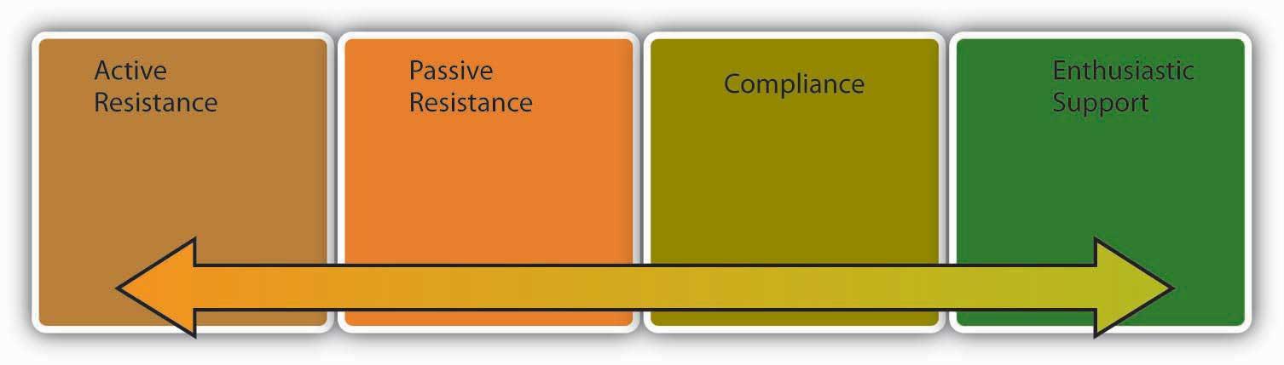
Reactions to change may take many forms.
Active resistance is the most negative reaction to a proposed change attempt. Those who engage in active resistance may sabotage the change effort and be outspoken objectors to the new procedures. In contrast, passive resistance involves being disturbed by changes without necessarily voicing these opinions. Instead, passive resisters may dislike the change quietly, feel stressed and unhappy, and even look for a new job without necessarily bringing their concerns to the attention of decision makers. Compliance, however, involves going along with proposed changes with little enthusiasm. Finally, those who show enthusiastic support are defenders of the new way and actually encourage others around them to give support to the change effort as well.
To be successful, any change attempt will need to overcome resistance on the part of employees. Otherwise, the result will be loss of time and energy as well as an inability on the part of the organization to adapt to the changes in the environment and make its operations more efficient. Resistance to change also has negative consequences for the people in question. Research shows that when people react negatively to organizational change, they experience negative emotions, use sick time more often, and are more likely to voluntarily leave the company.
- Fugate, M., Kinicki, A. J., & Prussia, G. E. (2008). Employee coping with organizational change: An examination of alternative theoretical perspectives and models. Personnel Psychology, 61, 1–36
These negative effects can be present even when the proposed change clearly offers benefits and advantages over the status quo.
The following is a dramatic example of how resistance to change may prevent improving the status quo. Have you ever wondered why the keyboards we use are shaped the way they are? The QWERTY keyboard, named after the first six letters in the top row, was actually engineered to slow us down. When the typewriter was first invented in the 19th century, the first prototypes of the keyboard would jam if the keys right next to each other were hit at the same time. Therefore, it was important for manufacturers to slow typists down. They achieved this by putting the most commonly used letters to the left-hand side and scattering the most frequently used letters all over the keyboard. Later, the issue of letters being stuck was resolved. In fact, an alternative to the QWERTY developed in the 1930s by educational psychologist August Dvorak provides a much more efficient design and allows individuals to double traditional typing speeds. Yet the Dvorak keyboard never gained wide acceptance. The reasons? Large numbers of people resisted the change. Teachers and typists resisted because they would lose their specialized knowledge. Manufacturers resisted due to costs inherent in making the switch and the initial inefficiencies in the learning curve.
- Diamond, J. (2005). Guns, germs, and steel: The fates of human societies. New York: W. W. Norton.
In short, the best idea does not necessarily win, and changing people requires understanding why they resist.

Why Do People Resist Change?

Disrupted Habits
People often resist change for the simple reason that change disrupts our habits. When you hop into your car for your morning commute, do you think about how you are driving? Most of the time probably not, because driving generally becomes an automated activity after a while. You may sometimes even realize that you have reached your destination without noticing the roads you used or having consciously thought about any of your body movements. Now imagine you drive for a living and even though you are used to driving an automatic car, you are forced to use a stick shift. You can most likely figure out how to drive a stick, but it will take time, and until you figure it out, you cannot drive on auto pilot. You will have to reconfigure your body movements and practice shifting until you become good at it. This loss of a familiar habit can make you feel clumsy; you may even feel that your competence as a driver is threatened. For this simple reason, people are sometimes surprisingly outspoken when confronted with simple changes such as updating to a newer version of a particular software or a change in their voice mail system.

Personality
Some people are more resistant to change than others. Recall that one of the Big Five personality traits is Openness to Experience; obviously, people who rank high on this trait will tend to accept change readily. Research also shows that people who have a positive self-concept are better at coping with change, probably because those who have high self-esteem may feel that whatever the changes are, they are likely to adjust to it well and be successful in the new system. People with a more positive self-concept and those who are more optimistic may also view change as an opportunity to shine as opposed to a threat that is overwhelming. Finally, risk tolerance is another predictor of how resistant someone will be to stress. For people who are risk avoidant, the possibility of a change in technology or structure may be more threatening.
- Judge, T. A., Thoresen, C. J., Pucik, V., & Welbourne, T. M. (1999). Managerial coping with organizational change. Journal of Applied Psychology, 84, 107–122
- Wanberg, C. R., & Banas, J. T. (2000). Predictors and outcomes of openness to changes in a reorganizing workplace. Journal of Applied Psychology, 85, 132–142

Feelings of Uncertainty
Change inevitably brings feelings of uncertainty. You have just heard that your company is merging with another. What would be your reaction? Such change is often turbulent, and it is often unclear what is going to happen to each individual. Some positions may be eliminated. Some people may see a change in their job duties. Things may get better—or they may get worse. The feeling that the future is unclear is enough to create stress for people because it leads to a sense of lost control.
- Ashford, S. J., Lee, C. L., & Bobko, P. (1989). Content, causes, and consequences of job insecurity: A theory-based measure and substantive test. Academy of Management Journal, 32, 803–829
- Fugate, M., Kinicki, A. J., & Prussia, G. E. (2008). Employee coping with organizational change: An examination of alternative theoretical perspectives and models. Personnel Psychology, 61, 1–36

Fear of Failure
People also resist change when they feel that their performance may be affected under the new system. People who are experts in their jobs may be less than welcoming of the changes because they may be unsure whether their success would last under the new system. Studies show that people who feel that they can perform well under the new system are more likely to be committed to the proposed change, while those who have lower confidence in their ability to perform after changes are less committed.
- Herold, D. M., Fedor, D. B., & Caldwell, S. (2007). Beyond change management: A multilevel investigation of contextual and personal influences on employees’ commitment to change. Journal of Applied Psychology, 92, 942–951

Personal Impact of Change
It would be too simplistic to argue that people resist all change, regardless of its form. In fact, people tend to be more welcoming of change that is favorable to them on a personal level (such as giving them more power over others or change that improves quality of life such as bigger and nicer offices). Research also shows that commitment to change is highest when proposed changes affect the work unit with a low impact on how individual jobs are performed.
- Fedor, D. M., Caldwell, S., & Herold, D. M. (2006). The effects of organizational changes on employee commitment: A multilevel investigation. Personnel Psychology, 59, 1–29

Prevalence of Change
Any change effort should be considered within the context of all the other changes that are introduced in a company. Does the company have a history of making short-lived changes? If the company structure went from functional to product-based to geographic to matrix within the past five years and the top management is in the process of going back to a functional structure again, a certain level of resistance is to be expected because employees are likely to be fatigued as a result of the constant changes. Moreover, the lack of a history of successful changes may cause people to feel skeptical toward the newly planned changes. Therefore, considering the history of changes in the company is important to understanding why people resist. Another question is, how big is the planned change? If the company is considering a simple switch to a new computer program, such as introducing Microsoft Access for database management, the change may not be as extensive or stressful compared with a switch to an enterprise resource planning (ERP) system such as SAP or PeopleSoft, which require a significant time commitment and can fundamentally affect how business is conducted.
- Labianca, G., Gray, B., & Brass D. J. (2000). A grounded model of organizational schema change during empowerment. Organization Science, 11, 235–257
- Rafferty, A. E., & Griffin. M. A. (2006). Perceptions of organizational change: A stress and coping perspective. Journal of Applied Psychology, 91, 1154–1162

Perceived Loss of Power
One other reason people may resist change is that change may affect their power and influence in the organization. Imagine that your company moved to a more team-based structure, turning supervisors into team leaders. In the old structure, supervisors were in charge of hiring and firing all those reporting to them. Under the new system, this power is given to the team. Instead of monitoring the progress the team is making toward goals, the job of a team leader is to provide support and mentoring to the team in general and ensure that the team has access to all resources to be effective. Given the loss in prestige and status in the new structure, some supervisors may resist the proposed changes even if it is better for the organization to operate around teams.
In summary, there are many reasons individuals resist change, which may prevent an organization from making important changes.

Is All Resistance Bad?
Resistance to change may be a positive force in some instances. In fact, resistance to change is a valuable feedback tool that should not be ignored. Why are people resisting the proposed changes? Do they believe that the new system will not work? If so, why not? By listening to people and incorporating their suggestions into the change effort, it is possible to make a more effective change. Some of a company’s most committed employees may be the most vocal opponents of a change effort. They may fear that the organization they feel such a strong attachment to is being threatened by the planned change effort and the change will ultimately hurt the company. In contrast, people who have less loyalty to the organization may comply with the proposed changes simply because they do not care enough about the fate of the company to oppose the changes. As a result, when dealing with those who resist change, it is important to avoid blaming them for a lack of loyalty.
- Ford, J. D., Ford, L. W., & D’Amelio, A. (2008). Resistance to change: The rest of the story. Academy of Management Review, 33, 362–377

KEY TAKEAWAY
Organizations change in response to changes in the environment and in response to the way decision makers interpret these changes. When it comes to organizational change, one of the biggest obstacles is resistance to change. People resist change because change disrupts habits, conflicts with certain personality types, causes a fear of failure, can have potentially negative effects, can result in a potential for loss of power, and, when done too frequently, can exhaust employees.

EXERCISES
- Can you think of an organizational or personal change that you had to go through? Have you encountered any resistance to this change? What were the reasons?
- How would you deal with employees who are resisting change because their habits are threatened? How would you deal with them if they are resisting because of a fear of failure?

7.5 Planning and Executing Change Effectively

LEARNING OBJECTIVES
- Describe Lewin’s three-stage model of planned change.
- Describe how organizations may embrace continuous change.
How do you plan, organize, and execute change effectively? Some types of change, such as mergers, often come with job losses. In these situations, it is important to remain fair and ethical while laying off otherwise exceptional employees. Once change has occurred, it is vital to take any steps necessary to reinforce the new system. Employees can often require continued support well after an organizational change.
One of the most useful frameworks in this area is the three-stage model of planned change developed in the 1950s by psychologist Kurt Lewin.
- Lewin K. (1951). Field theory in social science. New York: Harper & Row
This model assumes that change will encounter resistance. Therefore, executing change without prior preparation is likely to lead to failure. Instead, organizations should start with unfreezing, or making sure that organizational members are ready for and receptive to change. This is followed bychange, or executing the planned changes. Finally, refreezing involves ensuring that change becomes permanent and the new habits, rules, or procedures become the norm.

Figure 7.14 Lewin’s Three-Stage Process of Change
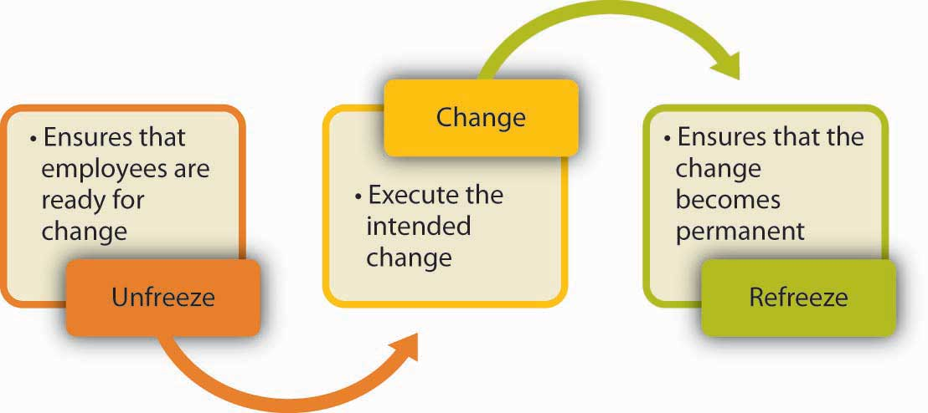

Unfreezing Before Change
Many change efforts fail because people are insufficiently prepared for change. When employees are not prepared, they are more likely to resist the change effort and less likely to function effectively under the new system. What can organizations do before change to prepare employees? There are a number of things that are important at this stage.

Communicating a Plan for Change
Do people know what the change entails, or are they hearing about the planned changes through the grapevine or office gossip? When employees know what is going to happen, when, and why, they may feel more comfortable. Research shows that those who have more complete information about upcoming changes are more committed to a change effort.
- Wanberg, C. R., & Banas, J. T. (2000). Predictors and outcomes of openness to changes in a reorganizing workplace. Journal of Applied Psychology, 85, 132–142
Moreover, in successful change efforts, the leader not only communicates a plan but also an overall vision for the change.
- Herold, D. M., Fedor D. B., Caldwell, S., & Liu, Y. (2008). The effects of transformational and change leadership on employees’ commitment to a change: A multilevel study. Journal of Applied Psychology, 93, 346–357
When this vision is exciting and paints a picture of a future that employees would be proud to be a part of, people are likely to be more committed to change.
Ensuring that top management communicates with employees about the upcoming changes also has symbolic value.
- Armenakis, A. A., Harris, S. G., & Mossholder, K. W. (1993). Creating readiness for organizational change. Human Relations, 46, 681–703
When top management and the company CEO discuss the importance of the changes in meetings, employees are provided with a reason to trust that this change is a strategic initiative. For example, while changing the employee performance appraisal system, the CEO of Kimberly Clark made sure to mention the new system in all meetings with employees, indicating that the change was supported by the CEO.

Develop a Sense of Urgency
People are more likely to accept change if they feel that there is a need for it. If employees feel their company is doing well, the perceived need for change will be smaller. Those who plan the change will need to make the case that there is an external or internal threat to the organization’s competitiveness, reputation, or sometimes even its survival and that failure to act will have undesirable consequences. For example, Lou Gerstner, the former CEO of IBM, executed a successful transformation of the company in the early 1990s. In his biography Elephants Can Dance, Gerstner highlights how he achieved cooperation as follows: “Our greatest ally in shaking loose the past was IBM’s eminent collapse. Rather than go with the usual impulse to put on a happy face, I decided to keep the crisis front and center. I didn’t want to lose the sense of urgency.”
- Gerstner, L. V. (2002). Who says elephants can’t dance? Inside IBM’s historic turnaround. New York: HarperCollins
- Kotter, J. P. (1996). Leading change. Boston: Harvard Business School Press

Building a Coalition
To convince people that change is needed, the change leader does not necessarily have to convince every person individually. In fact, people’s opinions toward change are affected by opinion leaders or those people who have a strong influence over the behaviors and attitudes of others.
- Burkhardt, M. E. (1994). Social interaction effects following a technological change: A longitudinal investigation. Academy of Management Journal, 37, 869–898
- Kotter, J. P. (1995, March–April). Leading change: Why transformations fail. Harvard Business Review, 73(2), 59–67
Instead of trying to get everyone on board at the same time, it may be more useful to convince and prepare the opinion leaders. Understanding one’s own social networks as well as the networks of others in the organization can help managers identify opinion leaders. Once these individuals agree that the proposed change is needed and will be useful, they will become helpful allies in ensuring that the rest of the organization is ready for change.
- Armenakis, A. A., Harris, S. G., & Mossholder, K. W. (1993). Creating readiness for organizational change. Human Relations, 46, 681–703
For example, when Paul Pressler became the CEO of Gap Inc. in 2002, he initiated a culture change effort in the hope of creating a sense of identity among the company’s many brands such as Banana Republic, Old Navy, and Gap. For this purpose, employees were segmented instead of trying to reach out to all employees at the same time. Gap Inc. started by training the 2,000 senior managers in “leadership summits,” who in turn were instrumental in ensuring the cooperation of the remaining 150,000 employees of the company.
- Nash, J. A. (Nov/Dec 2005). Comprehensive campaign helps Gap employees embrace cultural change. Communication World, 22(6)

Provide Support
Employees should feel that their needs are not ignored. Therefore, management may prepare employees for change by providing emotional and instrumental support. Emotional support may be in the form of frequently discussing the changes, encouraging employees to voice their concerns, and simply expressing confidence in employees’ ability to perform effectively under the new system. Instrumental support may be in the form of providing a training program to employees so that they know how to function under the new system. Effective leadership and motivation skills can assist managers to provide support to employees.

Allow Employees to Participate
Studies show that employees who participate in planning change efforts tend to have more positive opinions about the change. Why? They will have the opportunity to voice their concerns. They can shape the change effort so that their concerns are addressed. They will be more knowledgeable about the reasons for change, alternatives to the proposed changes, and why the chosen alternative was better than the others. Finally, they will feel a sense of ownership of the planned change and are more likely to be on board.
- Wanberg, C. R., & Banas, J. T. (2000). Predictors and outcomes of openness to changes in a reorganizing workplace. Journal of Applied Psychology, 85, 132–142
Participation may be more useful if it starts at earlier stages, preferably while the problem is still being diagnosed. For example, assume that a company suspects there are problems with manufacturing quality. One way of convincing employees that there is a problem that needs to be solved would be to ask them to take customer calls about the product quality. Once employees experience the problem firsthand, they will be more motivated to solve the problem.

Executing Change
The second stage of Lewin’s three-stage change model is executing change. At this stage, the organization implements the planned changes on technology, structure, culture, or procedures. The specifics of how change should be executed will depend on the type of change. However, there are three tips that may facilitate the success of a change effort.

Continue to Provide Support
As the change is under way, employees may experience high amounts of stress. They may make mistakes more often or experience uncertainty about their new responsibilities or job descriptions. Management has an important role in helping employees cope with this stress by displaying support, patience, and continuing to provide support to employees even after the change is complete.

Create Small Wins
During a change effort, if the organization can create a history of small wins, change acceptance will be more likely.
- Kotter, J. P. (1996). Leading change. Boston: Harvard Business School Press; Reay, T., Golden-Biddle, K., & Germann, K. (2006). Legitimizing a new role: Small wins and microprocesses of change. Academy of Management Journal, 49, 977–998
If the change is large in scope and the payoff is a long time away, employees may not realize change is occurring during the transformation period. However, if people see changes, improvements, and successes along the way, they will be inspired and motivated to continue the change effort. For this reason, breaking up the proposed change into phases may be a good idea because it creates smaller targets. Small wins are also important for planners of change to make the point that their idea is on the right track. Early success gives change planners more credibility while early failures may be a setback.
- Hamel, G. (2000, July/August). Waking up IBM.Harvard Business Review, 78(4), 137–146

Eliminate Obstacles
When the change effort is in place, many obstacles may crop up along the way. There may be key people who publicly support the change effort while silently undermining the planned changes. There may be obstacles rooted in a company’s structure, existing processes, or culture. It is the management’s job to identify, understand, and remove these obstacles.
- Kotter, J. P. (1995, March–April). Leading change: Why transformations fail. Harvard Business Review, 73(2), 59–67
Ideally, these obstacles would have been eliminated before implementing the change, but sometimes unexpected roadblocks emerge as change is under way.

Refreezing
After the change is implemented, the long-term success of a change effort depends on the extent to which the change becomes part of the company’s culture. If the change has been successful, the revised ways of thinking, behaving, and performing should become routine. To evaluate and reinforce (“refreeze”) the change, there are a number of things management can do.

Publicize Success
To make change permanent, the organization may benefit from sharing the results of the change effort with employees. What was gained from the implemented changes? How much money did the company save? How much did the company’s reputation improve? What was the reduction in accidents after new procedures were put in place? Sharing concrete results with employees increases their confidence that the implemented change was a right decision.

Reward Change Adoption
To ensure that change becomes permanent, organizations may benefit from rewarding those who embrace the change effort (an aspect of the controlling function). The rewards do not necessarily have to be financial. The simple act of recognizing those who are giving support to the change effort in front of their peers may encourage others to get on board. When the new behaviors employees are expected to demonstrate (such as using a new computer program, filling out a new form, or simply greeting customers once they enter the store) are made part of an organization’s reward system, those behaviors are more likely to be taken seriously and repeated, making the change effort successful.
- Gale, S. F. (2003). Incentives and the art of changing behavior. Workforce Management, 82(11), 48–54

Embracing Continuous Change
While Lewin’s three-stage model offers many useful insights into the process of implementing change, it views each organizational change as an episode with a beginning, middle, and end. In contrast with this episodic change assumption, some management experts in the 1990s began to propose that change is—or ought to be—a continuous process.
The learning organization is an example of a company embracing continuous change. By setting up a dynamic feedback loop, learning can become a regular part of daily operations. If an employee implements a new method or technology that seems to be successful, a learning organization is in a good position to adopt it. By constantly being aware of how employee actions and outcomes affect others as well as overall company productivity, the inevitable small changes throughout organizations can be rapidly absorbed and tailored for daily operations. When an organization understands that change does indeed occur constantly, it will be in a better position to make use of good changes and intervene if a change seems detrimental.

KEY TAKEAWAY
Effective change effort can be conceptualized as a three-step process in which employees are first prepared for change, then change is implemented, and finally the new behavioral patterns become permanent. According to emerging contemporary views, it can also be seen as a continuous process that affirms the organic, ever-evolving nature of an organization.

EXERCISES
- What are the benefits of employee participation in change management?
- Imagine that you are introducing a new system to college students where they would have to use a special ID number you create for them for activities such as logging on to campus computers or using library resources. How would you plan and implement the change? Explain using Lewin’s three-stage framework.
- Why are successful companies less likely to change? What should companies do to make organizational change part of their culture?

7.6 Building Your Change Management Skills

LEARNING OBJECTIVE
- Identify guidelines for overcoming resistance to change.

Overcoming Resistance to Your Proposals
You feel that a change is needed. You have a great idea. But people around you do not seem convinced. They are resisting your great idea. How do you make change happen?
- Listen to naysayers. You may think that your idea is great, but listening to those who resist may give you valuable ideas about why it may not work and how to design it more effectively.
- Is your change revolutionary? If you are trying to change dramatically the way things are done, you will find that resistance is greater. If your proposal involves incrementally making things better, you may have better luck.
- Involve those around you in planning the change. Instead of providing the solutions, make them part of the solution. If they admit that there is a problem and participate in planning a way out, you would have to do less convincing when it is time to implement the change.
- Assess your credibility. When trying to persuade people to change their ways, it helps if you have a history of suggesting implementable changes. Otherwise, you may be ignored or met with suspicion. This means you need to establish trust and a history of keeping promises over time before you propose a major change.
- Present data to your audience. Be prepared to defend the technical aspects of your ideas and provide evidence that your proposal is likely to work.
- Appeal to your audience’s ideals. Frame your proposal around the big picture. Are you going to create happier clients? Is this going to lead to a better reputation for the company? Identify the long-term goals you are hoping to accomplish that people would be proud to be a part of.
- Understand the reasons for resistance. Is your audience resisting because they fear change? Does the change you propose mean more work for them? Does it affect them in a negative way? Understanding the consequences of your proposal for the parties involved may help you tailor your pitch to your audience.
Based on:
- McGoon, C. (March 1995). Secrets of building influence.Communication World, 12(3), 16

- Michelman, P. (July 2007). Overcoming resistance to change.Harvard Management Update, 12(7), 3–4

- Stanley, T. L. (January 2002). Change: A common-sense approach. Supervision, 63(1), 7–10

KEY TAKEAWAY
There are several steps you can take to help you overcome resistance to change. Many of them share the common theme of respecting those who are resistant so you can understand and learn from their concerns.

EXERCISES
- What do you think are some key reasons why people resist change?
- Do you think some people are more resistant to change regardless of what it is? Why do you think this is?

Chapter 8

Organizational Culture

WHAT’S IN IT FOR ME?
Reading this chapter will help you do the following:
- Describe what organizational culture is and why it is important for an organization.
- Understand the dimensions that make up a company’s culture.
- Understand the creation and maintenance of organizational culture.
- Understand the factors that create cultural change.
- Develop personal culture management skills.
Organizations, just like individuals, have their own personalities—more typically known as organizational cultures. Understanding how culture is created, communicated, and changed will help you to be a more effective manager. But first, let’s define organizational culture.

Figure 8.2 The P-O-L-C Framework

8.1 Case in Point: Google Creates Unique Culture

Figure 8.3
Source:http://en.wikipedia.org/wiki/File:Googleplex_Welcome_Sign.jpg by Ardo191.
Google (NASDAQ: GOOG) is one of the best-known and most admired companies around the world, so much so that “googling” is the term many use to refer to searching information on the Web. What started out as a student project by two Stanford University graduates—Larry Page and Sergey Brin—in 1996, Google became the most frequently used Web search engine on the Internet with 1 billion searches per day in 2009, as well as other innovative applications such as Gmail, Google Earth, Google Maps, and Picasa. Google grew from 10 employees working in a garage in Palo Alto to 10,000 employees operating around the world by 2009. What is the formula behind this success?
Google strives to operate based on solid principles that may be traced back to its founders. In a world crowded with search engines, they were probably the first company that put users first. Their mission statement summarizes their commitment to end-user needs: “To organize the world’s information and to make it universally accessible and useful.” While other companies were focused on marketing their sites and increasing advertising revenues, Google stripped the search page of all distractions and presented users with a blank page consisting only of a company logo and a search box. Google resisted pop-up advertising, because the company felt that it was annoying to end-users. They insisted that all their advertisements would be clearly marked as “sponsored links.” This emphasis on improving user experience and always putting it before making more money in the short term seems to have been critical to their success.
Keeping their employees happy is also a value they take to heart. Google created a unique work environment that attracts, motivates, and retains the best players in the field. Google was ranked as the number 1 “Best Place to Work For” by Fortune magazine in 2007 and number 4 in 2010. This is not surprising if one looks closer to how Google treats employees. On their Mountain View, California, campus called the “Googleplex,” employees are treated to free gourmet food options including sushi bars and espresso stations. In fact, many employees complain that once they started working for Google, they tend to gain 10 to 15 pounds! Employees have access to gyms, shower facilities, video games, on-site child care, and doctors. Google provides 4 months of paternal leave with 75% of full pay and offers $500 for take-out meals for families with a newborn. These perks create a place where employees feel that they are treated well and their needs are taken care of. Moreover, they contribute to the feeling that they are working at a unique and cool place that is different from everywhere else they may have worked.
In addition, Google encourages employee risk taking and innovation. How is this done? When a vice president in charge of the company’s advertising system made a mistake costing the company millions of dollars and apologized for the mistake, she was commended by Larry Page, who congratulated her for making the mistake and noting that he would rather run a company where they are moving quickly and doing too much, as opposed to being too cautious and doing too little. This attitude toward acting fast and accepting the cost of resulting mistakes as a natural consequence of working on the cutting edge may explain why the company is performing much ahead of competitors such as Microsoft and Yahoo! One of the current challenges for Google is to expand to new fields outside of their Web search engine business. To promote new ideas, Google encourages all engineers to spend 20% of their time working on their own ideas.
Google’s culture is reflected in their decision making as well. Decisions at Google are made in teams. Even the company management is in the hands of a triad: Larry Page and Sergey Brin hired Eric Schmidt to act as the CEO of the company, and they are reportedly leading the company by consensus. In other words, this is not a company where decisions are made by the senior person in charge and then implemented top down. It is common for several small teams to attack each problem and for employees to try to influence each other using rational persuasion and data. Gut feeling has little impact on how decisions are made. In some meetings, people reportedly are not allowed to say “I think…” but instead must say “the data suggest….” To facilitate teamwork, employees work in open office environments where private offices are assigned only to a select few. Even Kai-Fu Lee, the famous employee whose defection from Microsoft was the target of a lawsuit, did not get his own office and shared a cubicle with two other employees.
How do they maintain these unique values? In a company emphasizing hiring the smartest people, it is very likely that they will attract big egos that may be difficult to work with. Google realizes that its strength comes from its “small company” values that emphasize risk taking, agility, and cooperation. Therefore, they take their hiring process very seriously. Hiring is extremely competitive and getting to work at Google is not unlike applying to a college. Candidates may be asked to write essays about how they will perform their future jobs. Recently, they targeted potential new employees using billboards featuring brain teasers directing potential candidates to a Web site where they were subjected to more brain teasers. Each candidate may be interviewed by as many as eight people on several occasions. Through this scrutiny, they are trying to select “Googley” employees who will share the company’s values, perform at high levels, and be liked by others within the company.
Will this culture survive in the long run? It may be too early to tell, given that the company was only founded in 1998. The founders emphasized that their initial public offering (IPO) would not change their culture and they would not introduce more rules or change the way things are done in Google to please Wall Street. But can a public corporation really act like a start-up? Can a global giant facing scrutiny on issues including privacy, copyright, and censorship maintain its culture rooted in its days in a Palo Alto garage? Larry Page is quoted as saying, “We have a mantra: don’t be evil, which is to do the best things we know how for our users, for our customers, for everyone. So I think if we were known for that, it would be a wonderful thing.”
Primary Resource:
Secondary Resources:
- Elgin, B., Hof, R. D., & Greene, J. (2005, August 8). Revenge of the nerds—again. BusinessWeek. Retrieved April 30, 2010, from http://www.businessweek.com/technology/content/jul2005/tc20050728_5127_tc024.htm
- Hardy, Q. (2005, November 14). Google thinks small. Forbes, 176(10)
- Lashinky, A. (2006, October 2). Chaos by design. Fortune, 154(7)
- Mangalindan, M. (2004, March 29). The grownup at Google: How Eric Schmidt imposed better management tactics but didn’t stifle search giant. Wall Street Journal, p. B1
- Lohr, S. (2005, December 5). At Google, cube culture has new rules. New York Times. Retrieved April 30, 2010, from http://www.nytimes.com/2005/12/05/technology/05google.html
- Schoeneman, D. (2006, December 31). Can Google come out to play? New York Times. Retrieved April 30, 2010, from http://www.nytimes.com/2006/12/31/fashion/31google.html
- Warner, M. (2004, June). What your company can learn from Google. Business 2.0, 5(5)

DISCUSSION QUESTIONS
- Culture is an essential element of organizing in the P-O-L-C framework. Do you think Google has a strong culture? What would it take to make changes in that culture, for better or for worse?
- Do you think Google’s unique culture will help or hurt Google in the long run?
- What are the factors responsible for the specific culture that exists in Google?
- What type of decision-making approach has Google taken? Do you think this will remain the same over time? Why or why not?
- Do you see any challenges Google may face in the future because of its emphasis on having a risk-taking culture?

8.2 Understanding Organizational Culture

LEARNING OBJECTIVES
- Define organizational culture.
- Understand why organizational culture is important.
- Understand the different levels of organizational culture.

What Is Organizational Culture?
Organizational culture refers to a system of shared assumptions, values, and beliefs that show people what is appropriate and inappropriate behavior.
- Chatman, J. A., & Eunyoung Cha, S. (2003). Leading by leveraging culture. California Management Review, 45, 19–34
- Kerr, J., & Slocum, J. W. (2005). Managing corporate culture through reward systems. Academy of Management Executive, 19, 130–138
These values have a strong influence on employee behavior as well as organizational performance. In fact, the term organizational culture was made popular in the 1980s when Peters and Waterman’s best-selling book In Search of Excellence made the argument that company success could be attributed to an organizational culture that was decisive, customer-oriented, empowering, and people-oriented. Since then, organizational culture has become the subject of numerous research studies, books, and articles. Organizational culture is still a relatively new concept. In contrast to a topic such as leadership, which has a history spanning several centuries, organizational culture is a young but fast-growing area within management.
Culture is largely invisible to individuals just as the sea is invisible to the fish swimming in it. Even though it affects all employee behaviors, thinking, and behavioral patterns, individuals tend to become more aware of their organization’s culture when they have the opportunity to compare it to other organizations. It is related to the second of the three facets that compose the P-O-L-C function of organizing. The organizing function involves creating and implementing organizational design decisions. The culture of the organization is closely linked to organizational design. For instance, a culture that empowers employees to make decisions could prove extremely resistant to a centralized organizational design, hampering the manager’s ability to enact such a design. However, a culture that supports the organizational structure (and vice versa) can be very powerful.

Why Does Organizational Culture Matter?
An organization’s culture may be one of its strongest assets or its biggest liability. In fact, it has been argued that organizations that have a rare and hard-to-imitate culture enjoy a competitive advantage.
- Barney, J. B. (1986). Organizational culture: Can it be a source of sustained competitive advantage? Academy of Management Review, 11, 656–665
In a survey conducted by the management consulting firm Bain & Company in 2007, worldwide business leaders identified corporate culture to be as important as corporate strategy for business success.
- Why culture can mean life or death for your organization. (September, 2007). HR Focus, 84, 9
This comes as no surprise to leaders of successful businesses, who are quick to attribute their company’s success to their organization’s culture.
Culture, or shared values within the organization, may be related to increased performance. Researchers found a relationship between organizational cultures and company performance, with respect to success indicators such as revenues, sales volume, market share, and stock prices.
- Kotter, J. P., & Heskett, J. L. (1992). Corporate Culture and Performance. New York: Free Press; Marcoulides, G. A., & Heck, R. H. (1993, May). Organizational culture and performance: Proposing and testing a model.Organizational Science, 4, 209–225
At the same time, it is important to have a culture that fits with the demands of the company’s environment. To the extent that shared values are proper for the company in question, company performance may benefit from culture.
- Arogyaswamy, B., & Byles, C. H. (1987). Organizational culture: Internal and external fits. Journal of Management, 13, 647–658
For example, if a company is in the high-tech industry, having a culture that encourages innovativeness and adaptability will support its performance. However, if a company in the same industry has a culture characterized by stability, a high respect for tradition, and a strong preference for upholding rules and procedures, the company may suffer because of its culture. In other words, just as having the “right” culture may be a competitive advantage for an organization, having the “wrong” culture may lead to performance difficulties, may be responsible for organizational failure, and may act as a barrier preventing the company from changing and taking risks.
In addition to having implications for organizational performance, organizational culture is an effective control mechanism dictating employee behavior. Culture is a more powerful way of controlling and managing employee behaviors than organizational rules and regulations. For example, when a company is trying to improve the quality of its customer service, rules may not be helpful, particularly when the problems customers present are unique. Instead, creating a culture of customer service may achieve better results by encouraging employees to think like customers, knowing that the company priorities in this case are clear: Keeping the customer happy is preferable to other concerns, such as saving the cost of a refund. Therefore, the ability to understand and influence organizational culture is an important item for managers to have in their tool kit when they are carrying out their controlling P-O-L-C function as well as their organizing function.

Levels of Organizational Culture

Figure 8.5 Three Levels of Organizational Culture
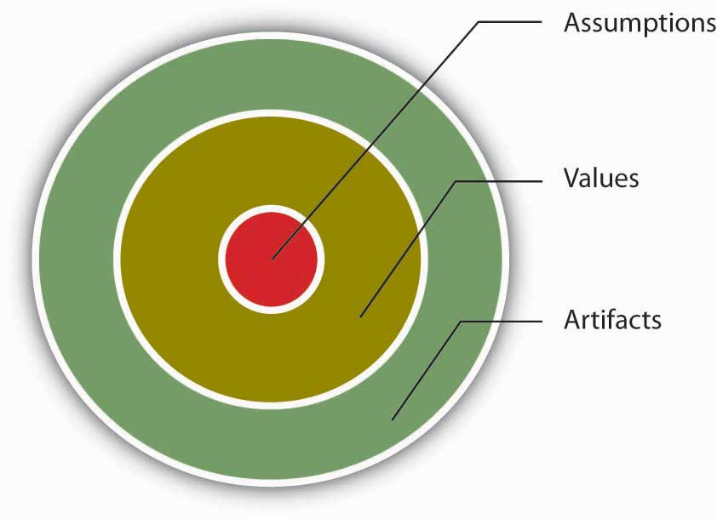
Source: Adapted from Schein, E. H. (1992).Organizational Culture and Leadership. San Francisco: Jossey-Bass.
Organizational culture consists of some aspects that are relatively more visible, as well as aspects that may lie below one’s conscious awareness. Organizational culture can be thought of as consisting of three interrelated levels.
- Schein, E. H. (1992). Organizational culture and leadership. San Francisco: Jossey-Bass
At the deepest level, below our awareness, lie basic assumptions. These assumptions are taken for granted and reflect beliefs about human nature and reality. At the second level, values exist. Values are shared principles, standards, and goals. Finally, at the surface, we have artifacts, or visible, tangible aspects of organizational culture. For example, in an organization, a basic assumption employees and managers share might be that happy employees benefit their organizations. This might be translated into values such as egalitarianism, high-quality relationships, and having fun. The artifacts reflecting such values might be an executive “open door” policy, an office layout that includes open spaces and gathering areas equipped with pool tables, and frequent company picnics.
Understanding the organization’s culture may start from observing its artifacts: its physical environment, employee interactions, company policies, reward systems, and other observable characteristics. When you are interviewing for a position, observing the physical environment, how people dress, where they relax, and how they talk to others is definitely a good start to understanding the company’s culture. However, simply looking at these tangible aspects is unlikely to give a full picture of the organization, since an important chunk of what makes up culture exists below one’s degree of awareness. The values and, deeper, the assumptions that shape the organization’s culture can be uncovered by observing how employees interact and the choices they make, as well as by inquiring about their beliefs and perceptions regarding what is right and appropriate behavior.

KEY TAKEAWAY
Organizational culture is a system of shared assumptions, values, and beliefs that helps individuals understand which behaviors are and are not appropriate within an organization. Cultures can be a source of competitive advantage for organizations. Strong organizational cultures can be an organizing as well as a controlling mechanism for organizations. And finally, organizational culture consists of three levels: assumptions that are below the surface, values, and artifacts.

EXERCISES
- Why do companies need culture?
- Give an example of a company culture being a strength and a weakness.
- In what ways does culture serve as a controlling mechanism?
- If assumptions are below the surface, why do they matter?
- Share examples of artifacts you have noticed at different organizations.

8.3 Measuring Organizational Culture

LEARNING OBJECTIVES
- Understand different dimensions of organizational culture.
- Understand the role of culture strength.
- Explore subcultures within organizations.

Dimensions of Culture
Which values characterize an organization’s culture? Even though culture may not be immediately observable, identifying a set of values that might be used to describe an organization’s culture helps us identify, measure, and manage culture more effectively. For this purpose, several researchers have proposed various culture typologies. One typology that has received a lot of research attention is the Organizational Culture Profile (OCP) where culture is represented by seven distinct values.
- Chatman, J. A., & Jehn, K. A. (1991). Assessing the relationship between industry characteristics and organizational culture: How different can you be? Academy of Management Journal, 37, 522–553
- O’Reilly, C. A., III, Chatman, J. A., & Caldwell, D. F. (1991). People and organizational culture: A profile comparison approach to assessing person-organization fit. Academy of Management Journal, 34, 487–516

Figure 8.6 Dimensions of Organizational Culture Profile (OCP)
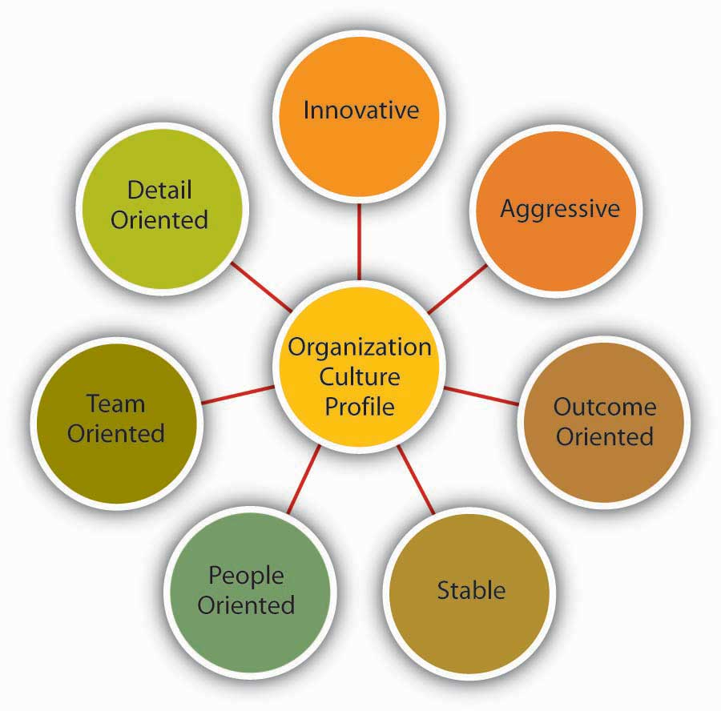
Source: Adapted from information in O’Reilly, C. A., III, Chatman, J. A., & Caldwell, D. F. (1991). People and organizational culture: A profile comparison approach to assessing person-organization fit. Academy of Management Journal, 34, 487–516.

Innovative Cultures
According to the OCP framework, companies that have innovative cultures are flexible, adaptable, and experiment with new ideas. These companies are characterized by a flat hierarchy and titles and other status distinctions tend to be downplayed. For example, W. L. Gore & Associates is a company with innovative products such as GORE-TEX® (the breathable fabric that is windproof and waterproof), Glade dental floss, and Elixir guitar strings, earning the company the distinction as the most innovative company in the United States by Fast Company magazine in 2004. W. L. Gore consistently manages to innovate and capture the majority of market share in a wide variety of industries, in large part because of its unique culture. In this company, employees do not have bosses in the traditional sense, and risk taking is encouraged by celebrating failures as well as successes.
- Deutschman, A. (2004, December). The fabric of creativity. Fast Company, 89, 54–62
Companies such as W. L. Gore, Genentech, and Google also encourage their employees to take risks by allowing engineers to devote 20% of their time to projects of their own choosing.

Aggressive Cultures
Companies with aggressive cultures value competitiveness and outperforming competitors; by emphasizing this, they often fall short in corporate social responsibility. For example, Microsoft is often identified as a company with an aggressive culture. The company has faced a number of antitrust lawsuits and disputes with competitors over the years. In aggressive companies, people may use language such as “we will kill our competition.” In the past, Microsoft executives made statements such as “we are going to cut off Netscape’s air supply…Everything they are selling, we are going to give away,” and its aggressive culture is cited as a reason for getting into new legal troubles before old ones are resolved.
- Greene, J., Reinhardt, A., & Lowry, T. (2004, May 31). Teaching Microsoft to make nice?Business Week, 3885, 80–81
- Schlender, B. (1998, June 22). Gates’s crusade. Fortune, 137, 30–32

Figure 8.7
Microsoft, the company that Bill Gates co-founded, has been described as having an aggressive culture.
Source:http://simple.wikipedia.org/wiki/Image:Bill_Gates_in_Poland_cropped.jpg

Outcome-Oriented Cultures
The OCP framework describes outcome-oriented cultures as those that emphasize achievement, results, and action as important values. A good example of an outcome-oriented culture may be the electronics retailer Best Buy. Having a culture emphasizing sales performance, Best Buy tallies revenues and other relevant figures daily by department. Employees are trained and mentored to sell company products effectively, and they learn how much money their department made every day.
- Copeland, M. V. (2004, July). Best Buy’s selling machine. Business 2.0, 5, 92–102
In 2005, the company implemented a Results Oriented Work Environment (ROWE) program that allows employees to work anywhere and anytime; they are evaluated based on results and fulfillment of clearly outlined objectives.
- Thompson, J. (2005, September). The time we waste. Management Today, 44–47
Outcome-oriented cultures hold employees as well as managers accountable for success and use systems that reward employee and group output. In these companies, it is more common to see rewards tied to performance indicators as opposed to seniority or loyalty. Research indicates that organizations that have a performance-oriented culture tend to outperform companies that are lacking such a culture.
- Nohria, N., Joyce, W., & Roberson, B. (2003, July). What really works. Harvard Business Review, 81, 42–52
At the same time, when performance pressures lead to a culture where unethical behaviors become the norm, individuals see their peers as rivals, and short-term results are rewarded, the resulting unhealthy work environment serves as a liability.
- Probst, G., & Raisch, S. (2005). Organizational crisis: The logic of failure. Academy of Management Executive, 19, 90–105

Stable Cultures
Stable cultures are predictable, rule-oriented, and bureaucratic. When the environment is stable and certain, these cultures may help the organization to be effective by providing stable and constant levels of output.
- Westrum, R. (2004, August). Increasing the number of guards at nuclear power plants. Risk Analysis: An International Journal, 24, 959–961
These cultures prevent quick action and, as a result, may be a misfit to a changing and dynamic environment. Public sector institutions may be viewed as stable cultures. In the private sector, Kraft Foods is an example of a company with centralized decision making and rule orientation that suffered as a result of the culture-environment mismatch.
- Thompson, S. (2006, September 18). Kraft CEO slams company, trims marketing staff. Advertising Age, 77, 3–62
Its bureaucratic culture is blamed for killing good ideas in early stages and preventing the company from innovating. When the company started a change program to increase the agility of its culture, one of its first actions was to fight bureaucracy with more bureaucracy: The new position of vice president of “business process simplification” was created but was later eliminated.
- Boyle, M. (2004, November 15). Kraft’s arrested development. Fortune, 150, 144
- Thompson, S. (2005, February 28). Kraft simplification strategy anything but. Advertising Age, 76, 3–63
- Thompson, S. (2006, September 18). Kraft CEO slams company, trims marketing staff. Advertising Age, 77, 3–62

People-Oriented Cultures
People-oriented cultures value fairness, supportiveness, and respecting individual rights. In these organizations, there is a greater emphasis on and expectation of treating people with respect and dignity.
- Erdogan, B., Liden, R. C., & Kraimer, M. L. (2006). Justice and leader-member exchange: The moderating role of organizational culture. Academy of Management Journal, 49, 395–406
One study of new employees in accounting companies found that employees, on average, stayed 14 months longer in companies with people-oriented cultures.
- Sheridan, J. (1992). Organizational culture and employee retention. Academy of Management Journal, 35, 1036–1056
Starbucks is an example of a people-oriented culture. The company pays employees above minimum wage, offers health care and tuition reimbursement benefits to its part-time as well as full-time employees, and has creative perks such as weekly free coffee for all associates. As a result of these policies, the company benefits from a turnover rate lower than the industry average.
- Weber, G. (2005, February). Preserving the counter culture. Workforce Management, 84, 28–34
- Motivation secrets of the 100 best employers. (2003, October). HR Focus, 80, 1–15

Team-Oriented Cultures
Companies with a team-oriented culture are collaborative and emphasize cooperation among employees. For example, Southwest Airlines facilitates a team-oriented culture by cross-training its employees so that they are capable of helping one another when needed. The company also emphasizes training intact work teams.
- Bolino, M. C., & Turnley, W. H. (2003). Going the extra mile: Cultivating and managing employee citizenship behavior. Academy of Management Executive, 17, 60–71
In Southwest’s selection process, applicants who are not viewed as team players are not hired as employees.
- Miles, S. J., & Mangold, G. (2005). Positioning Southwest Airlines through employee branding. Business Horizons, 48, 535–545
In team-oriented organizations, members tend to have more positive relationships with their coworkers and particularly with their managers.
- Erdogan, B., Liden, R. C., & Kraimer, M. L. (2006). Justice and leader-member exchange: The moderating role of organizational culture. Academy of Management Journal, 49, 395–406

Figure 8.8
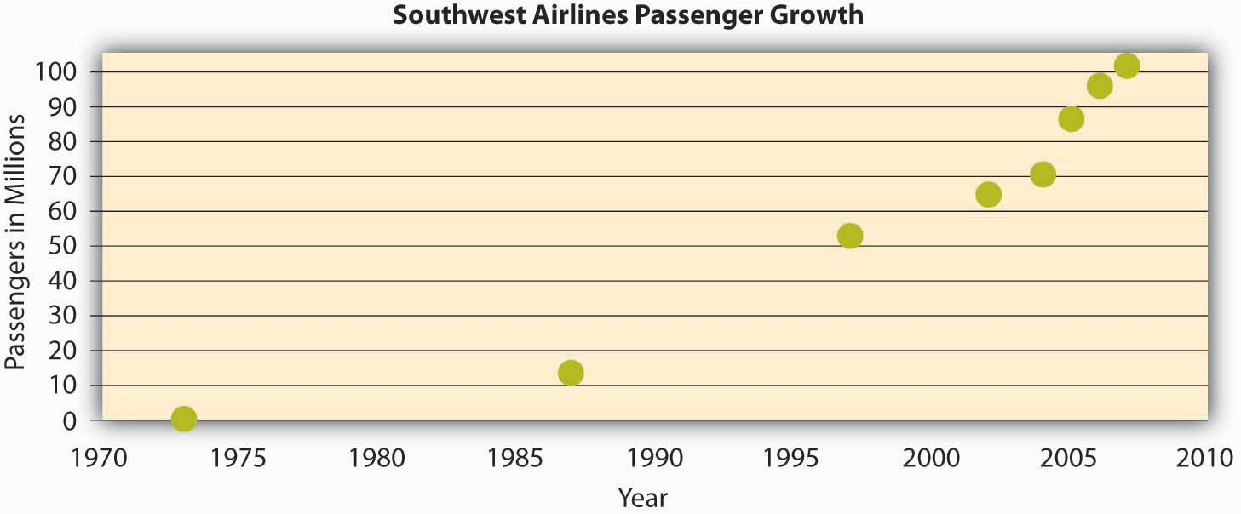
The growth in the number of passengers flying with Southwest Airlines from 1973 until 2007 when Southwest surpassed American Airlines as the most flown U.S. airline. While price has played a role in this, their emphasis on service has been a key piece of their culture and competitive advantage.
Source: Adapted from http://upload.wikimedia.org/wikipedia/commons/6/69/Southwest-airlines-passengers.jpg

Detail-Oriented Cultures
Organizations with a detail-oriented culture are characterized in the OCP framework as emphasizing precision and paying attention to details. Such a culture gives a competitive advantage to companies in the hospitality industry by helping them differentiate themselves from others. For example, Four Seasons and Ritz Carlton are among hotels who keep records of all customer requests such as which newspaper the guest prefers or what type of pillow the customer uses. This information is put into a computer system and used to provide better service to returning customers. Any requests hotel employees receive, as well as overhear, might be entered into the database to serve customers better.

Strength of Culture
A strong culture is one that is shared by organizational members
- Arogyaswamy, B., & Byles, C. M. (1987). Organizational culture: Internal and external fits. Journal of Management, 13, 647–658
- Chatman, J. A., & Eunyoung Cha, S. (2003). Leading by leveraging culture. California Management Review, 45, 20–34
—that is, a culture in which most employees in the organization show consensus regarding the values of the company. The stronger a company’s culture, the more likely it is to affect the way employees think and behave. For example, cultural values emphasizing customer service will lead to higher-quality customer service if there is widespread agreement among employees on the importance of customer-service-related values.
- Schneider, B., Salvaggio, A., & Subirats, M. (2002). Climate strength: A new direction for climate research. Journal of Applied Psychology, 87, 220–229
It is important to realize that a strong culture may act as an asset or a liability for the organization, depending on the types of values that are shared. For example, imagine a company with a culture that is strongly outcome-oriented. If this value system matches the organizational environment, the company may perform well and outperform its competitors. This is an asset as long as members are behaving ethically. However, a strong outcome-oriented culture coupled with unethical behaviors and an obsession with quantitative performance indicators may be detrimental to an organization’s effectiveness. Enron is an extreme example of this dysfunctional type of strong culture.
One limitation of a strong culture is the difficulty of changing it. In an organization where certain values are widely shared, if the organization decides to adopt a different set of values, unlearning the old values and learning the new ones will be a challenge because employees will need to adopt new ways of thinking, behaving, and responding to critical events. For example, Home Depot had a decentralized, autonomous culture where many business decisions were made using “gut feeling” while ignoring the available data. When Robert Nardelli became CEO of the company in 2000, he decided to change its culture starting with centralizing many of the decisions that were previously left to individual stores. This initiative met with substantial resistance, and many high-level employees left during Nardelli’s first year. Despite getting financial results such as doubling the sales of the company, many of the changes he made were criticized. He left the company in January 2007.
- Charan, R. (2006, April). Home Depot’s blueprint for culture change. Harvard Business Review, 84, 60–70
- Herman, J., & Wernle, B. (2007, August 13). The book on Bob Nardelli: Driven, demanding. Automotive News, 81, 42

Figure 8.10
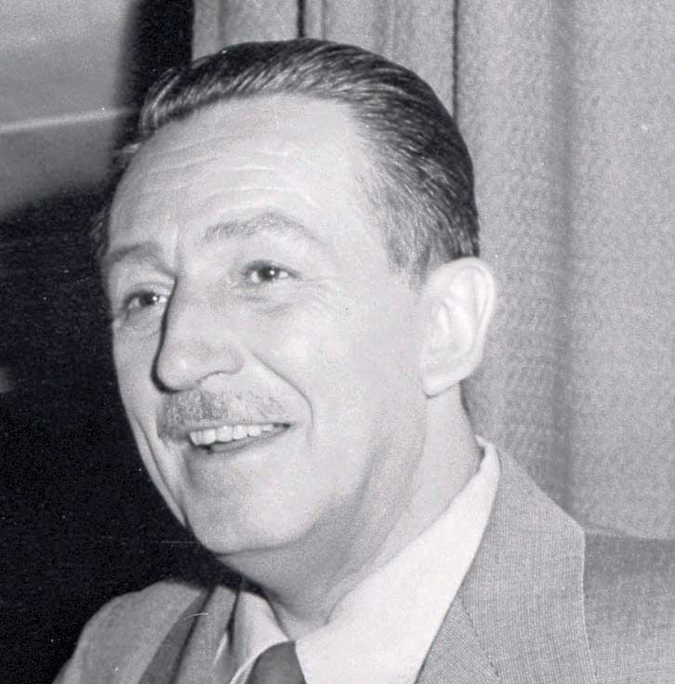
Walt Disney created a strong culture at his company that has evolved since its founding in 1923.
Source:http://en.wikipedia.org/wiki/Image:Walt_disney_portrait.jpg
A strong culture may also be a liability during a merger. During mergers and acquisitions, companies inevitably experience a clash of cultures, as well as a clash of structures and operating systems. Culture clash becomes more problematic if both parties have unique and strong cultures. For example, during the merger of Daimler-Benz with Chrysler to create DaimlerChrysler, the differing strong cultures of each company acted as a barrier to effective integration. Daimler had a strong engineering culture that was more hierarchical and emphasized routinely working long hours. Daimler employees were used to being part of an elite organization, evidenced by flying first class on all business trips. However, Chrysler had a sales culture where employees and managers were used to autonomy, working shorter hours, and adhering to budget limits that meant only the elite flew first class. The different ways of thinking and behaving in these two companies introduced a number of unanticipated problems during the integration process.
- Badrtalei, J., & Bates, D. L. (2007). Effect of organizational cultures on mergers and acquisitions: The case of DaimlerChrysler. International Journal of Management, 24, 303–317
- Bower, J. L. (2001). Not all M&As are alike—and that matters. Harvard Business Review, 79, 92–101

Do Organizations Have a Single Culture?
So far, we have assumed that a company has a single culture that is shared throughout the organization. In reality there might be multiple cultures within the organization. For example, people working on the sales floor may experience a different culture from that experienced by people working in the warehouse. Cultures that emerge within different departments, branches, or geographic locations are called subcultures. Subcultures may arise from the personal characteristics of employees and managers, as well as the different conditions under which work is performed. In addition to understanding the broader organization’s values, managers will need to make an effort to understand subculture values to see their effect on workforce behavior and attitudes.
Sometimes, a subculture may take the form of a counterculture. Defined as shared values and beliefs that are in direct opposition to the values of the broader organizational culture,
- Kerr, J., & Slocum, J. W., Jr. (2005). Managing corporate culture through reward systems. Academy of Management Executive, 19, 130–138
countercultures are often shaped around a charismatic leader. For example, within a largely bureaucratic organization, an enclave of innovativeness and risk taking may emerge within a single department. A counterculture may be tolerated by the organization as long as it is bringing in results and contributing positively to the effectiveness of the organization. However, its existence may be perceived as a threat to the broader organizational culture. In some cases, this may lead to actions that would take away the autonomy of the managers and eliminate the counterculture.

KEY TAKEAWAY
Culture can be understood in terms of seven different culture dimensions, depending on what is most emphasized within the organization. For example, innovative cultures are flexible, adaptable, and experiment with new ideas, while stable cultures are predictable, rule-oriented, and bureaucratic. Strong cultures can be an asset or liability for an organization but can be challenging to change. Multiple cultures may coexist in a single organization in the form of subcultures and countercultures.

EXERCISES
- Think about an organization you are familiar with. On the basis of the dimensions of OCP, how would you characterize its culture?
- Out of the culture dimensions described, which dimension do you think would lead to higher levels of employee satisfaction and retention? Which one would be related to company performance?
- What are pros and cons of an outcome-oriented culture?
- When bureaucracies were first invented, they were considered quite innovative. Do you think that different cultures are more or less effective at different points in time and in different industries? Why or why not?
- Can you imagine an effective use of subcultures within an organization?

8.4 Creating and Maintaining Organizational Culture

LEARNING OBJECTIVES
- Understand how cultures are created.
- Learn how to maintain a culture.
- Recognize organizational culture signs.

How Are Cultures Created?
Where do cultures come from? Understanding this question is important in understanding how they can be changed. An organization’s culture is shaped as the organization faces external and internal challenges and learns how to deal with them. When the organization’s way of doing business provides a successful adaptation to environmental challenges and ensures success, those values are retained. These values and ways of doing business are taught to new members as the way to do business.
- Schein, E. H. (1992). Organizational Culture and Leadership. San Francisco: Jossey-Bass
The factors that are most important in the creation of an organization’s culture include founders’ values, preferences, and industry demands.

Figure 8.11 Model Describing How Cultures Are Created and Maintained
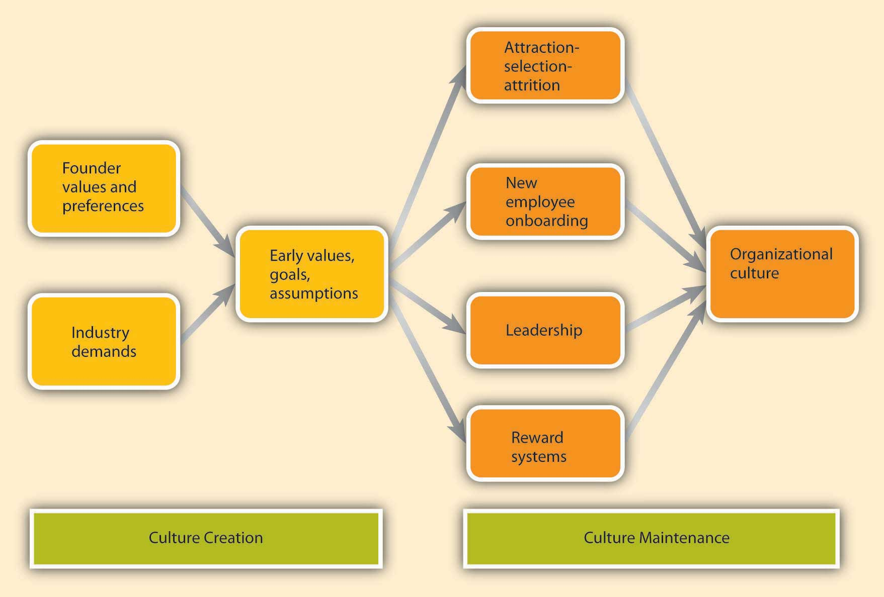

Founder Values
A company’s culture, particularly during its early years, is inevitably tied to the personality, background, and values of its founder or founders, as well as their vision for the future of the organization. When entrepreneurs establish their own businesses, the way they want to do business determines the organization’s rules, the structure set up in the company, and the people they hire to work with them. For example, some of the existing corporate values of the ice cream company Ben & Jerry’s Homemade Holdings Inc. can easily be traced to the personalities of its founders Ben Cohen and Jerry Greenfield. In 1978, the two high school friends opened up their first ice-cream shop in a renovated gas station in Burlington, Vermont. Their strong social convictions led them to buy only from the local farmers and devote a certain percentage of their profits to charities. The core values they instilled in their business can still be observed in the current company’s devotion to social activism and sustainability, its continuous contributions to charities, use of environmentally friendly materials, and dedication to creating jobs in low-income areas. Even though Unilever acquired the company in 2000, the social activism component remains unchanged and Unilever has expressed its commitment to maintaining it.
- Kiger, P. J. (April, 2005). Corporate crunch. Workforce Management, 84, 32–38
- Rubis, L., Fox, A., Pomeroy, A., Leonard, B., Shea, T. F., Moss, D., et al. (2005). 50 for history. HR Magazine, 50, 13, 10–24
- Smalley, S. (2007, December 3). Ben & Jerry’s bitter crunch. Newsweek, 150, 50
Founder values become part of the corporate culture to the degree to which they help the company be successful. For example, the social activism of Ben and Jerry’s was instilled in the company because the founders strongly believed in these issues. However, these values probably would not be surviving 3 decades later if they had not helped the company in its initial stages. In the case of Ben and Jerry’s, these values helped distinguish their brand from larger corporate brands and attracted a loyal customer base. Thus, by providing a competitive advantage, these values were retained as part of the corporate culture and were taught to new members as the right way to do business.

Figure 8.12
Ben & Jerry’s has locations around the world, including this store in Singapore.
Source:http://commons.wikimedia.org/wiki/Image:BenJerry-UnitedSquare.jpg

Industry Demands
While founders undoubtedly exert a powerful influence over corporate cultures, the industry characteristics also play a role. Companies within the same industry can sometimes have widely differing cultures. At the same time, the industry characteristics and demands act as a force to create similarities among organizational cultures. For example, despite some differences, many companies in the insurance and banking industries are stable and rule-oriented, many companies in the high-tech industry have innovative cultures, and those in nonprofit industry may be people-oriented. If the industry is one with a large number of regulatory requirements—for example, banking, health care, and high-reliability (such as nuclear power plant) industries—then we might expect the presence of a large number of rules and regulations, a bureaucratic company structure, and a stable culture. The industry influence over culture is also important to know because this shows that it may not be possible to imitate the culture of a company in a different industry, even though it may seem admirable to outsiders.

How Are Cultures Maintained?
As a company matures, its cultural values are refined and strengthened. The early values of a company’s culture exert influence over its future values. It is possible to think of organizational culture as an organism that protects itself from external forces. Organizational culture determines what types of people are hired by an organization and what types of people are left out. Moreover, once new employees are hired, the company assimilates new employees and teaches them the way things are done in the organization. We call these processes attraction-selection-attrition and onboarding processes. We will also examine the role of leaders and reward systems in shaping and maintaining an organization’s culture.

Attraction-Selection-Attrition
Organizational culture is maintained through a process known as attraction-selection-attrition (ASA). First, employees are attracted to organizations where they will fit in. Someone who has a competitive nature may feel comfortable in and may prefer to work in a company where interpersonal competition is the norm. Others may prefer to work in a team-oriented workplace. Research shows that employees with different personality traits find different cultures attractive. For example, out of the Big Five personality traits, employees who demonstrate neurotic personalities were less likely to be attracted to innovative cultures, whereas those who had openness to experience were more likely to be attracted to innovative cultures.
- Judge, T. A., & Cable, D. M. (1997). Applicant personality, organizational culture, and organization attraction. Personnel Psychology, 50, 359–394
Of course, this process is imperfect, and value similarity is only one reason a candidate might be attracted to a company. There may be other, more powerful attractions such as good benefits. At this point in the process, the second component of the ASA framework prevents them from getting in:selection. Just as candidates are looking for places where they will fit in, companies are also looking for people who will fit into their current corporate culture. Many companies are hiring people for fit with their culture, as opposed to fit with a certain job. For example, Southwest Airlines prides itself for hiring employees based on personality and attitude rather than specific job-related skills, which they learn after they are hired. Companies use different techniques to weed out candidates who do not fit with corporate values. For example, Google relies on multiple interviews with future peers. By introducing the candidate to several future coworkers and learning what these coworkers think of the candidate, it becomes easier to assess the level of fit.
Even after a company selects people for person-organization fit, there may be new employees who do not fit in. Some candidates may be skillful in impressing recruiters and signal high levels of culture fit even though they do not necessarily share the company’s values. In any event, the organization is eventually going to eliminate candidates eventually who do not fit in through attrition. Attrition refers to the natural process where the candidates who do not fit in will leave the company. Research indicates that person-organization misfit is one of the important reasons for employee turnover.
- Kristof-Brown, A. L., Zimmerman, R. D., & Johnson, E. C. (2005). Consequences of individuals’ fit at work: a meta-analysis of person–job, person–organization, person–group, and person–supervisor fit. Personnel Psychology, 58, 281–342
- O’Reilly, C. A., III, Chatman, J. A., & Caldwell, D. F. (1991). People and organizational culture: A profile comparison approach to assessing person-organization fit. Academy of Management Journal, 34, 487–516
Because of the ASA process, the company attracts, selects, and retains people who share its core values, whereas those people who are different in core values will be excluded from the organization either during the hiring process or later on through naturally occurring turnover. Thus, organizational culture will act as a self-defending organism where intrusive elements are kept out. Supporting the existence of such self-protective mechanisms, research shows that organizations demonstrate a certain level of homogeneity regarding personalities and values of organizational members.
- Giberson, T. R., Resick, C. J., & Dickson, M. W. (2005). Embedding leader characteristics: An examination of homogeneity of personality and values in organizations. Journal of Applied Psychology, 90, 1002–1010

New Employee Onboarding
Another way in which an organization’s values, norms, and behavioral patterns are transmitted to employees is through onboarding (also referred to as the organizational socialization process). Onboarding refers to the process through which new employees learn the attitudes, knowledge, skills, and behaviors required to function effectively within an organization. If an organization can successfully socialize new employees into becoming organizational insiders, new employees will feel accepted by their peers and confident regarding their ability to perform; they will also understand and share the assumptions, norms, and values that are part of the organization’s culture. This understanding and confidence in turn translate into more effective new employees who perform better and have higher job satisfaction, stronger organizational commitment, and longer tenure within the company.
- Bauer, T. N., Bodner, T., Erdogan, B., Truxillo, D. M., & Tucker, J. S. (2007). Newcomer adjustment during organizational socialization: A meta-analytic review of antecedents, outcomes, and methods. Journal of Applied Psychology, 92, 707–721
Organizations engage in different activities to facilitate onboarding, such as implementing orientation programs or matching new employees with mentors.

What Can Employees Do During Onboarding?
New employees who are proactive, seek feedback, and build strong relationships tend to be more successful than those who do not.
- Bauer, T. N., & Green, S. G. (1998). Testing the combined effects of newcomer information seeking and manager behavior on socialization. Journal of Applied Psychology, 83, 72–83
- Kammeyer-Mueller, J. D., & Wanberg, C. R. (2003). Unwrapping the organizational entry process: Disentangling multiple antecedents and their pathways to adjustment. Journal of Applied Psychology, 88, 779–794
- Wanberg, C. R., & Kammeyer-Mueller, J. D. (2000). Predictors and outcomes of proactivity in the socialization process. Journal of Applied Psychology, 85, 373–385
For example, feedback seeking helps new employees. Especially on a first job, a new employee can make mistakes or gaffes and may find it hard to understand and interpret the ambiguous reactions of coworkers. By actively seeking feedback, new employees may find out sooner rather than later any behaviors that need to be changed and gain a better understanding of whether their behavior fits with the company culture and expectations.
Relationship building or networking (a facet of the organizing function) is another important behavior new employees may demonstrate. Particularly when a company does not have a systematic approach to onboarding, it becomes more important for new employees to facilitate their own onboarding by actively building relationships. According to one estimate, 35% of managers who start a new job fail in the new job and either voluntarily leave or are fired within one and a half years. Of these, over 60% report not being able to form effective relationships with colleagues as the primary reason for this failure.
- Fisher, A. (2005, March 7). Starting a new job? Don’t blow it. Fortune, 151, 48

What Can Organizations Do During Onboarding?
Many organizations, including Microsoft, Kellogg Company, and Bank of America take a more structured and systematic approach to new employee onboarding, while others follow a “sink or swim” approach where new employees struggle to figure out what is expected of them and what the norms are.
A formal orientation program indoctrinates new employees to the company culture, as well as introducing them to their new jobs and colleagues. An orientation program has a role in making new employees feel welcome in addition to imparting information that may help them be successful in their new jobs. Many large organizations have formal orientation programs consisting of lectures, videotapes, and written material, while some may follow more informal approaches. According to one estimate, most orientations last anywhere from one to five days, and some companies are currently switching to a computer-based orientation. Ritz Carlton, the company ranked number 1 in Training magazine’s 2007 top 125 list, uses a very systematic approach to employee orientation and views orientation as the key to retention. In the 2-day classroom orientation, employees spend time with management, dine in the hotel’s finest restaurant, and witness the attention to customer service detail firsthand. During these two days, they are introduced to the company’s intensive service standards, team orientation, and its own language. Later, on their 21st day they are tested on the company’s service standards and are certified.
- Durett, J. (2006, March 1). Technology opens the door to success at Ritz-Carlton. Retrieved November 15, 2008, from http://www.managesmarter.com/msg/search/article_display.jsp?vnu_content_id=1002157749
- Elswick, J. (2000, February). Puttin’ on the Ritz: Hotel chain touts training to benefit its recruiting and retention. Employee Benefit News, 14, 9
- The Ritz-Carlton Company: How it became a “legend” in service. (2001, January–February). Corporate University Review, 9, 16
Research shows that formal orientation programs are helpful in teaching employees about the goals and history of the company, as well as communicating the power structure. Moreover, these programs may also help with a new employee’s integration to the team. However, these benefits may not be realized to the same extent in computer-based orientations. In fact, compared to those taking part in a regular, face-to-face orientation, those undergoing a computer-based orientation were shown to have lower understanding of their job and the company, indicating that different formats of orientations may not substitute for each other.
- Klein, H. J., & Weaver, N. A. (2000). The effectiveness of an organizational level orientation training program in the socialization of new employees. Personnel Psychology, 53, 47–66
- Moscato, D. (2005, April). Using technology to get employees on board. HR Magazine, 50, 107–109
- Wesson, M. J., & Gogus, C. I. (2005). Shaking hands with a computer: An examination of two methods of organizational newcomer orientation. Journal of Applied Psychology, 90, 1018–1026

What Can Organizational Insiders Do During Onboarding?
One of the most important ways in which organizations can help new employees adjust to a company and a new job is through organizational insiders—namely, supervisors, coworkers, and mentors. Leaders have a key influence over onboarding and the information and support they provide determine how quickly employees learn about the company politics and culture, while coworker influence determines the degree to which employees adjust to their teams. Mentors can be crucial to helping new employees adjust by teaching them the ropes of their jobs and how the company really operates. A mentor is a trusted person who provides an employee with advice and support regarding career-related matters. Although a mentor can be any employee or manager who has insights that are valuable to the new employee, mentors tend to be relatively more experienced than their protégés. Mentoring can occur naturally between two interested individuals or organizations can facilitate this process by having formal mentoring programs. These programs may successfully bring together mentors and protégés who would not come together otherwise.
Research indicates that the existence of these programs does not guarantee their success, and there are certain program characteristics that may make these programs more effective. For example, when mentors and protégés feel that they had input in the mentor-protégé matching process, they tend to be more satisfied with the arrangement. Moreover, when mentors receive training beforehand, the outcomes of the program tend to be more positive.
- Allen, T. D., Eby, L. T., & Lentz, E. (2006). Mentorship behaviors and mentorship quality associated with formal mentoring programs: Closing the gap between research and practice. Journal of Applied Psychology, 91, 567–578
Because mentors may help new employees interpret and understand the company’s culture, organizations may benefit from selecting mentors who personify the company’s values. Thus, organizations may need to design these programs carefully to increase their chance of success.

Leadership
Leaders are instrumental in creating and changing an organization’s culture. There is a direct correspondence between the leader’s style and an organization’s culture. For example, when leaders motivate employees through inspiration, corporate culture tends to be more supportive and people-oriented. When leaders motivate by making rewards contingent on performance, the corporate culture tended to be more performance-oriented and competitive.
- Sarros, J. C., Gray, J., & Densten, I. L. (2002). Leadership and its impact on organizational culture. International Journal of Business Studies, 10, 1–26
In these and many other ways, what leaders do directly influences the cultures of their organizations. This is a key point for managers to consider as they carry out their leading P-O-L-C function.
Part of the leader’s influence over culture is through role modeling. Many studies have suggested that leader behavior, the consistency between organizational policy and leader actions, and leader role modeling determine the degree to which the organization’s culture emphasizes ethics.
- Driscoll, K., & McKee, M. (2007). Restorying a culture of ethical and spiritual values: A role for leader storytelling.Journal of Business Ethics, 73, 205–217
The leader’s own behaviors will signal to individuals what is acceptable behavior and what is unacceptable. In an organization in which high-level managers make the effort to involve others in decision making and seek opinions of others, a team-oriented culture is more likely to evolve. By acting as role models, leaders send signals to the organization about the norms and values that are expected to guide the actions of its members.
Leaders also shape culture by their reactions to the actions of others around them. For example, do they praise a job well done or do they praise a favored employee regardless of what was accomplished? How do they react when someone admits to making an honest mistake? What are their priorities? In meetings, what types of questions do they ask? Do they want to know what caused accidents so that they can be prevented, or do they seem more concerned about how much money was lost because of an accident? Do they seem outraged when an employee is disrespectful to a coworker, or does their reaction depend on whether they like the harasser? Through their day-to-day actions, leaders shape and maintain an organization’s culture.

Reward Systems
Finally, the company culture is shaped by the type of reward systems used in the organization and the kinds of behaviors and outcomes it chooses to reward and punish. One relevant element of the reward system is whether the organization rewards behaviors or results. Some companies have reward systems that emphasize intangible elements of performance as well as more easily observable metrics. In these companies, supervisors and peers may evaluate an employee’s performance by assessing the person’s behaviors as well as the results. In such companies, we may expect a culture that is relatively people- or team-oriented, and employees act as part of a family.
- Kerr, J., & Slocum, J. W., Jr. (2005). Managing corporate culture through reward systems. Academy of Management Executive, 19, 130–138
However, in companies in which goal achievement is the sole criterion for reward, there is a focus on measuring only the results without much regard to the process. In these companies, we might observe outcome-oriented and competitive cultures. Whether the organization rewards performance or seniority would also make a difference in culture. When promotions are based on seniority, it would be difficult to establish a culture of outcome orientation. Finally, the types of behaviors that are rewarded or ignored set the tone for the culture. Which behaviors are rewarded, which ones are punished, and which are ignored will determine how a company’s culture evolves. A reward system is one tool managers can wield when undertaking the controlling function.

Signs of Organizational Culture
How do you find out about a company’s culture? We emphasized earlier that culture influences the way members of the organization think, behave, and interact with one another. Thus, one way of finding out about a company’s culture is by observing employees or interviewing them. At the same time, culture manifests itself in some visible aspects of the organization’s environment. In this section, we discuss five ways in which culture shows itself to observers and employees.

Figure 8.13 Visual Elements of Culture
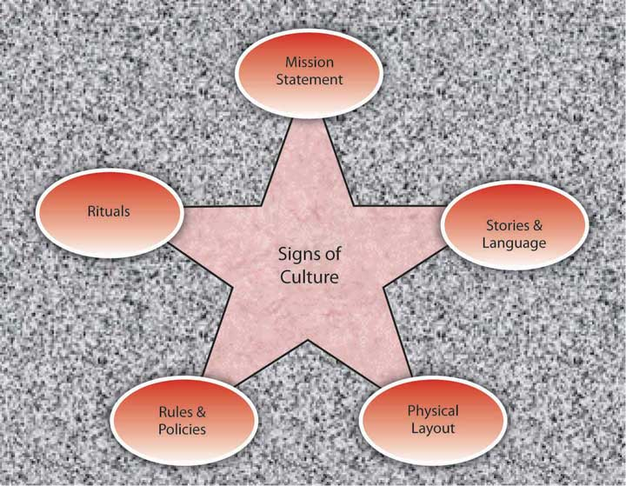

Mission Statement
A mission statement is a statement of purpose, describing who the company is and what it does. It serves an important function for organizations as part of the first facet of the planning P-O-L-C function. But, while many companies have mission statements, they do not always reflect the company’s values and its purpose. An effective mission statement is well known by employees, is transmitted to all employees starting from their first day at work, and influences employee behavior.
Some mission statements reflect who the company wants to be as opposed to who they actually are. If the mission statement does not affect employee behavior on a day-to-day basis, it has little usefulness as a tool for understanding the company’s culture. Enron provided an often-cited example of a disconnect between a company’s mission statement and how the company actually operated. Their missions and values statement started with “As a partner in the communities in which we operate, Enron believes it has a responsibility to conduct itself according to certain basic principles.” Their values statement included such ironic declarations as “We do not tolerate abusive or disrespectful treatment. Ruthlessness, callousness and arrogance don’t belong here.”
- Kunen, J. S. (2002, January 19). Enron’s vision (and values) thing. The New York Times, 19
A mission statement that is taken seriously and widely communicated may provide insights into the corporate culture. For example, the Mayo Clinic’s mission statement is “The needs of the patient come first.” This mission statement evolved from the founders who are quoted as saying, “The best interest of the patient is the only interest to be considered.” Mayo Clinics have a corporate culture that puts patients first. For example, no incentives are given to physicians based on the number of patients they see. Because doctors are salaried, they have no interest in retaining a patient for themselves, and they refer the patient to other doctors when needed.
- Jarnagin, C., & Slocum, J. W., Jr. (2007). Creating corporate cultures through mythopoetic leadership. Organizational Dynamics, 36, 288–302
Wal-Mart may be another example of a company that lives its mission statement and therefore its mission statement may give hints about its culture: “Saving people money so they can live better.”
- Wal-Mart Stores, Inc. (2008). Investor frequently asked questions. Retrieved November 20, 2008, fromhttp://walmartstores.com/Investors/7614.aspx

Rituals

Figure 8.14
Tradition is important at Mary Kay Cosmetics. Pink Cadillacs are given to top performers at large annual events.
Source:http://en.wikipedia.org/wiki/Image:MK_Cadillacs.jpg
Rituals refer to repetitive activities within an organization that have symbolic meaning.
- Anand, N. (2005). Blackwell Encyclopedic Dictionary of Management. Cambridge: Wiley
Usually rituals have their roots in the history of a company’s culture. They create camaraderie and a sense of belonging among employees. They also serve to teach employees corporate values and create identification with the organization. For example, at the cosmetics firm Mary Kay Inc., employees attend ceremonies recognizing their top salespeople with an award of a new car—traditionally a pink Cadillac. These ceremonies are conducted in large auditoriums where participants wear elaborate evening gowns and sing company songs that create emotional excitement. During this ritual, employees feel a connection to the company culture and its values such as self-determination, willpower, and enthusiasm.
- Jarnagin, C., & Slocum, J. W., Jr. (2007). Creating corporate cultures through mythopoetic leadership. Organizational Dynamics, 36, 288–302
Another example of rituals is the Saturday morning meetings of Wal-Mart. This ritual was first created by the company founder Sam Walton, who used these meetings to discuss which products and practices were doing well and which required adjustment. He was able to use this information to make changes in Wal-Mart’s stores before the start of the week, which gave him a competitive advantage over rival stores who would make their adjustments based on weekly sales figures during the middle of the following week. Today, hundreds of Wal-Mart associates attend the Saturday morning meetings in the Bentonville, Arkansas, headquarters. The meetings, which run from 7:00 a.m. to 9:30 a.m., start and end with the Wal-Mart cheer; the agenda includes a discussion of weekly sales figures and merchandising tactics. As a ritual, the meetings help maintain a small-company atmosphere, ensure employee involvement and accountability, communicate a performance orientation, and demonstrate taking quick action.
- Schlender, B. (2005, April 18). Wal-Mart’s $288 billion meeting. Fortune, 151, 90–106
- Wal around the world. (2001, December 8). Economist, 361, 55–57

Rules and Policies
Another way in which an observer may find out about a company’s culture is to examine its rules and policies. Companies create rules to determine acceptable and unacceptable behavior and, thus, the rules that exist in a company will signal the type of values it has. Policies about issues such as decision making, human resources, and employee privacy reveal what the company values and emphasizes. For example, a company that has a policy such as “all pricing decisions of merchandise will be made at corporate headquarters” is likely to have a centralized culture that is hierarchical, as opposed to decentralized and empowering. The presence or absence of policies on sensitive issues such as English-only rules, bullying and unfair treatment of others, workplace surveillance, open-door policies, sexual harassment, workplace romances, and corporate social responsibility all provide pieces of the puzzle that make up a company’s culture. This highlights how interrelated the P-O-L-C functions are in practice. Through rules and policies, the controlling function affects the organization’s culture, a facet of organizing.

Impact of HR Practices on Organizational Culture
Below are scenarios of critical decisions you may need to make as a manager one day. Read each question and select one response from each pair of statements. Then, think about the effect your choice would have on the company’s culture (your organizing function) as well as on your controlling function.
- Your company needs to lay off 10 people. Would you
  - lay off the newest 10 people?
  - lay off the 10 people who have the lowest performance evaluations?
- You’re asked to establish a dress code. Would you
  - ask employees to use their best judgment?
  - create a detailed dress code highlighting what is proper and improper?
- You need to monitor employees during work hours. Would you
  - not monitor them because they are professionals and you trust them?
  - install a program monitoring their Web usage to ensure that they are spending work hours actually doing work?
- You’re preparing performance appraisals. Would you
  - evaluate people on the basis of their behaviors?
  - evaluate people on the basis of the results (numerical sales figures, etc.)?
- Who will be promoted? Would you promote individuals based on
  - seniority?
  - objective performance?

Physical Layout
A company’s building, layout of employee offices, and other workspaces communicate important messages about a company’s culture. For example, visitors walking into the Nike campus in Beaverton, Oregon, can witness firsthand some of the distinguishing characteristics of the company’s culture. The campus is set on 74 acres and boasts an artificial lake, walking trails, soccer fields, and cutting-edge fitness centers. The campus functions as a symbol of Nike’s values such as energy, physical fitness, an emphasis on quality, and a competitive orientation. In addition, at fitness centers on the Nike headquarters, only those using Nike shoes and apparel are allowed in. This sends a strong signal that loyalty is expected. The company’s devotion to athletes and their winning spirit are manifested in campus buildings named after famous athletes, photos of athletes hanging on the walls, and their statues dotting the campus.
- Capowski, G. S. (1993, June) Designing a corporate identity. Management Review, 82, 37–41
- Collins, J., & Porras, J. I. (1996). Building your company’s vision. Harvard Business Review, 74, 65–77
- Labich, K., & Carvell, T. (1995, September 18). Nike vs. Reebok. Fortune, 132, 90–114
- Mitchell, C. (2002). Selling the brand inside. Harvard Business Review, 80, 99–105
The layout of the office space also is a strong indicator of a company’s culture. A company that has an open layout where high-level managers interact with employees may have a culture of team orientation and egalitarianism, whereas a company where most high-level managers have their own floor may indicate a higher level of hierarchy. Microsoft employees tend to have offices with walls and a door because the culture emphasizes solitude, concentration, and privacy. In contrast, Intel is famous for its standard cubicles, which reflect its egalitarian culture. The same value can also be observed in its avoidance of private and reserved parking spots.
- Clark, D. (2007, October 15). Why Silicon Valley is rethinking the cubicle office. Wall Street Journal, 250, B9
The degree to which playfulness, humor, and fun are part of a company’s culture may be indicated in the office environment. For example, Jive Software boasts a colorful, modern, and comfortable office design. Their break room is equipped with a keg of beer, free snacks and sodas, an Xbox 360, and Nintendo Wii. A casual observation of their work environment sends the message that employees who work there see their work as fun.
- Jive Software. (2008). Careers. Retrieved November 20, 2008, from http://www.jivesoftware.com/company.

Stories and Language
Perhaps the most colorful and effective way in which organizations communicate their culture to new employees and organizational members is through the skillful use of stories. A story can highlight a critical event an organization faced and the organization’s response to it, or a heroic effort of a single employee illustrating the company’s values. The stories usually engage employee emotions and generate employee identification with the company or the heroes of the tale. A compelling story may be a key mechanism through which managers motivate employees by giving their behavior direction and by energizing them toward a certain goal.
- Beslin, R. (2007). Story building: A new tool for engaging employees in setting direction. Ivey Business Journal, 71, 1–8
Moreover, stories shared with new employees communicate the company’s history, its values and priorities, and create a bond between the new employee and the organization. For example, you may already be familiar with the story of how a scientist at 3M invented Post-it notes. Arthur Fry, a 3M scientist, was using slips of paper to mark the pages of hymns in his church choir, but they kept falling off. He remembered a superweak adhesive that had been invented in 3M’s labs, and he coated the markers with this adhesive. Thus, the Post-it notes were born. However, marketing surveys for the interest in such a product were weak and the distributors were not convinced that it had a market. Instead of giving up, Fry distributed samples of the small yellow sticky notes to secretaries throughout his company. Once they tried them, people loved them and asked for more. Word spread and this led to the ultimate success of the product. As you can see, this story does a great job of describing the core values of a 3M employee: Being innovative by finding unexpected uses for objects, persevering, and being proactive in the face of negative feedback.
- Higgins, J. M., & McAllester, C. (2002) Want innovation? Then use cultural artifacts that support it. Organizational Dynamics, 31, 74–84
Language is another way to identify an organization’s culture. Companies often have their own acronyms and buzzwords that are clear to them and help set apart organizational insiders from outsiders. In business, this code is known as jargon. Jargon is the language of specialized terms used by a group or profession. Every profession, trade, and organization has its own specialized terms.

KEY TAKEAWAY
Organizational cultures are created by a variety of factors, including founders’ values and preferences, industry demands, and early values, goals, and assumptions. Culture is maintained through attraction-selection-attrition, new employee onboarding, leadership, and organizational reward systems. Signs of a company’s culture include the organization’s mission statement, stories, physical layout, rules and policies, and rituals.

EXERCISES
- Do you think it is a good idea for companies to emphasize person-organization fit when hiring new employees? What advantages and disadvantages do you see when hiring people who fit with company values?
- What is the influence of company founders on company culture? Give examples based on your personal knowledge.
- What are the methods companies use to aid with employee onboarding? What is the importance of onboarding for organizations?
- What type of a company do you feel you would fit in? What type of a culture would be a misfit for you? In your past work experience, were there any moments when you felt that you did not fit in? Why?
- What is the role of physical layout as an indicator of company culture? What type of a physical layout would you expect from a company that is people-oriented? Team-oriented? Stable?

8.5 Creating Culture Change

LEARNING OBJECTIVE
- Understand the process of culture change.

How Do Cultures Change?
As emphasized throughout this chapter, culture is a product of its founder’s values, its history, and collective experiences. Hence, culture is part of a company’s DNA and is resistant to change efforts. Unfortunately, many organizations realize that their current culture constitutes a barrier against organizational productivity and performance. Particularly when there is a mismatch between an organization’s values and the demands of its environment, changing the culture becomes the key to the company turnaround.
Achieving culture change is challenging, and there are many companies that ultimately fail in this mission. Research and case studies of companies that successfully changed their culture indicate that the following six steps increase the chances of success.
- Schein, E. H. (1990). Organizational culture.American Psychologist, 45, 109–119

Figure 8.15 Process of Culture Change
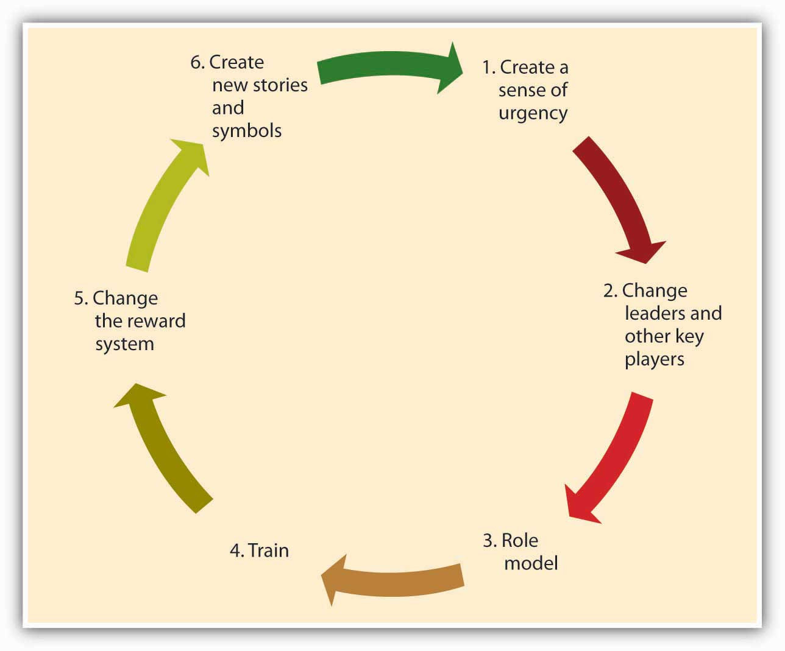

Creating a Sense of Urgency
For the change effort to be successful, it is important to communicate the need for change to employees. One way of doing this is to create a sense of urgency on the part of employees, explaining to them why changing the fundamental way in which business is done is so important. In successful culture change efforts, leaders communicate with employees and present a case for culture change as the essential element that will lead the company to eventual success. As an example, consider the situation at IBM in 1993 when Lou Gerstner was brought in as CEO and chairman. After decades of dominating the market for mainframe computers, IBM was rapidly losing market share to competitors, and its efforts to sell personal computers—the original PC—were seriously undercut by cheaper “clones.” In the public’s estimation, the name IBM had become associated with obsolescence. Gerstner recalls that the crisis IBM was facing became his ally in changing the organization’s culture. Instead of spreading optimism about the company’s future, he used the crisis at every opportunity to get buy-in from employees.
- Gerstner, L. V. (2002). Who says elephants can’t dance? New York: HarperCollins

Changing Leaders and Other Key Players
A leader’s vision is an important factor that influences how things are done in an organization. Thus, culture change often follows changes at the highest levels of the organization. Moreover, to implement the change effort quickly and efficiently, a company may find it helpful to remove managers and other powerful employees who are acting as a barrier to change. Because of political reasons, self-interest, or habits, managers may create powerful resistance to change efforts. In such cases, replacing these positions with employees and managers giving visible support to the change effort may increase the likelihood that the change effort succeeds. For example, when Robert Iger replaced Michael Eisner as CEO of the Walt Disney Company, one of the first things he did was to abolish the central planning unit, which was staffed by people close to ex-CEO Eisner. This department was viewed as a barrier to creativity at Disney and its removal from the company was helpful in ensuring the innovativeness of the company culture.
- McGregor, J., McConnon, A., Weintraub, A., Holmes, S., & Grover, R. (2007, May 14). The 25 Most Innovative Companies. Business Week, 4034, 52–60

Role Modeling
Role modeling is the process by which employees modify their own beliefs and behaviors to reflect those of the leader.
- Kark, R., & Van Dijk, D. (2007). Motivation to lead, motivation to follow: The role of the self-regulatory focus in leadership processes. Academy of Management Review, 32, 500–528
CEOs can model the behaviors that are expected of employees to change the culture because these behaviors will trickle down to lower-level employees. For example, when Robert Iger took over Disney, to show his commitment to innovation, he personally became involved in the process of game creation, attended summits of developers, and gave feedback to programmers about the games. Thus, he modeled his engagement in the idea creation process. In contrast, the modeling of inappropriate behavior from the top will lead to the same behavior trickling down to lower levels. A recent example to this type of role modeling is the scandal involving Hewlett-Packard board members. In 2006, when board members were suspected of leaking confidential company information to the press, the company’s top-level executives hired a team of security experts to find the source of the leak. The investigators sought the phone records of board members, looking for links to journalists. For this purpose, they posed as board members and called phone companies to obtain itemized home phone records of board members and journalists. When the investigators’ methods came to light, HP’s chairman and four other top executives faced criminal and civil charges. When such behavior is modeled at top levels, it is likely to have an adverse effect on the company culture.
- Barron, J. (2007, January). The HP way: Fostering an ethical culture in the wake of scandal. Business Credit, 109, 8–10

Training
Well-crafted training programs may be instrumental in bringing about culture change by teaching employees the new norms and behavioral styles. For example, after the space shuttle Columbiadisintegrated on reentry from a February 2003 mission, NASA decided to change its culture to become more safety sensitive and minimize decision-making errors that lead to unsafe behaviors. The change effort included training programs in team processes and cognitive bias awareness. Similarly, when auto repairer Midas felt the need to change its culture to be more committed to customers, they developed a program to train employees to be more familiar with customer emotions and connect better with them. Customer reports have been overwhelmingly positive in stores that underwent this training.
- BST to guide culture change effort at NASA. (2004 June). Professional Safety, 49, 16
- J. B. (2001, June). The Midas touch. Training, 38, 26

Changing the Reward System
The criteria with which employees are rewarded and punished have a powerful role in determining the cultural values of an organization. Switching from a commission-based incentive structure to a straight salary system may be instrumental in bringing about customer focus among sales employees. Moreover, by rewarding and promoting employees who embrace the company’s new values and promoting these employees, organizations can make sure that changes in culture have a lasting effect. If the company wants to develop a team-oriented culture where employees collaborate with one another, then using individual-based incentives may backfire. Instead, distributing bonuses to intact teams might be more successful in bringing about culture change.

Creating New Symbols and Stories
Finally, the success of the culture change effort may be increased by developing new rituals, symbols, and stories. Continental Airlines is a company that successfully changed its culture to be less bureaucratic and more team-oriented in 1990s. One of the first things management did to show employees that they really meant to abolish many of the company’s detailed procedures and create a culture of empowerment was to burn the heavy 800-page company policy manual in their parking lot. The new manual was only 80 pages. This action symbolized the upcoming changes in the culture and served as a powerful story that circulated among employees. Another early action was redecorating waiting areas and repainting all their planes, again symbolizing the new order of things.
- Higgins, J., & McAllester, C. (2004). If you want strategic change, don’t forget to change your cultural artifacts. Journal of Change Management, 4, 63–73
By replacing the old symbols and stories, the new symbols and stories will help enable the culture change and ensure that the new values are communicated.

KEY TAKEAWAY
Organizations need to change their culture to respond to changing conditions in the environment, to remain competitive, and to avoid complacency or stagnation. Culture change often begins by the creation of a sense of urgency. Next, a change of leaders and other key players may enact change and serve as effective role models of new behavior. Training can also be targeted toward fostering these new behaviors. Reward systems are changed within the organization. Finally, the organization creates new stories and symbols. Successful culture change requires managers that are proficient at all of the P-O-L-C functions. Creating and communicating a vision is part of planning; leadership and role modeling are part of leading; designing effective reward systems is part of controlling; all of which combine to influence culture, a facet of organizing.

EXERCISES
- Can new employees change a company’s culture? If so, how?
- Are there any conditions under which change is not possible? If so, what would such conditions be?
- Have you ever observed a change process at an organization you were involved with? If so, what worked well and what didn’t?
- What recommendations would you have for someone considering a major change of culture within their own organization?

8.6 Developing Your Personal Skills: Learning to Fit In

LEARNING OBJECTIVES
- Understand what you can proactively do to understand a new organizational environment.
- Some guidelines for proactive onboarding.

Before You Join
How do you find out about a company’s culture before you join? Here are several tips that will allow you to more accurately gauge the culture of a company you are interviewing with.
First, do your research. Talking to friends and family members who are familiar with the company, doing an online search for news articles about the company, browsing the company’s Web site, and reading its mission statement would be a good start.
Second, observe the physical environment. Do people work in cubicles or in offices? What is the dress code? What is the building structure? Do employees look happy, tired, or stressed? The answers to these questions are all pieces of the puzzle.
Third, read between the lines. For example, the absence of a lengthy employee handbook or detailed procedures might mean that the company is more flexible and less bureaucratic.
Fourth, reflect on how you are treated. The recruitment process is your first connection to the company. Were you treated with respect? Do they maintain contact with you or are you being ignored for long stretches at a time?
Fifth, ask questions. What happened to the previous incumbent of this job? What does it take to be successful in this firm? What would their ideal candidate for the job look like? The answers to these questions will reveal a lot about the way they do business.
Finally, listen to your gut. Your feelings about the place in general, and your future manager and coworkers in particular, are important signs that you should not ignore.
Adapted from:
- Daniel, L., & Brandon, C. (2006). Finding the right job fit. HR Magazine, 51, 62–67
- Sacks, D. (2005). Cracking your next company’s culture. Fast Company, 99, 85–87

You’ve Got a New Job! Now How Do You Get on Board?
- Gather information. Try to find as much about the company and the job as you can before your first day. After you start working, be a good observer, gather information, and read as much as you can to understand your job and the company. Examine how people are interacting, how they dress, and how they act, in order to avoid behaviors that might indicate to others that you are a misfit.
- Manage your first impression. First impressions may endure, so make sure that you dress properly, are friendly, and communicate your excitement to be a part of the team. Be on your best behavior!
- Invest in relationship development. The relationships you develop with your manager and with coworkers will be essential for you to adjust to your new job. Take the time to strike up conversations with them. If there are work functions during your early days, make sure not to miss them!
- Seek feedback. Ask your manager or coworkers how well you are doing and whether you are meeting expectations. Listen to what they are telling you and listen to what they are not saying. Then, make sure to act on any suggestions for improvement—you may create a negative impression if you consistently ignore the feedback you receive.
- Show success early on. To gain the trust of your new manager and colleagues, you may want to establish a history of success early. Volunteer for high-profile projects where you will be able to demonstrate your skills. Alternatively, volunteer for projects that may serve as learning opportunities or that may put you in touch with the key people in the company.

KEY TAKEAWAY
There are a number of ways to learn about an organization’s culture before you formally join it. Take the time to consider whether the culture you are observing seems like the right fit for you. Once you get a job, you can do key things to maximize your onboarding success.

EXERCISES
- What clues does your college or school give about its culture?
- What are four things you could do today to learn more about an organization you are interested in?
- Imagine that your good friend is starting a new job next week. What recommendations would you give your friend to help him or her do a great job onboarding into the organization?

Chapter 9

Social Networks

WHAT’S IN IT FOR ME?
Reading this chapter will help you do the following:
- Understand the social network vocabulary.
- Know why social networks and networking are valuable.
- Know some of the ethical considerations related to social network analysis.
- Understand the difference between personal, operational, and strategic social networks.
- Map your own social network and understand its implications.
Most management textbooks do not cover the subject of social networks. This is an unfortunate oversight. Social networks can be considered “the invisible organization”—they are the pathways through which communication and resources flow and how work actually gets done. We include this chapter on social networks in the organizing section of the book because, like organizational design, the management of social networks is important in the planning-organizing-leading-controlling (P-O-L-C) framework. An organization chart might communicate who reports to whom, but it is ultimately the internal (within organization) and external (ties between members of the organization and people outside the organization such as suppliers or customers) social networks that really explain productivity (or impediments to productivity).

Figure 9.2 The P-O-L-C Framework
You are probably already active in social networks through such Web communities as MySpace, Facebook, and LinkedIn. However, these sites are really only the tip of the iceberg when it comes to the role of social networks in management. Networks provide managers with three unique advantages: (1) access to information and knowledge, (2) access to diverse skill sets, and (3) power. While managers see these advantages at work every day, they might not pause to consider how their networks regulate them. In this chapter, you will learn about the role and importance of social networks, and social network analysis, in the organizing facet of the P-O-L-C framework. You will also have an opportunity to map and evaluate your own social network, and answer questions about its effectiveness for you personally and professionally.

9.1 Case in Point: Networking Powers Relationships

Networking has the potential to open doors and create possibilities for jobs and partnerships. Networking establishes connections between individuals and access to information that one might not normally have access to. Reaching out to strangers can be an intimidating and nerve-racking experience. In business, the more central you are, the more power you have. Creating connections and ties to other people affords you the opportunity for power and the ability to more closely control your future, so while at times networking might feel awkward and uncomfortable, it is a necessary and important part of establishing and maintaining a career.
Online social networking sites play an important role in this networking process for individuals both professionally and personally. With 1,200 employees in 2010, Facebook has 350 million users around the world, and LinkedIn has over 60 million members in over 200 countries. A new member joins LinkedIn every second, and about half of the members are outside the United States. These online sites have created new opportunities for networking and allow individuals to branch out beyond their normal world of industry, school, and business. The key is to avoid costly missteps as employers have begun to search online for information about prospective and current employees. In 2009, 8% of companies reported that they had fired an employee for misuse of social media.
Many of these online sites have become a tool for business. For example, LinkedIn targets working professionals and provides them a way to maintain lists of business connections and to use those connections to gain introduction to people using mutual contacts. Unlike other social networking sites, LinkedIn is almost entirely used by professionals. The power of social networking flows in both directions. Employers can screen applicants through their online accounts and recruiters more than ever are using these sites to view background information, individual skill sets, and employment history, which can be cross-referenced with submitted applications. Job seekers can review the profiles of those at top management firms and search for mutual contacts. LinkedIn also provides statistics about firms, which can be useful information for individuals looking at potential employers.
Networking is about building your brand and managing relationships. Using social networks as a vehicle to market one’s self and make professional connections is becoming increasingly common, as well as using loose ties or connections through others to open doors and land jobs. In an increasingly high-tech and digital world, it is important to be aware and conscience of the digital footprint that we create. But with careful cultivation these online networks can present many opportunities.
Primary Resource:
Secondary Resources:
- Hof, R. (2008, October 28). Facebook in a suit: LinkedIn launches applications platform. BusinessWeek. Retrieved March 23, 2010, from http://www.businessweek.com/the_thread/techbeat/archives/2008/10/linkedin_launch.html
- Horswill, A. (2009). How to get a job online using social networking. The Courier Mail. Retrieved March 23, 2010, from LexisNexis Academic database
- Lavenda, D. (2010, March 10). 10 tips for safe and effective social networking. Fast Company. Retrieved March 23, 2010, from http://www.fastcompany.com/1577857/10-tips-for-safe-and-effective-social-networking
- How to use social networking sites for marketing and PR. (2008, December 24). AllBusiness. Retrieved April 23, 2010, from http://www.allbusiness.com/marketing-advertising/public-relations/11674037-1.html
- Ostrow, A. (2009, August). Facebook fired: 8% of US companies have sacked social media miscreants. Mashable. Retrieved March 30, 2010, from http://mashable.com/2009/08/10/social-media-misuse

DISCUSSION QUESTIONS
- If social networks are an essential element of the organizing facet of the P-O-L-C framework, should employers track the use of LinkedIn or Facebook among their employees? Why or why not?
- How is online networking different from or similar to in-person networking? Please describe your experience with both.
- What are the downfalls and benefits of social networking?
- In what ways are indirect ties as powerful and important as direct ties?
- To what extent have you built your own brand? Is this something that you have ever considered before?

9.2 An Introduction to the Lexicon of Social Networks

LEARNING OBJECTIVES
- Be able to define a social network.
- Understand the key dimensions of social networks.
- Identify various types of social networks.
This section draws on extensive social network research to help you understand the managerial implications of that body of knowledge. Social networks often complement or compete with such aspects of organizations as formal organization structure (think “org chart”), work processes (think “job description”), human resource practices, leadership style, and organization culture. This is particularly problematic in knowledge-intensive settings where management is counting on collaboration among employees with different types of expertise. People rely heavily on their networks of relationships to find information and solve problems—one of the most consistent findings in the social science literature is that who you know often has a great deal to do with what you come to know. An excellent review of this literature is found in:
- Kilduff, M., & Tsai, W. (2004). Social networks and organizations. Beverly Hills, CA; Sage
Yet both practical experience and scholarly research indicate significant difficulty in getting people with different expertise, backgrounds, and problem-solving styles to integrate their unique perspectives effectively.It is one problem to learn or act on knowledge with others who think like you (such as in a community of practice); however, it is an entirely different problem to do this in diverse social contexts, such as cross-functional teams, where people often do not share a common vision, language, metrics of performance, or even understanding of the problem. For example, sociologists have demonstrated how correct information can have little or no effect on critical decision processes.
- Vaughn, D. (1996). The Challenger launch decision: Risky technology, culture and deviance at NASA. Chicago: University of Chicago Press
Further, organizational theorists have shown that a person’s knowledge can be role constrained.
- March, J., & Olsen, J. (1975). The uncertainty of the past: Organizational learning under ambiguity. European Journal of Political Research, 3, 147–171
From a manager’s standpoint, simply moving boxes on an organizational chart is not sufficient to ensure effective collaboration among workers.

What Is a Social Network?
If you were asked for a definition of a social network, your intuition would probably provide you with a pretty close answer. A social network can be characterized as a patterned set of relationships between two or more people—or, as they are called in the social science literature, actors. It can be depicted in asociogram, as shown in the following figure. The term “actors” is broader, as it includes all possible types of information/knowledge processing entities: the individuals, groups, organizations, or supraorganizations that constitute the network.
- Granovetter, M. (1985). Economic action and social structure: The problem of embeddedness. American Journal of Sociology, 91, 481–510
- Granovetter, M. (1995). Getting a job: A study of contacts and careers (2nd ed.). Chicago: University of Chicago Press
For instance, all of the people named in the figure are actors, but you could also consider each work group or department as an actor if you were concerned with the interaction among these groups rather than with the interaction within the groups or among individuals. The characteristics of a social network also are the determinants of social capital, that is, the resources—such as ideas, information, money, trust—available in and through personal and business networks. You can have social capital, as can organizations. However, since social capital is based on relationships, no single person can claim ownership of it, but it is important and manageable.

Figure 9.4 Sociogram: A Simple Social Network
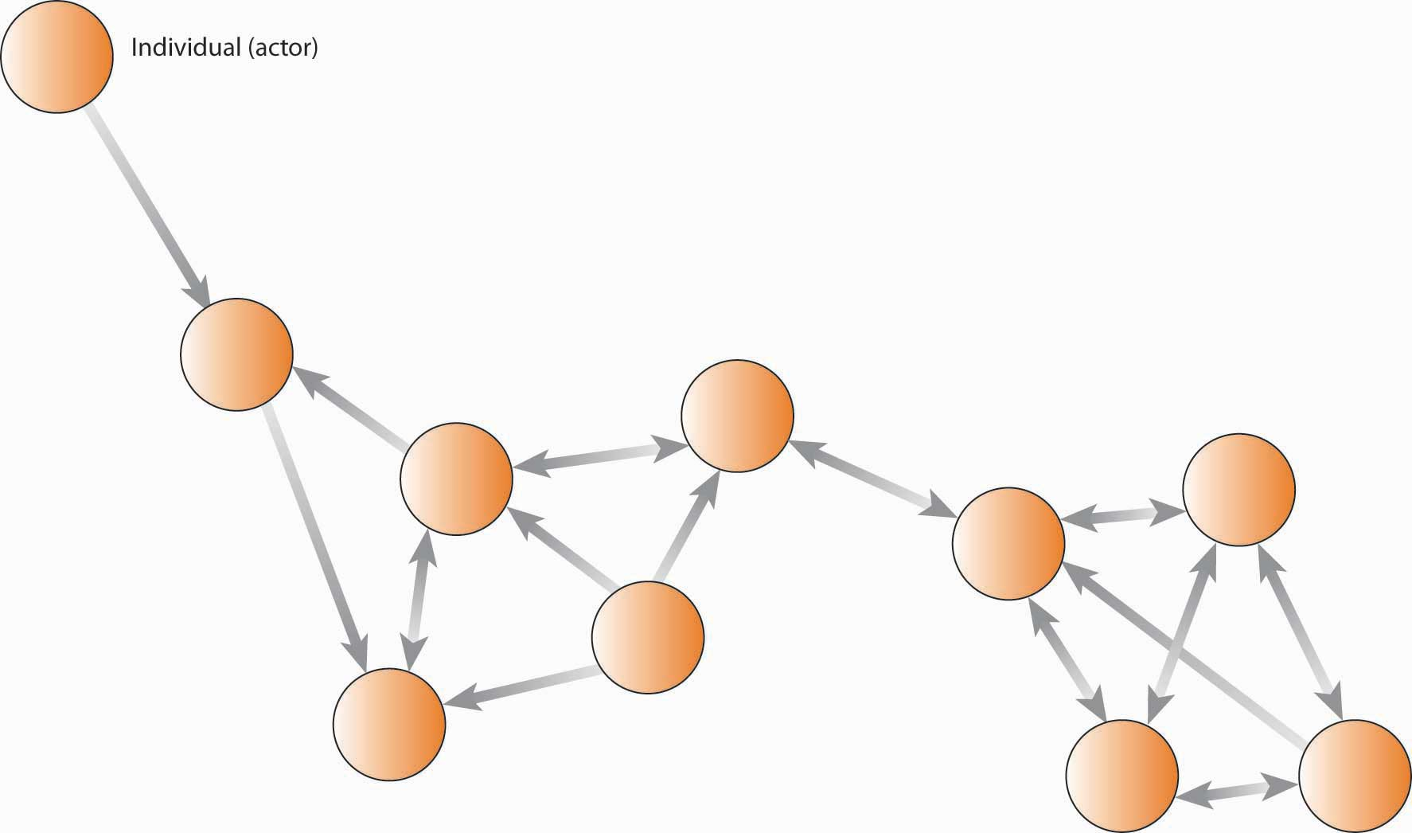

Social Network Analysis and the Quality of Work Interactions
The mapping and measuring of relationships and flows among people, groups, organizations, computers, Web sites, and other actors is called social network analysis (SNA), which we will discuss in greater detail later in the chapter. Each connection, or relationship, between actors is known as anetwork tie, while each actor, or point on the network, is referred to as a node. In the previous figure, Thomas is a node and his connections to Albert, Eric, Martha, and others are network ties. Direct tiesare those in which a single link spans two actors; indirect ties are where connections exist between actors, but only through other actors (hence, indirect ties). You can see that Thomas has four direct tiesand is indirectly tied to everyone in the network. Conceptually, you probably have indirect ties to everyone on the planet but that does not necessarily mean they come to mind as part of your social network.

Figure 9.5 Example of a Social Network Based on Information Ties
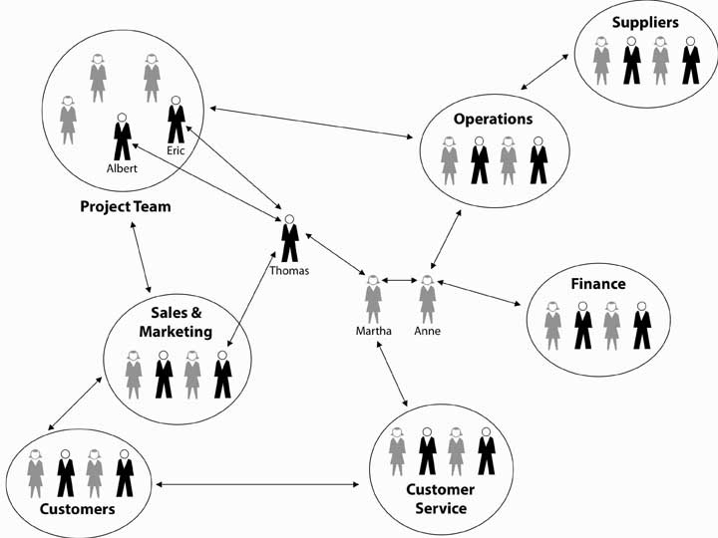

Figure 9.6
Actor Kevin Bacon founded sixdegrees.org to help charities network and share resources.
Source:http://en.wikipedia.org/wiki/Image:Kevinbacongfdl.PNG
Network size would be the number of actors. Though you might be interested in the count of all network members, you also might want to know how many people are one, two, or three links away. Long before computer networking was invented, psychologists Jeffrey Travers and Stanley Milgram conducted a low-tech experiment that looked directly at this question.
- Travers, J., & Milgram, S. (1969). An experimental study in the small world problem. Sociometry, 32(4), 425–443
They asked how many links might be necessary to get an envelope from one randomly chosen person to another randomly chosen person in the United States. They found that, on average, there were six links—or “degrees of separation”—between any two people randomly drawn from the U.S. population (at the time) of 250 million. Flipping the numbers around, Travers and Milgram then estimated that each individual had a potential network of 3,000 to 10,000 people. You may be familiar with this larger body of work in terms of “how many degrees of separation are you from Kevin Bacon?” or the notion of the “six degrees of separation.”

Social Network Characteristics
The extent to which a given actor is in the middle of the network is referred to as centrality (i.e., network centrality), though the definition of “middle” can vary from who has the most ties, to who is the unique connection between two other groups. Centrality is good because it puts the actor in a position to gather information, and to serve as broker between the parties that are connected via that actor.
Another basic network indicator is density, which essentially reflects how many people in a network are connected (usually directly) to each other. You can imagine that there are a number of possible network configurations based simply on permutations of network size, centrality, and density. For instance, you can have a large or tiny network, be central or peripheral in the network, and have a dense or sprawling network. Each of these structures has implications for how the network might serve its various actors.
The tie between actors can be directional or bidirectional (i.e., reciprocal flows between actors); similarly, a network can be described as social, personal, professional, informational, and so on, depending on what is of most interest.

A Sampling of Social Network Types
As a manager, you might be interested in your employees’ (1) communication network, (2) information network, (3) problem-solving network, (4) knowledge network, or (5) access network.
These dimensions, and their specific definitions, are taken from:
- Cross, R., Borgatti, S., & Parker, A. (2002). Making invisible work visible California Management Review, 44(2), 25–46
A communication network is the informal structure of an organization as represented in ongoing patterns of interaction, either in general or with respect to a given issue. For instance, people on the same office floor may periodically congregate in the break room or by the soda machine and engage in informal communication. For this reason, some descriptions of social networks focus on the informal network. That is, the pattern of interactions among employees that aren’t a direct consequence of the organization chart, job descriptions, and so on.
An information network shows who goes to whom for advice on work-related matters. For example, if you have a question about filling out a form, or answering a customer’s question, who do you regularly seek out for answers? A problem-solving network indicates who goes to whom to engage in dialogue that helps people solve problems at work. For instance, “whenever this machine breaks down I know I can turn to Pat for help.” A knowledge network captures who is aware of whose knowledge and skills, and an access network shows who has access to whose knowledge and expertise.
The example with Pat is also a knowledge network because it appears that you understand that Pat has the needed knowledge, and there is no barrier impeding your access to Pat. However, if the organization had rules telling you that you needed to talk to Pat’s boss before getting assistance from Pat, then the knowledge network and access network would look different. You can imagine that each of these types of networks might reveal a different structure, depending on the question—for example, the linkages would be different across iterations of the figure. You can see that information is flowing back and forth between different actors in the network. However, it does not appear that information is flowing directly between all network members—for instance, the sales and marketing, finance, and operations staff do not communicate directly with each other. However, if you were to combine the staff from those functions in the same office space, you would likely create a new communication network, which in turn could change the information ties of all the members.
More recent work in social network research has also considered the way that individuals interact, as well as their potential impact on network relationships.
- Bavelas, A. (1950). Communication patterns in task-oriented groups. Journal of Acoustical Society of America, 22, 725–730
- Leavitt, H. (1951). Some effects of certain communication patterns on group performance. Journal of Abnormal and Social Psychology, 46, 38–50
- Shaw, M. (1964). Communication networks. In L. Berkowitz (Ed.), Advances in experimental social psychology. New York: Academic Press
Five key dimensions of work quality can also be taken into account with social networks: (1) activity, (2) control, (3) access, (4) influence, and (5) power. Activity gauges how active a person is in the network. For example, an individual may be in the network, but actually do little to affect what is going on. Control gauges how much control a person has over the flow of information. Centrality is obviously one indicator of control, but there may be other determinants of control such as intelligence, personality, or even a particular skill set. In highly technical fields, for example, one individual (a node) can make a big difference on information flow, even if he or she is situated in a fairly open and balanced network. Access tells you how easily a person in the network can get the resources that he or she needs to be successful in the organization. How many steps, for instance, are they away from those individuals or units that are most instrumental for their success?Influence and power are different but related characteristics. Influence shows how much potential linfluence a person wields in the network, while power tells you how able they are to get things done. You may be interested in other dimensions of work quality, so feel free to experiment with them in SNA.

KEY TAKEAWAY
Social networks are the invisible structure in organizations—they capture the actual pathways of how information flows and how work is done. Network size, centrality, and density were identified as key features of social networks, and you have a general understanding of at least five types of social networks: communication, information, problem solving, knowledge, and access.

EXERCISES
- What is a social network?
- What is social network analysis?
- Why is network size important?
- Why is network centrality important?
- Why is network density important?
- What are some key types of social networks?

9.3 How Managers Can Use Social Networks to Create Value

LEARNING OBJECTIVES
- Understand the roles of reciprocity, exchange, and similarity.
- See how social networks create value in career management.
- See how social networks create value in and across organizations.
You probably have an intuitive sense of how and why social networks are valuable for you, personally and professionally. The successful 2008 U.S. presidential campaign of Barack Obama provides a dramatic example of how individuals can benefit when they understand and apply the principles and power of social networking.
- Cox, C. (2008, October 7). Retrieved November 13, 2008, from http://blog.styleapple.com/styleapple-creative-design-blog-the-place-where-creative-pros-flex-their-muscles/bid/5866/Arguably-The-Most-Effective-Branding-Campaign-Ever
In this section, we discuss three fundamental principles of social network theory, then help you see how social networks create value in your career and within and across organizations.

Reciprocity, Exchange, and Similarity
Across all social networks, performance depends on the degree to which three fundamental principles are accounted for.
- Kilduff, M., & Tsai, W. (2004). Social networks and organizations. Beverly Hills, CA; Sage
The first is the principle of reciprocity, which simply refers to the degree to which you trade favors with others. With the principle of reciprocity, managers have the ability to get things done by providing services to others in exchange for the services they require. For instance, you are more likely to get assistance with a problem from a colleague at work when you have helped him or her out in the past. Although the quid pro quo may not be immediate, over time managers will receive only in proportion to what they give. Unless the exchanges are roughly equivalent over time, hard feelings or distrust will result. In organizations, few transactions are one-shot deals. Most are ongoing trades of “favors.” Therefore, two outcomes are important: success in achieving the objective and success in improving the relationship such that the next exchange will be more productive.
The second principle is the principle of exchange. Like the reciprocity principle, it refers to “trading favors,” but it is different in this way: the principle of exchange proposes that there may be greater opportunity for trading favors when the actors are different from one another. In fact, according to network theory, “difference” is what makes network ties useful in that such difference increases the likelihood that each party brings a complementary resource to the table. Going back to our example where you sought out assistance from a colleague, you probably needed that assistance because that person brought a different skill set, knowledge, or other resources to bear on the problem. That is, since you were different, the value of exchange was greater.
The third principle is the principle of similarity. Psychologists studying human behavior have observed that relationships, and therefore network ties, tend to develop spontaneously between people with common backgrounds, values, and interests. Similarity, to the extent that your network is composed only of like-minded folks, also makes it more likely that an individual may be dependent on a handful of people with common interests.
Why is it important to understand these three principles? As a manager, you will find your network useful to the extent that you can balance the effects of the three principles. Because of similarity, it is easier to build networks with those with whom you have various things in common, though this similarity makes the network less useful if you need new ideas or other resources not in the current group. A critical mistake is to become overly dependent on one person or on only a few network relationships. Not only can those relationships sour but also the manager’s usefulness to others depends critically on his or her other connections. Those people most likely to be attractive potential protégés, for example, will also be likely to have alternative contacts and sponsors available to them.
Similarity also means that you have to work harder to build strong exchange networks, since their formation is not spontaneous. Most personal networks are highly clustered—that is, your friends are likely to be friends with one another as well. And, if you made those friends by introducing yourself to them, the chances are high that their experiences and perspectives echo your own. Because ideas generated within this type of network circulate among the same people with shared views, a potential winner can wither away and die if no one in the group has what it takes to bring that idea to fruition. But what if someone within that cluster knows someone else who belongs to a whole different group? That connection, formed by an information broker, can expose your idea to a new world, filled with fresh opportunities for success. Diversity makes the difference.
Finally, for reciprocity to work, you have to be willing and able to trade or reciprocate favors, and this means that you might need access to other people or resources outside the current network. For example, you may have to build relationships with other individuals such that you can use them to help you contribute to your existing network ties.

Social Networks and Careers
We owe our knowledge about the relationship between social network characteristics and finding a job to Stanford sociologist Mark Granovetter. In a groundbreaking study, Granovetter found that job seekers are more likely to find a job through weak ties than through strong ties.
- Granovetter, M. (1974).Getting a job: A study of contacts and careers (2nd ed.). Chicago: University of Chicago Press
He demonstrated that while job hunters use social connections to find work, they don’t use close friends. Rather, survey respondents said they found jobs through acquaintances: old college friends, former colleagues, people they saw only occasionally or just happened to run into at the right moment. New information, about jobs or anything else, rarely comes from your close friends, because they tend to know the same things and people you do. Strong ties, as you might expect, exist among individuals who know one another well and engage in relatively frequent, ongoing resource exchanges. Weak ties, in contrast, exist among individuals who know one another, at least by reputation, but who do not engage in a regular exchange of resources. In fact, Granovetter showed that those who relied on weak ties to get a job fared better in the market in terms of higher pay, higher occupational status, greater job satisfaction, and longer job tenure. While much in the world has changed since Granovetter’s 1974 research, subsequent studies continue to affirm his basic findings on the consequences of social network structure.
- Goleman. D. (2006). Social intelligence. New York: Bantam
As you might expect, for weak ties to be effective though, there must be some basis for affinity between the indirectly connected individuals, but this affinity can simply be having the same birth month or high school or college alma mater.

Figure 9.8 The Value of Weak Ties
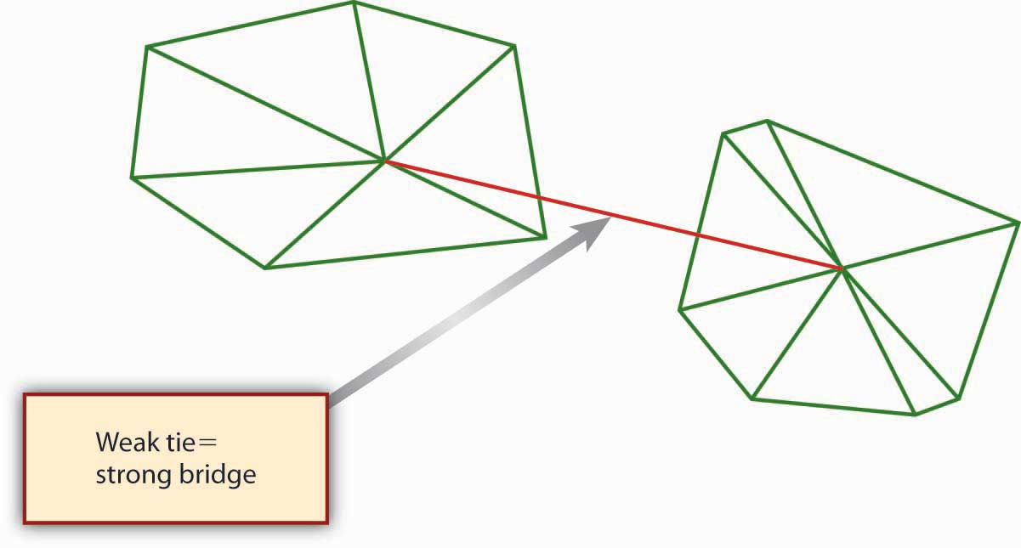
The value of weak ties is highly counterintuitive; we tend to think of relationships being more valuable when we have strong ties to others. However, if you think about it, the value of a weak tie lies in the fact that it is typically a bridging tie, that is, a tie that provides nonredundant information and resources. In the case of a job search, the weak tie serves as a strong bridge. “Social Networking as a Career-Building Strategy” suggests some personal strategies you might consider with your own social networks.

Social Networking as a Career-Building Strategy
Penelope Trunk, author of “The Brazen Careerist” column and blog (blog.penelopetrunk.com), views job hunting not as an event but as a lifestyle. She advises that in today’s business environment, people change jobs so often that they need to keep their eye on the market even if they just started a new job. In her view, “the people who control their destiny most effectively leave their job when they find a better one, not when they are tossed out because of layoffs or reorganizations.” This also means that social networking should be a central element in any job-search strategy. And because many jobs are filled by knowing someone who knows about an open position, Trunk argues that it’s more important to network than it is to read the want ads. Trunk evokes the principle of reciprocity when she says, “building a network is adding value to lots of peoples’ lives so that they, in turn, will want to add value to yours.” Another useful strategy is to network proactively rather than reacting to concerns about your present job or news of a possible opening. By being proactive, you will increase your chances of being in the right place at the right time.
Career networking opportunities are plentiful; regardless of where you live, you can use the Internet to read blogs, subscribe to e-mail newsletters, and make friends on social networking sites. When you consider the principle of exchange, you realize that your networking possibilities are not limited to people in your chosen field—you can actually gain more by networking with those in related fields, or even in jobs far removed from yours. With the exchange principle in mind, even residents of sparsely populated rural areas can network with their neighbors a few miles down the road.

- Trunk, P. (2008, March 1). Take control of your career destiny. Wisconsin State Journal, B1.

Use LinkedIn to Find a Job—or Have a Job Find You
LinkedIn (http://www.LinkedIn.com) is the largest online network of experienced professionals from around the world, representing 150 industries. Other business networking sites include Plaxo.com, Ryze.com, and Xing.com (primarily Europe and China). Here are eight effective networking job-hunting tactics to employ with LinkedIn (or with any networking site):
- Create a Profile. Create a detailed profile on LinkedIn, including employment (current and past), education, industry, and Web sites.
- Consider a Photo. You can add a photo (a headshot is recommended or upload a larger photo and edit it) to your LinkedIn profile. Note that it must be a small photo—no larger than 80 × 80 pixels.
- Keywords and Skills. Include all your resume keywords and skills in your profile, so your profile will be found.
- Build Your Network. Connect with other members and build your network. The more connections you have, the more opportunities you have, with one caveat, “Connect to people you know and trust or have a business relationship with, no need to go crazy and connect with everyone.”
- Get Recommendations. Recommendations from people you have worked with carry a lot of weight.
- Search Jobs. Use the job search section to find job listings.
- Use Answers. The Answers section of LinkedIn is a good way to increase your visibility. Respond to questions, and ask a question if you need information or assistance.
- Stay Connected. Use LinkedIn Mobile (m.linkedin.com) to view profiles, invite new connections, and access to LinkedIn Answers from your phone.

But No More Than 150 Ties!
It is important to note here a factor called Dunbar’s number. That is, there is some natural upper limit to the size of network you can effectively maintain, even with online tools like Facebook and LinkedIn. The existence of an upper boundary makes sense if you think about it—each contact you add to your network will likely require some amount of time to sustain. In 1993, Oxford anthropologist Robin Dunbar theorized that “this limit is a direct function of relative neocortex size [your brain’s center of higher brain functions], and that this in turn limits group size…the limit imposed by neocortical processing capacity is simply on the number of individuals with whom a stable inter-personal relationship can be maintained.”
- Bialik, C. (2007, November 16). Sorry, you may have gone over your limit of network friends. Wall Street Journal.
On the periphery, the number also includes past colleagues such as high school friends with whom a person would want to get reacquainted if they met again.

Figure 9.9
Mark Zuckerberg, cofounder of Facebook, helped to bring social networking to 90 million users.
Source:http://commons.wikimedia.org/wiki/Image:Zuckerberg2.jpg

Making Invisible Work Visible
In 2002, organizations researchers Rob Cross, Steve Borghatti, and Andrew Parker published the results of their study of the social networking characteristics of 23 Fortune 500 firms.
- Cross, R., Borgatti, S., & Parker, A. (2002). Making invisible work visible. California Management Review, 44(2), 25–46
These researchers were concerned that traditional analysis of organizational structure might miss the true way that critical work was being done in modern firms—that is, they theorized that social networks, and not the structure presented on the organization chart, might be a better indicator of the flow of knowledge, information, and other vital strategic resources in the organization. One goal of their research was to better define scenarios where conducting a social network analysis would likely yield sufficient benefit to justify the investment of time and energy on the part of the organization.
Cross and colleagues found that SNA was particularly valuable as a diagnostic tool for managers attempting to promote collaboration and knowledge sharing in important networks. Specifically, they found SNA uniquely effective in:
- Promoting effective collaboration within a strategically important group.
- Supporting critical junctures in networks that cross functional, hierarchical, or geographic boundaries.
- Ensuring integration within groups following strategic restructuring initiatives.

Connect and Develop
Consumer product giant Procter & Gamble (P&G) pioneered the idea of connect and develop, which refers to developing new products and services through a vast social network spanning parts of P&G and many other external organizations. Like many companies, P&G historically relied on internal capabilities and those of a network of trusted suppliers to invent, develop, and deliver new products and services to the market. It did not actively seek to connect with potential external partners. Similarly, the P&G products, technologies and know-how it developed were used almost solely for the manufacture and sale of P&G’s core products. Beyond this, P&G seldom licensed them to other companies.
However, around 2003 P&G woke up to the fact that, in the areas in which its does business, there are millions of scientists, engineers, and other companies globally. Why not collaborate with them? P&G now embraces open innovation, and it calls this approach “Connect + Develop.” It even has a Web site with Connect + Develop as its address (http://www.pgconnectdevelop.com). This open innovation network at P&G works both ways—inbound and outbound—and encompasses everything from trademarks to packaging, marketing models to engineering, and business services to design.
On the inbound side, P&G is aggressively looking for solutions for its needs, but also will consider any innovation—packaging, design, marketing models, research methods, engineering, and technology—that would improve its products and services. On the outbound side, P&G has a number of assets available for license: trademarks, technologies, engineering solutions, business services, market research methods and models, and more.
As of 2005, P&G’s Connect + Develop strategy had already resulted in more than 1,000 active agreements. Types of innovations vary widely, as do the sources and business models. P&G is interested in all types of high-quality, on-strategy business partners, from individual inventors or entrepreneurs to smaller companies and those listed in the FORTUNE 500—even competitors. Inbound or out, know-how or new products, examples of success are as diverse as P&G’s product categories. Some of these stories are shown in “P&G Connect + Develop Success Stories.”

P&G Connect + Develop Success Stories
Bringing Technology Into P&G
Olay Regenerist
How a small French company became part of P&G Beauty’s $2 billion brand
A few years ago, the folks in P&G’s skin care organization were looking both internally and externally for antiwrinkle technology options for next-generation Olay products. At a technical conference in Europe, P&G first learned of a new peptide technology that wound up being a key component used in the blockbuster product, Olay Regenerist.
The technology was developed by a small cosmetics company in France. They not only developed the peptide but also the in vitro and clinical data that convinced P&G to evaluate this material. After they shared some of their work at a conference attended by P&G’s skin-care researchers, they accepted an invitation for their technologists to visit P&G and present their entire set of data on the antiwrinkle effects of the new peptide. This company now continues to collaborate with P&G on new technology upstream identification and further upstream P&G projects.
Taking Technology Out of P&G
Calsura
Not all calcium is created equal.
When P&G was in the juice business, it discovered Calsura, a more absorbable calcium that helps build stronger bones faster, and keeps them stronger for life. The addition of Calsura calcium makes any food or drink a great source of the daily calcium needed for building stronger bones faster in kids, and keeping bones stronger throughout adulthood; Calsura is proven to be 30% more absorbable than regular calcium. Today, P&G licenses the Calsura technology to several companies.
University Collaboration
University of Cincinnati Live Well Collaborative
Collaborating with a university in a new way
P&G has partnered with the prestigious design school at the University of Cincinnati to develop products specifically for consumers over age 50. Using design labs, university students and P&G researchers collaborate to study the unique needs of the over-50 consumer. The goal is to develop and commercialize products that are designed for this consumer bracket.
- http://www.pg.com (retrieved June 4, 2008).

The Innovation Network
Strategy consultant McKinsey & Company points to recent academic research that finds differences in individual creativity and intelligence matter far less for organizational innovation than connections and networks. That is, networked employees can realize their innovations and make them catch on more quickly than nonnetworked employees can.
- Fleming, L., & Marx, M. (2006). Managing creativity in small worlds. California Management Review, 48(4), 6–27
On the basis of what was found by Cross and colleagues across many large firms, within P&G in particular, and in their own research, McKinsey has observed four important steps in the innovation network process.
- How companies approach innovation: A McKinsey global survey. (2007). McKinsey Quarterly
These four critical steps in designing, implementing, and managing an innovation network are summarized in the following figure.

Figure 9.10Managing the Innovation Network
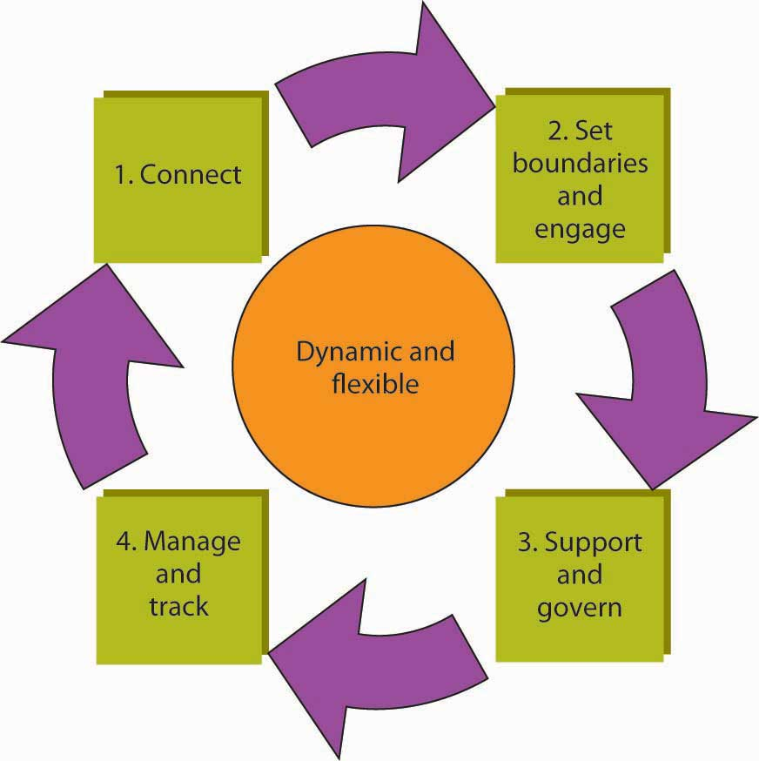
Adapted from http://www.mckinseyquarterly.com (retrieved June 4, 2008)
The first step, connect, involves the identification of key people in the organization with an innovation mind-set. Such individuals are not wed to the status quo and are comfortable with change and uncertainty. It is important to involve individuals with different backgrounds and approaches to innovation. For instance, some individuals are great at generating ideas while others may be better at researching and validating them. This group of individuals would then be defined as a network. The second step, set boundaries and engage, is where the network’s goals and objectives are defined. It is important to make it clear how the network’s goals and objectives will contribute to the organization’s goals and larger strategy, mission, and vision. Time frames and desired target outcomes are stated as well.
In the third step, support and govern, the leadership structure for the network is decided on, along with any protocols for meeting, sharing ideas, and decision making. With these process guidelines in place, the network members can then make sure that they have identified the resources necessary to conduct their work. This includes gaining sponsorship and buy-in from other parts of the organization, including upper management. Finally, the fourth step involves managing and tracking. This last step covers a spectrum of needs, ranging from how network members will be recognized and rewarded for their contributions, the agreement about process-tracking criteria, and some guidelines on how new members join the network and others leave.
As mentioned in the connect stage of developing an innovation network, you can fine-tune the network’s goals by identifying the appropriate mix and balance of employees. Innovation networks, like cross-functional teams, require different skills and attitudes. In McKinsey’s experience, they include combinations of several archetypes. Which one are you?
- Idea generators prefer to come up with ideas, believe that asking the right questions is more important than having the right answers, and are willing to take risks on high-profile experiments.
- Researchers mine data to find patterns, which they use as a source of new ideas. They are the most likely members of the network to seek consumer insights and to regard such insights as a primary input.
- Experts value proficiency in a single domain and relish opportunities to get things done.
- Producers orchestrate the activities of the network. Others come to them for new ideas or to get things done. They are also the most likely members of the network to be making connections across teams and groups.

KEY TAKEAWAY
This section showed how social networks create value. We started by introducing the social network theory concepts of reciprocity, exchange, and similarity. We then discussed using social networks as a vehicle for advancing your own career. The section concluded by explaining how social networks create value in and across organizations, with specific examples of making invisible work visible, Procter & Gamble’s Connect + Develop, and McKinsey’s “innovation network” concept.

EXERCISES
- What does the social network concept of reciprocity mean, and what are its pros and cons?
- What does the social network concept of exchange mean, and what are its pros and cons?
- What does the social network concept of similarity mean, and what are its pros and cons?
- How do social networks create value in a career management setting?
- How do social networks create value in an organizational setting?
- What are some ways that an organization can manage the social network to be more innovative?

9.4 Ethical Considerations With Social Network Analysis

LEARNING OBJECTIVES
- Understanding the ethics of social network analysis.
- Developing a toolkit for managing the ethical issues.
- Suggest why ignoring social networks may be unethical.

What Is Social Network Analysis?
Before delving into the ethical issues, let’s revisit social network analysis. Social networking is built on the idea that there is a determinable structure to how people know each other, whether directly or indirectly. Notions such as six degrees of separation—that everyone on earth is separated from everyone else by no more than six intermediate personal relationships—have popularized the idea that people can be (however unknowingly) connected through common associates. As we mentioned at the beginning of this chapter, social network analysis (SNA) is the mapping and measuring of relationships and flows between people, groups, organizations, computers, Web sites, and other information/knowledge processing entities. This can be done with paper and pencil surveys, software programs, and even comparing e-mail and phone logs, but the desired output is essentially the same. Social networks are the invisible organization. That is, they are the actual organization behind the printed organization chart.

Ethical Implications
Application of the principles behind P-O-L-C should help managers lead their organizations to bigger and better things, and social networks are a key ingredient in the “organizing” component.
We have adapted these ethical concerns from:
- Borghatti, S. P., & Molina, J.-L. (2003). Ethical and strategic issues in organizational network analysis. Journal of Applied Behavioral Science, 39(3), 337–349
- Borghatti, S. P., & Molina, J.-L. (2005) Toward ethical guidelines for network research in organizations. Social Networks, 27, 107–117
So, what harm can there be if a manager uses SNA to uncover the invisible structure in their organization? Three top ethical concerns are (1) violation of privacy, (2) psychological harm, and (3) harm to individual standing. Let’s look at each of these three ethical concerns in turn.

Violation of Privacy
Managers typically use surveys (sometimes with the aid of consultants) to capture and map the structure of a social network. If each employee has consented to the survey, then the manager is on much more solid ground. Care must be taken, however, that participants are aware of the survey’s objectives and applications. Recall that a network diagram reflects a pattern or relationship among people, such that survey participants will actually be reporting, by definition, on what other individuals are doing. For instance, if a communication network in your organization is being mapped, you might be asked who you initiate communication with and who initiates it with you. You might also be asked for some indication of communication frequency. So, even if you agreed to complete the survey, the other people that you identify as part of your network may have not.
Surveys are not the only basis for mapping social networks. Indeed, think about the network that might be reflected by the contacts on your cell phone or e-mail lists. Given technology today this data could be readily converted into a social network map showing who corresponded with whom and the length of such correspondence. Moreover, with content coding software, even the content of the e-mails could be coded. This type of social network mapping has more obvious ethical implications because participants of the map may never know that they are actually being mapped!
In both the survey-based and electronic mapping approaches, you might keep the identities of individuals confidential, thereby protecting their privacy. However, it may be possible to guess the names of individuals by virtue of their location in the network. For example, if a certain type of information can only originate with one part of an organization, it might be pretty obvious to inside observers how such information flowed internally and externally. Similarly, “organizations are typically quite small, so that even a small number of attributes can uniquely identify individuals.”
- Borghatti, S. P., & Molina, J.-L. (2005). Toward ethical guidelines for network research in organizations. Social Networks, 27, 107–117
Second, demographic information on each person is often available in the human resources database or is common knowledge because everyone knows everyone else. Even if the outcome of such informal information flows is positive, the actual communication may be prohibited internally by organizational rules and procedures. For example, you are likely familiar with the way Post-its were developed at 3M through internal entrepreneurial actions—at the time, however, some of those actions were not an explicit part of 3M’s rules and procedures (though, fortunately for 3M, its “bootlegging policy” gave the inventors an opportunity to explore market options for the adhesive that did not stick).To foster creativity, 3M encourages technical staff members to spend up to 15% of their time on projects of their own choosing. Also known as the “bootlegging” policy, the 15% rule has been the catalyst for some of 3M’s most famous products, such as Scotch Tape and—of course—Post-it notes.
- Retrieved November 17, 2008, from http://solutions.3m.com/wps/portal/3M/en_HK/post-it/index/post-it_past_present/history/the_whole_story?PC_7_RJH9U523086C5023CPSB8R18O2_assetType=MMM_Article&PC_7_RJH9U523086C5023CPSB8R18O2_assetId=1180595718358&PC_7_RJH9U523086C5023CPSB8R18O2_univid=1180595718358.

Harm to Individual Standing
The two remaining ethical issues are somewhat related. As you can imagine from the previous examples, violation of privacy might lead to unforeseen, and possibly unwarranted, disciplinary action. This would harm an individual’s standing. For instance, if a social network map revealed that one individual or an entire department is the bottleneck for information flowing from one part of the organization to another, action might be taken against that individual or members of the department. It may truly be the case that this person or department is a roadblock to progress; but it may just as likely be the case that managers on one side or the other (in terms of social network) of the apparent bottleneck are not very good at delegating or eliciting information. Similarly, the organization may just be trying to run too much through one particular individual in the network. What one views as an indication of individual incompetency may, in fact, be a need for training or the addition of staff to move the information more effectively.
The possible harm to individual standing should be noted if 3M had used a social network map to understand the roots of its Post-it homerun and had internal policies prohibiting the use of time and money on nonapproved projects. If a network survey revealed that 3M’s breakthrough was caused byrogue employees—that is, employees who were not following the rules about new product development and so on—the individual credited with that innovation might have been reprimanded or fired. This, of course, was not the case in 3M, but you can imagine how organizational policies meant to foster internal efficiencies might prohibit an individual from contravening them, regardless of the benefits of the eventual outcome.
Finally, the purpose of the network analysis may be to identify areas of the firm that just aren’t critical to its mission, vision, and strategy. As social network researchers Steve Borgatti and Jose-Luis Molina note, “This introduces dangers for the respondents because management may make job or personnel changes (e.g., firing non-central workers) based on the network analysis. In fact, in the case of a consulting engagement, this may be the explicit purpose of the research, at least from the point of view of management.”
- Borghatti, S. P., & Molina, J.-L. (2005). Toward ethical guidelines for network research in organizations. Social Networks, 27, 107–117
Obviously, one of the roles of management is to determine the efficient and effective allocation of resources. SNA can be a useful tool in this determination, but the purpose of the analysis should be made clear to participants from the outset.

Psychological Harm
This third area can be subtle, but it is very important as well. Psychological harm might arise when information is used in a way that manipulates the behavior of individuals. For instance, managers are likely to develop maps of social networks because their managers believe that there might be better ways of planning, organizing, leading, and controlling. As Borgatti and Molina point out, however, SNA in this context is explicitly part of a transformation process in which the group is shown data about itself, such as network diagrams, and asked to react to it. Experience suggests that this technique serves as a powerful catalyst for change. “It is dangerous, however, because of the powerful emotions it engenders in a group setting and this can put the researcher in the position of practicing therapy without a license.”
- Borghatti, S. P., & Molina, J.-L. (2005). Toward ethical guidelines for network research in organizations. Social Networks, 27, 107–117 (quote on p. 114)

A Framework for Managing the Ethical Issues of SNA
Now that you understand some of the ethical issues arising from SNA you are in a better position to anticipate and manage them. Of course, we should refresh your memory on the general ethical decision-making guidelines before delving into more SNA-specific ones. In brief, the following are the six steps:
- Assess the situation. What are you being asked to do? Is it illegal? Is it unethical? Who might be harmed?
- Identify the stakeholders and consider the situation from their point of view. For example, consider the point of view of the company’s employees, top management, stockholders, customers, suppliers, and community.
- Consider the alternatives you have available to you and how they affect the stakeholders. These include:
  - consequences
  - duties, rights, and principles
  - implications for personal integrity and character
- Consider the effects of your actions. How does the action make you feel about yourself? How would you feel if your actions were reported tomorrow in the Wall Street Journal (or your daily newspaper)? How would you explain your actions to your mother or to your 10-year-old child?
- Make a decision. This might involve going to your boss or to a neutral third party (such as an ombudsman or ethics committee). Know your values and your limits. If the company does nothing to rectify the situation, do you want to continue working for the company?
- Monitor outcomes. Track what actually happens and compare it to what you expected.
- Hartman, L., & DesJardins, J. (2008). Business ethics: Decision-making for personal integrity and social responsibility. New York: McGraw-Hill.
Beyond these general guidelines, there are three specific ways that you might manage SNA related ethical concerns. These are (1) full disclosure, (2) anonymization and opt-out options, and (3) participant training and feedback. Let’s look at each of these in turn.
First, you might consider some way of applying the notion of informed consent to the participants of an exercise that maps the organization’s social networks. This means that each person included in the mapping process would be told the purpose of the exercise, along with what the outcome would look like. We provide an example disclosure form where they would also be apprised of the possible risks. For instance, one SNA informed consent form includes the following paragraph:
Risks and costs Since management will see the results of this study, there is a chance that someone in management could consider your set of communication contacts to be inappropriate for someone in your position, and could think less of you. Please note, however, that the researchers have obtained a signed agreement from management stipulating that the data will be used for improving communication in the company and will not be used in an evaluative way.
- Borghatti, S. P., & Molina, J.-L. (2005). Toward ethical guidelines for network research in organizations. Social Networks, 27, 107–117
Second, managers can consider different ways of making the process anonymous or giving individuals the option to opt-out of the mapping process. For example, department-level network information could be presented instead of individual-level information. Where it is impossible to protect the privacy wishes of one individual, then an op-out option is the only way to protect their privacy, though this will clearly affect the accuracy of the SNA. If an individual opts out, this should mean that their name appears nowhere on the social network diagram (even if they are identified by another individual as being part of their social network). For instance, in the sample map, you can see that the map would be very disjointed if John and Holly opted out of the SNA.

Figure 9.12 A Social Network Survey Participant Disclosure Form
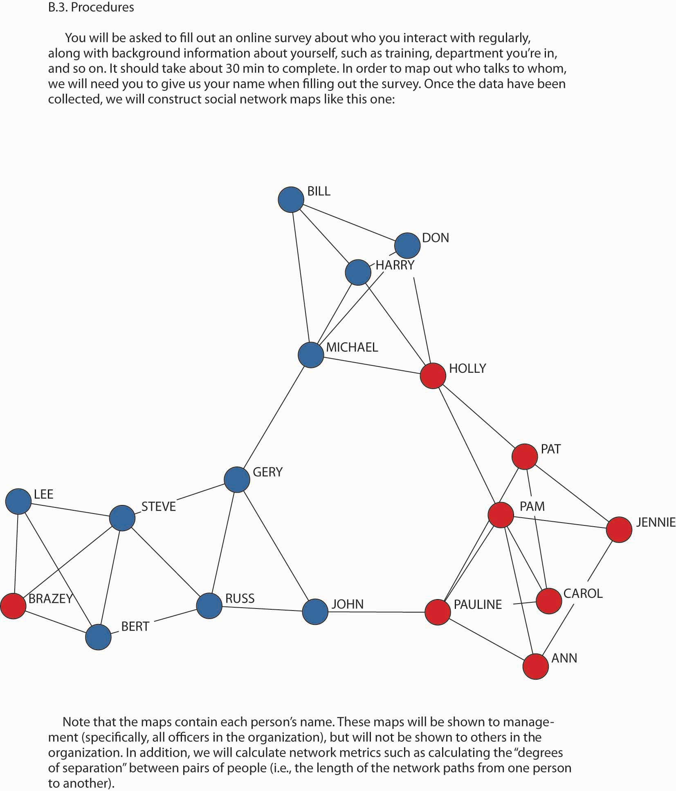
Source: Reproduced with permission of Borghatti, S. P., & Molina, J.-L. (2005). Toward ethical guidelines for network research in organizations. Social Networks, 27, 107–117.
Finally, managers can consider the application of SNA in conjunction with a larger employee development program where participants are taught about social network analysis and then their results are debriefed with them one on one. Where there are still concerns for privacy, individuals can map their own social networks and then act on them personally. It is management’s responsibility to steward the organization’s resources in a way that is consistent with the mission and vision. In that sense, SNA is a valuable tool for understanding how the organization’s work actually gets done. However, because it is such a powerful and revealing tool, managers must be thoughtful in its ethical application.

The Ethical Argument in Favor of Managing Social Networks
We close this section with some discussion of why it might actually be unethical to neglect the organization’s social network. Be sensitive to the ethical issues surrounding the management of social networks, but that does not mean leaving social network relationships to chance. For instance, if you know that your department would be more productive if person A and person B were connected, as a manager wouldn’t you want to make that connection happen? In many firms, individuals are paid based on performance, so this connection might not only increase the department’s performance, but its personal incomes as well.
The broader issue is that social networks exist and that the social capital they provide is an important and powerful vehicle for getting work done. That means that the ethical manager should not neglect them. Wayne Baker, author of Achieving success through Social Capital, puts it this way:
“The ethics of social capital [i.e., social network relationships] requires that we all recognize our moral duty to consciously manage relationships. No one can evade this duty—not managing relationships ismanaging them. The only choice is how to manage networks of relationships. To be an effective networker, we can’t directly pursue the benefits of networks, or focus on what we can get from our networks. In practice, using social capital means putting our networks into action and service for others. The great paradox is that by contributing to others, you are helped in return, often far in excess of what anyone would expect or predict.”
- Baker, W. (2000). Achieving success through social capital. San Francisco: Jossey-Bass

KEY TAKEAWAY
Now that you have a better understanding of social networks and SNA you need to understand some of the ethical implications of the application of such knowledge. You learned that SNA gives rise to concerns about privacy, harm to individual standing, and psychological harm. You were reminded that the general ethical decision-making framework applies to your use of SNA, but you also learned some specific approaches to managing SNA-related ethical issues. Finally, you were presented with arguments about why neglect of an organization’s social network also can have negative ethical implications.

EXERCISES
- What is social network analysis?
- Why should managers be concerned about the ethical implications of social network analysis?
- What might be some of the unforeseen consequences of SNA for you as an employee?
- How would the privacy of employees be affected even if they are not directly surveyed as part of the SNA?
- What steps can you take to improve the ethical bases for conducting SNA?
- Why might it be unethical for managers to neglect the organization’s social networks?

9.5 Personal, Operational, and Strategic Networks

LEARNING OBJECTIVES
- See networks as something you can, and need to, manage.
- Know about different network forms—personal, operational, and strategic.
- Understand some of the actions you need to take to move your network forward.
This section draws heavily on recent research by Herminia Ibarra, Brian Uzzi, and others, to help you understand the different forms that social networks can take. Ibarra and Uzzi have been studying the social networks and social networking tactics and strategies of managers for more than 20 years and are considered thought-leaders in the field.
- Ibarra, H., & Hunter, M. (2007, January). How leaders build and use networks. Harvard Business Review, 40–47
- Ibarra, H. (2006). Career Change. In J. H. Greenhaus & G. A. Callanan (Eds.), The encyclopedia of career development, 7782. Beverly Hills, CA; Sage
Their most recent work suggests that strong, useful networks don’t just happen at the watercooler. They have to be carefully constructed.
What separates successful managers from the rest of the pack? Networking: creating a fabric of personal contacts to provide the support, feedback, and resources needed to get things done. Yet many managers avoid networking. Some think they don’t have time for it. Others disdain it as manipulative. To succeed as a manager, Ibarra recommends building three types of networks:
- Personal—kindred spirits outside your organization who can help you with personal advancement.
- Operational—people you need to accomplish your assigned, routine tasks.
- Strategic—people outside your control who will enable you to reach key organizational objectives.
These networks, their purpose, and how to build network membership, are summarized in “Personal, Operational, and Strategic Networks.” Most importantly, Ibarra’s work suggests that leaders need to possess all three types of networks, and not just one or two. Let’s take a look at each one of these networks.

Table 9.1 Personal, Operational, and Strategic Networks
 | The purpose of this network is to… | If you want to find network members, try…
Personal network | exchange important referrals and needed outside information; develop professional skills through coaching and mentoring | participating in alumni groups, clubs, professional associations, and personal interest communities.
Operational network | get your work done, and get it done efficiently. | identifying individuals who can block or support a project.
Strategic network | figure out future priorities and challenges; get stakeholder support for them. | identifying lateral and vertical relationships with other functional and business unit managers—people outside your immediate control—who can help you determine how your role and contribution fit into the overall picture.

Personal Networks
“Personal networks are largely external, made up of discretionary links to people outside the workplace with whom we have something in common. As a result, what makes a personal network powerful is its referral potential. According to the famous six degrees of separation principle, our personal contacts are valuable to the extent that they help us reach, in as few connections as possible, the far-off person who has the information we need.”
- Ibarra, H., & Hunter, M. (2007, January). How leaders create and use networks, Harvard Business Review, 2–8 (quote, 5)
Personal networking engages kindred spirits from outside an organization in an individual’s efforts to learn and find opportunities for personal advancement. Personal networks are one’s circle of casual acquaintances, typically composed of people outside of the company you work for. Before you have a job in a particular company, many of your network ties are personal, oriented toward current interests and future potential interests. Key contacts are typically discretionary—that is, it is not always clear who is most relevant.
Most personal networks are highly clustered—that is, your friends are likely to be friends with one another as well. And, if you made those friends by introducing yourself to them (as opposed to being introduced by a mutual acquaintance), the chances are high that their experiences and perspectives echo your own. Ideas generated within a personal network typically circulate among the same people with shared views. This creates the risk that a potential winning idea can go unexploited if no one in the group has what it takes to bring that idea to fruition.
But what if someone within that cluster knows someone else who belongs to a whole different group? That connection, formed by an information broker, can expose your idea to a new world, filled with fresh opportunities for success. Diversity and breadth, that is, reaching out to contacts who can make referrals, makes the difference. Through professional associations, alumni groups, clubs, and personal interest communities, managers gain new perspectives that allow them to advance in their careers. This is what we mean by personal networking.
While personal networks are important, particularly to the extent that they provide you with valuable resources and access to needed resources, the challenge is to convert them into network resources that also help with operational and strategic needs. Too often, however, those individuals in the personal network just aren’t the right types of ties to be beneficial operationally or strategically, which is why you need to look at broadening your network to address operating and strategic needs.

Operational Networks
“All managers need to build good working relationships with the people who can help them do their jobs. The number and breadth of people involved can be impressive—such operational networks include not only direct reports and superiors but also peers within an operational unit, other internal players with the power to block or support a project, and key outsiders such as suppliers, distributors, and customers. The purpose of this type of networking is to ensure coordination and cooperation among people who have to know and trust one another in order to accomplish their immediate tasks…Either you’re necessary to the job and helping to get it done, or you’re not.”
- Ibarra, H., & Hunter, M. (2007, January). How leaders create and use networks, Harvard Business Review, 2–8 (quote, 3)
On the basis of a close study of 30 emerging leaders, Ibarra and Hunter found that operational networking was geared toward doing one’s assigned tasks more effectively. It involves cultivating stronger relationships with colleagues whose membership in the network is clear; their roles define them as stakeholders. The previous quote provides you with a good working definition of operational network: “Either you’re necessary to the job and helping get it done, or you’re not.” That is, anyone who satisfies this criterion should be considered part of your operational network.
So, now you have two networking bases covered. At least you know how to identify the gaps in your personal and operational network. Your personal network provides access to external resources and referrals; your operational network helps you get the work done. Thus, most operational networking occurs within an organization, and ties are determined in large part by routine, short-term demands. Relationships formed with outsiders, such as board members, customers, and regulators, are directly task-related and tend to be bounded and constrained by demands determined at a higher level. But as a manager moves into a leadership role, his or her network must reorient itself externally and toward the future. This is the role played by strategic networking.

Strategic Networks
“Making a successful leadership transition requires a shift from the confines of a clearly defined operational network…It is a challenge to make the leap from a lifetime of functional contributions and hands-on control to the ambiguous process of building and working through networks. Leaders must accept that networking is one of the most important requirements of their new leadership roles and continue to allocate enough time and effort to see it pay off.”
- Ibarra, H., & Hunter, M. (2007, January). How leaders create and use networks, Harvard Business Review, 2–8 (quote, 6)
Whereas an operational network is fairly narrowly focused, with the locus of contacts formed around specific objectives, a strategic network necessarily involves lateral and vertical ties to stakeholders inside and outside of the firm. As Ibarra and Hunter found in their research, strategic networking is the ability to marshal information, support, and resources from one sector of a network to achieve results in another. Pushed to its logical limit, the basis of this difference is that effective leaders are highly dependent on others to get things done. The irony here is that the individuals in your network, who are the lifeline for building up the big picture, are also individuals who are likely to be outside of your immediate control. While this may seem obvious, it is often difficult to transition from a purely operational network to a strategic one, either due to simple time constraints (strategic networking takes time, often without immediate or obvious benefits) or because of negative personal attitudes toward strategic networking (for instance, “that’s too political and goes against my values”).

Making It Happen
Networks create value, but networking takes real work. Beyond that obvious point, accept that networking is one of the most important requirements of a leadership role. To overcome any qualms about it, identify a person you respect who networks effectively and ethically. Observe how he or she uses networks to accomplish goals. You probably will also have to reallocate your time. This means becoming a master at the art of delegation, to liberate time you can then spend on cultivating networks.
Building a network obviously means that you need to establish connections. Create reasons for interacting with people outside your function or organization; for instance, by taking advantage of social interests to set the stage for addressing strategic concerns. Ibarra and Hunter found that personal networking will not help a manager through the leadership transition unless he or she learns how to bring those connections to bear on organizational strategy. In “Guy Kawasaki’s Guide to Networking through LinkedIn,” you are introduced to a number of network growth strategies using that powerful Web-based tool.
Finally, remind yourself that networking requires you to apply the principle of reciprocity. That is, give and take continually—though a useful mantra in networking is “give, give, give.” Don’t wait until you really need something badly to ask for a favor from a network member. Instead, take every opportunity to give to—and receive from—people in your networks, regardless of whether you need help.

Guy Kawasaki’s Guide to Networking Through LinkedIn
LinkedIn (http://www.Linkedin.com) is the top business social networking site. With more than 30 million members by the end of 2008, its membership dwarfs that of the second-largest business networking site, Plaxo. LinkedIn is an online network of experienced professionals from around the world representing 150 industries.Retrieved June 4, 2008, from http://www.linkedin.com/static?key=company_info&trk=hb_ft_abtli. Yet, it’s still a tool that is underutilized, so entrepreneur Guy Kawasaki compiled a list of ways to increase the value of LinkedIn.Retrieved June 4, 2008, from http://blog.guykawasaki.com. Some of Kawasaki’s key points are summarized here that can help you develop the strategic side of your social network (though it will help you with job searches as well):
Increase your visibility. By adding connections, you increase the likelihood that people will see your profile first when they’re searching for someone to hire or do business with. In addition to appearing at the top of search results, people would much rather work with people who their friends know and trust.
Improve your connectability. Most new users put only their current company in their profile. By doing so, they severely limit their ability to connect with people. You should fill out your profile like it’s a resume, so include past companies, education, affiliations, and activities. You can also include a link to your profile as part of an e-mail signature. The added benefit is that the link enables people to see all your credentials.
Perform blind, “reverse,” and company reference checks. Use LinkedIn’s reference check tool to input a company name and the years the person worked at the company to search for references. Your search will find the people who worked at the company during the same time period. Since references provided by a candidate will generally be glowing, this is a good way to get more balanced data.
Make your interview go more smoothly. You can use LinkedIn to find the people that you’re meeting. Knowing that you went to the same school, play hockey, or share acquaintances is a lot better than an awkward silence after, “I’m doing fine, thank you.”
Gauge the health of a company. Perform an advanced search for company name and uncheck the “Current Companies Only” box. This will enable you to scrutinize the rate of turnover and whether key people are abandoning ship. Former employees usually give more candid opinions about a company’s prospects than someone who’s still on board.

KEY TAKEAWAY
In this section, you were introduced to a different slant on social networks—a slant that helps you manage your networks based on where you might be in an organization. Personal networks are important and tend to follow you everywhere. In this section, we stressed the access-to-information and referral benefits of personal networks. Operational networks are those that help you get your immediate work done, and if the key stakeholders in the work process aren’t already in your operational network, then you have some network rework in order. Finally, strategic networks are those that involved a much broader stakeholder group and typically involved individuals who are out of your direct control. One key takeaway from this section is that effective leaders are effective networkers, and you will need to figure out the style of networking that works for you as you move higher in an organization.

EXERCISES
- What characterizes a personal social network?
- What benefits do members of a personal social network provide to each other?
- What characterizes an operational social network?
- What is a simple rule of thumb for determining if someone should be in your operational network?
- What characterizes a strategic social network?
- What two barriers interfere with the development of strategic networks?

9.6 Mapping and Your Own Social Network

LEARNING OBJECTIVES
- Understand what is involved in social network analysis.
- Be able to analyze your own social network.
- Be able to identify the gaps in your network and develop a plan to fill those gaps.
As you have already learned, the mapping and measuring of relationships and flows between people, groups, organizations, computers, Web sites, and other information/knowledge processing entities is called social network analysis. Social network analysis is not the same thing as networking, where networking is the activities you might engage in to build your social network. In this section, you will learn the basics of mapping your own social network. It will give you a sense of the size of your network, along with some other useful characteristics to work with such as density.

Step One: What Purpose Should the Network Serve?
There are a number of possible purposes for a social network.The first author, Mason A. Carpenter, has been using social networking mapping in his classes for the past 15 years. This particular mapping tool has evolved over that time and is inspired by the larger body of social network research. There is no magic to this particular grid tool, and you are welcome to use and adapt it as the need arises. This grid simply asks students to identify who might be helpful in their network, the nature of their relationship with these individuals, and which members know each other. As a manager, you are probably most concerned with these six.
- Cross, R., Borgatti, S., & Parker, A. (2002). Making invisible work visible. California Management Review, 44(2), 25–46
First, a communication network is the informal structure of an organization as represented in ongoing patterns of interaction, either in general or with respect to a given issue. Second, an information network shows who goes to whom for advice on work-related matters. Third, a problem-solving network indicates who goes to whom to engage in dialogue that helps people solve problems at work. Fourth, a knowledge network captures who is aware of whose knowledge and skills, and an access network (fifth) shows who has access to whose knowledge and expertise. The sixth and final purpose is a career network, which reflects those individuals in your network who are likely to be helpful in your search for a new job or quest for a promotion. Given that you are reading a principles of management book, a career network may be the most interesting to you.

Step Two: Who Are Your Contacts and What Is Your Relationship with Them?
Let’s assume that we are mapping your career network. A career network is simply those individuals who might be instrumental in helping you secure a new job or promotion. You can simply draft out a list of names, using names or just initials, but the goal is to develop a fairly complete list. The list can be as long or as short as you want to make it, though keep in mind that there is probably a limit to how effectively you can maintain a large network where you expect each relationship to be strong and meaningful, or at least one where the contact would probably respond to your request for assistance. Managers with 15 years of experience might list 30 to 50 names, while a college student might list 15 to 25 names. These are just averages, though, and individuals can be much higher or lower, depending on their situation.
The following three questions are sometimes useful in drafting out this initial list.
- If you look back over the last two to three years, who are the people with whom you have discussed important school or work matters? This may have been for bouncing around ideas for important projects, getting support or cooperation for your initiatives, evaluating opportunities, or any other matters of importance to you.
- What people have been most helpful and useful in accomplishing your job, in a work, school, or volunteer setting? Consider people who have provided leads, made introductions, offered advice in your decision making, or provided resources.
- Who has directly influenced your career? List those people who have contributed most significantly to your professional development and career advancement during the past two to three years.
Now that you have your list, briefly categorize the names based on (1) the strength of your relationship (very close, close, not very close, distant) and (2) who they are and where they come from. For this second facet, you might want to consider the following:
Total no. of ties _______ | No. Ties | % of Total
1. Your senior (higher up in your or another organization) | _____ | _____
2. Your peer (at your level in your or another organization) | _____ | _____
3. Your junior (below you in your or another organization) | _____ | _____
4. From a different functional or product area | _____ | _____
5. From a different business unit or office in your firm | _____ | _____
6. From a different firm | _____ | _____
7. The same gender as you are | _____ | _____
8. Members of the same racial or ethnic group as you are | _____ | _____
9. The same nationality as you are | _____ | _____
You will come back to this information after the next step, but you already have a better picture of your network just after this second step. For instance, you know how many people are in this network, and the relative presence of different types of network members.

Step Three: Who Knows Whom? Computing Network Density
Transfer your list of names to a grid like the one shown in the Sample Network Grid. Be sure to note your relationship with them, in terms ranging from very close to distant. To complete the grid you place a check in the box where one individual knows another. For instance, in this exhibit, Mary knows Zachary, Wesley, and Gerry.

Figure 9.15 Sample Network Grid
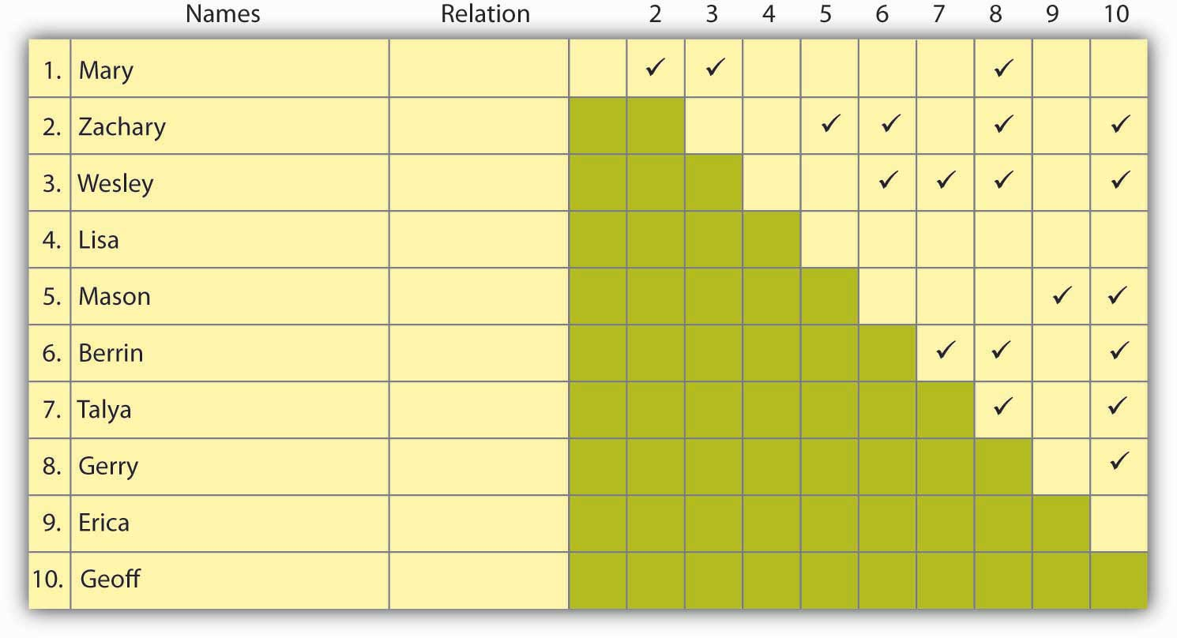

Computing Network Density
Once you have finished check-marking who knows whom, compute the density of your network using the following:
a. Total number of people in your network  To follow our example, N = 10 (i.e., there are 10 names) | N = __10_
b. Maximum Density (i.e., if everyone in your network knew each other). Our maximum density is (10 × 9) ÷ 2 = 45  [N × (N - 1)] ÷ 2 = M | M = __45_
c. Total number of checkmarks on your network grid (i.e., the number of relationships among people in your network).  In our example, C = 19. | C = __19_
d. Density of Your Network. Our D = 19 ÷ 45 = .42  C ÷ M = D | D = __.42_
In our example, if our calculations are correct, the density of this network is .42. If each person in this network knew every other person, then the density would be 1.0; if no one knew one another, outside of the person whose network this was, then the density would be 0.0. In our example, the network density is close to the middle, which means that about fewer than half the people have common network ties, while a little more than half have unique relationships. You might also want to run this calculation for a subset of the ties based on whether they are very strong, distant, and so on. If you do use a subset, though, then remember to use that number as your starting point (N = no. very close ties, for instance).

What Is a Good Number?
There is little research to tell us exactly how big (or small) or how dense (or sparse) the ideal network should be, although there are some facts to consider. Remember Dunbar’s number from earlier in the chapter? Some studies have suggested an upper limit of 150 network ties, but, again, that is a pretty big number if you also characterize those ties as “very close.” It is perhaps more reasonable if a few are very close and the rest are spread out in the “close” to “distant” categories. If you have a n

etwork of 15 to 20 people whose names come to mind quickly, that is probably a useful size, particularly if your network density is around the middle. Remember, you just set up a network where you were sort of the center point, and each member of your network, even if he/she is peripheral to yours, is the center of his/her own network.
A good number for density is between .40 and .60—that is, some people know one another, and some do not. The advantage of having people in your network who know one another is that they are likely to communicate more frequently and provide a set of shared relationships that you can use to move information, ideas, and other resources forward. Also, if any one of your network members, who knows no one else in the network, leaves the network for some reason, you will no longer have access to the stuff he or she provided for you.
You also want a number of unique ties though, since those relationships provide you access to unique information, resources, and ideas. Because of the network theory principles of reciprocity and exchange your network is likely to be more responsive when you have helped others in the network (reciprocate favors), and such reciprocation is most likely when you have access to unique resources (the exchange principle).

Step Four: Assess and Take Action
Let’s take a look at the information you now have about your network. From step 2 you have the size of your network, and the percentage of ties that break out by relationship (very strong to distant) and characteristics (company, demographics, and so on). From step 3 you have the density of your network, and that helps shed additional light on the information generated in step 2.
This puts you in a pretty good position. If you think your network is too small, you have a way to identify the gaps in your network that, if filled, would both grow your network and fill those key gaps. If density is too high, then the pathway is similar as well. If you think that you have a great network already, then you can validate this with the information generated in steps 2 and 3. In all likelihood, you will see opportunities to shore up gaps and develop strategies for doing so.
Here are some pointers from effective managers on how to make sure your network is creating value for you:
- When entering a new position, effective managers identify the people on whom they depend for getting things done and focus their energies on cultivating relationships with those people.
- Effective managers consider others as potential allies, even when they may appear to be adversaries. They develop awareness of key goals and resources valued by the potential ally and attempt to find areas of mutual benefit.
- Relationships with people who are dissimilar on multiple dimensions (e.g., a senior manager in another division) are the most difficult to cultivate and therefore require the most explicit strategies.
- Effective managers tend to be keenly aware of their personal preferences and interaction styles for developing their networks. For example, those who are not comfortable with extracurricular socializing may make extra time for informal conversations at work.

KEY TAKEAWAY
You now have a good understanding of how to analyze the basic characteristics of your social network or that of another individual. In this section you were introduced to a pencil-and-paper approach to social network analysis, though you can also use electronic forms that map more complex relationships, and perhaps show how multiple networks are tied (or not tied) together. This section closed with showing you how to bolster the value created by your social network.

EXERCISES
- How might social network analysis help you find a new job?
- What are the basis steps in social network analysis?
- What information do you need to analyze your social network?
- Why is the size of your network important?
- Why is the density of your network important?
- What can you do to create value through your social network?

Chapter 10

Leading People and Organizations

WHAT’S IN IT FOR ME?
Reading this chapter will help you do the following:
- Define what leadership is and identify traits of effective leaders.
- Describe behaviors that effective leaders demonstrate.
- Specify the contexts in which various leadership styles are effective.
- Explain the concepts of transformational, transactional, charismatic, servant, and authentic leadership.
- Develop your own leadership skills.

Figure 10.2 The P-O-L-C Framework
Perhaps this is obvious, but leadership is the first of five facets constituting a manager’s leading function in the P-O-L-C framework. Leadership may be defined as the act of influencing others to work toward a goal. Leaders exist at all levels of an organization. Some leaders hold a position of authority and may use the power that comes from their position, as well as their personal power, to influence others; they are called formal leaders. In contrast, informal leaders are without a formal position of authority within the organization but demonstrate leadership by influencing others through personal forms of power. One caveat is important here: Leaders do not rely on the use of force to influence people. Instead, people willingly adopt the leader’s goal as their own goal. If a person is relying on force and punishment, the person is a dictator, not a leader.
What makes leaders effective? What distinguishes people who are perceived as leaders from those who are not perceived as leaders? More importantly, how do we train future leaders and improve their leadership ability? These are important questions that have attracted scholarly attention in the past several decades. In this chapter, we will review the history of leadership studies and summarize the major findings relating to these important questions. Around the world, we view leaders as at least partly responsible for their team’s or company’s success and failure. Company chief executive officers (CEOs) are paid millions of dollars in salaries and stock options with the assumption that they hold their company’s future in their hands. In politics, education, sports, and profit and nonprofit sectors, influence of leaders over the behaviors of individuals and organizations is rarely questioned. When people and organizations fail, managers and CEOs are often viewed as responsible. Some people criticize the assumption that leadership always matters and call this belief “the romance of leadership.” However, research evidence pointing to the importance of leaders for organizational success is accumulating.
- Hogan, R., Curphy, G. J., & Hogan, J. (1994). What we know about leadership: Effectiveness and personality. American Psychologist, 49, 493–504

10.1 Case in Point: Indra Nooyi Draws on Vision and Values to Lead

Figure 10.3
Source: Used by permission of PepsiCo Incorporated.
She is among the top 100 most influential people according to Time magazine’s 2008 list. She has also ranked number 4 in Forbes’s “Most Influential Women in the World” (2010), number 1 inFortune’s “50 Most Powerful Women” (2006 through 2009), and number 22 in Fortune’s “25 Most Powerful People in Business” (2007). The lists go on and on. To those familiar with her work and style, this should come as no surprise: Even before she became the CEO of PepsiCo Inc. (NYSE: PEP) in 2006, she was one of the most powerful executives at PepsiCo and one of the two candidates being groomed for the coveted CEO position. Born in Chennai, India, Nooyi graduated from Yale’s School of Management and worked in companies such as the Boston Consulting Group Inc., Motorola Inc., and ABB Inc. She also led an all-girls rock band in high school, but that is a different story.
What makes her one of the top leaders in the business world today? To start with, she has a clear vision for PepsiCo, which seems to be the right vision for the company at this point in time. Her vision is framed under the term “performance with purpose,” which is based on two key ideas: tackling the obesity epidemic by improving the nutritional status of PepsiCo products and making PepsiCo an environmentally sustainable company. She is an inspirational speaker and rallies people around her vision for the company. She has the track record to show that she means what she says. She was instrumental in PepsiCo’s acquisition of the food conglomerate Quaker Oats Company and the juice maker Tropicana Products Inc., both of which have healthy product lines. She is bent on reducing PepsiCo’s reliance on high-sugar, high-calorie beverages, and she made sure that PepsiCo removed trans fats from all its products before its competitors. On the environmental side, she is striving for a net zero impact on the environment. Among her priorities are plans to reduce the plastic used in beverage bottles and find biodegradable packaging solutions for PepsiCo products. Her vision is long term and could be risky for short-term earnings, but it is also timely and important.
Those who work with her feel challenged by her high-performance standards and expectation of excellence. She is not afraid to give people negative feedback—and with humor, too. She pushes people until they come up with a solution to a problem and does not take “I don’t know” for an answer. For example, she insisted that her team find an alternative to the expensive palm oil and did not stop urging them forward until the alternative arrived: rice bran oil.
Nooyi is well liked and respected because she listens to those around her, even when they disagree with her. Her background cuts across national boundaries, which gives her a true appreciation for diversity, and she expects those around her to bring their values to work. In fact, when she graduated from college, she wore a sari to a job interview at Boston Consulting, where she got the job. She is an unusually collaborative person in the top suite of a Fortune 500 company, and she seeks help and information when she needs it. She has friendships with three ex-CEOs of PepsiCo who serve as her informal advisors, and when she was selected to the top position at PepsiCo, she made sure that her rival for the position got a pay raise and was given influence in the company so she did not lose him. She says that the best advice she received was from her father, who taught her to assume that people have good intentions. Nooyi notes that expecting people to have good intentions helps her prevent misunderstandings and show empathy for them. It seems that she is a role model to other business leaders around the world, and PepsiCo is well positioned to tackle the challenges the future may bring.
Primary Resource:
Secondary Resources:
- Birger, J., Chandler, C., Frott, J., Gimbel, B., Gumbel, P., et al. (2008, May 12). The best advice I ever got. Fortune, 157(10), 70–80
- Brady, D. (2007, June 11). Keeping cool in hot water. BusinessWeek. Retrieved April 30, 2010, from http://www.businessweek.com/magazine/content/07_24/b4038067.htm
- Compton, J. (2007, October 15). Performance with purpose. Beverage World, 126(10), 32
- McKay, B. (2008, May 6). Pepsi to cut plastic used in bottles. Wall Street Journal, Eastern edition, p. B2
- Morris, B., & Neering, P. A. (2008, May 3). The Pepsi challenge: Can this snack and soda giant go healthy? CEO Indra Nooyi says yes but cola wars and corn prices will test her leadership. Fortune, 157(4), 54–66
- Schultz, H. (2008, May 12). Indra Nooyi. Time, 171(19), 116–117
- Seldman, M. (2008, June). Elevating aspirations at PepsiCo. T+D, 62(6), 36–38
- The Pepsi challenge (2006, August 19).Economist. Retrieved April 30, 2010, from http://www.economist.com/business-finance/displaystory.cfm?story_id=7803615

DISCUSSION QUESTIONS
- How might a leader like Nooyi influence PepsiCo’s use of P-O-L-C tools beyond her obvious role in the leadership dimension?
- Do you think Indra Nooyi’s vision of “performance with purpose” has been effective? Why or why not?
- How does charisma relate to leadership? Do you think the CEO of PepsiCo possesses this characteristic?
- What makes Indra Nooyi so successful at her job? Is it her level of authority, or is it something else?
- What do the types of advisors that Indra Nooyi relies on tell you about her values?
- How much passion does Indra Nooyi seem to bring to her role as CEO of PepsiCo?

10.2 Who Is a Leader? Trait Approaches to Leadership

LEARNING OBJECTIVES
- Learn the position of trait approaches in the history of leadership studies.
- Explain the traits that are associated with leadership.
- Discuss the limitations of trait approaches to leadership.
The earliest approach to the study of leadership sought to identify a set of traits that distinguished leaders from nonleaders. What were the personality characteristics and physical and psychological attributes of people who are viewed as leaders? Because of the problems in measurement of personality traits at the time, different studies used different measures. By 1940, researchers concluded that the search for leadership-defining traits was futile. In recent years, though, after advances in personality literature such as the development of the Big Five personality framework, researchers have had more success in identifying traits that predict leadership.
- House, R. J., & Aditya, R. N. (1997). The social scientific study of leadership: Quo Vadis? Journal of Management, 23, 409–473
Most importantly, charismatic leadership, which is among the contemporary approaches to leadership, may be viewed as an example of a trait approach.
The traits that show relatively strong relations with leadership are as follows:
- Judge, T. A., Bono, J. E., Ilies, R., & Gerhardt, M. W. (2002). Personality and leadership: A qualitative and quantitative review. Journal of Applied Psychology, 87, 765–780

Intelligence
General mental ability, which psychologists refer to as “g” and which is often called IQ in everyday language, has been related to a person’s emerging as a leader within a group. Specifically, people who have high mental abilities are more likely to be viewed as leaders in their environment.
- House, R. J., & Aditya, R. N. (1997). The social scientific study of leadership: Quo Vadis? Journal of Management, 23, 409–473
- Ilies, R., Gerhardt, M. W., & Huy, L. (2004). Individual differences in leadership emergence: Integrating meta-analytic findings and behavioral genetics estimates. International Journal of Selection and Assessment, 12, 207–219
- Lord, R. G., De Vader, C. L., & Alliger, G. M. (1986). A meta-analysis of the relation between personality traits and leadership perceptions: An application of validity generalization procedures. Journal of Applied Psychology, 71, 402–410
- Taggar, S., Hackett, R., & Saha, S. (1999). Leadership emergence in autonomous work teams: Antecedents and outcomes. Personnel Psychology, 52, 899–926
We should caution, though, that intelligence is a positive but modest predictor of leadership. In addition to having high IQ, effective leaders tend to have high emotional intelligence (EQ). People with high EQ demonstrate a high level of self-awareness, motivation, empathy, and social skills. The psychologist who coined the term emotional intelligence, Daniel Goleman, believes that IQ is a threshold quality: it matters for entry- to high-level management jobs, but once you get there, it no longer helps leaders because most leaders already have high IQ. According to Goleman, what differentiates effective leaders from ineffective ones becomes their ability to control their own emotions and understand other people’s emotions, their internal motivation, and their social skills.
- Goleman, D. (2004, January). What makes a leader? Harvard Business Review, 82(1), 82–91
Many observers believe that Carly Fiorina, the ousted CEO of HP, demonstrated high levels of intelligence but low levels of empathy for the people around her, which led to an overreliance on numbers while ignoring the human cost of her decisions.
- Karlgaard, R. (2/18/2002). Vote Carly, Forbes,169(4), 37

Figure 10.4 Big Five Personality Traits
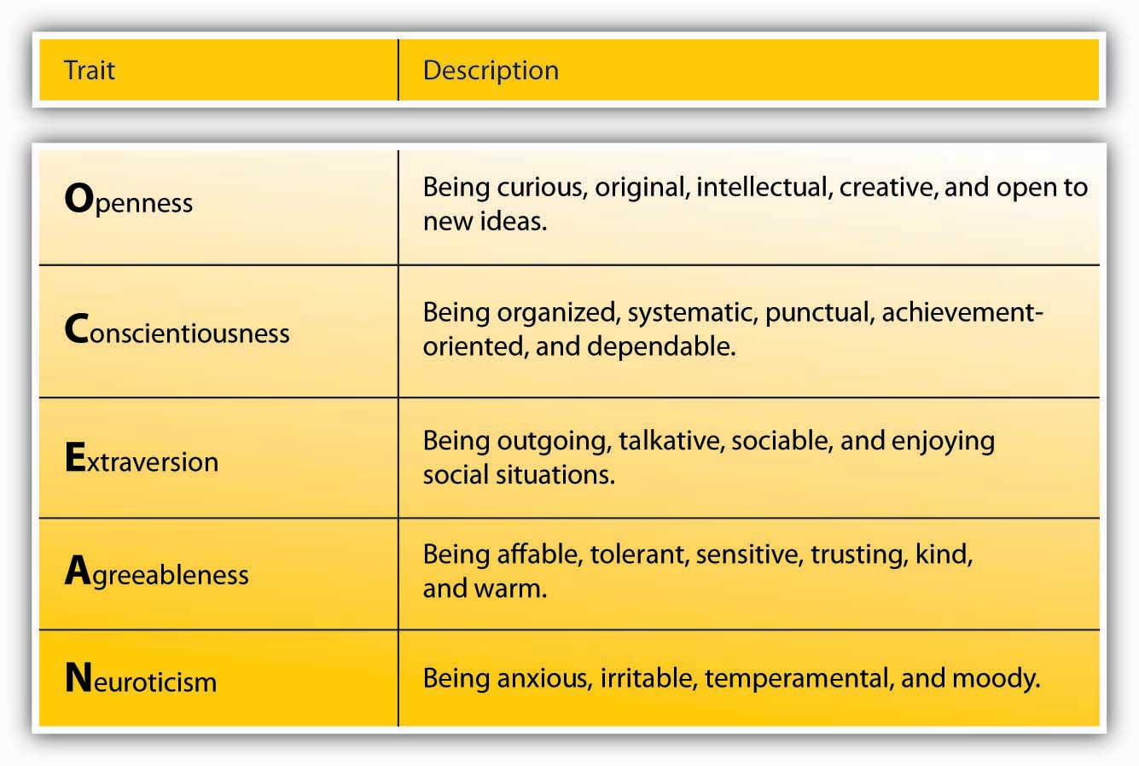
Source: Goldberg, L. R. (1990). An alternative “description of personality”: The big-five factor structure.Journal of Personality & Social Psychology, 59, 1216–1229.
Psychologists have proposed various systems for categorizing the characteristics that make up an individual’s unique personality; one of the most widely accepted is the Big Five model, which rates an individual according to openness to experience, conscientiousness, extraversion, agreeableness, and Neuroticism. Several of the Big Five personality traits have been related to leadership emergence (whether someone is viewed as a leader by others) and leadership effectiveness.

Figure 10.5
Steve Ballmer, CEO of Microsoft, is an extraverted leader. For example, to celebrate Microsoft’s 25th anniversary, Ballmer enthusiastically popped out of the anniversary cake to surprise the audience.
Source:http://en.wikipedia.org/wiki/Image:Steve_ballmer_2007_outdoors2.jpg
For example, extraversion is related to leadership. extraverts are sociable, assertive, and energetic people. They enjoy interacting with others in their environment and demonstrate self-confidence. Because they are both dominant and sociable in their environment, they emerge as leaders in a wide variety of situations. Out of all personality traits, extraversion has the strongest relationship to both leader emergence and leader effectiveness. Research shows that conscientious people are also more likely to be leaders. This is not to say that all effective leaders are extraverts, but you are more likely to find extraverts in leadership positions. An example of an introverted leader is Jim Buckmaster, the CEO of Craigslist. He is known as an introvert, and he admits to not having meetings because he does not like them.
- Buckmaster, Jim. (2008, May). How does he manage? Classified Web site boss. Management Today, 15

Another personality trait related to leadership is conscientiousness. Conscientious people are organized, take initiative, and demonstrate persistence in their endeavors. Conscientious people are more likely to emerge as leaders and be effective as leaders. Finally, people who haveopenness to experience—those who demonstrate originality, creativity, and are open to trying new things—tend to emerge as leaders and tend to be effective as leaders.

Self-Esteem
Self-esteem is not one of the Big Five personality traits, but it is an important aspect of one’s personality. The degree to which people are at peace with themselves and have an overall positive assessment of their self-worth and capabilities seems to be relevant to whether they will be viewed as a leader. Leaders with high self-esteem support their subordinates more, and when punishment needs to be administered, they punish more effectively.
- Atwater, L. E., Dionne, S. D., Camobreco, J. F., Avolio, B. J., & Lau, A. (1998). Individual attributes and leadership style: Predicting the use of punishment and its effects. Journal of Organizational Behavior, 19, 559–576
- Niebuhr, R. E., & Davis, K. R. (1984). Self-esteem: Relationship with leader behavior perceptions as moderated by the duration of the superior-subordinate dyad association, Personality and Social Psychology Buletin, 10, 51–59
It is possible that those with high self-esteem have greater levels of self-confidence and this affects their image in the eyes of their followers. Self-esteem may also explain the relationship between some physical attributes and emerging as a leader. For example, research shows a strong relationship between height and being viewed as a leader (as well as one’s career success over life). It is proposed that self-esteem may be the key to the connection of height with leadership, because people who are taller are also found to have higher self-esteem and therefore may project greater levels of charisma as well as confidence to their followers.
- Judge, T. A., & Cable, D. M. (2004). The effect of physical height on workplace success and income: Preliminary test of a theoretical model. Journal of Applied Psychology, 89, 428–441

Integrity

Figure 10.6 Traits Associated with Leadership
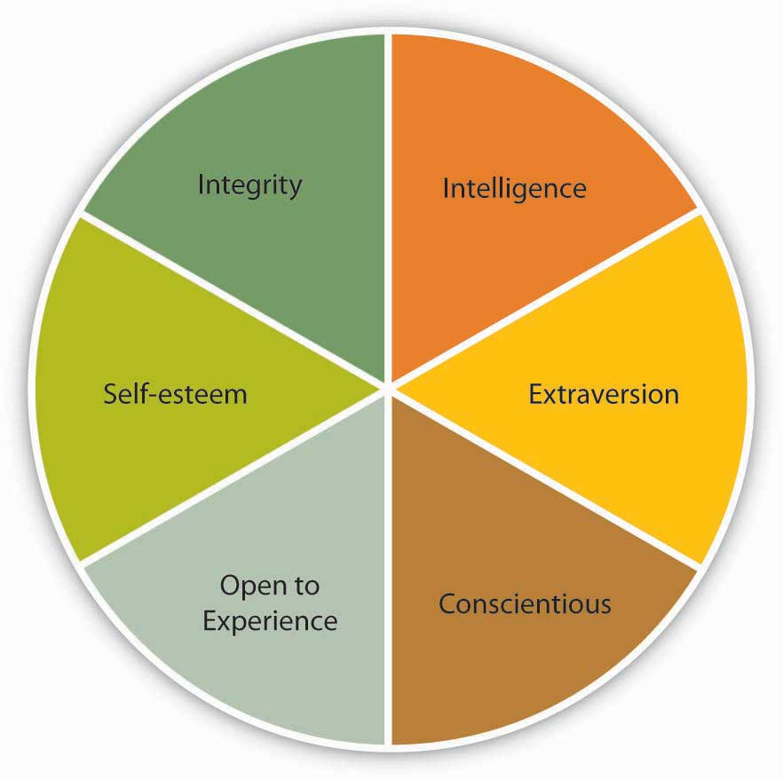
Research also shows that people who are effective as leaders tend to have a moral compass and demonstrate honesty and integrity.
- Reave, L. (2005). Spiritual values and practices related to leadership effectiveness. Leadership Quarterly, 16, 655–687
Leaders whose integrity is questioned lose their trustworthiness, and they hurt their company’s business along the way. For example, when it was revealed that Whole Foods CEO John Mackey was using a pseudonym to make negative comments online about the company’s rival Wild Oats, his actions were heavily criticized, his leadership was questioned, and the company’s reputation was affected.
- Farrell, G., & Davidson, P. (2007, July 13). Whole Foods’ CEO was busy guy online. USA Today, Section: Money, 04B

Figure 10.7
Condoleezza Rice had different responsibilities as the provost of Stanford University compared with her role as secretary of state for the United States. Do you think these differences affected her behavior as a leader?
Source:http://en.wikipedia.org/wiki/Image:Condoleezza_Rice_cropped.jpg
There are also some traits that are negatively related to emerging as a leader and being successful as a leader. For example, agreeable people who are modest, good natured, and avoid conflict are less likely to be perceived as leaders.
- Judge, T. A., Bono, J. E., Ilies, R., & Gerhardt, M. W. (2002). Personality and leadership: A qualitative and quantitative review. Journal of Applied Psychology, 87, 765–780
The key to benefiting from the findings of trait researchers is to be aware that not all traits are equally effective in predicting leadership potential across all circumstances. Some organizational situations allow leader traits to make a greater difference.
- House, R. J., & Aditya, R. N. (1997). The social scientific study of leadership: Quo Vadis? Journal of Management, 23, 409–473
For example, in small, entrepreneurial organizations where leaders have a lot of leeway to determine their own behavior, the type of traits leaders have may make a difference in leadership potential. In large, bureaucratic, and rule-bound organizations, such as the government and the military, a leader’s traits may have less to do with how the person behaves and whether the person is a successful leader.
- Judge, T. A., Bono, J. E., Ilies, R., & Gerhardt, M. W. (2002). Personality and leadership: A qualitative and quantitative review. Journal of Applied Psychology, 87, 765–780
Moreover, some traits become relevant in specific circumstances. For example, bravery is likely to be a key characteristic in military leaders but not necessarily in business leaders. Scholars now conclude that instead of trying to identify a few traits that distinguish leaders from nonleaders, it is important to identify the conditions under which different traits affect a leader’s performance, as well as whether a person emerges as a leader.
- Hackman, J. R., & Wageman, R. (2007). Asking the right questions about leadership: Discussion and conclusions. American Psychologist, 62, 43–47

KEY TAKEAWAY
Many studies searched for a limited set of personal attributes, or traits, which would make someone be viewed as a leader and be successful as a leader. Some traits are consistently related to leadership, such as intelligence (both mental ability and emotional intelligence), personality (extraversion, conscientiousness, openness to experience, self-esteem), and integrity. The main limitation of the trait approach was that it ignored the situation in which leadership occurred. Therefore, it is more useful to specify the conditions under which different traits are needed.

EXERCISES
- Think of a leader you admire. What traits does this person have? Are they consistent with the traits discussed in this chapter? If not, why is this person effective despite the presence of different traits?
- Can the findings of trait approaches be used to train potential leaders? Which traits seem easier to teach? Which are more stable?
- How can organizations identify future leaders with a given set of traits? Which methods would be useful for this purpose?
- What other traits can you think of that would be relevant to leadership?

10.3 What Do Leaders Do? Behavioral Approaches to Leadership

LEARNING OBJECTIVES
- Explain the behaviors that are associated with leadership.
- Identify the three alternative decision-making styles leaders use and the conditions under which they are more effective.
- Discuss the limitations of behavioral approaches to leadership.
When the trait researchers became disillusioned in 1940s, their attention turned to studying leader behaviors. What did effective leaders actually do? Which behaviors helped them to be perceived as leaders? Which behaviors increased their success?

Leader Behaviors
In order to understand behaviors of effective leaders, researchers at Ohio State University and University of Michigan used many different techniques such as observing leaders in laboratory settings as well as surveying them. This research stream led to the discovery of two broad categories of behaviors: task-oriented behaviors (sometimes called initiating structure) and people-oriented behaviors (also called consideration). Task-oriented leader behaviors involve structuring the roles of subordinates, providing them with instructions, and behaving in ways that will increase the performance of the group. Task-oriented behaviors are directives given to employees to get things done and to ensure that organizational goals are met. People-oriented leader behaviors include showing concern for employee feelings and treating employees with respect. People-oriented leaders genuinely care about the well-being of their employees and they demonstrate their concern in their actions and decisions. At the time, researchers thought that these two categories of behaviors were the keys to the puzzle of leadership.
- House, R. J., & Aditya, R. N. (1997). The social scientific study of leadership: Quo Vadis? Journal of Management, 23, 409–473
However, research did not support the argument that demonstrating both of these behaviors would necessarily make leaders effective.
- Nystrom, P. C. (1978). Managers and the hi-hi leader myth. Academy of Management Journal, 21, 325–331
When we look at the overall findings regarding these leader behaviors, it seems that both types of behaviors, in the aggregate, are beneficial to organizations but for different purposes. For example, when leaders demonstrate people-oriented behaviors, employees tend to be more satisfied and react more positively. However, when leaders are task-oriented, productivity tends to be a bit higher.
- Judge, T. A., Piccolo, R. F., & Ilies, R. (2004). The forgotten ones? The validity of consideration and initiating structure in leadership research. Journal of Applied Psychology, 89, 36–51
Moreover, the situation in which these behaviors are demonstrated seems to matter. In small companies, task-oriented behaviors were found to be more effective than in large companies.
- Miles, R. H., & Petty, M. M. (1977). Leader effectiveness in small bureaucracies. Academy of Management Journal, 20, 238–250
There is also some evidence that working under a leader with very high levels of task-oriented behaviors may cause burnout on the part of employees.
- Seltzer, J., & Numerof, R. E. (1988). Supervisory leadership and subordinate burnout. Academy of Management Journal, 31, 439–446

Leader Decision Making
Another question behavioral researchers focused on was how leaders actually make decisions, and the influence of decision-making styles on leader effectiveness and employee reactions. Three types of decision-making styles were studied. In authoritarian decision making, leaders make the decision alone without necessarily involving employees in the decision-making process. When leaders usedemocratic decision making, employees participate in the making of the decision. Finally, leaders using laissez-faire decision making leave employees alone to make the decision; the leader provides minimum guidance and involvement in the decision.
As with other lines of research on leadership, research did not identify one decision-making style as the best one. It seems that the effectiveness of the style the leader is using depends on the circumstances. A review of the literature shows that when leaders use more democratic decision-making styles, employees tend to be more satisfied, but the effects on decision quality or employee productivity are weaker. Moreover, instead of expecting to be involved in every single decision, employees seem to care more about the overall participativeness of the organizational climate.
- Miller, K. I., & Monge, P. R. (1986). Participation, satisfaction, and productivity: A meta-analytic review. Academy of Management Journal, 29, 727–753
Different types of employees may also expect different levels of involvement. In a study conducted in a research organization, scientists viewed democratic leadership most favorably and authoritarian leadership least favorably,
- Baumgartel, H. (1957). Leadership style as a variable in research administration. Administrative Science Quarterly, 2, 344–360
but employees working in large groups where opportunities for member interaction was limited preferred authoritarian leader decision making.
- Vroom, V. H., & Mann, F. C. (1960). Leader authoritarianism and employee attitudes.Personnel Psychology, 13, 125–140
Finally, the effectiveness of each style seems to depend on who is using it. There are examples of effective leaders using both authoritarian and democratic styles. For example, Larry Page and Sergey Brin at Google are known for their democratic decision-making styles. At Hyundai USA, high-level managers use authoritarian decision-making styles, and the company is performing well.
- Deutschman, A. (2004, September). Googling for courage. Fast Company, 86, 58–59
- Welch, D., Kiley, D., & Ihlwan, M. (2008, March 17). My way or the highway at Hyundai. Business Week, 4075, 48–51

Figure 10.9
Google cofounders Larry Page and Sergey Brin (shown here) are known for their democratic decision-making styles.
Source:http://commons.wikimedia.org/wiki/Image:Sergey_Brin,_Web_2.0_Conference.jpg
The track record of the laissez-faire decision-making style is more problematic. Research shows that this style is negatively related to employee satisfaction with leaders and leader effectiveness.
- Judge, T. A., & Piccolo, R. F. (2004). Transformational and transactional leadership: A meta-analytic test of their relative validity. Journal of Applied Psychology, 89, 755–768
Laissez-faire leaders create high levels of ambiguity about job expectations on the part of employees, and employees also engage in higher levels of conflict when leaders are using the laissez-faire style.
- Skogstad, A., Einarsen, S., Torsheim, T., Aasland, M. S., & Hetland, H. (2007). The destructiveness of laissez-faire leadership behavior. Journal of Occupational Health Psychology, 12, 80–92

Limitations of Behavioral Approaches
Behavioral approaches, similar to trait approaches, fell out of favor because they neglected the environment in which behaviors are demonstrated. The hope of the researchers was that the identified behaviors would predict leadership under all circumstances, but it may be unrealistic to expect that a given set of behaviors would work under all circumstances. What makes a high school principal effective on the job may be very different from what makes a military leader, which would be different from behaviors creating success in small or large business enterprises. It turns out that specifying the conditions under which these behaviors are more effective may be a better approach.

KEY TAKEAWAY
When researchers failed to identify a set of traits that would distinguish effective from ineffective leaders, research attention turned to the study of leader behaviors. Leaders may demonstrate task-oriented and people-oriented behaviors. Both seem to be related to important outcomes, with task-oriented behaviors more strongly relating to leader effectiveness and people-oriented behaviors leading to employee satisfaction. Leaders can also make decisions using authoritarian, democratic, or laissez-faire styles. While laissez-faire has certain downsides, there is no best style and the effectiveness of each style seems to vary across situations. Because of the inconsistency of results, researchers realized the importance of the context in which leadership occurs, which paved the way to contingency theories of leadership.

EXERCISES
- Give an example of a leader you admire whose behavior is primarily task-oriented, and one whose behavior is primarily people-oriented.
- What are the limitations of authoritarian decision making? Under which conditions do you think authoritarian style would be more effective?
- What are the limitations of democratic decision making? Under which conditions do you think democratic style would be more effective?
- What are the limitations of laissez-faire decision making? Under which conditions do you think laissez-faire style would be more effective?
- Examine your own leadership style. Which behaviors are you more likely to demonstrate? Which decision-making style are you more likely to use?

10.4 What Is the Role of the Context? Contingency Approaches to Leadership

LEARNING OBJECTIVES
- Learn about the major situational conditions that determine the effectiveness of different leadership styles.
- Identify the conditions under which highly task-oriented and highly people-oriented leaders can be successful based on Fiedler’s contingency theory.
- Discuss the main premises of the Path-Goal theory of leadership.
- Describe a method by which leaders can decide how democratic or authoritarian their decision making should be.
What is the best leadership style? By now, you must have realized that this may not the right question to ask. Instead, a better question might be: under which conditions are different leadership styles more effective? After the disappointing results of trait and behavioral approaches, several scholars developed leadership theories that specifically incorporated the role of the environment. Researchers started following a contingency approach to leadership—rather than trying to identify traits or behaviors that would be effective under all conditions, the attention moved toward specifying the situations under which different styles would be effective.

Fiedler’s Contingency Theory
The earliest and one of the most influential contingency theories was developed by Frederick Fiedler.
- Fiedler, F. (1967). A theory of leadership effectiveness, New York: McGraw-Hill; Fiedler, F. E. (1964). A contingency model of leader effectiveness. In L. Berkowitz (ed.), Advances in experimental social psychology (Vol. 1, 149–190). New York: Academic Press
According to the theory, a leader’s style is measured by a scale called Least Preferred Coworker (LPC) scale. People who are filling out this survey are asked to think of a person who is their least preferred coworker. Then, they rate this person in terms of how friendly, nice, and cooperative this person is. Imagine someone you did not enjoy working with. Can you describe this person in positive terms? In other words, if you can say that the person you hated working with was still a nice person, you would have a high LPC score. This means that you have a people-oriented personality and you can separate your liking of a person from your ability to work with that person. However, if you think that the person you hated working with was also someone you did not like on a personal level, you would have a low LPC score. To you, being unable to work with someone would mean that you also dislike that person. In other words, you are a task-oriented person.
According to Fiedler’s theory, different people can be effective in different situations. The LPC score is akin to a personality trait and is not likely to change. Instead, placing the right people in the right situation or changing the situation is important to increase a leader’s effectiveness. The theory predicts that in “favorable” and “unfavorable” situations, a low LPC leader—one who has feelings of dislike for coworkers who are difficult to work with—would be successful. When situational favorableness is medium, a high LPC leader—one who is able to personally like coworkers who are difficult to work with—is more likely to succeed.
How does Fiedler determine whether a situation is favorable, medium, or unfavorable? There are three conditions creating situational favorableness: (1) leader-subordinate relations, (2) position power, and (3) task structure. If the leader has a good relationship with most people, has high position power, and the task is structured, the situation is very favorable. When the leader has low-quality relations with employees, has low position power, and the task is relatively unstructured, the situation is very unfavorable.
Research partially supports the predictions of Fiedler’s contingency theory.
- Peters, L. H., Hartke, D. D., & Pohlmann, J. T. (1985). Fiedler’s contingency theory of leadership: An application of the meta-analysis procedures of Schmidt and Hunter. Psychological Buletin, 97, 274–285
- Strube, M. J., & Garcia, J. E. (1981). A meta-analytic investigation of Fiedler’s contingency model of leadership effectiveness. Psychological Buletin, 90, 307–321
- Vecchio, R. P. (1983). Assessing the validity of Fiedler’s contingency model of leadership effectiveness: A closer look at Strube and Garcia.Psychological Buletin, 93, 404–408
Specifically, there is more support for the theory’s predictions about when low LPC leadership should be used, but the part about when high LPC leadership would be more effective received less support. Even though the theory was not supported in its entirety, it is a useful framework to think about when task- versus people-oriented leadership may be more effective. Moreover, the theory is important because of its explicit recognition of the importance of the context of leadership.

Figure 10.10 Situational Favorableness
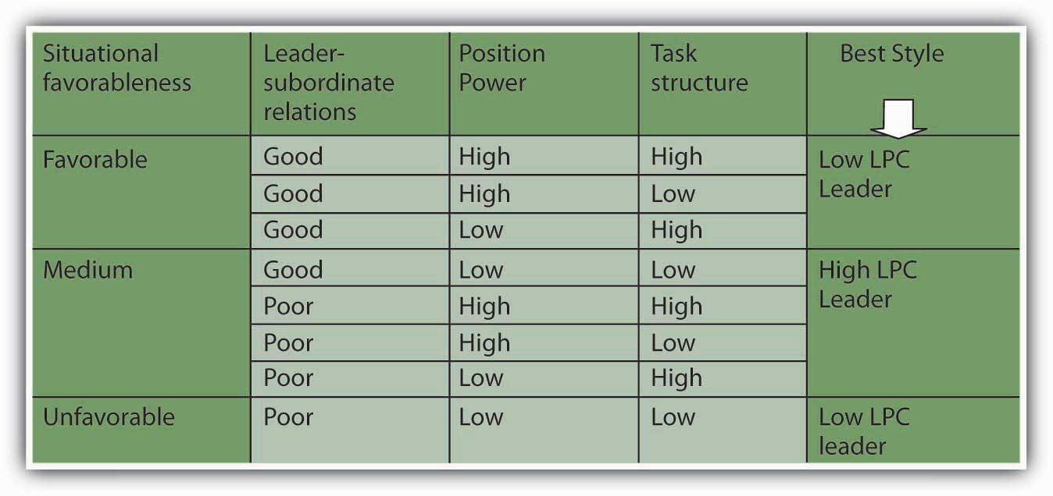
Source: Based on information in Fiedler, F. (1967). A Theory of Leadership Effectiveness. New York: McGraw-Hill; Fiedler, F. E. (1964). A contingency model of leader effectiveness. In L. Berkowitz (Ed.), Advances in Experimental Social Psychology (Vol. 1, pp. 149–190). New York: Academic Press.

Situational Leadership
Another contingency approach to leadership is Kenneth Blanchard and Paul Hersey’s Situational Leadership Theory (SLT) which argues that leaders must use different leadership styles depending on their followers’ development level.
- Hersey, P.H., Blanchard, K.H., ' Johnson, D.E. (2007). Management of Organizational Behavior: Leadership human resources. Upper Saddle River, NJ: Prentice Hall
According to this model, employee readiness (defined as a combination of their competence and commitment levels) is the key factor determining the proper leadership style. This approach has been highly popular with 14 million managers across 42 countries undergoing SLT training and 70% of Fortune 500 companies employing its use. http://www.situational.com/Views/SituationalLeadership/RightHereRightNow.aspx
The model summarizes the level of directive and supportive behaviors that leaders may exhibit. The model argues that to be effective, leaders must use the right style of behaviors at the right time in each employee’s development. It is recognized that followers are key to a leader’s success. Employees who are at the earliest stages of developing are seen as being highly committed but with low competence for the tasks. Thus, leaders should be highly directive and less supportive. As the employee becomes more competent, the leader should engage in more coaching behaviors. Supportive behaviors are recommended once the employee is at moderate to high levels of competence. And finally, delegating is the recommended approach for leaders dealing with employees who are both highly committed and highly competent. While the SLT is popular with managers, relatively easy to understand and use, and has endured for decades, research has been mixed in its support of the basic assumptions of the model.
- Blank, W., Green, S.G., ' Weitzel, J.R. (1990). A test of the situational leadership theory.Personnel Psychology, 43, 579–597
- Graeff, C. L. (1983). The situational leadership theory: A critical review. Academy of Management Review, 8, 285–291
- Fernandez, C.F., ' Vecchio, R.P. (2002). Situational leadership theory revisited: A test of an across-jobs perspective. Leadership Quarterly, 8, 67–84
Therefore, while it can be a useful way to think about matching behaviors to situations, overreliance on this model, at the exclusion of other models, is premature.

Table 10.1
Follower Readiness Level | Competence (Low) | Competence (Low) | Competence (Moderate to High) | Competence (High)
 | Commitment (High) | Commitment (Low) | Commitment (Variable) | Commitment (High)
Recommended Leader Style | Directing Behavior | Coaching Behavior | Supporting Behavior | Delegating Behavior
Situational Leadership Theory helps leaders match their style to follower readiness levels.

Path-Goal Theory of Leadership
Robert House’s path-goal theory of leadership is based on the expectancy theory of motivation.
- House, R. J. (1971). A path goal theory of leader effectiveness. Administrative Science Quarterly, 16(3), 321–338
Expectancy theory of motivation suggests that employees are motivated when they believe—or expect—that (1) their effort will lead to high performance, (2) their high performance will be rewarded, and (3) the rewards they will receive are valuable to them. According to the path-goal theory of leadership, the leader’s main job is to make sure that all three of these conditions exist. Thus, leaders will create satisfied and high-performing employees by making sure that employee effort leads to performance, and their performance is rewarded. The leader removes roadblocks along the way and creates an environment that subordinates find motivational.
The theory also makes specific predictions about what type of leader behavior will be effective under which circumstances.
- House, R. J. (1996). Path-goal theory of leadership: Lessons, legacy, and a reformulated theory. Leadership Quarterly, 7, 323–352
- House, R. J., & Mitchell, T. R. (1974). Path-goal theory of leadership. Journal of Contemporary Business, 3, 81–97
The theory identifies four leadership styles. Each of these styles can be effective, depending on the characteristics of employees (such as their ability level, preferences, locus of control, achievement motivation) and characteristics of the work environment (such as the level of role ambiguity, the degree of stress present in the environment, the degree to which the tasks are unpleasant).

Four Leadership Styles
Path-goal theory of leadership identifies four styles leaders may adopt. Directive leadersprovide specific directions to their employees. They lead employees by clarifying role expectations, setting schedules, and making sure that employees know what to do on a given workday. The theory predicts that the directive style will work well when employees are experiencing role ambiguity on the job. If people are unclear about how to go about doing their jobs, giving them specific directions will motivate them. However, if employees already have role clarity, and if they are performing boring, routine, and highly structured jobs, giving them direction does not help. In fact, it may hurt them by creating an even more restricting atmosphere. Directive leadership is also thought to be less effective when employees have high levels of ability. When managing professional employees with high levels of expertise and job-specific knowledge, telling them what to do may create a low empowerment environment, which impairs motivation.
Supportive leaders provide emotional support to employees. They treat employees well, care about them on a personal level, and are encouraging. Supportive leadership is predicted to be effective when employees are under a lot of stress or when they are performing boring and repetitive jobs. When employees know exactly how to perform their jobs but their jobs are unpleasant, supportive leadership may also be effective.
Participative leaders make sure that employees are involved in making important decisions. Participative leadership may be more effective when employees have high levels of ability and when the decisions to be made are personally relevant to them. For employees who have a high internal locus of control, or the belief that they can control their own destinies, participative leadership gives employees a way of indirectly controlling organizational decisions, which will be appreciated.
Achievement-oriented leaders set goals for employees and encourage them to reach their goals. Their style challenges employees and focuses their attention on work-related goals. This style is likely to be effective when employees have both high levels of ability and high levels of achievement motivation.

Figure 10.12 Predictions of Path-Goal Theory
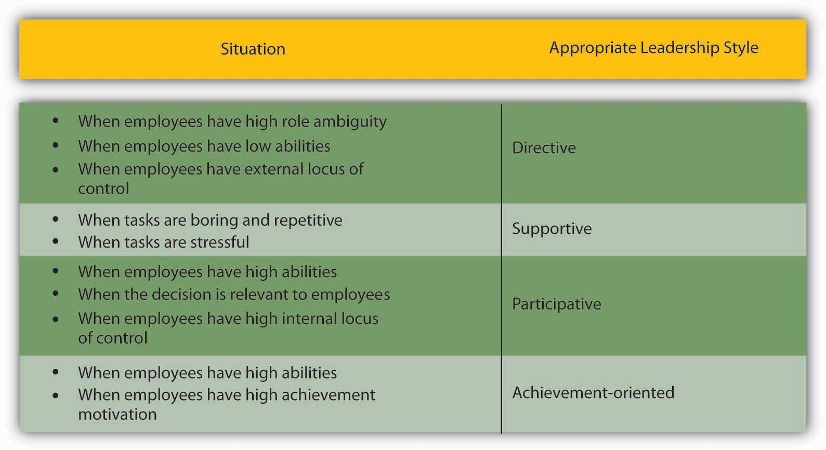
Source: On the basis of information presented in House, R. J. (1996). Path-goal theory of leadership: Lessons, legacy, and a reformulated theory. Leadership Quarterly, 7, 323–352; House, R. J., & Mitchell, T. R. (1974). Path-goal theory of leadership. Journal of Contemporary Business, 3, 81–97.
The path-goal theory of leadership has received partial but encouraging levels of support from researchers. Because the theory is highly complicated, it has not been fully and adequately tested.
- House, R. J., & Aditya, R. N. (1997). The social scientific study of leadership: Quo Vadis? Journal of Management, 23, 409–473
- Stinson, J. E., & Johnson, T. W. (1975). The path-goal theory of leadership: A partial test and suggested refinement. Academy of Management Journal, 18, 242–252
- Wofford, J. C., & Liska, L. Z. (1993). Path-goal theories of leadership: A meta-analysis. Journal of Management, 19, 857–876
The theory’s biggest contribution may be that it highlights the importance of a leader’s ability to change styles, depending on the circumstances. Unlike Fiedler’s contingency theory, in which the leader’s style is assumed to be fixed and only the environment can be changed, House’s path-goal theory underlines the importance of varying one’s style, depending on the situation.

Vroom and Yetton’s Normative Decision Model
Yale School of Management professor Victor Vroom and his colleagues Philip Yetton and Arthur Jago developed a decision-making tool to help leaders determine how much involvement they should seek when making decisions.
- Vroom, V. H. (2000). Leadership and the decision making process.Organizational Dynamics, 68, 82–94
- Vroom, V. H., & Yetton, P. W. (1973). Leadership and Decision-Making. Pittsburgh: University of Pittsburgh Press
- Jago, A., & Vroom, V. H. (1980). An evaluation of two alternatives to the Vroom/Yetton Normative Model. Academy of Management Journal, 23, 347–355
- Vroom, V. H., & Jago, A. G. 1988. The new leadership: Managing participation in organizations. Englewood Cliffs, NJ: Prentice Hall.
The model starts by having leaders answer several key questions and working their way through a funnel based on their responses.
Let’s try it. Imagine that you want to help your employees lower their stress so that you can minimize employee absenteeism. There are a number of approaches you could take to reduce employee stress, such as offering gym memberships, providing employee assistance programs, establishing a nap room, and so forth. Let’s refer to the model and start with the first question. As you answer each question as high (H) or low (L), follow the corresponding path down the funnel.
- Decision significance. The decision has high significance because the approach chosen needs to be effective at reducing employee stress for the insurance premiums to be lowered. In other words, there is a quality requirement to the decision. Follow the path through H.
- Importance of commitment. Does the leader need employee cooperation to implement the decision? In our example, the answer is high, because employees may simply ignore the resources if they do not like them. Follow the path through H.
- Leader expertise. Does the leader have all the information needed to make a high-quality decision? In our example, leader expertise is low. You do not have information regarding what your employees need or what kinds of stress reduction resources they would prefer. Follow the path through L.
- Likelihood of commitment. If the leader makes the decision alone, what is the likelihood that the employees would accept it? Let’s assume that the answer is Low. Based on the leader’s experience with this group, they would likely ignore the decision if the leader makes it alone. Follow the path from L.
- Goal alignment. Are the employee goals aligned with organizational goals? In this instance, employee and organizational goals may be aligned because you both want to ensure that employees are healthier. So let’s say the alignment is high, and follow H.
- Group expertise. Does the group have expertise in this decision-making area? The group in question has little information about which alternatives are costlier or more user friendly. We’ll say group expertise is low. Follow the path from L.
- Team competence. What is the ability of this particular team to solve the problem? Let’s imagine that this is a new team that just got together and they have little demonstrated expertise to work together effectively. We will answer this as low, or L.
Based on the answers to the questions we gave, the normative approach recommends consulting employees as a group. In other words, the leader may make the decision alone after gathering information from employees and is not advised to delegate the decision to the team or to make the decision alone with no input from the team members.

Figure 10.13
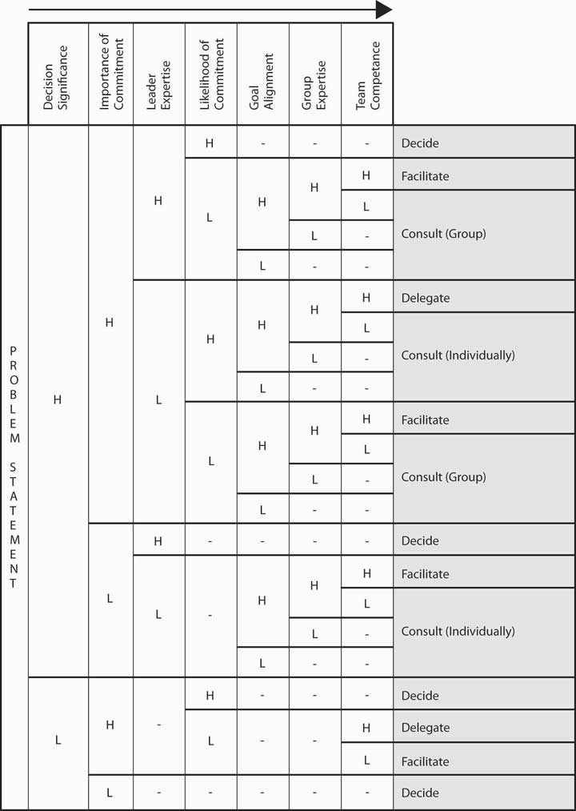
Vroom and Yetton’s leadership decision tree shows leaders which styles will be most effective in different situations.
Used by permission from Victor H. Vroom.
Vroom and Yetton’s model is somewhat complicated, but research results support the validity of the model. On average, leaders using the style recommended by the model tend to make more effective decisions compared with leaders using a style not recommended by the model.
- Vroom, V. H., & Jago, G. (1978). On the validity of the Vroom Yetton model. Journal of Applied Psychology, 63, 151–162

KEY TAKEAWAY
The contingency approaches to leadership describe the role the situation would play in choosing the most effective leadership style. Fiedler’s contingency theory argued that task-oriented leaders would be most effective when the situation was the most and the least favorable, whereas relationship-oriented leaders would be effective when situational favorableness was moderate. Situational Leadership Theory takes the maturity level of followers into account. House’s path-goal theory states that the leader’s job is to ensure that employees view their effort as leading to performance and increase the belief that performance would be rewarded. For this purpose, leaders would use directive, supportive, participative, and achievement-oriented leadership styles, depending on what employees needed to feel motivated. Vroom and Yetton’s normative decision model is a guide leaders can use to decide how participative they should be given decision environment characteristics.

EXERCISES
- Do you believe that the least preferred coworker technique is a valid method of measuring someone’s leadership style? Why or why not?
- Do you believe that leaders can vary their style to demonstrate directive, supportive, achievement-oriented and participative styles with respect to different employees? Or does each leader tend to have a personal style that he or she regularly uses toward all employees?
- What do you see as the limitations of the Vroom-Yetton leadership decision-making approach?
- Which of the leadership theories covered in this section do you think are most useful, and least useful, to practicing managers? Why?

10.5 Contemporary Approaches to Leadership

LEARNING OBJECTIVES
- Learn about the difference between transformational and transactional leaders.
- Find out about charismatic leadership and how it relates to leader performance.
- Describe how high-quality leader-subordinate relationships develop.
- Define servant leadership and evaluate its potential for leadership effectiveness.
- Define authentic leadership and evaluate its potential for leadership effectiveness.
What leadership theories make the greatest contributions to today’s business environment? In this section, we will review the most recent developments in the field of leadership.

Transformational Leadership
Transformational leadership theory is a recent addition to the literature, but more research has been conducted on this theory than all the contingency theories combined. The theory distinguishes between transformational and transactional leaders. Transformational leaders lead employees by aligning employee goals with the leader’s goals. Thus, employees working for transformational leaders start focusing on the company’s well-being rather than on what is best for them as individual employees. However, transactional leaders ensure that employees demonstrate the right behaviors because the leader provides resources in exchange.
- Bass, B. M. (1985). Leadership and performance beyond expectations. New York: Free Press; Burns, J. M. (1978). Leadership. New York: Harper & Row.
Transformational leaders have four tools in their possession, which they use to influence employees and create commitment to the company goals.
- Bass, B. M. (1985). Leadership and performance beyond expectations. New York: Free Press
- Burns, J. M. (1978). Leadership. New York: Harper & Row; Bycio, P., Hackett, R. D., & Allen, J. S. (1995)
Further assessment of Bass’s (1985) conceptualization of transactional and transformational leadership.
- Journal of Applied Psychology, 80, 468–478
- Judge, T. A., & Piccolo, R. F. (2004). Transformational and transactional leadership: A meta-analytic test of their relative validity. Journal of Applied Psychology, 89, 755–768
First, transformational leaders are charismatic. Charisma refers to behaviors leaders demonstrate that inspire confidence, commitment, and admiration toward the leader.
- Shamir, B., House, R. J., & Arthur, M. B. (1993). The motivational effects of charismatic leadership: A self-concept based theory. Organization Science, 4, 577–594
Charismatic individuals have a “magnetic” personality that is appealing to followers. Leaders such as Barack Obama, John F. Kennedy, Ronald Reagan, Mahatma Gandhi, Mustafa Kemal Ataturk (founder of the Republic of Turkey), and Winston Churchill are viewed as charismatic. Second, transformational leaders use inspirational motivation or come up with a vision that is inspiring to others. Third is the use of intellectual stimulation, which means that they challenge organizational norms and status quo, and they encourage employees to think creatively and work harder. Finally, they useindividualized consideration, which means that they show personal care and concern for the well-being of their followers. Examples of transformational business leaders include Steve Jobs of Apple; Lee Iacocca, who transformed Chrysler in the 1980s; and Jack Welch, who was the CEO of General Electric for 20 years. Each of these leaders is charismatic and is held responsible for the turnarounds of their companies.
While transformational leaders rely on their charisma, persuasiveness, and personal appeal to change and inspire their companies, transactional leaders use three other methods. Contingent rewardsmean rewarding employees for their accomplishments. Active management by exception involves leaving employees to do their jobs without interference, but at the same time proactively predicting potential problems and preventing them from occurring. Passive management by exception is similar in that it involves leaving employees alone, but in this method, the manager waits until something goes wrong before coming to the rescue.
Which leadership style do you think is more effective, transformational or transactional? Research shows that transformational leadership is a powerful influence over leader effectiveness as well as employee satisfaction.
- Judge, T. A., & Piccolo, R. F. (2004). Transformational and transactional leadership: A meta-analytic test of their relative validity. Journal of Applied Psychology, 89, 755–768
In fact, transformational leaders increase the intrinsic motivation of their followers, build more effective relationships with employees, increase performance and creativity of their followers, increase team performance, and create higher levels of commitment to organizational change efforts.
- Herold, D. M., Fedor, D. B., Caldwell, S., Liu, Y. (2008). The effects of transformational and change leadership on employees’ commitment to a change: A multilevel study. Journal of Applied Psychology, 93, 346–357
- Piccolo, R. F., & Colquitt, J. A. (2006). Transformational leadership and job behaviors: The mediating role of core job characteristics. Academy of Management Journal, 49, 327–340
- Schaubroeck, J., Lam, S. K., & Cha, S. E. (2007). Embracing transformational leadership: Team values and the impact of leader behavior on team performance. Journal of Applied Psychology, 92, 1020–1030
- Shin, S. J., & Zhou, J. (2003). Transformational leadership, conservation, and creativity: Evidence from Korea.Academy of Management Journal, 46, 703–714
- Wang, H., Law, K. S., Hackett, R. D., Duanxu, W., Zhen, X. C. (2005). Leader-member exchange as a mediator of the relationship between transformational leadership and followers’ performance and organizational citizenship behavior.Academy of Management Journal, 48, 420–432
However, except for passive management by exception, the transactional leadership styles are also effective, and they also have positive influences over leader performance as well as employee attitudes.
- Judge, T. A., & Piccolo, R. F. (2004). Transformational and transactional leadership: A meta-analytic test of their relative validity. Journal of Applied Psychology, 89, 755–768
To maximize their effectiveness, leaders are encouraged to demonstrate both transformational and transactional styles. They should also monitor themselves to avoid demonstrating passive management by exception or leaving employees to their own devices until problems arise.
Why is transformational leadership more effective? The key factor may be trust. Trust is the belief that the leader will show integrity, fairness, and predictability in his or her dealings with others. Research shows that when leaders demonstrate transformational leadership behaviors, followers are more likely to trust the leader. The tendency to trust in transactional leaders is substantially lower. Because transformational leaders express greater levels of concern for people’s well-being, and appeal to people’s values, followers are more likely to believe that the leader has a trustworthy character.
- Dirks, K. T., & Ferrin, D. L. (2002). Trust in leadership: Meta-analytic findings and implications for research and practice. Journal of Applied Psychology, 87, 611–628
Is transformational leadership genetic? Some people assume that charisma is something people are born with. You either have charisma or you don’t. However, research does not support this idea. We must acknowledge that there is a connection between some personality traits and charisma. Specifically, people who have a neurotic personality tend to demonstrate lower levels of charisma, and people who are extraverted tend to have higher levels of charisma. However, personality explains only around 10% of the variance in charisma.
- Bono, J. E., & Judge, T. A. (2004). Personality and transformational and transactional leadership: A meta-analysis. Journal of Applied Psychology, 89, 901–910
A large body of research has shown that it is possible to train people to increase their charisma and increase their transformational leadership.
- Barling, J., Weber, T., & Kelloway, E. K. (1996). Effects of transformational leadership training on attitudinal and financial outcomes: A field experiment. Journal of Applied Psychology, 81, 827–832
- Dvir, T., Eden, D., Avolio, B. J., & Shamir, B. (2002). Impact of transformational leadership on follower development and performance: A field experiment. Academy of Management Journal, 45, 735–744
- Frese, M., Beimel, S., & Schoenborg, S. (2003). Action training for charismatic leadership: Two evaluations of studies of a commercial training module on inspirational communication of a vision. Personnel Psychology, 56, 671–697

Figure 10.14
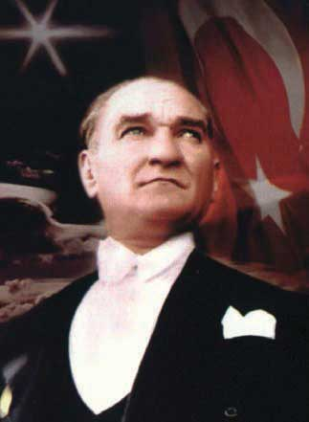
Mustafa Kemal Ataturk, the founder of Turkish Republic and its first president, is known as a charismatic leader. He is widely admired and respected in Turkey and around the world. His picture appears in all schools, state buildings, denominations of Turkish lira, and in many people’s homes in Turkey.
Source:http://commons.wikimedia.org/wiki/File:Ataturk_and_flag_of_Turkey.jpg
Even if charisma may be teachable, a more fundamental question remains: is it really needed? Charisma is only one element of transformational leadership and leaders can be effective without charisma. In fact, charisma has a dark side. For every charismatic hero such as Lee Iacocca, Steve Jobs, and Virgin’s Sir Richard Branson, there are charismatic personalities who harmed their organizations or nations, such as Adolph Hitler of Germany and Jeff Skilling of Enron. Leadership experts warn that when organizations are in a crisis, a board of directors or hiring manager may turn to heroes who they hope will save the organization and sometimes hire people who have no other particular qualifications outside of perceived charisma.
- Khurana, R. (September 2002). The curse of the superstar CEO. Harvard Business Review, 80(9), 60–66
An interesting study shows that when companies have performed well, their CEOs are perceived as charismatic, but CEO charisma has no relation to the future performance of a company.
- Agle, B. R., Nagarajan, N. J., Sonnenfeld, J. A., & Srinivasan, D. (2006)
Does CEO charisma matter? An empirical analysis of the relationships among organizational performance, environmental uncertainty, and top management team perceptions of CEO charisma.
- Academy of Management Journal, 49, 161–174
So, what we view as someone’s charisma may be largely because of their association with a successful company, and the success of a company depends on a large set of factors, including industry effects and historical performance. While it is true that charismatic leaders may sometimes achieve great results, the search for charismatic leaders under all circumstances may be irrational.

Leader-Member Exchange Theory
Leader-member exchange (LMX) theory proposes that the type of relationship leaders have with their followers (members of the organization) is the key to understanding how leaders influence employees. Leaders form different types of relationships with their employees. In high-quality LMX relationships, the leader forms a trust-based relationship with the member. The leader and member like each other, help each other when needed, and respect one another. In these relationships, the leader and the member are both ready to go above and beyond their job descriptions to promote the other’s ability to succeed. In contrast, in low-quality LMX relationships, the leader and the member have lower levels of trust, liking, and respect toward each other. These relationships do not have to involve actively disliking each other, but the leader and member do not go beyond their formal job descriptions in their exchanges. In other words, the member does his or her job, the leader provides rewards and punishments, and the relationship does not involve high levels of loyalty or obligation toward each other.
- Dansereau, F., Jr., Graen, G., & Haga, W. J. (1975). A vertical dyad linkage approach to leadership within formal organizations: A longitudinal investigation of the role making process.Organizational Behavior & Human Performance, 13(1), 46–78
- Erdogan, B., & Liden, R. C. (2002). Social exchanges in the workplace: A review of recent developments and future research directions in leader-member exchange theory. In L. L. Neider & C. A. Schriesheim (Eds.), Leadership (pp. 65–114). Greenwich, CT: Information Age Press
- Gerstner, C. R., & Day, D. V. (1997). Meta-analytic review of leader-member exchange theory: Correlates and construct issues. Journal of Applied Psychology, 82, 827–844
- Graen, G. B., & Uhl-Bien, M. (1995). Relationship-based approach to leadership: Development of leader-member exchange (LMX) theory over 25 years: Applying a multi-level multi-domain perspective. Leadership Quarterly, 6(2), 219–247
- Liden, R. C., & Maslyn, J. M. (1998). Multidimensionality of leader-member exchange: An empirical assessment through scale development. Journal of Management, 24, 43–72

Figure 10.15 Factors Contributing to the Development of a High-Quality Leader-Member Exchange and Its Consequences
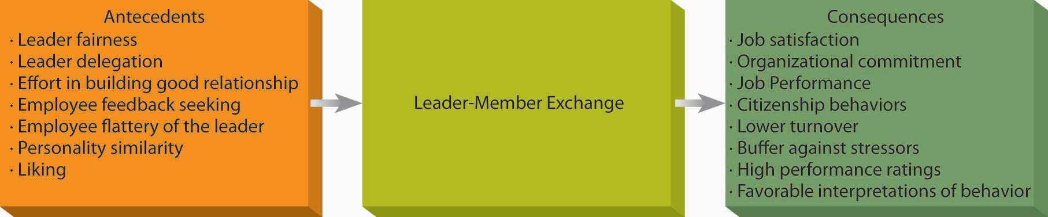
If you have work experience, you may have witnessed the different types of relationships managers form with their employees. In fact, many leaders end up developing differentiated relationships with their followers. Within the same work group, they may have in-group members who are close to them and out-group members who are more distant. If you have ever been in a high-quality LMX relationship with your manager, you may attest to its advantages. Research shows that high-quality LMX members are more satisfied with their jobs, more committed to their companies, have higher levels of clarity about what is expected of them, and perform at a higher level.
- Gerstner, C. R., & Day, D. V. (1997). Meta-analytic review of leader-member exchange theory: Correlates and construct issues. Journal of Applied Psychology, 82, 827–844
- Hui, C., Law, K. S., & Chen, Z. X. (1999). A structural equation model of the effects of negative affectivity, leader-member exchange, and perceived job mobility on in-role and extra-role performance: A Chinese case. Organizational Behavior and Human Decision Processes, 77, 3–21
- Kraimer, M. L., Wayne, S. J., & Jaworski, R. A. (2001). Sources of support and expatriate performance: The mediating role of expatriate adjustment. Personnel Psychology, 54, 71–99
- Liden, R. C., Wayne, S. J., & Sparrowe, R. T. (2000). An examination of the mediating role of psychological empowerment on the relations between the job, interpersonal relationships, and work outcomes.Journal of Applied Psychology, 85, 407–416
- Settoon, R. P., Bennett, N., & Liden, R. C. (1996). Social exchange in organizations: Perceived organizational support, leader-member exchange, and employee reciprocity. Journal of Applied Psychology, 81, 219–227
- Tierney, P., Farmer, S. M., & Graen, G. B. (1999). An examination of leadership and employee creativity: The relevance of traits and relationships.Personnel Psychology, 52, 591–620
- Wayne, S. J., Shore, L. M., & Liden. R. C. (1997). Perceived organizational support and leader-member exchange: A social exchange perspective. Academy of Management Journal, 40, 82–111
Their high levels of performance may not be a surprise because they may receive higher levels of resources and help from their managers as well as more information and guidance. If they have questions, these employees feel more comfortable seeking feedback or information.
- Chen, Z., Lam, W., & Zhong, J. A. (2007). Leader-member exchange and member performance: A new look at individual-level negative feedback seeking behavior and team-level empowerment climate. Journal of Applied Psychology, 92, 202–212
Because of all the help, support, and guidance they receive, those employees who have a good relationship with the manager are in a better position to perform well. Given all they receive, these employees are motivated to reciprocate to the manager, and therefore they demonstrate higher levels of citizenship behaviors such as helping the leader and coworkers.
- Ilies, R., Nahrgang, J. D., & Morgeson, F. P. (2007). Leader-member exchange and citizenship behaviors: A meta-analysis. Journal of Applied Psychology, 92, 269–277
Being in a high-quality LMX relationship is also advantageous because a high-quality relationship is a buffer against many stressors, such as being a misfit in a company, having personality traits that do not match job demands, and having unmet expectations.
- Bauer, T. N., Erdogan, B., Liden, R. C., & Wayne, S. J. (2006). A longitudinal study of the moderating role of extraversion: Leader-member exchange, performance, and turnover during new executive development. Journal of Applied Psychology, 91, 298–310
- Erdogan, B., Kraimer, M. L., & Liden, R. C. (2004). Work value congruence and intrinsic career success. Personnel Psychology, 57, 305–332
- Major, D. A., Kozlowski, S. W., Chao, G. T., Gardner, P. D. (1995). A longitudinal investigation of newcomer expectations, early socialization outcomes, and the moderating effects of role development factors. Journal of Applied Psychology, 80, 418–431
The list of benefits high-quality LMX employees receive is long, and it is not surprising that these employees are less likely to leave their jobs.
- Ferris, G. R. (1985). Role of leadership in the employee withdrawal process: A constructive replication. Journal of Applied Psychology, 70, 777–781
- Graen, G. B., Liden, R. C., & Hoel, W. (1982). Role of leadership in the employee withdrawal process.Journal of Applied Psychology, 67, 868–872
The problem, of course, is that not all employees have a high-quality relationship, and those who are in the leader’s out-group may suffer as a result. But how do you end up developing such a high-quality relationship with the leader? That seems to depend on many factors. Managers can help develop such a high-quality and trust-based relationship by treating their employees in a fair and dignified manner.
- Masterson, S. S., Lewis, K., Goldman, B. M., & Taylor, M. S. (2000). Integrating justice and social exchange: The differing effects of fair procedures and treatment on work relationships. Academy of Management Journal, 43, 738–748
They can also test to see whether the employee is trustworthy by delegating certain tasks when the employee first starts working with the manager.
- Bauer, T. N., & Green, S. G. (1996). Development of a leader-member exchange: A longitudinal test. Academy of Management Journal, 39, 1538–1567
Employees also have an active role in developing the relationship. Employees can seek feedback to improve their performance, be open to learning new things on the job, and engage in political behaviors such as flattery.
- Colella, A., & Varma, A. (2001). The impact of subordinate disability on leader-member exchange relationships. Academy of Management Journal, 44, 304–315
- Maslyn, J. M., & Uhl-Bien, M. (2001). Leader-member exchange and its dimensions: Effects of self-effort and other’s effort on relationship quality, Journal of Applied Psychology, 86, 697–708
- Janssen, O., & Van Yperen, N. W. (2004). Employees’ goal orientations, the quality of leader-member exchange, and the outcomes of job performance and job satisfaction. Academy of Management Journal, 47, 368–384
- Wing, L., Xu, H., & Snape, E. (2007). Feedback-seeking behavior and leader-member exchange: Do supervisor-attributed motives matter? Academy of Management Journal, 50, 348–363
Interestingly, high performance on the employee’s part does not seem to be enough to develop a high-quality exchange with the leader. Instead, interpersonal factors such as personality similarity and liking are more powerful influences over how the relationship develops.
- Engle, E. M., & Lord, R. G. (1997). Implicit theories, self-schemas, and leader-member exchange. Academy of Management Journal, 40, 988–1010
- Liden, R. C., Wayne, S. J., & Stilwell, D. (1993). A longitudinal study on the early development of leader-member exchanges. Journal of Applied Psychology, 78, 662–674
- Wayne, S. J., Shore, L. M., & Liden. R. C. (1997). Perceived organizational support and leader-member exchange: A social exchange perspective. Academy of Management Journal, 40, 82–111
Finally, the relationship development occurs in a slightly different manner in different types of companies; corporate culture matters in how leaders develop these relationships. In performance-oriented cultures, how the leader distributes rewards seem to be the relevant factor, whereas in people-oriented cultures, whether the leader treats people with dignity is more relevant.
- Erdogan, B., Liden, R. C., & Kraimer, M. L. (2006). Justice and leader-member exchange: The moderating role of organizational culture. Academy of Management Journal, 49, 395–406
Should you worry if you do not have a high-quality relationship with your manager? One problem in a low-quality exchange is that you may not have access to the positive work environment available to the high-quality LMX members. Second, low LMX employees may feel that their situation is unfair. Even when their objective performance does not warrant it, those who have a good relationship with the leader tend to receive positive performance appraisals.
- Duarte, N. T., Goodson, J. R., & Klich, N. R. (1994). Effects of dyadic quality and duration on performance appraisal. Academy of Management Journal, 37, 499–521
Moreover, they are more likely to be given the benefit of the doubt. For example, when they succeed, the manager is more likely to think that they succeeded because they put forth a lot of effort and they had high abilities, whereas for low LMX members who perform objectively well, the manager is less likely to think so.
- Heneman, R. L., Greenberger, D. B., & Anonyuo, C. (1989). Attributions and exchanges: The effects of interpersonal factors on the diagnosis of employee performance. Academy of Management Journal, 32, 466–476
In other words, the leader may interpret the same situation differently, depending on which employee is involved and may reward low LMX employees less even when they are performing well. In short, those with a low-quality relationship with the leader may experience a work environment that may not be very supportive or fair.
Despite its negative consequences, we cannot say that all employees want to have a high-quality relationship with the leader. Some employees may genuinely dislike the leader and may not value the rewards in the leader’s possession. If the leader is not well liked in the company and is known as abusive or unethical, being close to such a person may imply guilt by association. For employees who have no interest in advancing their careers in the current company (such as a student employee who is working in retail but has no interest in retail as a career), having a low-quality exchange may afford the opportunity to just do one’s job without having to go above and beyond these job requirements. Finally, not all leaders are equally capable of influencing their employees by having a good relationship with their employees: It also depends on the power and influence of the leader in the overall company and how the leader himself or herself is treated within the company. Leaders who are more powerful will have more to share with employees who are close to them.
- Erdogan, B., & Enders, J. (2007). Support from the top: Supervisors’ perceived organizational support as a moderator of leader-member exchange to satisfaction and performance relationships. Journal of Applied Psychology, 92, 321–330
- Sparrowe, R. T., & Liden, R. C. (2005). Two routes to influence: Integrating leader-member exchange and social network perspectives. Administrative Science Quarterly, 50, 505–535
- Tangirala, S., Green, S. G., & Ramanujam, R. (2007). In the shadow of the boss’s boss: Effects of supervisors’ upward exchange relationships on employees. Journal of Applied Psychology, 92, 309–320
What LMX theory implies for leaders is that one way of influencing employees is through the types of relationships leaders form with their employees. These relationships develop naturally because of the work-related and personal interactions between the manager and the employee. Because they occur naturally, some leaders may not be aware of the power that lies in them. These relationships have an important influence over employee attitudes and behaviors. In the worst case, they have the potential to create a negative work environment characterized by favoritism and unfairness. Therefore, managers are advised to be aware of how they build these relationships; put forth effort in cultivating these relationships consciously; be open to forming good relationships to people from all backgrounds regardless of their permanent characteristics such as sex, race, age, or disability status; and prevent these relationships from leading to an unfair work environment.

Self-Assessment: Rate Your LMX
Answer the following questions using 1 = not at all, 2 = somewhat, 3 = fully agree
- _____ I like my supervisor very much as a person.
- _____ My supervisor is the kind of person one would like to have as a friend.
- _____ My supervisor is a lot of fun to work with.
- _____ My supervisor defends my work actions to a superior, even without complete knowledge of the issue in question.
- _____ My supervisor would come to my defense if I were “attacked” by others.
- _____ My supervisor would defend me to others in the organization if I made an honest mistake.
- _____ I do work for my supervisor that goes beyond what is specified in my job description.
- _____ I am willing to apply extra efforts, beyond those normally required, to further the interests of my work group.
- _____ I do not mind working my hardest for my supervisor.
- _____ I am impressed with my supervisor’s knowledge of his/her job.
- _____ I respect my supervisor’s knowledge of and competence on the job.
- _____ I admire my supervisor’s professional skills.
Scoring:
Add your score for 1, 2, 3 = _____ This is your score on the Liking factor of LMX.
A score of 3 to 4 indicates a low LMX in terms of liking. A score of 5 to 6 indicates an average LMX in terms of liking. A score of 7+ indicates a high-quality LMX in terms of liking.
Add your score for 4, 5, 6 = _____ This is your score on the Loyalty factor of LMX.
A score of 3 to 4 indicates a low LMX in terms of loyalty. A score of 5 to 6 indicates an average LMX in terms of loyalty. A score of 7+ indicates a high-quality LMX in terms of loyalty.
Add your score for 7, 8, 9 = _____ This is your score on the Contribution factor of LMX.
A score of 3 to 4 indicates a low LMX in terms of contribution. A score of 5 to 6 indicates an average LMX in terms of contribution. A score of 7+ indicates a high-quality LMX in terms of contribution.
Add your score for 10, 11, 12 = _____ This is your score on the Professional Respect factor of LMX.
A score of 3 to 4 indicates a low LMX in terms of professional respect. A score of 5 to 6 indicates an average LMX in terms of professional respect. A score of 7+ indicates a high-quality LMX in terms of professional respect.
Adapted from:
- Liden, R. C., & Maslyn, J. M. (1998). Multidimensionality of leader-member exchange: An empirical assessment through scale development. Journal of Management, 24, 43–72
Used by permission of Sage Publications.

Servant Leadership
The early 21st century has been marked by a series of highly publicized corporate ethics scandals: between 2000 and 2003, we witnessed Enron, WorldCom, Arthur Andersen, Qwest, and Global Crossing shake investor confidence in corporations and leaders. The importance of ethical leadership and keeping long-term interests of stakeholders in mind is becoming more widely acknowledged.
Servant leadership approach defines the leader’s role as serving the needs of others. According to this approach, the primary mission of the leader is to develop employees and help them reach their goals. Servant leaders put their employees first, understand their personal needs and desires, empower them, and help them develop in their careers. Unlike mainstream management approaches, the overriding objective in servant leadership is not necessarily getting employees to contribute to organizational goals. Instead, servant leaders feel an obligation to their employees, customers, and the external community. Employee happiness is seen as an end in itself, and servant leaders sometimes sacrifice their own well-being to help employees succeed. In addition to a clear focus on having a moral compass, servant leaders are also interested in serving the community. In other words, their efforts to help others are not restricted to company insiders, and they are genuinely concerned about the broader community surrounding their company.
- Greenleaf, R. K. (1977). Servant leadership: A journey into the nature of legitimate power and greatness (p. 335). Mahwah, NJ: Paulist Press
- Liden, R. C., Wayne, S., J., Zhao, H., & Henderson, D. (2008). Servant leadership: Development of a multidimensional measure and multi-level assessment. Leadership Quarterly, 19, 161–177
According to historian Doris Kearns Goodwin, Abraham Lincoln was a servant leader because of his balance of social conscience, empathy, and generosity.
- Goodwin, D. K. (2005, June 26). The master of the game. Time. Retrieved November 20, 2008, from http://www.time.com/time/printout/0,8816,1077300,00.html
Even though servant leadership has some overlap with other leadership approaches such as transformational leadership, its explicit focus on ethics, community development, and self-sacrifice are distinct characteristics of this leadership style. Research shows that servant leadership has a positive effect on employee commitment, employee citizenship behaviors toward the community (such as participating in community volunteering), and job performance.
- Liden, R. C., Wayne, S., J., Zhao, H., & Henderson, D. (2008). Servant leadership: Development of a multidimensional measure and multi-level assessment. Leadership Quarterly, 19, 161–177
Leaders who follow the servant leadership approach create a climate of fairness in their departments, which leads to higher levels of interpersonal helping behavior.
- Ehrhart, M. G. (2004). Leadership and procedural justice climate as antecedents of unit-level organizational citizenship behavior. Personnel Psychology, 57, 61–94
Servant leadership is a tough transition for many managers who are socialized to put their own needs first, be driven by success, and tell people what to do. In fact, many of today’s corporate leaders are not known for their humility! However, leaders who have adopted this approach attest to its effectiveness. David Wolfskehl, of Action Fast Print in New Jersey, founded his printing company when he was 24. He marks the day he started asking employees what he can do for them as the beginning of his company’s new culture. In the next two years, his company increased its productivity by 30%.
- Buchanan, L. (May, 2007). In praise of selflessness: Why the best leaders are servants. Inc, 29(5), 33–35

Authentic Leadership
Leaders have to be a lot of things to a lot of people. They operate within different structures, work with different types of people, and they have to be adaptable. At times, it may seem that a leader’s smartest strategy would be to act as a social chameleon, changing his or her style whenever doing so seems advantageous. But this would lose sight of the fact that effective leaders have to stay true to themselves. The authentic leadership approach embraces this value: its key advice is “be yourself.” Think about it: We all have different backgrounds, different life experiences, and different role models. These trigger events over the course of our lifetime that shape our values, preferences, and priorities. Instead of trying to fit into societal expectations about what a leader should be like, act like, or look like, authentic leaders derive their strength from their own past experiences. Thus, one key characteristic of authentic leaders is that they are self-aware. They are introspective, understand where they are coming from, and have a thorough understanding of their own values and priorities. Second, they are not afraid to act the way they are. In other words, they have high levels of personal integrity. They say what they think. They behave in a way consistent with their values—they practice what they preach. Instead of trying to imitate other great leaders, they find their style in their own personality and life experiences.
- Avolio, B. J., & Gardner, W. L. (2005). Authentic leadership development: Getting to the root of positive forms of leadership. Leadership Quarterly, 16, 315–338
- Gardner, W. L., Avolio, B. J., Luthans, F., May, D. R., & Walumbwa, F. (2005). “Can you see the real me?” A self-based model of authentic leader and follower development. Leadership Quarterly, 16, 343–372
- George, B. (2007). Authentic leaders: They inspire and empower others. Leadership Excellence, 24(9), 16–17
- Ilies, R., Morgeson, F. P., & Nahrgang, J. D. (2005). Authentic leadership and eudaemonic well-being: Understanding leader-follower outcomes. Leadership Quarterly, 16, 373–394
- Sparrowe, R. T. (2005). Authentic leadership and the narrative self. Leadership Quarterly, 16, 419–439
One example of an authentic leader is Howard Schultz, the founder of Starbucks coffeehouses. As a child, Schultz witnessed the job-related difficulties his father experienced because of medical problems. Even though he had no idea he would have his own business one day, the desire to protect people was shaped in those years and became one of his foremost values. When he founded Starbucks, he became an industry pioneer in providing health insurance and retirement coverage to part-time as well as full-time employees.
- Shamir, B., & Eilam, G. (2005). What’s your story? A life-stories approach to authentic leadership development. Leadership Quarterly, 16, 395–417

Figure 10.16
An example of an authentic leader is Howard Schultz, the founder of Starbucks coffeehouses. Witnessing his father losing jobs because of medical problems, he became passionate about a company’s need to care for its employees.
Source:http://upload.wikimedia.org/wikipedia/commons/archive/a/ae/20081006001508!Howard-Schultz-Starbucks.jpg
Authentic leadership requires understanding oneself. Therefore, in addition to self-reflection, feedback from others is needed to gain a true understanding of one’s behavior and effect on others. Authentic leadership is viewed as a potentially influential style because employees are more likely to trust such a leader. Moreover, working for authentic leaders is likely to lead to greater levels of satisfaction, performance, and overall well-being on the part of employees.
- Walumbwa, F. O., Avolio, B. J., Gardner, W. L., Wernsing, T. S., & Peterson, S. J. (2008). Authentic leadership: Development and validation of a theory-based measure. Journal of Management, 34, 89–126
Best-selling author Jim Collins studied companies that had, in his opinion, gone from good to great, and he found they had one thing in common.
- Collins, J. (2001). Good to great: Why some companies make the leap…and others don’t. London: Random House Business Books
All of these companies had what he calls Level 5 leaders who build organizations through their personal humility and professional will. He notes that Level 5 leaders are modest and understated. In many ways, they can be seen as truly authentic leaders.

KEY TAKEAWAY
Contemporary approaches to leadership include transformational leadership, leader-member exchange, servant leadership, and authentic leadership. The transformational leadership approach highlights the importance of leader charisma, inspirational motivation, intellectual stimulation, and individualized consideration as methods of influence. Its counterpart is the transactional leadership approach, in which the leader focuses on getting employees to achieve organizational goals. According to leader-member exchange (LMX) approach, the unique, trust-based relationships leaders develop with employees is the key to leadership effectiveness. Recently, leadership scholars started to emphasize the importance of serving others and adopting a customer-oriented view in leadership; another recent focus is on the importance of being true to oneself as a leader. While each leadership approach focuses on a different element of leadership, effective leaders will need to change their style based on the demands of the situation as well as using their own values and moral compass.

EXERCISES
- What are the characteristics of transformational leaders? Are transformational leaders more effective than transactional leaders?
- What is charisma? What are the advantages and disadvantages of charismatic leadership? Should organizations look for charismatic leaders when selecting managers?
- What are the differences (if any) between a leader having a high-quality exchange with employees and being friends with employees?
- What does it mean to be a servant leader? Do you know any leaders whose style resembles servant leaders? What are the advantages of adopting such a leadership style?
- What does it mean to be an authentic leader? How would such a style be developed?

10.6 Developing Your Leadership Skills

LEARNING OBJECTIVES
- Develop your charismatic leadership.
- Learn how to be a servant leader.
- Follow a process to develop your own authentic leadership.

Figure 10.17
The CEO of PepsiCo, Indra Nooyi, is a leader who demonstrates passion for her vision and energizes those around her toward her vision for the company and causes she believes in.
Source:http://en.wikipedia.org/wiki/Image:Indra_Nooyi _-_World_Economic_Forum_Annual _Meeting_Davos_2008.jpg
In this section, we will give you tips to help you develop your charismatic, servant, and authentic leadership skills. Each of these contemporary approaches to leadership is believed to be related to employee attitudes and a healthy work environment.

Develop Your Charismatic Leadership Skills
Charismatic individuals have a “magnetic” personality that is appealing to followers. While many people assume that charisma is inborn, it is possible to improve your charisma by following these suggestions:
Have a vision around which people can gather. When framing requests or addressing to others, instead of emphasizing short-term goals, stress the importance of the long-term vision. When giving a message, think about the overarching purpose. What is the ultimate goal? Why should people care? What are you trying to achieve?
Tie the vision to history. In addition to stressing the ideal future, charismatic leaders bring up the history and how the shared history ties to the future.
Watch your body language. Charismatic leaders are energetic and passionate about their ideas. This involves truly believing in your own ideas. When talking to others, you may want to look confident, look them in the eye, and express your belief in your ideas.
Make sure that employees have confidence in themselves. You can achieve this by showing that you believe in them and trust their abilities. If they have real reason to doubt their abilities, make sure that you help them address the underlying issue, such as through training and mentoring.
Challenge the status quo. Charismatic leaders solve current problems by radically rethinking the way things are done and suggesting alternatives that are risky, novel, and unconventional.

- Frese, M., Beimel, S., & Schoenborg, S. (2003). Action training for charismatic leadership: Two evaluations of studies of a commercial training module on inspirational communication of a vision. Personnel Psychology, 56, 671–697
- Shamir, B., House, R. J., & Arthur, M. B. (1993). The motivational effects of charismatic leadership: A self-concept based theory. Organization Science, 4, 577–594

Develop Your Servant Leadership Skills
One of the influential leadership paradigms involves leaders putting others first. This could be a hard transition for an achievement-oriented and success-driven manager who rises to high levels. Here are some tips to achieve servant leadership.
Don’t ask what your employees can do for you. Think of what you can do for them. Your job as a leader is to be of service to them. How can you relieve their stress? Protect them from undue pressure? Pitch in to help them? Think about creative ways of helping ease their lives.
One of your key priorities should be to help employees reach their goals. This involves getting to know them. Learn about who they are and what their values and priorities are.
Be humble. You are not supposed to have all the answers and dictate to others. One way of achieving this humbleness may be to do volunteer work.
Be open with your employees. Ask them questions. Give them information so that they understand what is going on in the company.
Find ways of helping the external community. Giving employees opportunities to be involved in community volunteer projects or even thinking and strategizing about making a positive impact on the greater community would help.

- Buchanan, L. (May, 2007). In praise of selflessness: Why the best leaders are servants. Inc, 29(5), 33–35
- Douglas, M. E. (2005, March). Service to others. Supervision, 66(3), 6–9
- Ramsey, R. D. (2005, October). The new buzz word. Supervision, 66(10), 3–5

Develop Your Authentic Leadership Skills
Authentic leaders have high levels of self-awareness and their behavior is driven by their core personal values. This leadership approach recognizes the importance of self-reflection and understanding one’s life history. Address the following questions to gain a better understanding of your own core values and authentic leadership style.

Understand Your History
- Review your life history. What are the major events in your life? How did these events make you the person you are right now?
- Think about your role models. Who were your role models as you were growing up? What did you learn from your role models?

Take Stock of Who You Are Now
- Describe your personality. How does your personality affect your life?
- Know your strengths and weaknesses. What are they and how can you continue to improve yourself?

Reflect on Your Successes and Challenges
- Keep a journal. Research shows that journaling is an effective tool for self-reflection. Write down challenges you face and how you will surmount them; periodically review your entries to check your progress.

Make Integrity a Priority
- Understand your core values. What are your core values? Name three of your most important values.
- Do an ethics check. Are you being consistent with your core values? If not, how can you get back on track?

Understand the Power of Words
- Words shape reality. Keep in mind that the words you use to describe people and situations matter. For example, how might the daily reality be different if you refer to those you manage as associates or team members rather than employees or subordinates?
In view of your answers to the questions above, what kind of a leader would you be if you truly acted out your values? How would people working with you respond to such a leadership style?

KEY TAKEAWAY
The various leadership styles have their pros and cons. It is valuable to be able to assess them in light of your situation and your personal style. Authenticity has become recognized as being important regardless of the other leadership styles one uses. Anyone can be an authentic leader if he or she develops those skills. There is no time like the present to start!

EXERCISES
- What is the connection between leadership and ethics?
- Do you believe that ethical leaders are more successful in organizations?
- Have you ever had an authentic leader? What did this person do that made you consider him or her to be authentic? How effective was his or her leadership?

Chapter 11

Decision Making

WHAT’S IN IT FOR ME?
Reading this chapter will help you do the following:
- Understand what decision making is.
- Know key causes of faulty decision making.
- Compare and contrast individual and group decision making.
- Understand how to develop your own personal decision-making skills.

Figure 11.2 The P-O-L-C Framework
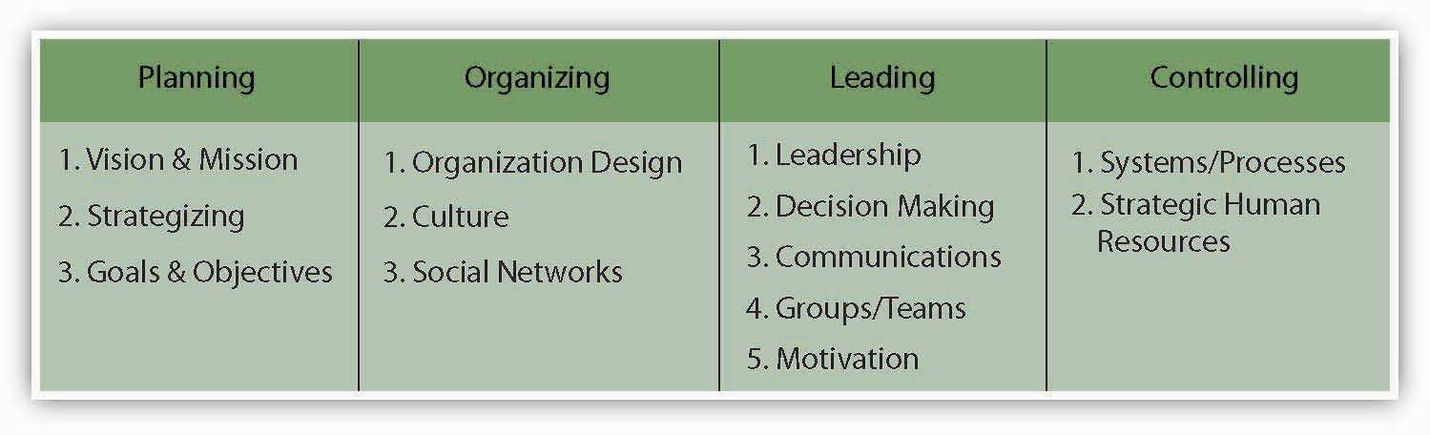
While leadership is a combination of many things, your characterization of particular leaders and their leadership effectiveness is often a reflection of the decisions that they have made or not made. In this chapter, you’ll learn that while decisions are made every day within organizations, the process does not always go as well as it could. Understanding how decisions are made, how they can be biased, and how to make the decision-making process run smoothly will help you to be a more effective manager. But first, let’s define decision making.

11.1 Case in Point: Bernard Ebbers Creates Biased Decision Making at WorldCom

Figure 11.3
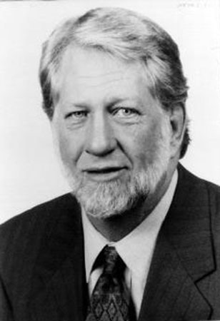
Source: U.S. National Communications System.
You could argue that Bernard Ebbers, of the now defunct WorldCom, created a culture of poor decision making. As CEO, Ebbers avoided internal company conflict at all costs, and he ultimately avoided the reality that WorldCom, once the dominant company in the telecommunications industry, was in serious economic trouble. Notorious for his temper, employees were reluctant to present Ebbers with company information that he didn’t like. A 2002 Economist article describes Ebbers as “parochial, stubborn, preoccupied with penny-pinching.…Mr. Ebbers was a difficult man to work for.” Under Ebbers, WorldCom’s $9 billion accounting fraud grew in order to avoid facing its worsening economic reality.
WorldCom’s roots stem from a Mississippi telecom company called LDDS where Ebbers was CEO. Growing to over 80,000 employees through multiple acquisitions of other telecom businesses, WorldCom became the overwhelming industry leader. However, many of WorldCom’s executives had worked with Ebbers since his start as CEO 2 decades before. Ebbers, who was regularly seen in cowboy boots and a 10-gallon hat, led his close-knit staff in a “shoot from the hip” style. He was resistant to new technology and famously refused to use e-mail to communicate with his employees. A well-known company mantra was “That’s the way we did it at LDDS.” Ebbers lead WorldCom through over 60 acquisitions over a period of 15 years. He grew annual revenues from $1 million in 1984 to over $17 billion in 1998. However, Ebbers had little regard for long-term plans and avoided making larger strategic decisions as his company accumulated increasing debt.
As WorldCom acquired new companies, its accounting procedures, computer systems, and customer service issues became increasingly more complex, and industry experts note that WorldCom struggled to keep up with the growth. Company employees who tried to bring initial problems to Ebbers’s attention were discouraged; Ebbers made it clear he only wanted to hear good news and then based decisions on this good news. This avoidance of factoring in potential problems during decision making created a company culture that demanded success at all costs. That ultimately included falsifying financial reports. For example, former employees admitted to registering “rolling revenue” to inflate earnings, recording a single sale multiple times. Another 2002 Economist article reports that this and other dishonest techniques were “endemic in the sales hierarchy of WorldCom.…Increasing reported revenues came above all else.”
Despite efforts to inflate the books, WorldCom’s stock prices dramatically declined, and Ebbers left the company in 2002 after pressure from WorldCom’s board of directors. What came to light after his departure, however, highlighted the significant problems he avoided confronting. Under new CEO John Sidgmore, internal auditor Cynthia Cooper uncovered multiple instances of financial dishonesty and illegal activity overseen by CFO Scott Sullivan, a close confidant of Ebbers. A 2002 Wall Street Journal article reports, “As she pursued the trail of fraud, Ms. Cooper time and again was obstructed by fellow employees, some of whom disapproved of WorldCom’s accounting methods but were unwilling to contradict their bosses or thwart the company’s goals.”
Ultimately Cooper’s investigation revealed the fraud that took place under Sullivan and Ebbers. Sullivan later admitted to having booked $3.8 billion of costs as capital expenditures and that five quarters’ worth of profits should have been recorded as losses. Ebbers’s refusal to honestly face the harsh economic truth for WorldCom was ultimately highlighted to be a source of WorldCom’s financial problems. In 2005, he was found guilty of fraud, conspiracy, and filing false documentation. WorldCom was purchased for $7.6 billion and subsequently integrated into Verizon (NYSE: VE) in 2006, and Ebbers began serving a 25-year jail sentence in 2005.
Primary Resource:
Secondary Resources:
- Markham, J. W. (2006). A financial history of modern U.S. corporate scandals: From Enron to reform. New York: M. E. Sharpe Inc.
- Pulliam, S., & Solomon, D. (2002, October 30). Uncooking the books. Wall Street Journal, Eastern edition. Retrieved April 4, 2010, from http://proquest.umi.com.proxy.lib.pdx.edu/pqdweb?RQT=318&mid=7510&S=1270430724&lientId=11319&Inst =PROD&Name=PQD&Type=PQD
- The big lie: Inside the rise and fraud of WorldCom. (2005). CNBC. Retrieved April 4, 2010, fromhttp://www.hulu.com/watch/46528/cnbc-originals-the-big-lie#s-p9-so-i0
- When something is rotten: The best defence against “infectious greed” is a healthy corporate culture. (2002, July 25). Economist. Retrieved April 4, 2010, from http://www.economist.com
- Yesterday’s man: WorldCom’s Bernie Ebbers typified the lionised chief executive. Now he is an ex-lion. (2002, May 2). Economist. Retrieved April 4, 2010, from http://www.economist.com

DISCUSSION QUESTIONS
- Decision making is a key component of the leading facet of the P-O-L-C framework. What decision-making traps might WorldCom’s board have succumbed to? Why might the concept of groupthink be especially relevant to boards?
- What potential causes of poor decision making existed at WorldCom during Bernard Ebbers’ administration?
- What might have happened if Ebbers had been prone to a different conflict-handling style, such as compromise or collaboration?
- How did having a small “inner circle” of leadership affect the decision-making culture at WorldCom?
- What key decisions did Cynthia Cooper make?
- What responsibility did the board of directors have to detect and confront the decision-making problems at WorldCom?

11.2 Understanding Decision Making

LEARNING OBJECTIVES
- Define decision making.
- Understand different types of decisions.

What Is Decision Making?
Decision making refers to making choices among alternative courses of action—which may also include inaction. While it can be argued that management is decision making, half of the decisions made by managers within organizations fail.
- Ireland, R. D., & Miller, C. C. (2004). Decision making and firm success. Academy of Management Executive, 18, 8–12
- Nutt, P. C. (2002). Why decisions fail. San Francisco: Berrett-Koehler; Nutt, P. C. (1999). Surprising but true: Half the decisions in organizations fail. Academy of Management Executive, 13, 75–90
Therefore, increasing effectiveness in decision making is an important part of maximizing your effectiveness at work. This chapter will help you understand how to make decisions alone or in a group while avoiding common decision-making traps.
Individuals throughout organizations use the information they gather to make a wide range of decisions. These decisions may affect the lives of others and change the course of an organization. For example, the decisions made by executives and consulting firms for Enron ultimately resulted in a $60 billion loss for investors, thousands of employees without jobs, and the loss of all employee retirement funds. But Sherron Watkins, a former Enron employee and now-famous whistleblower, uncovered the accounting problems and tried to enact change. Similarly, the decisions made by firms to trade in mortgage-backed securities is having negative consequences for the entire U.S. economy. Each of these people made a decision, and each person, as well as others, is now living with the consequences of his or her decisions.
Because many decisions involve an ethical component, one of the most important considerations in management is whether the decisions you are making as an employee or manager are ethical. Here are some basic questions you can ask yourself to assess the ethics of a decision. Is this decision fair?
- Will I feel better or worse about myself after I make this decision?
- Does this decision break any organizational rules?
- Does this decision break any laws?
- How would I feel if this decision was broadcast on the news?
- Blanchard, K., & Peale, N. V. (1988). The power of ethical management. New York: William Morrow

Types of Decisions
Despite the far-reaching nature of the decisions in the previous example, not all decisions have major consequences or even require a lot of thought. For example, before you come to class, you make simple and habitual decisions such as what to wear, what to eat, and which route to take as you go to and from home and school. You probably do not spend much time on these mundane decisions. These types of straightforward decisions are termed programmed decisions; these are decisions that occur frequently enough that we develop an automated response to them. The automated response we use to make these decisions is called the decision rule. For example, many restaurants face customer complaints as a routine part of doing business. Because this is a recurring problem for restaurants, it may be regarded as a programmed decision. To deal with this problem, the restaurant might have a policy stating that every time they receive a valid customer complaint, the customer should receive a free dessert, which represents a decision rule. Making strategic, tactical, and operational decisions is an integral part of the planning function in the P-O-L-C (planning-organizing-leading-controlling) model.
However, decisions that are unique and important require conscious thinking, information gathering, and careful consideration of alternatives. These are called nonprogrammed decisions. For example, in 2005, McDonald’s became aware of a need to respond to growing customer concerns regarding foods high in fat and calories. This is a nonprogrammed decision because for several decades, customers of fast-food restaurants were more concerned with the taste and price of the food, rather than the healthiness. In response, McDonald’s decided to offer healthier alternatives, such as substituting apple slices in Happy Meals for French fries and discontinuing the use of trans fats. A crisis situation also constitutes a nonprogrammed decision for companies. For example, the leadership of Nutrorim was facing a tough decision. They had recently introduced a new product, ChargeUp with Lipitrene, an improved version of their popular sports drink powder, ChargeUp. But a phone call came from a state health department to inform them that several cases of gastrointestinal distress had been reported after people consumed the new product. Nutrorim decided to recall ChargeUp with Lipitrene immediately. Two weeks later, it became clear that the gastrointestinal problems were unrelated to ChargeUp with Lipitrene. However, the damage to the brand and to the balance sheets was already done. This unfortunate decision caused Nutrorim to rethink the way decisions were made under pressure so that they now gather information to make informed choices even when time is of the essence.
- Garvin, D. A. (2006, January). All the wrong moves. Harvard Business Review, 18–23

Figure 11.5
To ensure consistency around the globe such as at this St. Petersburg, Russia, location, McDonald’s trains all restaurant managers (over 65,000 so far) at Hamburger University where they take the equivalent of two years of college courses and learn how to make decisions. The curriculum is taught in 28 languages.
Source:http://upload.wikimedia.org/wikipedia/commons/a/a2/McDonalds_in_St_Petersburg_2004.JPG
Decision making can also be classified into three categories based on the level at which they occur. Strategic decisions set the course of organization. Tactical decisions are decisions about how things will get done. Finally, operational decisions are decisions that employees make each day to run the organization. For example, remember the restaurant that routinely offers a free dessert when a customer complaint is received. The owner of the restaurant made a strategic decision to have great customer service. The manager of the restaurant implemented the free dessert policy as a way to handle customer complaints, which is a tactical decision. And, the servers at the restaurant are making individual decisions each day evaluating whether each customer complaint received is legitimate to warrant a free dessert.

Figure 11.6 Decisions Commonly Made within Organizations
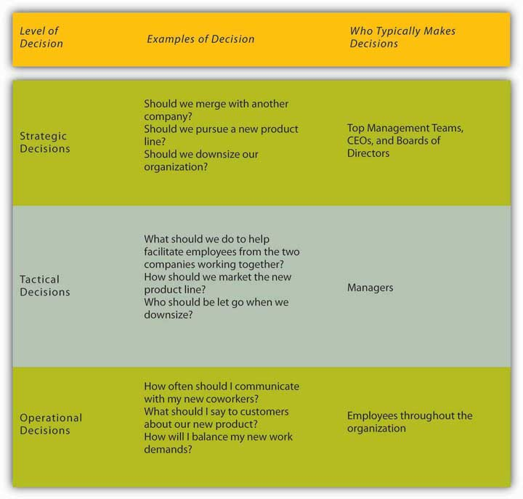
In this chapter, we are going to discuss different decision-making models designed to understand and evaluate the effectiveness of nonprogrammed decisions. We will cover four decision-making approaches starting with the rational decision-making model, moving to the bounded rationality decision-making model, the intuitive decision-making model, and ending with the creative decision-making model.

Making Rational Decisions
The rational decision-making model describes a series of steps that decision makers should consider if their goal is to maximize the quality of their outcomes. In other words, if you want to make sure you make the best choice, going through the formal steps of the rational decision-making model may make sense.
Let’s imagine that your old, clunky car has broken down and you have enough money saved for a substantial down payment on a new car. It is the first major purchase of your life, and you want to make the right choice. The first step, therefore, has already been completed—we know that you want to buy a new car. Next, in step 2, you’ll need to decide which factors are important to you. How many passengers do you want to accommodate? How important is fuel economy to you? Is safety a major concern? You only have a certain amount of money saved, and you don’t want to take on too much debt, so price range is an important factor as well. If you know you want to have room for at least five adults, get at least 20 miles per gallon, drive a car with a strong safety rating, not spend more than $22,000 on the purchase, and like how it looks, you’ve identified the decision criteria. All of the potential options for purchasing your car will be evaluated against these criteria.
Before we can move too much further, you need to decide how important each factor is to your decision in step 3. If each is equally important, then there is no need to weight them, but if you know that price and gas mileage are key factors, you might weight them heavily and keep the other criteria with medium importance. Step 4 requires you to generate all alternatives about your options. Then, in step 5, you need to use this information to evaluate each alternative against the criteria you have established. You choose the best alternative (step 6) and you go out and buy your new car (step 7).
Of course, the outcome of this decision will be related to the next decision made; that is where the evaluation in step 8 comes in. For example, if you purchase a car but have nothing but problems with it, you are unlikely to consider the same make and model in purchasing another car the next time!

Figure 11.8 Steps in the Rational Decision-Making Model
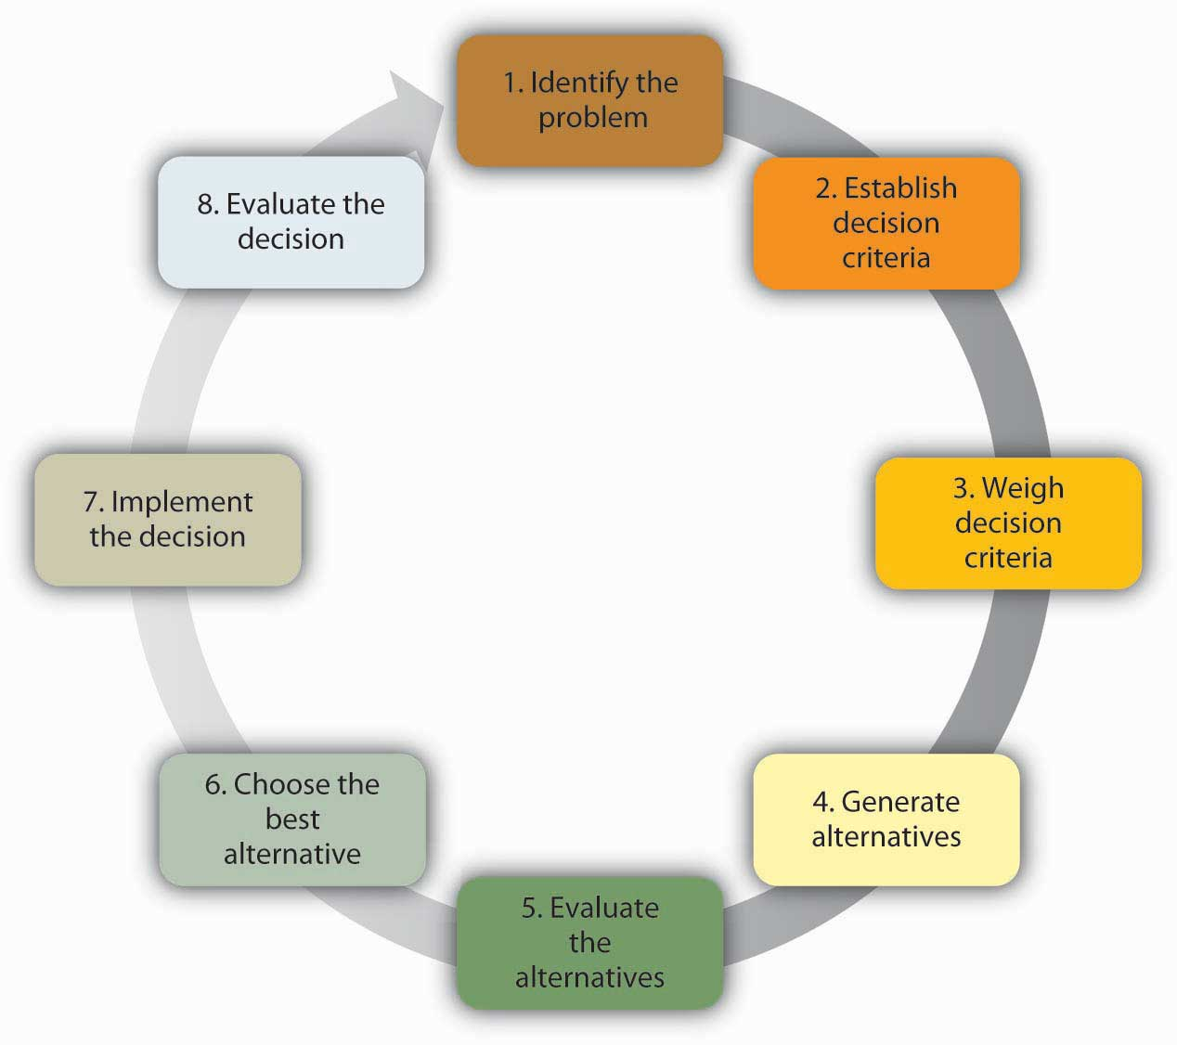
While decision makers can get off track during any of these steps, research shows that limiting the search for alternatives in the fourth step can be the most challenging and lead to failure. In fact, one researcher found that no alternative generation occurred in 85% of the decisions studied.
- Nutt, P. C. (1994). Types of organizational decision processes. Administrative Science Quarterly, 29, 414–550

Conversely, successful managers are clear about what they want at the outset of the decision-making process, set objectives for others to respond to, carry out an unrestricted search for solutions, get key people to participate, and avoid using their power to push their perspective.
- Nutt, P. C. (1998). Surprising but true: Half the decisions in organizations fail. Academy of Management Executive, 13, 75–90
The rational decision-making model has important lessons for decision makers. First, when making a decision you may want to make sure that you establish your decision criteria before you search for all alternatives. This would prevent you from liking one option too much and setting your criteria accordingly. For example, let’s say you started browsing for cars before you decided your decision criteria. You may come across a car that you think really reflects your sense of style and make an emotional bond with the car. Then, because of your love for this car, you may say to yourself that the fuel economy of the car and the innovative braking system are the most important criteria. After purchasing it, you may realize that the car is too small for all of your friends to ride in the back seat when you and your brother are sitting in front, which was something you should have thought about! Setting criteria before you search for alternatives may prevent you from making such mistakes. Another advantage of the rational model is that it urges decision makers to generate all alternatives instead of only a few. By generating a large number of alternatives that cover a wide range of possibilities, you are likely to make a more effective decision in which you do not need to sacrifice one criterion for the sake of another.
Despite all its benefits, you may have noticed that this decision-making model involves a number of unrealistic assumptions. It assumes that people understand what decision is to be made, that they know all their available choices, that they have no perceptual biases, and that they want to make optimal decisions. Nobel Prize–winning economist Herbert Simon observed that while the rational decision-making model may be a helpful tool for working through problems, it doesn’t represent how decisions are frequently made within organizations. In fact, Simon argued that it didn’t even come close!
Think about how you make important decisions in your life. Our guess is that you rarely sit down and complete all eight steps in the rational decision-making model. For example, this model proposed that we should search for all possible alternatives before making a decision, but this can be time consuming and individuals are often under time pressure to make decisions. Moreover, even if we had access to all the information, it could be challenging to compare the pros and cons of each alternative and rank them according to our preferences. Anyone who has recently purchased a new laptop computer or cell phone can attest to the challenge of sorting through the different strengths and limitations of each brand, model, and plans offered for support and arriving at the solution that best meets their needs.
In fact, the availability of too much information can lead to analysis paralysis, where more and more time is spent on gathering information and thinking about it, but no decisions actually get made. A senior executive at Hewlett-Packard admits that his company suffered from this spiral of analyzing things for too long to the point where data gathering led to “not making decisions, instead of us making decisions.”
- Zell, D. M., Glassman, A. M., & Duron, S. A. (2007). Strategic management in turbulent times: The short and glorious history of accelerated decision making at Hewlett-Packard.Organizational Dynamics, 36, 93–104
Moreover, you may not always be interested in reaching an optimal decision. For example, if you are looking to purchase a house, you may be willing and able to invest a great deal of time and energy to find your dream house, but if you are looking for an apartment to rent for the academic year, you may be willing to take the first one that meets your criteria of being clean, close to campus, and within your price range.

Making “Good Enough” Decisions
The bounded rationality model of decision making recognizes the limitations of our decision-making processes. According to this model, individuals knowingly limit their options to a manageable set and choose the best alternative without conducting an exhaustive search for alternatives. An important part of the bounded rationality approach is the tendency to satisfice, which refers to accepting the first alternative that meets your minimum criteria. For example, many college graduates do not conduct a national or international search for potential job openings; instead, they focus their search on a limited geographic area and tend to accept the first offer in their chosen area, even if it may not be the ideal job situation. Satisficing is similar to rational decision making, but it differs in that rather than choosing the best choice and maximizing the potential outcome, the decision maker saves time and effort by accepting the first alternative that meets the minimum threshold.

Making Intuitive Decisions
The intuitive decision-making model has emerged as an important decision-making model. It refers to arriving at decisions without conscious reasoning. Eighty-nine percent of managers surveyed admitted to using intuition to make decisions at least sometimes, and 59% said they used intuition often.
- Burke, L. A., & Miller, M. K. (1999). Taking the mystery out of intuitive decision making. Academy of Management Executive, 13, 91–98
When we recognize that managers often need to make decisions under challenging circumstances with time pressures, constraints, a great deal of uncertainty, highly visible and high-stakes outcomes, and within changing conditions, it makes sense that they would not have the time to formally work through all the steps of the rational decision-making model. Yet when CEOs, financial analysts, and healthcare workers are asked about the critical decisions they make, seldom do they attribute success to luck. To an outside observer, it may seem like they are making guesses as to the course of action to take, but it turns out that they are systematically making decisions using a different model than was earlier suspected. Research on life-or-death decisions made by fire chiefs, pilots, and nurses finds that these experts do not choose among a list of well-thought-out alternatives. They don’t decide between two or three options and choose the best one. Instead, they consider only one option at a time. The intuitive decision-making model argues that, in a given situation, experts making decisions scan the environment for cues to recognize patterns.
- Breen, B. (2000, August), “What’s your intuition?” Fast Company, 290; Klein, G. (2003). Intuition at work. New York: Doubleday
- Salas, E., & Klein, G. (2001). Linking expertise and naturalistic decision making. Mahwah, NJ: Lawrence Erlbaum.
Once a pattern is recognized, they can play a potential course of action through to its outcome based on their prior experience. Due to training, experience, and knowledge, these decision makers have an idea of how well a given solution may work. If they run through the mental model and find that the solution will not work, they alter the solution and retest it before setting it into action. If it still is not deemed a workable solution, it is discarded as an option and a new idea is tested until a workable solution is found. Once a viable course of action is identified, the decision maker puts the solution into motion. The key point is that only one choice is considered at a time. Novices are not able to make effective decisions this way because they do not have enough prior experience to draw upon.

Making Creative Decisions
In addition to the rational decision making, bounded rationality models, and intuitive decision making, creative decision making is a vital part of being an effective decision maker. Creativity is the generation of new, imaginative ideas. With the flattening of organizations and intense competition among organizations, individuals and organizations are driven to be creative in decisions ranging from cutting costs to creating new ways of doing business. Please note that, while creativity is the first step in the innovation process, creativity and innovation are not the same thing. Innovation begins with creative ideas, but it also involves realistic planning and follow-through.
The five steps to creative decision making are similar to the previous decision-making models in some keys ways. All of the models include problem identification, which is the step in which the need for problem solving becomes apparent. If you do not recognize that you have a problem, it is impossible to solve it. Immersion is the step in which the decision maker thinks about the problem consciously and gathers information. A key to success in creative decision making is having or acquiring expertise in the area being studied. Then, incubation occurs. During incubation, the individual sets the problem aside and does not think about it for a while. At this time, the brain is actually working on the problem unconsciously. Then comes illumination or the insight moment, when the solution to the problem becomes apparent to the person, usually when it is least expected. This is the “eureka” moment similar to what happened to the ancient Greek inventor Archimedes, who found a solution to the problem he was working on while he was taking a bath. Finally, the verification and application stage happens when the decision maker consciously verifies the feasibility of the solution and implements the decision.
A NASA scientist describes his decision-making process leading to a creative outcome as follows: He had been trying to figure out a better way to de-ice planes to make the process faster and safer. After recognizing the problem, he had immersed himself in the literature to understand all the options, and he worked on the problem for months trying to figure out a solution. It was not until he was sitting outside of a McDonald’s restaurant with his grandchildren that it dawned on him. The golden arches of the “M” of the McDonald’s logo inspired his solution: he would design the de-icer as a series of M’s!Interview by author Talya Bauer at Ames Research Center, Mountain View, CA, 1990. This represented the illumination stage. After he tested and verified his creative solution, he was done with that problem except to reflect on the outcome and process.

Figure 11.9 The Creative Decision-Making Process
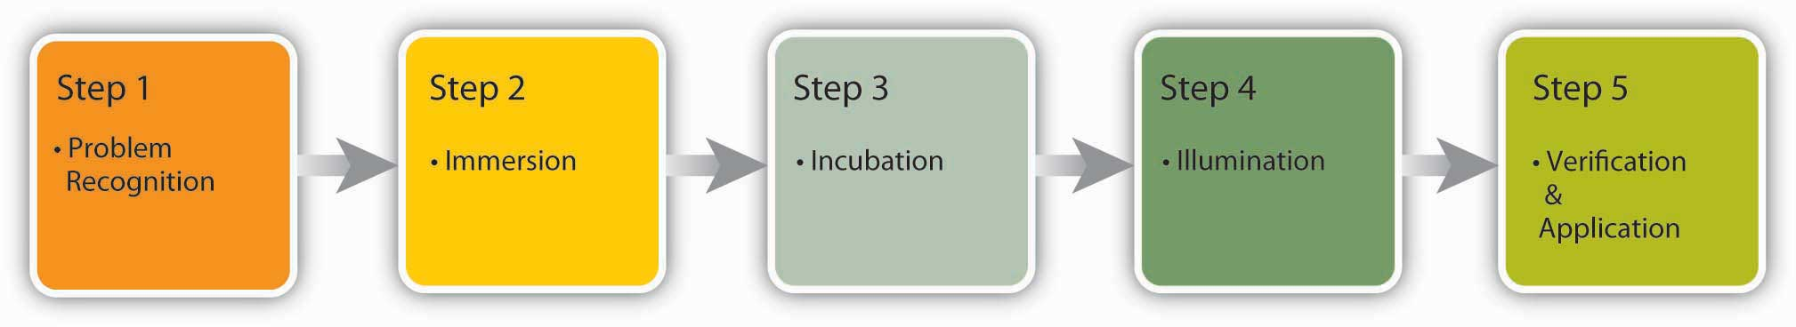

How Do You Know If Your Decision-Making Process Is Creative?
Researchers focus on three factors to evaluate the level of creativity in the decision-making process.Fluency refers to the number of ideas a person is able to generate. Flexibility refers to how different the ideas are from one another. If you are able to generate several distinct solutions to a problem, your decision-making process is high on flexibility. Originality refers to an idea’s uniqueness. You might say that Reed Hastings, founder and CEO of Netflix, is a pretty creative person. His decision-making process shows at least two elements of creativity. We do not exactly know how many ideas he had over the course of his career, but his ideas are fairly different from one another. After teaching math in Africa with the Peace Corps, Hastings was accepted at Stanford University, where he earned a master’s degree in computer science. Soon after starting work at a software company, he invented a successful debugging tool, which led to his founding the computer troubleshooting company Pure Software in 1991. After a merger and the subsequent sale of the resulting company in 1997, Hastings founded Netflix, which revolutionized the DVD rental business through online rentals with no late fees. In 2007, Hastings was elected to Microsoft’s board of directors. As you can see, his ideas are high in originality and flexibility.
- Conlin, M. (2007, September 14). Netflix: Recruiting and retaining the best talent.Business Week Online. Retrieved March 1, 2008, from http://www.businessweek.com/managing/content/sep2007/ca20070913_564868.htm?campaign_id=rss_null

Figure 11.10 Dimensions of Creativity
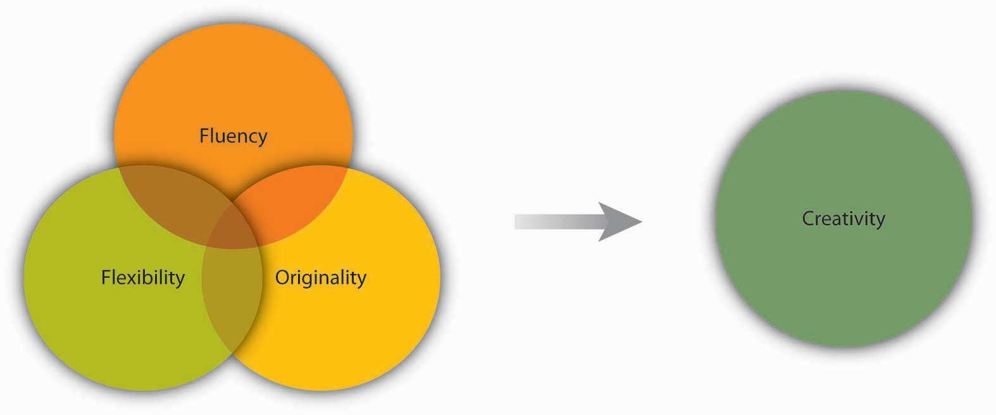
Some experts have proposed that creativity occurs as an interaction among three factors: (1) people’s personality traits (openness to experience, risk taking), (2) their attributes (expertise, imagination, motivation), and (3) the context (encouragement from others, time pressure, and physical structures).
- Amabile, T. M. (1988). A model of creativity and innovation in organizations. In B. M. Staw & L. L. Cummings (Eds.), Research in Organizational Behavior, 10 123–167 Greenwich, CT: JAI Press
- Amabile, T. M., Conti, R., Coon, H., Lazenby, J., & Herron, M. (1996). Assessing the work environment for creativity. Academy of Management Journal, 39, 1154–1184
- Ford, C. M., & Gioia, D. A. (2000). Factors influencing creativity in the domain of managerial decision making. Journal of Management, 26, 705–732
- Tierney, P., Farmer, S. M., & Graen, G. B. (1999). An examination of leadership and employee creativity: The relevance of traits and relationships. Personnel Psychology, 52, 591–620
- Woodman, R. W., Sawyer, J. E., & Griffin, R. W. (1993). Toward a theory of organizational creativity.Academy of Management Review, 18, 293–321
For example, research shows that individuals who are open to experience, are less conscientious, more self-accepting, and more impulsive, tend to be more creative.
- Feist, G. J. (1998). A meta-analysis of personality in scientific and artistic creativity. Personality and Social Psychology Review, 2, 290–309
There are many techniques available that enhance and improve creativity. Linus Pauling, the Nobel prize winner who popularized the idea that vitamin C could help build the immunity system, said, “The best way to have a good idea is to have a lot of ideas.” One popular way to generate ideas is to use brainstorming. Brainstorming is a group process of generated ideas that follows a set of guidelines that include no criticism of ideas during the brainstorming process, the idea that no suggestion is too crazy, and building on other ideas (piggybacking). Research shows that the quantity of ideas actually leads to better idea quality in the end, so setting high idea quotas where the group must reach a set number of ideas before they are done, is recommended to avoid process loss and to maximize the effectiveness of brainstorming. Another unique aspect of brainstorming is that the more people are included in brainstorming, the better the decision outcome will be because the variety of backgrounds and approaches give the group more to draw from. A variation of brainstorming is wildstormingwhere the group focuses on ideas that are impossible and then imagines what would need to happen to make them possible.
- Scott, G., Leritz, L. E., & Mumford, M. D. (2004). The effectiveness of creativity training: A quantitative review. Creativity Research Journal, 16, 361–388

Ideas for Enhancing Organizational Creativity
We have seen that organizational creativity is vital to organizations. Here are some guidelines for enhancing organizational creativity within teams.

Team Composition (Organizing/Leading)
- Diversify your team to give them more inputs to build on and more opportunities to create functional conflict while avoiding personal conflict.
- Change group membership to stimulate new ideas and new interaction patterns.
- Leaderless teams can allow teams freedom to create without trying to please anyone up front.

Team Process (Leading)
- Engage in brainstorming to generate ideas—remember to set a high goal for the number of ideas the group should come up with, encourage wild ideas, and take brainwriting breaks.
- Use the nominal group technique in person or electronically to avoid some common group process pitfalls. Consider anonymous feedback as well.
- Use analogies to envision problems and solutions.

Leadership (Leading)
- Challenge teams so that they are engaged but not overwhelmed.
- Let people decide how to achieve goals, rather than telling them what goals to achieve.
- Support and celebrate creativity even when it leads to a mistake. But set up processes to learn from mistakes as well.
- Model creative behavior.

Culture (Organizing)
- Institute organizational memory so that individuals do not spend time on routine tasks.
- Build a physical space conducive to creativity that is playful and humorous—this is a place where ideas can thrive.
- Incorporate creative behavior into the performance appraisal process.

- Amabile, T. M. (1998). How to kill creativity. Harvard Business Review, 76, 76–87
- Gundry, L. K., Kickul, J. R., & Prather, C. W. (1994). Building the creative organization. Organizational Dynamics, 22, 22–37
- Keith, N., & Frese, M. (2008). Effectiveness of error management training: A meta-analysis. Journal of Applied Psychology, 93, 59–69
- Pearsall, M. J., Ellis, A. P. J., & Evans, J. M. (2008). Unlocking the effects of gender faultlines on team creativity: Is activation the key? Journal of Applied Psychology, 93, 225–234
- Thompson, L. (2003). Improving the creativity of organizational work groups. Academy of Management Executive, 17, 96–109

And finally, avoiding groupthink can be an important skill to learn.
- “Six recommendations for avoiding Groupthink” in Janis, I. L. (1972). Victims of groupthink. New York: Houghton Mifflin
- Whyte, G. (1991). Decision failures: Why they occur and how to prevent them.Academy of Management Executive, 5, 23–31
The four different decision-making models—rational, bounded rationality, intuitive, and creative—vary in terms of how experienced or motivated a decision maker is to make a choice. Choosing the right approach will make you more effective at work and improve your ability to carry out all the P-O-L-C functions.

Figure 11.11
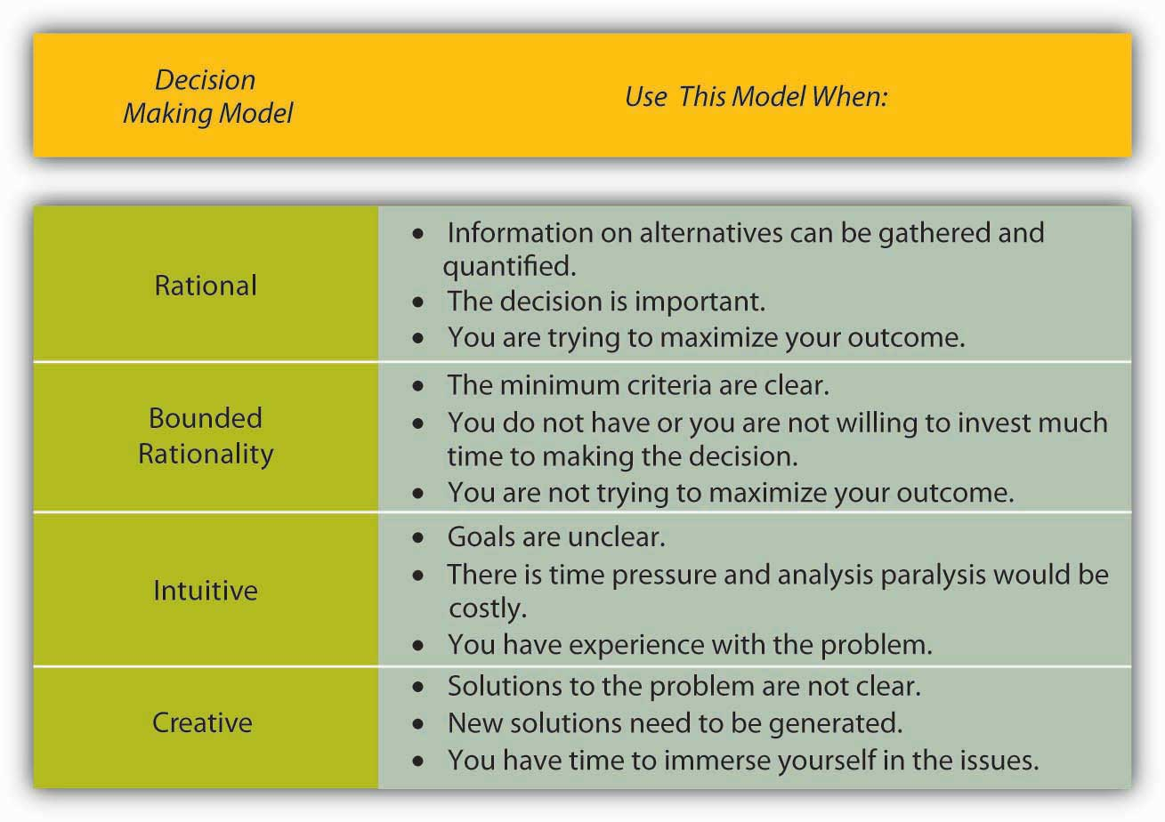
Which decision-making model should I use?

KEY TAKEAWAY
Decision making is choosing among alternative courses of action, including inaction. There are different types of decisions, ranging from automatic, programmed decisions to more intensive nonprogrammed decisions. Structured decision-making processes include rational decision making, bounded rationality, intuitive, and creative decision making. Each of these can be useful, depending on the circumstances and the problem that needs to be solved.

EXERCISES
- What do you see as the main difference between a successful and an unsuccessful decision? How much does luck versus skill have to do with it? How much time needs to pass to answer the first question?
- Research has shown that over half of the decisions made within organizations fail. Does this surprise you? Why or why not?
- Have you used the rational decision-making model to make a decision? What was the context? How well did the model work?
- Share an example of a decision where you used satisficing. Were you happy with the outcome? Why or why not? When would you be most likely to engage in satisficing?
- Do you think intuition is respected as a decision-making style? Do you think it should be? Why or why not?

11.3 Faulty Decision Making

LEARNING OBJECTIVES
- Understand overconfidence bias and how to avoid it.
- Understand hindsight bias and how to avoid it.
- Understand anchoring and how to avoid it.
- Understand framing bias and how to avoid it.
- Understand escalation of commitment and how to avoid it.
No matter which model you use, you need to know and avoid the decision-making traps that exist. Daniel Kahnemann (another Nobel prize winner) and Amos Tversky spent decades studying how people make decisions. They found that individuals are influenced by overconfidence bias, hindsight bias, anchoring bias, framing bias, and escalation of commitment.

Potential Challenges to Decision Making

Overconfidence Bias
Overconfidence bias occurs when individuals overestimate their ability to predict future events. Many people exhibit signs of overconfidence. For example, 82% of the drivers surveyed feel they are in the top 30% of safe drivers, 86% of students at the Harvard Business School say they are better looking than their peers, and doctors consistently overestimate their ability to detect problems.
- Tilson, W. (1999, September 20). The perils of investor overconfidence. Retrieved March 1, 2008, from http://www.fool.com/BoringPort/1999/BoringPort990920.htm
Much like a friend who is always 100% sure he can pick the winners of this week’s football games despite evidence to the contrary, these individuals are suffering from overconfidence bias. People who purchase lottery tickets as a way to make money are probably suffering from overconfidence bias. It is three times more likely for a person driving 10 miles to buy a lottery ticket to be killed in a car accident than to win the jackpot.
- Orkin, M. (1991). Can you win? The real odds for casino gambling, sports betting and lotteries. New York: W. H. Freeman
To avoid this bias, take the time to stop and ask yourself whether you are being realistic in your judgments.

Hindsight Bias
Hindsight bias is the opposite of overconfidence bias, as it occurs when looking backward in time where mistakes made seem obvious after they have already occurred. In other words, after a surprising event occurred, many individuals are likely to think that they already knew this was going to happen. This may be because they are selectively reconstructing the events. Hindsight bias becomes a problem especially when judging someone else’s decisions. For example, let’s say a company driver hears the engine making unusual sounds before starting her morning routine. Being familiar with this car in particular, the driver may conclude that the probability of a serious problem is small and continue to drive the car. During the day, the car malfunctions, stranding her away from the office. It would be easy to criticize her decision to continue to drive the car because, in hindsight, the noises heard in the morning would make us believe that she should have known something was wrong and she should have taken the car in for service. However, the driver may have heard similar sounds before with no consequences, so based on the information available to her at the time, she may have made a reasonable choice. Therefore, it is important for decision makers to remember this bias before passing judgments on other people’s actions.

Anchoring
Anchoring refers to the tendency for individuals to rely too heavily on a single piece of information. Job seekers often fall into this trap by focusing on a desired salary while ignoring other aspects of the job offer such as additional benefits, fit with the job, and working environment. Similarly, but more dramatically, lives were lost in the Great Bear Wilderness Disaster when the coroner declared all five passengers of a small plane dead within five minutes of arriving at the accident scene, which halted the search effort for potential survivors, when, in fact, the next day two survivors walked out of the forest. How could a mistake like this have been made? One theory is that decision biases played a large role in this serious error; anchoring on the fact that the plane had been consumed by flames led the coroner to call off the search for any possible survivors.
- Becker, W. S. (2007). Missed opportunities: The Great Bear Wilderness Disaster. Organizational Dynamics, 36, 363–376

Framing Bias
Framing bias refers to the tendency of decision makers to be influenced by the way that a situation or problem is presented. For example, when making a purchase, customers find it easier to let go of a discount as opposed to accepting a surcharge, even though they both might cost the person the same amount of money. Similarly, customers tend to prefer a statement such as “85% lean beef” as opposed to “15% fat”!
- Li, S., Sun, Y., & Wang, Y. (2007). 50% off or buy one get one free? Frame preference as a function of consumable nature in dairy products. Journal of Social Psychology, 147, 413–421
It is important to be aware of this tendency because, depending on how a problem is presented to us, we might choose an alternative that is disadvantageous simply because of how it is framed.

Escalation of Commitment
Escalation of commitment occurs when individuals continue on a failing course of action after information reveals this may be a poor path to follow. It is sometimes called sunk costs fallacy because the continuation is often based on the idea that one has already invested in this course of action. For example, imagine a person purchases a used car that turns out to need another repair every few weeks. An effective way of dealing with this situation might be to sell the car without incurring further losses, donate the car, or drive it without repairing it until it falls apart. However, many people spend hours of their time and hundreds, even thousands of dollars repairing the car in the hopes that they will justify their initial investment in buying the car.
A classic example of escalation of commitment from the corporate world may be Motorola’s Iridium project. In 1980s, the phone coverage around the world was weak—it could take hours of dealing with a chain of telephone operators in several different countries to get a call through from, say, Cleveland to Calcutta. Thus, there was a real need within the business community to improve phone access around the world. Motorola envisioned solving this problem using 66 low-orbiting satellites, enabling users to place a direct call to any location around the world. At the time of idea development, the project was technologically advanced, sophisticated, and made financial sense. Motorola spun off Iridium as a separate company in 1991. It took researchers 15 years to develop the product from idea to market release. However, in the 1990s, the landscape for cell phone technology was dramatically different from the 1980s, and the widespread cell phone coverage around the world eliminated a large base of the projected customer base for Iridium. Had they been paying attention to these developments, the decision makers would probably have abandoned the project at some point in the early 1990s. Instead, they released the Iridium phone to the market in 1998. The phone cost $3,000 and it was literally the size of a brick. Moreover, it was not possible to use the phone in moving cars or inside buildings! Not surprisingly, the launch was a failure and Iridium filed for bankruptcy in 1999.
- Finkelstein, S., & Sanford, S. H. (2000, November). Learning from corporate mistakes: The rise and fall of Iridium. Organizational Dynamics, 29(2), 138–148
The company was ultimately purchased for $25 million by a group of investors (whereas it cost the company $5 billion to develop its product), scaled down its operations, and modified it for use by the Department of Defense to connect soldiers in remote areas not served by landlines or cell phones.
Why does escalation of commitment occur? There may be many reasons, but two are particularly important. First, decision makers may not want to admit that they were wrong. This may be because of personal pride or being afraid of the consequences of such an admission. Second, decision makers may incorrectly believe that spending more time and energy might somehow help them recover their losses. Effective decision makers avoid escalation of commitment by distinguishing between when persistence may actually pay off versus when persistence might mean escalation of commitment. To avoid escalation of commitment, you might consider having strict turning back points. For example, you might determine up front that you will not spend more than $500 trying to repair the car and will sell the car when you reach that point. You might also consider assigning separate decision makers for the initial buying and subsequent selling decisions. Periodical evaluations of an initially sound decision to see whether the decision still makes sense is also another way of preventing escalation of commitment. This becomes particularly important in projects such as the Iridium where the initial decision is not immediately implemented but instead needs to go through a lengthy development process. In such cases, it becomes important to assess the soundness of the initial decision periodically in the face of changing market conditions. Finally, creating an organizational climate where individuals do not fear admitting that their initial decision no longer makes economic sense would go a long way in preventing escalation of commitment, as it could lower the regret the decision maker may experience.
- Wong, K. F. E., & Kwong, J. Y. Y. (2007). The role of anticipated regret in escalation of commitment. Journal of Applied Psychology, 92, 545–554

Figure 11.13
Motorola released the Iridium phone to the market in 1998. The phone cost $3,000 and was literally the size of a brick. This phone now resides at the Smithsonian Air and Space Museum in Dulles, Virginia.
Source: http://upload.wikimedia.org/wikipedia/commons/b/b0/Iridium_phone.jpg
So far we have focused on how individuals make decisions and how to avoid decision traps. Next we shift our focus to the group level. There are many similarities and many differences between individual and group decision making. There are many factors that influence group dynamics and also affect the group decision-making process. We will discuss some of them in the next section.

KEY TAKEAWAY
Understanding decision-making traps can help you avoid and manage them. Overconfidence bias can cause you to ignore obvious information. Hindsight bias can similarly cause a person to incorrectly believe in their ability to predict events. Anchoring and framing biases show the importance of the way problems or alternatives are presented in influencing one’s decision. Escalation of commitment demonstrates how individuals’ desire for consistency, or to avoid admitting a mistake, can cause them to continue to invest in a decision that is not prudent.

EXERCISES
- Describe a time when you fell into one of the decision-making traps. How did you come to realize that you had made a poor decision?
- How can you avoid escalation of commitment?
- Share an example of anchoring.
- Which of the traps seems the most dangerous for decision makers and why?

11.4 Decision Making in Groups

LEARNING OBJECTIVES
- Understand the pros and cons of individual and group decision making.
- Learn to recognize the signs of groupthink.
- Recognize different tools and techniques for making better decisions.

When It Comes to Decision Making, Are Two Heads Better Than One?
When it comes to decision making, are two heads better than one? The answer to this question depends on several factors. Group decision making has the advantages of drawing from the experiences and perspectives of a larger number of individuals. Hence, they have the potential to be more creative and lead to a more effective decision. In fact, groups may sometimes achieve results beyond what they could have done as individuals. Groups also make the task more enjoyable for members in question. Finally, when the decision is made by a group rather than a single individual, implementation of the decision will be easier because group members will be invested in the decision. If the group is diverse, better decisions may be made because different group members may have different ideas based on their background and experiences. Research shows that for top management teams, groups that debate issues and that are diverse make decisions that are more comprehensive and better for the bottom line in terms of profitability and sales.
- Simons, T., Pelled, L. H., & Smith, K. A. (1999). Making use of difference: Diversity, debate, decision comprehensiveness in top management teams. Academy of Management Journal, 42, 662–673
Despite its popularity within organizations, group decision making suffers from a number of disadvantages. We know that groups rarely outperform their best member.
- Miner, F. C. (1984). Group versus individual decision making: An investigation of performance measures, decision strategies, and process losses/gains. Organizational Behavior and Human Performance, 33, 112–124
While groups have the potential to arrive at an effective decision, they often suffer from process losses. For example, groups may suffer from coordination problems. Anyone who has worked with a team of individuals on a project can attest to the difficulty of coordinating members’ work or even coordinating everyone’s presence in a team meeting. Furthermore, groups can suffer from social loafing, or the tendency of some members to put forth less effort while working within a group. Groups may also suffer fromgroupthink, the tendency to avoid critical evaluation of ideas the group favors. Finally, group decision making takes a longer time compared with individual decision making, given that all members need to discuss their thoughts regarding different alternatives.
Thus, whether an individual or a group decision is preferable will depend on the specifics of the situation. For example, if there is an emergency and a decision needs to be made quickly, individual decision making might be preferred. Individual decision making may also be appropriate if the individual in question has all the information needed to make the decision and if implementation problems are not expected. However, if one person does not have all the information and skills needed to make the decision, if implementing the decision will be difficult without the involvement of those who will be affected by the decision, and if time urgency is more modest, then decision making by a group may be more effective.

Figure 11.14 Advantages and Disadvantages of Different Levels of Decision Making
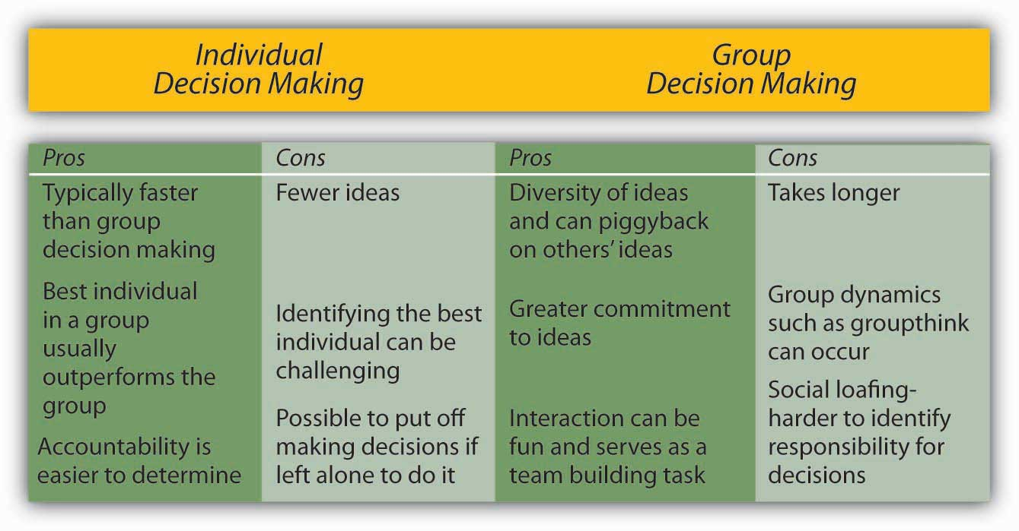

Groupthink
Have you ever been in a decision-making group that you felt was heading in the wrong direction, but you didn’t speak up and say so? If so, you have already been a victim of groupthink. Groupthink is a group pressure phenomenon that increases the risk of the group making flawed decisions by leading to reduced mental efficiency, reality testing, and moral judgment. Groupthink is characterized by eight symptoms that include:
Illusion of invulnerability shared by most or all of the group members that creates excessive optimism and encourages them to take extreme risks.
- Collective rationalizations where members downplay negative information or warnings that might cause them to reconsider their assumptions.
- An unquestioned belief in the group’s inherent morality that may incline members to ignore ethical or moral consequences of their actions.
- Stereotyped views of out-groups are seen when groups discount rivals’ abilities to make effective responses.
- Direct pressure on any member who expresses strong arguments against any of the group’s stereotypes, illusions, or commitments.
- Self-censorship when members of the group minimize their own doubts and counterarguments.
- Illusions of unanimity based on self-censorship and direct pressure on the group; the lack of dissent is viewed as unanimity.
- The emergence of self-appointed mindguards where one or more members protect the group from information that runs counter to the group’s assumptions and course of action.
- Janis, I. L. (1972). Victims of groupthink. New York: Houghton Mifflin.

Figure 11.15
Avoiding groupthink can be a matter of life or death. In January 1986, the space shuttle Challenger exploded 73 seconds after liftoff, killing all seven astronauts aboard. The decision to launch Challenger that day, despite problems with mechanical components of the vehicle and unfavorable weather conditions, is cited as an example of groupthink.
Source:http://en.wikipedia.org/wiki/Image:Challenger_flight_51-l_crew.jpg
While research on groupthink has not confirmed all of the theory, groups do tend to suffer from symptoms of groupthink when they are large and when the group is cohesive because the members like each other.
- Esser, J. K. (1998). Alive and well after 25 years: A review of groupthink research.Organizational Behavior and Human Decision Processes, 73, 116–141
- Mullen, B., Anthony, T., Salas, E., & Driskell, J. E. (1994). Group cohesiveness and quality of decision making: An integration of tests of the groupthink hypothesis. Small Group Research, 25, 189–204
The assumption is that the more frequently a group displays one or more of the eight symptoms, the worse the quality of their decisions will be.
However, if your group is cohesive, it is not necessarily doomed to engage in groupthink.

Recommendations for Avoiding Groupthink

Groups Should:
- Discuss the symptoms of groupthink and how to avoid them.
- Assign a rotating devil’s advocate to every meeting.
- Invite experts or qualified colleagues who are not part of the core decision-making group to attend meetings, and get reactions from outsiders on a regular basis and share these with the group.
- Encourage a culture of difference where different ideas are valued.
- Debate the ethical implications of the decisions and potential solutions being considered.

Individuals Should:
- Monitor their own behavior for signs of groupthink and modify behavior if needed.
- Check themselves for self-censorship.
- Carefully avoid mindguard behaviors.
- Avoid putting pressure on other group members to conform.
- Remind members of the ground rules for avoiding groupthink if they get off track.

Group Leaders Should:
- Break the group into two subgroups from time to time.
- Have more than one group work on the same problem if time and resources allow it. This makes sense for highly critical decisions.
- Remain impartial and refrain from stating preferences at the outset of decisions.
- Set a tone of encouraging critical evaluations throughout deliberations.
- Create an anonymous feedback channel where all group members can contribute to if desired.

Tools and Techniques for Making Better Decisions
Nominal Group Technique (NGT) was developed to help with group decision making by ensuring that all members participate fully. NGT is not a technique to be used at all meetings routinely. Rather, it is used to structure group meetings when members are grappling with problem solving or idea generation. It follows four steps.
- Delbecq, A. L., Van de Ven, A. H., & Gustafson, D. H. (1975). Group techniques for program planning: A guide to nominal group and Delphi processes. Glenview, IL: Scott, Foresman
First, each member of the group engages in a period of independently and silently writing down ideas. Second, the group goes in order around the room to gather all the ideas that were generated. This goes on until all the ideas are shared. Third, a discussion takes place around each idea and members ask for and give clarification and make evaluative statements. Finally, individuals vote for their favorite ideas by using either ranking or rating techniques. Following the four-step NGT helps to ensure that all members participate fully and avoids group decision-making problems such as groupthink.
Delphi Technique is unique because it is a group process using written responses to a series of questionnaires instead of physically bringing individuals together to make a decision. The first questionnaire asks individuals to respond to a broad question, such as stating the problem, outlining objectives, or proposing solutions. Each subsequent questionnaire is built from the information gathered in the previous one. The process ends when the group reaches a consensus. Facilitators can decide whether to keep responses anonymous. This process is often used to generate best practices from experts. For example, Purdue University professor Michael Campion used this process when he was editor of the research journal Personnel Psychology and wanted to determine the qualities that distinguished a good research article. Using the Delphi Technique, he was able to gather responses from hundreds of top researchers from around the world without ever having to leave his office and distill them into a checklist of criteria that he could use to evaluate articles submitted to the journal.
- Campion, M. A. (1993). Article review checklist: A criterion checklist for reviewing research articles in applied psychology. Personnel Psychology, 46, 705–718
Majority rule refers to a decision-making rule where each member of the group is given a single vote, and the option that receives the greatest number of votes is selected. This technique has remained popular, perhaps because of its simplicity, speed, ease of use, and representational fairness. Research also supports majority rule as an effective decision-making technique.
- Hastie, R., & Kameda, T. (2005). The robust beauty of majority rules in group decisions. Psychological Review, 112, 494–508
However, those who did not vote in favor of the decision will be less likely to support it.
Consensus is another decision-making rule that groups may use when the goal is to gain support for an idea or plan of action. While consensus tends to take longer in the first place, it may make sense when support is needed to enact the plan. The process works by discussing the issues, generating a proposal, calling for consensus, and discussing any concerns. If concerns still exist, the proposal is modified to accommodate them. These steps are repeated until consensus is reached. Thus, this decision-making rule is inclusive, participatory, cooperative, and democratic. Research shows that consensus can lead to better accuracy,
- Roch, S. G. (2007). Why convene rater teams: An investigation of the benfits of anticipated discussion, consensus, and rater motivation. Organizational Behavior and Human Decision Processes, 104, 14–29
and it helps members feel greater satisfaction with decisions
- Mohammed, S., & Ringseis, E. (2001). Cognitive diversity and consensus in group decision making: The role of inputs, processes, and outcomes. Organizational Behavior and Human Decision Processes, 85, 310–335
and to have greater acceptance. However, groups take longer with this approach and groups that cannot reach consensus become frustrated.
- Peterson, R. (1999). Can you have too much of a good thing? The limits of voice for improving satisfaction with leaders. Personality and Social Psychology, 25, 313–324
Group decision support systems (GDSS) are interactive computer-based systems that are able to combine communication and decision technologies to help groups make better decisions. Organizations know that having effective knowledge management systems to share information is important. Research shows that a GDSS can actually improve the output of group collaborative work through higher information sharing.
- Lam, S. S. K., & Schaubroeck, J. (2000). Improving group decisions by better pooling information: A comparative advantage of group decision support systems. Journal of Applied Psychology, 85, 565–573
Organizations know that having effective knowledge management systems to share information is important, and their spending reflects this reality. According to a 2002 article, businesses invested $2.7 billion into new systems in 2002 and projections were for this number to double every five years. As the popularity of these systems grows, they risk becoming counterproductive. Humans can only process so many ideas and information at one time. As virtual meetings grow larger, it is reasonable to assume that information overload can occur and good ideas will fall through the cracks, essentially recreating a problem that the GDSS was intended to solve that is to make sure every idea is heard. Another problem is the system possibly becoming too complicated. If the systems evolve to a point of uncomfortable complexity, it has recreated the problem of the bully pulpit and shyness. Those who understand the interface will control the narrative of the discussion, while those who are less savvy will only be along for the ride.
- Nunamaker, J. F., Jr., Dennis, A. R., Valacich, J. S., Vogel, D. R., George, J. F. (1991, July). Electronic meetings to support group work. Communications of the ACM, 34(7), 40–61
Lastly, many of these programs fail to take into account the factor of human psychology. These systems could make employees more reluctant to share information due to lack of control, lack of immediate feedback, the fear of “flaming” or harsher than normal criticism, and the desire to have original information hence more power.
- Babock, P. (2004, May). Shedding light on knowledge management. HR Magazine, pp. 47–50
Decision trees are diagrams in which answers to yes or no questions lead decision makers to address additional questions until they reach the end of the tree. Decision trees are helpful in avoiding errors such as framing bias.
- Wright, G., & Goodwin, P. (2002). Eliminating a framing bias by using simple instructions to “think harder” and respondents with managerial experience: Comment on “breaking the frame.” Strategic Management Journal, 23, 1059–1067
Decision trees tend to be helpful in guiding the decision maker to a predetermined alternative and ensuring consistency of decision making—that is, every time certain conditions are present, the decision maker will follow one course of action as opposed to others if the decision is made using a decision tree.

Figure 11.17
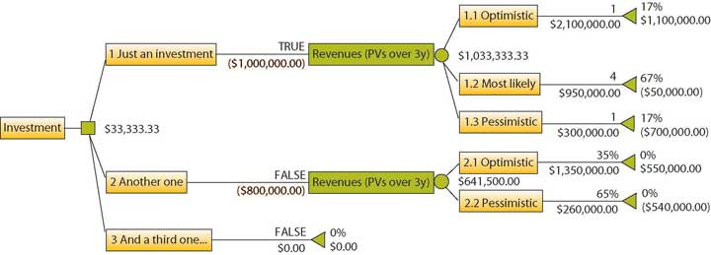
Using decision trees can improve investment decisions by optimizing them for maximum payoff. A decision tree consists of three types of nodes. Decision nodes are commonly represented by squares. Chance nodes are represented by circles. End nodes are represented by triangles.
Source: http://upload.wikimedia.org/wikipedia/en/9/93/Investment_decision_Insight.png

KEY TAKEAWAY
There are trade-offs between making decisions alone and within a group. Groups have greater diversity of experiences and ideas than individuals, but they also have potential process losses such as groupthink. Groupthink can be avoided by recognizing the eight symptoms discussed. Finally, there are a variety of tools and techniques available for helping to make more effective decisions in groups, including the Nominal Group Technique, Delphi Technique, majority rule, consensus, GDSS, and decision trees. Understanding the link between managing teams and making decisions is an important aspect of a manager’s leading function.

EXERCISES
- Do you prefer to make decisions in a group or alone? What are the main reasons for your preference?
- Have you been in a group that used the brainstorming technique? Was it an effective tool for coming up with creative ideas? Please share examples.
- Have you been in a group that experienced groupthink? If so, how did you deal with it?
- Which of the decision making tools discussed in this chapter (NGT, Delphi, etc.) have you used? How effective were they?

11.5 Developing Your Personal Decision-Making Skills

LEARNING OBJECTIVES
- Understand what you can do to avoid making poor decisions.
- Learn what a project premortem is.

Perform a Project “Premortem” to Fix Problems Before They Happen
Doctors routinely perform postmortems to understand what went wrong with a patient who has died. The idea is for everyone to learn from the unfortunate outcome so that future patients will not meet a similar fate. But, what if you could avoid a horrible outcome before it happened by identifying project risks proactively—before your project derails? Research suggests that the simple exercise of imagining what could go wrong with a given decision can increase your ability to identify reasons for future successes or failures by 30%.
- Mitchell, D. J., Russo, J., & Pennington, N. (1989). Back to the future: Temporal perspective in the explanation of events. Journal of Behaviorial Decision Making, 2, 25–38
A “premortem” is a way to imagine and to avoid what might go wrong before spending a cent or having to change course along the way.
- Breen, B. (2000, August). What’s your intuition? Fast Company, 290; Klein, G. (September 2007). Performing a project premortem. Harvard Business Review, 18–19
- Klein, G. (2003). The power of intuition: How to use your gut feelings to make better decisions at work. New York: Random House
- Pliske, R., McCloskey, M., & Klein, G. (2001). Decision skills training: Facilitating learning from experience. In E. Salas & G. Klein (Eds.), Linking expertise and naturalistic decision making 37–53. Mahwah, NJ: Lawrence Erlbaum
Gary Klein, an expert on decision making in fast-paced, uncertain, complex, and critical environments, recommends that decision makers follow this six-step premortem process to increase their chances of success.
- A planning team comes up with an outline of a plan, such as the launching of a new product.
- Either the existing group or a unique group is then told to imagine looking into a crystal ball and seeing that the new product failed miserably. They then write down all the reasons they can imagine that might have led to this failure.
- Each team member shares items from their list until all the potential problems have been identified.
- The list is reviewed for additional ideas.
- The issues are sorted into categories in the search for themes.
- The plan should then be revised to correct the flaws and avoid these potential problems.
The premortem technique allows groups to truly delve into “what if” scenarios. For example, in a premortem session at a Fortune 50 company, an executive imagined that a potential billion-dollar environmental sustainability project might fail because the CEO had retired.

KEY TAKEAWAY
There are a number of ways to learn about decision making that can help make you more effective. If the decision is important, conduct a premortem to anticipate what might go wrong. When a decision is going to involve others, be proactive in getting them to buy in before the decision is made. Individuals and groups can suffer from decision-making traps and process losses. Understanding that you can spot and avoid these traps is important in helping to make you a more effective manager.

EXERCISES
- How might you use the premortem technique to be more effective within groups at school or work?
- Imagine that your good friend is starting a new job next week as a manager. What recommendations would you give your friend to be successful with decision making at work?

Chapter 12

Communication in Organizations

WHAT’S IN IT FOR ME?
Reading this chapter will help you do the following:
- Define communication and understand the communication process.
- Understand and overcome barriers to effective communication.
- Compare and contrast different types of communication.
- Compare and contrast different communication channels.
- Develop your own communication skills.

Figure 12.2 The P-O-L-C Framework

12.1 Case in Point: Edward Jones Communicates Caring
Because of the economic turmoil that most financial institutions find themselves in today, it might come as a surprise that an individual investment company came in at number 2 on Fortune magazine’s “100 Best Companies to Work For” list in 2010, behind software giant SAS Institute Inc. Edward Jones Investments (a limited partnership company) was originally founded in St. Louis, Missouri, where its headquarters remain today. With more than 10,000 offices across the United States and Canada, they are able to serve nearly 7 million investors. This is the 10th year Edward Jones has made the Best Companies list. In addition, Edward Jones ranked highest with client satisfaction among full-service investment firms, according to an annual survey released by J. D. Power and Associates in 2009. How has Edward Jones maintained this favorable reputation in the eyes of both its employees and its customers?
It begins with the perks offered, including profit sharing and telecommuting. But if you ask the company’s CEO, Tim Kirley, he will likely tell you that it goes beyond the financial incentives, and at the heart of it is the culture of honest communication that he adamantly promotes. Kirley works with senior managers and team members in what makes up an open floor plan and always tries to maintain his approachability. Examples of this include direct communication, letters to staff and video, and Internet-posted talks. In addition, regular meetings are held to celebrate achievements and reinforce the firm’s ethos. Staff surveys are frequently administered and feedback is widely taken into consideration so that the 10,000 employees feel heard and respected.
According to Fortune’s managing editor, Hank Gilman, “The most important considerations for this year’s list were hiring and the ways in which companies are helping their employees weather the recession.” Edward Jones was able to persevere through the trauma of the recent financial crisis with no layoffs and an 8% one-year job growth. While a salary freeze was enacted, profit sharing continued. Kirley insists that the best approach to the recent economic downturn is to remain honest with his employees even when the news he is delivering is not what they want to hear.
Edward Jones was established in 1922 by Edward D. Jones Sr., and long ago, the company recognized the importance of a satisfied workforce and how that has the ability to translate into customer satisfaction and long-term growth. The company’s internal policy of open communication seems to carry over to how advisors value their relationship with individual customers. Investors are most likely to contact their advisor by directly visiting them at a local branch or by picking up the phone and calling them. Edward Jones’s managing partner, Jim Weddle, explains it best himself: “We are able to stay focused on the long-term because we are a partnership and we know who we are and what we do. When you respect the people who work here, you take care of them—not just in the good times, but in the difficult times as well.”
Primary Resource:
Secondary Resources:
- 100 best companies to work for. (2010, February 8). Fortune. Retrieved February 2, 2010, from http://money.cnn.com/magazines/fortune/bestcompanies/2010/full_list
- St. Louis firms makeFortune’s best workplaces. (2009, January 22). St. Louis Business Journal. Retrieved February 3, 2010, from http://www.bizjournals.com/stlouis/stories/2009/01/19/daily40.html
- Rodrigues, N., & Clayton, C. (2009). A positive difference in the office and the world. Sunday Times, pp. 10, 11. Retrieved from LexisNexis Academic database
- Lawlor, A. (2008, March 13). Edward Jones is one to work for. Sunday Times, Financial Adviser. Retrieved February 2, 2010, from LexisNexis Academic database
- Keeping clients happy. (2009, August 1). Registered Rep. Retrieved February 2, 2010, from http://registeredrep.com/planner-ria-practice/finance-keeping-clients-happy-0801

DISCUSSION QUESTIONS
- Communication is a key part of the leading facet of the P-O-L-C framework. What other things could Edward Jones do to increase its effectiveness in the area of communications?
- As an organization, what qualities do you think Edward Jones looks for when hiring new financial advisors? How do you think that affects its culture over time?
- With its success in North America, why do you think Edward Jones has not expanded across the Pacific or Atlantic Oceans?
- How has technology enabled Edward Jones to become more effective at communicating with its employees and customers?
- What types of customer service policies do think Edward Jones has in place? How do these relate to its culture over time?

12.2 Understanding Communication

LEARNING OBJECTIVES
- Define communication.
- Understand the communication process.
Communication supports each of a manager’s P-O-L-C functions. The ability to effectively communicate is a necessary condition for successfully planning, organizing, leading, and controlling. Communication is vital to organizations—it’s how we coordinate actions and achieve goals. It is defined in the Merriam-Webster’s dictionary as “a process by which information is exchanged between individuals through a common system of symbols, signs, or behavior.”
- Merriam-Webster online dictionary. (2008). Retrieved December 1, 2008, from http://www.merriam-webster.com/dictionary/communication
We know that 50%–90% of a manager’s time is spent communicating
- Schnake, M. E., Dumler, M. P., Cochran, D. S., & Barnett, T. R. (1990). Effects of differences in subordinate perceptions of superiors’ communication practices. The Journal of Business Communication, 27, 37–50
and that communication ability is related to a manager’s performance.
- Penley, L. E., Alexander, E. R., Jernigan, I. E., & Henwood, C. I. (1991). Communication abilities of managers: The relationship of performance. Journal of Management, 17, 57–76
In most work environments, a miscommunication is an annoyance—it can interrupt workflow by causing delays and interpersonal strife. And in some work arenas, like operating rooms and airplane cockpits, communication can be a matter of life and death.
So, just how prevalent is the problem of miscommunication in the workplace? You may be surprised to learn that the relationship between miscommunication and negative outcomes is strong. A recent NASA study suggests that deficient interpersonal communication was a causal factor in approximately 70%–80% of aviation accidents over a 20-year period.
- Baron, R. (2004). Barriers to effective communication: Implications for the cockpit. Retrieved July 3, 2008, from AirlineSafety.com: http://www.airlinesafety.com/editorials/BarriersToCommunication.htm
Poor communication can also lead to lawsuits. For example, you might think that malpractice suits are filed against doctors based on the outcome of their treatments alone. But a 1997 study of malpractice suits found that a primary influence on whether a doctor is sued is that doctor’s communication style. While the combination of a bad outcome and patient unhappiness can quickly lead to litigation, a warm, personal communication style leads to greater patient satisfaction. And satisfied patients are less likely to sue. Communications skills cut malpractice risk—study reveals most important reason that patients decide to file malpractice suits is because of poor communication by physicians and not medical errors. (1997, October). USA Today.

Figure 12.4
Success on complicated missions at NASA depends on strong communication.
Source: http://en.wikipedia.org/wiki/Image:Orion_briefing_model.jpg
For leaders and organizations, poor communication costs money and wastes time. One study found that 14% of each workweek is wasted on poor communication.Armour, S. (1998, September 30). Failure to Communicate Costly for Companies. USA Today, 1A. In contrast, effective communication is an asset for organizations and individuals alike. Effective communication skills, for example, are an asset for job seekers. A recent study of recruiters at 85 business schools ranked communication and interpersonal skills as the highest skills they were looking for, with 89% of the recruiters saying they were important.
- Alsop, R. (2006, September 20). The top business schools: Recruiters’ M.B.A. picks. Wall Street Journal Online. Retrieved September 20, 2006 from http://online.wsj.com/article/SB115860376846766495.html?mod=2_1245_1
Good communication can also help a company retain its star employees. Surveys find that when employees think their organizations do a good job of keeping them informed about matters that affect them and they have ready access to the information they need to do their jobs, they are more satisfied with their employers.
- What are the bottom line results of communicating? (2003, June). Pay for Performance Report, p. 1. Retrieved July 1, 2008, from http://www.mercerHR.com
So, can good communication increase a company’s market value? The answer seems to be yes. “When you foster ongoing communications internally, you will have more satisfied employees who will be better equipped to effectively communicate with your customers,” says Susan Meisinger, President/CEO of the Society for Human Resource Management, citing research findings that for organizations that are able to improve their communication integrity, their market value increases by as much as 7.1%.
- Meisinger, S. (2003, February). Enhancing communications—ours and yours. HR Magazine. Retrieved July 1, 2008, from http://www.shrm.org/hrmagazine/archive/0203toc.asp
We will explore the definition and benefits of effective communication in our next section.

The Communication Process

Figure 12.5
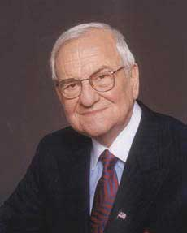
Lee Iacocca, past president and CEO of Chrysler until his retirement in 1992, said, “You can have brilliant ideas, but if you can’t get them across, your ideas won’t get you anywhere.”
Source:http://en.wikipedia.org/wiki/Lee_Iacocca
Communication fulfills three main functions within an organization: (1) transmitting information, (2) coordinating effort, and (3) sharing emotions and feelings. All these functions are vital to a successful organization. Transmitting information is vital to an organization’s ability to function. Coordinating effort within the organization helps people work toward the same goals. Sharing emotions and feelings bonds teams and unites people in times of celebration and crisis. Effective communication helps people grasp issues, build rapport with coworkers, and achieve consensus. So, how can we communicate effectively? The first step is to understand the communication process.
We all exchange information with others countless times a day, by phone, e-mail, printed word, and of course, in person. Let’s take a moment to see how a typical communication works using the Process Model of Communication as a guide.

Figure 12.6 The Process Model of Communication
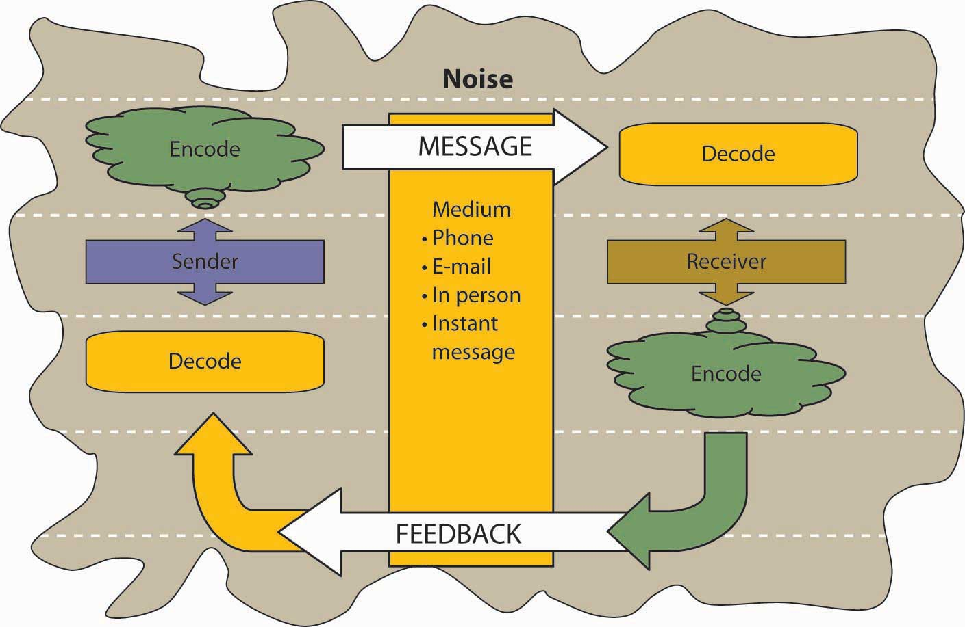
A Sender, such as a boss, coworker, or customer, originates the Message with a thought. For example, the boss’s thought could be: “Get more printer toner cartridges!”
The Sender encodes the Message, translating the idea into words.
The boss may communicate this thought by saying, “Hey you guys, we need to order more printer toner cartridges.”
The medium of this encoded Message may be spoken words, written words, or signs.
The receiver is the person who receives the Message.
The Receiver decodes the Message by assigning meaning to the words.
In this example, our Receiver, Bill, has a to-do list a mile long. “The boss must know how much work I already have.” the Receiver thinks. Bill’s mind translates his boss’s Message as, “Could you order some printer toner cartridges, in addition to everything else I asked you to do this week…if you can find the time?”
The meaning that the Receiver assigns may not be the meaning that the Sender intended because of such factors as noise. Noise is anything that interferes with or distorts the Message being transformed. Noise can be external in the environment (such as distractions) or it can be within the Receiver. For example, the Receiver may be highly nervous and unable to pay attention to the Message. Noise can even occur within the Sender: the Sender may be unwilling to take the time to convey an accurate Message or the words she chooses can be ambiguous and prone to misinterpretation.
Picture the next scene. The place: a staff meeting. The time: a few days later. The boss believes her Message has been received.
“Are the printer toner cartridges here yet?” she asks.
“You never said it was a rush job!” the Receiver protests.
“But!”
“But!”
Miscommunications like these happen in the workplace every day. We’ve seen that miscommunication does occur in the workplace. But how does a miscommunication happen? It helps to think of the communication process. The series of arrows pointing the way from the Sender to the Receiver and back again can, and often do, fall short of their target.

KEY TAKEAWAY
Communication is vital to organizations. Poor communication is prevalent and can have serious repercussions. Communication fulfills three functions within organizations: transmitting information, coordinating, and sharing emotions and feelings. Noise can disrupt or distort communication.

EXERCISES
- Where have you seen the communication process break down—at work? At school? At home?
- Explain how miscommunication might be related to an accident at work.
- Give an example of noise during the communication process.

12.3 Communication Barriers

LEARNING OBJECTIVES
- Understand different ways that the communication process can be sidetracked.
- Understand the problem of poor listening and how to promote active listening.

Barriers to Effective Communication
Communicating can be more of a challenge than you think, when you realize the many things that can stand in the way of effective communication. These include filtering, selective perception, information overload, emotional disconnects, lack of source familiarity or credibility, workplace gossip, semantics, gender differences, differences in meaning between Sender and Receiver, and biased language. Let’s examine each of these barriers.

Filtering
Filtering is the distortion or withholding of information to manage a person’s reactions. Some examples of filtering include a manager who keeps her division’s poor sales figures from her boss, the vice president, fearing that the bad news will make him angry. The old saying, “Don’t shoot the messenger!” illustrates the tendency of Receivers (in this case, the vice president) to vent their negative response to unwanted Messages on the Sender. A gatekeeper (the vice president’s assistant, perhaps) who doesn’t pass along a complete Message is also filtering. The vice president may delete the e-mail announcing the quarter’s sales figures before reading it, blocking the Message before it arrives.
As you can see, filtering prevents members of an organization from getting a complete picture of the way things are. To maximize your chances of sending and receiving effective communications, it’s helpful to deliver a Message in multiple ways and to seek information from multiple sources. In this way, the effect of any one person’s filtering the Message will be diminished.
Since people tend to filter bad news more during upward communication, it is also helpful to remember that those below you in an organization may be wary of sharing bad news. One way to defuse the tendency to filter is to reward employees who clearly convey information upward, regardless of whether the news is good and bad.
Here are some of the criteria that individuals may use when deciding whether to filter a Message or pass it on:
- Past experience: Was the Sender rewarded for passing along news of this kind in the past, or was she criticized?
- Knowledge, perception of the speaker: Has the Receiver’s direct superior made it clear that “no news is good news?”
- Emotional state, involvement with the topic, level of attention: Does the Sender’s fear of failure or criticism prevent him from conveying the Message? Is the topic within his realm of expertise, increasing his confidence in his ability to decode it, or is he out of his comfort zone when it comes to evaluating the Message’s significance? Are personal concerns impacting his ability to judge the Message’s value?
Once again, filtering can lead to miscommunications in business. Each listener translates the Message into his or her own words, creating his or her own version of what was said.
- Alessandra, T. (1993).Communicating at work. New York: Fireside

Selective Perception
Selective perception refers to filtering what we see and hear to suit our own needs. This process is often unconscious. Small things can command our attention when we’re visiting a new place—a new city or a new company. Over time, however, we begin to make assumptions about the way things are on the basis of our past experience. Often, much of this process is unconscious. “We simply are bombarded with too much stimuli every day to pay equal attention to everything so we pick and choose according to our own needs.”
- Pope, R. R. Selective perception. Illinois State University. Retrieved December 1, 2008, from http://lilt.ilstu.edu/rrpope/rrpopepwd/articles/perception3.html
Selective perception is a time-saver, a necessary tool in a complex culture. But it can also lead to mistakes.
Think back to the earlier example conversation between Bill, who was asked to order more toner cartridges, and his boss. Since Bill found his boss’s to-do list to be unreasonably demanding, he assumed the request could wait. (How else could he do everything else on the list?) The boss, assuming that Bill had heard the urgency in her request, assumed that Bill would place the order before returning to the other tasks on her list.
Both members of this organization were using selective perception to evaluate the communication. Bill’s perception was that the task of ordering could wait. The boss’s perception was that her time frame was clear, though unstated. When two selective perceptions collide, a misunderstanding occurs.

Information Overload
Information overload can be defined as “occurring when the information processing demands on an individual’s time to perform interactions and internal calculations exceed the supply or capacity of time available for such processing.”
- Schick, A. G., Gordon, L. A., & Haka, S. (1990). Information overload: A temporal approach. Accounting, Organizations, and Society, 15, 199–220
Messages reach us in countless ways every day. Some are societal—advertisements that we may hear or see in the course of our day. Others are professional—e-mails, and memos, voice mails, and conversations from our colleagues. Others are personal—messages and conversations from our loved ones and friends.
Add these together and it’s easy to see how we may be receiving more information than we can take in. This state of imbalance is known as information overload. Experts note that information overload is “A symptom of the high-tech age, which is too much information for one human being to absorb in an expanding world of people and technology. It comes from all sources including TV, newspapers, and magazines as well as wanted and unwanted regular mail, e-mail and faxes. It has been exacerbated enormously because of the formidable number of results obtained from Web search engines.”
- Retrieved July 1, 2008, from PC Magazine encyclopedia Web site,http://www.pcmag.com/encyclopedia_term/0,2542,t=information+overload&i=44950,00.asp
- Dawley, D. D., & Anthony, W. P. (2003). User perceptions of e-mail at work. Journal of Business and Technical Communication, 17, 170–200
Other research shows that working in such fragmented fashion has a significant negative effect on efficiency, creativity, and mental acuity.
Based on:
- Overholt, A. (2001, February). Intel’s got (too much) mail
- Fast Company. Retrieved July 2, 2008, from http://www.fastcompany.com/online/44/intel.html and http://blogs.intel.com/it/2006/10/information_overload.php
Going back to our example of Bill. Let’s say he’s in his cubicle on the phone with a supplier. While he’s talking, he hears the chime of e-mail alerting him to an important message from his boss. He’s scanning through it quickly, while still on the phone, when a coworker pokes his head around the cubicle corner to remind Bill that he’s late for a staff meeting. The supplier on the other end of the phone line has just given Bill a choice among the products and delivery dates he requested. Bill realizes he missed hearing the first two options, but he doesn’t have time to ask the supplier to repeat them all or to try reconnecting to place the order at a later time. He chooses the third option—at least he heard that one, he reasons, and it seemed fair. How good was Bill’s decision amid all the information he was processing at the same time?

Emotional disconnects
Emotional disconnects happen when the Sender or the Receiver is upset, whether about the subject at hand or about some unrelated incident that may have happened earlier. An effective communication requires a Sender and a Receiver who are open to speaking and listening to one another, despite possible differences in opinion or personality. One or both parties may have to put their emotions aside to achieve the goal of communicating clearly. A Receiver who is emotionally upset tends to ignore or distort what the Sender is saying. A Sender who is emotionally upset may be unable to present ideas or feelings effectively.

Lack of Source Credibility
Lack of source familiarity or credibility can derail communications, especially when humor is involved. Have you ever told a joke that fell flat? You and the Receiver lacked the common context that could have made it funny. (Or yes, it could have just been a lousy joke.) Sarcasm and irony are subtle, and potentially hurtful, commodities in business. It’s best to keep these types of communications out of the workplace as their benefits are limited, and their potential dangers are great. Lack of familiarity with the Sender can lead to misinterpreting humor, especially in less-rich information channels like e-mail. For example, an e-mail from Jill that ends with, “Men, like hens, should boil in vats of oil,” could be interpreted as anti-male if the Receiver didn’t know that Jill has a penchant for rhyme and likes to entertain coworkers by making up amusing sayings.
Similarly, if the Sender lacks credibility or is untrustworthy, the Message will not get through. Receivers may be suspicious of the Sender’s motivations (“Why am I being told this?”). Likewise, if the Sender has communicated erroneous information in the past, or has created false emergencies, his current Message may be filtered.
Workplace gossip, also known as the grapevine, is a lifeline for many employees seeking information about their company.
- Kurland, N. B., & Pelled, L. H. (2000). Passing the word: Toward a model of gossip and power in the workplace. Academy of Management Review, 25, 428–438
Researchers agree that the grapevine is an inevitable part of organizational life. Research finds that 70% of all organizational communication occurs at the grapevine level.
- Crampton, S. M. (1998). The informal communication network: factors influencing grapevine activity. Public Personnel Management. Retrieved July 2, 2008, from http://www.allbusiness.com/management/735210-1.html
Employees trust their peers as a source of Messages, but the grapevine’s informal structure can be a barrier to effective communication from the managerial point of view. Its grassroots structure gives it greater credibility in the minds of employees than information delivered through official channels, even when that information is false.
Some downsides of the office grapevine are that gossip offers politically minded insiders a powerful tool for disseminating communication (and self-promoting miscommunications) within an organization. In addition, the grapevine lacks a specific Sender, which can create a sense of distrust among employees—who is at the root of the gossip network? When the news is volatile, suspicions may arise as to the person or persons behind the Message. Managers who understand the grapevine’s power can use it to send and receive Messages of their own. They also decrease the grapevine’s power by sending official Messages quickly and accurately, should big news arise.

Semantics
Semantics is the study of meaning in communication. Words can mean different things to different people, or they might not mean anything to another person. For example, companies often have their own acronyms and buzzwords (called business jargon) that are clear to them but impenetrable to outsiders. For example, at IBM, GBS is focusing on BPTS, using expertise acquired from the PwC purchase (which had to be sold to avoid conflicts of interest in light of SOX) to fend other BPO providers and inroads by the Bangalore tiger. Does this make sense to you? If not, here’s the translation: IBM’s Global Business Services (GBS) division is focusing on offering companies Business Process Transformation Services (BPTS), using the expertise it acquired from purchasing the management consulting and technology services arm of PricewaterhouseCoopers (PwC), which had to sell the division because of the Sarbanes-Oxley Act (SOX, enacted in response to the major accounting scandals like the Enron). The added management expertise puts it above business process outsourcing (BPO) vendors who focus more on automating processes rather than transforming and improving them. Chief among these BPO competitors is Wipro, often called the “Bangalore tiger” because of its geographic origin and aggressive growth.
Given the amount of Messages we send and receive every day, it makes sense that humans try to find shortcuts—a way to communicate things in code. In business, this code is known as jargon. Jargon is the language of specialized terms used by a group or profession. It is common shorthand among experts and if used sensibly can be a quick and efficient way of communicating. Most jargon consists of unfamiliar terms, abstract words, nonexistent words, acronyms, and abbreviations, with an occasional euphemism thrown in for good measure. Every profession, trade, and organization has its own specialized terms.
- Wright, N. Keep it jargon-free. Retrieved July 2, 2008, from http://www.plainlanguage.gov/howto/wordsuggestions/jargonfree.cfm
At first glance, jargon seems like a good thing—a quicker way to send an effective communication, the way text message abbreviations can send common messages in a shorter, yet understandable way. But that’s not always how things happen. Jargon can be an obstacle to effective communication, causing listeners to tune out or fostering ill-feeling between partners in a conversation. When jargon rules the day, the Message can get obscured.
A key question to ask before using jargon is, “Who is the Receiver of my Message?” If you are a specialist speaking to another specialist in your area, jargon may be the best way to send a message while forging a professional bond—similar to the way best friends can communicate in code. For example, an information technology (IT) systems analyst communicating with another IT employee may use jargon as a way of sharing information in a way that reinforces the pair’s shared knowledge. But that same conversation should be held in standard English, free of jargon, when communicating with staff members outside the IT group.

Online Follow-Up
Here is a Web site of 80 buzz words in business:
http://www.amanet.org/movingahead/editorial2002_2003/nov03_80buzzwords.htm
and a discussion of why slang is a problem:
http://sbinfocanada.about.com/od/speakforsuccesscourse/a/speechlesson5.htm.

Gender Differences
Gender differences in communication have been documented by a number of experts, including linguistics professor Deborah Tannen in her best-selling book You Just Don’t Understand: Women and Men in Conversation.
- Tannen, D. (1991). You just don’t understand: Women and men in conversation. New York: Ballantine
Men and women work together every day. But their different styles of communication can sometimes work against them. Generally speaking, women like to ask questions before starting a project, while men tend to “jump right in.” A male manager who’s unaware of how many women communicate their readiness to work may misperceive a ready employee as not ready.
Another difference that has been noticed is that men often speak in sports metaphors, while many women use their home as a starting place for analogies. Women who believe men are “only talking about the game” may be missing out on a chance to participate in a division’s strategy and opportunities for teamwork and “rallying the troops” for success.
- Krotz, J. L. (n.d.). 6 tips for bridging the communication gap. Retrieved July 2, 2008, from Microsoft Small Business Center Web site, http://www.microsoft.com/smallbusiness/resources/management/leadership-training/women-vs-men-6-tips-for-bridging-the-communication-gap.aspx
“It is important to promote the best possible communication between men and women in the workplace,” notes gender policy adviser Dee Norton, who provided the above example. “As we move between the male and female cultures, we sometimes have to change how we behave (speak the language of the other gender) to gain the best results from the situation. Clearly, successful organizations of the future are going to have leaders and team members who understand, respect and apply the rules of gender culture appropriately.”
- Norton, D. Gender and communication—finding common ground. Retrieved July 2, 2008, from http://www.uscg.mil/leadership/gender.htm
Being aware of these gender differences can be the first step in learning to work with them, as opposed to around them. For example, keep in mind that men tend to focus more on competition, data, and orders in their communications, while women tend to focus more on cooperation, intuition, and requests. Both styles can be effective in the right situations, but understanding the differences is a first step in avoiding misunderstandings based on them.
Differences in meaning often exist between the Sender and Receiver. “Mean what you say, and say what you mean.” It’s an easy thing to say. But in business, what do those words mean? Different words mean different things to different people. Age, education, and cultural background are all factors that influence how a person interprets words. The less we consider our audience, the greater our chances of miscommunication will be. When communication occurs in the cross-cultural context, extra caution is needed given that different words will be interpreted differently across cultures and different cultures have different norms regarding nonverbal communication. Eliminating jargon is one way of ensuring that our words will convey real-world concepts to others. Speaking to our audience, as opposed to about ourselves, is another. Nonverbal Messages can also have different meanings.

Table 12.1 Gestures Around the Globe
Figure 12.8 | 1. “V” for victory. Use this gesture with caution! While in North America it signs victory or peace, in England and Australia it means something closer to “take this!”
Figure 12.9 | 2. The “OK” gesture. While in North America it means things are going well, in France it means a person is thought to be worthless, in Japan it refers to money, and in Brazil, Russia, and Germany it means something really not appropriate for the workplace.
Figure 12.10 | 3. The “thumbs up” means one in Germany, five in Japan, but a good job in North America. This can lead to confusion.
Figure 12.11 | 4. “Hook ‘em horns.” This University of Texas rallying call looks like the horns of a bull. However, in Italy it means you are being tricked, while in Brazil and Venezuela it means you are warding off evil.
Figure 12.12 | 5. Waving your hand. In much of Europe waving your hand indicates a disagreement. However, in North America it is routinely used as a way to signal greetings or to get someone’s attention.
- Axtell, R. E. (1998). Gestures: The do’s and taboos of body language around the world. New York: John Wiley
Managers who speak about “long-term goals and profits” to a staff that has received scant raises may find their core Message (“You’re doing a great job—and that benefits the folks in charge!”) has infuriated the group they hoped to inspire. Instead, managers who recognize the “contributions” of their staff and confirm that this work is contributing to company goals in ways “that will benefit the source of our success—our employees as well as executives,” will find their core Message (“You’re doing a great job—we really value your work”) is received as opposed to being misinterpreted.
Biased language can offend or stereotype others on the basis of their personal or group affiliation. The figure below provides a list of words that have the potential to be offensive in the left-hand column. The right-hand column provides more neutral words that you can use instead.
- Ashcraft, K., & Mumby, D. K. (2003). Reworking gender. Thousand Oaks, CA, Sage
- Miller, C., & Swift, K. (1980). The handbook of nonsexist writing. New York: Lippincott & Crowell
- Procter, M. (2007, September 11). Unbiased language. Retrieved July 2, 2008, from http://www.utoronto.ca/writing/unbias.html

Figure 12.13 Avoiding Biased Language
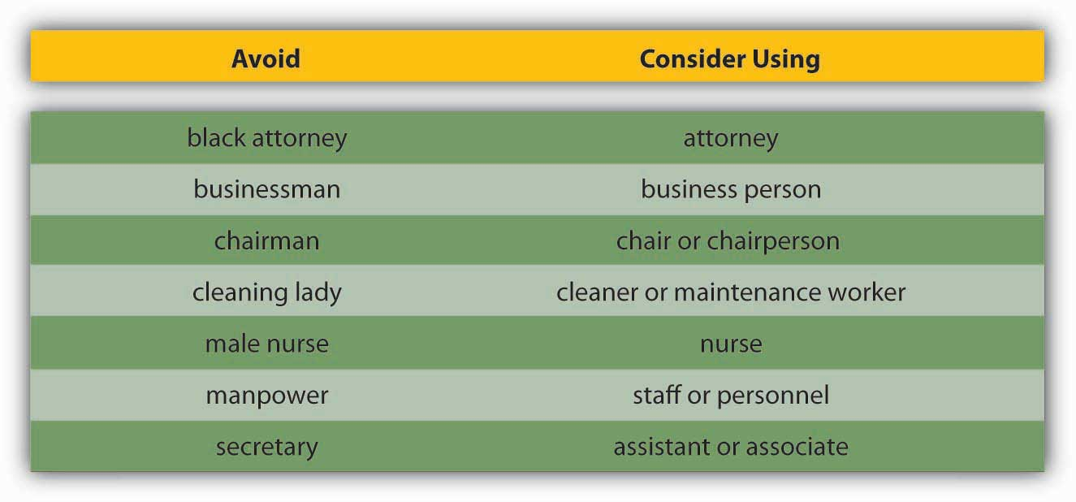
Effective communication is clear, factual, and goal-oriented. It is also respectful. Referring to a person by one adjective (a brain, a diabetic, an invalid) reduces that person to that one characteristic. Language that belittles or stereotypes a person poisons the communication process. Language that insults an individual or group based on age, ethnicity, sexual preference, or political beliefs violates public and private standards of decency, ranging from civil rights to corporate regulations.
The effort to create a neutral set of terms to refer to heritage and preferences has resulted in a debate over the nature of “political correctness.” Proponents of political correctness see it as a way to defuse the volatile nature of words that stereotyped groups and individuals in the past. Critics of political correctness see its vocabulary as stilted and needlessly cautious.
Many companies offer new employees written guides on standards of speech and conduct. These guides, augmented by common sense and courtesy, are solid starting points for effective, respectful workplace communication. Tips for appropriate workplace speech include but are not limited to
- Alternating the use of “he” and “she” when referring to people in general.
- Relying on human resources–generated guidelines.
- Remembering that terms that feel respectful or comfortable to us may not be comfortable or respectful to others.

Poor Listening and Active Listening
Former Chrysler CEO Lee Iacocca lamented, “I only wish I could find an institute that teaches people how to listen. After all, a good manager needs to listen at least as much as he needs to talk.”
- Iacocca, L., & Novak, W. (1984). Iacocca: An autobiography. New York: Bantam Press.
Research shows that listening skills are related to promotions.
- Sypher, B. D., Bostrom, R. N., & Seibert, J. H. (1989). Listening, communication abilities, and success at work. Journal of Business Communication, 26, 293–303
A Sender may strive to deliver a Message clearly. But the Receiver’s ability to listen effectively is equally vital to effective communication. The average worker spends 55% of her workdays listening. Managers listen up to 70% each day. But listening doesn’t lead to understanding in every case. Listening takes practice, skill, and concentration.
According to University of San Diego professor Phillip Hunsaker, “The consequences of poor listening are lower employee productivity, missed sales, unhappy customers, and billions of dollars of increased cost and lost profits. Poor listening is a factor in low employee morale and increased turnover because employees do not feel their managers listen to their needs, suggestions, or complaints.”
- Alessandra, T., Garner, H., & Hunsaker, P. L. (1993). Communicating at work. New York: Simon & Schuster
Clearly, if you hope to have a successful career in management, it behooves you to learn to be a good listener.
Alan Gulick, a Starbucks spokesperson, puts better listening to work in pursuit of better profits. If every Starbucks employee misheard one $10 order each day, he calculates, their errors would cost the company a billion dollars annually. To teach its employees to listen, Starbucks created a code that helps employees taking orders hear the size, flavor, and use of milk or decaf coffee. The person making the drink echoes the order aloud.
How can you improve your listening skills? The Roman philosopher Cicero said, “Silence is one of the great arts of conversation.” How often have we been in conversation with someone else where we are not really listening but itching to convey our portion? This behavior is known as “rehearsing.” It suggests the Receiver has no intention of considering the Sender’s Message and intends to respond to an earlier point instead. Clearly, rehearsing is an impediment to the communication process. Effective communication relies on another kind of listening: active listening.
Active listening can be defined as giving full attention to what other people are saying, taking time to understand the points being made, asking questions as appropriate, and not interrupting at inappropriate times.
- O*NET Resource Center, the nation’s primary source of occupational information. Retrieved July 2, 2008, from http://online.onetcenter.org/skills.
Active listening creates a real-time relationship between the Sender and the Receiver by acknowledging the content and receipt of a Message. As we’ve seen in the Starbucks example, repeating and confirming a Message’s content offers a way to confirm that the correct content is flowing between colleagues. The process creates a bond between coworkers while increasing the flow and accuracy of messaging.
Carl Rogers, founder of the “person-centered” approach to psychology, formulated five rules for active listening:
- Listen for message content
- Listen for feelings
- Respond to feelings
- Note all cues
- Paraphrase and restate
The good news is that listening is a skill that can be learned.
- Brownell, J. (1990). Perceptions of effective listeners: A management study. Journal of Business Communications, 27, 401–415
The first step is to decide that we want to listen. Casting aside distractions, such as by reducing background or internal noise, is critical. The Receiver takes in the Sender’s Message silently, without speaking. Second, throughout the conversation, show the speaker that you’re listening. You can do this nonverbally by nodding your head and keeping your attention focused on the speaker. You can also do it verbally, by saying things like, “Yes,” “That’s interesting,” or other such verbal cues. As you’re listening, pay attention to the Sender’s body language for additional cues about how they’re feeling. Interestingly, silence plays a major role in active listening. During active listening, we are trying to understand what has been said, and in silence, we can consider the implications. We can’t consider information and reply to it at the same time. That’s where the power of silence comes into play. Finally, if anything is not clear to you, ask questions. Confirm that you’ve heard the message accurately, by repeating back a crucial piece like, “Great, I’ll see you at 2 p.m. in my office.” At the end of the conversation, a “thank you” from both parties is an optional but highly effective way of acknowledging each other’s teamwork.
In summary, active listening creates a more dynamic relationship between a Receiver and a Sender. It strengthens personal investment in the information being shared. It also forges healthy working relationships among colleagues by making Speakers and Listeners equally valued members of the communication process.

KEY TAKEAWAY
Many barriers to effective communication exist. Examples include filtering, selective perception, information overload, emotional disconnects, lack of source familiarity or credibility, workplace gossip, semantics, gender differences, differences in meaning between Sender and Receiver, and biased language. The Receiver can enhance the probability of effective communication by engaging in active listening, which involves (1) giving one’s full attention to the Sender and (2) checking for understanding by repeating the essence of the Message back to the Sender.

EXERCISES
- Most people are poor listeners. Do you agree or disagree with this statement? Please support your position.
- Please share an example of how differences in shared meaning have affected you.
- Give an example of selective perception.
- Do you use jargon at or in your classes? If so, do you think it helps or hampers communication? Why or why not?
- In your experience, how is silence used in communication? How does your experience compare with the recommended use of silence in active listening?

12.4 Different Types of Communication

LEARNING OBJECTIVES
- Understand the features and advantages of verbal communication.
- Understand the features and advantages of written communication.
- Understand the features of nonverbal communication and how it interacts with verbal and written communications.
Communication can be categorized into three basic types: (1) verbal communication, in which you listen to a person to understand their meaning; (2) written communication, in which you read their meaning; and (3) nonverbal communication, in which you observe a person and infer meaning. Each has its own advantages, disadvantages, and even pitfalls.

Verbal Communication
Verbal communications in business take place over the phone or in person. The medium of the Message is oral. Let’s return to our printer cartridge example. This time, the Message is being conveyed from the Sender (the Manager) to the Receiver (an employee named Bill) by telephone. We’ve already seen how the Manager’s request to Bill (“We need to buy more printer toner cartridges”) can go awry. Now let’s look at how the same Message can travel successfully from Sender to Receiver.
Manager (speaking on the phone): “Good morning, Bill!”
(By using the employee’s name, the manager is establishing a clear, personal link to the Receiver.)
Manager: “Your division’s numbers are looking great.”
(The Manager’s recognition of Bill’s role in a winning team further personalizes and emotionalizes the conversation.)
Manager: “Our next step is to order more printer toner cartridges. Could you place an order for 1,000 printer toner cartridges with Jones Computer Supplies? Our budget for this purchase is $30,000, and the cartridges need to be here by Wednesday afternoon.”
(The Manager breaks down the task into several steps. Each step consists of a specific task, time frame, quantity, or goal.)
Bill: “Sure thing! I’ll call Jones Computer Supplies and order 1,000 more printer toner cartridges, not exceeding a total of $30,000, to be here by Wednesday afternoon.”
(Bill, who is good at active listening, repeats what he has heard. This is the Feedback portion of the communication, and verbal communication has the advantage of offering opportunities for immediate feedback. Feedback helps Bill to recognize any confusion he may have had hearing the manager’s Message. Feedback also helps the manager to tell whether she has communicated the Message correctly.)

Storytelling
Storytelling has been shown to be an effective form of verbal communication; it serves an important organizational function by helping to construct common meanings for individuals within the organization. Stories can help clarify key values and help demonstrate how things are done within an organization, and story frequency, strength, and tone are related to higher organizational commitment.
- McCarthy, J. F. (2008). Short stories at work: Storytelling as an indicator of organizational commitment. Group & Organization Management, 33, 163–193
The quality of the stories entrepreneurs tell is related to their ability to secure capital for their firms.
- Martens, M. L., Jennings, J. E., & Devereaux, J. P. (2007). Do the stories they tell get them the money they need? The role of entrepreneurial narratives in resource acquisition. Academy of Management Journal, 50, 1107–1132
Stories can serve to reinforce and perpetuate an organization’s culture, part of the organizing P-O-L-C function.

Crucial Conversations
While the process may be the same, high-stakes communications require more planning, reflection, and skill than normal day-to-day interactions at work. Examples of high-stakes communication events include asking for a raise or presenting a business plan to a venture capitalist. In addition to these events, there are also many times in our professional lives when we have crucial conversations—discussions where not only the stakes are high but also where opinions vary and emotions run strong.
- Patterson, K., Grenny, J., McMillan, R., & Switzler, A. (2002). Crucial conversations: Tools for talking when stakes are high. New York: McGraw-Hill
One of the most consistent recommendations from communications experts is to work toward using “and” instead of “but” as you communicate under these circumstances. In addition, be aware of your communication style and practice flexibility; it is under stressful situations that communication styles can become the most rigid.

Written Communication
In contrast to verbal communications, written business communications are printed messages. Examples of written communications include memos, proposals, e-mails, letters, training manuals, and operating policies. They may be printed on paper, handwritten, or appear on the screen. Normally, a verbal communication takes place in real time. Written communication, by contrast, can be constructed over a longer period of time. Written communication is often asynchronous (occurring at different times). That is, the Sender can write a Message that the Receiver can read at any time, unlike a conversation that is carried on in real time. A written communication can also be read by many people (such as all employees in a department or all customers). It’s a “one-to-many” communication, as opposed to a one-to-one verbal conversation. There are exceptions, of course: a voicemail is an oral Message that is asynchronous. Conference calls and speeches are oral one-to-many communications, and e-mails may have only one recipient or many.

Figure 12.14
Communication mediums have come a long way since Alexander Graham Bell’s original telephone.
Source:http://en.wikipedia.org/wiki/image:cnam-img_0564.jpg
Most jobs involve some degree of writing. According to the National Commission on Writing, 67% of salaried employees in large American companies and professional state employees have some writing responsibility. Half of responding companies reported that they take writing into consideration when hiring professional employees, and 91% always take writing into account when hiring (for any position, not just professional-level ones).
- Flink, H. (2007, March). Tell it like it is: Essential communication skills for engineers. Industrial Engineer, 39, 44–49
Luckily, it is possible to learn to write clearly. Here are some tips on writing well. Thomas Jefferson summed up the rules of writing well with this idea “Don’t use two words when one will do.” One of the oldest myths in business is that writing more will make us sound more important; in fact, the opposite is true. Leaders who can communicate simply and clearly project a stronger image than those who write a lot but say nothing.

Nonverbal Communication
What you say is a vital part of any communication. But what you don’t say can be even more important. Research also shows that 55% of in-person communication comes from nonverbal cues like facial expressions, body stance, and tone of voice. According to one study, only 7% of a Receiver’s comprehension of a Message is based on the Sender’s actual words; 38% is based on paralanguage (the tone, pace, and volume of speech), and 55% is based onnonverbal cues (body language).
- Mehrabian, A. (1981). Silent messages. New York: Wadsworth
Research shows that nonverbal cues can also affect whether you get a job offer. Judges examining videotapes of actual applicants were able to assess the social skills of job candidates with the sound turned off. They watched the rate of gesturing, time spent talking, and formality of dress to determine which candidates would be the most successful socially on the job.
- Gifford, R., Ng, C. F., & Wilkinson, M. (1985). Nonverbal cues in the employment interview: Links between applicant qualities and interviewer judgments. Journal of Applied Psychology, 70, 729–736
For this reason, it is important to consider how we appear in business as well as what we say. The muscles of our faces convey our emotions. We can send a silent message without saying a word. A change in facial expression can change our emotional state. Before an interview, for example, if we focus on feeling confident, our face will convey that confidence to an interviewer. Adopting a smile (even if we’re feeling stressed) can reduce the body’s stress levels.
To be effective communicators, we need to align our body language, appearance, and tone with the words we’re trying to convey. Research shows that when individuals are lying, they are more likely to blink more frequently, shift their weight, and shrug.
- Siegman, A. W. (1985). Multichannel integrations of nonverbal behavior. Hillsdale, NJ: Lawrence Erlbaum

Listen Up and Learn More!
To learn more about facial language from facial recognition expert Patrician McCarthy as she speaks with Senior Editor Suzanne Woolley at Business Week, view the online interview at http://feedroom.businessweek.com/index.jsp?fr_chl=1e2ee1e43e4a5402a862f79a7941fa625f5b0744.
Another element of nonverbal communication is tone. A different tone can change the perceived meaning of a message. Table 12.2 "Don’t Use That Tone with Me!" demonstrates how clearly this can be true, whether in verbal or written communication. If we simply read these words without the added emphasis, we would be left to wonder, but the emphasis shows us how the tone conveys a great deal of information. Now you can see how changing one’s tone of voice or writing can incite or defuse a misunderstanding.

Table 12.2 Don’t Use That Tone with Me!
Placement of the emphasis | What it means
I did not tell John you were late. | Someone else told John you were late.
I did not tell John you were late. | This did not happen.
I did not tell John you were late. | I may have implied it.
I did not tell John you were late. | But maybe I told Sharon and José.
I did not tell John you were late. | I was talking about someone else.
I did not tell John you were late. | I told him you still are late.
I did not tell John you were late. | I told him you were attending another meeting.
Changing your tone can dramatically change your meaning.
- Kiely, M. (1993, October). When “no” means “yes.” Marketing, 7–9
For an example of the importance of nonverbal communication, imagine that you’re a customer interested in opening a new bank account. At one bank, the bank officer is dressed neatly. She looks you in the eye when she speaks. Her tone is friendly. Her words are easy to understand, yet she sounds professional. “Thank you for considering Bank of the East Coast. We appreciate this opportunity and would love to explore ways that we can work together to help your business grow,” she says with a friendly smile.
At the second bank, the bank officer’s tie is stained. He looks over your head and down at his desk as he speaks. He shifts in his seat and fidgets with his hands. His words say, “Thank you for considering Bank of the West Coast. We appreciate this opportunity and would love to explore ways that we can work together to help your business grow,” but he mumbles, and his voice conveys no enthusiasm or warmth.
Which bank would you choose?
The speaker’s body language must match his or her words. If a Sender’s words and body language don’t match—if a Sender smiles while telling a sad tale, for example—the mismatch between verbal and nonverbal cues can cause a Receiver to actively dislike the Sender.
Here are a few examples of nonverbal cues that can support or detract from a Sender’s Message.

Body Language
A simple rule of thumb is that simplicity, directness, and warmth convey sincerity. And sincerity is key to effective communication. A firm handshake, given with a warm, dry hand, is a great way to establish trust. A weak, clammy handshake conveys a lack of trustworthiness. Gnawing one’s lip conveys uncertainty. A direct smile conveys confidence.

Eye Contact
In business, the style and duration of eye contact considered appropriate vary greatly across cultures. In the United States, looking someone in the eye (for about a second) is considered a sign of trustworthiness.

Facial Expressions
The human face can produce thousands of different expressions. These expressions have been decoded by experts as corresponding to hundreds of different emotional states.
- Ekman, P., Friesen, W. V., & Hager, J. C. The facial action coding system (FACS). Retrieved July 2, 2008, from http://face-and-emotion.com/dataface/facs/manual
Our faces convey basic information to the outside world. Happiness is associated with an upturned mouth and slightly closed eyes; fear with an open mouth and wide-eyed stare. Flitting (“shifty”) eyes and pursed lips convey a lack of trustworthiness. The effect of facial expressions in conversation is instantaneous. Our brains may register them as “a feeling” about someone’s character.

Posture
The position of our body relative to a chair or another person is another powerful silent messenger that conveys interest, aloofness, professionalism—or lack thereof. Head up, back straight (but not rigid) implies an upright character. In interview situations, experts advise mirroring an interviewer’s tendency to lean in and settle back in her seat. The subtle repetition of the other person’s posture conveys that we are listening and responding.

Touch
The meaning of a simple touch differs between individuals, genders, and cultures. In Mexico, when doing business, men may find themselves being grasped on the arm by another man. To pull away is seen as rude. In Indonesia, to touch anyone on the head or touch anything with one’s foot is considered highly offensive. In the Far East, according to business etiquette writer Nazir Daud, “it is considered impolite for a woman to shake a man’s hand.”
- Daud, N. (n.d.). Business etiquette. Retrieved July 2, 2008, from http://ezinearticles.com/?Business-Etiquette---Shaking-Hands-around-the-World&id=746227
Americans, as we have noted, place great value in a firm handshake. But handshaking as a competitive sport (“the bone-crusher”) can come off as needlessly aggressive, at home and abroad.

Space
Anthropologist Edward T. Hall coined the term proxemics to denote the different kinds of distance that occur between people. These distances vary between cultures. The figure below outlines the basic proxemics of everyday life and their meaning:

Figure 12.15 Interpersonal Distances
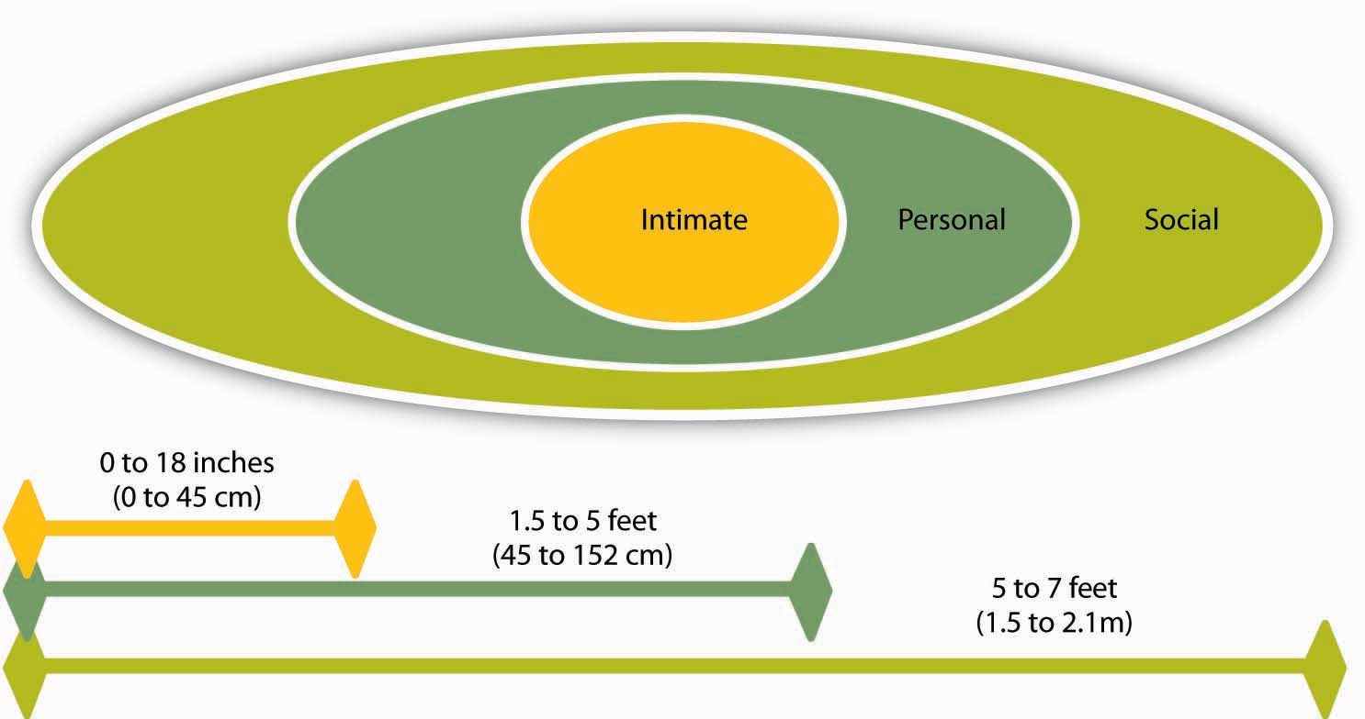
Standing too far away from a colleague (such as a public speaking distance of more than seven feet) or too close to a colleague (intimate distance for embracing) can thwart an effective verbal communication in business.
- Hall, E. T. (1966). The hidden dimension. New York: Doubleday

KEY TAKEAWAY
Types of communication include verbal, written, and nonverbal. Verbal communications have the advantage of immediate feedback, are best for conveying emotions, and can involve storytelling and crucial conversations. Written communications have the advantage of asynchronicity, of reaching many readers, and are best for conveying information. Both verbal and written communications convey nonverbal messages through tone; verbal communications are also colored by body language, eye contact, facial expression, posture, touch, and space.

EXERCISES
- When you see a memo or e-mail full of typos, poor grammar, or incomplete sentences, how do you react? Does it affect your perception of the Sender? Why or why not?
- How aware of your own body language are you? Has your body language ever gotten you into trouble when you were communicating with someone?
- If the meaning behind verbal communication is only 7% words, what does this imply for written communication?

12.5 Communication Channels

LEARNING OBJECTIVES
- Understand how communication channels affect communication.
- Recognize different communication directions within organizations.
The channel, or medium, used to communicate a message affects how accurately the message will be received. Verbal, written, and nonverbal communications have different strengths and weaknesses. In business, the decision to communicate verbally or in written form can be a powerful one. In addition, a smart manager is aware of the nonverbal messages conveyed by either type of communication—as noted earlier, only 7% of verbal communication comes from the words themselves.

Information Richness
Channels vary in their information richness. Information-rich channels convey more nonverbal information. As you may be able to guess from our earlier discussion of verbal and written communications, verbal communications are richer than written ones. Research shows that effective managers tend to use more information-rich communication channels than less effective managers.
- Allen, D. G., & Griffeth, R. W. (1997). Vertical and lateral information processing
- Fulk, J., & Boyd, B. (1991). Emerging theories of communication in organizations. Journal of Management, 17, 407–446
- Yates, J., & Orlikowski, W. J. (1992). Genres of organizational communication: A structurational approach to studying communication and media. Academy of Management Review, 17, 299–326
The figure below illustrates the information richness of different information channels.

Figure 12.16 Information Richness
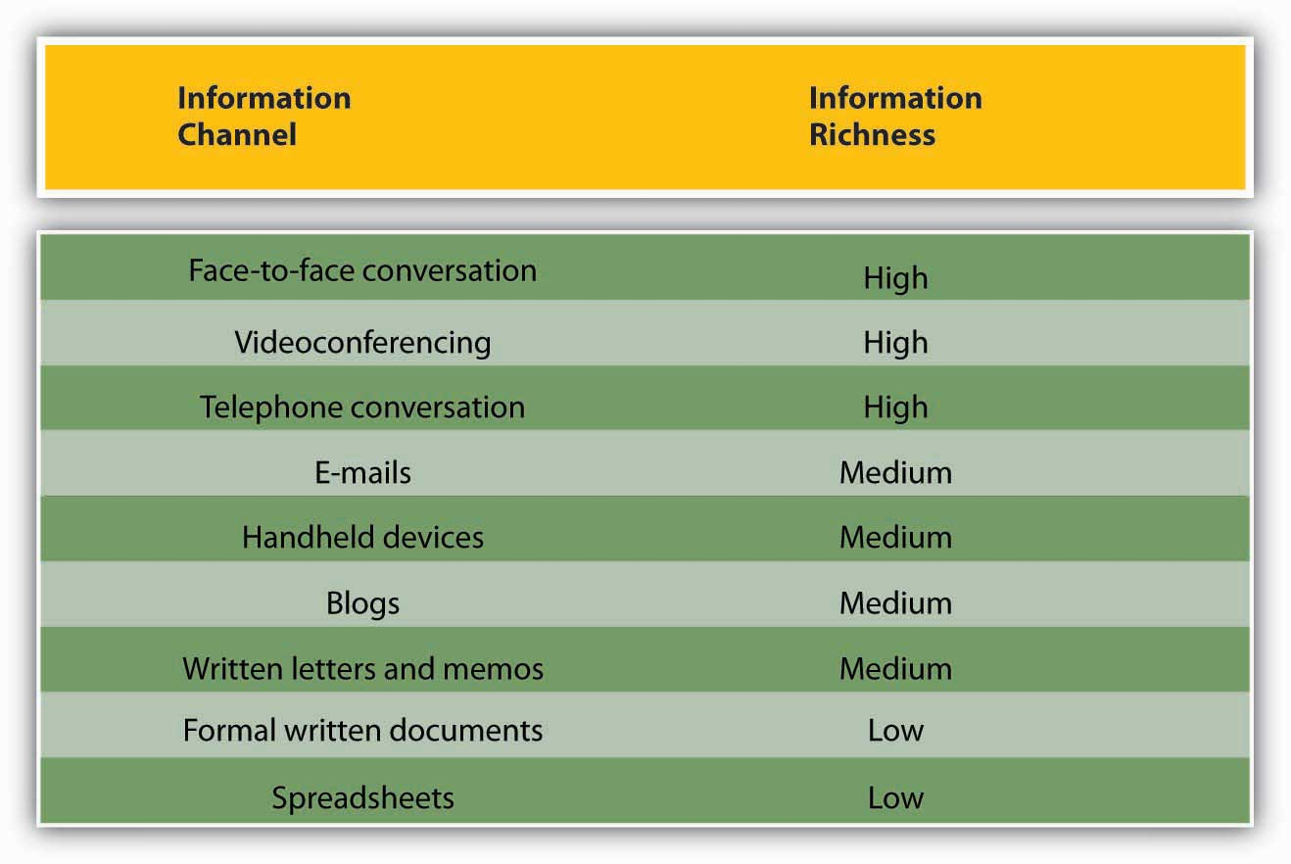
Source: Adapted from information in Daft, R. L., & Lenge, R. H. (1984). Information richness: A new approach to managerial behavior and organizational design. In B. Staw & L. Cummings (Eds.), Research in organizational behavior (Vol. 6, pp. 191–233). Greenwich, CT: JAI Press; and Lengel, R. H., & Daft, D. L. (1988). The selection of communication media as an executive skill. Academy of Management Executive, 11, 225–232.
Like face-to-face and telephone conversation, videoconferencing has high information richness because Receivers and Senders can see or hear beyond just the words—they can see the Sender’s body language or hear the tone of their voice. Handheld devices, blogs, and written letters and memos offer medium-rich channels because they convey words and pictures/photos. Formal written documents, such as legal documents, and spreadsheets, such as the division’s budget, convey the least richness because the format is often rigid and standardized. As a result, nuance is lost.
In business, the decision to communicate verbally or in written form can be powerful. In addition, a smart manager is aware of the nonverbal messages conveyed by either type of communication—as noted earlier, only 7% of a verbal communication comes from the words themselves.
When determining whether to communicate verbally or in writing, ask yourself: Do I want to convey facts or feelings? Verbal communications are a better way to convey feelings. Written communications do a better job of conveying facts.
Picture a manager making a speech to a team of 20 employees. The manager is speaking at a normal pace. The employees appear interested. But how much information is being transmitted? Not as much as the speaker believes! Humans listen much faster than they speak. The average public speaker communicates at a speed of about 125 words a minute. And that pace sounds fine to the audience. (In fact, anything faster than that probably would sound weird. To put that figure in perspective, someone having an excited conversation speaks at about 150 words a minute.) On the basis of these numbers, we could assume that the employees have more than enough time to take in each word the manager delivers. And that’s the problem. The average person in the audience can hear 400–500 words a minute.
- Lee, D., & Hatesohl, D. Listening: Our most used communication skill. University of Missouri. Retrieved July 2, 2008, from http://extension.missouri.edu/explore/comm/cm0150.htm
The audience has more than enough time to hear. As a result, they will each be processing many thoughts of their own, on totally different subjects, while the manager is speaking. As this example demonstrates, oral communication is an inherently flawed medium for conveying specific facts. Listeners’ minds wander! It’s nothing personal—in fact, it’s totally physical. In business, once we understand this fact, we can make more intelligent communication choices based on the kind of information we want to convey.
The key to effective communication is to match the communication channel with the goal of the communication.
- Barry, B., & Fulmer, I. S. (2004). The medium and the Message: The adaptive use of communication media in dyadic influence. Academy of Management Review, 29, 272–292
For example, written media may be a better choice when the Sender wants a record of the content, has less urgency for a response, is physically separated from the Receiver, doesn’t require a lot of feedback from the Receiver, or the Message is complicated and may take some time to understand. Oral communication, however, makes more sense when the Sender is conveying a sensitive or emotional Message, needs feedback immediately, and does not need a permanent record of the conversation. Use the guide provided for deciding when to use written versus verbal communication.

Figure 12.17 Guide for When to Use Written Versus Verbal Communication
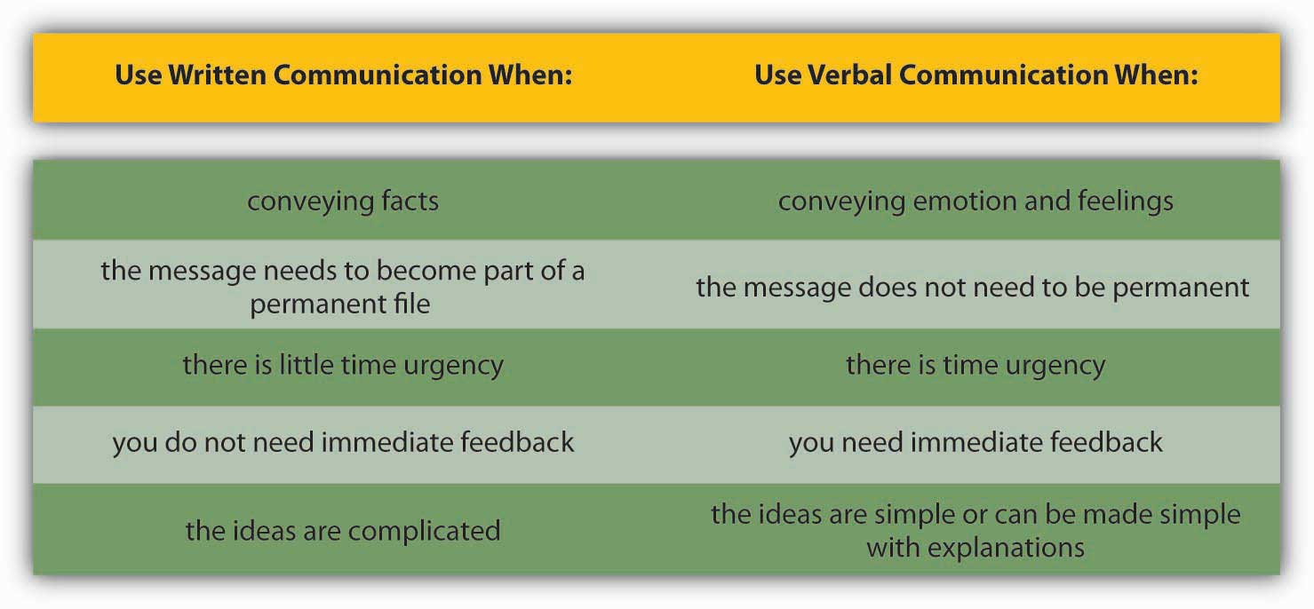

Business Use of E-Mail
The growth of e-mail has been spectacular, but it has also created challenges in managing information and an ever-increasing speed of doing business. Over 100 million adults in the United States use e-mail regularly (at least once a day).
- Taylor, C. (2002, June 10). 12 steps for email addicts. Time.com. Retrieved July 2, 2008, from http://www.time.com/time/magazine/article/0,9171,1002621,00.html
Internet users around the world send an estimated 60 billion e-mails every day, and many of those are spam or scam attempts.
- 60 Billion emails sent daily worldwide. (2006, April 26). Retrieved July 2, 2008, from CNET.UK:
That makes e-mail the second most popular medium of communication worldwide, second only to voice. A 2005 study estimated that less than 1% of all written human communications even reached paper—and we can imagine that this percentage has gone down even further since then.
- http://www.sims.berkeley.edu/research/projects/how-much-info/index.htm, as cited in David K. Isom. (2005, October 19). Electronic discovery: New power, new risks. Retrieved July 2, 2008, from http://utahbar.org/barjournal2000/html/november_2003_2.html
To combat the overuse of e-mail, companies such as Intel have even instituted “no e-mail Fridays” where all communication is done via other communication channels. Learning to be more effective in your e-mail communications is an important skill. To learn more, check out the business e-mail do’s and don’ts.

Business E-Mail Do’s and Don’ts
- DON’T send or forward chain e-mails.
- DON’T put anything in an e-mail that you don’t want the world to see.
- DON’T write a Message in capital letters—this is the equivalent of SHOUTING.
- DON’T routinely “cc” everyone all the time. Reducing inbox clutter is a great way to increase communication.
- DON’T hit Send until you spell-check your e-mail.
- DO use a subject line that summarizes your Message, adjusting it as the Message changes over time.
- DO make your request in the first line of your e-mail. (And if that’s all you need to say, stop there!)
- DO end your e-mail with a brief sign-off such as, “Thank you,” followed by your name and contact information.
- DO think of a work e-mail as a binding communication.
- DO let others know if you’ve received an e-mail in error.
- Leland, K., & Bailey, K. (2000). Customer service for dummies. New York: Wiley
- Information Technology Services (1997). Top 10 email dos and top ten email don’ts. Retrieved July 1, 2008, from the University of Illinois at Chicago Medical Center Web site: http://www.uic.edu/hsc/uicmc/its/customers/email-tips.htm
- Kawasaki, G. (2006, February 3). The effective emailer. Retrieved July 1, 2008, from How to Change the World Web site: http://blog.guykawasaki.com/2006/02/the_effective_e.html
An important, although often ignored, rule when communicating emotional information is that e-mail’s lack of richness can be your loss. As we saw in the chart above, e-mail is a medium-rich channel. It can convey facts quickly. But when it comes to emotion, e-mail’s flaws make it far less desirable a choice than oral communication—the 55% of nonverbal cues that make a conversation comprehensible to a listener are missing. E-mail readers don’t pick up on sarcasm and other tonal aspects of writing as much as the writer believes they will, researchers note in a recent study.
- Kruger, J. (2005). Egocentrism over email: Can we communicate as well as we think? Journal of Personality and Social Psychology, 89, 925–936
The Sender may believe she has included these emotional signifiers in her Message. But, with words alone, those signifiers are not there. This gap between the form and content of e-mail inspired the rise of emoticons—symbols that offer clues to the emotional side of the words in each Message. Generally speaking, however, emoticons are not considered professional in business communication.
You might feel uncomfortable conveying an emotionally laden message verbally, especially when the message contains unwanted news. Sending an e-mail to your staff that there will be no bonuses this year may seem easier than breaking the bad news face-to-face, but that doesn’t mean that e-mail is an effective or appropriate way to deliver this kind of news. When the Message is emotional, the Sender should use verbal communication. Indeed, a good rule of thumb is that the more emotionally laden messages require more thought in the choice of channel and how they are communicated.

Direction of Communication Within Organizations
Information can move horizontally, from a Sender to a Receiver, as we’ve seen. It can also move vertically, down from top management or up from the front line. Information can also move diagonally between and among levels of an organization, such as a Message from a customer service representative up to a manager in the manufacturing department, or a Message from the chief financial officer sent down to all department heads.

Figure 12.18
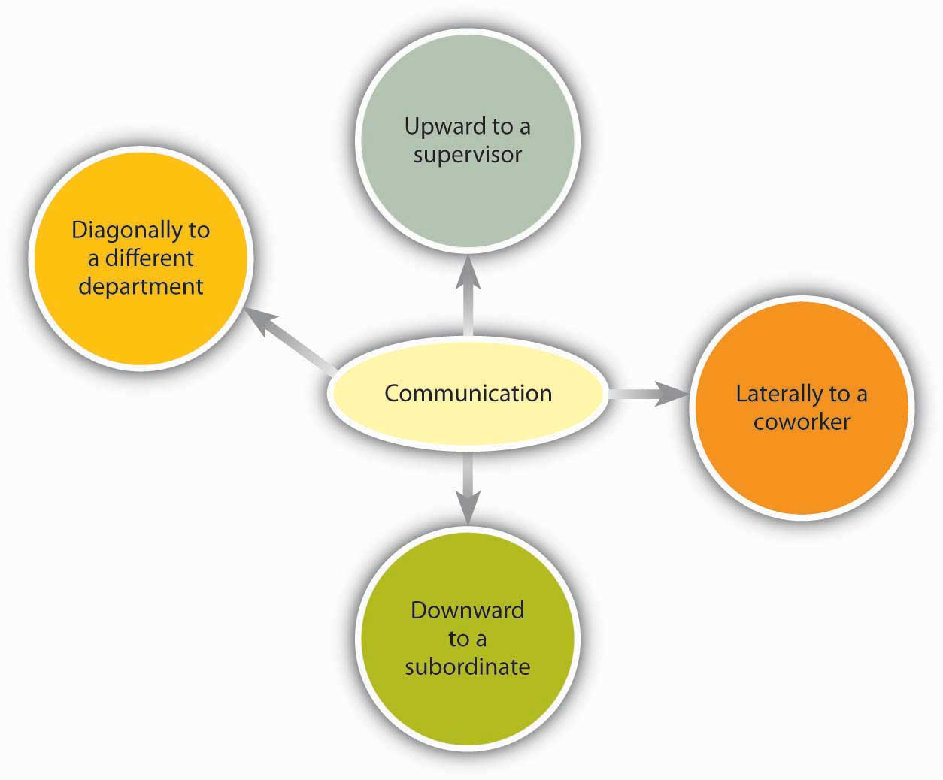
Communication flows in many different directions within an organization.
There is a chance for these arrows to go awry, of course. As Mihaly Csikszentmihalyi, author of best-selling books such as Flow, has noted, “In large organizations the dilution of information as it passes up and down the hierarchy, and horizontally across departments, can undermine the effort to focus on common goals.” Managers need to keep this in mind when they make organization design decisions as part of the organizing function.
The organizational status of the Sender can affect the Receiver’s attentiveness to the Message. For example, consider: A senior manager sends a memo to a production supervisor. The supervisor, who has a lower status within the organization, is likely to pay close attention to the Message. The same information, conveyed in the opposite direction, however, might not get the attention it deserves. The Message would be filtered by the senior manager’s perception of priorities and urgencies.
Requests are just one kind of communication in business. Other communications, both verbal or written, may seek, give, or exchange information. Research shows that frequent communications with one’s supervisor is related to better job performance ratings and overall organizational performance.
- Snyder, R. A., & Morris, J. H. (1984). Organizational communication and performance.Journal of Applied Psychology, 69, 461–465
- Kacmar, K. M., Witt, L. A., Zivnuska, S., & Guly, S. M. (2003). The interactive effect of leader-member exchange and communication frequency on performance ratings. Journal of Applied Psychology, 88, 764–772
Research also shows that lateral communication done between peers can influence important organizational outcomes such as turnover.
- Krackhardt, D., & Porter, L. W. (1986). The snowball effect: Turnover embedded in communication networks. Journal of Applied Psychology, 71, 50–55

Figure 12.19 Who Managers Spend Time Communicating with at Work
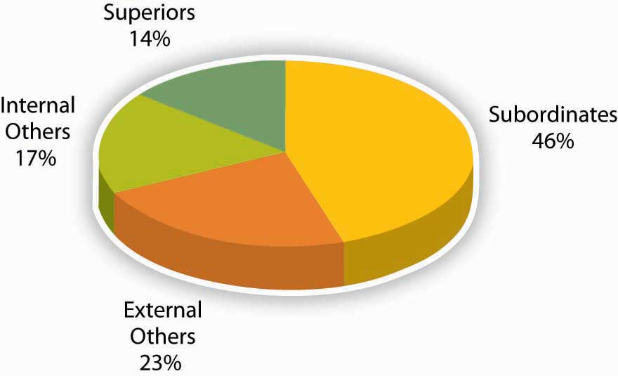
Source: Adapted from information in Luthans, F., & Larsen, J. K. (1986). How managers really communicate.Human Relations, 39, 161–178.

External Communications
External communications deliver specific business messages to individuals outside an organization. They may announce changes in staff or strategy, earnings, and more. The goal of an external communication is to create a specific Message that the Receiver will understand and share with others. Examples of external communications include the following:

Press Releases
Public relations professionals create external communications about a client’s product, services or practices for specific Receivers. These Receivers, it is hoped, will share the Message with others. In time, as the Message is passed along, it should appear to be independent of The Sender, creating the illusion of an independently generated consumer trend, public opinion, and so on.
The Message of a public relations effort may be b2b (business to business), b2c (business to consumer), or media related. The Message can take different forms. Press releases try to convey a newsworthy message, real or manufactured. It may be constructed like a news item, inviting editors or reporters to reprint the Message in part, or as a whole, with or without acknowledgment of the Sender’s identity. Public relations campaigns create Messages over time, through contests, special events, trade shows, and media interviews in addition to press releases.

Ads
Advertising places external business Messages before target Receivers through media buys. A media buy is a fee that is paid to a television network, Web site, or magazine by an advertiser for an on-air, site, or publication ad. The fee is based on the perceived value of the audience who watches, reads, or frequents the space where the ad will appear.
In recent years, Receivers have begun to filter advertiser’s Messages, a phenomenon that is perceived to be the result of the large amount of ads the average person sees each day and a growing level of consumer wariness of paid Messaging. Advertisers, in turn, are trying to create alternative forms of advertising that Receivers won’t filter. The advertorial is one example of an external communication that combines the look of an article with the focused Message of an ad. Product placements in videos, movies, and games are other ways that advertisers strive to reach Receivers with commercial Messages.

Web Pages
A Web page’s external communication can combine elements of public relations, advertising, and editorial content, reaching Receivers on multiple levels and in multiple ways. Banner ads, blogs, and advertiser-driven “click-through” areas are just a few of the elements that allow a business to deliver a Message to a Receiver online. The perceived flexibility of online communications can impart a less formal (and, therefore, more believable) quality to an external communication. A Message relayed in a daily blog post will reach a Receiver differently than if it is delivered in an annual report, for example. The popularity and power of blogs is growing, with 11% of Fortune 500 companies having official blogs (up from 4% in 2005). In fact, blogs have become so important to some companies as Coca-Cola, Kodak, and Marriott that they have created official positions within their organizations titled “Chief Blogging Officer.”
- Chief blogging officer title catching on with corporations. (2008, May 1). Workforce Management News in Brief. Retrieved July 2, 2008, from http://www.workforce.com/section/00/article/25/50/77.html
The “real-time” quality of Web communications may appeal to Receivers who might filter out a traditional ad and public relations message because of its “prefab” quality. Despite their “spontaneous” feel, many online pages can be revisited in perpetuity. For this reason, clear and accurate external communications are as vital for online use as they are in traditional media.

Customer Communications
Customer communications can include letters, catalogs, direct mail, e-mails, text messages, and telemarketing messages. Some Receivers automatically filter bulk messages like these. Others will be receptive. The key to a successful external communication to customers is to convey a business message in a personally compelling way—dramatic news, a money-saving coupon, and so forth.

KEY TAKEAWAY
Different communication channels are more or less effective at transmitting different kinds of information. Some types of communication are information rich while others are medium rich. In addition, communications flow in different directions within organizations. A major internal communication channel is e-mail, which is convenient but needs to be handled carefuly. External communication channels include PR/press releases, ads, Web pages, and customer communications such as letters and catalogs.

EXERCISES
- How could you use your knowledge of communication richness to be more effective in your own communications?
- What are the three biggest advantages and disadvantages you see regarding technology and communications?
- Explain the difference between internal and external communications in an organization, giving examples of each.

12.6 Developing Your Personal Communication Skills

LEARNING OBJECTIVES
- Learn how to improve your own listening habits.
- Learn how to handle personal communications in a career-friendly manner.
- Learn what communication freezers are and how to avoid them.
By being sensitive to the errors outlined in this chapter and adopting active listening skills, you may increase your communication effectiveness, increasing your ability to carry out the managerial functions of planning, organizing, leading, and controlling. The following are additional tools for helping you increase your communication effectiveness.

Ten Ways to Improve Your Listening Habits
- Start by stopping. Take a moment to inhale and exhale quietly before you begin to listen. Your job as a listener is to receive information openly and accurately.
- Don’t worry about what you’ll say when the time comes. Silence can be a beautiful thing.
- Join the Sender’s team. When she pauses, summarize what you believe she has said. “What I’m hearing is that we need to focus on marketing as well as sales. Is that correct?” Be attentive to physical as well as verbal communications. “I hear you saying that we should focus on marketing. But the way you’re shaking your head tells me the idea may not really appeal to you—is that right?”
- Don’t multitask while listening. Listening is a full-time job. It’s tempting to multitask when you and the Sender are in different places, but doing that is counterproductive. The human mind can only focus on one thing at a time. Listening with only half your brain increases the chances that you’ll have questions later, requiring more of the Speaker’s time. (And when the speaker is in the same room, multitasking signals a disinterest that is considered rude.)
- Try to empathize with the Sender’s point of view. You don’t have to agree; but can you find common ground?
- Confused? Ask questions. There’s nothing wrong with admitting you haven’t understood the Sender’s point. You may even help the Sender clarify the Message.
- Establish eye contact. Making eye contact with the speaker (if appropriate for the culture) is important.
- What is the goal of this communication? Ask yourself this question at different points during the communication to keep the information flow on track. Be polite. Differences in opinion can be the starting point of consensus.
- It’s great to be surprised. Listen with an open mind, not just for what you want to hear.
- Pay attention to what is not said. Does the Sender’s body language seem to contradict her Message? If so, clarification may be in order.
- Barrett, D. J. (2006). Leadership communication. New York: McGraw-Hill/Irwin
- Improving verbal skills. Retrieved July 2, 2008, fromhttp://www.itstime.com/aug97.htm
- Ten tips: Active Listening from Communication at work. (2007, June 4). Retrieved July 2, 2008, from http://communication.atwork-network.com/2007/06/04/ten-tips-active-listening

Career-Friendly Communications
Communication can occur without your even realizing it. Consider the following: Is your e-mail name professional? The typical convention for business e-mail contains some form of your name. While an e-mail name like “LazyGirl” or “DeathMonkey” may be fine for chatting online with your friends, they may send the wrong signal to individuals you e-mail such as professors and prospective employers.
- Is your outgoing voice mail greeting professional? If not, change it. Faculty and prospective recruiters will draw certain conclusions if, upon calling you, they hear a message that screams, “Party, party, party!”
- Do you have a “private” social networking Web site on MySpace.com, Facebook.com, or Xanga.com? If so, consider what it says about you to employers or clients. If it is information you wouldn’t share at work, it probably shouldn’t be there.
- Googled yourself lately? If not, you probably should. Potential employers have begun searching the Web as part of background checking and you should be aware of what’s out there about you.

Communication Freezers
Communication freezers put an end to effective communication by making the Receiver feel judged or defensive. Typical communication stoppers include critizing, blaming, ordering, judging, or shaming the other person. The following are some examples of things to avoid saying:
- Telling people what to do:
  - “You must…”
  - “You cannot…”
- Threatening with “or else” implied:
  - “You had better…”
  - “If you don’t…”
- Making suggestions or telling other people what they ought to do:
  - “You should…”
  - “It’s your responsibility to…”
- Attempting to educate the other person:
  - “Let me give you the facts.”
  - “Experience tells us that…”
- Judging the other person negatively:
  - “You’re not thinking straight.”
  - “You’re wrong.”
- Giving insincere praise:
  - “You have so much potential.”
  - “I know you can do better than this.”
- Psychoanalyzing the other person:
  - “You’re jealous.”
  - “You have problems with authority.”
- Making light of the other person’s problems by generalizing:
  - “Things will get better.”
  - “Behind every cloud is a silver lining.”
- Asking excessive or inappropriate questions:
  - “Why did you do that?”
  - “Who has influenced you?”
- Making light of the problem by kidding:
  - “Think about the positive side.”
  - “You think you’ve got problems!”

- Tramel, M., & Reynolds, H. (1981). Executive leadership. Englewood Cliffs, NJ: Prentice Hall; Saltman, D., & O’Dea, N. (n.d.). Conflict management workshop powerpoint presentation. Retrieved July 1, 2008, from http://www.nswrdn.com.au/client_images/6806.PDF
- Communication stoppers. Retrieved July 1, 2008, from Mental Health Today Web site: http://www.mental-health-today.com/Healing/communicationstop.htm

KEY TAKEAWAY
By practicing the skills associated with active listening, you can become more effective in your personal and professional relationships. Managing your online communications appropriately can also help you avoid career pitfalls. Finally, be aware of the types of remarks that freeze communication and try not to use them.

EXERCISES
- How can you assess if you are engaging in active listening?
- How does it feel when someone does not seem to be listening to you?
- Some companies have MySpace pages where employees can mingle and share ideas and information. Do you think this practice is a good idea? Why or why not?
- What advice would you give to someone who is going to become a first time manager in terms of communication?

Chapter 13

Managing Groups and Teams

WHAT’S IN IT FOR ME?
Reading this chapter will help you do the following:
- Recognize and understand group dynamics and development.
- Understand the difference between groups and teams.
- Understand how to organize effective teams.
- Recognize and address common barriers to team effectiveness.
- Build and maintain cohesive teams.

Figure 13.2 The P-O-L-C Framework
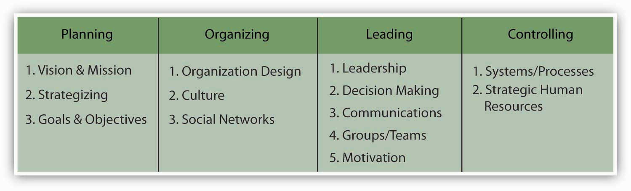
Groups and teams are ubiquitous on the organizational landscape and managers will find that team management skills are required within each of the planning-organizing-leading-controlling (P-O-L-C) functions. For instance, planning may often occur in teams, particularly in less centralized organizations or toward the higher levels of the firm. When making decisions about the structure of the firm and individual jobs, managers conducting their organizing function must determine how teams will be used within the organization. Teams and groups have implications for the controlling function because teams require different performance assessments and rewards. Finally, teams and groups are a facet of the leading function. Today’s managers must be both good team members and good team leaders. Managing groups and teams is a key component of leadership.
In your personal life, you probably already belong to various groups such as the group of students in your management class; you may also belong to teams, such as an athletic team or a musical ensemble. In your career, you will undoubtedly be called on to be part of, and mostly likely to manage, groups and teams.

13.1 Case in Point: General Electric Allows Teamwork to Take Flight
In Durham, North Carolina, Robert Henderson was opening a factory for General Electric Company (NYSE: GE). The goal of the factory was to manufacture the largest commercial jet engine in the world. Henderson’s opportunity was great and so were his challenges. GE hadn’t designed a jet engine from the ground up for over 2 decades. Developing the jet engine project had already cost GE $1.5 billion. That was a huge sum of money to invest—and an unacceptable sum to lose should things go wrong in the manufacturing stage.
How could one person fulfill such a vital corporate mission? The answer, Henderson decided, was that one person couldn’t fulfill the mission. Even Jack Welch, GE’s CEO at the time, said, “We now know where productivity comes from. It comes from challenged, empowered, excited, rewarded teams of people.”
Empowering factory workers to contribute to GE’s success sounded great in theory. But how to accomplish these goals in real life was a more challenging question. Factory floors, traditionally, are unempowered workplaces where workers are more like cogs in a vast machine than self-determining team members.
In the name of teamwork and profitability, Henderson traveled to other factories looking for places where worker autonomy was high. He implemented his favorite ideas at the factory at Durham. Instead of hiring generic “mechanics,” for example, Henderson hired staffers with FAA (Federal Aviation Administration) mechanic’s licenses. This superior training created a team capable of making vital decisions with minimal oversight, a fact that upped the factory’s output and his workers’ feelings of worth.
Henderson’s “self-managing” factory functioned beautifully. And it looked different, too. Plant manager Jack Fish described Henderson’s radical factory, saying Henderson “didn’t want to see supervisors, he didn’t want to see forklifts running all over the place, he didn’t even want it to look traditional. There’s clutter in most plants, racks of parts and so on. He didn’t want that.”
Henderson also contracted out non-job-related chores, such as bathroom cleaning, that might have been assigned to workers in traditional factories. His insistence that his workers should contribute their highest talents to the team showed how much he valued them. And his team valued their jobs in turn.
Six years later, a Fast Company reporter visiting the plant noted, “GE/Durham team members take such pride in the engines they make that they routinely take brooms in hand to sweep out the beds of the 18-wheelers that transport those engines—just to make sure that no damage occurs in transit.” For his part, Henderson, who remained at GE beyond the project, noted, “I was just constantly amazed by what was accomplished there.”
GE’s bottom line showed the benefits of teamwork, too. From the early 1980s, when Welch became CEO, until 2000, when he retired, GE generated more wealth than any organization in the history of the world.

Primary Resource:
Secondary Resources:
- Fishman, C. (1999, September). How teamwork took flight. Fast Company. Retrieved August 1, 2008, from http://www.fastcompany.com/node/38322/print
- Lear, R. (1998, July–August). Jack Welch speaks: Wisdom from the world’s greatest business leader. Chief Executive; Guttman, H. (2008, January–February) Leading high-performance teams: Horizontal, high-performance teams with real decision-making clout and accountability for results can transform a company. Chief Executive, pp. 231–233

DISCUSSION QUESTIONS
- Teams are an essential part of the leading facet of the P-O-L-C framework. Looking at the team role typology, how might you categorize the roles played by the teams in this case?
- What do you think brought individuals at GE together to work as a cohesive team?
- In the case of GE, do you view the team members or the management leaders as the most important part of the story?
- How do you think Henderson held his team members accountable for their actions?
- Do you think that GE offered a support system for its employees in order to create this type of team cohesion? If so, how might this have been accomplished?
- What are the benefits of creating a team whose members are educated to make vital decisions with minimal oversight, as GE did in hiring staffers with FAA mechanic’s licenses?

13.2 Group Dynamics

LEARNING OBJECTIVES
- Understand the difference between informal and formal groups.
- Learn the stages of group development.
- Identify examples of the punctuated equilibrium model.
- Learn how group cohesion, social loafing, and collective efficacy can affect groups.
Because many tasks in today’s world have become so complex, groups and teams have become an essential component of an organization’s success. The success of the group depends on the successful management of its members and making sure all aspects of work are fair for each member. Being able to work in a group is a key skill for managers and employees alike.

Types of Groups: Formal and Informal
What is a group? A group is a collection of individuals who interact with each other such that one person’s actions have an impact on the others. In organizations, most work is done within groups, and managing groups is key to each of the P-O-L-C functions. How groups function has important implications for organizational productivity. Groups where people get along, feel the desire to contribute, and are capable of coordinating their efforts may have high performance levels, whereas those characterized by extreme levels of conflict or hostility may demoralize members of the workforce.
In organizations, groups can be classified into two basic types: informal and formal. Informal work groups are made up of two or more individuals who are associated with one another in ways not prescribed by the formal organization. For example, a few people in the company who get together to play tennis on the weekend would be considered an informal group. A formal work group is made up of managers, subordinates, or both with close associations among group members that influence the behavior of individuals in the group. We will discuss many different types of formal work groups later on in this chapter.

Stages of Group Development
American organizational psychologist Bruce Tuckman presented a robust model in 1965 that is still widely used today. On the basis of his observations of group behavior in a variety of settings, he proposed a four-stage map of group evolution, known as the Forming-Storming-Norming-Performing Model.
- Tuckman, B. (1965). Developmental sequence in small groups. Psychological Bulletin, 63, 384–399
Later he enhanced the model by adding a fifth and final stage, adjourning. The phases are illustrated in the Stages of the Group Development Model. Interestingly enough, just as an individual moves through developmental stages such as childhood, adolescence, and adulthood, so does a group, although in a much shorter period of time.
According to this theory, to facilitate a group successfully, the leader needs to move through various leadership styles over time. Generally, this is accomplished by first being more direct, eventually serving as a coach, and later, once the group is able to assume more power and responsibility for itself, shifting to delegator.
While research has not confirmed that this is descriptive of how groups progress, knowing and following these steps can help groups be more effective. For example, groups that do not go through the storming phase early on will often return to this stage toward the end of the group process to address unresolved issues. Another example of the validity of the group development model involves groups that take the time to get to know each other socially in the forming stage. When this socialization occurs, groups tend to handle future challenges better because the individuals have an understanding of each other’s needs.

Figure 13.4 Stages of the Group Development Model
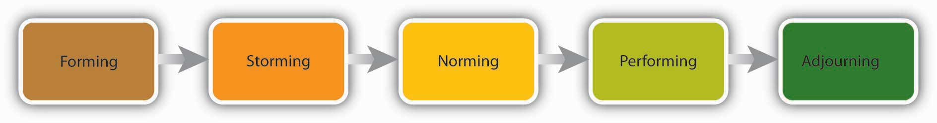

Forming
In the Forming stage, the group comes together for the first time. The members may already know each other or they may be total strangers. In either case, there is a level of formality, some anxiety, and a degree of guardedness as group members are not sure what is going to happen next. “Will I be accepted? What will my role be? Who has the power here?” These are some of the questions participants think about during this stage of group formation. Because of the large amount of uncertainty, members tend to be polite, conflict avoidant, and observant. They are trying to figure out the “rules of the game” without being too vulnerable. At this point, they may also be quite excited and optimistic about the task, perhaps experiencing a level of pride at being chosen to join a particular group.
Group members are trying to achieve several goals at this stage, although this may not necessarily be done consciously. First, they are trying to get to know one another. Often this can be accomplished by finding some common ground. Members also begin to explore group boundaries to determine what will be considered acceptable behavior. “Can I interrupt? Can I leave when I feel like it?” This trial phase may also involve testing the appointed leader or seeing whether a leader emerges from the group. At this point, group members are also discovering how the group will work in terms of what needs to be done and who will be responsible for each task. This stage is often characterized by abstract discussions about issues to be addressed by the group; those who like to get moving can become impatient with this part of the process. This phase is usually short in duration, perhaps a meeting or two.

Storming
Once group members feel sufficiently safe and included, they tend to enter the Storming phase. Participants focus less on keeping their guard up as they shed social facades, becoming more authentic and more argumentative. Group members begin to explore their power and influence, and they often stake out their territory by differentiating themselves from the other group members rather than seeking common ground. Discussions can become heated as participants raise conflicting points of view and values, or disagree over how tasks should be done and who is assigned to them. It is not unusual for group members to become defensive, competitive, or jealous. They may take sides or begin to form cliques within the group. Questioning and resisting direction from the leader is also quite common. “Why should I have to do this? Who designed this project in the first place? What gives you the authority to tell me what to do?”
Although little seems to get accomplished at this stage, it actually serves an important purpose: group members are becoming more authentic as they express their deeper thoughts and feelings. What they are really exploring is “Can I truly be me, have power, and be accepted?” During this chaotic stage, a great deal of creative energy that was previously buried is released and available for use, but it takes skill to move the group from Storming to Norming. In many cases, the group gets stuck in the Storming phase.
Once group members discover that they can be authentic and that the group is capable of handling differences without dissolving, they are ready to enter the next stage, Norming.

Norming
“We survived!” is the common sentiment as this stage. Group members often feel elated at this point, and they are much more committed to each other and the group’s goal. Feeling energized by knowing they can handle the “tough stuff,” group members are now ready to get to work. Finding themselves more cohesive and cooperative, participants find it easy to establish their own ground rules (or norms) and define their operating procedures and goals. The group tends to make big decisions, while subgroups or individuals handle the smaller decisions. It is hoped at this point the group members are more open and respectful toward each other and willing to ask one another for both help and feedback. They may even begin to form friendships and share more personal information.
At this point, the leader should become more of a facilitator by stepping back and letting the group assume more responsibility for its goal. Since the group’s energy is running high, this is an ideal time to host a social or team-building event.

Performing
Galvanized by a sense of shared vision and a feeling of unity, the group is ready to go into high gear. Members are more interdependent, individuality and differences are respected, and group members feel themselves to be part of a greater entity. At the Performing stage, participants are not only getting the work done, but they also pay greater attention to how they are doing it. They ask such questions as, “Do our operating procedures best support productivity and quality assurance? Do we have suitable means for addressing differences that arise so we can preempt destructive conflicts? Are we relating to and communicating with each other in ways that enhance group dynamics and help us achieve our goals? How can I further develop as a person to become more effective?” By now, the group has matured, becoming more competent, autonomous, and insightful.
Group leaders can finally move into coaching roles and help members grow in skill and leadership. These leadership shifts are essential for managers enacting the Leadership function to keep in mind. In fact, a manager who leads multiple teams may find it necessary to shift leadership styles not only over time but between teams at different stages.

Adjourning
Just as groups form, so do they end. For example, many groups or teams formed in a business context are project-oriented and therefore are temporary. Alternatively, a working group may dissolve because of an organizational restructuring. As with graduating from school or leaving home for the first time, these endings can be bittersweet, with group members feeling a combination of victory, grief, and insecurity about what is coming next. For those who like routine and bond closely with fellow group members, this transition can be particularly challenging. Group leaders and members alike should be sensitive to handling these endings respectfully and compassionately. An ideal way to close a group is to set aside time to debrief (“How did it all go? What did we learn?”), acknowledge one another, and celebrate a job well done.

The Punctuated-Equilibrium Model
As you may have noted, the five-stage model we have just reviewed is a linear process. According to the model, a group progresses to the Performing stage, at which point it finds itself in an ongoing, smooth-sailing situation until the group dissolves. In reality, subsequent researchers, most notably Joy H. Karriker, have found that the life of a group is much more dynamic and cyclical in nature.
- Karriker, J. H. (2005). Cyclical group development and interaction-based leadership emergence in autonomous teams: an integrated model. Journal of Leadership & Organizational Studies, 11(4), 54–64
For example, a group may operate in the Performing stage for several months. Then, because of a disruption, such as a competing emerging technology that changes the rules of the game or the introduction of a new CEO, the group may move back into the Storming phase before returning to Performing. Ideally, any regression in the linear group progression will ultimately result in a higher level of functioning. Proponents of this cyclical model draw from behavioral scientist Connie Gersick’s study of punctuated equilibrium.
- Gersick, C. J. G. (1991). Revolutionary change theories: A multilevel exploration of the punctuated equilibrium paradigm. Academy of Management Review, 16(1), 10–36
The concept of punctuated equilibrium was first proposed in 1972 by paleontologists Niles Eldredge and Stephen Jay Gould, who both believed that evolution occurred in rapid, radical spurts rather than gradually over time. Identifying numerous examples of this pattern in social behavior, Gersick found that the concept applied to organizational change. She proposed that groups remain fairly static, maintaining a certain equilibrium for long periods. Change during these periods is incremental, largely due to the resistance to change that arises when systems take root and processes become institutionalized. In this model, revolutionary change occurs in brief, punctuated bursts, generally catalyzed by a crisis or a problem that breaks through the systemic inertia and shakes up the deep organizational structures in place. At this point, the organization or group has the opportunity to learn and create new structures that are better aligned with current realities. Whether the group does this is not guaranteed. In sum, in Gersick’s model, groups can repeatedly cycle through the Storming and Performing stages, with revolutionary change taking place during short transitional windows. For organizations and groups who understand that disruption, conflict, and chaos are inevitable in the life of a social system, these disruptions represent opportunities for innovation and creativity.

Figure 13.5 The Punctuated Equilibrium Model
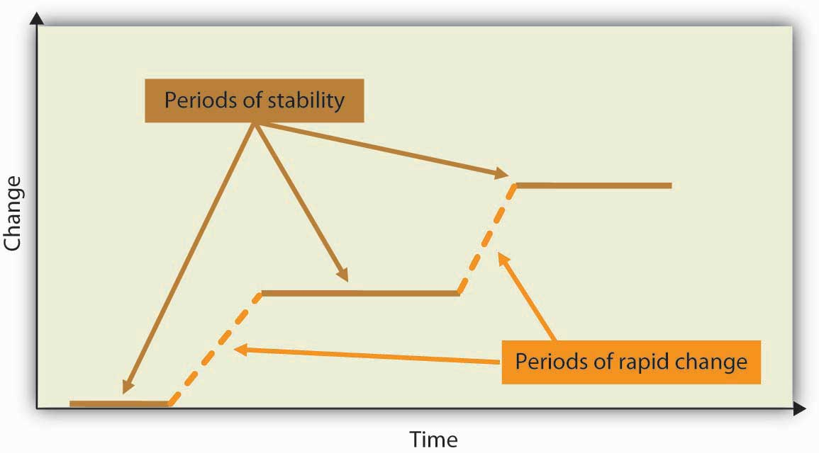

Cohesion, Social Loafing, and Collective Efficacy
Cohesion can be thought of as a kind of social glue. It refers to the degree of camaraderie within the group. Cohesive groups are those in which members are attached to each other and act as one unit. The more cohesive a group, the more productive it will be and the more rewarding the experience will be for the group’s members.
- Beal, D. J., Cohen, R. R., Burke, M. J., & McLendon, C. L. (2003). Cohesion and performance in groups: A meta-analytic clarification of construct relations. Journal of Applied Psychology, 88, 989–1004
- Evans, C. R., & Dion, K. L. (1991). Group cohesion and performance: A meta-analysis. Small Group Research, 22, 175–186
Cohesive groups tend to have the following characteristics: they have a collective identity; they experience a moral bond and a desire to remain part of the group; they share a sense of purpose, working together on a meaningful task or cause; and they establish a structured pattern of communication.
The fundamental factors affecting group cohesion include the following:
- Similarity. The more similar group members are in terms of age, sex, education, skills, attitudes, values, and beliefs, the more likely the group will bond.
- Stability. The longer a group stays together, the more cohesive it becomes.
- Size. Smaller groups tend to have higher levels of cohesion.
- Support. When group members receive coaching and are encouraged to support their fellow team members, group identity strengthens.
- Satisfaction. Cohesion is correlated with how pleased group members are with one another’s performance, behavior, and conformity to group norms.
As you might imagine, there are many benefits in creating a cohesive group. Members are generally more personally satisfied and feel greater self-confidence and self-esteem in a group where they feel they belong. For many, membership in such a group can be a buffer against stress, which can improve mental and physical well-being. Because members are invested in the group and its work, they are more likely to regularly attend and actively participate in the group, taking more responsibility for the group’s functioning. In addition, members can draw on the strength of the group to persevere through challenging situations that might otherwise be too hard to tackle alone.

Can a Group Have Too Much Cohesion?
Despite the advantages of cohesion, too much cohesion can be detrimental to a group. Because members can come to value belonging over all else, an internal pressure to conform may arise where some members modify their behavior to adhere to group norms. Members may become conflict avoidant, focusing on trying to please one another so as not to be ostracized. In some cases, members might censor themselves to maintain the party line. As such, the group is dominated by a superficial sense of harmony and discourages diversity of thought. Having less tolerance for deviants, who threaten the group’s static identity, cohesive groups will often disapprove of members who dare to disagree. Members attempting to make a change may be criticized, undermined, or even ostracized by other members, who perceive their attempts as a threat to the status quo. The painful possibility of being marginalized can keep many members in line with the majority.
The more strongly members identify with the group, the easier it is to see outsiders as inferior or, in extreme cases, as enemies. It is easy to see how this can lead to increased insularity. This form of prejudice can have a downward spiral effect. The group is not getting corrective feedback from within its own confines, and it is closing itself off from input and a cross-fertilization of ideas from the outside. In such an environment, groups can easily adopt extreme ideas that will not be challenged. Denial increases as problems are ignored and failures are blamed on external factors. With limited, often biased, information and no internal or external opposition, groups like these can make disastrous decisions.
Groupthink is a group pressure phenomenon that increases the risk of the group making flawed decisions by allowing reductions in mental efficiency, reality testing, and moral judgment. A famous example of groupthink is the decision to invade Cuba made by President John F. Kennedy and his cabinet in 1961. In a matter of days, Cuban forces repelled the invaders, whose objective was to overthrow the entire Cuban government, resulting in many casualties and captured troops. In retrospect, there were many reasons why the Bay of Pigs invasion was doomed from the start, but the planning and approval were characterized by a belief that the insiders knew best and did not need to consider “devil’s advocate” points of view. As this example illustrates, groupthink is a serious risk in highly cohesive groups.
- Janis, I. L. (1972). Victims of groupthink. New York: Houghton Mifflin
Cohesive groups can go awry in much milder ways. For example, group members can value their social interactions so much that they have fun together but spend little time on accomplishing their assigned task. Or a group’s goal may begin to diverge from the larger organization’s goal and those trying to uphold the organization’s goal may be criticized (for example, students may tease the class “brain” for doing well in school).
In addition, research shows that cohesion leads to acceptance of group norms.
- Goodman, P. S., Ravlin, E., & Schminke, M. (1987). Understanding groups in organizations. Research in Organizational Behavior, 9, 121–173
Groups with high task commitment tend to do well, but suppose you belong to a group in which the norms are to work as little as possible! As you might imagine, these groups accomplish little and can actually work together against the organization’s goals.

Figure 13.6
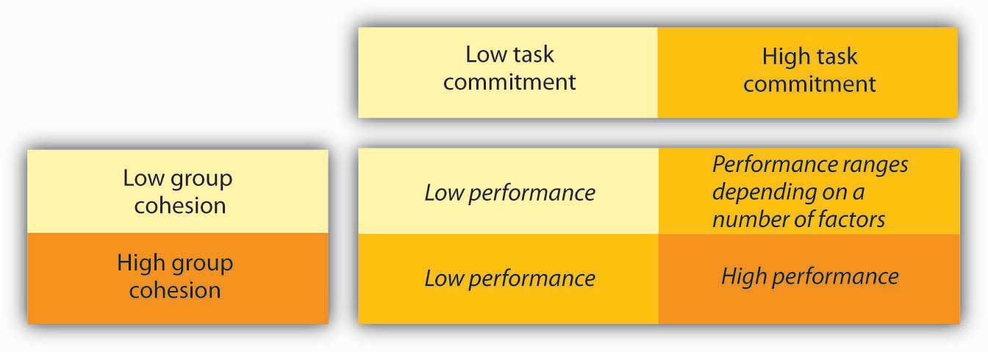
Groups with high cohesion and high task commitment tend to be the most effective.

Social Loafing
Social loafing refers to the tendency of individuals to put in less effort when working in a group context. This phenomenon, also known as the Ringelmann effect, was first noted by French agricultural engineer Max Ringelmann in 1913. In one study, he had people pull on a rope individually and in groups. He found that as the number of people pulling increased, the group’s total pulling force was less than the sum of individual efforts had been when measured alone.
- Karau, S. J., & Williams, K. D. (1993). Social loafing: A meta-analytic review and theoretical integration. Journal of Personality and Social Psychology, 65, 681–706
Why do people work less hard when they are working with other people? Observations show that as the size of the group grows, this effect becomes larger as well.
- Karau, S. J., & Williams, K. D. (1993). Social loafing: A meta-analytic review and theoretical integration. Journal of Personality and Social Psychology, 65, 681–706
The social loafing tendency is not so much a matter of laziness as a matter of perceiving that one will receive neither one’s fair share of rewards if the group is successful nor blame if the group fails. Rationales for this behavior include, “My own effort will have little effect on the outcome.” “Others aren’t pulling their weight, so why should I?” Or “I don’t have much to contribute, and no one will notice anyway.” This is a consistent effect across a great number of group tasks and countries.
- Gabrenya, W. L., Latane, B., & Wang, Y. (1983). Social loafing in cross-cultural perspective.Journal of Cross-Cultural Perspective, 14, 368–384
- Harkins, S., & Petty, R. E. (1982). Effects of task difficulty and task uniqueness on social loafing. Journal of Personality and Social Psychology, 43, 1214–1229
- Taylor, D. W., & Faust, W. L. (1952). Twenty questions: Efficiency of problem-solving as a function of the size of the group. Journal of Experimental Psychology, 44, 360–363;
- Ziller, R. C. (1957)Four techniques of group decision-making under uncertainty. Journal of Applied Psychology,41, 384–388
Research also shows that perceptions of fairness are related to less social loafing.
- Price, K. H., Harrison, D. A., & Gavin, J. H. (2006). Withholding inputs in team contexts: Member composition, interaction processes, evaluation structure, and social loafing. Journal of Applied Psychology, 91, 1375–1384
Therefore, teams that are deemed as more fair should also see less social loafing.

Collective Efficacy
Collective efficacy refers to a group’s perception of its ability to successfully perform well.
- Bandura, A. (1997). Self-efficacy: The exercise of control. San Francisco: Jossey-Bass
A group with high collective efficacy is one whose members share a belief in the group’s capability to pursue its agreed-upon course of action and attain its goals. Collective efficacy is influenced by a number of factors, including watching others (“that group did it and we’re better than them”), verbal persuasion (“we can do this”), and how a person feels (“this is a good group”). Research shows that a group’s collective efficacy is positively related to its performance.
- Gully, S. M., Incalcaterra, K. A., Joshi, A., & Beaubien, J. M. (2002). A meta-analysis of team-efficacy, potency, and performance: Interdependence and level of analysis as moderators of observed relationships. Journal of Applied Psychology, 87, 819–832
- Porter, C. O. L. H (2005). Goal orientation: Effects on backing up behavior, performance, efficacy, and commitment in teams. Journal of Applied Psychology, 90, 811–818
- Tasa, K., Taggar, S., & Seijts, G. H. (2007). The development of collective efficacy in teams: A multilevel and longitudinal perspective. Journal of Applied Psychology, 92, 17–27
In addition, this relationship is stronger when task interdependence (the degree an individual’s task is linked to someone else’s work) is high rather than low.

KEY TAKEAWAY
Groups may be either formal or informal. Groups go through developmental stages much like individuals do. The Forming-Storming-Norming-Performing-Adjourning Model is useful in prescribing stages that groups should pay attention to as they develop. The punctuated-equilibrium model of group development argues that groups often move forward during bursts of change after long periods without change. Groups that are similar, stable, small, supportive, and satisfied tend to be more cohesive than groups that are not. Cohesion can help support group performance if the group values task completion, but too much cohesion can also be a concern for groups. Social loafing increases as groups become larger. When collective efficacy is high, groups tend to perform better.

EXERCISES
- How do the tactics related to group dynamics involve the managerial functions outlined by the P-O-L-C framework?
- If you believe the punctuated-equilibrium model is true about groups, how can you use this knowledge to help your own group?
- Think about the most cohesive group you have ever been in. How did it compare to less cohesive groups in terms of similarity, stability, size, support, and satisfaction?
- Why do you think social loafing occurs within groups? What can be done to combat it?
- Have you seen instances of collective efficacy helping or hurting a team? Please explain your answer.

13.3 Understanding Team Design Characteristics

LEARNING OBJECTIVES
- Understand the difference between groups and teams.
- Understand the factors leading to the rise in the use of teams.
- Understand how tasks and roles affect teams.
- Identify different types of teams.
- Identify team design considerations.
Effective teams give companies a significant competitive advantage. In a high-functioning team, the sum is truly greater than the parts. Team members not only benefit from one another’s diverse experiences and perspectives but also stimulate each other’s creativity. Plus, for many people, working in a team can be more fun than working alone. Let’s take a closer look at what a team is, the different team characteristics, types of teams companies use, and how to design effective teams.

Differences Between Groups and Teams
Organizations consist of groups of people. What exactly is the difference between a group and a team? A group is a collection of individuals. Within an organization, groups might consist of project-related groups such as a product group or division or they can encompass an entire store or branch of a company. The performance of a group consists of the inputs of the group minus any process losses such as the quality of a product, ramp-up time to production, or the sales for a given month. Process loss is any aspect of group interaction that inhibits group functioning.
Why do we say group instead of team? A collection of people is not a team, though they may learn to function in that way. A team is a particular type of group: a cohesive coalition of people working together to achieve mutual goals. Being on a team does not equate to a total suppression of personal agendas, but it does require a commitment to the vision and involves each individual working toward accomplishing the team’s objective. Teams differ from other types of groups in that members are focused on a joint goal or product, such as a presentation, discussing a topic, writing a report, creating a new design or prototype, or winning a team Olympic medal. Moreover, teams also tend to be defined by their relatively smaller size. For instance, according to one definition, “A team is a small number of people with complementary skills who are committed to a common purpose, performance goals, and approach for which they are mutually accountable.”
- Katzenbach, J. R., & Smith, D. K. (1993). The wisdom of teams: Creating the high-performance organization. Boston: Harvard Business School

Figure 13.7
Teams are only as good as their weakest link. While Michael Phelps has been dubbed “the world’s greatest swimmer” and received a great deal of personal attention, such as meeting President George W. Bush, he could not have achieved his record eight gold medals in one Olympic games without the help of his teammates Aaron Peirsol, Brendan Hansen, and Jason Lezak.
Source: http://simple.wikipedia.org/wiki/Image:Michael_Phelps_with_President _Bush_-_20080811.jpeg
The purpose of assembling a team is to accomplish larger, more complex goals than what would be possible for an individual working alone or even the simple sum of several individuals working independently. Teamwork is also needed in cases where multiple skills are tapped or where buy-in is required from several individuals. Teams can, but do not always, provide improved performance. Working together to further a team agenda seems to increase mutual cooperation between what are often competing factions. The aim and purpose of a team is to perform, get results, and achieve victory in the workplace. The best managers are those who can gather together a group of individuals and mold them into an effective team.
The key properties of a true team include collaborative action where, along with a common goal, teams have collaborative tasks. Conversely, in a group, individuals are responsible only for their own area. They also share the rewards of strong team performance with their compensation based on shared outcomes. Compensation of individuals must be based primarily on a shared outcome, not individual performance. Members are also willing to sacrifice for the common good in which individuals give up scarce resources for the common good instead of competing for those resources. For example, teams occur in sports such as soccer and basketball, in which the individuals actively help each other, forgo their own chance to score by passing the ball, and win or lose collectively as a team.

Teams in Organizations
The early 1990s saw a dramatic rise in the use of teams within organizations, along with dramatic results such as the Miller Brewing Company increasing productivity 30% in the plants that used self-directed teams compared with those that used the traditional organization. This same method allowed Texas Instruments in Malaysia to reduce defects from 100 parts per million to 20 parts per million. In addition, Westinghouse reduced its cycle time from 12 weeks to 2 weeks, and Harris Electronics was able to achieve an 18% reduction in costs.
- Welins, R., Byham, W., & Dixon, G. (1994). Inside Teams. San Francisco: Jossey-Bass
The team method has served countless companies over the years through both quantifiable improvements and more subtle individual worker-related benefits.
Companies such as Square D, a maker of circuit breakers, switched to self-directed teams and found that overtime on machines like the punch press dropped 70% under teams. Productivity increased because the setup operators were able to manipulate the work in much more effective ways than a supervisor could dictate.
- Moskal, B. (1988, June 20). Supervisors, begone! Industry Week, p. 32
In 2001, clothing retailer Chico’s FAS was looking to grow its business. The company hired Scott Edmonds as president, and two years later revenues had almost doubled from $378 million to $760 million. By 2006, revenues were $1.6 billion, and Chico’s had nine years of double-digit same-store sales growth. What did Edmonds do to get these results? He created a horizontal organization “ruled by high-performance teams with real decision-making clout and accountability for results, rather than by committees that pass decisions up to the next level or toss them over the wall into the nearest silo.”
The use of teams also began to increase because advances in technology have resulted in more complex systems that require contributions from multiple people across the organization. Overall, team-based organizations have more motivation and involvement, and teams can often accomplish more than individuals.
- Cannon-Bowers, J. A. and Salas, E. (2001, February). Team effectiveness and competencies. In W. Karwowski (Ed.), International encyclopedia of ergonomics and human factors (1383). London: CRC Press
It is no wonder organizations are relying on teams more and more.

Do We Need a Team?
Teams are not a cure-all for organizations. To determine whether a team is needed, organizations should consider whether a variety of knowledge, skills, and abilities are needed, whether ideas and feedback are needed from different groups within the organization, how interdependent the tasks are, if wide cooperation is needed to get things done, and whether the organization would benefit from shared goals.
- Rees, F. (1997). Teamwork from start to finish. San Francisco: Jossey-Bass
If the answer to these questions is “yes,” then a team or teams might make sense. For example, research shows that the more team members perceive that outcomes are interdependent, the better they share information and the better they perform.
- De Dreu, C. K. W. (2007). Cooperative outcome interdependence, task reflexivity, and team effectiveness: A motivated information processing perspective. Journal of Applied Psychology, 92, 628–638

Team Tasks and Roles
Teams differ in terms of the tasks they are trying to accomplish and the roles team members play.
As early as the 1970s, J. R. Hackman identified three major classes of tasks: (1) production tasks, (2) idea generation tasks, and (3) problem-solving tasks.
- Hackman, J. R. (1976). Group influences on individuals. In M. D. Dunnette (Ed.), Handbook of industrial and organizational psychology. Chicago: Rand-McNally
Production tasks include actually making something, such as a building, a product, or a marketing plan. Idea generation tasks deal with creative tasks, such as brainstorming a new direction or creating a new process. Problem-solving tasks refer to coming up with plans for actions and making decisions, both facets of managerial P-O-L-C functions (planning and leading). For example, a team may be charged with coming up with a new marketing slogan, which is an idea generation task, while another team might be asked to manage an entire line of products, including making decisions about products to produce, managing the production of the product lines, marketing them, and staffing their division. The second team has all three types of tasks to accomplish at different points in time.

Task Interdependence
Another key to understanding how tasks are related to teams is to understand their level of task interdependence. Task interdependence refers to the degree that team members depend on one another to get information, support, or materials from other team members to be effective. Research shows that self-managing teams are most effective when their tasks are highly interdependent.
- Langfred, C. W. (2005). Autonomy and performance in teams: The multilevel moderating effect of task interdependence. Journal of Management, 31, 513–529
- Liden, R. C., Wayne, S. J., & Bradway, L. K. (1997). Task interdependence as a moderator of the relation between group control and performance. Human Relations, 50, 169–181
There are three types of task interdependence. Pooled interdependence exists when team members may work independently and simply combine their efforts to create the team’s output. For example, when students meet to divide the sections of a research paper and one person simply puts all the sections together to create one paper, the team is using the pooled interdependence model. However, they might decide that it makes more sense to start with one person writing the introduction of their research paper, then the second person reads what was written by the first person and, drawing from this section, writes about the findings within the paper. Using the findings section, the third person writes the conclusions. If one person’s output becomes another person’s input, the team would be experiencing sequential interdependence. And finally, if the student team decided that in order to create a top notch research paper they should work together on each phase of the research paper so that their best ideas would be captured at each stage, they would be undertaking reciprocal interdependence. Another important type of interdependence that is not specific to the task itself isoutcome interdependence, where the rewards that an individual receives depend on the performance of others.

Team Roles
While relatively little research has been conducted on team roles, recent studies show that individuals who are more aware of team roles and the behavior required for each role perform better than individuals that do not. This fact remains true for both student project teams as well as work teams, even after accounting for intelligence and personality.
- Mumford, T. V., Van Iddekinge, C. H., Morgeson, F. P., & Campion, M. A. (2008). The team role test: Development and validation of a team role knowledge situational judgment test. Journal of Applied Psychology, 93, 250–267
Early research found that teams tend to have two categories of roles: those related to the tasks at hand and those related to the team’s functioning. For example, teams that only focus on production at all costs may be successful in the short run, but if they pay no attention to how team members feel about working 70 hours a week, they are likely to experience high turnover.
On the basis of decades of research on teams, 10 key roles have been identified.
- Bales, R. F. (1950).Interaction process analysis: A method for the study of small groups. Cambridge, MA: Addison-Wesley
- Benne, K. D., & Sheats, P. (1948). Functional roles of group members. Journal of Social Issues,4, 41–49
- Belbin, R. M. (1993). Management teams: Why they succeed or fail. Oxford: Butterworth-Heinemann
Team leadership is effective when leaders are able to adapt the roles they are contributing to or asking others to contribute to fit what the team needs, given its stage and the tasks at hand.
- Kozlowski, S. W. J., Gully, S. M., McHugh, P. P., Salas, E., & Cannon-Bowers, J. A. (1996). A dynamic theory of leadership and team effectiveness: Developmental and task contingent roles. In G. Ferris (Ed.), Research in personnel and human resource management (Vol. 14, pp. 253–305)Greenwich, CT: JAI Press
- Kozlowski, S. W. J., Gully, S. M., Salas, E., & Cannon-Bowers, J. A. (1996). Team leadership and development: Theory, principles, and guidelines for training leaders and teams. In M. M. Beyerlein, D. A. Johnson, & S. T. Beyerlein (Eds.), Advances in interdisciplinary studies of work teams (Vol. 3, pp. 253–291) Greenwich, CT: JAI Press.
Ineffective leaders might always engage in the same task role behaviors when what they really need to do is focus on social roles, put disagreements aside, and get back to work. While these behaviors can be effective from time to time, if the team doesn’t modify its role behaviors as things change, they most likely will not be effective.

Figure 13.9
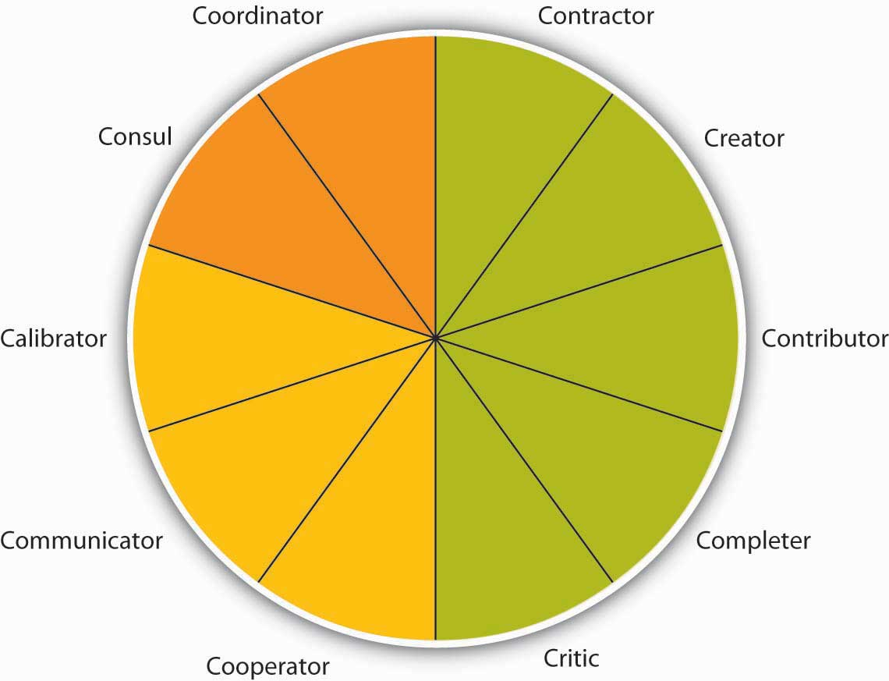
Teams are based on many roles being carried out as summarized by the Team Role Typology. These 10 roles include task roles (green), social roles (yellow), and boundary spanning roles (orange).
Source: Mumford, T. V., Van Iddekinge, C. H., Morgeson, F. P., & Campion, M. A. (2008). The team role test: Development and validation of a team role knowledge situational judgment test. Journal of Applied Psychology, 93, 250–267; Mumford, T. V., Campion, M. A., & Morgeson, F. P. (2006). Situational judgments in work teams: A team role typology. In J. A. Weekley & R. E. Ployhart (Eds.), Situational judgment tests: Theory, measurement (pp. 319–343). Mahwah, NJ: Lawrence Erlbaum.

Task Roles
Five roles make up the task portion of the role typology. The contractor role includes behaviors that serve to organize the team’s work, including creating team time lines, production schedules, and task sequencing. The creator role deals more with changes in the team’s task process structure. For example, reframing the team goals and looking at the context of goals would fall under this role. The contributor role is important because it brings information and expertise to the team. This role is characterized by sharing knowledge and training those who have less expertise to strengthen the team. Research shows that teams with highly intelligent members and evenly distributed workloads are more effective than those with uneven workloads.
- Ellis, A. P. J., Hollenbeck, J. R., Ilgen, D. R., Porter, C. O. L. H., West, B. J., & Moon, H. (2003). Team learning: Collectively connecting the dots. Journal of Applied Psychology, 88, 821–835
The completer role is also important as it is often where ideas are transformed into action. Behaviors associated with this role include following up on tasks such as gathering needed background information or summarizing the team’s ideas into reports. Finally, the critic role includes “devil’s advocate” behaviors which go against the assumptions being made by the team.

Social Roles
Social roles serve to keep the team operating effectively. When the social roles are filled, team members feel more cohesive and the group is less prone to suffer process losses or biases, such as social loafing, groupthink, or a lack of participation from all members. Three roles fall under the umbrella of social roles. The cooperator role includes supporting those with expertise toward the team’s goals. This is a proactive role. The communicator role includes behaviors that are targeted at collaboration such as practicing good listening skills and appropriately using humor to diffuse tense situations. Having a good communicator helps the team to feel more open to sharing ideas. And the calibrator role is an important one and serves to keep the team on track in terms of suggesting any needed changes to the team’s process. This role includes initiating discussions about potential team problems such as power struggles or other tensions. Similarly, this role may involve settling disagreements or pointing out what is working and what is not in terms of team process.

Boundary-Spanning Roles
The final two roles are related to activities outside of the team that help to connect the team to the larger organization.
- Anacona, D. G. (1990). Outward bound: Strategies for team survival in an organization. Academy of Management Journal, 33, 334–365
- Anacona, D. G. (1992). Bridging the boundary: External activity and performance in organizational teams. Administrative Science Quarterly, 37, 634–665
- Druskat, V. U., & Wheeler, J. V. (2003). Managing from the boundary: The effective leadership of self-managing work teams. Academy of Management Journal, 46, 435–457
- Teams that engage in a greater level of boundary-spanning behaviors increase their team effectiveness.Marrone, J. A., Tesluk, P. E., & Carson, J. B. (2007) A multi-level investigation of antecedents and consequences of team member boundary-spanning behavior. Academy of Management Journal, 50, 1423–1439
The consul role includes gathering information from the larger organization and informing those within the organization about team activities, goals, and successes. Often the consul role is filled by team managers or leaders. The coordinator role includes interfacing with others within the organization so that the team’s efforts are in line with other individuals and teams within the organization.

Types of Teams
There are many different types of teams, and a given team may be described according to multiple types. For example, a team of scientists writing a research article for publication may be temporary, virtual, and cross-functional.
Teams may be permanent or long term, but more typically, a team exists for a limited time. In fact, one-third of all teams in the United States are temporary.
- Gordon, J. (1992). Work teams: How far have they come? Training, 29, 59–62
An example of a temporary team is a task force that addresses a specific issue or problem until it is resolved. Other teams may be temporary or ongoing such as product development teams. In addition, matrix organizations have cross-functional teams where individuals from different parts of the organization staff the team, which may be temporary or long-standing.

Virtual Teams
Virtual teams are teams in which members are not located in the same physical place. They may be in different cities, states, or even different countries. Some virtual teams are formed by necessity, such as to take advantage of lower labor costs in different countries; one study found that upward of 8.4 million individuals worldwide work virtually in at least one team.
- Ahuja, M., & Galvin, J. (2003). Socialization in virtual group. Journal of Management, 29, 161–185
Often, virtual teams are formed to take advantage of distributed expertise or time—the needed experts may be living in different cities. A company that sells products around the world, for example, may need technologists who can solve customer problems at any hour of the day or night. It may be difficult to find the caliber of people needed who would be willing to work at 2 a.m. on a Saturday, for example. So companies organize virtual technical support teams. BakBone Software, for instance, has a 13-member technical support team. Each member has a degree in computer science and is divided among offices in California, Maryland, England, and Tokyo. BakBone believes it has been able to hire stronger candidates by drawing from a diverse talent pool and hiring in different geographic regions rather than limiting hiring to one region or time zone.
- Alexander, S. (2000, November 10). Virtual teams going global. Infoworld. Retrieved February 12, 2009, from http://www.infoworld.com/articles/ca/xml/00/11/13/001113cavirtual.html
Despite potential benefits, virtual teams present special management challenges, particularly to the controlling function. Managers often think that they have to see team members working to believe that work is being done. Because this kind of oversight is impossible in virtual team situations, it is important to devise evaluation schemes that focus on deliverables. Are team members delivering what they said they would? In self-managed teams, are team members producing the results the team decided to measure itself on?
Another special challenge of virtual teams is building trust. Will team members deliver results just as they would in face-to-face teams? Can members trust one another to do what they said they would do? Companies often invest in bringing a virtual team together at least once so members can get to know one another and build trust.
- Kirkman, B. L., Rosen, B., Gibson, C. B., Tesluk, P. E., & McPherson, S. O. (2002). Five challenges to virtual team success: Lessons from Sabre, Inc. Academy of Management Executive, 16, 67–79
In manager-led virtual teams, managers should be held accountable for their team’s results and evaluated on their ability as a team leader.
Finally, communication is especially important in virtual teams, through e-mail, phone calls, conference calls, or project management tools that help organize work. If individuals in a virtual team are not fully engaged and tend to avoid conflict, team performance can suffer.
- Montoya-Weiss, M. M., Massey, A. P., & Song, M. (2001). Getting it together: Temporal coordination and conflict management in global virtual teams. Academy of Management Journal, 44, 1251–1262
A wiki is an Internet-based method for many people to collaborate and contribute to a document or discussion. Essentially, the document remains available for team members to access and amend at any time. The most famous example is Wikipedia, which is gaining traction as a way to structure project work globally and get information into the hands of those that need it. Empowered organizations put information into everyone’s hands.
- Kirkman, B. L., & Rosen, B. (2000). Powering up teams. Organizational Dynamics, 28(3), 48–66
Research shows that empowered teams are more effective than those that are not empowered.
- Mathieu, J. E., Gilson, L. L., & Ruddy, T. M. (2006). Empowerment and team effectiveness: An empirical test of an integrated model. Journal of Applied Psychology, 91, 97–108

Top Management Teams
Top management teams are appointed by the chief executive officer (CEO) and, ideally, reflect the skills and areas that the CEO considers vital for the company. There are no formal rules about top management team design or structure. The top management team often includes representatives from functional areas, such as finance, human resources, and marketing or key geographic areas, such as Europe, Asia, and North America. Depending on the company, other areas may be represented such as legal counsel or the company’s chief technologist. Typical top management team member titles include chief operating officer (COO), chief financial officer (CFO), chief marketing officer (CMO), or chief technology officer (CTO). Because CEOs spend an increasing amount of time outside their companies (i.e., with suppliers, customers, regulators, and so on), the role of the COO has taken on a much higher level of internal operating responsibilities. In most American companies, the CEO also serves as chairman of the board and can have the additional title of president. Companies have top management teams to help set the company’s vision and strategic direction, key tasks within the planning P-O-L-C function. Top teams make decisions on new markets, expansions, acquisitions, or divestitures. The top team is also important for its symbolic role: how the top team behaves dictates the organization’s culture and priorities by allocating resources and by modeling behaviors that will likely be emulated lower down in the organization. Importantly, the top team is most effective when team composition is functionally and demographically diverse and when it can truly operate as a team, not just as group of individual executives.
- Carpenter, M. A., Geletkanycz, M. A., & Sanders, W. G. (2004). The upper echelons revisited: The antecedents, elements, and consequences of TMT composition. Journal of Management, 30, 749–778
That “the people make the place” holds especially true for members of the top management team. In a study of 15 firms that demonstrated excellence, defined as sustained performance over a 15-year period, leadership researcher Jim Collins noted that those firms attended to people first and strategy second. “They got the right people on the bus, moved the wrong people off the bus, ushered the right people to the right seats—then they figured out where to drive it.”
- Collins, J. (2001, July–August). Level leadership. Harvard Business Review, 66–76
The best teams plan for turnover. Succession planning is the process of identifying future members of the top management team. Effective succession planning allows the best top teams to achieve high performance today and create a legacy of high performance for the future.

Team Leadership and Autonomy
Teams also vary in terms of how they are led. Traditional or manager-led teams are teams in which the manager serves as the team leader. The manager assigns work to other team members. These types of teams are the most natural to form, wherein managers have the power to hire and fire team members and are held accountable for the team’s results.
Self-managed teams are a new form of team that rose in popularity with the Total Quality Movement in the 1980s. Unlike manager-led teams, these teams manage themselves and do not report directly to a supervisor. Instead, team members select their own leader, and they may even take turns in the leadership role. Self-managed teams also have the power to select new team members. As a whole, the team shares responsibility for a significant task, such as assembly of an entire car. The task is ongoing rather than temporary such as a charity fund drive for a given year.
Organizations began to use self-managed teams as a way to reduce hierarchy by allowing team members to complete tasks and solve problems on their own. The benefits of self-managed teams extend much further. Research has shown that employees in self-managed teams have higher job satisfaction, increased self-esteem, and grow more on the job. The benefits to the organization include increased productivity, increased flexibility, and lower turnover. Self-managed teams can be found at all levels of the organization, and they bring particular benefits to lower-level employees by giving them a sense of ownership of their jobs that they may not otherwise have. The increased satisfaction can also reduce absenteeism because employees do not want to let their team members down.
Typical team goals are improving quality, reducing costs, and meeting deadlines. Teams also have a “stretch” goal, which is difficult to reach but important to the business unit. Many teams also have special project goals. Texas Instruments (TI), a company that makes semiconductors, used self-directed teams to make improvements in work processes.
- Welins, R., Byham, W., & Dixon, G. (1994). Inside teams. San Francisco: Jossey-Bass
Teams were allowed to set their own goals in conjunction with managers and other teams. TI also added an individual component to the typical team compensation system. This individual component rewarded team members for learning new skills that added to their knowledge. These “knowledge blocks” include topics such as leadership, administration, and problem solving. The team decides what additional skills people might need to help the team meet its objectives. Team members would then take classes or otherwise demonstrate their proficiency in that new skill on the job to be certified for mastering the skill. Individuals could then be evaluated based on their contribution to the team and how they are building skills to support the team.
Self-managed teams are empowered, which means that they have the responsibility as well as theauthority to achieve their goals. Team members have the power to control tasks and processes and to make decisions. Research shows that self-managed teams may be at a higher risk of suffering from negative outcomes due to conflict, so it is important that they are supported with training to help them deal with conflict effectively.
- Alper, S., Tjosvold, D., & Law, K. S. (2000). Conflict management, efficacy, and performance in organizational teams. Personnel Psychology, 53, 625–642
- Langfred, C. W. (2007). The downside of self-management: A longitudinal study of the effects of conflict on trust, autonomy, and task interdependence in self-managing teams. Academy of Management Journal, 50, 885–900
- Self-managed teams may still have a leader who helps them coordinate with the larger organization.Morgeson, F. P. (2005). The external leadership of self-managing teams: Intervening in the context of novel and disruptive events. Journal of Applied Psychology, 90, 497–508
For a product team composed of engineering, production, and marketing employees, empowerment means that the team can decide everything about a product’s appearance, production, and cost without having to get permission or sign-off from higher management. As a result, empowered teams can more effectively meet tighter deadlines. At AT&T, for example, the model-4200 phone team cut development time in half while lowering costs and improving quality by using the empowered team approach.
- Parker, G. (1994). Cross-functional teams. San Francisco: Jossey-Bass
A special form of self-managed teams areself-directed teams in which they also determine who will lead them with no external oversight.

Figure 13.10
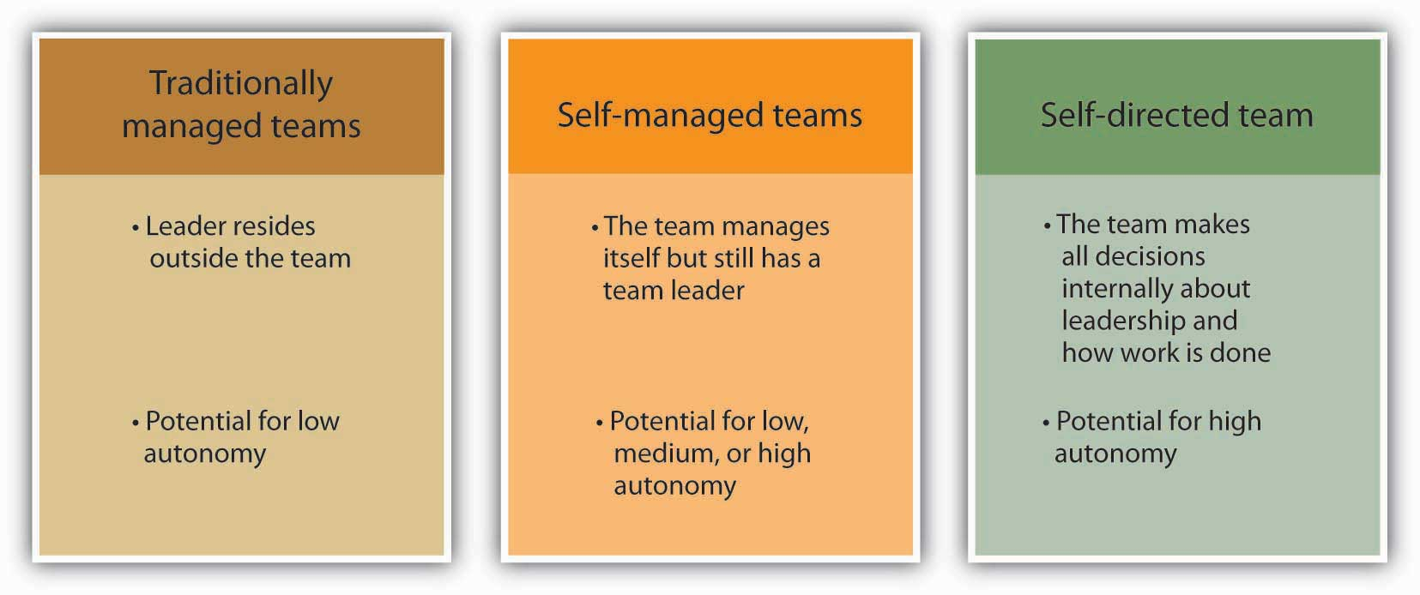
Team leadership is a major determinant of how autonomous a team can be.

Designing Effective Teams
Designing an effective team means making decisions about team composition (who should be on the team), team size (the optimal number of people on the team), and team diversity (should team members be of similar background, such as all engineers, or of different backgrounds). Answering these questions will depend, to a large extent, on the type of task that the team will be performing. Teams can be charged with a variety of tasks, from problem solving to generating creative and innovative ideas to managing the daily operations of a manufacturing plant.

Who Are the Best Individuals for the Team?
A key consideration when forming a team is to ensure that all the team members are qualified for the roles they will fill for the team. This process often entails understanding the knowledge, skills, and abilities (KSAs) of team members as well as the personality traits needed before starting the selection process.
- Humphrey, S. E., Hollenbeck, J. R., Meyer, C. J., & Ilgen, D. R. (2007). Trait configurations in self-managed teams: A conceptual examination of the use of seeding for maximizing and minimizing trait variance in teams. Journal of Applied Psychology, 92, 885–892
When talking to potential team members, be sure to communicate the job requirements and norms of the team. To the degree that this is not possible, such as when already existing groups are used, think of ways to train the team members as much as possible to help ensure success. In addition to task knowledge, research has shown that individuals who understand the concepts covered in this chapter and in this book such as conflict resolution, motivation, planning, and leadership actually perform better on their jobs. This finding holds for a variety of jobs, including officer in the United States Air Force, an employee at a pulp mill, or a team member at a box manufacturing plant.
- Hirschfeld, R. R., Jordan, M. H., Field, H. S., Giles, W. F., & Armenakis, A. A. (2006). Becoming team players: Team members’ mastery of teamwork knowledge as a predictor of team task proficiency and observed teamwork effectiveness. Journal of Applied Psychology, 91, 467–474
- Stevens, M. J., & Campion, M. A. (1999). Staffing work teams: Development and validation of a selection test for teamwork settings. Journal of Management, 25, 207–228

How Large Should My Team Be?
Interestingly, research has shown that regardless of team size, the most active team member speaks 43% of the time. The difference is that the team member who participates the least in a three-person team is still active 23% of the time versus only 3% in a 10-person team.
- McGrath, J. E. (1984). Groups: Interaction and performance. Englewood Cliffs, NJ: Prentice Hall
- Solomon, H. (1960). Mathematical thinking in the measurement of behavior. Glencoe, IL: Free Press
When deciding team size, a good rule of thumb is a size of 2 to 20 members. The majority of teams have 10 members or less because the larger the team, the harder it is to coordinate and interact as a team. With fewer individuals, team members are more able to work through differences and agree on a common plan of action. They have a clearer understanding of others’ roles and greater accountability to fulfill their roles (remember social loafing?). Some tasks, however, require larger team sizes because of the need for diverse skills or because of the complexity of the task. In those cases, the best solution is to create subteams where one member from each subteam is a member of a larger coordinating team. The relationship between team size and performance seems to greatly depend on the level of task interdependence, with some studies finding larger teams outproducing smaller teams and other studies finding just the opposite.
- Campion, M. A., Medsker, G. J., & Higgs, A. C. (1993). Relations between work group characteristics and effectiveness: Implications for designing effective work groups. Personnel Psychology, 46, 823–850
- Magjuka, R. J., & Baldwin, T. T. (1991). Team-based employee involvement programs: Effects of design and administration. Personnel Psychology, 44, 793–812
- Vinokur-Kaplan, D. (1995). Treatment teams that work (and those that don’t): An application of Hackman’s group effectiveness model to interdisciplinary teams in psychiatric hospitals. Journal of Applied Behavioral Science, 31, 303–327
The bottom line is that team size should be matched to the goals of the team.

How Diverse Should My Team Be?
Team composition and team diversity often go hand in hand. Teams whose members have complementary skills are often more successful because members can see each other’s blind spots. One team member’s strengths can compensate for another’s weaknesses.
- Jackson, S. E., Joshi, A., & Erhardt, N. L. (2003). Recent research on team and organizational diversity: SWOT analysis and implications. Journal of Management, 29, 801–830
- Van Knippenberg, D., De Dreu, C. K. W., & Homan, A. C. (2004). Work group diversity and group performance: An integrative model and research agenda. Journal of Applied Psychology, 89, 1008–1022
For example, consider the challenge that companies face when trying to forecast future sales of a given product. Workers who are educated as forecasters have the analytic skills needed for forecasting, but these workers often lack critical information about customers. Salespeople, in contrast, regularly communicate with customers, which means they’re in the know about upcoming customer decisions. But salespeople often lack the analytic skills, discipline, or desire to enter this knowledge into spreadsheets and software that will help a company forecast future sales. Putting forecasters and salespeople together on a team tasked with determining the most accurate product forecast each quarter makes the best use of each member’s skills and expertise.
Diversity in team composition can help teams come up with more creative and effective solutions. Research shows that teams that believe in the value of diversity performed better than teams that do not.
- Homan, A. C., van Knippenberg, D., Van Kleef, G. A., & De Dreu, C. K. W. (2007). Bridging faultlines by valuing diversity: Diversity beliefs, information elaboration, and performance in diverse work groups. Journal of Applied Psychology, 92, 1189–1199
The more diverse a team is in terms of expertise, gender, age, and background, the more ability the group has to avoid the problems of groupthink.
- Surowiecki. J. (2005). The wisdom of crowds. New York: Anchor Books
For example, different educational levels for team members were related to more creativity in research and development teams and faster time to market for new products.
- Eisenhardt, K. M., & Tabrizi, B. N. (1995). Accelerating adaptive processes: Product innovation in the global computer industry.Administrative Science Quarterly, 4, 84–110
- Shin, S. J., & Zhou, J. (2007). When is educational specialization heterogeneity related to creativity in research and development teams? Transformational leadership as a moderator. Journal of Applied Psychology, 92, 1709–1721
Members will be more inclined to make different kinds of mistakes, which means that they’ll be able to catch and correct those mistakes.

KEY TAKEAWAY
Teams, though similar to groups, are different in both scope and composition. A team is a particular type of group: a cohesive coalition of people working together to achieve mutual goals. In the 21st century, many companies have moved toward the extensive use of teams. The task a team is charged with accomplishing affects how they perform. In general, task interdependence works well for self-managing teams. Team roles consist of task, social, and boundary-spanning roles. Different types of teams include task forces, product development teams, cross-functional teams, and top management teams. Team leadership and autonomy varies depending on whether the team is traditionally managed, self-managed, or self-directed. Teams are most effective when teams consist of members with the right KSAs for the tasks, are not too large, contain diversity across team members. Decisions about where and how to use teams, the leadership of teams, and the structure of teams illustrate the overlap in the design and leading P-O-L-C functions.

EXERCISES
- Think of the last team you were in. Did the task you were asked to do affect the team? Why or why not?
- Which of the 10 work roles do you normally take in a team? How difficult or easy do you think it would be for you to take on a different role?
- Have you ever worked in a virtual team? If so, what were the challenges and advantages of working virtually?
- How large do you think teams should be and why?

13.4 Organizing Effective Teams

LEARNING OBJECTIVES
- Understand how to create team norms, roles, and expectations.
- Identify keys to running effective team meetings.
When a team is well organized, it tends to perform well. Well-designed teams are able to capitalize on positive events while maintaining composure when facing a negative event. There are several strategies that can boost team effectiveness through effective organization.

Establishing Team Norms and Contracts
A key to successful team design is to have clear norms, roles, and expectations among team members. Problems such as social loafing or groupthink can be avoided by paying careful attention to team member differences and providing clear definitions for roles, expectancy, measurement, and rewards.

Team Norms
Norms are shared expectations about how things operate within a group or team. Just as new employees learn to understand and share the assumptions, norms, and values that are part of an organization’s culture, they also must learn the norms of their immediate team. This understanding helps teams be more cohesive and perform better. Norms are a powerful way of ensuring coordination within a team. For example, is it acceptable to be late to meetings? How prepared are you supposed to be at the meetings? Is it acceptable to criticize someone else’s work? These norms are shaped early during the life of a team and affect whether the team is productive, cohesive, and successful.
Explore some ideas about team norms by doing the Square Wheels exercise.

Square Wheels Exercise and Group Discussion
Sometimes it can be challenging to start a conversation around team ground rules and performance. The following exercise can be used to get a team talking about what works and what doesn’t in teams they’ve worked in and how your team can be designed most effectively.
This picture of a cart with square wheels is an illustration of how many organizations seem to operate. Print out the illustration and have everyone in your team write on the paper, identifying as many of the key issues and opportunities for improvement as you can. Following this, have a conversation around what this illustration might mean for your own team.
Used with permission. © Performance Management Company, 1992–2004 Square Wheels® is a registered servicemark of PMC. http://www.SquareWheels.com email:Scott@SquareWheels.com 864-292-8700

Team Contracts
Scientific research as well as experience working with thousands of teams show that teams that are able to articulate and agree on established ground rules, goals, and roles and develop a team contractaround these standards are better equipped to face challenges that may arise within the team.
- Katzenback, J. R., & Smith, D. K. (1993). The wisdom of teams. Boston: Harvard Business School Press
- Porter, T. W., & Lilly, B. S. (1996) The effects of conflict, trust, and task commitment on project team performance. International Journal of Conflict Management, 7, 361–376
Having a team contract does not necessarily mean that the team will be successful, but it can serve as a road map when the team veers off course. Questions that can help to create a meaningful team contract include:
- Team Values and Goals: What are our shared team values? What is our team goal?
- Team Roles and Leadership: Who does what within this team? (Who takes notes at the meeting? Who sets the agenda? Who assigns tasks? Who runs the meetings?) Does the team have a formal leader? If so, what are his or her roles?
- Team Decision Making: How are minor decisions made? How are major decisions made?
- Team Communication: Who do you contact if you cannot make a meeting? Who communicates with whom? How often will the team meet?
- Team Performance: What constitutes good team performance? What if a team member tries hard but does not seem to be producing quality work? How will poor attendance/work quality be dealt with?

Team Meetings
Anyone who has been involved in a team knows it involves team meetings. While few individuals relish meetings, they serve an important function in terms of information sharing and decision making. They also serve an important social function and can help to build team cohesion and a task function in terms of coordination. Unfortunately, we’ve all attended lengthy meetings that were a waste of time and where little happened that couldn’t have been accomplished by reading an e-mail in five minutes. To run effective meetings, it helps to think of meetings in terms of three sequential steps.
- Haynes, M. E. (1997).Effective meeting skills. Menlo Park, C Crisp

Before the Meeting
Much of the effectiveness of a meeting is determined before the team gathers. There are three key things you can do to ensure the team members get the most out of their meeting.
First, ask yourself: Is a meeting needed? Leaders should do a number of things before the meeting to help make it effective. The first thing is to be sure a meeting is even needed. If the meeting is primarily informational, ask yourself whether it is imperative that the group fully understands the information and whether future decisions will be built on this information. If so, a meeting may be needed. If not, perhaps simply communicating with everyone in a written format will save valuable time. Similarly, decision-making meetings make the most sense when the problem is complex and important, there are questions of fairness to be resolved, and commitment is needed moving forward.
Second, create and distribute an agenda. An agenda is important in helping to inform those invited about the purpose of the meeting. It also helps organize the flow of the meeting and keep the team on track.
Third, send a reminder before the meeting. Reminding everyone of the purpose, time, and location of the meeting helps everyone prepare themselves. Anyone who has attended a team meeting only to find there is no reason to meet because members haven’t completed their agreed-upon tasks knows that, as a result, team performance or morale can be negatively affected. Follow up to make sure everyone is prepared. As a team member, inform others immediately if you will not be ready with your tasks so they can determine whether the meeting should be postponed.

During the Meeting
During the meeting, there are several things you can do to make sure the team starts and keeps on track.
Start the meeting on time. Waiting for members who are running late only punishes those who are on time and reinforces the idea that it’s OK to be late. Starting the meeting promptly sends an important signal that you are respectful of everyone’s time.
Follow the meeting agenda. Veering off agenda communicates to members that it is not important. It also makes it difficult for others to keep track of where you are in the meeting and can facilitate important points not being addressed.
Manage group dynamics for full participation. As you’ve seen in this chapter, there are a number of group dynamics that can limit a team’s functioning. Be on the lookout for full participation and engagement from all team members as well as any potential problems such as social loafing, group conflict, or groupthink.
Summarize the meeting with action items. Be sure to clarify team member roles moving forward. If individual’s tasks are not clear, chances are role confusion will arise later. There should be clear notes from the meeting regarding who is responsible for each action item and the timeframes associated with next steps.
End the meeting on time. This is vitally important as it shows that you respect everyone’s time and are organized. If another meeting is needed to follow up, schedule it later, but don’t let the meeting run over.

After the Meeting
Follow up on action items. After the meeting you probably have several action items. In addition, it is likely that you’ll need to follow up on the action items of others.

Figure 13.14
Conducting meetings standing up saves time yet keeps information flowing across the team. See Bluedorn, A. C., Turban, D. B., & Love, M. S. (1999). The effects of stand-up and sit-down meeting formats on meeting outcomes. Journal of Applied Psychology, 84, 277–285. This technique is used by Johnson & Johnson, Ritz-Carlton, ThoughtWorks, Agile Software, and Corning.
Photo used by permission by Jason Yip.

KEY TAKEAWAY
Much like group development, team socialization takes place over the life of the team. The stages move from evaluation to commitment to role transition. Team norms are important for the team process and help to establish who is doing what for the team and how the team will function. Creating a team contract helps with this process. Keys to address in a team contract are team values and goals, team roles and leadership, team decision making, team communication expectations, and how team performance is characterized. Team meetings can help a team coordinate and share information. Effective meetings include preparation, management during the meeting, and follow up on action items generated in the meeting.

EXERCISES
- Have the norms for most of the teams you have belonged to been formal or informal? How do you think that has affected these teams?
- Have you ever been involved in creating a team contract? Explain how you think that may have influenced how the team functioned?
- Should the person requesting a meeting always prepare a meeting agenda? Why or why not?
- Do you think conducting team meetings standing up is a good idea? Why or why not?

13.5 Barriers to Effective Teams

LEARNING OBJECTIVE
- Recognize common barriers to effective teams and how to address them
Problems can arise in any team that will hurt the team’s effectiveness. Here are some common problems faced by teams and how to deal with them.

Common Barriers to Effective Teams

Challenges of Knowing Where to Begin
At the start of a project, team members may be at a loss as to how to begin. Also, they may have reached the end of a task but are unable to move on to the next step or put the task to rest.
Floundering often results from a lack of clear goals, so the remedy is to go back to the team’s mission or plan and make sure that it is clear to everyone. Team leaders can help move the team past floundering by asking, “What is holding us up? Do we need more data? Do we need assurances or support? Does anyone feel that we’ve missed something important?”

Dominating Team Members
Some team members may have a dominating personality that encroaches on the participation or airtime of others. This overbearing behavior may hurt the team morale or the momentum of the team.
A good way to overcome this barrier is to design a team evaluation to include a “balance of participation” in meetings. Knowing that fair and equitable participation by all will affect the team’s performance evaluation will help team members limit domination by one member and encourage participation from all members, even shy or reluctant ones. Team members can say, “We’ve heard from Mary on this issue, so let’s hear from others about their ideas.”

Poor Performance of Some Team Members
Research shows that teams deal with poor performers in different ways, depending on members’ perceptions of the reasons for poor performance.
- Jackson, C. L., & LePine, J. A. (2003). Peer responses to a team’s weakest link: A test and extension of LePine and Van Dyne’s model. Journal of Applied Psychology, 88, 459–475
In situations in which the poor performer is perceived as lacking in ability, teams are more likely to train the member. In situations in which members perceive the individual as simply being low on motivation, they are more likely to try to motivate or reject the poor performer.
Keep in mind that justice is an important part of keeping individuals working hard for the team.
- Colquitt, J. A. (2004). Does the justice of the one interact with the justice of the many? Reactions to procedural justice in teams. Journal of Applied Psychology, 89, 633–646
Be sure that poor performers are dealt with in a way that is deemed fair by all the team members.

Poorly Managed Team Conflict
Disagreements among team members are normal and should be expected. Healthy teams raise issues and discuss differing points of view because that will ultimately help the team reach stronger, more well-reasoned decisions. Unfortunately, sometimes disagreements arise because of personality issues or feuds that predated the teams’ formation.
Ideally, teams should be designed to avoid bringing adversaries together on the same team. If that is not possible, the next best solution is to have adversaries discuss their issues privately, so the team’s progress is not disrupted. The team leader or other team member can offer to facilitate the discussion. One way to make a discussion between conflicting parties meaningful is to form a behavioral contract between the two parties. That is, if one party agrees to do X, the other will agree to do Y.
- Scholtes, P. (1988). The team handbook. Madison, WI: Joiner Associates

KEY TAKEAWAY
Barriers to effective teams include the challenges of knowing where to begin, dominating team members, the poor performance of team members, and poorly managed team conflict.

EXERCISES
- Have you ever been involved in a team where one or more dominating team members hurt the team’s performance? Share what happened and how the team dealt with this.
- Have you ever been involved in a team where conflict erupted between team members? How was the situation handled?

13.6 Developing Your Team Skills

LEARNING OBJECTIVE
- Identify guidelines for developing cohesion in your team.

Steps to Creating and Maintaining a Cohesive Team
There are several steps you can take as a manager to help build a cohesive team. For example, you can work to:
- Align the group with the greater organization. Establish common objectives in which members can get involved.
- Let members have choices in setting their own goals. Include them in decision making at the organizational level.
- Define clear roles. Demonstrate how each person’s contribution furthers the group goal—everyone is responsible for a special piece of the puzzle.
- Situate group members in proximity to one another. This builds familiarity.
- Give frequent praise, both to individuals and to the group, and encourage them to praise each other. This builds individual self-confidence, reaffirms positive behavior, and creates an overall positive atmosphere.
- Treat all members with dignity and respect. This demonstrates that there are no favorites and everyone is valued.
- Celebrate differences. This highlights each individual’s contribution while also making diversity a norm.
- Establish common rituals. Thursday morning coffee, monthly potlucks—these reaffirm group identity and create shared experiences.

KEY TAKEAWAY
There are many things you can do to help build a cohesive team. One key thing to remember is that too much cohesion without strong performance norms can be a problem. Many of the ways to build cohesive groups are also fun, such as celebrating successes and creating rituals.

EXERCISES
- Think of the most cohesive group you have ever been in. What factors made the group so close?
- What are some challenges you see to creating a cohesive group?
- How does team size affect cohesion?

Chapter 14

Motivating Employees

WHAT’S IN IT FOR ME?
Reading this chapter will help you do the following:
- Understand need-based theories of motivation.
- Understand process-based theories of motivation.
- Describe how fairness perceptions are determined and their consequences.
- Learn to use performance appraisals in a motivational way.
- Learn to apply organizational rewards in a motivational way.
- Develop your personal motivation skills.
Motivation is defined as “the intention of achieving a goal, leading to goal-directed behavior.”
- Columbia encyclopedia. (2004). New York: Columbia University Press
When we refer to someone as being motivated, we mean that the person is trying hard to accomplish a certain task. Motivation is clearly important for someone to perform well. However, motivation alone is not sufficient. Ability—having the skills and knowledge required to perform the job—is also important and is sometimes the key determinant of effectiveness. Finally, environmental factors—having the resources, information, and support one needs to perform well—are also critical to determine performance.

Figure 14.2 The P-O-L-C Framework
What makes employees willing to “go the extra mile” to provide excellent service, market a company’s products effectively, or achieve the goals set for them? Answering questions like this is of utmost importance to understand and manage the work behavior of our peers, subordinates, and even supervisors. As with many questions involving human beings, the answers are anything but simple. Instead, there are several theories explaining the concept of motivation.

Figure 14.3
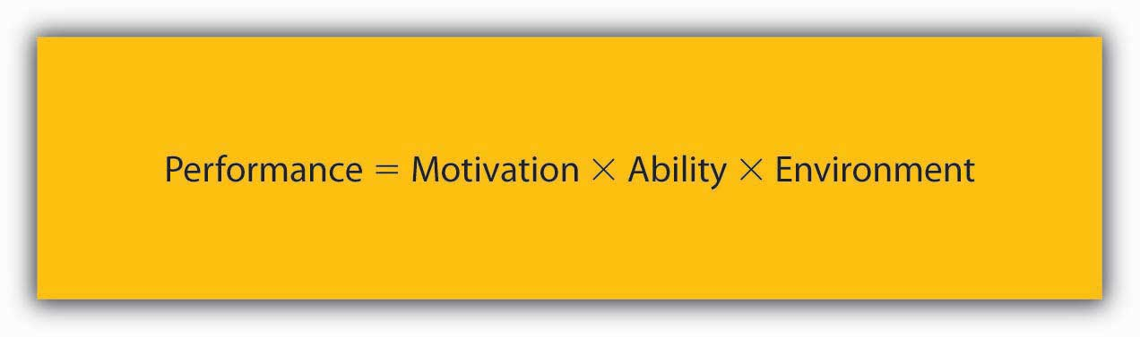
According to this equation, motivation, ability, and environment are the major influences over employee performance.
Source: Mitchell, T. R. (1982). Motivation: New directions for theory, research, and practice. The Academy of Management Review, 7, 80–88; Porter, L. W. & Lawler, E. E. (1968). Managerial attitudes and performance. Homewood, IL: Dorsey Press

14.1 Case in Point: Zappos Creates a Motivating Place to Work
It is unique to hear about a CEO who studies happiness and motivation and builds those principles into the company’s core values or about a company with a 5-week training course and an offer of $2,000 to quit anytime during that 5 weeks if you feel the company is not a good fit. Top that off with an on-site life coach who also happens to be a chiropractor, and you are really talking about something you don’t hear about every day. Zappos is known as much for its 365-day return policy and free shipping as it is for its innovative corporate culture. Although acquired in 2009 by Amazon (NASDAQ: AMZN), Zappos managed to move from number 23 in 2009 on Fortune magazine’s “100 Best Companies to Work For” list to 15 in 2010.
Performance is a function of motivation, ability, and the environment in which you work. Zappos seems to be creating an environment that encourages motivation and builds inclusiveness. The company delivers above and beyond basic workplace needs and addresses the self-actualization needs that most individuals desire from their work experience. CEO Tony Hsieh believes that the secret to customer loyalty is to make a corporate culture of caring a priority. This is reflected in the company’s 10 core values and its emphasis on building a team and a family. During the interview process, applicants are asked questions relating to the company’s values, such as gauging their own weirdness, open-mindedness, and sense of family. Although the offer to be paid to quit during the training process has increased from its original number of $400, only 1% of trainees take the offer. Work is structured differently at Zappos as well. For example, there is no limit to the time customer service representatives spend on a phone call, and they are encouraged to make personal connections with the individuals on the other end rather than try to get rid of them.
Although Zappos has over 1,300 employees, the company has been able to maintain a relatively flat organizational structure and prides itself on its extreme transparency. In an exceptionally detailed and lengthy letter to employees, Hsieh spelled out what the new partnership with Amazon would mean for the company, what would change, and more important, what would remain the same. As a result of this type of company structure, individuals have more freedom, which can lead to greater satisfaction.
Although Zappos pays its employees well and offers attractive benefits such as employees receiving full health-care coverage and a compressed workweek, the desire to work at Zappos seems to go beyond that. As Hsieh would say, happiness is the driving force behind almost any action an individual takes. Whether your goals are for achievement, affiliation, or simply to find an enjoyable environment in which to work, Zappos strives to address these needs.
Primary Resource:
Secondary Resources:
- Robischon, N. (2009, July 22). Amazon buys Zappos for $847 million. Fast Company. Retrieved February 28, 2010, from http://www.fastcompany.com/blog/noah-robischon/editors-desk/amazon -buys-zappos-807-million
- Walker, A. (2009, March 14). Zappos’ Tony Hsieh on Twitter, phone calls and the pursuit of happiness. Fast Company. Retrieved February 27, 2010, from http://www.fastcompany.com/blog/alissa-walker/member-blog/tony-hsiehs-zapposcom
- Happy feet—Inside the online shoe utopia. (2009, September 14). New Yorker. Retrieved February 28, 2010, from http://about.zappos.com/press-center/media-coverage/happy-feet-inside-online-shoe-utopia
- 100 best companies to work for. (2010, February 8). Fortune. Retrieved February 26, 2010, from http://money.cnn.com/magazines/fortune/bestcompanies/2010/snapshots/15.html

DISCUSSION QUESTIONS
- Motivation is an essential element of the leading facet of the P-O-L-C framework. What are other means that organizations use to motivate employees besides those used by Zappos?
- What potential organizational changes might result from the acquisition by Amazon?
- Why do you think Zappos’ approach is not utilized more often? In other words, what are the challenges to these techniques?
- Why do you think Zappos offers a $2,000 incentive to quit?
- Would you be motivated to work at Zappos? Why or why not?

14.2 Need-Based Theories of Motivation

LEARNING OBJECTIVES
- Explain how employees are motivated according to Maslow’s hierarchy of needs.
- Explain how ERG theory addresses the limitations of Maslow’s hierarchy.
- Describe the difference between factors contributing to employee motivation and how these differ from factors contributing to dissatisfaction.
- Describe the needs for achievement, power, and affiliation, and how these needs affect work behavior.
The earliest answer to motivation involved understanding individual needs. Specifically, early researchers thought that employees try hard and demonstrate goal-driven behavior to satisfy needs. For example, an employee who is always walking around the office talking to people may have a need for companionship and his behavior may be a way of satisfying this need. There are four major theories in the need-based category: Maslow’s hierarchy of needs, ERG theory, Herzberg’s dual factor theory, and McClelland’s acquired needs theory.

Maslow’s Hierarchy of Needs
Abraham Maslow is among the most prominent psychologists of the 20th century and the hierarchy of needs, accompanied by the pyramid representing how human needs are ranked, is an image familiar to most business students and managers. Maslow’s theory is based on a simple premise: Human beings have needs that are hierarchically ranked.
- Maslow, A. H. (1943). A theory of human motivation.Psychological Review, 50, 370–396
- Maslow, A. H. (1954). Motivation and personality. New York: Harper
There are some needs that are basic to all human beings, and in their absence, nothing else matters. As we satisfy these basic needs, we start looking to satisfy higher-order needs. Once a lower-level need is satisfied, it no longer serves as a motivator.
The most basic of Maslow’s needs are physiological needs. Physiological needs refer to the need for air, food, and water. Imagine being very hungry. At that point, all your behavior may be directed at finding food. Once you eat, though, the search for food ceases and the promise of food no longer serves as a motivator. Once physiological needs are satisfied, people tend to become concerned about safety. Are they safe from danger, pain, or an uncertain future? One level up, social needs refer to the need to bond with other human beings, to be loved, and to form lasting attachments. In fact, having no attachments can negatively affect health and well-being.
- Baumeister, R. F., & Leary, M. R. (1995). The need to belong: Desire for interpersonal attachments as a fundamental human motivation. Psychological Bulletin, 117, 497–529
The satisfaction of social needs makes esteem needs more salient. Esteem needs refer to the desire to be respected by one’s peers, feeling important, and being appreciated. Finally, at the highest level of the hierarchy, the need for self-actualization refers to “becoming all you are capable of becoming.” This need manifests itself by acquiring new skills, taking on new challenges, and behaving in a way that will lead to the satisfaction of one’s life goals.

Figure 14.5 Maslow’s Hierarchy of Needs
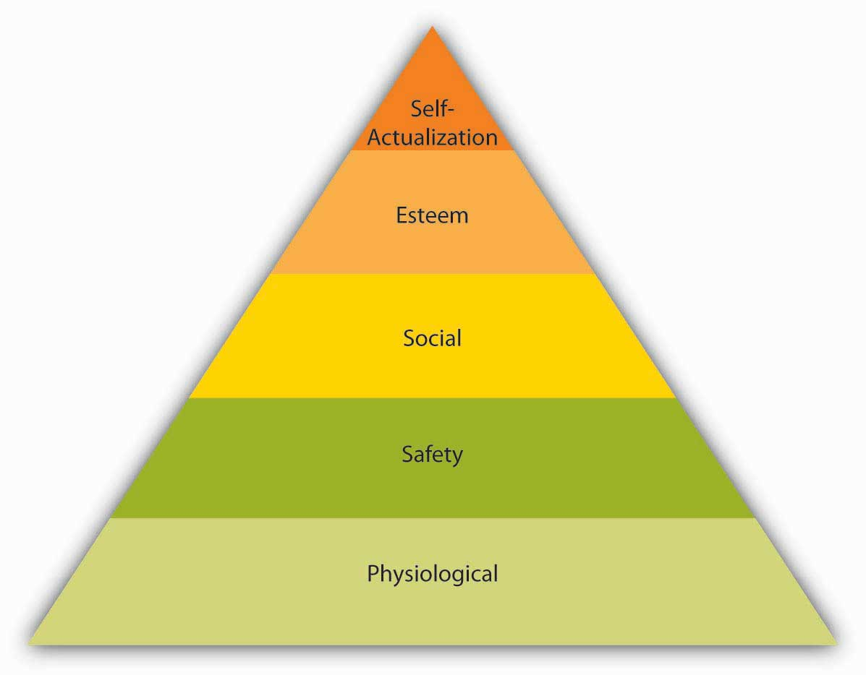
Source: Adapted from Maslow, A. H. (1954). Motivation and personality. New York: Harper.
Maslow’s hierarchy is a systematic way of thinking about the different needs employees may have at any given point and explains different reactions they may have to similar treatment. An employee who is trying to satisfy her esteem needs may feel gratified when her supervisor praises her. However, another employee who is trying to satisfy his social needs may resent being praised by upper management in front of peers if the praise sets him apart from the rest of the group.
So, how can organizations satisfy their employees’ various needs? By leveraging the various facets of the planning-organizing-leading-controlling (P-O-L-C) functions. In the long run, physiological needs may be satisfied by the person’s paycheck, but it is important to remember that pay may satisfy other needs such as safety and esteem as well. Providing generous benefits, including health insurance and company-sponsored retirement plans, as well as offering a measure of job security, will help satisfy safety needs. Social needs may be satisfied by having a friendly environment, providing a workplace conducive to collaboration and communication with others. Company picnics and other social get-togethers may also be helpful if the majority of employees are motivated primarily by social needs (but may cause resentment if they are not and if they have to sacrifice a Sunday afternoon for a company picnic). Providing promotion opportunities at work, recognizing a person’s accomplishments verbally or through more formal reward systems, job titles that communicate to the employee that one has achieved high status within the organization are among the ways of satisfying esteem needs. Finally, self-actualization needs may be satisfied by providing development and growth opportunities on or off the job, as well as by assigning interesting and challenging work. By making the effort to satisfy the different needs each employee may have at a given time, organizations may ensure a more highly motivated workforce.

ERG Theory
ERG theory of Clayton Alderfer is a modification of Maslow’s hierarchy of needs.
- Alderfer, C. P. (1969). An empirical test of a new theory of human needs. Organizational Behavior and Human Performance, 4, 142–175
Instead of the five needs that are hierarchically organized, Alderfer proposed that basic human needs may be grouped under three categories, namely, Existence, Relatedness, and Growth(see the following figure). Existence need corresponds to Maslow’s physiological and safety needs, relatedness corresponds to social needs, and growth need refers to Maslow’s esteem and self actualization.

Figure 14.7 ERG Theory
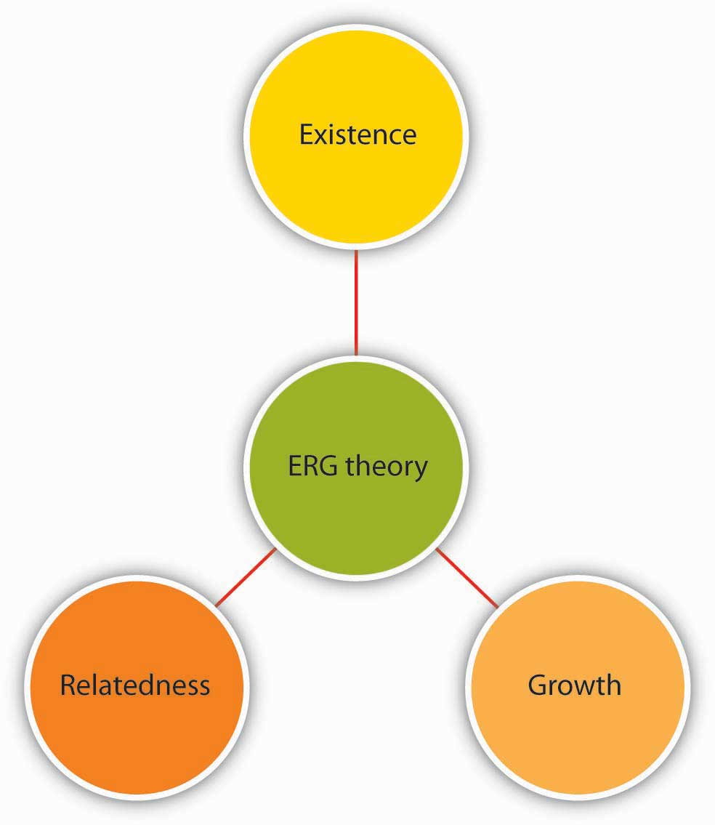
Source: Based on Alderfer, C. P. (1969). An empirical test of a new theory of human needs. Organizational Behavior and Human Performance, 4, 142–175.
ERG theory’s main contribution to the literature is its relaxation of Maslow’s assumptions. For example, ERG theory does not rank needs in any particular order and explicitly recognizes that more than one need may operate at a given time. Moreover, the theory has a “frustration-regression” hypothesis, suggesting that individuals who are frustrated in their attempts to satisfy one need may regress to another one. For example, someone who is frustrated by the lack of growth opportunities in his job and slow progress toward career goals may regress to relatedness needs and start spending more time socializing with one’s coworkers. The implication of this theory is that we need to recognize the multiple needs that may be driving an individual at a given point to understand his behavior and to motivate him.

Two-Factor Theory
Frederick Herzberg approached the question of motivation in a different way. By asking individuals what satisfies them on the job and what dissatisfies them, Herzberg came to the conclusion that aspects of the work environment that satisfy employees are very different from aspects that dissatisfy them.
- Herzberg, F., Mausner, B., & Snyderman, B. (1959). The motivation to work. New York: Wiley
- Herzberg, F. (1965). The motivation to work among Finnish supervisors. Personnel Psychology, 18, 393–402
Herzberg labeled factors causing dissatisfaction of workers as “hygiene” factors because these factors were part of the context in which the job was performed, as opposed to the job itself. Hygiene factors included company policies, supervision, working conditions, salary, safety, and security on the job. To illustrate, imagine that you are working in an unpleasant work environment. Your office is too hot in the summer and too cold in the winter. You are being harassed and mistreated. You would certainly be miserable in such a work environment. However, if these problems were solved (your office temperature is just right and you are not harassed at all), would you be motivated? Most likely, you would take the situation for granted. In fact, many factors in our work environment are things that we miss when they are absent, but take for granted if they are present.
In contrast, motivators are factors that are intrinsic to the job, such as achievement, recognition, interesting work, increased responsibilities, advancement, and growth opportunities. According to Herzberg’s research, motivators are the conditions that truly encourage employees to try harder.

Figure 14.8 Two-Factor Theory of Motivation
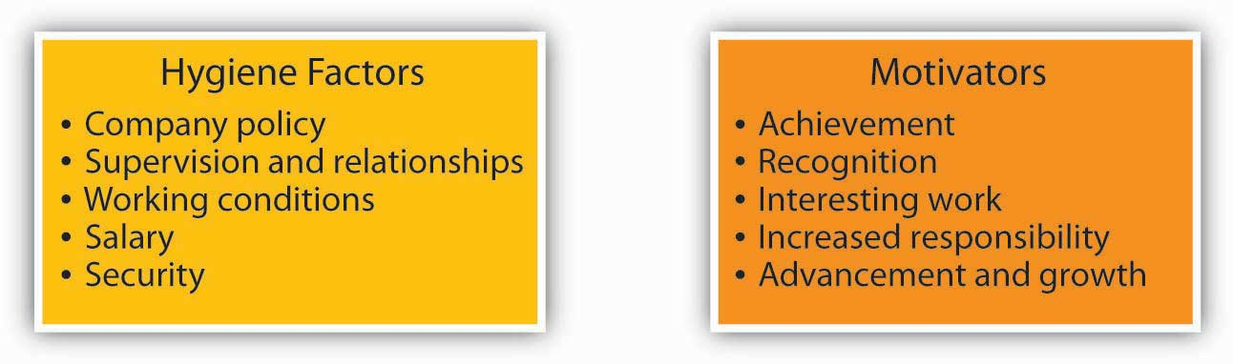
Source: Based on Herzberg, F., Mausner, B., & Snyderman, B. (1959). The motivation to work. New York: Wiley; Herzberg, F. (1965). The motivation to work among Finnish supervisors. Personnel Psychology, 18, 393–402.
Herzberg’s research, which is summarized in the figure above, has received its share of criticism.
- Cummings, L. L., & Elsalmi, A. M. (1968). Empirical research on the bases and correlates of managerial motivation. Psychological Bulletin, 70, 127–144
- House, R. J., & Wigdor, L. A. (1967). Herzberg’s dual-factor theory of job satisfaction and motivation: A review of the evidence and a criticism. Personnel Psychology, 20, 369–389
One criticism relates to the classification of the factors as hygiene or motivator. For example, pay is viewed as a hygiene factor. However, pay is not necessarily a contextual factor and may have symbolic value by showing employees that they are being recognized for their contributions as well as communicating to them that they are advancing within the company. Similarly, quality of supervision or relationships employees form with their supervisors may determine whether they are assigned interesting work, whether they are recognized for their potential, and whether they take on more responsibilities. Despite its limitations, the two-factor theory can be a valuable aid to managers because it points out that improving the environment in which the job is performed goes only so far in motivating employees.

Acquired Needs Theory
Among the need-based approaches to motivation, Douglas McClelland’s acquired needs theory is the one that has received the greatest amount of support. According to this theory, individuals acquire three types of needs as a result of their life experiences. These needs are need for achievement, need for affiliation, and need for power. All individuals possess a combination of these needs.
Those who have high need for achievement have a strong need to be successful. A worker who derives great satisfaction from meeting deadlines, coming up with brilliant ideas, and planning his or her next career move may be high in need for achievement. Individuals high on need for achievement are well suited to positions such as sales where there are explicit goals, feedback is immediately available, and their effort often leads to success.
- Harrell, A. M., & Stahl, M. J. (1981). A behavioral decision theory approach for measuring McClelland’s trichotomy of needs. Journal of Applied Psychology, 66, 242–247
- Trevis, C. S., & Certo, S. C. (2005). Spotlight on entrepreneurship. Business Horizons, 48, 271–274
- Turban, D. B., & Keon, T. L. (1993). Organizational attractiveness: An interactionist perspective. Journal of Applied Psychology, 78, 184–193
Because of their success in lower-level jobs, those in high need for achievement are often promoted to higher-level positions.
- McClelland, D. C., & Boyatzis, R. E. (1982). Leadership motive pattern and long-term success in management. Journal of Applied Psychology, 67, 737–743
However, a high need for achievement has important disadvantages in management. Management involves getting work done by motivating others. When a salesperson is promoted to be a sales manager, the job description changes from actively selling to recruiting, motivating, and training salespeople. Those who are high in need for achievement may view managerial activities such as coaching, communicating, and meeting with subordinates as a waste of time. Moreover, they enjoy doing things themselves and may find it difficult to delegate authority. They may become overbearing or micromanaging bosses, expecting everyone to be as dedicated to work as they are, and expecting subordinates to do things exactly the way they are used to doing.
- McClelland, D. C., & Burnham, D. H. (1976). Power is the great motivator. Harvard Business Review, 25, 159–166
Individuals who have a high need for affiliation want to be liked and accepted by others. When given a choice, they prefer to interact with others and be with friends.
- Wong, M. M., & Csikszentmihalyi, M. (1991). Affiliation motivation and daily experience: Some issues on gender differences. Journal of Personality and Social Psychology, 60, 154–164
Their emphasis on harmonious interpersonal relationships may be an advantage in jobs and occupations requiring frequent interpersonal interaction, such as social worker or teacher. In managerial positions, a high need for affiliation may again serve as a disadvantage because these individuals tend to be overly concerned about how they are perceived by others. Thus, they may find it difficult to perform some aspects of a manager’s job such as giving employees critical feedback or disciplining poor performers.
Finally, those with high need for power want to influence others and control their environment. Need for power may be destructive of one’s relationships if it takes the form of seeking and using power for one’s own good and prestige. However, when it manifests itself in more altruistic forms, such as changing the way things are done so that the work environment is more positive or negotiating more resources for one’s department, it tends to lead to positive outcomes. In fact, need for power is viewed as important for effectiveness in managerial and leadership positions.
- McClelland, D. C., & Burnham, D. H. (1976). Power is the great motivator. Harvard Business Review, 25, 159–166
- Spangler, W. D., & House, R. J. (1991). Presidential effectiveness and the leadership motive profile. Journal of Personality and Social Psychology, 60, 439–455
- Spreier, S. W. (2006). Leadership run amok. Harvard Business Review, 84, 72–82
McClelland’s theory of acquired needs has important implications for motivating employees. While someone who has high need for achievement may respond to goals, those with high need for affiliation may be motivated to gain the approval of their peers and supervisors, whereas those who have high need for power may value gaining influence over the supervisor or acquiring a position that has decision-making authority. And, when it comes to succeeding in managerial positions, individuals who are aware of the drawbacks of their need orientation can take steps to overcome these drawbacks.

KEY TAKEAWAY
Need-based theories describe motivated behavior as individual efforts to meet needs. According to this perspective, the manager’s job is to identify what people need and then to make sure that the work environment becomes a means of satisfying these needs. Maslow’s hierarchy categorizes human needs into physiological, safety, social, esteem, and self-actualization needs. ERG theory is a modification of Maslow’s hierarchy, where the five needs are collapsed into three categories (existence, relatedness, and growth). The two-factor theory differentiates between factors that make people dissatisfied on the job (hygiene factors) and factors that truly motivate employees. Finally, acquired-needs theory argues that individuals possess stable and dominant motives to achieve, acquire power, or affiliate with others. Each of these theories explains characteristics of a work environment that motivate employees.

EXERCISES
- Many managers assume that if an employee is not performing well, the reason must be lack of motivation. What is the problem with this assumption?
- Review Maslow’s hierarchy of needs. Do you agree with the particular ranking of employee needs?
- Review the hygiene and motivators in the two-factor theory. Are there any hygiene factors that you would consider to be motivators and vice versa?
- A friend of yours is competitive, requires frequent and immediate feedback, and enjoys accomplishing things. She has recently been promoted to a managerial position and seeks your advice. What would you tell her?
- Which motivation theory have you found to be most useful in explaining why people behave in a certain way? Why?

14.3 Process-Based Theories

LEARNING OBJECTIVES
- Explain how employees evaluate the fairness of reward distributions.
- List the three questions individuals consider when deciding whether to put forth effort at work.
- Describe how managers can use learning and reinforcement principles to motivate employees.
- Learn the role that job design plays in motivating employees.
- Describe why goal setting motivates employees.
In contrast to the need-based theories we have covered so far, process-based theories view motivation as a rational process. Individuals analyze their environment, develop reactions and feelings, and react in certain ways. Under this category, we will review equity theory, expectancy theory, and reinforcement theory. We will also discuss the concepts of job design and goal setting as motivational strategies.

Equity Theory
Imagine that your friend Marie is paid $10 an hour working as an office assistant. She has held this job for six months. She is very good at what she does, she comes up with creative ways to make things easier in the workplace, and she is a good colleague who is willing to help others. She stays late when necessary and is flexible if asked to rearrange her priorities or her work hours. Now imagine that Marie finds out her manager is hiring another employee, Spencer, who is going to work with her, who will hold the same job title and will perform the same type of tasks. Spencer has more advanced computer skills, but it is unclear whether these will be used on the job. The starting pay for Spencer will be $14 an hour. How would Marie feel? Would she be as motivated as before, going above and beyond her duties?
If your reaction to this scenario was along the lines of “Marie would think it’s unfair,” your feelings may be explained using equity theory.
- Adams, J. S. (1965). Inequity in social exchange. In L. Berkowitz (Ed.), Advances in experimental social psychology (Vol. 2, 267–299). New York: Academic Press
According to this theory, individuals are motivated by a sense of fairness in their interactions. Moreover, our sense of fairness is a result of the social comparisons we make. Specifically, we compare our inputs and outputs with someone else’s inputs and outputs. We perceive fairness if we believe that the input-to-output ratio we are bringing into the situation is similar to the input/output ratio of a comparison person, or a referent. Perceptions of inequity create tension within us and drive us to action that will reduce perceived inequity. This process is illustrated in the Equity Formula.

Figure 14.10 The Equity Formula
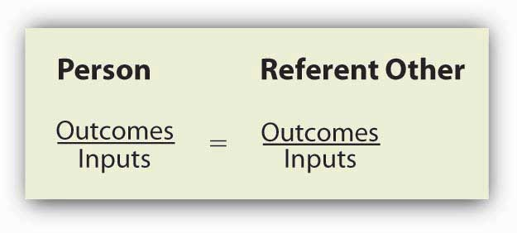
Source: Based on Adams, J. S. (1965). Inequity in social exchange. In L. Berkowitz (Ed.),Advances in Experimental Social Psychology (Vol. 2, pp. 267–299). New York: Academic Press.

What Are Inputs and Outputs?
Inputs are the contributions the person feels he or she is making to the environment. In the previous example, the hard work Marie was providing, loyalty to the organization, the number of months she has worked there, level of education, training, and her skills may have been relevant inputs. Outputs are the rewards the person feels he or she is receiving from the situation. The $10 an hour Marie is receiving was a salient output. There may be other outputs, such as the benefits received or the treatment one gets from the boss. In the prior example, Marie may reason as follows: “I have been working here for six months. I am loyal and I perform well (inputs). I am paid $10 an hour for this (outputs). The new guy, Spencer, does not have any experience here (referent’s inputs) but will be paid $14 (referent’s outcomes). This situation is unfair.”
We should emphasize that equity perceptions develop as a result of a subjective process. Different people may look at exactly the same situation and perceive different levels of equity. For example, another person may look at the same scenario and decide that the situation is fair because Spencer has computer skills and the company is paying extra for these skills.

Who Is the Referent?
The referent other may be a specific person or an entire category of people. For example, Marie might look at want ads for entry-level clerical workers and see whether the pay offered is in the $10 per hour range; in this case, the referent other is the category of entry-level clerical workers, including office assistants, in Marie’s local area. Referents should be comparable to us—otherwise the comparison is not meaningful. It would be illogical for Marie to compare herself to the CEO of the company, given the differences in the nature of inputs and outcomes. Instead, she would logically compare herself to those performing similar tasks within the same organization or a different organization.

Reactions to Unfairness
The theory outlines several potential reactions to perceived inequity, which are summarized in Table 14.1 "Potential Responses to Inequity". Oftentimes, the situation may be dealt with perceptually, bydistorting our perceptions of our own or referent’s inputs and outputs. For example, Marie may justify the situation by downplaying her own inputs (“I don’t really work very hard on this job”), valuing the outputs more highly (“I am gaining valuable work experience, so the situation is not that bad”), distorting the other person’s inputs (“Spencer really is more competent than I am and deserves to be paid more”) or distorting the other person’s outputs (“Spencer gets $14 but will have to work with a lousy manager, so the situation is not unfair”).

Table 14.1 Potential Responses to Inequity
Reactions to inequity | Example
Distort perceptions | Changing one’s thinking to believe that the referent actually is more skilled than previously thought
Increase referent’s inputs | Encouraging the referent to work harder
Reduce own input | Deliberately putting forth less effort at work. Reducing the quality of one’s work
Increase own outcomes | Negotiating a raise for oneself or using unethical ways of increasing rewards such as stealing from the company
Change referent | Comparing oneself to someone who is worse off
Leave the situation | Quitting one’s job
Seek legal action | Suing the company or filing a complaint if the unfairness in question is under legal protection
- Carrell, M. R., & Dittrich, J. E. (1978). Equity theory: The recent literature, methodological considerations, and new directions. Academy of Management Review, 3, 202–210
- Goodman, P. S., & Friedman, A. (1971). An examination of Adams’s theory of inequity. Administrative Science Quarterly, 16, 271–288
- Greenberg, J. (1993). Stealing in the name of justice: Informational and interpersonal moderators of theft reactions to underpayment inequity.Organizational Behavior and Human Decision Processes, 54, 81–103
- Schmidt, D. R., & Marwell, G. (1972). Withdrawal and reward reallocation as responses to inequity. Journal of Experimental Social Psychology, 8, 207–211
Another way of addressing perceived inequity is to reduce one’s own inputs or increase one’s own outputs. If Marie works less hard, perceived inequity would be reduced. And, indeed, research shows that people who perceive inequity tend to reduce their work performance or reduce the quality of their inputs.
- Carrell, M. R., & Dittrich, J. E. (1978). Equity theory: The recent literature, methodological considerations, and new directions. Academy of Management Review, 3, 202–210
- Goodman, P. S., & Friedman, A. (1971). An examination of Adams’ theory of inequity. Administrative Science Quarterly, 16, 271–288
Increasing one’s outputs can be achieved through legitimate means such as negotiating a pay raise. At the same time, research shows that those feeling inequity sometimes resort to stealing to balance the scales.
- Greenberg, J. (1993). Stealing in the name of justice: Informational and interpersonal moderators of theft reactions to underpayment inequity. Organizational Behavior and Human Decision Processes, 54, 81–103
Other options include changing the comparison person (for example, Marie may learn that others doing similar work in different organizations are paid only minimum wage) and leaving the situation by quitting one’s job.
- Schmidt, D. R., & Marwell, G. (1972). Withdrawal and reward reallocation as responses to inequity. Journal of Experimental Social Psychology, 8, 207–211
We might even consider taking legal action as a potential outcome of perceived inequity. For example, if Marie finds out that the main reason behind the pay gap is gender, she may react to the situation by taking legal action because sex discrimination in pay is illegal in the United States.

Overpayment Inequity
What would you do if you felt you were overrewarded? In other words, how would you feel if you were the new employee, Spencer (and you knew that your coworker Marie was being paid $4 per hour less than you)? Originally, equity theory proposed that overrewarded individuals would experience guilt and would increase their effort to restore perceptions of equity. However, research does not provide support for this argument. Instead, it seems that individuals experience less distress as a result of being overrewarded.
- Austin, W., & Walster, E. (1974). Reactions to confirmations and disconfirmations of expectancies of equity and inequity. Journal of Personality and Social Psychology, 30, 208–216
It is not hard to imagine that individuals find perceptual ways to deal with a situation like this, such as believing that they have more skills and bring more to the situation compared with the referent person. Therefore, research does not support equity theory’s predictions with respect to people who are overpaid.
- Evan, W. M., & Simmons, R. G. (1969). Organizational effects of inequitable rewards: Two experiments in status inconsistency. IEEE Engineering Management Review, 1, 95–108

Individual Differences in Reactions to Inequity
So far, we have assumed that once people feel that the situation is inequitable, they will be motivated to react. However, does inequity disturb everyone equally? Researchers identified a personality trait that explains different reactions to inequity and named this trait equity sensitivity.
- Huseman, R. C., Hatfield, J. D., & Miles, E. W. (1987). A new perspective on equity theory: The equity sensitivity construct. Academy of Management Review, 12, 222–234
Equity sensitive individuals experience distress when they feel they are overrewarded or underrewarded and expect to maintain equitable relationships. At the same time, there are some individuals who are benevolents who give without waiting to receive much in return and entitleds who expect to receive a lot without giving much in return. Thus, the theory is more useful in explaining the behavior of equity sensitive individuals, and organizations will need to pay particular attention to how these individuals view their relationships.

Fairness Beyond Equity: Procedural and Interactional Justice
Equity theory looks at perceived fairness as a motivator. However, the way equity theory defines fairness is limited to fairness regarding rewards. Starting in the 1970s, researchers of workplace fairness began taking a broader view of justice. Equity theory deals with outcome fairness, and therefore, it is considered to be a distributive justice theory. Distributive justice refers to the degree to which the outputs received from the organization are fair. Two other types of fairness have been identified: Procedural justice and interactional justice.
Let’s assume that Marie found out she is getting a promotion that will include a pay raise, increased responsibilities, and prestige. If Marie feels she deserves to be promoted, she would perceive high distributive justice (“getting the promotion is fair”). However, Marie later found out that the department manager picked her name out of a hat! What would she feel? She might still like the outcome but feel that the decision-making process was unfair since it wasn’t based on performance. This response would involve feelings of procedural injustice. Procedural justice refers to the degree to which fair decision-making procedures are used. Research shows that employees care about procedural justice for many organizational decisions, including layoffs, employee selection, surveillance of employees, performance appraisals, and pay decisions.
- Alge, B. J. (2001). Effects of computer surveillance on perceptions of privacy and procedural justice. Journal of Applied Psychology, 86, 797–804
- Bauer, T. N., Maertz, C. P., Jr., Dolen, M. R., & Campion, M. A. (1998). Longitudinal assessment of applicant reactions to employment testing and test outcome feedback. Journal of Applied Psychology, 83, 892–903
- Kidwell, R. E. (1995). Pink slips without tears. Academy of Management Executive, 9, 69–70
They tend to care about procedural justice particularly when they do not get the outcome they feel they deserve.
- Brockner, J., & Wiesenfeld, B. M. (1996). An integrative framework for explaining reactions to decisions: Interactive effects of outcomes and procedures. Psychological Bulletin, 120, 189–208
If Marie does not get the promotion and finds out that management chose the candidate by picking a name out of a hat, she may view this as adding insult to injury. When people do not get the rewards they want, they tend to hold management responsible if procedures are not fair.
- Brockner, J., Fishman, A. Y., Reb, J., Goldman, B., Spiegel, S., & Garden, C. (2007). Procedural fairness, outcome favorability, and judgments of an authority’s responsibility. Journal of Applied Psychology, 92, 1657–1671
Research has identified many ways of achieving procedural justice. For example, giving employeesadvance notice before laying them off, firing them, or disciplining them is perceived as fairer.
- Kidwell, R. E. (1995). Pink slips without tears. Academy of Management Executive, 9, 69–70
- Allowing employees voice into decision making is also important. Alge, B. J. (2001). Effects of computer surveillance on perceptions of privacy and procedural justice. Journal of Applied Psychology, 86, 797–804
- Kernan, M. C., & Hanges, P. J. (2002). Survivor reactions to reorganization: Antecedents and consequences of procedural, interpersonal, and informational justice. Journal of Applied Psychology, 87, 916–928
- Lind, E. A., Kanfer, R., & Earley, C. P. (1990). Voice, control, and procedural justice: Instrumental and noninstrumental concerns in fairness judgments. Journal of Personality and Social Psychology, 59, 952–959
When designing a performance appraisal system or implementing a reorganization, asking employees for their input may be a good idea because it increases perceptions of fairness. Even when it is not possible to have employees participate, providing explanations is helpful in fostering procedural justice.
- Schaubroeck, J., May, D. R., & William, B. F. (1994). Procedural justice explanations and employee reactions to economic hardship: A field experiment. Journal of Applied Psychology, 79, 455–460
Finally, people expect consistency in treatment.
- Bauer, T. N., Maertz, C. P., Jr., Dolen, M. R., & Campion, M. A. (1998). Longitudinal assessment of applicant reactions to employment testing and test outcome feedback. Journal of Applied Psychology, 83, 892–903
If one person is given extra time when taking a test while another is not, individuals would perceive decision making as unfair.
Now let’s imagine Marie’s boss telling her she is getting the promotion. The manager’s exact words: “Yes, Marie, we are giving you the promotion. The job is so simple that we thought even you can handle it.” Now what is Marie’s reaction? The unpleasant feelings she may now experience are explained by interactional justice. Interactional justice refers to the degree to which people are treated with respect, kindness, and dignity in interpersonal interactions. We expect to be treated with dignity by our peers, supervisors, and customers. When the opposite happens, we feel angry. Even when faced with negative outcomes such as a pay cut, being treated with dignity and respect serves as a buffer and alleviates our stress.
- Greenberg, J. (2006). Losing sleep over organizational injustice: Attenuating insomniac reactions to underpayment inequity with supervisory training in interactional justice. Journal of Applied Psychology, 91, 58–69
Employers would benefit from paying attention to all three types of justice perceptions. In addition to being the right thing to do, justice perceptions lead to outcomes companies care about. Injustice is directly harmful to employee psychological health and well-being and contributes to stress.
- Greenberg, J. (2004). Managing workplace stress by promoting organizational justice. Organizational Dynamics, 33, 352–365
- Tepper, B. J. (2001). Health consequences of organizational injustice: tests of main and interactive effects. Organizational Behavior and Human Decision Processes, 86, 197–215
High levels of justice create higher levels of employee commitment to organizations, are related to higher job performance, higher levels of organizational citizenship (behaviors that are not part of one’s job description but help the organization in other ways such as speaking positively about the company and helping others), and higher levels of customer satisfaction, whereas low levels of justice lead to retaliation and supporting union certification movements.
- Blader, S. L. (2007). What leads organizational members to collectivize? Injustice and identification as precursors of union certification.Organization Science, 18, 108–126
- Cohen-Charash Y., & Spector P. E. (2001). The role of justice in organizations: A meta-analysis. Organizational Behavior and Human Decision Processes, 86, 278–321
- Colquitt, J. A., Conlon, D. E., Wesson, M. J., Porter, C. O. L. H., & Ng, K. Y. (2001). Justice at the millennium: A meta-analytic review of 25 years of organizational justice research. Journal of Applied Psychology, 86, 425–445
- Cropanzano, R., Bowen, D. E., & Gilliland, S. W. (2007). The management of organizational justice. Academy of Management Perspectives, 21, 34–48
- Masterson, S. S. (2001). A trickle-down model of organizational justice: Relating employees’ and customers’ perceptions of and reactions to fairness. Journal of Applied Psychology, 86, 594–604
- Masterson, S. S., Lewis, K., Goldman, B. M., & Taylor, S. M. (2000). Integrating justice and social exchange: The differing effects of fair procedures and treatment on work relationships. Academy of Management Journal, 43, 738–748
- Moorman, R. H. (1991). Relationship between organizational justice and organizational citizenship behaviors: Do fairness perceptions influence employee citizenship? Journal of Applied Psychology, 76, 845–855
- Skarlicki, D. P., & Folger, R. (1997). Retaliation in the workplace: The roles of distributive, procedural, and interactional justice. Journal of Applied Psychology, 82, 434–443

Expectancy Theory
According to expectancy theory, individual motivation to put forth more or less effort is determined by a rational calculation.
- Porter, L. W., & Lawler, E. E. (1968). Managerial attitudes and performance. Homewood: IL: Irwin
- Vroom, V. H. (1964). Work and motivation. New York: Wiley
According to this theory, individuals ask themselves three questions.

Figure 14.11 Summary of Expectancy Theory
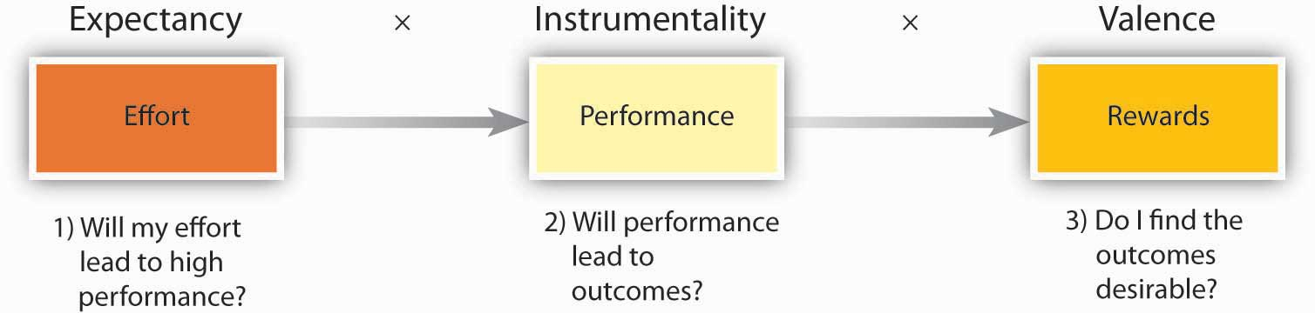
Source: Based on Porter, L. W., & Lawler, E. E. (1968). Managerial attitudes and performance. Homewood, IL: Irwin; Vroom, V. H. (1964). Work and motivation. New York: Wiley.
The first question is whether the person believes that high levels of effort will lead to desired outcomes. This perception is labeled as expectancy. For example, do you believe that the effort you put forth in a class is related to learning worthwhile material and receiving a good grade? If you do, you are more likely to put forth effort.
The second question is the degree to which the person believes that performance is related to secondary outcomes such as rewards. This perception is labeled as instrumentality. For example, do you believe that passing the class is related to rewards such as getting a better job, or gaining approval from your instructor, from your friends, or parents? If you do, you are more likely to put forth effort.
Finally, individuals are also concerned about the value of the rewards awaiting them as a result of performance. The anticipated satisfaction that will result from an outcome is labeled as valence. For example, do you value getting a better job or gaining approval from your instructor, friends, or parents? If these outcomes are desirable to you, you are more likely to put forth effort.
As a manager, how can you influence these perceptions to motivate employees? In fact, managers can influence all three perceptions.
- Cook, C. W. (1980). Guidelines for managing motivation. Business Horizons, 23, 61–69
To influence their expectancy perceptions, managers may train their employees, or hire people who are qualified for the jobs in question. Low expectancy may also be due to employees feeling that something other than effort predicts performance, such as political behaviors on the part of employees. In this case, clearing the way to performance and creating an environment in which employees do not feel blocked will be helpful. The first step in influencing instrumentality is to connect pay and other rewards to performance using bonuses, award systems, and merit pay. Publicizing any contests or award programs is helpful in bringing rewards to the awareness of employees. It is also important to highlight that performance and not something else is being rewarded. For example, if a company has an employee-of-the-month award that is rotated among employees, employees are unlikely to believe that performance is being rewarded. In the name of being egalitarian, such a reward system may actually hamper the motivation of highest performing employees by eroding instrumentality. Finally, to influence valence, managers will need to find out what their employees value. This can be done by talking to employees, or surveying them about what rewards they find valuable.

Reinforcement Theory
Reinforcement theory is based on the work of Ivan Pavlov in behavioral conditioning and the later work B. F. Skinner did on operant conditioning.
- Skinner, B. F. (1953). Science and human behavior. New York: Free Press
According to this theory, behavior is a function of its consequences. Imagine that even though no one asked you to, you stayed late and drafted a report. When the manager found out, she was ecstatic and took you out to lunch and thanked you genuinely. The consequences following your good deed were favorable, and therefore you are more likely to do similar good deeds in the future. In contrast, if your manager had said nothing about it and ignored the sacrifice you made, you would be less likely to demonstrate similar behaviors in the future, or your behavior would likely become extinct.
Despite the simplicity of reinforcement theory, how many times have you seen positive behavior ignored or, worse, negative behavior rewarded? In many organizations, this is a familiar scenario. People go above and beyond the call of duty, and yet their behaviors are ignored or criticized. People with disruptive habits may receive no punishments because the manager is afraid of the reaction the person will give when confronted. They may even receive rewards such as promotions so that the person is transferred to a different location and becomes someone else’s problem! Moreover, it is common for people to be rewarded for the wrong kind of behavior. Steven Kerr labeled this phenomenon as “the folly of rewarding A while hoping for B.”
- Kerr, S. (1995). On the folly of rewarding A while hoping for B. Academy of Management Executive, 9, 7–14
For example, a company may make public statements about the importance of quality. Yet, they choose to reward shipments on time regardless of the number of known defects contained in the shipments. As a result, employees are more likely to ignore quality and focus on hurrying the delivery process.

Reinforcement Interventions

Figure 14.12 Reinforcement Methods
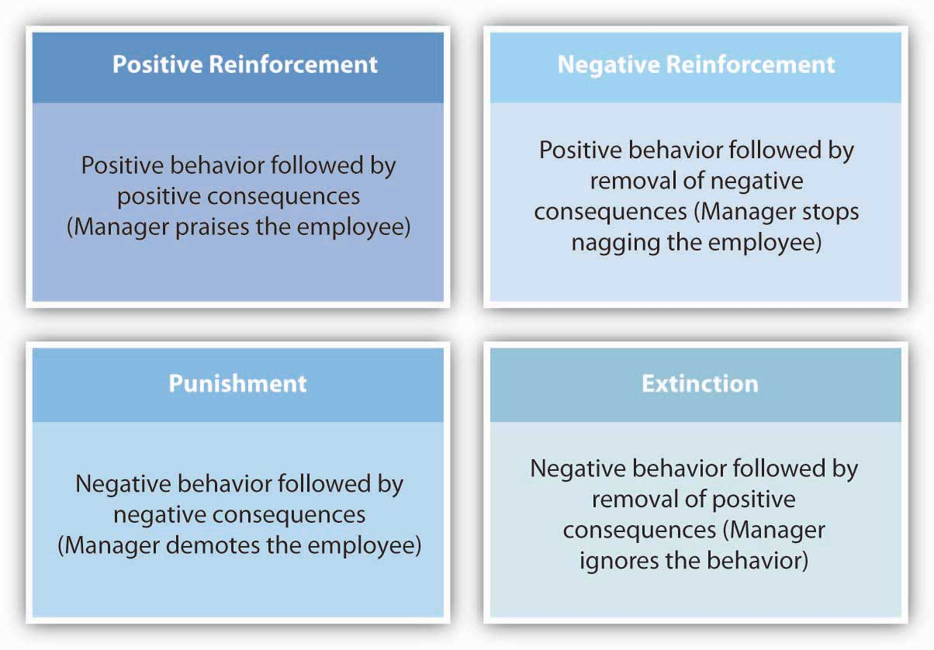
Reinforcement theory describes four interventions to modify employee behavior. Two of these are methods of increasing the frequency of desired behaviors while the remaining two are methods of reducing the frequency of undesired behaviors.
Positive reinforcement is a method of increasing the desired behavior.
- Beatty, R. W., & Schneier, C. E. (1975). A case for positive reinforcement. Business Horizons, 18, 57–66
Positive reinforcement involves making sure that behavior is met with positive consequences. Praising an employee for treating a customer respectfully is an example of positive reinforcement. If the praise immediately follows the positive behavior, the employee will see a link between behavior and positive consequences and will be motivated to repeat similar behaviors.
Negative reinforcement is also used to increase the desired behavior. Negative reinforcement involves removal of unpleasant outcomes once desired behavior is demonstrated. Nagging an employee to complete a report is an example of negative reinforcement. The negative stimulus in the environment will remain present until positive behavior is demonstrated. The problem with negative reinforcement may be that the negative stimulus may lead to unexpected behaviors and may fail to stimulate the desired behavior. For example, the person may start avoiding the manager to avoid being nagged.
Extinction occurs when a behavior ceases as a result of receiving no reinforcement. For example, suppose an employee has an annoying habit of forwarding e-mail jokes to everyone in the department, cluttering up people’s in-boxes and distracting them from their work. Commenting about the jokes, whether in favorable or unfavorable terms, may be encouraging the person to keep forwarding them. Completely ignoring the jokes may reduce their frequency.
Punishment is another method of reducing the frequency of undesirable behaviors. Punishment involves presenting negative consequences following unwanted behaviors. Giving an employee a warning for consistently being late to work is an example of punishment.

Reinforcement Schedules
In addition to types of reinforcements, the timing or schedule on which reinforcement is delivered has a bearing on behavior.
- Beatty, R. W., & Schneier, C. E. (1975). A case for positive reinforcement. Business Horizons, 18, 57–66
Reinforcement is presented on a continuous schedule if reinforcers follow all instances of positive behavior. An example of a continuous schedule would be giving an employee a sales commission every time he makes a sale. Fixed ratio schedules involve providing rewards every nth time the right behavior is demonstrated, for example, giving the employee a bonus for every 10th sale he makes. Fixed interval schedules involve providing a reward after a specified period of time, such as giving a sales bonus once a month regardless of how many sales have been made. Variable ratioinvolves a random pattern, such as giving a sales bonus every time the manager is in a good mood.
A systematic way in which reinforcement theory principles are applied is called Organizational Behavior Modification (or OB Mod).
- Luthans, F., & Stajkovic, A. D. (1999). Reinforce for performance: The need to go beyond pay and even rewards. Academy of Management Executive, 13, 49–57
This is a systematic application of reinforcement theory to modify employee behaviors. The model consists of five stages. The process starts with identifying the behavior that will be modified. Let’s assume that we are interested in reducing absenteeism among employees. In step 2, we need to measure the baseline level of absenteeism. In step 3, the behavior’s antecedents and consequences are determined. Why are employees absent? More importantly, what is happening when an employee is absent? If the behavior is being unintentionally rewarded, we may expect these to reinforce absenteeism behavior. For example, suppose that absences peak each month on the days when a departmental monthly report is due, meaning that coworkers and supervisors must do extra work to prepare the report. To reduce the frequency of absenteeism, it will be necessary to think of financial or social incentives to follow positive behavior and negative consequences to follow negative behavior. In step 4, an intervention is implemented. Removing the positive consequences of negative behavior may be an effective way of dealing with the situation, for example, starting the monthly report preparation a few days earlier, or letting employees know that if they are absent when the monthly report is being prepared, their contribution to the report will be submitted as incomplete until they finish it. Punishments may be used in persistent cases. Finally, in step 5 the behavior is measured periodically and maintained. Studies examining the effectiveness of OB Mod have been supportive of the model in general. A review of the literature found that OB Mod interventions resulted in an average of 17% improvement in performance.
- Stajkovic, A. D., & Luthans, F. (1997). A meta-analysis of the effects of organizational behavior modification on task performance, 1975–1995. Academy of Management Journal, 40, 1122–1149

Figure 14.14 Stages of OB Modification
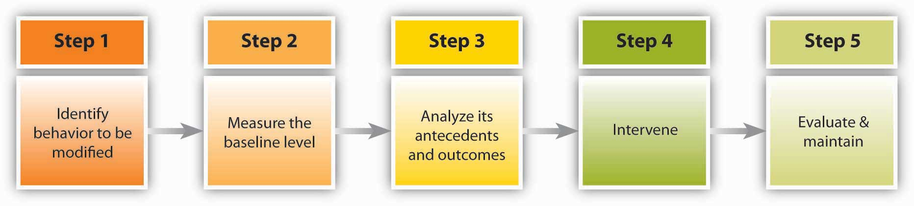
Based on information presented in Stajkovic, A. D., & Luthans, F. (1997). A meta-analysis of the effects of organizational behavior modification on task performance, 1975-1995. Academy of Management Journal, 40, 1122–1149.

Job Design
Many of us assume that the most important motivator at work would be pay. Yet, studies point to a different factor as the major influence over worker motivation: Job design. How a job is designed has a major impact on employee motivation, job satisfaction, commitment to organization, as well as absenteeism and turnover. Job design is just one of the many organizational design decisions managers must make when engaged in the organizing function.
The question of how to properly design jobs so that employees are more productive and more satisfied has received managerial and research attention since the beginning of the 20th century.

Scientific Management and Job Specialization
Perhaps the earliest attempt to design jobs was presented by Frederick Taylor in his 1911 book Principles of Scientific Management. Scientific management proposed a number of ideas that have been influential in job design. One idea was to minimize waste by identifying the best method to perform the job to ensure maximum efficiency. Another one of the major advances of scientific management was job specialization, which entails breaking down tasks to their simplest components and assigning them to employees so that each person would perform few tasks in a repetitive manner. While this technique may be very efficient in terms of automation and standardization, from a motivational perspective, these jobs will be boring and repetitive and therefore associated with negative outcomes such as absenteeism.
- Campion, M. A., & Thayer, P. W. (1987). Job design: Approaches, outcomes, and trade-offs. Organizational Dynamics, 15, 66–78
Job specialization is also an ineffective way of organizing jobs in rapidly changing environments where employees close to the problem should modify their approach based on the demands of the situation.
- Wilson, F. M. (1999). Rationalization and rationality From the founding fathers to eugenics. In Organizational behaviour: A critical introduction. Oxford: Oxford University Press

Rotation, Job Enlargement, and Enrichment
One of the early alternatives to job specialization was job rotation, which involves moving employees from job to job at regular intervals, thereby relieving the monotony and boredom typical in repetitive jobs. For example, Maids International, a company that provides cleaning services to households and businesses, uses job rotation such that maids cleaning the kitchen in one house would clean the bedroom in another house.
- Denton, D. K. (1994). …I hate this job. Business Horizons, 37, 46–52
Using this technique, among others, the company was able to reduce its turnover level. In a study conducted in a supermarket, cashiers were rotated to work in different departments. As a result of the rotation, employee stress level was reduced as measured by their blood pressure. Moreover, they reported fewer pain symptoms in their neck and shoulders.
- Rissen, D., Melin, B., Sandsjo, L., Dohns, I., & Lundberg, U. (2002). Psychophysiological stress reactions, trapezius muscle activity, and neck and shoulder pain among female cashiers before and after introduction of job rotation. Work & Stress, 16, 127–137
Job rotation has a number of advantages for organizations. It is an effective way for employees to acquire new skills, as the rotation involves cross-training to new tasks; this means that organizations increase the overall skill level of their employees.
- Campion, M. A., Cheraskin, L., & Stevens, M. J. (1994). Career-related antecedents and outcomes of job rotation. Academy of Management Journal, 37, 1518–1542
In addition, job rotation is a means of knowledge transfer between departments.
- Kane, A. A., Argote, L., & Levine, J. M. (2005). Knowledge transfer between groups via personnel rotation: Effects of social identity and knowledge quality. Organizational Behavior and Human Decision Processes, 96, 56–71
For the employees, rotation is a benefit because they acquire new skills, which keeps them marketable in the long run.
Anecdotal evidence suggests that companies successfully rotate high-level employees to train their managers and increase innovativeness in the company. For example, Nokia uses rotation at all levels, such as assigning lawyers to act as country managers or moving network engineers to handset design. These approaches are thought to bring a fresh perspective to old problems.
- Wylie, I. (May 2003). Calling for a renewable future. Fast Company, 70, 46–48
India’s information technology giant Wipro, which employs about 80,000 employees, uses a 3-year plan to groom future leaders of the company by rotating them through different jobs.
- Ramamurti, R. (2001). Wipro’s Chairman Azim Premji on Building a world-class Indian company. Academy of Management Executive, 15, 13–19
Job enlargement refers to expanding the tasks performed by employees to add more variety. Like job rotation, job enlargement can reduce boredom and monotony as well as use human resources more effectively. When jobs are enlarged, employees view themselves as being capable of performing a broader set of tasks.
- Parker, S. K. (1998). Enhancing role breadth self-efficacy: The roles of job enrichment and other organizational interventions. Journal of Applied Psychology, 83, 835–852
Job enlargement is positively related to employee satisfaction and higher-quality customer services, and it increases the chances of catching mistakes.
- Campion, M. A., & McClelland, C. L. (1991). Interdisciplinary examination of the costs and benefits of enlarged jobs: A job design quasi-experiment. Journal of Applied Psychology, 76, 186–198
At the same time, the effects of job enlargement may depend on thetype of enlargement. For example, exclusively giving employees simpler tasks had negative consequences on employee satisfaction with the job of catching errors, whereas giving employees more tasks that require them to be knowledgeable in different areas seemed to have more positive effects.
- Campion, M. A., & McClelland, C. L. (1993). Follow-up and extension of the interdisciplinary costs and benefits of enlarged jobs. Journal of Applied Psychology, 78, 339–351
Job enrichment is a job redesign technique that allows workers more control over how they perform their own tasks, giving them more responsibility. As an alternative to job specialization, companies using job enrichment may experience positive outcomes such as reduced turnover, increased productivity, and reduced absences.
- McEvoy, G. M., & Cascio, W. F. (1985). Strategies for reducing employee turnover. Journal of Applied Psychology, 70, 342–353
- Locke, E. A., Sirota, D., & Wolfson, A. D. (1976). An experimental case study of the successes and failures of job enrichment in a government agency. Journal of Applied Psychology, 61, 701–711
This may be because employees who have the authority and responsibility over their own work can be more efficient, eliminate unnecessary tasks, take shortcuts, and overall increase their own performance. At the same time, there is some evidence that job enrichment may sometimes cause employees to be dissatisfied.
- Locke, E. A., Sirota, D., & Wolfson, A. D. (1976). An experimental case study of the successes and failures of job enrichment in a government agency. Journal of Applied Pscyhology, 61, 701–711
The reason may be that employees who are given additional autonomy and responsibility may expect greater levels of pay or other types of compensation, and if this expectation is not met, they may feel frustrated. One more thing to remember is that job enrichment may not be suitable for all employees.
- Cherrington, D. J., & Lynn, E. J. (1980). The desire for an enriched job as a moderator of the enrichment-satisfaction relationship.Organizational Behavior and Human performance, 25, 139–159
- Hulin, C. L., & Blood, M. R. (1968). Job enlargement, individual differences, and worker responses. Psychological Bulletin, 69, 41–55
Not all employees desire to have control over how they work, and if they do not have this desire, they may feel dissatisfied in an enriched job.

Job Characteristics Model
The job characteristics model is one of the most influential attempts to design jobs to increase their motivational properties.
- Hackman, J. R., & Oldham, G. R. (1975). Development of the job diagnostic survey. Journal of Applied Psychology, 60, 159–170
Proposed in the 1970s by Hackman and Oldham, the model describes five core job dimensions, leading to three critical psychological states, which lead to work-related outcomes. In this model, shown in the following figure, there are five core job dimensions.

Figure 14.16 Job Characteristics Model
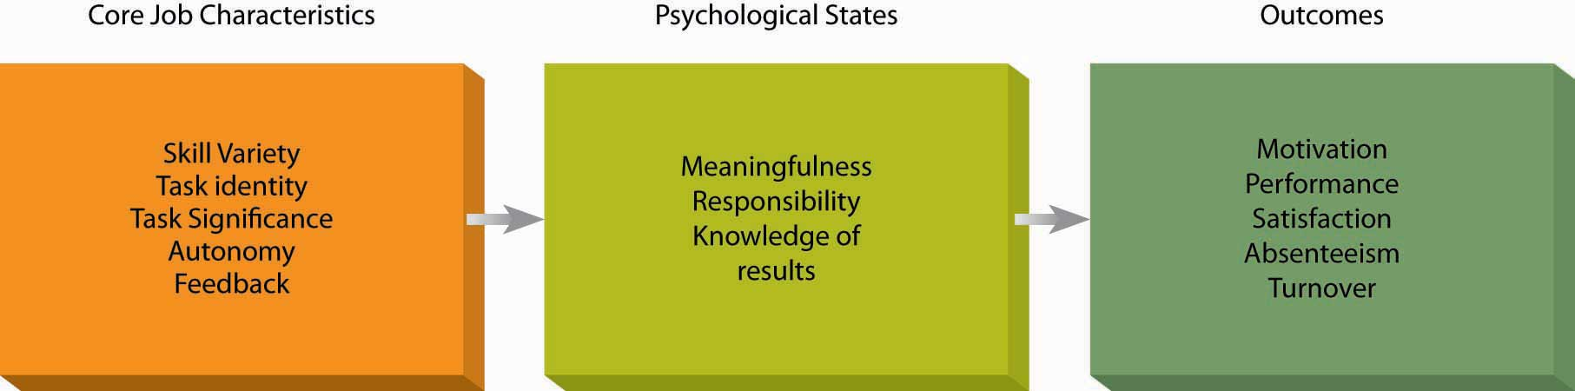
Adapted from Hackman, J. R., & Oldham, G. R. (1975). Development of the job diagnostic survey. Journal of Applied Psychology, 60, 159–170.
Skill variety refers to the extent to which the job requires the person to use multiple high-level skills. A car wash employee whose job consists of directing employees into the automated carwash demonstrates low levels of skill variety, whereas a car wash employee who acts as a cashier, maintains carwash equipment, and manages the inventory of chemicals demonstrates high skill variety.
Task identity refers to the degree to which the person completes a piece of work from start to finish. A Web designer who designs parts of a Web site will have low task identity because the work blends in with other Web designers’ work, and in the end, it will be hard for the person to claim responsibility for the final output. The Webmaster who designs the entire Web site will have high task identity.
Task significance refers to whether the person’s job substantially affects other people’s work, health, or well-being. A janitor who cleans the floor at an office building may find the job low in significance, thinking it is not an important job. However, janitors cleaning the floors at a hospital may see their role as essential in helping patients recover in a healthy environment. When they see their tasks as significant, employees tend to feel that they are making an impact on their environment and their feelings of self worth are boosted.
- Grant, A. M. (2008). The significance of task significance: Job performance effects, relational mechanisms, and boundary conditions. Journal of Applied Psychology, 93, 108–124
Autonomy is the degree to which the person has the freedom to decide how to perform tasks. As an example, a teacher who is required to follow a predetermined textbook, cover a given list of topics, and use a specified list of classroom activities has low autonomy, whereas a teacher who is free to choose the textbook, design the course content, and use any materials she sees fit has higher levels of autonomy. Autonomy increases motivation at work, but it also has other benefits. Autonomous workers are less likely to adopt a “this is not my job” attitude and instead be proactive and creative.
- Morgeson, F. P., Delaney-Klinger, K., & Hemingway, M. A. (2005). The importance of job autonomy, cognitive ability, and job-related skill for predicting role breadth and job performance. Journal of Applied Psychology,90, 399–406
- Parker, S. K., Wall, T. D., & Jackson, P. R. (1997). “That's not my job”: Developing flexible employee work orientations. Academy of Management Journal, 40, 899–929
- Parker, S. K., Williams, H. M., & Turner, N. (2006). Modeling the antecedents of proactive behavior at work. Journal of Applied Psychology, 91, 636–652
- Zhou, J. (1998). Feedback valence, feedback style, task autonomy, and achievement orientation: Interactive effects on creative performance. Journal of Applied Psychology, 83, 261–276
Giving employees autonomy is also a great way to train them on the job. For example, Gucci’s CEO Robert Polet describes autonomy he received while working at Unilever as the key to his development of leadership talents.
- Gumbel, P. (2008, January 21). Galvanizing Gucci. Fortune, 157(1), 80–88
Feedback refers to the degree to which the person learns how effective he or she is at work. Feedback may come from other people such as supervisors, peers, subordinates, customers, or from the job. A salesperson who makes informational presentations to potential clients but is not informed whether they sign up has low feedback. If this salesperson receives a notification whenever someone who has heard his presentation becomes a client, feedback will be high.
The mere presence of feedback is not sufficient for employees to feel motivated to perform better, however. In fact, in about one-third of the cases, feedback was detrimental to performance.
- Kluger, A. N., & DeNisi, A. (1996). The effects of feedback interventions on performance: A historical review, a meta-analysis, and a preliminary feedback intervention theory. Psychological Bulletin, 119, 254–284
In addition to whether feedback is present, the character of the feedback (positive or negative), whether the person is ready to receive the feedback, and the manner in which feedback was given will all determine whether employees feel motivated or demotivated as a result of feedback.

Goal Setting Theory
Goal setting theory is one of the most influential and practical theories of motivation. It has been supported in over 1,000 studies with employees, ranging from blue-collar workers to research and development employees, and there is strong evidence that setting goals is related to performance improvements.
- Locke, E. A., & Latham, G. P. (1990). A theory of goal setting and task performance. Englewood Cliffs, NJ: Prentice-Hall.
- Ivancevich, J. M., & McMahon, J. T. (1982). The effects of goal setting, external feedback, and self-generated feedback on outcome variables: A field experiment. Academy of Management Journal, 25, 359–372
- Latham, G. P., & Locke, E. A. (2006). Enhancing the benefits and overcoming the pitfalls of goal setting. Organizational Dynamics, 35, 332–340
- Umstot, D. D., Bell, C. H., & Mitchell, T. R. (1976). Effects of job enrichment and task goals on satisfaction and productivity: Implications for job design. Journal of Applied Psychology, 61, 379–394
In fact, according to one estimate, goal setting improves performance between 10% and 25% or more.
- Pritchard, R. D., Roth, P. L., Jones, S. D., Galgay, P. J., & Watson, M. D. (1988). Designing a goal-setting system to enhance performance: A practical guide. Organizational Dynamics, 17, 69–78
On the basis of evidence such as this, thousands of companies around the world are using goal setting in some form, including companies such as Coca-Cola, PricewaterhouseCoopers, Nike, Intel, and Microsoft to name a few.

Setting SMART Goals
The mere presence of a goal does not motivate individuals. Think about New Year’s resolutions that you may have made and failed to keep. Maybe you decided that you should lose some weight but then never put a concrete plan in action. Maybe you decided that you would read more but didn’t. Why did you, like 97% of those who set New Year’s resolutions, fail to meet your goal?
Accumulating research evidence indicates that effective goals are SMART. SMART goals are specific, measurable, achievable, realistic, and timely. Here is a sample SMART goal: Wal-Mart recently set a goal to eliminate 25% of the solid waste from its U.S. stores by the year 2009. This goal meets all the conditions of being SMART if we assume that it is an achievable goal.
- Heath, D., & Heath, C. (2008, February). Make goals not resolutions. Fast Company, 122, 58–59
Even though it seems like a simple concept, in reality many goals that are set within organizations may not be SMART. For example, Microsoft recently conducted an audit of its goal-setting and performance review system and found that only about 40% of the goals were specific and measurable.
- Shaw, K. N. (2004). Changing the goal-setting process at Microsoft. Academy of Management Executive, 18, 139–142

Why Do SMART Goals Motivate?

Figure 14.17
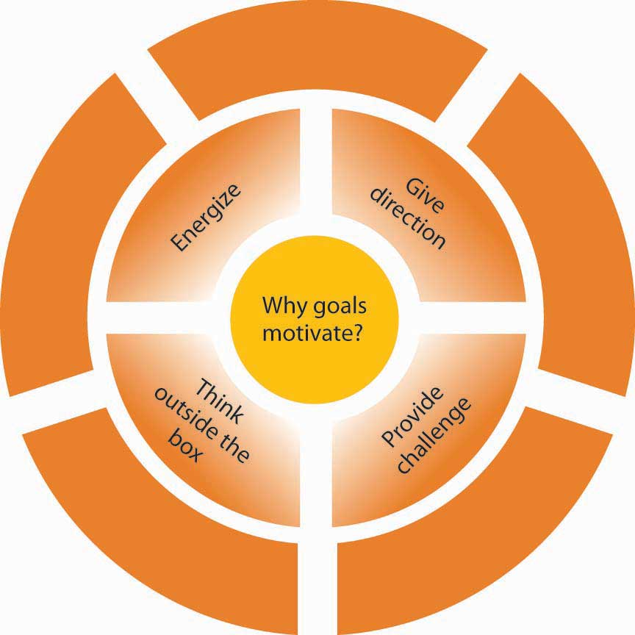
Why do SMART goals motivate?
Based on information contained in Latham, G. P. (2004). The motivational benefits of goal setting. Academy of Management Executive,18, 126–129; Seijts, G. H., & Latham, G. P. (2005). Learning versus performance goals: When should each be used? Academy of Management Executive,19, 124–131; Shaw, K. N. (2004). Changing the goal-setting process at Microsoft. Academy of Management Executive,18, 139–142.
There are at least four reasons why goals motivate.
- Latham, G. P. (2004). The motivational benefits of goal-setting. Academy of Management Executive, 18, 126–129
- Seijts, G. H., & Latham, G. P. (2005). Learning versus performance goals: When should each be used? Academy of Management Executive, 19, 124–131
- Shaw, K. N. (2004). Changing the goal-setting process at Microsoft. Academy of Management Executive, 18, 139–142
First, goals give us direction; therefore, goals should be set carefully. Giving employees goals that are not aligned with company goals will be a problem because goals will direct employee’s energy to a certain end. Second, goals energize people and tell them not to stop until they reach that point. Third, having a goal provides a challenge. When people have goals and when they reach them, they feel a sense of accomplishment. Finally, SMART goals urge people to think outside the box and rethink how they are working. If a goal is substantially difficult, merely working harder will not get you the results. Instead, you will need to rethink the way you usually work and devise a creative way of working. It has been argued that this is how designers and engineers in Japan came up with the bullet train. Having a goal that went way beyond the current speed of trains prevented engineers from making minor improvements and urged them to come up with a radically different concept.
- Kerr, S., & Landauer, S. (2004). Using stretch goals to promote organizational effectiveness and personal growth: General Electric and Goldman Sachs. Academy of Management Executive, 18, 134–138

Are There Downsides to Goal Setting?
As with any management technique, there may be some downsides to goal setting.
- Locke, E. A. (2004). Linking goals to monetary incentives. Academy of Management Executive, 18, 130–133
- Pritchard, R. D., Roth, P. L., Jones, S. D., Galgay, P. J., & Watson, M. D. (1988). Designing a goal-setting system to enhance performance: A practical guide. Organizational Dynamics, 17, 69–78
- Seijts, G. H., & Latham, G. P. (2005). Learning versus performance goals: When should each be used? Academy of Management Executive, 19, 124–131
First, setting goals for specific outcomes may hamper employee performance if employees lack skills and abilities to reach the goals. In these situations, setting goals for behaviors and for learning may be more effective than setting goals for outcomes. Second, goal setting may motivate employees to focus on a goal and ignore the need to respond to new challenges. For example, one study found that when teams had difficult goals and when employees within the team had high levels of performance orientation, teams had difficulty adapting to unforeseen circumstances.
- Lepine, J. A. (2005). Adaptation of teams in response to unforeseen change: Effects of goal difficulty and team composition in terms of cognitive ability and goal orientation.Journal of Applied Psychology, 90, 1153–1167
Third, goals focus employee attention on the activities that are measured, which may lead to sacrificing other important elements of performance. When goals are set for production numbers, quality may suffer. As a result, it is important to set goals touching on all critical aspects of performance. Finally, aggressive pursuit of goals may lead to unethical behaviors. Particularly when employees are rewarded for goal accomplishment but there are no rewards whatsoever for coming very close to reaching the goal, employees may be tempted to cheat.
None of these theories are complete by themselves, but each theory provides us with a framework we can use to analyze, interpret, and manage employee behaviors in the workplace, which are important skills managers use when conducting their leading function. In fact, motivation is important throughout the entire P-O-L-C framework because most managerial functions involve accomplishing tasks and goals through others.

KEY TAKEAWAY
Process-based theories use the mental processes of employees as the key to understanding employee motivation. According to equity theory, employees are demotivated when they view reward distribution as unfair. In addition to distributive justice, research identified two other types of fairness (procedural and interactional), which also affect worker reactions and motivation. According to expectancy theory, employees are motivated when they believe that their effort will lead to high performance (expectancy), that their performance will lead to outcomes (instrumentality), and that the outcomes following performance are desirable (valence). Reinforcement theory argues that behavior is a function of its consequences. By properly tying rewards to positive behaviors, eliminating rewards following negative behaviors and punishing negative behaviors, leaders can increase the frequency of desired behaviors. In job design, there are five components that increase the motivating potential of a job: Skill variety, task identity, task significance, autonomy, and feedback. These theories are particularly useful in designing reward systems within a company. Goal-setting theory is one of the most influential theories of motivation. To motivate employees, goals should be SMART (specific, measurable, achievable, realistic, and timely). Setting goals and objectives is a task managers undertake when involved in the planning portion of the P-O-L-C function.

EXERCISES
- Your manager tells you that the best way of ensuring fairness in reward distribution is to keep the pay a secret. How would you respond to this assertion?
- What are the distinctions among procedural, interactional, and distributive justice? List ways in which you could increase each of these justice perceptions.
- Using an example from your own experience in school or at work, explain the concepts of expectancy, instrumentality, and valence.
- Some practitioners and researchers consider OB Mod as unethical because it may be viewed as employee manipulation. What would be your reaction to this criticism?
- Consider a job you held in the past. Analyze the job using the framework of job characteristics model.
- If a manager tells you to “sell as much as you can,” is this goal likely to be effective? Why or why not?

14.4 Developing Your Personal Motivation Skills

LEARNING OBJECTIVES
- Understand what you can do to give feedback through an effective performance appraisal.
- Learn guidelines for proactively seeking feedback.

Guidelines for Giving Feedback in a Performance Appraisal MeetingMake employee appraisals more productive. (2007. September). HR Focus, 84(9), 1, 11–15

Ryan, L. (2007, January 1). Coping with performance-review anxiety.Business Week Online, p. 6

Stone, D. L. (1984). The effects of feedback sequence and expertise of the rater on perceived feedback accuracy. Personnel Psychology, 37, 487–506

Sulkowicz, K. (2007, September 10). Straight talk at review time. Business Week, 16
Before the meeting, ask the person to complete a self-appraisal. This is a great way of making sure that employees become active participants in the process and are heard. Complete the performance appraisal form and document your rating using several examples. Be sure that your review covers the entire time since the last review, not just recent events. Handle the logistics. Be sure that you devote sufficient time to each meeting. If you schedule them tightly back to back, you may lose your energy in later meetings. Be sure that the physical location is conducive to a private conversation.
During the meeting, be sure to recognize effective performance through specific praise. Do not start the meeting with a criticism. Starting with positive instances of performance helps establish a better mood and shows that you recognize what the employee is doing right. Give employees opportunities to talk. Ask them about their greatest accomplishments, as well as opportunities for improvement. Show empathy and support. Remember: your job as a manager is to help the person solve performance problems. Identify areas where you can help. Conclude by setting goals and creating an action plan for the future.
After the meeting, continue to give the employee periodic and frequent feedback. Follow through on the goals that were set.

Five Guidelines for Seeking FeedbackAdapted from ideas in Jackman, J. M., & Strober, M. H. (2003, April). Fear of feedback. Harvard Business Review, 81(4), 101–107

Wing, L., Xu, H., & Snape, E. (2007). Feedback-seeking behavior and leader-member exchange: Do supervisor-attributed motives matter? Academy of Management Journal, 50, 348–363

Lee, H. E., Park, H. S., Lee, T. S., & Lee, D. W. (2007). Relationships between LMX and subordinates’ feedback-seeking behaviors. Social Behavior & Personality: An International Journal, 35, 659–674
Research shows that receiving feedback is a key to performing well. If you are not receiving enough feedback on the job, it is better to seek it instead of trying to guess how well you are doing.
- Consider seeking regular feedback from your boss. This also has the added benefit of signaling to the manager that you care about your performance and want to be successful.
- Be genuine in your desire to learn. When seeking feedback, your aim should be improving yourself as opposed to creating the impression that you are a motivated employee. If your manager thinks that you are managing impressions rather than genuinely trying to improve your performance, feedback seeking may hurt you.
- Develop a good relationship with your manager as well as the employees you manage. This would have the benefit of giving you more feedback in the first place. It also has the upside of making it easier to ask direct questions about your own performance.
- Consider finding trustworthy peers who can share information with you regarding your performance. Your manager is not the only helpful source of feedback.
- Be gracious when you receive unfavorable feedback. If you go on the defensive, there may not be a next time. Remember, even if it may not feel like it sometimes, feedback is a gift. You can improve your performance by using feedback constructively. Consider that the negative feedback giver probably risked your goodwill by being honest. Unless there are factual mistakes in the feedback, do not try to convince the person that the feedback is inaccurate.

KEY TAKEAWAY
Giving effective feedback is a key part of a manager’s job. To do so, plan the delivery of feedback before, during, and after the meeting. In addition, there are a number of ways to learn about your own performance. Take the time to seek feedback and act on it. With this information, you can do key things to maximize your success and the success of those you manage.

EXERCISES
- Why can discussing performance feedback with employees be so hard?
- What barriers do you perceive in asking for feedback?
- How would you react if one of your employees came to you for feedback?
- Imagine that your good friend is starting a new job next week. What recommendations would you give to help your friend do a great job seeking feedback?

Chapter 15

The Essentials of Control

WHAT’S IN IT FOR ME?
Reading this chapter will help you do the following:
- Understand what is meant by organizational control.
- Differentiate among different levels, types, and forms of control.
- Know the essentials of financial controls.
- Know the essentials of nonfinancial controls.
- Know the basics of lean control systems.
- Craft a Balanced Scorecard for an organization or yourself.
This chapter helps you to understand the key elements of organizational control, often seen in the form of internal systems and processes, as they relate to the planning-organizing-leading-controlling (P-O-L-C) framework. While there are many possible forms and formats, organizational controls should serve two basic functions. First, they should help managers determine whether and why their strategy is achieving the desired results. Second, they should be an early warning system in cases where the organization is getting a little (or a lot) off track.

Figure 15.2 The P-O-L-C Framework

15.1 Case in Point: Newell Rubbermaid Leverages Cost Controls to Grow
Newell Company grew to be a diversified manufacturer and marketer of simple household items, cookware, and hardware. In the early 1950s, Newell Company’s business consisted solely of manufactured curtain rods that were sold through hardware stores and retailers like Sears. Since the 1960s, however, the company has diversified extensively through acquisitions of businesses for paintbrushes, writing pens, pots and pans, hairbrushes, and the like. Over 90% of its growth can be attributed to these many small acquisitions, whose performance Newell improved tremendously through aggressive restructuring and its corporate emphasis on cost cutting and cost controls. Usually within a year of the acquisition, Newell would bring in new leadership and install its own financial controller in the acquired unit. Then, three standard sets of controls were introduced: an integrated financial accounting system, a sales and order processing and tracking system, and a flexible manufacturing system. Once these systems were in place, managers were able to control costs by limiting expenses to those previously budgeted. Administration, accounting, and customer-related financial accounting aspects of the acquired business were also consolidated into Newell’s corporate headquarters to further reduce and control costs.
While Newell Company’s 16 different lines of business may appear quite different, they all share the common characteristics of being staple manufactured items sold primarily through volume retail channels like Wal-Mart, Target, and Kmart. Because Newell operates each line of business autonomously (separate manufacturing, research and development [R&D], and selling responsibilities for each), it is perhaps best described as pursuing a related, linked diversification strategy. The common linkages are both internal (accounting systems, product merchandising skills, and acquisition competency) and external (distribution channel of volume retailers). Beyond its internal systems and processes, Newell was also able to control costs through outcome controls. That is, business managers were paid a bonus based on the profitability of their particular unit—in fact, the firm’s strategy is to achieve profits, not simply growth at the expense of profits. Newell managers could expect a base salary equal to the industry average but could earn bonuses ranging from 35% to 100% based on their rank and unit profitability.
In 1999, Newell acquired Rubbermaid, a U.S.-based manufacturer of flexible plastic products like trash cans, reheatable and freezable food containers, and a broad range of other plastic storage containers designed for home and office use. While Rubbermaid was highly innovative (over 80% of its growth has come from internal new product development), it had difficulty controlling costs and was losing ground against powerful customers like Wal-Mart. Newell believed that the market power it wielded with retailers like Wal-Mart would help it turn Rubbermaid’s prospects around. The acquisition deal between these two companies resulted in a single company that was twice as big and became known as Newell Rubbermaid Inc. (NYSE: NWL). In 2010, Fortune named Newell Rubbermaid the number 7 “Most Admired Company” in the home equipment and furnishings category.
Primary Resource:
Secondary Resources:
- http://www.bain.com/masteringthemerger/case_example_new_rbbmd_trans.asp
- http://www.newellrubbermaid.com/public/Our-Company/Our-History.aspx.

DISCUSSION QUESTIONS
- The controlling facet of the P-O-L-C framework introduces you to a variety of controls. What do other organizations you are familiar with do with regard to control that is similar to or different from what we see in the case of Newell?
- What types of controls does Newell use?
- Does Newell use behavioral controls? What are some examples?
- Does Newell use outcome controls? What are some examples?
- How do the controls Newell uses fit its strategy?
- At the end of the case, how has Newell adjusted its strategy? What changes in controls has it made as a result?

15.2 Organizational Control

LEARNING OBJECTIVES
- Know what is meant by organizational control.
- Recognize that controls have costs.
- Understand the benefits of controls.
Up to this point you have probably become familiar with the planning, organizing, and leading components of the P-O-L-C framework. This section addresses the controlling component, often taking the form of internal systems and process, to complete your understanding of P-O-L-C. As you know, planning comprises all the activities associated with the formulation of your strategy, including the establishment of near- and long-term goals and objectives. Organizing and leading are the choices made about the way people work together and are motivated to achieve individual and group goals and objectives.

What Is Organizational Control?
The fourth facet of P-O-L-C, organizational control, refers to the process by which an organization influences its subunits and members to behave in ways that lead to the attainment of organizational goals and objectives. When properly designed, such controls should lead to better performance because an organization is able to execute its strategy better.
- Kuratko, D. F., Ireland, R. D., & Hornsby. J. S. (2001). Improving firm performance through entrepreneurial actions: Acordia’s corporate entrepreneurship strategy. Academy of Management Executive, 15(4), 60–71
As shown in the the P-O-L-C framework figure, we typically think of or talk about control in a sequential sense, where controls (systems and processes) are put in place to make sure everything is on track and stays on track. Controls can be as simple as a checklist, such as that used by pilots, flight crews, and some doctors.
- http://www.thehealthcareblog.com/the_health_care_blog/2007/12/pilots-use-chec.html
Increasingly, however, organizations manage the various levels, types, and forms of control through systems called Balanced Scorecards. We will discuss these in detail later in the chapter.
Organizational control typically involves four steps: (1) establish standards, (2) measure performance, (3) compare performance to standards, and then (4) take corrective action as needed. Corrective action can include changes made to the performance standards—setting them higher or lower or identifying new or additional standards. Sometimes we think of organizational controls only when they seem to be absent, as in the 2008 meltdown of U.S. financial markets, the crisis in the U.S. auto industry, or the much earlier demise of Enron and MCI/Worldcom due to fraud and inadequate controls. However, as shown in the figure, good controls are relevant to a large spectrum of firms beyond Wall Street and big industry.

The Need for Control in Not-for-Profit Organizations
We tend to think about controls only in the for-profit organization context. However, controls are relevant to a broad spectrum of organizations, including governments, schools, and charities. Jack Siegel, author of A Desktop Guide for Nonprofit Directors, Officers, and Advisors: Avoiding Trouble While Doing Good, outlines this top 10 list of financial controls that every charity should put in place:
Control 1—Require two signatures for checks written on bank and investment accounts. This prevents unapproved withdrawals and payments.
Control 2—The organization’s bank statements should be reconciled on a monthly basis by someone who does not have signature authority over the accounts. This is a further check against unapproved withdrawals and payments.
Control 3—Since cash is particularly susceptible to theft, organizations should eliminate the use of cash to the extent possible.
Control 4—Organizations should only purchase goods from an approved list of vendors. This provides protection from phony invoices submitted by insiders.
Control 5—Many charities have discovered “ghost employees” on their payrolls. To minimize this risk, organizations should tightly control the payroll list by developing a system of reports between payroll/accounting and the human resources department.
Control 6—Organizations should require all otherwise reimbursable expenses to be preauthorized. Travel and entertainment expenses should be governed by a clearly articulated written policy that is provided to all employees.
Control 7—Physical inventories should be taken on a regular and periodic basis and then be reconciled against the inventories carried on the books. Besides the possible detection of theft, this control also provides a basis for an insurance claim in the case of a fire, flood, or other disaster.
Control 8—Every organization should develop an annual budgeting process. The nonprofit’s employees should prepare the budget, but the board should review and approve it.
Control 9—Organizations should use a competitive bidding process for purchases above a certain threshold. In reviewing bids, organizations should look for evidence of collusion.
Control 10—Organizations that regularly received grants with specific requirements should have someone who is thoroughly versed in grant administration.
- http://www.charitygovernance.com/charity_governance/2007/10/ten-financial-c.html#more

The Costs and Benefits of Organizational Controls
Organizational controls provide significant benefits, particularly when they help the firm stay on track with respect to its strategy. External stakeholders, too, such as government, investors, and public interest groups have an interest in seeing certain types or levels of control are in place. However, controls also come at a cost. It is useful to know that there are trade-offs between having and not having organizational controls, and even among the different forms of control. Let’s look at some of the predominant costs and benefits of organizational controls, which are summarized in the following figure.

Costs
Controls can cost the organization in several areas, including (1) financial, (2) damage to culture and reputation, (3) decreased responsiveness, and (4) botched implementation. An example of financial cost is the fact that organizations are often required to perform and report the results of a financial audit. These audits are typically undertaken by external accounting firms, which charge a substantial fee for their services; the auditor may be a large firm like Accenture or KPMG, or a smaller local accounting office. Such audits are a way for banks, investors, and other key stakeholders to understand how financially fit the organization is. Thus, if an organization needs to borrow money from banks or has investors, it can only obtain these benefits if it incurs the monetary and staffing costs of the financial audit.
Controls also can have costs in terms of organization culture and reputation. While you can imagine that organizations might want to keep track of employee behavior, or otherwise put forms of strict monitoring in place, these efforts can have undesirable cultural consequences in the form of reduced employee loyalty, greater turnover, or damage to the organization’s external reputation. Management researchers such as the late London Business School professor Sumantra Ghoshal have criticized theory that focuses on the economic aspects of man (i.e., assumes that individuals are always opportunistic). According to Ghoshal, “A theory that assumes that managers cannot be relied upon by shareholders can make managers less reliable.”
- Ghoshal S., & Moran, P. (1996). Bad for practice: A critique of the transaction cost theory. Academy of Management Review. 21(1), 13–47
Such theory, he warned, would become a self-fulfilling prophecy.
Less theoretical are practical examples such as Hewlett-Packard’s (HP) indictment on charges of spying on its own board of directors. In a letter to HP’s board, director Tom Perkins said his accounts were “hacked” and attached a letter from AT&T explaining how the breach occurred. Records of calls made from Perkins’s home phone were obtained simply with his home phone number and the last four digits of his Social Security number. His long-distance account records were obtained when someone called AT&T and pretended to be Perkins, according to the letter from AT&T.
- http://i.n.com.com/pdf/ne/2006/perkins_letter.pdf
HP Chairman Patricia Dunn defended this rather extreme form of control as legal, but the amount of damage to the firm’s reputation from these charges led the firm to discontinue the practice. It also prompted the resignation of several directors and corporate officers.
- http://news.zdnet.com/2100-9595_22-149452.html
The third potential cost of having controls is that they can afford less organizational flexibility and responsiveness. Typically, controls are put in place to prevent problems, but controls can also create problems. For instance, the Federal Emergency Management Agency (FEMA) is responsible for helping people and business cope with the consequences of natural disasters, such as hurricanes. After Hurricane Katrina devastated communities along the U.S. Gulf Coast in 2005, FEMA found that it could not provide prompt relief to the hurricane victims because of the many levels of financial controls that it had in place.
- U.S. Government Printing Office. (2006, February 15). Executive summary. Select Bipartisan Committee to Investigate the Preparation for and Response to Hurricane Katrina
The fourth area of cost, botched implementation, may seem obvious, but it is more common than you might think (or than managers might hope). Sometimes the controls are just poorly understood, so that their launch creates significant unintended, negative consequences. For example, when Hershey Foods put a new computer-based control system in place in 1999, there were so many problems with its installation that it was not able to fulfill a large percentage of its Halloween season chocolate sales that year. It did finally get the controls in working order, but the downtime created huge costs for the company in terms of inefficiencies and lost sales.
- Retrieved January 30, 2009, from Hershey profits for 4Q 1999 down 11% due to SAP implementation problem http://www.greenspun.com/bboard/q-and-a-fetch-msg.tcl?msg_id=002SUM
Some added controls may also interfere with others. For instance, a new quality control system may improve product performance but also delay product deliveries to customers.

Benefits
Although organizational controls come at some cost, most controls are valid and valuable management tools. When they are well designed and implemented, they provide at least five possible areas of benefits, including (1) improved cost and productivity control, (2) improved quality control, (3) opportunity recognition, (4) better ability to manage uncertainty and complexity, and (5) better ability to decentralize decision making. Let’s look at each one of these benefits in turn.

Summary of Control Costs and Benefits
- Key Costs
  - Financial costs—direct (i.e., paying for an accountant for an audit) and indirect (i.e., people such as internal quality control the organization employs whose primary function is related to control).
  - Culture and reputation costs—the intangible costs associated with any form of control. Examples include damaged relationships with employees, or tarnished reputation with investors or government.
  - Responsiveness costs—downtime between a decision and the actions required to implement it due to compliance with controls.
  - Poorly implemented controls—implementation is botched or the implementation of a new control conflicts with other controls.
- Key Benefits
  - Cost and productivity control—ensures that the firm functions effectively and efficiently.
  - Quality control—contributes to cost control (i.e., fewer defects, less waste), customer satisfaction (i.e., fewer returns), and greater sales (i.e., repeat customers and new customers).
  - Opportunity recognition—helps managers identify and isolate the source of positive surprises, such as a new growth market. Though opportunities can also be found in internal comparisons of cost control and productivity across units.
  - Manage uncertainty and complexity—keeps the organization focused on its strategy, and helps managers anticipate and detect negative surprises and respond opportunistically to positive surprises.
  - Decentralized decision making—allows the organization to be more responsive by moving decision making to those closest to customers and areas of uncertainty.
First, good controls help the organization to be efficient and effective by helping managers to control costs and productivity levels. Cost can be controlled using budgets, where managers compare actual expenses to forecasted ones. Similarly, productivity can be controlled by comparing how much each person can produce, in terms of service or products. For instance, you can imagine that the productivity of a fast-food restaurant like McDonald’s depends on the speed of its order takers and meal preparers. McDonald’s can look across all its restaurants to identify the target speed for taking an order or wrapping a burger, then measure each store’s performance on these dimensions.
Quality control is a second benefit of controls. Increasingly, quality can be quantified in terms of response time (i.e., How long did it take you to get that burger?) or accuracy (Did the burger weigh one-quarter pound?). Similarly, Toyota tracks the quality of its cars according to hundreds of quantified dimensions, including the number of defects per car. Some measures of quality are qualitative, however. For instance, Toyota also tries to gauge how “delighted” each customer is with its vehicles and dealer service. You also may be familiar with quality control through the Malcolm Baldrige National Quality Program Award. The Baldrige award is given by the president of the United States to businesses—manufacturing and service, small and large—and to education, health care, and nonprofit organizations that apply and are judged to be outstanding in seven areas: leadership; strategic planning; customer and market focus; measurement, analysis, and knowledge management; human resource focus; process management; and results.
- Retrieved January 30, 2009, from http://www.nist.gov/public_affairs/factsheet/baldfaqs.htm
Controlling—how well the organization measures and analyzes its processes—is a key criterion for winning the award. The Baldrige award is given to organizations in a wide range of categories and industries, from education to ethics to manufacturing.
The third area by which organizations can benefit from controls is opportunity recognition. Opportunities can come from outside of the organization and typically are the result of a surprise. For instance, when Nestlé purchased the Carnation Company for its ice cream business, it had also planned to sell off Carnation’s pet food line of products. However, through its financial controls, Nestlé found that the pet food business was even more profitable than the ice cream, and kept both. Opportunities can come from inside the organization too, as would be the case if McDonald’s finds that one of its restaurants is exceptionally good at managing costs or productivity. It can then take this learned ability and transfer it to other restaurants through training and other means.
Controls also help organizations manage uncertainty and complexity. This is a fourth area of benefit from well-designed and implemented controls. Perhaps the most easily understood example of this type of benefit is how financial controls help an organization navigate economic downturns. Without budgets and productivity controls in place, the organization might not know it has lost sales or expenses are out of control until it is too late.

Control Criteria for the Baldrige National Quality Award
Measurement, Analysis, and Improvement of Organizational Performance: How Do You Measure, Analyze, and then Improve Organizational Performance? (45 points)
Describe how your organization measures, analyzes, aligns, reviews, and improves its performance using data and information at all levels and in all parts of your organization. Describe how you systematically use the results of reviews to evaluate and improve processes.
Within your response, include answers to the following questions:
- Performance Measurement
  - How do you select, collect, align, and integrate data and information for tracking daily operations and for tracking overall organizational performance, including progress relative to strategic objectives and action plans? What are your key organizational performance measures, including key short-term and longer-term financial measures? How do you use these data and information to support organizational decision making and innovation?
  - How do you select and ensure the effective use of key comparative data and information to support operational and strategic decision making and innovation?
  - How do you keep your performance measurement system current with business needs and directions? How do you ensure that your performance measurement system is sensitive to rapid or unexpected organizational or external changes?
  - Performance Analysis, Review, and Improvement
  - How do you review organizational performance and capabilities? What analyses do you perform to support these reviews and to ensure that the conclusions are valid? How do you use these reviews to assess organizational success, competitive performance, and progress relative to strategic objectives and action plans? How do you use these reviews to assess your organization’s ability to respond rapidly to changing organizational needs and challenges in your operating environment?
  - How do you translate organizational performance review findings into priorities for continuous and breakthrough improvement and into opportunities for innovation? How are these priorities and opportunities deployed to work group and functional-level operations throughout your organization to enable effective support for their decision making? When appropriate, how are the priorities and opportunities deployed to your suppliers, partners, and collaborators to ensure organizational alignment?
  - How do you incorporate the results of organizational performance reviews into the systematic evaluation and improvement of key processes?
- Retrieved January 30, 2009, from http://www.quality.nist.gov
The fifth area of benefit in organizational control is related to decentralized decision making. Organization researchers have long argued that performance is best when those people and areas of the organization that are closest to customers and pockets of uncertainty also have the ability (i.e., the information and authority) to respond to them.
- Galbraith, J. R. (1974). Organization design: An information processing view. Interfaces, 4, 28–36
Galbraith believes that “the greater the uncertainty of the task, the greater the amount of information that must be processed between decision makers during the execution of the task to get a given level of performance.” Firms can reduce uncertainty through better planning and coordination, often by rules, hierarchy, or goals. Galbraith states that “the critical limiting factor of an organizational form is the ability to handle the non-routine events that cannot be anticipated or planned for.” Going back to our McDonald’s example, you can imagine that it would be hard to give a store manager information about her store’s performance and possible choices if information about performance were only compiled at the city, region, or corporate level. With store-level performance tracking (or, even better, tracking of performance by the hour within a store), McDonald’s gives store managers the information they need to respond to changes in local demand. Similarly, it equips McDonald’s to give those managers the authority to make local decisions, track that decision-making performance, and feed it back into the control and reward systems.

KEY TAKEAWAY
This chapter introduced the basics of controls, the process by which an organization influences its subunits and members to behave in ways that lead to attaining organizational goals and objectives. When properly designed, controls lead to better performance by enabling the organization to execute its strategy better. Managers must weigh the costs and benefits of control, but some minimum level of control is essential for organizational survival and success.

EXERCISES
- What do properly conceived and implemented controls allow an organization to do?
- What are three common steps in organizational control?
- What are some of the costs of organizational controls?
- What are some of the benefits of organizational controls?
- How do managers determine when benefits outweigh costs?

15.3 Types and Levels of Control

LEARNING OBJECTIVES
- Know the difference between strategic and operational controls.
- Understand the different types of controls.
- Be able to differentiate between financial and nonfinancial controls.
Recognizing that organizational controls can be categorized in many ways, it is helpful at this point to distinguish between two sets of controls: (1) strategic controls and (2) management controls, sometimes called operating controls.
- Harrison, J. S., & St. John, C. H. (2002). Foundations in Strategic Management (2nd ed., 118–129). Cincinnati, OH: South-Western College

Two Levels of Control: Strategic and Operational
Imagine that you are the captain of a ship. The strategic controls make sure that your ship is going in the right direction; management and operating controls make sure that the ship is in good condition before, during, and after the voyage. With that analogy in mind, strategic control is concerned with tracking the strategy as it is being implemented, detecting any problem areas or potential problem areas suggesting that the strategy is incorrect, and making any necessary adjustments.
- Venkataraman, S., & Sarasvathy, S. D. (2001). Strategy and entrepreneurship: Outlines of an untold story. In M. A. Hitt, R. E. Freeman, & J. S. Harrison (Eds.),Handbook of strategic management (650–668) Oxford: Blackwell
Strategic controls allow you to step back and look at the big picture and make sure all the pieces of the picture are correctly aligned.
Ordinarily, a significant time span occurs between initial implementation of a strategy and achievement of its intended results. For instance, if you wanted to captain your ship from San Diego to Seattle you might need a crew, supplies, fuel, and so on. You might also need to wait until the weather lets you make the trip safely! Similarly, in larger organizations, during the time you are putting the strategy into place, numerous projects are undertaken, investments are made, and actions are undertaken to implement the new strategy. Meanwhile, the environmental situation and the firm’s internal situation are developing and evolving. The economy could be booming or perhaps falling into recession. Strategic controls are necessary to steer the firm through these events. They must provide some means of correcting direction on the basis of intermediate performance and new information.
Operational control, in contrast to strategic control, is concerned with executing the strategy. Where operational controls are imposed, they function within the framework established by the strategy. Normally these goals, objectives, and standards are established for major subsystems within the organization, such as business units, projects, products, functions, and responsibility centers.
- Matthews, J. (1999). Strategic moves. Supply Management, 4(4), 36–37
Typical operational control measures include return on investment, net profit, cost, and product quality. These control measures are essentially summations of finer-grained control measures. Corrective action based on operating controls may have implications for strategic controls when they involve changes in the strategy.

Types of Control
It is also valuable to understand that, within the strategic and operational levels of control, there are several types of control. The first two types can be mapped across two dimensions: level of proactivity and outcome versus behavioral. The following table summarizes these along with examples of what such controls might look like.

Proactivity
Proactivity can be defined as the monitoring of problems in a way that provides their timely prevention, rather than after the fact reaction. In management, this is known as feedforward control; it addresses what can we do ahead of time to help our plan succeed. The essence of feedforward control is to see the problems coming in time to do something about them. For instance, feedforward controls include preventive maintenance on machinery and equipment and due diligence on investments.

Table 15.1 Types and Examples of Control
Control Proactivity | Behavioral control | Outcome control
Feedforward control | Organizational culture | Market demand or economic forecasts
Concurrent control | Hands-on management supervision during a project | The real-time speed of a production line
Feedback control | Qualitative measures of customer satisfaction | Financial measures such as profitability, sales growth

Concurrent Controls
The process of monitoring and adjusting ongoing activities and processes is known as concurrent control. Such controls are not necessarily proactive, but they can prevent problems from becoming worse. For this reason, we often describe concurrent control as real-time control because it deals with the present. An example of concurrent control might be adjusting the water temperature of the water while taking a shower.

Feedback Controls
Finally, feedback controls involve gathering information about a completed activity, evaluating that information, and taking steps to improve the similar activities in the future. This is the least proactive of controls and is generally a basis for reactions. Feedback controls permit managers to use information on past performance to bring future performance in line with planned objectives.

Control as a Feedback Loop
In this latter sense, all these types of control function as a feedback mechanism to help leaders and managers make adjustments in the strategy, as perhaps is reflected by changes in the planning, organizing, and leading components. This feedback loop is characterized in the following figure.

Figure 15.5 Controls as Part of a Feedback Loop
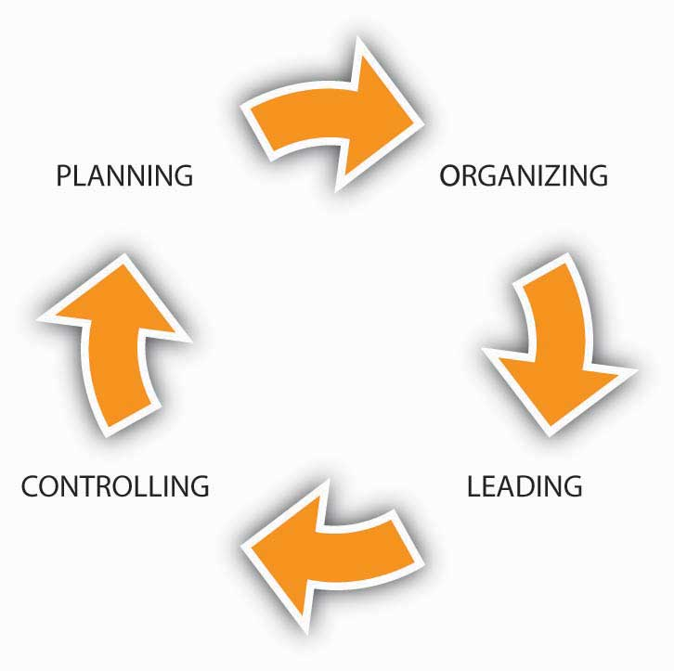
Why might it be helpful for you to think of controls as part of a feedback loop in the P-O-L-C process? Well, if you are the entrepreneur who is writing the business plan for a completely new business, then you would likely start with the planning component and work your way to controlling—that is, spell out how you are going to tell whether the new venture is on track. However, more often, you will be stepping into an organization that is already operating, and this means that a plan is already in place. With the plan in place, it may be then up to you to figure out the organizing, leading, or control challenges facing the organization.

Outcome and Behavioral Controls
Controls also differ depending on what is monitored, outcomes or behaviors. Outcome controls are generally preferable when just one or two performance measures (say, return on investment or return on assets) are good gauges of a business’s health. Outcome controls are effective when there’s little external interference between managerial decision making on the one hand and business performance on the other. It also helps if little or no coordination with other business units exists.
Behavioral controls involve the direct evaluation of managerial and employee decision making, not of the results of managerial decisions. Behavioral controls tie rewards to a broader range of criteria, such as those identified in the Balanced Scorecard. Behavioral controls and commensurate rewards are typically more appropriate when there are many external and internal factors that can affect the relationship between a manager’s decisions and organizational performance. They’re also appropriate when managers must coordinate resources and capabilities across different business units.

Financial and Nonfinancial Controls
Finally, across the different types of controls in terms of level of proactivity and outcome versus behavioral, it is important to recognize that controls can take on one of two predominant forms: financial and nonfinancial controls. Financial control involves the management of a firm’s costs and expenses to control them in relation to budgeted amounts. Thus, management determines which aspects of its financial condition, such as assets, sales, or profitability, are most important, tries to forecast them through budgets, and then compares actual performance to budgeted performance. At a strategic level, total sales and indicators of profitability would be relevant strategic controls.
Without effective financial controls, the firm’s performance can deteriorate. PSINet, for example, grew rapidly into a global network providing Internet services to 100,000 business accounts in 27 countries. However, expensive debt instruments such as junk bonds were used to fuel the firm’s rapid expansion. According to a member of the firm’s board of directors, PSINet spent most of its borrowed money “without the financial controls that should have been in place.”
- Woolley, S. (2001, May). Digital hubris. Forbes, 66–70.
With a capital structure unable to support its rapidly growing and financially uncontrolled operations, PSINet and 24 of its U.S. subsidiaries eventually filed for bankruptcy.
- Retrieved January 30, 2009, from PSINet announces NASDAQ delisting. (2001, June 1).http://www.psinet.com
While we often think of financial controls as a form of outcome control, they can also be used as a behavioral control. For instance, if managers must request approval for expenditures over a budgeted amount, then the financial control also provides a behavioral control mechanism as well.
Increasing numbers of organizations have been measuring customer loyalty, referrals, employee satisfaction, and other such performance areas that are not financial. In contrast to financial controls,nonfinancial controls track aspects of the organization that aren’t immediately financial in nature but are expected to lead to positive performance outcomes. The theory behind such nonfinancial controls is that they should provide managers with a glimpse of the organization’s progress well before financial outcomes can be measured.
- Ittner, C., & Larcker, D. F. (2003, November). Coming up short on nonfinancial performance measurement. Harvard Business Review, 2–8
And this theory does have some practical support. For instance, GE has found that highly satisfied customers are the best predictor of future sales in many of its businesses, so it regularly tracks customer satisfaction.

KEY TAKEAWAY
Organizational controls can take many forms. Strategic controls help managers know whether a chosen strategy is working, while operating controls contribute to successful execution of the current strategy. Within these types of strategy, controls can vary in terms of proactivity, where feedback controls were the least proactive. Outcome controls are judged by the result of the organization’s activities, while behavioral controls involve monitoring how the organization’s members behave on a daily basis. Financial controls are executed by monitoring costs and expenditure in relation to the organization’s budget, and nonfinancial controls complement financial controls by monitoring intangibles like customer satisfaction and employee morale.

EXERCISES
- What is the difference between strategic and operating controls? What level of management would be most concerned with operating controls?
- If feedforward controls are the most proactive, then why do organizations need or use feedback controls?
- What is the difference between behavioral and outcome controls?
- What is the difference between nonfinancial and financial controls? Is a financial control a behavioral or an outcome control?

15.4 Financial Controls

LEARNING OBJECTIVES
- Understand the nature of financial controls.
- Know how a balance sheet works.
- Know how an income profit and loss statement works.
- See the sources of cash flow.
As we discussed in the previous section, financial controls are a key element of organizational success and survival. There are three basic financial reports that all managers need to understand and interpret to manage their businesses successfully: (1) the balance sheet, (2) the income/profit and loss (P&L) statement, and (3) the cash flow statement. These three reports are often referred to collectively as “the financials.” Banks often require a projection of these statements to obtain financing.
Financial controls provide the basis for sound management and allow managers to establish guidelines and policies that enable the business to succeed and grow. Budgeting, for instance, generally refers to a simple listing of all planned expenses and revenues. On the basis of this listing, and a starting balance sheet, you can project a future one. The overall budget you create is a monthly or quarterly projection of what the balance sheet and income statement will look like but again based on your list of planned expenses and revenues.
While you do not need to be an accountant to understand this section, good managers have a good grasp of accounting fundamentals. You might want to open a window to AccountingCoach.com or a similar site as you work through this section to begin to build your accounting knowledge tool kit.
- Retrieved October 21, 2008, from http://www.accountingcoach.com

The Nature of Financial Controls
Imagine that you are on the board of Success-R-Us, an organization whose financial controls are managed in an excellent manner. Each year, after the organization has outlined strategies to reach its goals and objectives, funds are budgeted for the necessary resources and labor. As money is spent, statements are updated to reflect how much was spent, how it was spent, and what it obtained. Managers, who report to the board, use these financial statements, such as an income statement or balance sheet, to monitor the progress of programs and plans. Financial statements provide management with information to monitor financial resources and activities. The income statement shows the results of the organization’s operations, such as revenues, expenses, and profit or loss. The balance sheet shows what the organization is worth (assets) at a single point in time, and the extent to which those assets were financed through debt (liabilities) or owner’s investment (equity).
Success-R-Us conducts financial audits, or formal investigations, to ensure that financial management practices follow generally accepted procedures, policies, laws, and ethical guidelines. In Success-R-Us, audits are conducted both internally—by members of the company’s accounting department—and externally by Green Eyeshade Inc., an accounting firm hired for this purpose.
Financial ratio analysis examines the relationship between specific figures on the financial statements and helps explain the significance of those figures: By analyzing financial reports, the managers at Success-R-Us are able to determine how well the business is doing and what may need to be done to improve its financial viability.
While actual financial performance is always historical, Success-R-Us’s proactive managers plan ahead for the problems the business is likely to encounter and the opportunities that may arise. To do this, they use pro forma financials, which are projections; usually these are projected for three fiscal years. Being proactive requires reading and analyzing the financial statements on a regular basis. Monthly, and sometimes daily or weekly, financial analysis is preferred. (In the business world as a whole, quarterly is more common, and some organizations do this only once a year, which is not often enough.) The proactive manager has financial data available based on actual results and compares them to the budget. This process points out weaknesses in the business before they reach crisis proportion and allows the manager to make the necessary changes and adjustments before major problems develop.
Years ago, Success-R-Us experienced problems because its management style was insufficiently proactive. A reactive manager waits to react to problems and then solves them by crisis management. This type of manager goes from crisis to crisis with little time in between to notice opportunities that may become available. The reactive manager’s business is seldom prepared to take advantage of new opportunities quickly. Businesses that are managed proactively are more likely to be successful, and this is the result that Success-R-Us is experiencing since it instituted a company-wide initiative to promote proactive controls.
Like most organizations, Success-R-Us uses computer software programs to do record keeping and develop financials. These programs provide a chart of accounts that can be individualized to the business and the templates for each account ledger, the general ledgers, and the financial reports. These programs are menu driven and user-friendly, but knowing how to input the data correctly is not enough. A manager must also know where to input each piece of data and how to analyze the reports compiled from the data. Widely accepted accounting guidelines dictate that if you have not learned a manual record-keeping system, you need to do this before attempting to use a computerized system.

The Balance Sheet
The balance sheet is a snapshot of the business’s financial position at a certain point in time. This can be any day of the year, but balance sheets are usually done at the end of each month. With a budget in hand, you project forward and develop pro forma statements to monitor actual progress against expectations.
As shown in the following table, this financial statement is a listing of total assets (what the business owns—items of value) and total liabilities (what the business owes). The total assets are broken down into subcategories of current assets, fixed assets, and other assets. The total liabilities are broken down into subcategories of current liabilities, long-term liabilities/debt, and owner’s equity.

Assets
Current assets are those assets that are cash or can be readily converted to cash in the short term, such as accounts receivable or inventory. In the balance sheet shown for Success-R-Us, the current assets are cash, petty cash, accounts receivable, inventory, and supplies.

Table 15.2 Sample Balance Sheet
Success-R-Us Balance Sheet
December 31, 2009
Assets |  | Liabilities
Current Assets |  | Current Liabilities
Cash | $12,300 | Notes Payable | $5,000
Petty Cash | 100 | Accounts Payable | 35,900
 |  | Wages Payable | 14,600
Accounts Receivable | 40,500 | Interest Payable | 2,900
Inventory | 31,000 | Warranty Liability | 1,100
Supplies | 5,300
Total Current Assets | 89,000 | Total Current Liabilities | 61,000
Investments | 36,000 | Long-term Liabilities
 |  | Notes Payable | 20,000
Property, Plant and Equipment |  | Bonds Payable | 400,000
Land | 5,500 | Total Long-term Liabilities | 420,000
Land Improvements | 6,500
Buildings | 180,000
Equipment | 201,000 | Total Liabilities | 481,000
Less Accum. Depreciation | (56,000)
Prop., Plant, and Equipment net | 337,000
Intangible Assets |  | Stockholders’ Equity
Goodwill | 105,000 | Common Stocks | 110,000
Trade Names | 200,000 | Retained Earnings | 229,000
Total Intangible Assets | 305,000 | Less Treasury Stock | (50,000)
Other Assets | 3,000
Total Assets | $770,000 | Total Liability and Stockholder Equity | $770,000
Some business people define current assets as those the business expects to use or consume within the coming fiscal year. Thus, a business’s noncurrent assets would be those that have a useful life of more than 1 year. These include fixed assets and intangible assets.
Fixed assets are those assets that are not easily converted to cash in the short term; that is, they are assets that only change over the long term. Land, buildings, equipment, vehicles, furniture, and fixtures are some examples of fixed assets. In the balance sheet for Success-R-Us, the fixed assets shown are furniture and fixtures and equipment. These fixed assets are shown as less accumulated depreciation.
Intangible assets (net) may also be shown on a balance sheet. These may be goodwill, trademarks, patents, licenses, copyrights, formulas, and franchises. In this instance, net means the value of intangible assets minus amortization.

Liabilities
Current liabilities are those coming due in the short term, usually the coming year. These are accounts payable; employment, income and sales taxes; salaries payable; federal and state unemployment insurance; and the current year’s portion of multiyear debt. A comparison of the company’s current assets and its current liabilities reveals its working capital. Many managers use an accounts receivable aging report and a current inventory listing as tools to help them in management of the current asset structure.
Long-term debt, or liabilities, may be bank notes or loans made to purchase the business’s fixed asset structure. Long-term debt/liabilities come due in a period of more than 1 year. The portion of a bank note that is not payable in the coming year is long-term debt/liability.
For example, Success-R-Us’s owner may take out a bank note to buy land and a building. If the land is valued at $50,000 and the building is valued at $50,000, the business’s total fixed assets are $100,000. If $20,000 is made as a down payment and $80,000 is financed with a bank note for 15 years, the $80,000 is the long-term debt.

Owner’s Equity
Owner’s equity refers to the amount of money the owner has invested in the firm. This amount is determined by subtracting current liabilities and long-term debt from total assets. The remaining capital/owner’s equity is what the owner would have left in the event of liquidation, or the dollar amount of the total assets that the owner can claim after all creditors are paid.”

The Income Profit and Loss Statement (P&L)
The profit and loss statement (P&L) shows the relation of income and expenses for a specific time interval. The income/P&L statement is expressed in a 1-month format, January 1 through January 31, or a quarterly year-to-date format, January 1 through March 31. This financial statement is cumulative for a 12-month fiscal period, at which time it is closed out. A new cumulative record is started at the beginning of the new 12-month fiscal period.
The P&L statement is divided into five major categories: (1) sales or revenue, (2) cost of goods sold/cost of sales, (3) gross profit, (4) operating expenses, and (5) net income. Let’s look at each category in turn.

Table 15.3 Sample Income Statement
Success-R-Us Income Statement
For the year ended December 31, 2009
Sales/Revenues (all on credit) | $500,000
Cost of Goods Sold | 380,000
Gross Profit | 120,000
Operating Expenses
Selling Expenses | 35,000
Administrative Expenses | 45,000
Total Operating Expenses | 80,000
Operating Income | 40,000
Interest Expense | 12,000
Income before Taxes | 28,000
Income Tax Expense | 5,000
Net Income after Taxes | 23,000

Sales or Revenue
The sales or revenue portion of the income statement is where the retail price of the product is expressed in terms of dollars times the number of units sold. This can be product units or service units. Sales can be expressed in one category as total sales or can be broken out into more than one type of sales category: car sales, part sales, and service sales, for instance. In our Success-R-Us example, the company sold 20,000 books at a retail price of $25 each, for total revenues of $500,000. Because Success-R-Us sells all of its books on credit (i.e., you can charge them on your credit card), the company does not collect cash for these sales until the end of the month, or whenever the credit card company settles up with Success-R-Us.

Cost of Goods Sold/Cost of Sales
The cost of goods sold/sales portion of the income statement shows the cost of products purchased for resale, or the direct labor cost (service person wages) for service businesses. Cost of goods sold/sales also may include additional categories, such as freight charges cost or subcontract labor costs. These costs also may be expressed in one category as total cost of goods sold/sales or can be broken out to match the sales categories: car purchases, parts, purchases, and service salaries, for example.
Breaking out sales and cost of goods sold/sales into separate categories can have an advantage over combining all sales and costs into one category. When you break out sales, you can see how much each product you have sold costs and the gross profit for each product. This type of analysis enables you to make inventory and sales decisions about each product individually.

Gross Profit
The gross profit portion of the income/P&L statement tells the difference between what you sold the product or service for and what the product or service cost you. The goal of any business is to sell enough units of product or service to be able to subtract the cost and have a high enough gross profit to cover operating expenses, plus yield a net income that is a reasonable return on investment. The key to operating a profitable business is to maximize gross profit.
If you increase the retail price of your product too much above the competition, you might lose units of sales to the competition and not yield a high enough gross profit to cover your expenses. However, if you decrease the retail price of your product too much below the competition, you might gain additional units of sales but not make enough gross profit per unit sold to cover your expenses.
While this may sound obvious, a carefully thought out pricing strategy maximizes gross profit to cover expenses and yield a positive net income. At a very basic level, this means that prices are set at a level where marginal and operating costs are covered. Beyond this, pricing should carefully be set to reflect the image you want portrayed and, if desired, promote repeat business.

Operating Expenses
The operating expense section of the income/P&L statement is a measurement of all the operating expenses of the business. There are two types of expenses, fixed and variable. Fixed expenses are those expenses that do not vary with the level of sales; thus, you will have to cover these expenses even if your sales are less than the expenses. The entrepreneur has little control over these expenses once they are set. Some examples of fixed expenses are rent (contractual agreement), interest expense (note agreement), an accounting or law firm retainer for legal services of X amount per month for 12 months, and monthly charges for electricity, phone, and Internet connections.
Variable expenses are those expenses that vary with the level of sales. Examples of variable expenses include bonuses, employee wages (hours per week worked), travel and entertainment expenses, and purchases of supplies. (Note: categorization of these may differ from business to business.) Expense control is an area where the entrepreneur can maximize net income by holding expenses to a minimum.

Net Income
The net income portion of the income/P&L statement is the bottom line. This is the measure of a firm’s ability to operate at a profit. Many factors affect the outcome of the bottom line. Level of sales, pricing strategy, inventory control, accounts receivable control, ordering procedures, marketing of the business and product, expense control, customer service, and productivity of employees are just a few of these factors. The net income should be enough to allow growth in the business through reinvestment of profits and to give the owner a reasonable return on investment.

The Cash Flow Statement
The cash flow statement is the detail of cash received and cash expended for each month of the year. A projected cash flow statement helps managers determine whether the company has positive cash flow. Cash flow is probably the most immediate indicator of an impending problem, since negative cash flow will bankrupt the company if it continues for a long enough period. If company’s projections show a negative cash flow, managers might need to revisit the business plan and solve this problem.
You may have heard the joke: “How can I be broke if I still have checks in my check book (or if I still have a debit/credit card, etc.)?” While perhaps poor humor, many new managers similarly think that the only financial statement they need to manage their business effectively is an income/P&L statement; that a cash flow statement is excess detail. They mistakenly believe that the bottom-line profit is all they need to know and that if the company is showing a profit, it is going to be successful. In the long run, profitability and cash flow have a direct relationship, but profit and cash flow do not mean the same thing in the short run. A business can be operating at a loss and have a strong cash flow position. Conversely, a business can be showing an excellent profit but not have enough cash flow to sustain its sales growth.
The process of reconciling cash flow is similar to the process you follow in reconciling your bank checking account. The cash flow statement is composed of: (1) beginning cash on hand, (2) cash receipts/deposits for the month, (3) cash paid out for the month, and (4) ending cash position.

KEY TAKEAWAY
The financial controls provide a blueprint to compare against the actual results once the business is in operation. A comparison and analysis of the business plan against the actual results can tell you whether the business is on target. Corrections, or revisions, to policies and strategies may be necessary to achieve the business’s goals. The three most important financial controls are: (1) the balance sheet, (2) the income statement (sometimes called a profit and loss statement), and (3) the cash flow statement. Each gives the manager a different perspective on and insight into how well the business is operating toward its goals. Analyzing monthly financial statements is a must since most organizations need to be able to pay their bills to stay in business.

EXERCISES
- What are financial controls? In your answer, describe how you would go about building a budget for an organization.
- What is the difference between an asset and a liability?
- What is the difference between the balance sheet and an income statement? How are the balance sheet and income statement related?
- Why is it important to monitor an organization’s cash flow?

15.5 Nonfinancial Controls

LEARNING OBJECTIVES
- Become familiar with nonfinancial controls.
- Learn about common mistakes associated with nonfinancial controls.
- Be able to devise possible solutions to common mistakes in nonfinancial controls.
If you have ever completed a customer satisfaction survey related to a new product or service purchase, then you are already familiar with nonfinancial controls. Nonfinancial controls are defined as controls where nonfinancial performance outcomes are measured. Why is it important to measure such outcomes? Because they are likely to affect profitability in the long term.
How do we go about identifying nonfinancial controls? In some areas it is easy to do, and in others more difficult. For instance, if Success-R-Us were having trouble retaining employees (meaning that turnover is high), it might be incurring higher recruiting and training costs and lower customer satisfaction, as a result. Some possible nonfinancial controls are described next.

Examples of Nonfinancial Performance Controls
- Human Resources
  - Employee satisfaction
  - Average tenure
  - Turnover
- Marketing
  - New products launched
  - Customer satisfaction
  - Brand power
- Production
  - Number of defects
  - Product returns
  - Capacity utilization
- Purchasing
  - New products introduced by suppliers
  - Quality of purchased inputs
- Research and Development
  - New patents
  - Number of employees with PhDs
- Customer Service
  - Average complaint response time
  - Average wait time

Common Mistakes with Nonfinancial Controls
In a review of current nonfinancial control practices, Harvard professors Chris Ittner and David Larcker commented, “Tracking things like customer satisfaction and employee turnover can powerfully supplement traditional bookkeeping. Unfortunately, most companies botch the job.”
- Ittner, C., & Larcker, D. F. (2003, November). Coming up short on nonfinancial performance measurement.Harvard Business Review, 2–8
Ittner and Larcker somewhat cynically conclude their study by stating, “The original purpose of nonfinancial performance measures was to fill out the picture provided by traditional accounting. Instead, such measures have become a shabby substitute for financial performance.”
- Ittner, C., & Larcker, D. F. (2003, November). Coming up short on nonfinancial performance measurement.Harvard Business Review, 2–8
However, research also shows that those firms that put these nonfinancial controls in place, and can validate them, earn much higher profits than those that don’t.
- Ittner, C., & Larcker, D. F. (2003, November). Coming up short on nonfinancial performance measurement. Harvard Business Review, 2–8
With the aim of working toward an understanding of how to put such controls into place, let’s first look at common mistakes that organizations make.

Not Using Nonfinancial Controls
While poorly conceived and implemented nonfinancial controls are certainly a cost for organizations, such ineptness is no defense for not including them in every modern organization’s system of controls. If management were a poker game, then the ability to use nonfinancial controls would be a table stake in the game—that is, you only get to play if you have skills with them. The world is simply changing too fast, and competitors’ capabilities are evolving too quickly, such that managers who relied only on financial controls would soon find their organizations in trouble. You can help us come up with plenty of examples here, but let’s simply look at the relationship between customer satisfaction and a retail store’s sales. A dissatisfied customer is hard to get back (and may have been dissatisfied enough to leave the store before even making that first purchase)!
While interest in nonfinancial controls is exploding, it seems somewhat disappointing that they aren’t living up to the job. Why do so many companies appear to misunderstand how to set and use nonfinancial controls effectively? Let’s take a look at four additional top mistakes Ittner and Larcker identified in their research.

Not Linked to Strategy
This mistake appears to be a common one but its root cause—failure to adapt the control system to the specific strategy of the organization—is not obvious. Growth in interest in nonfinancial controls has led to widespread adoption of such systems as the Balanced Scorecard, Performance Prism, or the Intellectual Capital Navigator. However, because these systems are complex, managers tend to put them in place without tailoring them to the specific needs and characteristics of their organization.
Several things can go wrong when nonfinancial controls are not linked to the strategy. First, control systems tend to be tied to reward systems, and if managers and employees are being paid based on the achievement of certain nonstrategic, nonfinancial outcomes, then the firm’s strategy and, hence, performance, could suffer. Second, if the controls are not linked to the strategy, or the linkages are unclear, then managers do not really understand which nonfinancial controls are the most important. This leads us to the second common mistake.

Failing to Validate the Links
There are two big challenges that organizations face when trying to use nonfinancial controls. First, nonfinancial controls are indirectly related to financial performance; the relationship is like a sequence of nonfinancial outcomes that cascade down to financial performance. For instance, (1) good employee recruiting leads to (2) satisfied employees, which leads to (3) an employee base that creates value, which leads to (4) satisfied customers, which leads to (5) profitable customer buying patterns, which lead to (6) good profitability. Yikes! You can see how these six nonfinancial outcomes might lead to good financial performance, but you can also imagine that it might be challenging to identify and manage the inputs to each step.
The second challenge is, once you’ve taken the step of identifying these linkages, to show that the linkages actually exist. However, while more companies are putting such models into place, few are collecting the information to test and validate the actual relationships in their organization. In fact, Ittner and Larcker found that less than a quarter of the firms that they surveyed actually did any formal validation of the nonfinancial model they had developed.
You can imagine the possible problems that might be created with such an unvalidated system. For one, the organization might be investing in all these steps, without any evidence of their effectiveness. Worse, some of the steps might actually lead to lower performance—unfortunately, without validation, managers just don’t know. For example, an organization might believe that better technology in a product leads to more sales. If this technology also leads to a higher-cost product, and customers are very price-sensitive, then the new technology nonfinancial control could lead to worse financial performance.

Failing to Set Appropriate Performance Targets
The third common area of weakness in the use of nonfinancial controls is somewhat related to the second. Our example with technology shows this relationship well. For instance, managers might not have validated the link between better technology and downstream customer purchasing preferences; or, technology might have been important, but only up to the point that it did not affect product price. So, while technology was a valid part of our nonfinancial controls, we also need to consider the appropriate level of technology—that is, set the right nonfinancial objective for level of technology, customer service, or whatever nonfinancial control is of interest.
You can imagine that a firm might want to set high goals, and therefore control, for such things as customer satisfaction or employee turnover. But you can probably also imagine what the costs might be of getting 100% customer satisfaction or zero employee turnover. At some point, you have to make some cost-benefit decisions unless your resources (time, money, etc.) are unlimited.
Failing to set appropriate performance targets can take on another form. In such cases, instead of setting inappropriate nonfinancial controls and related targets, the organization simply has set too many.
- Brown, M. G. (1996). Keeping score. New York: Productivity Press
This can happen when a new control system is put in place, but the old one is not removed. Just as often, it can occur because management has not made the hard choices about which nonfinancial controls are most important and invested in validating their usage.

Measurement Failure
We have seen so far that the first three common failings are (1) failure to tie nonfinancial controls to the strategy, (2) failure to validate the relationships between nonfinancial and financial controls, and (3) failure to set the appropriate nonfinancial control targets. The fourth failing is somewhat technical, but it also relates to validity and validation—that is, in many cases, an inappropriate measure is used to assess whether a targeted nonfinancial control is being achieved.
This can happen for a number of reasons. First, different parts of the business may assess customer satisfaction differently. This makes it very hard to evaluate consistently the relationship between customer satisfaction (a nonfinancial control) and financial performance. Second, even when a common basis for evaluation is used, the meaning may not be clear in the context of how it is measured. For example, if you created a simple survey of customer satisfaction, where you were scored on a range from 1 (satisfied) to 7 (unsatisfied), what does each individual score between 1 and 7 mean? Finally, sometimes the nonfinancial control or objective is complex. Customer or employee satisfaction, for instance, are not necessarily easily captured on a scale of 1 to 7. Now imagine trying to introduce controls for leadership ability (i.e., we know if we have strong leaders, they make good choices, which eventually lead to good financial performance) or innovativeness (i.e., cool products lead to more customer enthusiasm, which eventually leads to financial performance). Such intangibles are extremely difficult to measure and to track.

Possible Solutions
Now that you have an understanding of the common challenges and mistakes that organizations face when working with nonfinancial controls, including the omission of them entirely, you have the foundation for understanding how to use them effectively. For organizations that manage well with nonfinancial controls, the benefits definitely outweigh the costs. Since we outlined five possible areas for mistakes, let’s work briefly through five possible solution areas.

Use Nonfinancial Controls
As we mentioned earlier in this section, the delayed and historic nature of financial controls makes it risky to rely on them alone. Step back and reflect on the organization’s strategy, then pick one or several nonfinancial controls such as customer or employee satisfaction as a starting point. It is critical that you start with a conceptual model using simple boxes and arrows in terms of what nonfinancial control leads to another, and so on.
The following figure shows a working model of these relationships for a retail store that sells unique products. This leads us to our second solution.

Figure 15.8 Sample Mix of Nonfinancial and Financial Controls
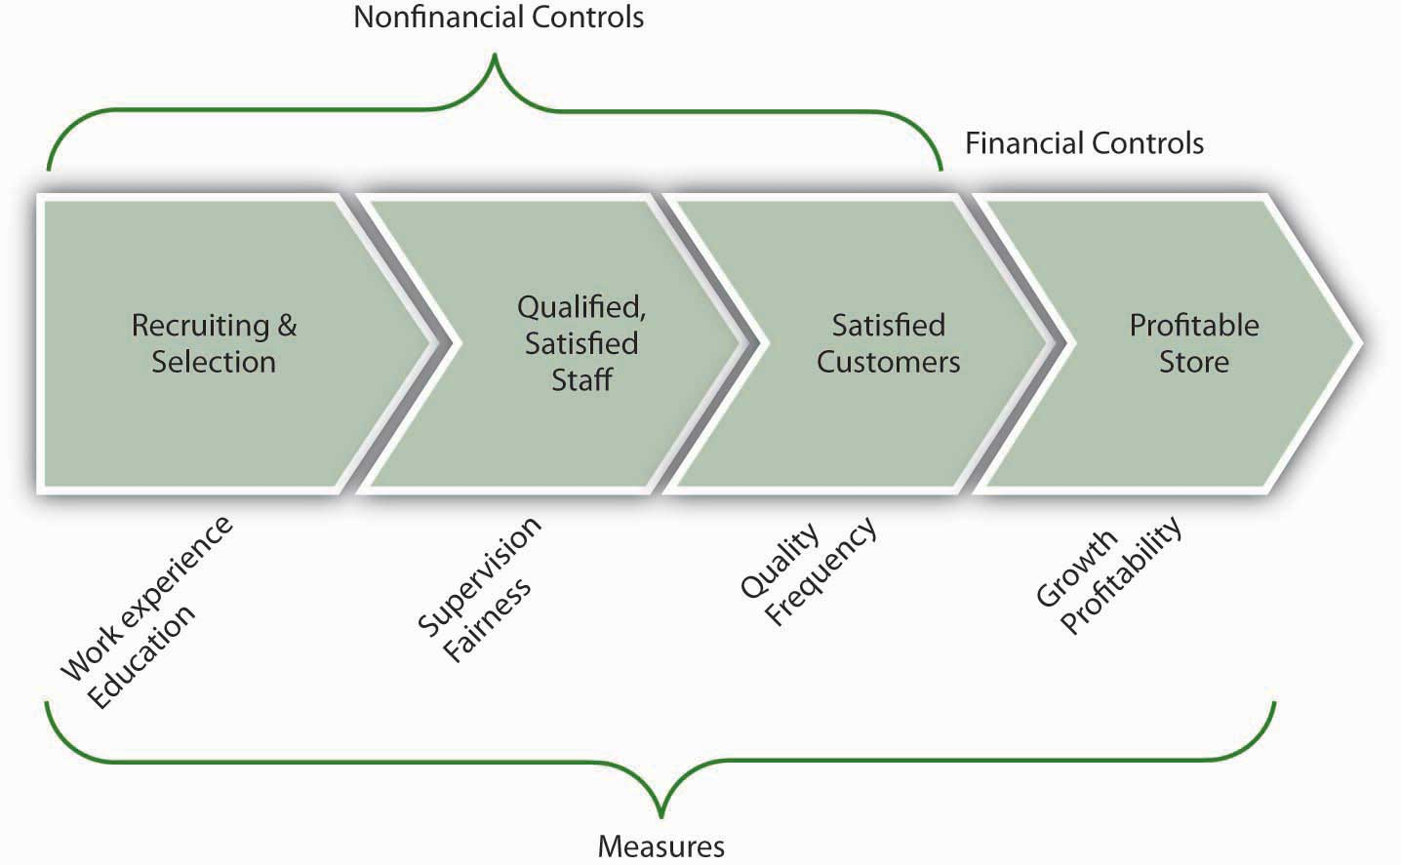

Tie the Controls to the Strategy
Be sure to confirm that whichever nonfinancial controls are in place, they reflect and reinforce the unique strategy of the organization. This also should remind you that, if the strategy ever changes, you should go back and revalidate the links between the nonfinancial controls and the strategy. For instance, in our retail store example, part of the strategy is to sell unique products, which means that employees with particular work experience and education may provide better customer service than inexperienced employees. If the store changed its strategy to sell more generic products, however, it might not need such experienced or educated employees anymore.

Validate the Links Between Nonfinancial and Financial Controls
As you recall, organizations often use more than one nonfinancial control with the assumption that they cascade down to bottom-line financial performance. Of course, when there are fewer nonfinancial controls, it is easier to detect relationships among them. Regardless, with information collected about the controls, management must seek to use simple statistical techniques to verify the causal relationship between one control and another, and eventually financial performance. For instance, if nonfinancial controls were functioning as assumed, you might find that when employees are more satisfied, customers are more satisfied, and when both are more satisfied, more higher-profit-margin products are sold. If such relationships can’t be proved, then managers must revisit their choice of nonfinancial controls.

Set Appropriate Performance Targets
Extending the prior example, you would want to be sure that you set employee and customer satisfaction control targets appropriately. Assuming that you validated the linkages, while it might be nice to reach 100% satisfaction levels across employees and customers, it might not be cost-effective. This does not mean that you abandon the use of such controls; instead you must determine whether 90% satisfaction (or some other number) still leads to greater product sales.

Validate the Performance Measures
Finally, make sure that what you ultimately measure fits well with the control objectives. For instance, with our retail store example, would you measure work experience by the number of years that an applicant has worked? Or would you want experience with a particular type of product or service? Similarly, with regard to education, you would want to make a choice as to measuring grade-point average, standardized test score, or major. As a reminder, this type of validation is relevant to nonfinancial and financial measures alike. For instance, if our hypothetical store’s sales are growing, but profitability is going down, then we would want to figure out why these financial controls aren’t painting the same picture. For example, it might be that we’ve hired more salespeople, who help us sell more, but that we are not selling enough to cover the additional costs of the added people’s salaries. These examples should help you see the point about using the right measure.

KEY TAKEAWAY
Nonfinancial controls, such as those related to employee satisfaction, customer service, and so on, are an important and increasingly applied form of organizational control. While firms that use nonfinancial controls well also perform much better than firms that don’t use them, there is a plethora of managerial mistakes made with regard to their conceptualization, implementation, or both. Beyond simply using nonfinancial controls, best practices around such controls include aligning them with the strategy, validating the links between nonfinancial controls and financial controls, setting appropriate control performance targets, and confirming the right measure of the desired control.

EXERCISES
- What are nonfinancial controls? Name some examples.
- What should be the relationship between nonfinancial and financial controls?
- What are some common mistakes made by managers with regard to nonfinancial controls?
- What are some solutions to the common mistakes you identified?

15.6 Lean Control

LEARNING OBJECTIVES
- Know what is meant by lean controls, and why the subject can be confusing.
- Understand the application of lean.
- Know the five core principals of lean.
Lean control, or simply lean, has become an immensely popular business control and improvement methodology in recent years. Lean control is a highly refined example of nonfinancial controls in action.Lean is a system of nonfinancial controls used to improve product and service quality and decrease waste. Research suggests that up to 70% of manufacturing firms are using some form of lean in their business operations.PrintPlanet launches lean manufacturing forum. (2008, August 11).
- Retrieved January 30, 2009, from http://members.whattheythink.com/home/wttnews080811.cfm
Lean was initially focused on improving manufacturing operations but is now used to improve product development, order processing, and a variety of other nonmanufacturing processes (sometimes called “lean in the office”).

What Is Meant by Lean Control?
Lean’s popularity has both resulted from, and been driven by, an explosion in the volume of lean-related educational resources. Amazon offers almost 1,800 books and other materials about lean, and Yahoo! hosts over 90 online discussion groups relating to lean. Colleges and universities, industry trade associations, and private consulting firms routinely offer courses, seminars, and conferences to explain what lean is and how to use it.
Lean control is a number of things. According to James Womack, “it is a process for measuring and reducing inventory and streamlining production. It is a means for changing the way a company measures plant performance. It is a knowledge-based system. It takes years of hard work, preparation and support from upper management. Lean is so named because it purports to use much less of certain resources (space, inventory, workers, etc.) than is used by normal mass-production systems to produce comparable output.” The term came into widespread use with the 1990 publication of the book The Machine That Changed the World, by James P. Womack, Daniel T. Jones, and Daniel Roos.
- Womack, J. P., Jones, D. T., & Roos, D. (1990). The machine that changed the world. New York: Rawson Associates, 1990
This abundance of education resources on the topic of lean is actually a mixed blessing for managers who are just now becoming interested in lean. On the one hand, today’s managers don’t have to search far to find lean materials or programs. But the wealth of lean resources can also be a source of confusion for two main reasons. First, there is no universal definition of lean and little agreement about what the truly core principles of lean are. For instance, quality programs such as Six-Sigma, or even lean Six Sigma, are other titles competing for the “lean” intellectual space. Therefore, lean experts often approach the subject from differing perspectives and describe lean in different ways. To make matters worse, lean is a topic that produces a significant amount of zealotry. So, many experts strongly argue that their particular “brand” of lean is the one right way to implement and use lean. In these circumstances, it’s no wonder that managers become confused about where and how to begin.

Lean Applications
Lean will always be associated with Toyota Motor Corporation because most lean tools and techniques were developed by Toyota in Japan beginning in the 1950s. After World War II, Toyota’s leaders were determined to make the company a full-range car and truck manufacturing enterprise, but they faced several serious challenges. The Japanese motor vehicle market was small and yet demanded a fairly wide range of vehicle types. This meant that Toyota needed to find a way to earn a profit while manufacturing a variety of vehicles in low volumes. In addition, capital was extremely scarce, which made it impossible for Toyota to make large purchases of the latest production equipment. To succeed, or even survive, Toyota needed a way to build vehicles that would require fewer resources. To achieve this goal, Toyota’s leaders, principally Eiji Toyoda and Taiichi Ohno, began to create and implement the production techniques and tools that came to be known as lean.
- Retrieved January 30, 2009, from http://www.toyota.co.jp/en/history/index.html
To gain the most benefits from lean, managers must be able to determine what specific lean tools and techniques will be effective in their particular business. And to make that determination, they must clearly understand what lean is designed to accomplish (its primary objectives) and what core principles lean is based on. With this understanding, managers can decide which lean tools will work well in their business, which lean tools will need to be modified or adapted to work well, and which tools are simply not appropriate.
What, then, are the major objectives and core principles of lean? Despite the arguments and debates that often surround attempts to define and describe lean, it is clear that the ultimate objective of lean is the avoidance of muda, or wasteful activity, in all business operations. As shown in the following figure, muda comprises seven deadly wastes. In the lean world, waste means any activity or condition that consumes resources but creates no value for customers. Therefore, waste includes the production of defective products that must be remade or fixed, the production of more products than the market will buy, excessive work-in-process inventories, overprocessing (processing steps that aren’t really needed or that add no value), unnecessary movement of people or products, and unnecessary waiting by employees.

Elimination of Waste Is the Soul of Lean
Muda is a Japanese term for activity that is wasteful and doesn’t add value. It is also a key concept in lean control. Waste reduction is an effective way to increase profitability. Here are the seven deadly wastes, along with their definitions:
- Defects prevent the customer from accepting the product produced. The effort to create these defects is wasted. New waste management processes must be added in an effort to reclaim some value for the otherwise scrap product.
- Overproduction is the production or acquisition of items before they are actually required. It is the most dangerous waste of the company because it hides the production problems. Overproduction must be stored, managed, and protected.
- Transportation is a cost with no added value. In addition, each time a product is moved it stands the risk of being damaged, lost, and delayed. Transportation does not transform the product in any way that the consumer is willing to pay for.
- Waiting refers to both the time spent by the workers waiting for resources to arrive, the queue for their products to empty as well as the capital sunk in goods and services that are not yet delivered to the customer. It is often the case that there are processes to manage this waiting.
- Inventory in the form of raw materials, work-in-progress, or finished goods represents a capital outlay that has not yet produced an income either by the producer or for the consumer. Any of these three items not being actively processed to add value is waste.
- Motion refers to the actions performed by the producer, worker, or equipment. Motion has significance to damage, wear, and safety. It also includes the fixed assets and expenses incurred in the production process.
- Overprocessing is defined as using a more expensive or otherwise valuable resource than is needed for the task or adding features that are designed for but unneeded by the customer. There is a particular problem with this item regarding people. People may need to perform tasks that they are overqualified for to maintain their competency. This training cost can be used to offset the waste associated with overprocessing.

The Five Core Principles of Lean
Lean methodologies are lean because they enable a business to do more with less. A lean organization uses less human effort, less equipment, less facilities space, less time, and less capital—while always coming closer to meeting customers’ exact needs. Therefore, lean is not just another cost-cutting program of the kind we often see in business organizations. Lean is much more about the conservation of valuable resources than it is about cost cutting.
In their best-selling book, Lean Thinking, James Womack and Daniel Jones identified five core principles of lean.
- Womack, J. P., & Jones, D. T. (2003). Lean thinking. New York: Simon & Schuster
Let’s examine them one by one.

Define Value from the Customer’s Perspective
The first core principle in the Womack/Jones lean framework is that value must be defined and specified from the customer’s perspective. While this seems simple enough, it requires much more than high-sounding, generic statements. To be meaningful, value must be defined in terms of specific products. This means that managers must understand how each specific product meets the needs of specific customers at a specific price and at a specific time.

Describe the Value Stream for Each Product or Service
The second core principle of lean is to describe the value stream for each product or service (or, in some cases, for groups or families of similar products). The value stream is the set of activities that the business is performing to bring a finished product to a customer. It includes both direct manufacturing activities and indirect activities such as order processing, purchasing, and materials management. Developing a detailed description or map of each value stream usually reveals huge amounts of waste. It enables managers to identify which value stream activities add value to the product, which activities add no value but cannot be immediately eliminated for various reasons, and which activities create no value and can be immediately eliminated (or at least reduced substantially).

Create Flow in Each Value Stream
The third essential principle of lean is embodied in the word flow. When a value stream has been completely described as unnecessary, non-value-adding activities have been eliminated, the basic idea of flow is to arrange the remaining activities sequentially, so that products will move smoothly and continuously from one activity to the next. However, flow means more than ease of movement. Flow is the lean principle that directly challenges the traditional “batch-and-queue” model of manufacturing, where people and equipment are organized and located by function, and products (and component parts) are manufactured in large batches. Lean organizations strive to improve flow by reducing the size of production batches, and in the process, they increase flexibility and lower costs.

Produce at the Pace (Pull) of Actual Customer Demand
Producing at the pace or pull of actual customer demand is the fourth key principle of lean. One of the greatest benefits of moving from traditional batch-and-queue manufacturing to continuous flow production is that lead times fall dramatically. Reduced lead times and increased flexibility mean that lean organizations can respond to actual customer demand rather than attempt to predict in advance what that level of demand will be. This allows lean organizations to substantially lower both finished goods and work-in-process inventories.

Strive to Continuously Improve All Business Operations
The fifth core principle of lean is continuous improvement, expressed in Japanese by the word kaizen. Companies that implement lean adopt the mind-set that it is always possible to improve any business activity, and they regularly conduct kaizen events throughout their organizations to improve specific processes or operations. Today, Toyota is recognized as one of the most “lean” business enterprises in the world. Even more daunting, and humbling, is the fact that Toyota is still striving to improve.

KEY TAKEAWAY
Lean control, or simply lean, is the system of nonfinancial controls used to improve product and service quality and decrease waste. While popularized through the dramatic successes of Toyota in auto manufacturing, lean processes are used to improve quality and decrease waste in most service and manufacturing industries around the world. In this section, you saw examples of the seven deadly wastes (muda) and the five core principles of lean which culminate in continuous improvement, or kaizen.

EXERCISES
- What is lean control?
- What types of industries might find lean controls valuable?
- What does muda mean and what are some examples of it?
- What are the five lean principles?
- Pick a company you are familiar with—what would it need to do differently to comply with the five lean principles?

15.7 Crafting Your Balanced Scorecard

LEARNING OBJECTIVES
- Understand the Balanced Scorecard concept.
- See how the Balanced Scorecard integrates nonfinancial and financial controls.
- Be able to outline a personal Balanced Scorecard.

An Introduction to the Balanced Scorecard
You have probably learned a bit about Balanced Scorecards already from this book or other sources. The Balanced Scorecard was originally introduced to integrate financial and nonfinancial controls in a way that provided a balanced understanding of the determinants of firm performance. It has since evolved into a strategic performance management tool of sorts because it helps managers identify and understand the way that operating controls are tied to strategic controls, and ultimately, firm performance. In this broader sense, a Balanced Scorecard is a control system that translates an organization’s vision, mission, and strategy into specific, quantifiable goals and to monitor the organization’s performance in terms of achieving these goals.
According to Robert S. Kaplan and David P. Norton, the Balanced Scorecard approach “examines performance in four areas. Financial analysis, the most traditionally used performance indicator, includes assessments of measures such as operating costs and return-on-investment. Customer analysis looks at customer satisfaction and retention. Internal analysis looks at production and innovation, measuring performance in terms of maximizing profit from current products and following indicators for future productivity. Finally, learning and growth analysis explores the effectiveness of management in terms of measures of employee satisfaction and retention and information system performance.”
- Kaplan, R., & Norton, D. (2001). The strategy-focused organization. Boston: Harvard Business School Press
Whereas the scorecard identifies financial and nonfinancial areas of performance, the second step in the scorecard process is the development of a strategy map. The idea is to identify key performance areas in learning and growth and show how these cascade forward into the internal, customer, and financial performance areas. Typically, this is an iterative process where managers test relationships among the different areas of performance. If the organization is a for-profit business like IBM, then managers would want to be able to show how and why the choice made in each area ultimately led to high profitability and stock prices.

Figure 15.11 The Balanced Scorecard Hierarchy
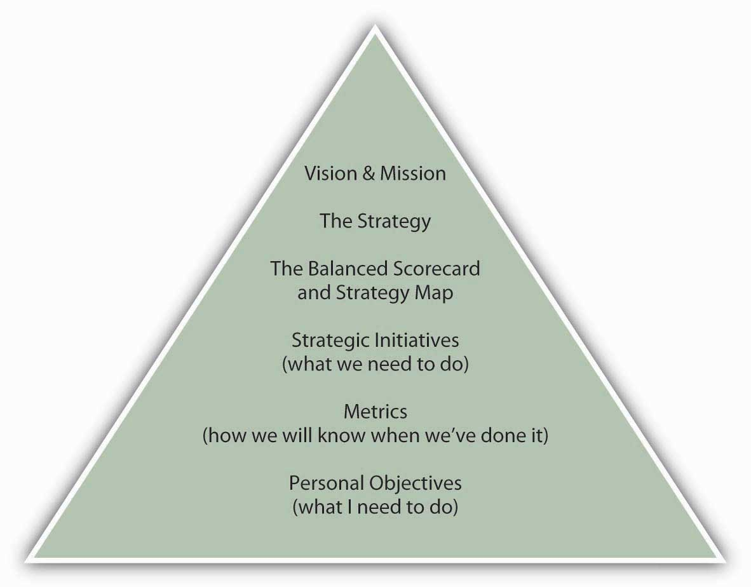
With the scorecard and strategy map in hand, managers then break broad goals down successively into vision, strategies, strategic initiatives, and metrics. As an example, imagine that an organization has a goal of maintaining employee satisfaction in its vision and mission statements. This would be the organization’s vision in the domain of learning and growth, since employee satisfaction is indirectly related to financial performance. Strategies for achieving that learning and growth vision might include approaches such as increasing employee-management communication. Initiatives undertaken to implement the strategy could include, for example, regularly scheduled meetings with employees. Metrics could include quantifications of employee suggestions or employee surveys. Finally, managers would want to test their assumptions about the relationship between employee satisfaction and the downstream areas such as internal, customer, and financial performance. For example, satisfied employees may be more productive and less likely to quit (internal), which leads to better products or services and customer relations (customer), which leads to lower employee recruiting and training costs and greater sales and repeat sales (financial). This sequence of causal relationships is summarized in the following figure.

Figure 15.12 The Strategy Map: A Causal Relationship between Nonfinancial and Financial Controls
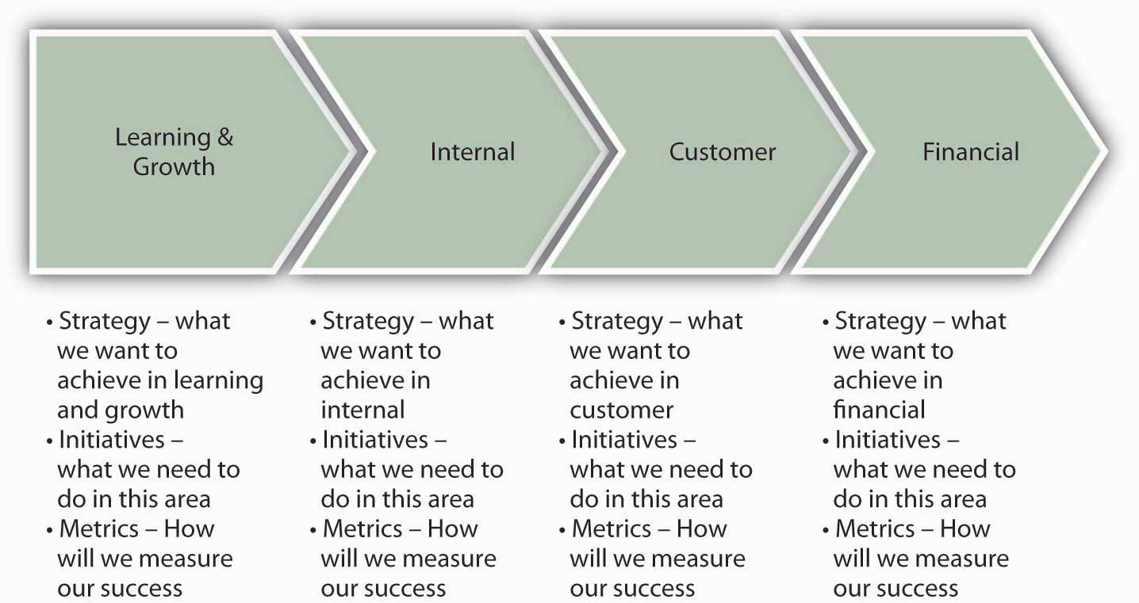

Your Personal Balanced Scorecard
Now that you have an understanding of nonfinancial and financial controls, and specific cases such as lean control systems and the Balanced Scorecard, it’s time to apply the notion of the Balanced Scorecard to your personal situation. Recall that the figure shows your position in the context of the Balanced Scorecard—it asks you to state your personal objectives, in the context of the organization’s objectives. However, in developing your own Balanced Scorecard, you will be laying out a road map to achieve your personal and professional objectives (or mission and vision more broadly), which may overlap a lot or very little with the organization’s objectives. While you can choose to focus the scorecard more narrowly on something like your career, you will be much better served by the personal Balanced Scorecard if you pursue a holistic (personal + professional) approach. For example, you may have particular personal goals about financial independence, and this would relate to other choices you might want to make about your personal and professional priorities.
Social psychologist Hubert Rampersad has sought to translate the business Balanced Scorecard into a personal balanced score by providing you with the following four suggestions.
- Learning and growth: your skills and learning ability. How do you learn, and how can you be successful in the future? For example, the course that you are taking in conjunction with this book may lead to a degree, be a prerequisite for other courses, and so on.
- Internal: your physical health and mental state. How can you control these to create value for yourself and others? How can you remain feeling good at work as well as in your spare time? For instance, your objectives and activities related to physical and emotional fitness.
- Customer (external): relations with your spouse, children, friends, employer, colleagues, and others. How do they see you?
- Financial: financial stability. To what degree are you able to fulfill your financial needs? Again, do you seek financial independence, resources to fund other endeavors?
- Rampersad, H. K. (2006).The personal Balanced Scorecard: The way to individual happiness, personal integrity, and organizational effectiveness. Greenwich, CT: Information Age
The best way to put these suggestions into action is to work on the scorecard in several sessions, as there is a wide range of factors to consider. Your objective for the first session should be to develop your personal vision statement and list several areas of development in learning, internal, customer, and financial facets of the scorecard. You should be able to fit the scorecard on a single page, for easy and frequent reference. You can use your next session with the scorecard to refine your developmental objectives and set relevant measures and near-term objectives. Post the scorecard where you can refer to it often. And, just as with organizations, if your circumstances change, then that is the critical time to revalidate or revise your personal Balanced Scorecard.

KEY TAKEAWAY
You learned about the essential components of the Balanced Scorecard and saw how, when correctly conceived and implemented, it integrates an organization’s vision, mission, and strategy with its nonfinancial and financial controls. As with correctly implemented nonfinancial controls, the components of the Balanced Scorecard need to be clearly tied to the strategy, and relationships among nonfinancial and financial controls validated. Appropriate control performance targets need to be set, and the appropriate indicators of performance used to gauge nonfinancial and financial performance. This section concluded by outlining for you the steps you might follow in building a personal Balanced Scorecard.

EXERCISES
- What is a Balanced Scorecard? What is the difference between a Balanced Scorecard and a simple list of nonfinancial and financial controls?
- What roles do vision, mission, and strategy play in the development of a Balanced Scorecard?
- What might be some of the differences between an organization’s Balanced Scorecard and your personal Balanced Scorecard? What might be some of the similarities?
- Under what circumstances should an organization’s or an individual’s Balanced Scorecard be revised?

Chapter 16

Strategic Human Resource Management

WHAT’S IN IT FOR ME?
Reading this chapter will help you do the following:
- Understand the scope and changing role of strategic human resource management (SHRM) in principles of management.
- Visualize the battlefield in the war for talent.
- Engage in effective selection and placement strategies.
- Understand the roles of pay structure and pay for performance.
- Design a high-performance work system.
- Use the human resources Balanced Scorecard to gauge and proactively manage human capital, including your own.
You have probably heard the saying, people make the place. In today’s fast-changing environment, organizations need employees who understand the organization’s strategy and are empowered to execute it. To achieve this, organizations need to follow a strategic human resource management (SHRM) approach. SHRM ensures that people are a key factor in a firm’s competitive advantage. Thus, as summarized in the following figure, SHRM is an integral part of the control portion of the planning-organizing-leading-controlling (P-O-L-C) framework.

Figure 16.2 The P-O-L-C Framework
Organizations need human resources (HR) to be a partner in identifying, attracting, and hiring the type of employees who will be most qualified to help the company achieve its goals. SHRM requires attracting the right employees to the company, identifying metrics to help employees stay on target to meet the company’s goals, and rewarding them appropriately for their efforts so that they stay engaged and motivated. Having all these components in place—designing a high-performance work system—improves organizational performance and unleashes employee talent.

16.1 Case in Point: Kronos Uses Science to Find the Ideal Employee

Figure 16.4
Source: Kensavage/Wikimedia Commons.
You are interviewing a candidate for a position as a cashier in a supermarket. You need someone polite, courteous, patient, and dependable. The candidate you are talking to seems nice. But how do you know who is the right person for the job? Will the job candidate like the job or get bored? Will they have a lot of accidents on the job or be fired for misconduct? Don’t you wish you knew before hiring? One company approaches this problem scientifically, saving companies time and money on hiring hourly wage employees.
Retail employers do a lot of hiring, given their growth and high turnover rate. According to one estimate, replacing an employee who leaves in retail costs companies around $4,000. High turnover also endangers customer service. Therefore, retail employers have an incentive to screen people carefully so that they hire people with the best chance of being successful and happy on the job. Unicru, an employee selection company, developed software that quickly became a market leader in screening hourly workers. The company was acquired by Massachusetts-based Kronos Inc. (NASDAQ: KRON) in 2006 and is currently owned by a private equity firm.
The idea behind the software is simple: If you have a lot of employees and keep track of your data over time, you have access to an enormous resource. By analyzing this data, you can specify the profile of the “ideal” employee. The software captures the profile of the potential high performers, and applicants are screened to assess their fit with this particular profile. More important, the profile is continually updated as studies that compare employee profiles to job performance are conducted. As the number of studies gets larger, the software does a better job of identifying the right people for the job.
If you applied for a job in retail, you may have already been a part of this database: the users of this system include giants such as Universal Studios, Costco Wholesale Corporation, Burger King, and other retailers and chain restaurants. In companies such as Albertsons or Blockbuster, applicants can either use a kiosk in the store to answer a list of questions and to enter their background, salary history, and other information or apply online from their home computers. The software screens people on basic criteria such as availability in scheduling as well as personality traits.
Candidates are asked to agree or disagree with statements such as “I often make last-minute plans” or “I work best when I am on a team.” Additionally, questions about how an applicant would react in specific job-related situations and about person-job fit are included. After the candidates complete the questions, hiring managers are sent a report complete with a color-coded suggested course of action. Red means the candidate does not fit the job, yellow indicates the hiring manager should proceed with caution, and green means the candidate is likely a good fit. Because of the use of different question formats and complex scoring methods, the company contends that faking answers to the questions of the software is not easy because it is difficult for candidates to predict the desired profile.
Matching candidates to jobs has long been viewed as a key way of ensuring high performance and low turnover in the workplace, and advances in computer technology are making it easier and more efficient to assess candidate–job fit. Companies using such technology are cutting down the time it takes to hire people, and it is estimated that using such technologies lowers their turnover by 10%–30%.
Primary Resource:
Secondary Resources:
- Based on information from Berta, D. (2002, February 25). Industry increases applicant screening amid labor surplus, security concerns. Nation’s Restaurant News, 36(8), 4
- Frauenheim, E. (2006, March 13). Unicru beefs up data in latest screening tool. Workforce Management, 85(5), 9–10
- Frazier, M. (2005, April). Help wanted. Chain Store Age, 81(4), 37–39
- Haaland, D. E. (2006, April 17). Safety first: Hire conscientious employees to cut down on costly workplace accidents. Nation’s Restaurant News, 40(16), 22–24
- Overholt, A. (2002, February). True or false? You’re hiring the right people. Fast Company, 55, 108–109
- Rafter, M. V. (2005, May). Unicru breaks through in the science of “smart hiring.” Workforce Management, 84(5), 76–78

DISCUSSION QUESTIONS
- Strategic human resource management (SHRM) is included in your P-O-L-C framework as an essential element of control. Based on what you have learned about Kronos, how might SHRM be related to the planning, organizing, and leading facets of the P-O-L-C framework?
- What can a company do in addition to using techniques like these to determine whether a person is a good candidate for a job?
- What are potential complicating factors in using personality testing for employee selection?
- Why do you think that retail companies are particularly prone to high turnover rates?
- What steps do you take as a job seeker to ensure that an organization is a good fit for you?

16.2 The Changing Role of Strategic Human Resource Management in Principles of Management

LEARNING OBJECTIVES
- Understand how HR is becoming a strategic partner.
- Understand the importance of an organization’s human capital.
- List the key elements of SHRM.
- Explain the importance of focusing on outcomes.
The role of HR is changing. Previously considered a support function, HR is now becoming a strategic partner in helping a company achieve its goals. A strategic approach to HR means going beyond the administrative tasks like payroll processing. Instead, managers need to think more broadly and deeply about how employees will contribute to the company’s success.

HR as a Strategic Partner
Strategic human resource management (SHRM) is not just a function of the HR department—all managers and executives need to be involved because the role of people is so vital to a company’s competitive advantage.
- Becker, B. E., & Huselid, M. A. (2006). Strategic human resources management: Where do we go from here? Journal of Management, 32(6): 898–925
In addition, organizations that value their employees are more profitable than those that do not.
- Huselid, M. A. (1995). The impact of human resource management practices on turnover, productivity, and corporate financial performance.Academy of Management Journal, 38, 635–672
- Pfeffer, J. (1998). The human equation: Building profits by putting people first. Boston: Harvard Business School Press
- Pfeffer, J., & Veiga, J. F. (1999). Putting people first for organizational success. Academy of Management Executive, 13, 37–48
- Welbourne, T., & Andrews, A. (1996). Predicting performance of initial public offering firms: Should HRM be in the equation? Academy of Management Journal, 39, 910–911
Research shows that successful organizations have several things in common, such as providing employment security, engaging in selective hiring, using self-managed teams, being decentralized, paying well, training employees, reducing status differences, and sharing information.
- Pfeffer, J., & Veiga, J. F. 1999. Putting people first for organizational success. Academy of Management Executive, 13, 37–48
When organizations enable, develop, and motivate human capital, they improve accounting profits as well as shareholder value in the process.
- Brian E., Becker, B. E., Huselid, M. A., & Ulrich, D. (2002). Six key principles for measuring human capital performance in your organization. University of Maryland Working Paper
The most successful organizations manage HR as a strategic asset and measure HR performance in terms of its strategic impact.
Here are some questions that HR should be prepared to answer in this new world.
- Competence: To what extent does our company have the required knowledge, skills, and abilities to implement its strategy?
- Consequence: To what extent does our company have the right measures, rewards, and incentives in place to align people’s efforts with the company strategy?
- Governance: To what extent does our company have the right structures, communications systems and policies to create a high-performing organization?
- Learning and Leadership: To what extent can our company respond to uncertainty and learn and adapt to change quickly?
- Ulrich, D. (1998).Delivering results. Boston: Harvard Business School Press

The Importance of Human Capital
Employees provide an organization’s human capital. Your human capital is the set of skills that you have acquired on the job, through training and experience, and which increase your value in the marketplace. The Society of Human Resource Management’s Research Quarterly defined an organization’s human capital as follows: “A company’s human capital asset is the collective sum of the attributes, life experience, knowledge, inventiveness, energy and enthusiasm that its people choose to invest in their work.”
- Weatherly, L. (2003, March). Human capital—the elusive asset; measuring and managing human capital: A strategic imperative for HR. Research Quarterly, Society for Human Resource Management. Retrieved June 1, 2003, from http://www.shrm.org/research/quarterly/0301capital.pdf

Focus on Outcomes
Unfortunately, many HR managers are more effective in the technical or operational aspects of HR than they are in the strategic, even though the strategic aspects have a much larger effect on the company’s success.
- Huselid, M. A., Jackson, S. E., & Schuler, R. S. (1997). Technical and strategic human resource management effectiveness as determinants of firm performance. Academy of Management Journal,40(1), 171–188
In the past, HR professionals focused on compliance to rules, such as those set by the federal government, and they tracked simple metrics like the number of employees hired or the number of hours of training delivered. The new principles of management, however, require a focus on outcomes and results, not just numbers and compliance. Just as lawyers count how many cases they’ve won—not just how many words they used—so, too must HR professionals track how employees are using the skills they’ve learned to attain goals, not just how many hours they’ve spent in training.
- Ulrich, D. (1998.) Delivering results. Boston: Harvard Business School Press
John Murabito, executive vice president and head of HR and Services at Cigna, says that HR executives need to understand the company’s goals and strategy and then provide employees with the skills needed. Too often, HR execs get wrapped up in their own initiatives without understanding how their role contributes to the business. That is dangerous, because when it comes to the HR department, “anything that is administrative or transactional is going to get outsourced,” Murabito says.
- Marquez, J. (2007, September 10). On the front line: A quintet of 2006’s highest-paid HR leaders discuss how they are confronting myriad talent management challenges as well as obstacles to being viewed by their organizations as strategic business partners. Workforce Management, 86(5), 22
Indeed, the number of HR outsourcing contracts over $25 million has been increasing, with 2,708 active contracts under way in 2007.
- TPI Counts 2700+ Outsourcing Contracts. (2007, December). Retrieved January 30, 2009, fromhttp://www.sharedxpertise.org/file/230/trends--research.html
For example, the Bank of America outsourced its HR administration to Arinso. Arinso will provide timekeeping, payroll processing, and payroll services for 10,000 Bank of America employees outside the U.S.
- HRO Europe, August 23, 2006. Retrieved January 30, 2009, from http://www.hroeurope.com
To avoid outsourcing, HR needs to stay relevant and accept accountability for its business results. In short, the people strategy needs to be fully aligned with the company’s business strategy and keep the focus on outcomes.

Key Elements of HR
Beyond the basic need for compliance with HR rules and regulations, the four key elements of HR are summarized in the following figure. In high-performing companies, each element of the HR system is designed to reflect best practice and to maximize employee performance. The different parts of the HR system are strongly aligned with company goals.

Figure 16.5 Key HR Elements
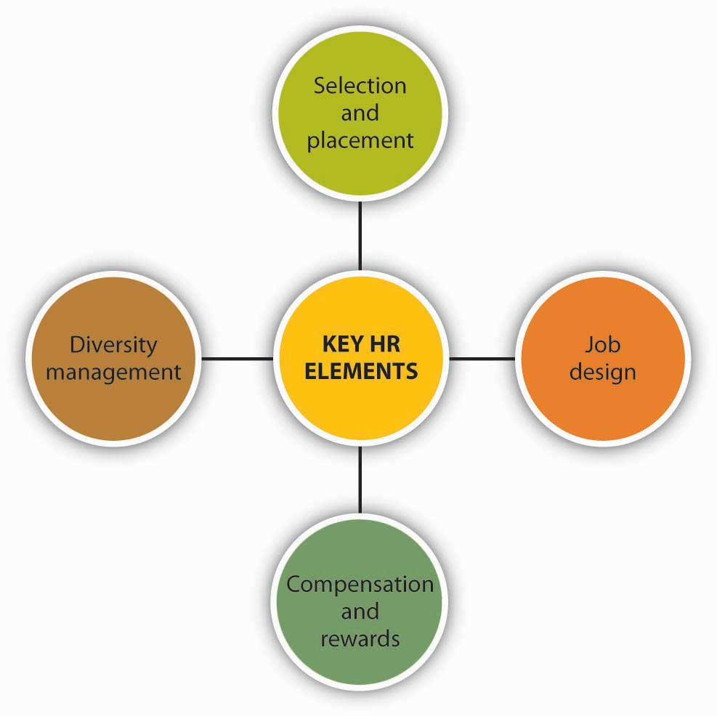

Selection and Placement
When hiring, acquaint prospective new hires with the nature of the jobs they will be expected to fulfill. This includes explaining the technical competencies needed (for example, collecting statistical data) and defining behavioral competencies. Behavioral competencies may have a customer focus, such as the ability to show empathy and support of customers’ feelings and points of view, or a work management focus, such as the ability to complete tasks efficiently or to know when to seek guidance.
In addition, make the organization’s culture clear by discussing the values that underpin the organization—describe your organization’s “heroes.” For example, are the heroes of your company the people who go the extra mile to get customers to smile? Are they the people who toil through the night to develop new code? Are they the ones who can network and reach a company president to make the sale? By sharing such stories of company heroes with your potential hires, you’ll help reinforce what makes your company unique. This, in turn, will help the job candidates determine whether they’ll fit into your organization’s culture.

Job Design
Design jobs that involve doing a whole piece of work and are challenging but doable. Job design refers to the process of putting together various elements to form a job, bearing in mind organizational and individual worker requirements, as well as considerations of health, safety, and ergonomics. Train employees to have the knowledge and skills to perform all parts of their job and give them the authority and accountability to do so.
- Lawler, E. (1992). The ultimate advantage. San Francisco: Jossey-Bass. Job enrichment is important for retaining your employees
One company that does training right is Motorola. As a global company, Motorola operates in many countries, including China. Operating in China presents particular challenges in terms of finding and hiring skilled employees. In a recent survey conducted by the American Chamber of Commerce in Shanghai, 37% of U.S.-owned enterprises operating in China said that recruiting skilled employees was their biggest operational problem.
- Lane K., & Pollner, F. (2008, August 15). How to address China’s growing talent shortage. McKinsey Quarterly, 17–25
Indeed, more companies cited HR as a problem than cited regulatory concerns, bureaucracy, or infringement on intellectual property rights. The reason is that Chinese universities do not turn out candidates with the skills that multinational companies need. As a result, Motorola has created its own training and development programs to bridge the gap. For example, Motorola’s China Accelerated Management Program is designed for local managers. Another program, Motorola’s Management Foundation program, helps train managers in areas such as communication and problem solving. Finally, Motorola offers a high-tech MBA program in partnership with Arizona State University and Tsinghua University so that top employees can earn an MBA in-house.
- Lane K., & Pollner, F. (2008, August 15). How to address China’s growing talent shortage. McKinsey Quarterly, 36–41
Such programs are tailor-made to the low-skilled but highly motivated Chinese employees.

Compensation and Rewards
Evaluate and pay people based on their performance, not simply for showing up on the job. Offer rewards for skill development and organizational performance, emphasizing teamwork, collaboration, and responsibility for performance. Help employees identify new skills to develop so that they can advance and achieve higher pay and rewards. Compensation systems that include incentives, gainsharing, profit-sharing, and skill-based pay reward employees who learn new skills and put those skills to work for the organization. Employees who are trained in a broad range of skills and problem solving are more likely to grow on the job and feel more satisfaction. Their training enables them to make more valuable contributions to the company, which, in turn, gains them higher rewards and greater commitment to the company.
- Barnes, W. F. (2001). The challenge of implementing and sustaining high performance work systems in the United States: An evolutionary analysis of I/N Tek and Kote. PhD dissertation, University of Notre Dame
The company likewise benefits from employees’ increased flexibility, productivity, and commitment.
When employees have access to information and the authority to act on that information, they’re more involved in their jobs and more likely to make the right decision and take the necessary actions to further the organization’s goals. Similarly, rewards need to be linked to performance, so that employees are naturally inclined to pursue outcomes that will gain them rewards and further the organization’s success at the same time.

Diversity Management
Another key to successful SHRM in today’s business environment is embracing diversity. In past decades, “diversity” meant avoiding discrimination against women and minorities in hiring. Today, diversity goes far beyond this limited definition; diversity management involves actively appreciating and using the differing perspectives and ideas that individuals bring to the workplace. Diversity is an invaluable contributor to innovation and problem-solving success. As James Surowiecki shows in The Wisdom of Crowds, the more diverse the group in terms of expertise, gender, age, and background, the more ability the group has to avoid the problems of groupthink.
- Surowiecki. J. (2005). The wisdom of crowds. New York: Anchor Books
Diversity helps company teams to come up with more creative and effective solutions. Teams whose members have complementary skills are often more successful because members can see one another’s blind spots. Members will be more inclined to make different kinds of mistakes, which means that they’ll be able to catch and correct those mistakes.

KEY TAKEAWAY
Human resources management is becoming increasingly important in organizations because today’s knowledge economy requires employees to contribute ideas and be engaged in executing the company’s strategy. HR is thus becoming a strategic partner by identifying the skills that employees need and then providing employees with the training and structures needed to develop and deploy those competencies. All the elements of HR—selection, placement, job design, and compensation—need to be aligned with the company’s strategy so that the right employees are hired for the right jobs and rewarded properly for their contributions to furthering the company’s goals.

EXERCISES
- What are the advantages of the new SHRM approach?
- Name three elements of HR.
- What must HR do to be a true strategic partner of the company?
- What benefits does a diverse workforce provide the company?
- If you were an HR manager, what steps would you take to minimize the outsourcing of jobs in your department?

16.3 The War for Talent

LEARNING OBJECTIVES
- Define talent management.
- Attract the right workers to your organization.
- Understand how to keep your stars.
- Understand the benefits of good talent management.
You have likely heard the term, the war for talent, which reflects competition among organizations to attract and retain the most able employees. Agencies that track demographic trends have been warning for years that the U.S. workforce will shrink in the second and third decades of the 21st century as the baby boom generation (born 1945–1961) reaches retirement age. According to one source, there will be 11.5 million more jobs than workers in the United States by 2010.
- Extreme talent shortage makes competition fierce for key jobs and highlights needs for leadership development. (2007, November 26).Business Wire, 27
Even though many boomers say they want to (or have to) continue working past the traditional age of retirement, those who do retire or who leave decades-long careers to pursue “something I’ve always wanted to do” will leave employers scrambling to replace well-trained, experienced workers. As workers compete for the most desirable jobs, employers will have to compete even more fiercely to find the right talent.

What Talent Management Means
Peter Cappelli of the Wharton School Cappelli, defines talent management as anticipating the need for human capital and setting a plan to meet it. It goes hand in hand with succession planning, the process whereby an organization ensures that employees are recruited and developed to fill each key role within the company. Most companies, unfortunately, do not plan ahead for the talent they need, which means that they face shortages of critical skills at some times and surpluses at other times. Other companies use outdated methods of succession planning that don’t accurately forecast the skills they’ll need in the future.
- Peter Cappelli of the Wharton School Cappelli, P. (2008, March). Talent management for the 21st century, Boston. Harvard Business Review, 17–36
Interestingly, however, techniques that were developed to achieve productivity breakthroughs in manufacturing can be applied to talent management. For example, it is expensive to develop all talent internally; training people takes a long time and requires accurate predictions about which skill will be needed. Such predictions are increasingly difficult to make in our uncertain world. Therefore, rather than developing everyone internally, companies can hire from the outside when they need to tap specific skills. In manufacturing, this principle is known as “make or buy.” In HR, the solution is to make and buy; that is, to train some people and to hire others from the external marketplace. In this case, “making” an employee means hiring a person who doesn’t yet have all the needed skills to fulfill the role, but who can be trained (“made”) to develop them. The key to a successful “make” decision is to distinguish between the high-potential employees who don’t yet have the skills but who can learn them from the mediocre employees who merely lack the skills. The “buy” decision means hiring an employee who has all the necessary skills and experience to fulfill the role from day one. The “buy” decision is useful when it’s too difficult to predict exactly which skills will be needed in the future.
- Buhler, Patricia M. (2008, March). Managing in the new millennium; succession planning: Not just for the c suite. Supervision, 69(3), 19-23
Another principle from manufacturing that works well in talent management is to run smaller batch sizes. That is, rather than sending employees to 3-year-long training programs, send them to shorter programs more frequently. With this approach, managers don’t have to make the training decision so far in advance. They can wait to decide exactly which skills employees will learn closer to the time the skill is needed, thus ensuring that employees are trained on the skills they’ll actually use.

Attracting the Right Workers to the Organization
Winning the war for talent means more than simply attracting workers to your company. It means attracting the right workers—the ones who will be enthusiastic about their work. Enthusiasm for the job requires more than having a good attitude about receiving good pay and benefits—it means that an employee’s goals and aspirations also match those of the company. Therefore, it’s important to identify employees’ preferences and mutually assess how well they align with the company’s strategy. To do this, the organization must first be clear about the type of employee it wants. Companies already do this with customers: marketing executives identify specific segments of the universe of buyers to target for selling products. Red Bull, for example, targets college-age consumers, whereas SlimFast goes for adults of all ages who are overweight. Both companies are selling beverages but to completely different consumer segments. Similarly, companies need to develop a profile of the type of workers they want to attract. Do you want entrepreneurial types who seek autonomy and continual learning, or do you want team players who enjoy collaboration, stability, and structure? Neither employee type is inherently “better” than another, but an employee who craves autonomy may feel constrained within the very same structure in which a team player would thrive.
Earlier, we said that it was important to “mutually assess” how well employees’ preferences aligned with the company’s strategy. One-half of “mutual” refers to the company, but the other half refers to the job candidates. They also need to know whether they’ll fit well into the company. One way to help prospective hires make this determination is to describe to them the “signature experience” that sets your company apart. As Tamara Erickson and Lynda Gratton define it, your company’s signature experience is the distinctive practice that shows what it’s really like to work at your company.
- Erickson, T., & Gratton, L. (2007, March). What it means to work here. Harvard Business Review, 23–29
For example, here are the signature experiences of two companies, Whole Foods and Goldman Sachs: At Whole Foods, team-based hiring is a signature experience—employees in each department vote on whether a new employee will be retained after a 4-week trial period. This demonstrates to potential hires that Whole Foods is all about collaboration. In contrast, Goldman Sachs’s signature experience is multiple one-on-one interviews. The story often told to prospective hires is of the MBA student who went through 60 interviews before being hired. This story signals to new hires that they need to be comfortable meeting endless new people and building networks across the company. Those who enjoy meeting and being interviewed by so many diverse people are exactly the ones who will fit into Goldman’s culture.
The added benefit of hiring workers who match your organizational culture and are engaged in their work is that they will be less likely to leave your company just to get a higher salary.

Keeping Star Employees
The war for talent stems from the approaching shortage of workers. As we mentioned earlier in this chapter, the millions of baby boomers reaching retirement age are leaving a gaping hole in the U.S. workforce. What’s more, workers are job-hopping more frequently than in the past. According to the U.S. Bureau of Labor Statistics, the average job tenure has dropped from 15 years in 1980 to 4 years in 2007. As a manager, therefore, you need to give your employees reasons to stay with your company. One way to do that is to spend time talking with employees about their career goals. Listen to their likes and dislikes so that you can help them use the skills they like using or develop new ones they wish to acquire.
- Kaye, B. (2008). Love ’em or lose ’em. San Francisco: Barrett-Koehler
Don’t be afraid to “grow” your employees. Some managers want to keep their employees in their department. They fear that helping employees grow on the job will mean that employees will outgrow their job and leave it.
- Field, A. (2008, June). Do your stars see a reason to stay? Harvard Management Update
But, keeping your employees down is a sure way to lose them. What’s more, if you help your employees advance, it’ll be easier for you to move up because your employees will be better able to take on the role you leave behind.
In some cases, your employees may not be sure what career path they want. As a manager, you can help them identify their goals by asking questions such as:
- What assignments have you found most engaging?
- Which of your accomplishments in the last six months made you proudest?
- What makes for a great day at work?
- Butler, T. (2007). Getting unstuck. Boston: Harvard Business School Press

What Employees Want
Employees want to grow and develop, stretching their capabilities. They want projects that engage their heads as well as their hearts, and they want to connect with the people and things that will help them achieve their professional goals.
- Deloitte Research. (2007). It’s Do you know where your talent is? why acquisition and retention strategies don’t work. Geneva, Switzerland: Deloitte-Touch Research Report
Here are two ways to provide this to your employees: First, connect people with mentors and help them build their networks. Research suggests that successful managers dedicate 70% more time to networking activities and 10% more time to communication than their less successful counterparts.
- Luthans, F., Yodgetts, R., & Rosenkrantz, S. (1988). Real managers. Cambridge: Ballinger
What makes networks special? Through networks, people energize one another, learn, create, and find new opportunities for growth. Second, help connect people with a sense of purpose. Focusing on the need for purpose is especially important for younger workers, who rank meaningful work and challenging experiences at the top of their job search lists.
- Sheahan, P. (2006). Generation Y: Thriving (and surviving) with generation Y at work. Victoria, Australia: Hardie Grant Books

Benefits of Good Talent Management
Global consulting firm McKinsey & Company conducted a study to identify a possible link between a company’s financial performance and its success in managing talent. The survey results, reported in May 2008, show that there was indeed a relationship between a firm’s financial performance and its global talent management practices. Three talent management practices in particular correlated highly with exceptional financial performance:
- Creating globally consistent talent evaluation processes.
- Achieving cultural diversity in a global setting.
- Developing and managing global leaders.McKinsey global-talent-management survey of over 450 executives. (2007, December). Retrieved January 30, 2009, from http://www.mckinseyquarterly.com/article_print.aspx?L2=18&L3=31&ar=2140
The McKinsey survey found that companies achieving scores in the top third in any of these three areas had a 70% chance of achieving financial performance in the top third of all companies.
- Guthridge, M., & Komm, A. B. (1988, May). Why multinationals struggle to manage talent. McKinsey Quarterly, 19–25
Let’s take a closer look at what each of these three best practices entail. First, having consistent talent evaluation means that employees around the world are evaluated on the same standards. This is important because it means that if an employee from one country transfers to another, his or her manager can be assured that the employee has been held to the same level of skills and standards. Second, having cultural diversity means having employees who learn something about the culture of different countries, not just acquire language skills. This helps bring about open-mindedness across cultures. Finally, developing global leaders means rotating employees across different cultures and giving them international experience. Companies who do this best also have policies of giving managers incentives to share their employees with other units.

KEY TAKEAWAY
The coming shortage of workers makes it imperative for managers to find, hire, retain, and develop their employees. Managers first need to define the skills that the company will need for the future. Then, they can “make or buy”—that is, train or hire—employees with the needed skills. Retaining these employees requires engaging them on the job. Good talent management practices translate to improved financial performance for the company as a whole.

EXERCISES
- How might a manager go about identifying the skills that the company will need in the future?
- Describe the “make or buy” option and how it can be applied to HR.
- How would you go about attracting and recruiting talented workers to your organization? Suggest ideas you would use to retain stars and keep them happy working for you.
- What skills might an organization like a bank need from its employees?

16.4 Effective Selection and Placement Strategies

LEARNING OBJECTIVES
- Explain why a good job description benefits the employer and the applicant.
- Describe how company culture can be used in selecting new employees.
- Discuss the advantages and disadvantages of personnel testing.
- Describe some considerations in international staffing and placement
Selecting the right employees and placing them in the right positions within the company is a key HR function and is vital to a company’s success. Companies should devote as much care and attention to this “soft” issue as they do to financial planning because errors will have financial impact and adverse effects on a company’s strategy.

Job-Description Best Practices
Walt has a problem. He works as a manager in a medium-sized company and considers himself fortunate that the organizational chart allows him a full-time administrative assistant (AA). However, in the two years Walt has been in his job, five people have held this AA job. The most recent AA, who resigned after four weeks, told Walt that she had not known what the job would involve. “I don’t do numbers, I’m not an accountant,” she said. “If you want someone to add up figures and do calculations all day, you should say so in the job description. Besides, I didn’t realize how long and stressful my commute would be—the traffic between here and my house is murder!”
Taken aback, Walt contacted the company’s HR department to clarify the job description for the AA position. What he learned was that the description made available to applicants was, indeed, inadequate in a number of ways. Chances are that frequent turnover in this AA position is draining Walt’s company of resources that could be used for much more constructive purposes.
An accurate and complete job description is a powerful SHRM tool that costs little to produce and can save a bundle in reduced turnover. While the realistic description may discourage some applicants (for example, those who lack an affinity for calculations might not bother to apply for Walt’s AA position), those who follow through with the application process are much more likely to be satisfied with the job once hired. In addition to summarizing what the worker will actually be doing all day, here are some additional suggestions for writing an effective job description:
- List the job requirements in bullet form so that job seekers can scan the posting quickly.
- Use common industry terms, which speak to knowledgeable job seekers.
- Avoid organization-specific terms and acronyms, which would confuse job seekers.
- Use meaningful job titles (not the internal job codes of the organization).
- Use key words taken from the list of common search terms (to maximize the chance that a job posting appears on a job seeker’s search).
- Include information about the organization, such as a short summary and links to more detailed information.
- Highlight special intangibles and unusual benefits of the job and workplace (e.g., flextime, travel, etc.).
- Specify the job’s location (and nearest large city) and provide links to local community pages (to entice job seekers with quality-of-life information).

Tailoring Recruitment to Match Company Culture
Managers who hire well don’t just hire for skills or academic background; they ask about the potential employee’s philosophy on life or how the candidate likes to spend free time. These questions help the manager assess whether the cultural fit is right. A company in which all work is done in teams needs team players, not just “A” students. Ask questions like, “Do you have a personal mission statement? If not, what would it be if you wrote one today?”
- Pfeffer, J. (1998). The human equation. Boston: Harvard Business School Press. to identify potential hires’ preferences
At Google, for example, job candidates are asked questions like, “If you could change the world using Google’s resources, what would you build?”
- Slater, C. (2008, March). The faces and voices of Google.Fast Company, 37–45
Google wants employees who will think and act on a grand scale, employees who will take on the challenges of their jobs, whatever their job may be. Take Josef DeSimone, who’s Google’s executive chef. DeSimone, who’s worked everywhere from family-style restaurants to Michelin-caliber ones, was amazed to learn that Google had 17 cafes for its employees. “Nobody changes the menu daily on this scale,” he says. “It’s unheard of.” When he was hired, DeSimone realized, “Wow, you hire a guy who’s an expert in food and let him run with it! You don’t get in his way or micromanage.”
- Slater, C. (2008, March). Josef DeSimone—executive chef. Fast Company, 46–48
Google applies this approach to all positions and lets employees run with the challenge.
Traditionally, companies have built a competitive advantage by focusing on what they have—structural advantages such as economies of scale, a well-established brand, or dominance in certain market segments. Companies such as Southwest Airlines, by contrast, see its people as their advantage: “Our fares can be matched; our airplanes and routes can be copied. But we pride ourselves on our customer service,” said Sherry Phelps, director of corporate employment. That’s why Southwest looks for candidates who generate enthusiasm and leans toward extraverted personalities.
- Bruce, A. (1997, March). Southwest: Back to the FUNdamentals. HR Focus, 74(3), 11
- Freiberg, K., & Freiberg, J. (2003).Nuts! Southwest Airlines’s crazy recipe for business and personal success. Austin, TX: Bard
- Hallowell, R. (1996, Winter). Southwest Airlines: A case study linking employee needs satisfaction and organizational capabilities to competitive advantage. Human Resource Management, 35(4), 513–529
- Heskett J. L., & Hallowell, R. (1993). Southwest Airlines—1993 (A). Harvard Business School Case; Southwest Airlines’ Herb Kelleher: Unorthodoxy at work. (1995, January). Management Review, 2–9
- LaBarre, P. (1996, February 5). Lighten up! Blurring the line between fun and work not only humanizes organizations but strengthens the bottom line. Industry Week, 245(3), 53–67
- Labich, K. (1994, May 2). Is Herb Kelleher America’s best CEO? Fortune, 44–45
- and McNerney, D. J. (1996 August). Employee motivation: creating a motivated workforce. HR Focus, 73(8), 1
- Tomkins, R. (1996, November 11). HR: The seriously funny airline. Financial Times (33137), 14, A1–A5
Southwest hires for attitude, flight attendants have been known to sing the safety instructions, and pilots tell jokes over the public address system.
Southwest Airlines makes clear right from the start the kind of people it wants to hire. For example, recruitment ads showed Southwest founder Herb Kelleher dressed as Elvis and read: “Work in a Place Where Elvis Has Been Spotted…The qualifications? It helps to be outgoing. Maybe even a bit off-center. And be prepared to stay awhile. After all, we have the lowest employee turnover rate in the industry.” People may scoff or question why Southwest indulges in such showy activities or wonder how an airline can treat its jobs so lightly. Phelps answers, “We do take our work seriously. It’s ourselves that we don’t.” People who don’t have a humane, can-do attitude are fired. Southwest has a probationary period during which it determines the compatibility of new hires with the culture. People may be excellent performers, but if they don’t match the culture, they are let go. As Southwest’s founder Kelleher once said, “People will write me and complain, ‘Hey, I got terminated or put on probation for purely subjective reasons.’ And I’ll say, ‘Right! Those are the important reasons.’”
In many states, employees are covered under what is known as the at-will employment doctrine. At-will employment is a doctrine of American law that defines an employment relationship in which either party can break the relationship with no liability, provided there was no express contract for a definite term governing the employment relationship and that the employer does not belong to a collective bargaining unit (i.e., a union).
- Rothstein, M. A., Knapp, Andria S., & Liebman, Lance. (1987). Cases and materials on employment law (p. 738). New York: Foundation Press
However, there are legal restrictions on how purely subjective the reasons for firing can be. For instance, if the organization has written hiring and firing procedures and does not follow them in selective cases, then those cases might give rise to claims of wrongful termination. Similarly, in situations where termination is clearly systematic, for example, based on age, race, religion, and so on, wrongful termination can be claimed.

Tools and Methods: Interviewing and Testing
To make good selection and placement decisions, you need information about the job candidate. Two time-tested methods to get that information are testing and interviewing.
A detailed interview begins by asking the candidate to describe his work history and then getting as much background on his most recent position (or the position most similar the open position). Ask about the candidate’s responsibilities and major accomplishments. Then, ask in-depth questions about specific job situations. Called situational interviews, these types of interviews can focus on past experience or future situations. For example, experienced-based questions are “Tell me about a major initiative you developed and the steps you used to get it adopted.” Or, “Describe a problem you had with someone and how you handled it.” In contrast, future-oriented situation interview questions ask candidates to describe how they would handle a future hypothetical situation, such as: “Suppose you came up with a faster way to do a task, but your team was reluctant to make the change. What would you do in that situation?”
In addition to what is asked, it is also important that interviewers understand what they should not ask, largely because certain questions lead to answers that may be used to discriminate. There are five particularly sensitive areas. First, the only times you can ask about age are when it is a requirement of a job duty or you need to determine whether a work permit is required. Second, it is rarely appropriate or legal to ask questions regarding race, color, national origin, or gender. Third, although candidates may volunteer religious or sexually-orientated information in an interview, you still need to be careful not to discriminate. Ask questions that are relevant to work experience or qualifications. Fourth, firms cannot discriminate for health or disabilities; you may not ask about smoking, health-related questions, or disabilities in an interview. Finally, you may not ask questions about marital status, children, personal life, pregnancy, or arrest record. These kinds of questions could be tempting to ask if you are interviewing for a position requiring travel; however, you can only explain the travel requirements and confirm that the requirements are acceptable.
In addition to interviews, many employers use testing to select and place job applicants. Any tests given to candidates must be job related and follow guidelines set forth by the Equal Opportunity Employment Commission to be legal. For the tests to be effective, they should be developed by reputable psychologists and administered by professionally qualified personnel who have had training in occupations testing in an industrial setting. The rationale behind testing is to give the employer more information before making the selection and placement decision—information vital to assessing how well a candidate is suited to a particular job. Most preemployment assessment tests measure thinking styles, behavioral traits, and occupational interests. The results are available almost immediately after a candidate completes the roughly hour-long questionnaire. Thinking styles tests can tell the potential employer how fast someone can learn new things or how well he or she can verbally communicate. Behavioral traits assessments measure energy level, assertiveness, sociability, manageability, and attitude. For example, a high sociability score would be a desirable trait for salespeople.
- Mrosko, T. (2006, August). The personnel puzzle: Preemployment testing can help your bottom line. Inside Business, 8(8), 60–73

International Staffing and Placement
In our increasingly global economy, managers need to decide between using expatriates or hiring locals when staffing international locations. On the surface, this seems a simple choice between the firm-specific expertise of the expatriate and the cultural knowledge of the local hire. In reality, companies often fail to consider the high probability and high cost of expatriates failing to adapt and perform in their international assignments.
For example, cultural issues can easily create misunderstandings between expatriate managers and employees, suppliers, customers, and local government officials. At an estimated cost of $200,000 per failed expatriate, international assignment decisions are often made too lightly in many companies. The challenge is to overcome the natural tendency to hire a well-known, corporate insider over an unknown local at the international site. Here are some indications to use to determine whether an expatriate or a local hire would be best.
Managers may want to choose an expatriate when:
- Company-specific technology or knowledge is important.
- Confidentiality in the staff position is an issue.
- There is a need for speed (assigning an expatriate is usually faster than hiring a local).
- Work rules regarding local workers are restrictive.
- The corporate strategy is focused on global integration/
Managers may want to staff the position with a local hire when:
- The need to interact with local customers, suppliers, employees, or officials is paramount.
- The corporate strategy is focused on multidomestic/market-oriented operations.
- Cost is an issue (expatriates often bring high relocation/travel costs).
- Immigration rules regarding foreign workers are restrictive.
- There are large cultural distances between the host country and candidate expatriates.
- Weems, Rebecca E. (1998). Ethnocentric staffing and international assignments: a transaction cost theory approach. Presentation at the Academy of Management Conference, August 9–12

KEY TAKEAWAY
Effective selection and placement means finding and hiring the right employees for your organization and then putting them into the jobs for which they are best suited. Providing an accurate and complete job description is a key step in the selection process. An important determination is whether the candidate’s personality is a good fit for the company’s culture. Interviewing is a common selection method. Situational interviews ask candidates to describe how they handled specific situations in the past (experience-based situational interviews) and how they would handle hypothetical questions in the future (future-oriented situational interviews.) Other selection tools include cognitive tests, personality inventories, and behavioral traits assessments. Specific personalities may be best suited for positions that require sales, teamwork, or entrepreneurship, respectively. In our increasingly global economy, managers need to decide between using expatriates or hiring locals when staffing international locations.

EXERCISES
- What kind of information would you include in a job description?
- Do you think it is important to hire employees who fit into the company culture? Why or why not?
- List questions that you would ask in a future-oriented situational interview.
- What requirements must personnel tests meet?
- If you were hiring to fill a position overseas, how would you go about selecting the best candidate?

16.5 The Roles of Pay Structure and Pay for Performance

LEARNING OBJECTIVES
- Explain the factors to be considered when setting pay levels.
- Understand the value of pay for performance plans.
- Discuss the challenges of individual versus team-based pay.
Pay can be thought of in terms of the “total reward” that includes an individual’s base salary, variable pay, share ownership, and other benefits. A bonus, for example, is a form of variable play. A bonus is a one-time cash payment, often awarded for exceptional performance. Providing employees with an annual statement of all these benefits they receive can help them understand the full value of what they are getting.
- Anderson, I. (2007, August 1). Human resources: War or revolution? Mondaq Business Briefing, p. n.a.

Pay System Elements
As summarized in the following table, pay can take the form of direct or indirect compensation. Nonmonetary pay can include any benefit an employee receives from an employer or job that does not involve tangible value. This includes career and social rewards, such as job security, flexible hours and opportunity for growth, praise and recognition, task enjoyment, and friendships. Direct pay is an employee’s base wage. It can be an annual salary, hourly wage, or any performance-based pay that an employee receives, such as profit-sharing bonuses.

Table 16.1 Elements of a Pay System
Nonmonetary pay | Includes benefits that do not involve tangible value.
Direct pay | Employee’s base wage
Indirect pay | Everything from legally required programs to health insurance, retirement, housing, etc.
Basic pay | Cash wage paid to the employee. Because paying a wage is a standard practice, the competitive advantage can only come by paying a higher amount.
Incentive pay | A bonus paid when specified performance objectives are met. May inspire employees to set and achieve a higher performance level and is an excellent motivator to accomplish goals.
Stock options | A right to buy a piece of the business that may be given to an employee to reward excellent service. An employee who owns a share of the business is far more likely to go the extra mile for the operation.
Bonuses | A gift given occasionally to reward exceptional performance or for special occasions. Bonuses can show an employer appreciates his or her employees and ensures that good performance or special events are rewarded.
Indirect compensation is far more varied, including everything from legally required public protection programs such as social security to health insurance, retirement programs, paid leave, child care, or housing. Some indirect compensation elements are required by law: social security, unemployment, and disability payments. Other indirect elements are up to the employer and can offer excellent ways to provide benefits to the employees and the employer as well. For example, a working parent may take a lower-paying job with flexible hours that will allow him or her to be home when the children get home from school. A recent graduate may be looking for stable work and an affordable place to live. Both of these individuals have different needs and, therefore, would appreciate different compensation elements.

Setting Pay Levels
When setting pay levels for positions, managers should make sure that the pay level is fair relative to what other employees in the position are being paid. Part of the pay level is determined by the pay level at other companies. If your company pays substantially less than others, it’s going to be the last choice of employment unless it offers something overwhelmingly positive to offset the low pay, such as flexible hours or a fun, congenial work atmosphere. Besides these external factors, companies conduct a job evaluation to determine the internal value of the job—the more vital the job to the company’s success, the higher the pay level. Jobs are often ranked alphabetically—“A” positions are those on which the company’s value depends, “B” positions are somewhat less important in that they don’t deliver as much upside to the company, and “C” positions are those of least importance—in some cases, these are outsourced.
The most vital jobs to one company’s success may not be the same as in other companies. For example, information technology companies may put top priority on their software developers and programmers, whereas for retailers such as Nordstrom, the “A” positions are those frontline employees who provide personalized service. For an airline, pilots would be a “B” job because, although they need to be well trained, investing further in their training is unlikely to increase the airline’s profits. “C” positions for a retailer might include back office bill processing, while an information technology company might classify customer service as a “C” job.
When setting reward systems, it’s important to pay for what the company actually hopes to achieve. Steve Kerr, vice president of corporate management at General Electric, talks about the common mistakes that companies make with their reward systems, such as saying they value teamwork but only rewarding individual effort. Similarly, companies say they want innovative thinking or risk taking, but they reward people who “make the numbers.”
- Kerr, S. (1995). On the folly of rewarding for A, while hoping for B. Academy of Management Executive, 9(1), 25–37
If companies truly want to achieve what they hope for, they need payment systems aligned with their goals. For example, if retention of star employees is important to your company, reward managers who retain top talent. At Pepsico, for instance, one-third of a manager’s bonus is tied directly to how well the manager did at developing and retaining employees. Tying compensation to retention makes managers accountable.
- Field, A. (2008, June). Do your starts see a reason to stay? Harvard Management Update, 5–6

Pay for Performance
As its name implies, pay for performance ties pay directly to an individual’s performance in meeting specific business goals or objectives. Managers (often together with the employees themselves) design performance targets to which the employee will be held accountable. The targets have accompanying metrics that enable employees and managers to track performance. The metrics can be financial indicators, or they can be indirect indicators such as customer satisfaction or speed of development. Pay-for-performance schemes often combine a fixed base salary with a variable pay component (such as bonuses or stock options) that vary with the individual’s performance.

Innovative Employee Recognition Programs
In addition to regular pay structures and systems, companies often create special programs that reward exceptional employee performance. For example, the financial software company Intuit, Inc., instituted a program called Spotlight. The purpose of Spotlight is to “spotlight performance, innovation and service dedication.”
- Hoyt, David. (2008, March). Employee recognition at Intuit; and Spotlight. Global Strategic Recognition Program. Stanford Graduate School of Business Case Study. Retrieved January 30, 2009, from http://www.globoforce.com/corporate/eng/our-customers/casestudies/intuit.html?KeepThis=true&TB_iframe=true&height=400&width=600
Unlike regular salaries or year-end bonuses, spotlight awards can be given on the spot for specific behavior that meets the reward criteria, such as filing a patent, inventing a new product, or meeting a milestone for years of service. Rewards can be cash awards of $500 to $3,000 and can be made by managers without high-level approval. In addition to cash and noncash awards, two Intuit awards feature a trip with $500 in spending money.
- Intuit spotlights strategic importance of global employee recognition. (2008, August 15). Retrieved January 30, 2009, from http://howtomanagehumanresources.blogspot.com/2008/08/intuit-spotlights-strategic-importance.html

Pay Structures for Groups and Teams
So far, we have discussed pay in terms of individual compensation, but many employers also use compensation systems that reward all of the organization’s employees as a group or various groups and teams within the organization. Let’s examine some of these less traditional pay structures.

Gainsharing
Sometimes called profit sharing, gainsharing is a form of pay for performance. In gainsharing, the organization shares the financial gains with employees. Employees receive a portion of the profit achieved from their efforts. How much they receive is determined by their performance against the plan. Here’s how gainsharing works: First, the organization must measure the historical (baseline) performance. Then, if employees help improve the organization’s performance on those measures, they share in the financial rewards achieved. This sharing is typically determined by a formula.
The effectiveness of a gainsharing plan depends on employees seeing a relationship between what they do and how well the organization performs. The larger the size of the organization, the harder it is for employees to see the effect of their work. Therefore, gainsharing plans are more effective in companies with fewer than 1,000 people.
- Lawler, E. (1992). The ultimate advantage. San Francisco: Jossey-Bass
Gainsharing success also requires the company to have good performance metrics in place so that employees can track their process. The gainsharing plan can only be successful if employees believe and see that if they perform better, they will be paid more. The pay should be given as soon as possible after the performance so that the tie between the two is established.
When designing systems to measure performance, realize that performance appraisals need to focus on quantifiable measures. Designing these measures with input from the employees helps make the measures clear and understandable to employees and increases their buy-in that the measures are reasonable.

Team-Based Pay
Many managers seek to build teams, but face the question of how to motivate all the members to achieve the team’s goals. As a result, team-based pay is becoming increasingly accepted. In 1992, only 3% of companies had team-based pay. By 1996, 9% did, and another 39% were planning such systems.
- Flannery, T. (1996). People, performance, and pay (p. 117). New York: Free Press
With increasing acceptance and adoption come different choices and options of how to structure team-based pay. One way to structure the pay is to first identify the type of team you have—parallel, work, project, or partnership—and then choose the pay option that is most appropriate to that team type. Let’s look at each team type in turn and the pay structures best suited for each.
Parallel teams are teams that exist alongside (parallel to) an individual’s daily job. For example, a person may be working in the accounting department but also be asked to join a team on productivity. Parallel teams are often inter-departmental, meet part time, and are formed to deal with a specific issue. The reward for performance on this team would typically be a merit increase or a recognition award (cash or noncash) for performance on the team.
A project team is likewise a temporary team, but it meets full time for the life of the project. For example, a team may be formed to develop a new project and then disband when the new product is completed. The pay schemes appropriate for this type of team include profit sharing, recognition rewards, and stock options. Team members evaluate each other’s performance.
A partnership team is formed around a joint venture or strategic alliance. Here, profit sharing in the venture is the most common pay structure. Finally, with the work team, all individuals work together daily to accomplish their jobs. Here, skill-based pay and gainsharing are the payment schemes of choice, with team members evaluating one another’s performance.

Pay Systems That Reward Both Team and Individual Performance
There are two main theories of how to reward employees. Nancy KatzKatz, N. R. (1998). Promoting a healthy balance between individual achievement and team success: The impact of hybrid reward systems. Presented at the Do Rewards Make a Difference? session at the Academy of Management Conference, August 9–12. characterized the theories as two opposing camps. The first camp advocates rewarding individual performance, through plans such as commissions-sales schemes and merit-based-pay. The claim is that this will increase employees’ energy, drive, risk taking, and task identification. The disadvantages of rewarding individual performance are that employees will cooperate less, that high performers may be resented by others in the corporation, and that low performers may try to undermine top performers.
The second camp believes that organizations should reward team performance, without regard for individual accomplishment. This reward system is thought to bring the advantages of increased helping and cooperation, sharing of information and resources, and mutual-respect among employees. The disadvantages of team-based reward schemes are that they create a lack of drive, that low performers are “free riders,” and that high performers may withdraw or become tough cops.
Katz sought to identify reward schemes that achieve the best of both worlds. These hybrid pay systems would reward individual and team performance, promoting excellence at both levels. Katz suggested two possible hybrid reward systems. The first system features a base rate of pay for individual performance that increases when the group reaches a target level of performance. In this reward system, individuals have a clear pay-for-performance incentive, and their rate of pay increases when the group as a whole does well. In the second hybrid, the pay-for-performance rate also increases when a target is reached. Under this reward system, however, every team member must reach a target level of performance before the higher pay rate kicks in. In contrast with the first hybrid, this reward system clearly incentivizes the better performers to aid poorer performers. Only when the poorest performer reaches the target does the higher pay rate kick in.

KEY TAKEAWAY
Compensation plans reward employees for contributing to company goals. Pay levels should reflect the value of each type of job to the company’s overall success. For some companies, technical jobs are the most vital, whereas for others frontline customer service positions determine the success of the company against its competitors. Pay-for-performance plans tie an individual’s pay directly to his or her ability to meet performance targets. These plans can reward individual performance or team performance or a combination of the two.

EXERCISES
- What factors would you consider when setting a pay level for a particular job?
- What might be the “A” level positions in a bank?
- If you were running a business decision, would you implement a pay-for-performance scheme? Why or why not?
- Describe the difference between a base salary, a bonus, and a gainsharing plan.
- Discuss the advantages and disadvantages of rewarding individual versus team performance.

16.6 Designing a High-Performance Work System

LEARNING OBJECTIVES
- Define a high-performance work system.
- Describe the role of technology in HR.
- Describe the use of HR systems to improve organizational performance.
- Describe succession planning and its value.
Now it is your turn to design a high-performance work system (HPWS). HPWS is a set of management practices that attempt to create an environment within an organization where the employee has greater involvement and responsibility. Designing a HPWS involves putting all the HR pieces together. A HPWS is all about determining what jobs a company needs done, designing the jobs, identifying and attracting the type of employee needed to fill the job, and then evaluating employee performance and compensating them appropriately so that they stay with the company.

e-HRM
At the same time, technology is changing the way HR is done. The electronic human resource management (e-HRM) business solution is based on the idea that information technologies, including the Web, can be designed for human resources professionals and executive managers who need support to manage the workforce, monitor changes, and gather the information needed in decision making. At the same time, e-HRM can enable all employees to participate in the process and keep track of relevant information. For instance, your place of work provides you with a Web site where you can login; get past and current pay information, including tax forms (i.e., 1099, W-2, and so on); manage investments related to your 401(k); or opt for certain medical record-keeping services.
More generally, for example, many administrative tasks are being done online, including:
- providing and describing insurance and other benefit options
- enrolling employees for those benefits
- enrolling employees in training programs
- administering employee surveys to gauge their satisfaction
Many of these tasks are being done by employees themselves, which is referred to as employee self-service. With all the information available online, employees can access it themselves when they need it.
Part of an effective HR strategy is using technology to reduce the manual work performance by HR employees. Simple or repetitive tasks can be performed self-service through e-HRM systems that provide employees with information and let them perform their own updates. Typical HR services that can be formed in an e-HRM system include:
- Answer basic compensation questions.
- Look up employee benefits information.
- Process candidate recruitment expenses.
- Receive and scan resumes into recruiting software.
- Enroll employees in training programs.
- Maintain training catalog.
- Administer tuition reimbursement.
- Update personnel files.
Organizations that have invested in e-HRM systems have found that they free up HR professionals to spend more time on the strategic aspects of their job. These strategic roles include employee development, training, and succession planning.

The Value of High-Performance Work Systems
Employees who are highly involved in conceiving, designing, and implementing workplace processes are more engaged and perform better. For example, a study analyzing 132 U.S. manufacturing firms found that companies using HPWSs had significantly higher labor productivity than their competitors. The key finding was that when employees have the power to make decisions related to their performance, can access information about company costs and revenues, and have the necessary knowledge, training, and development to do their jobs—and are rewarded for their efforts—they are more productive.
- Konrad, A. M. (2006, March/April). Engaging employees through high-involvement work practices. Ivey Business Journal Online, 1–6. Retrieved January 30, 2009, from http://www.iveybusinessjournal.com
For example, Mark Youndt and his colleagues demonstrated that productivity rates were significantly higher in manufacturing plants where the HRM strategy focused on enhancing human capital.
- Youndt, M., Snell, S., Dean, J., & Lepak, K. (1996). Human resource management, manufacturing strategy, and firm performance. Academy of Management Journal, 39, 836–866
Delery and Doty found a positive relationship between firm financial performance and a system of HRM practices.
- Delery, J., & Doty, H. (1996). Modes of theorizing in strategic human resource management: Tests of universalistic, contingency, and configurational performance predictions. Academy of Management Journal 39, 802–835
Huselid, Jackson, and Schuler found that increased HRM effectiveness corresponded to an increase in sales per employee, cash flow, and company market value.
- Huselid, M., Jackson, S., and Schuler, R. (1997). Technical and strategic human resource management effectiveness as determinants of firm performance. Academy of Management Journal 40, 171–188.
HPWS can be used globally to good result. For example, Fey and colleagues studied 101 foreign-based firms operating in Russia and found significant linkages between HRM practices, such as incentive-based compensation, job security, employee training, and decentralized decision making, and subjective measures of firm performance.
- Fey, C., Bjorkman, I., & Pavlovskaya, A. (2000). The effect of human resource management practices on firm performance in Russia. International Journal of Human Resource Management, 11, 1–18

Improving Organizational Performance
Organizations that want to improve their performance can use a combination of HR systems to get these improvements. For example, performance measurement systems help underperforming companies improve performance. The utility company Arizona Public Service used a performance measurement system to rebound from dismal financial results. The company developed 17 “critical success indicators,” which it measures regularly and benchmarks against the best companies in each category. Of the 17, nine were identified as “major critical success indicators.” They are:
- cost to produce kilowatt hour
- customer satisfaction
- fossil plants availability
- operations and maintenance expenditures
- construction expenditures
- ranking as corporate citizen in Arizona
- safety all-injury incident rate
- nuclear performance
- shareholder value return on assets
Each department sets measurable goals in line with these indicators, and a gainsharing plan rewards employees for meeting the indicators.
In addition, companies can use reward schemes to improve performance. Better-performing firms tend to invest in more sophisticated HRM practices, which further enhances organizational performance.
- Shih, H.-A., Chiang, Y.-H., & Hsu, C.-C. (2006, August). Can high performance work systems really lead to better performance? International Journal of Manpower, 27(8), 741–763
Currently, about 20% of firms link employee compensation to the firm’s earnings. They use reward schemes such as employee stock ownership plans, gainsharing, and profit sharing. This trend is increasing.
Researcher Michel Magnan wanted to find out: Is the performance of an organization with a profit-sharing plan better than other firms? And, does adoption of a profit-sharing plan lead to improvement in an organization’s performance?
The reasons profit-sharing plans would improve organizational performance go back to employee motivation theory. A profit-sharing plan will likely encourage employees to monitor one another’s behavior because “loafers” would erode the rewards for everyone. Moreover, profit sharing should lead to greater information sharing, which increases the productivity and flexibility of the firm.
Magnan studied 294 Canadian credit unions in the same region (controlling for regional and sector-specific economic effects). Of the firms studied, 83 had profit sharing plans that paid the bonus in full at the end of the year. This meant that employees felt the effect of the organizational performance reward immediately, so it had a stronger motivational effect than a plan that put profits into a retirement account, where the benefit would be delayed (and essentially hidden) until retirement.
Magnan’s results showed that firms with profit-sharing plans had better performance on most facets of organizational performance. They had better performance on asset growth, market capitalization, operating costs, losses on loans, and return on assets than firms without profit-sharing plans. The improved performance was especially driven by activities where employee involvement had a quick, predictable effect on firm performance, such as giving loans or controlling costs.
Another interesting finding was that when firms adopted a profit-sharing plan, their organizational performance went up. Profit-sharing plans appear to be a good turnaround tool because the firms that showed the greatest improvement were those that had not been performing well before the profit-sharing plan. Even firms that had good performance before adopting a profit-sharing plan had better performance after the profit-sharing plan.
- Magnan, M., & St-Onge, S. (1998). Profit sharing and firm performance: A comparative and longitudinal analysis. Presented at the Academy of Management Conference, August 9–12

Succession Planning
Succession planning is a process whereby an organization ensures that employees are recruited and developed to fill each key role within the company. In a recent survey, HR executives and non-HR executives were asked to name their top human capital challenge. Nearly one-third of both executive groups cited succession planning, but less than 20% of companies with a succession plan addressed nonmanagement positions. Slightly more than 40% of firms didn’t have a plan in place.
- Buhler, P. M. (2008, March). Managing in the new millennium; succession planning: not just for the c suite. Supervision, 69(3), 19
Looking across organizations succession planning takes a number of forms (including no form at all). An absence of succession planning should be a red flag, since the competitive advantage of a growing percentage of firms is predicated on their stock of human capital and ability to manage such capital in the future. One of the overarching themes of becoming better at succession is that effective organizations become much better at developing and promoting talent from within. The figure “Levels of Succession Planning” summarizes the different levels that firms can work toward.

Levels of Succession Planning
- Level 1: No planning at all.
- Level 2: Simple replacement plan. Typically the organization has only considered what it will do if key individuals leave or become debilitated.
- Level 3: The company extends the replacement plan approach to consider lower-level positions, even including middle managers.
- Level 4: The company goes beyond the replacement plan approach to identify the competencies it will need in the future. Most often, this approach is managed along with a promote-from-within initiative.
- Level 5: In addition to promoting from within, the organization develops the capability to identify and recruit top talent externally. However, the primary source of successors should be from within, unless there are key gaps where the organization does not have key capabilities.
Dow Chemical exemplifies some best practices for succession planning:
- Dow has a comprehensive plan that addresses all levels within the organization, not just executive levels.
- CEO reviews the plan, signaling its importance.
- Managers regularly identify critical roles in the company and the competencies needed for success in those roles.
- Dow uses a nine-box grid for succession planning, plotting employees along the two dimensions of potential and performance.
- High potential employees are recommended for training and development, such as Dow Academy or an MBA.
Interpublic Group, a communications and advertising agency, established a formal review process in 2005 in which the CEOs of each Interpublic business would talk with the CEO about the leaders in their organization. The discussions span the globe because half of the company’s employees work outside the United States. A key part of the discussions is to then meet with the individual employees to tell them about the opportunities available to them. “In the past, what I saw happen was that an employee would want to leave and then all of a sudden they hear about all of the career opportunities available to them,” he says. “Now I want to make sure those discussions are happening before anyone talks about leaving,” said Timothy Sompolski, executive vice president and chief human resources officer at Interpublic Group.
- Marquez, J. (2007, September 10). On the front line; A quintet of 2006’s highest-paid HR leaders discuss how they are confronting myriad talent management challenges as well as obstacles to being viewed by their organizations as strategic business partners. Workforce Management, 86(5), 22
The principles of strategic human resource management and high-performance work systems apply to nonprofit enterprises as well as for-profit companies, and the benefits of good HR practices are just as rewarding. When it comes to succession planning, nonprofits face a particularly difficult challenge of attracting workers to a field known for low pay and long hours. Often, the people attracted to the enterprise are drawn by the cause rather than by their own aspirations for promotion. Thus, identifying and training employees for leadership positions is even more important. What’s more, the talent shortage for nonprofits will be even more acute: A study by the Meyer Foundation and CompassPoint Nonprofit Service found that 75% of nonprofit executive directors plan to leave their jobs by 2011.
- Damast, A. (2008, August 11). Narrowing the nonprofit gap. BusinessWeek, p. 58

KEY TAKEAWAY
A high-performance work system unites the social and technical systems (people and technology) and aligns them with company strategy. It ensures that all the interrelated parts of HR are aligned with one another and with company goals. Technology and structure supports employees in their ability to apply their knowledge and skills to executing company strategy. HR decisions, such as the type of compensation method chosen, improve performance for organizations and enterprises of all types.

EXERCISES
- What are some ways in which HR can improve organizational performance?
- What is the most important aspect of high performance work systems? Name three benefits of high performance work systems.
- How does e-HRM help a company?
- If you were designing your company’s succession planning program, what guidelines would you suggest?

16.7 Tying It All Together—Using the HR Balanced Scorecard to Gauge and Manage Human Capital, Including Your Own

LEARNING OBJECTIVES
- Describe the Balanced Scorecard method and how it can be applied to HR.
- Discuss what is meant by “human capital.”
- Understand why metrics are important to improving company performance.
- Consider how your human capital might be mapped on an HR Balanced Scorecard.
You may already be familiar with the Balanced Scorecard, a tool that helps managers measure what matters to a company. Developed by Robert Kaplan and David Norton, the Balanced Scorecard helps managers define the performance categories that relate to the company’s strategy. The managers then translate those categories into metrics and track performance on those metrics. Besides traditional financial measures and quality measures, companies use employee performance measures to track their people’s knowledge, skills, and contribution to the company.
- Kaplan, R., & Norton, D. (1996). The Balanced Scorecard. Boston: Harvard Business School Press
The employee performance aspects of Balanced Scorecards analyze employee capabilities, satisfaction, retention, and productivity. Companies also track whether employees are motivated (for example, the number of suggestions made and implemented by employees) and whether employee performance goals are aligned with company goals.

Applying the Balanced Scorecard Method to HR
Because the Balanced Scorecard focuses on the strategy and metrics of the business, Mark Huselid and his colleagues took the Balanced Scorecard concept a step further and developed the HR and Workforce Scorecard to provide framework specific to HR. According to Huselid, the Workforce Scorecardidentifies and measures the behaviors, skills, mind-sets, and results required for the workforce to contribute to the company’s success. Specifically, as summarized in the figure, the Workforce Scorecard has four key sequential elements:
- Workforce Mind-Set and Culture: First, does the workforce understand the strategy, embrace it, and does it have the culture needed to support strategy execution?
- Workforce Competencies: Second, does the workforce, especially in the strategically important or “A” positions, have the skills it needs to execute strategy? (“A” positions are those job categories most vital to the company’s success.)
- Leadership and Workforce Behaviors: Third, are the leadership team and workforce consistently behaving in a way that will lead to attaining the company’s key strategic objectives?
- Workforce Success: Fourth, has the workforce achieved the key strategic objectives for the business? If the organization can answer “yes” to the first three elements, then the answer should be yes here as well.
- Huselid, M., Becker, B., & Beatty, D. (2005). The workforce scorecard: Managing human capital to execute strategy. Boston: Harvard Business School Press
- Huselid, M.A., Beatty, R.W., & Becker, B.E (2005, December). “A players” or “A positions”? The strategic logic of workforce management. Harvard Business Review

Figure 16.10
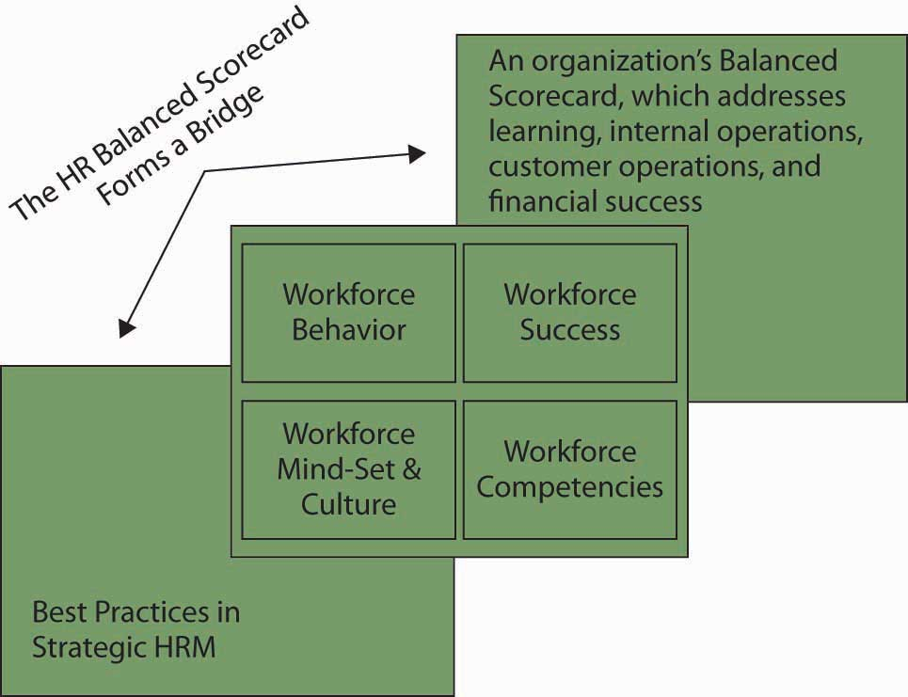
The HR Balanced Scorecard bridges HR best practices and the firm’s comprehensive Balanced Scorecard.

Human Capital
Implementing the HR scorecard requires a change in perspective, from seeing people as a cost to seeing people as the company’s most important asset to be managed—human capital. According to the Society of Human Resource Management’s Research Quarterly, “A company’s human capital asset is the collective sum of the attributes, life experience, knowledge, inventiveness, energy and enthusiasm that its people choose to invest in their work.”
- Weatherly, L. (2003, March). Human capital—the elusive asset; measuring and managing human capital: A strategic imperative for HR. Research Quarterly, Society for Human Resource Management. Retrieved June 1, 2003, from http://www.shrm.org/research/quarterly/0301capital.pdf
As you can tell by the definition, such an asset is difficult to measure because it is intangible, and factors like “inventiveness” are subjective and open to interpretation. The challenge for managers, then, is to develop measurement systems that are more rigorous and provide a frame of reference. The metrics can range from activity-based (transactional) metrics to strategic ones. Transactional metrics are the easiest to measure and include counting the number of new people hired, fired, transferred, and promoted. The measures associated with these include the cost of each new hire, the length of time and cost associated with transferring an employee, and so forth. Typical ratios associated with transactional metrics include the training cost factor (total training cost divided by the employees trained) and training cost percentage (total training cost divided by operating expense).
- Saratoga Institute—2003 SHRM National Conference, as quoted in Weatherly, L. (2003). The value of people: The challenges and opportunities of human capital measurement and reporting. SHRM Research Quarterly, 3, 14–25
But, these transactional measures don’t get at the strategic issues, namely, whether the right employees are being trained and whether they are remembering and using what they learned. Measuring training effectiveness requires not only devising metrics but actually changing the nature of the training.
The Bank of Montreal has taken this step. “What we’re trying to do at the Bank of Montreal is to build learning into what it is that people are doing,” said Jim Rush of the Bank of Montreal’s Institute for Learning. “The difficulty with training as we once conceived it is that you’re taken off your job, you’re taken out of context, you’re taken away from those things that you’re currently working on, and you go through some kind of training. And then you’ve got to come back and begin to apply that. Well, you walk back to that environment and it hasn’t changed. It’s not supportive or conducive to you behaving in a different kind of way, so you revert back to the way you were, very naturally.” To overcome this, the bank conducts training such that teams bring in specific tasks on which they are working, so that they learn by doing. This removes the gap between learning in one context and applying it in another. The bank then looks at performance indices directly related to the bottom line. “If we take an entire business unit through a program designed to help them learn how to increase the market share of a particular product, we can look at market share and see if it improved after the training,” Rush said.
- Rush, J. (1995 July). Interview backgrounder for Fast Company
Motorola has adopted a similar approach, using action learning in its Senior Executives Program. Action learning teams are assigned a specific project by Motorola’s CEO and are responsible for implementing the solutions they design. This approach not only educates the team members but also lets them implement the ideas, so they’re in a position to influence the organization. In this way, the training seamlessly supports Motorola’s goals.
As we can see in these examples, organizations need employees to apply the knowledge they have to activities that add value to the company. In planning and applying human capital measures, managers should use both retrospective (lagging) and prospective (leading) indicators. Lagging indicators are those that tell the company what it has accomplished (such as the Bank of Montreal’s documenting the effect that training had on a business unit’s performance). Leading indicators are forecasts that help an organization see where it is headed. Leading indicators include employee learning and growth indices.
- Weatherly, L. A. (2003). The value of people: The challenges and opportunities of human capital measurement and reporting. SHRM Research Quarterly, 3, 26–31

The Payoff
Given the complexity of what we’ve just discussed, some managers may be inclined to ask, “Why bother doing all this?” Research by John Lingle and William Schiemann provides a clear answer: Companies that make a concerted effort to measure intangibles such as employee performance, innovation, and change in addition to measuring financial measures perform better. Lingle and Schiemann examined how executives measured six strategic performance areas: financial performance, operating efficiency, customer satisfaction, employee performance, innovation and change, and community/environment issues. To evaluate how carefully the measures were tracked, the researchers asked the executives, “How highly do you value the information in each strategic performance area?” and “Would you bet your job on the quality of the information on each of these areas?” The researchers found that the companies that paid the closest attention to the metrics and had the most credible information were the ones identified as industry leaders over the previous three years (74% of measurement-managed companies compared with 44% of others) and reported financial performance in the top one-third of their industry (83% compared with 52%).
The scorecard is vital because most organizations have much better control and accountability over their raw materials than they do over their workforce. For example, a retailer can quickly identify the source of a bad product, but the same retailer can’t identify a poor-quality manager whose negative attitude is poisoning morale and strategic execution.
- Becker, B., & Huselid, M. (2006). Strategic human resources management: Where do we go from here? Journal of Management, 32, 898–925

Applying the Balanced Scorecard Method to Your Human Capital
Let’s translate the HR scorecard to your own Balanced Scorecard of human capital. As a reminder, the idea behind the HR scorecard is that if developmental attention is given to each area, then the organization will be more likely to be successful. In this case, however, you use the scorecard to better understand why you may or may not be effective in your current work setting. Your scorecard will comprise four sets of answers and activities.
- What is your mind-set and values? Do you understand the organization’s strategy and embrace it, and do you know what to do in order to implement the strategy? If you answered “no” to either of these questions, then you should consider investing some time in learning about your firm’s strategy. For the second half of this question, you may need additional coursework or mentoring to understand what it takes to move the firm’s strategy forward.
- What are your work-related competencies? Do you have the skills and abilities to get your job done? If you have aspirations to key positions in the organization, do you have the skills and abilities for those higher roles?
- What are the leadership and workforce behaviors? If you are not currently in a leadership position, do you know how consistently your leaders are behaving with regard to the achievement of strategic objectives? If you are one of the leaders, are you behaving strategically?
- Your success? Can you tie your mind-set, values, competencies, and behaviors to the organization’s performance and success?
This simple scorecard assessment will help you understand why your human capital is helping the organization or needs additional development itself. With such an assessment in hand, you can act to help the firm succeed and identify priority areas for personal growth, learning, and development.

KEY TAKEAWAY
The Balanced Scorecard, when applied to HR, helps managers align all HR activities with the company’s strategic goals. Assigning metrics to the activities lets managers track progress on goals and ensure that they are working toward strategic objectives. It adds rigor and lets managers quickly identify gaps. Companies that measure intangibles such as employee performance, innovation, and change perform better financially than companies that don’t use such metrics. Rather than investing equally in training for all jobs, a company should invest disproportionately more in developing the people in the key “strategic” (“A”) jobs of the company on which the company’s success is most dependent.

EXERCISES
- Define the Balanced Scorecard method.
- List the elements of a Workforce Scorecard.
- Discuss how human capital can be managed like a strategic asset.
- Why is it important to align HR metrics with company strategy?
- What kind of metrics would be most useful for HR to track?

